Online Fruits and Vegetables Shop UI
A Project Report
Subject Code: 23AID215
Subject Name: User Interface Design
Submitted By

A-2 | CH SAI SRI SAGAR | CB.AI.U4AID24011
 | P MODINI VARDHAN | CB.AI.U4AID24041
 | YARAGUTI ANU | CB.AI.U4AID24064
 | YERUVA AMRUTHA CHOWDARY | CB.AI.U4AID24065


AMRITA SCHOOL OF ARTIFICAL INTELLIGENCE
AMRITA VISHWA VIDYAPEETHAM
COIMBATORE 64112
MARCH 2026

2. INTRODUCTION
FreshMart is a user interface project developed as part of the User Interface Design (UID) course. The goal of this project is to design and implement an interactive and user-friendly web interface for an online fruits and vegetables shopping platform.
The website allows users to browse fresh fruits and vegetables, search for specific products, view detailed information about each item, and manage a shopping cart before checkout. The application focuses on improving the online grocery shopping experience by making product browsing simple, visually appealing, and efficient.
The system is developed using HTML, CSS, and JavaScript, which are the core technologies used in modern web development. HTML provides the structural layout of the web pages, CSS is used to design and style the user interface, and JavaScript enables dynamic behavior such as search functionality, product filtering, and cart interaction.
The interface follows modern UI design principles including clarity, responsiveness, consistency, and ease of navigation. The design ensures that users can easily locate products, explore categories, and complete their shopping process smoothly.
This project demonstrates how front-end technologies can be used to build a responsive and interactive web application without requiring complex server-side infrastructure.

3. INDIVIDUAL CONTRIBUTION
P. Modini Vardhan – Homepage and Navigation Interface
P. Modini Vardhan was responsible for designing the homepage layout and navigation system of the FreshMart website. This includes the header section containing the website logo, navigation menu, and product search bar.
The homepage also contains featured products and category sections that allow users to quickly explore available items. HTML was used to structure the layout while CSS was used to design the visual appearance of the navigation bar and product cards.
JavaScript was integrated to implement search functionality that dynamically filters products based on the user’s input. This contribution forms the primary interface through which users begin their shopping experience.

Yaraguti Anu – Product Listing and Category Interface
Yaraguti Anu developed the product listing interface where fruits and vegetables are displayed in an organized grid format.
Each product is presented in a card containing product image, product name, price per kilogram, freshness information, and quantity selection. CSS grid layout was used to arrange the products efficiently across different screen sizes.
JavaScript functionality was implemented to dynamically render product cards and allow users to search or filter products easily. This component enables users to browse products quickly and efficiently.

Ch Sai Sri Sagar – Product Detail Interface
Ch Sai Sri Sagar implemented the product detail page, which provides additional information about selected items.
The page displays the product image, name, price, freshness label such as “Arrived Today”, and health benefit indicators. Users can also adjust the product quantity before adding the item to the cart.
JavaScript logic dynamically updates the price based on quantity selection, creating an interactive and informative product detail interface.

Yeruva Amrutha Chowdary – Cart and Checkout Interface
Yeruva Amrutha Chowdary developed the shopping cart and checkout modules of the application.
The cart interface displays the selected products, their quantities, and the total price. Users can update quantities or remove items from the cart.
The checkout section allows users to enter delivery information such as address and contact number before confirming the order. JavaScript ensures that the total price updates automatically when cart items change.

4. Problem & User Description
Problem Description
Many online grocery websites have complex navigation structures and cluttered layouts, making it difficult for users to quickly find products. Customers may experience difficulty searching for items, understanding product freshness, or managing cart information.
The FreshMart interface addresses these problems by offering a clean and responsive design that simplifies product discovery and cart management. Search functionality and dynamic filtering allow users to locate products quickly, while real-time updates provide a smooth shopping experience.

User Description
The primary users of this application are customers who wish to purchase fresh fruits and vegetables online. These users may include students, working professionals, and families who prefer convenient online grocery shopping.
The interface is designed for users with basic web browsing knowledge and ensures accessibility across both desktop and mobile devices.
5. UI Design Explanation (Overall Project)
The FreshMart website follows a modern and minimal user interface design that prioritizes usability and clarity.
The application consists of several interconnected UI components:
• Navigation bar containing logo and search functionality
• Product listing section displaying fruits and vegetables
• Product detail interface providing additional product information
• Shopping cart interface for managing selected products
• Checkout page for completing the purchase process
The interface uses green color themes to represent freshness and organic products. Product cards are arranged in a grid layout to allow users to browse items efficiently.
Interactive elements such as hover effects, smooth transitions, and responsive layouts enhance the overall user experience. Media queries ensure that the interface adapts correctly to different screen sizes.

6. Individual Pages Explanation
P. Modini Vardhan – Homepage Interface
P. Modini Vardhan was responsible for designing and implementing the Homepage Interface of the FreshMart website. The homepage acts as the main entry point for users visiting the online grocery platform.
The work involved creating the navigation header section, which includes the FreshMart logo, search bar, and navigation icons such as Home, Account, and Cart. This section helps users quickly access different parts of the website.
Another important part of the homepage is the hero section, which introduces the website with the title “Farm Fresh Fruits & Vegetables”. This section highlights the key features of the platform such as fresh products, fast delivery, and organic options.
The homepage also includes category cards for items like apples, vegetables, berries, and mangoes. These category sections allow users to quickly navigate to specific product groups.
HTML was used to structure the layout of the homepage, CSS was used to design the visual appearance with a green theme representing freshness, and JavaScript was used to handle interactive elements such as the search functionality.
This page provides users with a clear introduction to the platform and guides them toward browsing products.

Yaraguti Anu – Product Listing Page
Yaraguti Anu developed the Product Listing Page, which displays all available fruits and vegetables in a structured grid layout.
The page contains multiple product cards, each displaying the product image, product name, price, freshness label, and quantity selection controls. These cards allow users to quickly view essential product information while browsing.
The listing page also includes a search functionality that allows users to type keywords and filter products dynamically. This feature is implemented using JavaScript to instantly update the displayed products without refreshing the page.
The grid layout for product cards was designed using CSS to ensure proper spacing and responsiveness across different screen sizes.
HTML was used to structure each product card, CSS was used to design the grid layout and product styling, and JavaScript was used to dynamically render products and manage the search feature.
This page allows users to browse multiple products efficiently and select items they wish to purchase.

Ch Sai Sri Sagar – Product Detail Page
Ch Sai Sri Sagar implemented the Product Detail Page, which provides additional information about a selected product.
When a user clicks on a product from the listing page, the system opens the product detail interface displaying detailed information such as the product image, product name, price per kilogram, and product rating.
This page also includes freshness indicators, such as “Arrived Today” or “Use Soon”, which help users understand the freshness level of the product.
Additional information such as health benefits, product description, and storage suggestions is displayed to help users make informed purchasing decisions.
The page also allows users to adjust the product quantity using increment and decrement buttons, and JavaScript dynamically updates the total price based on the selected quantity.
HTML structures the product layout, CSS enhances the visual design and alignment, and JavaScript controls the quantity adjustment and dynamic price updates.
This page improves user experience by providing detailed product information before adding items to the cart.

Yeruva Amrutha Chowdary – Cart and Checkout Page
Yeruva Amrutha Chowdary developed the Shopping Cart and Checkout Interface, which represents the final stage of the online shopping process.
The cart page displays the list of products selected by the user, along with their images, names, prices, and selected quantities. Users can increase or decrease the quantity of each product using interactive buttons.
JavaScript dynamically updates the subtotal and total price whenever the quantity of items changes. Users can also remove items from the cart if they decide not to purchase them.
The page also contains an order summary section that displays the total cost of the selected items along with delivery information.
A checkout button is provided to allow users to proceed to the final order confirmation stage. This step would typically include entering delivery details and confirming payment.
HTML structures the cart layout, CSS ensures the page is visually organized and responsive, and JavaScript manages cart updates and total price calculations.
This interface ensures that users can review and confirm their purchases before completing the order.
7. Code Samples
HTML Code Example (Product Card)
<div class="product-card">
<img src="images/mango.jpg" alt="Alphonso Mango">
<div class="product-info">
<h3 class="product-name">Alphonso Mango</h3>
<p class="product-price">₹200 / kg</p>
<div class="product-actions">
<button class="add-btn">Add to Cart</button>
</div>
</div>
</div>
This HTML structure creates a product card displaying the product image, name, price, and add-to-cart button.

CSS Code Example (Product Grid Layout)
.product-grid{
display:grid;
grid-template-columns:repeat(auto-fill,minmax(220px,1fr));
gap:20px;
padding:20px;
}
.product-card{
border-radius:12px;
padding:15px;
background:#ffffff;
box-shadow:0 4px 12px rgba(0,0,0,0.1);
transition:transform 0.3s ease;
}
.product-card:hover{
transform:translateY(-5px);
}
This CSS code creates a responsive grid layout for displaying products and adds hover animations for better user experience.

JavaScript Code Example (Search Function)
function runSearch(){
const query =
document.getElementById("searchInput")
.value
.toLowerCase();
const filteredProducts =
products.filter(product =>
product.name
.toLowerCase()
.includes(query));
renderProducts(filteredProducts);
}
This JavaScript function allows users to search for products dynamically without refreshing the webpage.

8. Screenshots of Output
Figure 1: Homepage Interface
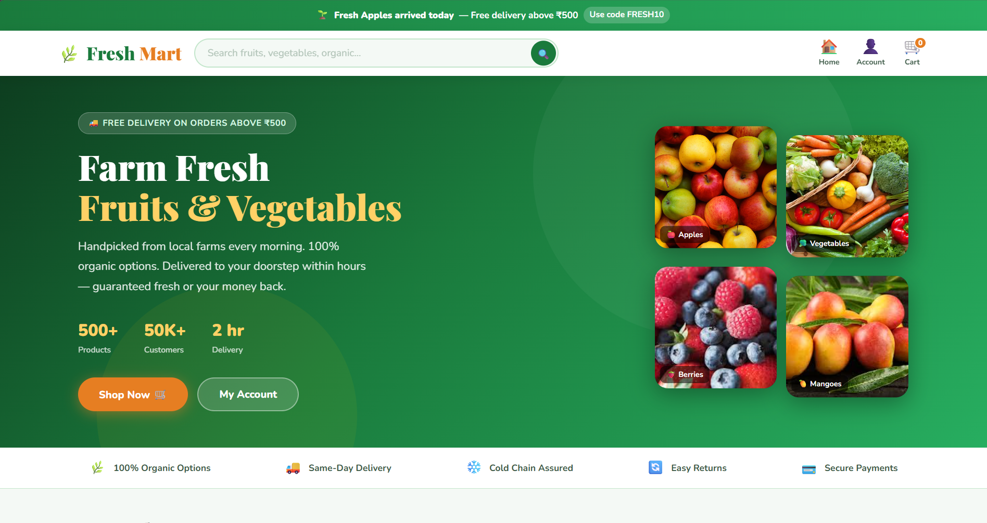
This screenshot shows the homepage of the FreshMart website. The page contains the navigation bar with the website logo, search bar, and menu options such as Home, Account, and Cart. The hero section highlights the platform with the title “Farm Fresh Fruits & Vegetables” and promotional information such as free delivery offers. Category cards allow users to quickly explore different product groups such as apples, vegetables, berries, and mangoes.

Figure 2: Product Listing Page
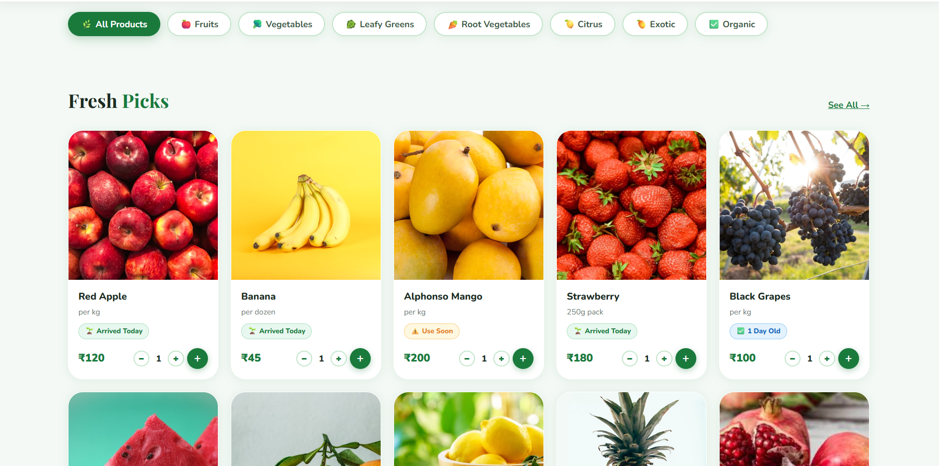
This screenshot shows the product listing interface where different fruits and vegetables are displayed in a grid layout. Each product card includes the product image, product name, price, freshness label, and quantity selection controls. Users can browse multiple products easily and adjust quantities before adding items to the cart.

Figure 3: Product Detail Page
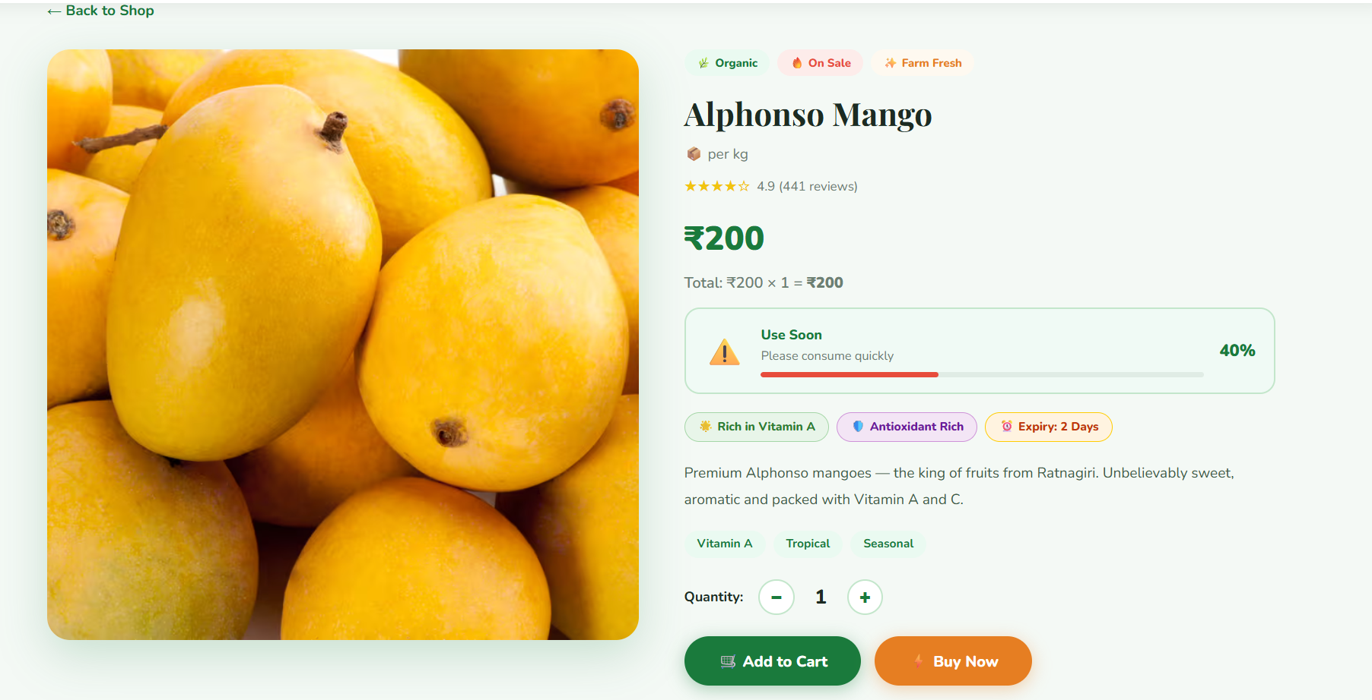

This screenshot shows the product detail interface for a selected product. The page displays detailed information including the product image, price, freshness indicator, health benefits, and product description. Users can adjust the product quantity using increment and decrement buttons, and the total price updates dynamically.

Figure 4: Cart Interface
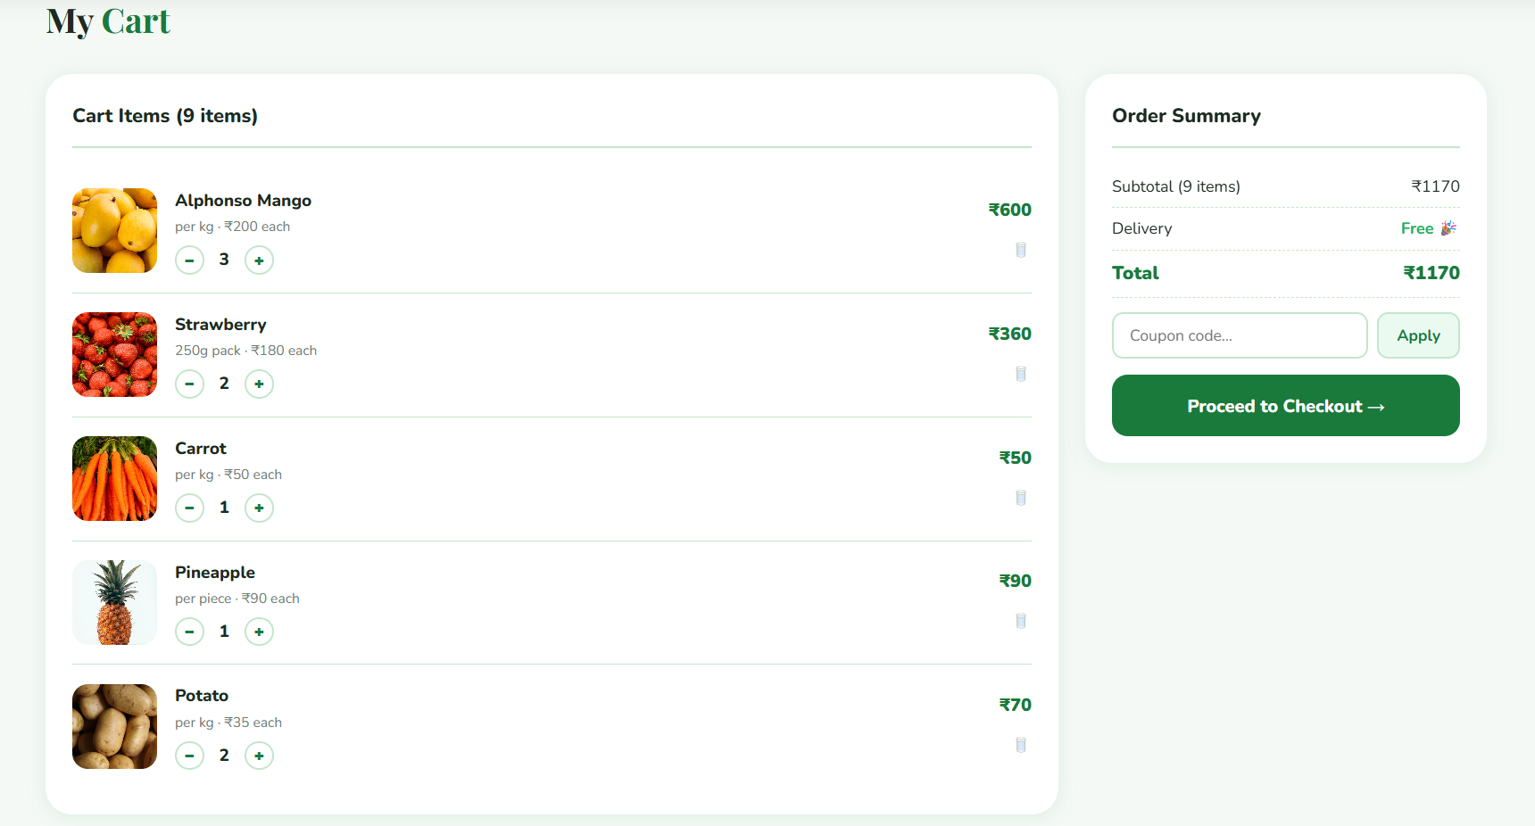
This screenshot shows the shopping cart interface where users can view the products they have selected for purchase. The page displays the product image, product name, quantity controls, and price for each item. The order summary section on the right side calculates the subtotal and total amount for the select
Figure 5: Checkout Interface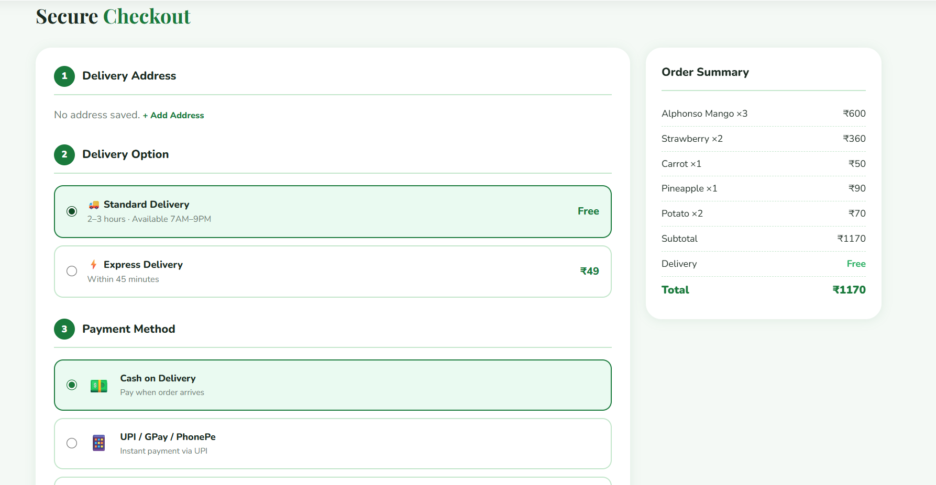
This screenshot represents the checkout stage of the shopping process. The checkout section allows users to review the order summary and proceed to confirm the purchase. It includes options such as applying coupon codes, viewing the final total amount, and proceeding to the checkout process.

