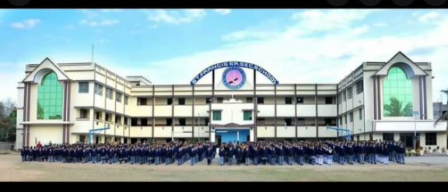

EDUCATION

ST. FRANCIS SENIOR SECONDARY SCHOOL

<https://www.stfrancisschooltnk.org/>

RESEARCH INTERESTS