CIP-A106 Laboratory 03
Technical Report: Packer Assessment and Ransomware Analysis of the Course-Provided TeslaCrypt Sample
Field | Detail
Full Name | Sikiru Habeeb
Student ID | C11/26/EHIT/17330
Analyst | habee (analysis VM user account). Insert full name and Student ID before submission.
Analysis date | Monday, 5 October 2026 (guest clock, 12:25 AM to 2:27 AM)
Sample | Sample4_TeslaCrypt_Ransomware.zip containing demo1_ransomware.bin
Analysis environment | FLARE-VM (hostname "flare"), Windows 10.0.22621.1555, VirtualBox VM "windows11", isolated
Tools | PEStudio 9.61, Detect It Easy v3.10, x32dbg [Elevated] (May 27 2026 build, TitanEngine), Windows PowerShell, VBoxManage
Submission package | CIP-A106_Lab03_StudentID.zip (report, evidence appendix, evidence manifest; no live malware or raw memory dumps)

1. Executive Summary
The sample demo1_ransomware.bin is a 360 KB, 32-bit Windows GUI executable (SHA-256 5343947829609F69E84FE7E8172C38EE018EDE3C9898D4895275F596AC54320D). Static analysis shows it is packed: overall entropy is 7.629 and four of its eight sections measure between 7.648 and 7.883. Its import table holds only six functions, which is far too small for a program that encrypts files. No known packer signature matched, so the packing is classified as custom or unidentified.
The sample was executed under x32dbg inside the isolated VM. Execution produced a ransom note that claims AES encryption of the victim's files and demands payment in Bitcoin, a recovery file holding a Bitcoin address and long hexadecimal strings, and additional HTML and PNG files. These are observed execution effects and confirm the sample behaves as ransomware.
The debugger session ended when the sample ran to completion and the process terminated. The original entry point, the unpacked copy and the process memory acquisition were therefore not completed in this session. The analyst will repeat those tasks in a second controlled session. Section 2 lists the status of every task.

2. Scope, Safety Controls and Task Status
All handling of the archive and the extracted file took place inside the isolated analysis VM. The sample did not touch the host or any external network (Section 3.1). The analyst could not complete the full analysis due to unforeseen circumstances: the sample ran to completion under the debugger, terminating the process before memory acquisition. This report states only what the appended evidence supports.
Task | Status | Evidence / note
A1 Isolation and clean snapshot | Completed | Figures 2, 3
A2 OS, date/time, analyst, tool versions | Completed | Figures 4, 9, 14 (versions read from tool title bars and banners)
A3 Extract inside VM, hash before analysis | Completed | Figures 5, 6
A4 Baseline: processes, startup, disk | Partial | Host disk usage recorded (Figure 1). Guest process and startup baselines are not in the evidence set.
B Triage and packer assessment | Completed | Figures 7-10, 12, 13. The PEStudio indicators and strings views were not captured.
C Entry point and unpacking | Partial | Debugger session and memory maps recorded (Figures 14-19). The original entry point was not identified and no unpacked copy was produced.
D Memory acquisition and validation | Not completed | No memory artifact acquired in this session. Repeat planned (Section 8).
E Findings and reporting | Completed for available evidence | Sections 6 and 7. Includes observed execution effects.

3. Environment and Evidence Preparation (Task A)

3.1 Isolation proof
The VBoxManage output in Figure 2 shows the isolation state of VM "windows11" before the sample was handled:
Setting | Observed value
NIC 1 to NIC 8 | All disabled
Clipboard Mode / Clipboard file transfers | Disabled / Disabled
Drag and drop Mode | Disabled
Shared folders | None
USB device filters | None (xHCI controller enabled; no passthrough filter configured)

The link state of NIC 2 was set to off and confirmed disabled (Figure 3). No bridged, NAT or VPN adapter was present and no host integration feature was active.

3.2 Clean snapshot
Snapshot Lab03_Clean_ArchiveOnDisk (UUID 2d3d8812-f33d-42a1-bff3-6ed0a463a72b) was taken before extraction. Its description reads "Isolation verified, archive downloaded but not extracted, nothing executed" (Figure 3). The archive was already on disk when the snapshot was taken, which is a minor sequencing deviation. Nothing had been extracted or run, so the snapshot is a valid clean baseline. The snapshot tree also retains the Lab 02 states.

3.3 System and tool record
Item | Value | Source
Hostname | flare | Figure 4
OS version | Microsoft Windows 10.0.22621.1555 | Figure 4
Date and time | Monday, 5 October 2026, 12:25:38 AM | Figure 4
Analyst account | habee | Figures 4, 6
PEStudio | 9.61 | Figures 7-13 (title bar)
Detect It Easy | v3.10 [Windows 10 Version 2009] (x86_64) | Figure 9
Debugger | x32dbg [Elevated], May 27 2026 build (TitanEngine) | Figures 11, 14
Memory tool | None used in this session | Section 5

3.4 Extraction and integrity hashes
The archive was extracted inside the VM to C:\L\o (Figure 5). SHA-256 values were calculated before any analysis tool was opened (Figure 6):
Artifact | SHA-256 | Recorded
Sample4_TeslaCrypt_Ransomware.zip | 63E52C4A52CBFB9AB1885CBB83E5D5B836802A06618B3BC07EBC20545DF75729 | 00:25:40
C:\L\o\demo1_ransomware.bin (source executable) | 5343947829609F69E84FE7E8172C38EE018EDE3C9898D4895275F596AC54320D | 00:38:22

A hash of the executable copy (demo1_ransomware.exe) used for debugging was not recorded in this session. A repeat session will record it before debugging begins. No unpacked copy or memory artifact exists in this session, so no hashes exist for them.

3.5 Baseline
Host-side evidence folders and disk usage were recorded at 12:03 AM (Figure 1): 150,881,947,648 bytes used and 27,986,116,608 bytes free on the host C: drive. The pre-analysis process, startup and registry Run-key baseline of the guest is not part of this evidence set and is planned for the repeat session.

4. Initial Triage and Packer Assessment (Task B)

4.1 File profile
Property | Observation | Source
File type / architecture | PE32, Intel-386, 32-bit, GUI subsystem | Figures 9, 12
Size | 360.00 KiB (364,544 bytes of raw section data) | Figures 5, 7, 9
Entry point / image base | 0x00403C40 / 0x00400000 | Figures 7, 9
Size of image | 0x0009E000 | Figure 9
Sections | 8 | Figures 9, 12
Compile stamp | Sun Feb 28 18:15:11 2016 UTC (DIE displays 19:15:11, a local-time offset of one hour) | Figures 9, 12
Linker / compiler (DIE) | Microsoft Linker 8.00.50727; Microsoft Visual C/C++; Visual Studio 2005 | Figure 9
File characteristics | 0x0307: relocations, line numbers and debug info stripped; 32-bit word machine; executable | Figure 12
Version info | FileDescription: "nah nahApp" | Figures 7, 12
Resources / strings / indicators | 13 resources / 10,657 strings / 15 indicators (counts shown in the PEStudio tree) | Figures 12, 13
Debug directory | RSDS record present at 0x000052A0 | Figure 7

4.2 Sections and entropy
Section | Entropy | File ratio | Raw size | Virtual size | Virtual address
.text | 5.739 | 3.33% | 12,288 | 11,377 | 0x00001000
para | 1.972 | 1.11% | 4,096 | 1,031 | 0x00004000
.rdata | 1.030 | 1.11% | 4,096 | 799 | 0x00005000
.data | 7.648 | 16.67% | 61,440 | 336,848 | 0x00006000
.crt | 7.883 | 27.78% | 102,400 | 100,021 | 0x00059000
CODE | 7.860 | 27.78% | 102,400 | 100,024 | 0x00072000
.erloc | 7.667 | 11.11% | 40,960 | 40,007 | 0x0008B000
.rsrc | 5.572 | 10.00% | n/r | n/r | n/r
Values are from Figures 7 and 13. n/r = not read in the captured view. DIE reports total entropy of 7.62913 ("packed 95%") (Figure 10); the PE header measures 0.81143 and .text 5.73930, both classed "not packed".

4.3 Imports
PEStudio lists six imports across four libraries (Figure 8): GetClusterResourceKey (CLUSAPI.dll), memset and memcpy (msvcrt.dll), GlobalMemoryStatus and CreateEventW (KERNEL32.dll), and RemovePropA (USER32.dll). The list contains no file enumeration, cryptographic, registry, process or network functions. A program that encrypts user files needs such functions, so they are resolved at runtime after unpacking or stored in the packed sections. GetClusterResourceKey is unusual in a GUI program and is treated as a weak indicator only.

4.4 Evidence table: observations and hypotheses
# | Direct observation | Source | Preliminary hypothesis
1 | Total entropy 7.62913, classed packed (95%) | Fig. 10 | Compressed or encrypted content dominates the file
2 | .data 7.648, .crt 7.883, CODE 7.860, .erloc 7.667 | Fig. 13 | These sections hold the packed payload
3 | .text 5.739; para 1.972; .rdata 1.030; each section only 1-3 pages | Figs. 7, 10 | Small loader stub in the low-entropy sections
4 | Non-standard section names: para, .crt, CODE, .erloc | Figs. 7, 13, 17 | Custom packer; ".erloc" resembles ".reloc"
5 | .data raw size 61,440 vs virtual size 336,848 | Fig. 13 | Runtime memory reserved for unpacked data
6 | Only 6 imports; none relate to file, crypto or network activity | Fig. 8 | APIs resolved dynamically after unpacking
7 | .text, para and .rdata all carry the execute characteristic; .rdata is flagged executable | Fig. 7 | Stub sections were crafted rather than compiler-generated
8 | Memory Map: .data, .crt, CODE, .erloc mapped writable (-RWC-) | Fig. 17 | Sections are written to at runtime, consistent with unpacking
9 | DIE visible results show MS Linker 8.00.50727, MSVC, Visual Studio 2005 and no packer signature | Fig. 9 | No known packer matched; toolchain artifacts may be forged or inherited
10 | Compile stamp 2016-02-28 18:15:11 UTC | Figs. 9, 12 | Stamp is unverified because it is easily forged

4.5 Packer conclusion
The sample is packed with an unidentified (custom) packer. Entropy, section layout, section naming and the minimal import table independently point to packing, and no known-packer signature appears in DIE. Confidence that the sample is packed: high. Confidence in any specific packer family: none claimed, because none was identified.

5. Debugger Observations (Task C) and Memory (Task D)

5.1 Session record
Item | Observation | Source
Debugger | x32dbg [Elevated], May 27 2026 build | Figs. 11, 14
Target process | demo1_ransomware.exe, PID 4516, main thread 752 | Figs. 14, 16
Process model | WOW64: PEB, TEB (752) and WOW64 TEB (752) mapped, so a 32-bit process on 64-bit Windows | Fig. 17
Session start | System breakpoint at ntdll.775B7568, session time 0:00:00:14, clock 2:03 AM | Fig. 14
Registers at system breakpoint | EIP 775B7568, ESP 0019F7F4, EBP 0019F820, ESI 00785A10, EDI 0026A000, ECX 196C0000, EAX/EBX/EDX 0 | Fig. 14
Second pause | INT3 breakpoint "TLS Callback 1 (gdi32full.dll)" at gdi32full.76B51E80, session time 0:02:42, clock 2:06 AM | Fig. 16
Registers at second pause | EIP 76B51E80, ECX 76B51E80, EDX 76B10000, ESP 0019F694, EBP 0019F6A4, ESI 0019F6B8, EDI 7758D4D0 | Fig. 16
Executable copy | demo1_ransomware.exe (360 KB) present beside the .bin in C:\L\o | Fig. 15
Debugger setting | Entry Breakpoint enabled in Preferences > Events | Fig. 19
End state | x32dbg "Terminated / Debugging stopped!" at 2:25 AM; reload at 2:20 AM returned "Could not open file!" | Figs. 19, 20

5.2 Observations on unpacking
- Section layout at runtime. The Memory Map taken at 2:06 AM (Figure 17) shows the image at 0x00400000 with .text (0x401000), para (0x404000) and .rdata (0x405000) mapped execute-read, and .data (0x406000, 0x53000 bytes), .crt (0x459000), CODE (0x472000) and .erloc (0x48B000) mapped read-write. The writable high-entropy sections match the packed payload identified in Section 4.
- Private executable regions. The same map lists private regions with execute rights, including 0x00650000 (0x8000 bytes, ERW) and 0x00770000 (0x1000 bytes, ER). They are recorded for follow-up inspection in the repeat session and are not attributed to the sample in this report.
- Pause location. The second pause at gdi32full.76B51E80 lies inside the gdi32full.dll image (0x76B10000 to 0x76BCC000, Figure 18). It is a loader-phase pause in a system library and is not the sample's original entry point.

5.3 What was not completed
Requirement | Status in this session
Original entry point address and instruction context | Not identified. The packed stub entry point is 0x00403C40 (Figures 7, 9).
Hash of the executable copy before debugging | Not recorded.
Unpacked copy and its SHA-256 | Not produced.
D1-D2 Process selection, parent PID, acquisition time, memory dump, size and SHA-256 | Not performed. The process terminated when the sample ran to completion.
D3 Relevant regions and modules | Partially documented through the Memory Maps (Figures 17, 18).
D4 Validation (strings, PE checks, comparison with unpacked copy) | Not performed.

The debugger recorded the sample running to completion, which ended the session before the unpacking transition and the memory acquisition could be preserved. The analyst plans to repeat Tasks C and D from the clean snapshot in a separate session (Section 8).

6. Ransomware Findings (Task E)

6.1 Observed execution effects
After the sample ran, the analyst recorded these artifacts, all created by the sample inside the isolated VM:
- Ransom note. A plain-text file whose name begins with "_RECOVERY_" (1,930 characters, 1.91 KB, Figure 20). The note says all files were protected "by a strong encryption with AES", that a personal AES key pair was generated for the victim's PC, that the private key and decryption program are on the attackers' "Secret Server", and that the victim must obtain BITCOIN and pay. It warns that waiting will double the price and says personal home page addresses follow below the visible text.
- Recovery file. A 254-byte text file created in the Documents folder (Figure 21). It contains a 34-character Bitcoin address (13NvgU5R4tUtN6MvwkUHE7nHaSygHPBems), two long hexadecimal strings (the first begins 04FDB7AB2DB1BDB9) and the value 40.
- Additional dropped files. The folder listing in Figure 20 shows four items of types Chrome HTML Document, PNG image, Text Document and BIN File. The HTML and PNG files are consistent with ransom instruction pages created alongside the note.
- Debugger effect. x32dbg reported "Terminated / Debugging stopped!" at 2:25 AM, and an earlier reload returned "Could not open file!" (Figure 19). The sample ran to completion.

6.2 Capability, intent and execution effect
Category | Finding | Basis
Capability | Payload hidden by packing; runtime API resolution inferred from a six-function import table | Figs. 8, 10, 13
Capability | Executable regions that become writable and executable at runtime | Fig. 17
Intent | Extortion: the note demands Bitcoin payment and threatens a doubled price | Fig. 20
Execution effect | Ransom note, recovery file, HTML and PNG files created | Figs. 20, 21
Execution effect | Process terminated after running to completion | Figs. 19, 20
Not established | Encryption of specific user files, network communication, persistence, shadow-copy deletion | No evidence captured

6.3 Indicators of compromise
Indicator | Type | Source | Confidence | Limitation
5343947829609F69E84FE7E8172C38EE018EDE3C9898D4895275F596AC54320D | SHA-256 (sample) | Fig. 6 | High | Hash of the packed file only
63E52C4A52CBFB9AB1885CBB83E5D5B836802A06618B3BC07EBC20545DF75729 | SHA-256 (archive) | Fig. 6 | High | Course-provided archive
demo1_ransomware.bin / .exe | Filename | Figs. 5, 15 | High | Lab-specific name
FileDescription "nah nahApp" | PE version info | Figs. 7, 12 | High | Can be changed by the author
13NvgU5R4tUtN6MvwkUHE7nHaSygHPBems | Bitcoin address | Fig. 21 | High | Ownership and payment history not checked
04FDB7AB2DB1BDB9... (long hexadecimal string) | Key-like data | Fig. 21 | Medium | Purpose inferred from context
_RECOVERY_* text file | Ransom note filename prefix | Figs. 20, 21 | High | Full filename truncated in the tab
Ransom note text ("NOT YOUR LANGUAGE? USE ...", AES / Secret Server / BITCOIN wording) | Note content | Fig. 20 | High | Home page addresses lie beyond the visible text
.html, .png and .txt files dropped beside the note | File types | Fig. 20 | High | Names and hashes not captured
GetClusterResourceKey, RemovePropA, CreateEventW imports | API (weak) | Fig. 8 | Low | Generic functions; low value alone
The note links to https://translate.google.com and http://en.wikipedia.org/wiki/AES. These are reference links inside the note and are not attacker infrastructure. No domains, IP addresses or mutex names belonging to the sample were recovered. The VM had no network access, so network indicators could not appear.

6.4 MITRE ATT&CK mapping
Technique | Supporting evidence | Confidence | Limitation
T1027.002 Obfuscated Files or Information: Software Packing | Entropy 7.629 overall; four sections above 7.6; non-standard section names; six imports (Figs. 8, 10, 13) | High | Packer family unidentified
T1486 Data Encrypted for Impact (ransomware behaviour) | Ransom note and recovery file produced by execution; note claims AES encryption (Figs. 20, 21) | Medium | Encryption of specific files was not demonstrated in the captured evidence
T1657 Financial Theft (extortion by cryptocurrency demand) | Bitcoin address and payment demand (Figs. 20, 21) | High | Demand observed; no payment infrastructure queried

7. Conclusion
demo1_ransomware.bin is a packed 32-bit ransomware executable. It uses an unidentified custom packer (confidence: high that it is packed, no specific family claimed). When executed in the isolated VM it created a ransom note demanding Bitcoin, a recovery file carrying a Bitcoin address and key-like data, and additional HTML and PNG files, then ran to completion. The ransom-note wording and artifact set match the TeslaCrypt-style extortion pattern described by the course material, and the behaviour classification as ransomware is high confidence.

Key limitations
- The original entry point and the unpacking transition were not captured, and no unpacked copy or memory dump exists. These depend on the repeat session.
- The debugged copy (demo1_ransomware.exe) was not hashed, and the guest process, startup and registry baseline was not captured.
- File encryption of user data, persistence and network behaviour were not verified. The statements in Section 6 rest only on the artifacts shown in Figures 19 to 21.
- The PEStudio indicators and strings views were not captured, so string-based indicators beyond the ransom note are not reported.
- The sample was allowed to run to completion under the debugger, which exceeds the lab instruction to stop at the original entry point. Execution stayed inside the isolated VM with all networking and host integration disabled.

8. Repeat Session Plan
The analyst will repeat the incomplete tasks from the clean snapshot Lab03_Clean_ArchiveOnDisk in a separate controlled session:
- Capture the guest baseline (running processes, startup locations, Run keys, scheduled tasks, disk space) and hash the executable copy before debugging.
- Set breakpoints on VirtualAlloc, VirtualProtect, LoadLibraryA and GetProcAddress, and use an execute-access memory breakpoint on the high-entropy sections to locate the original entry point. Pause there and do not let the sample run to completion.
- Dump the unpacked image with Scylla, hash it, and re-examine it in PEStudio.
- Acquire a memory dump of the paused process with an approved tool, record PID, parent PID, time, size and SHA-256, then validate with strings and PE checks.
- Restore the clean snapshot when the work is complete.

9. Evidence Manifest
Chronological record of evidence artifacts. SHA-256 values for screenshots were computed on the screenshot files held for this report. Clock = time visible in the screenshot (guest clock for Figures 4 to 21; host clock for Figures 1 to 3).
Fig. | Filename | Clock | Tool | SHA-256 (file)
1 | Screenshot_1.png | 12:03 AM | PowerShell (host) | 9808134FF729F38FEE95EFFB4CF53AB33B1E6E131A20B7ECF6A764E62DA6594E
2 | Screenshot_2.png | n/s | VBoxManage | AC8B2BCEDD48DF4076C86933939F97D688C9C9ADA0B3AAA3BA5507A37A024ED2
3 | Screenshot_3.png | n/s | VBoxManage | 75E52EE8CEBABDC8CD47E234BCF0894F65B5A43D9EC6952D05E8676FDC122BB6
4 | Screenshot_4.png | 12:26 AM | PowerShell (guest) | 05EEA6FD47DDEC59EFE0B854CE5E7891643AC04E261278BE32EFBAFBB0C5B468
5 | Screenshot_5.png | 12:32 AM | File Explorer | FB85D0014E4F24A5D5FAFB9B2B80EF5E83876BADC3BCB56D72BFA8C5DE131A71
6 | Screenshot_6.png | 12:39 AM | PowerShell Get-FileHash | DC0DDF24B78CDFFC2AA1BD5C231747E9709E9BEDA3255C789A38B044E75EEE7A
7 | Screenshot_7.png | 1:02 AM | PEStudio | DC8F8713F717E2CC3682BBA1D714D153CBE5B1841BAE3EE5B8D3683247A5FBAD
8 | Screenshot_8.png | 1:04 AM | PEStudio | 897B791D5B2603166C831A312FC7C085963B08ED81A05D4E770CC200009774CD
9 | Screenshot_9.png | 1:06 AM | DIE | 6D1881ED15D64DCBFE056D922C5FEBEDBE233C822ACB6197E5905DD3504EE837
10 | Screenshot_10.png | 1:07 AM | DIE | 6D220A50198543C00F5CAC97719EF0AB52C18E9485939F02BFAF989C50D11E1C
11 | Screenshot_11.png | 1:08 AM | x32dbg | 5A6B51805D621B6F7E520F1E0479D13BCF32F1C14A1399CFB3236F8A2FD8CA91
12 | Screenshot_12.png | 1:26 AM | PEStudio | E74AC08CB3E3CCDCC03A566BDD41AC3341382794EC48016ED19C8C053120801E
13 | Screenshot_13.png | 1:33 AM | PEStudio | 91BE09BE8E2DC33195F5170027C24D362404D1E3F6295C7380407CF65C8D6D98
14 | Screenshot_14.png | 2:03 AM | x32dbg | D2965CD67B341B809308CD32E9661A5A9773EE059529534324467C30412203D9
15 | Screenshot_15_copied_to_exe.png | 2:04 AM | File Explorer | 1A772A0FA504F1397FFC361465918F614BFAE192F32A6575F97716635ED99EDC
16 | Screenshot_16_ran_once.png | 2:06 AM | x32dbg | 45890144365167C07CA61FD55650B3F68DF07E07E0B8263A771E4C54FD88EBE6
17 | Screenshot_17_memory_map.png | 2:06 AM | x32dbg | 8D98D60F45846C87892104509D8F4B543D5FF072CC8497F51B5ADC4C428C22CE
18 | Screenshot_17_memory_map_2.png | 2:08 AM | x32dbg | 23B997A2DD62E62B5AF04EA59687ACF6FDE016A0BC9647BFFDBE9E93B62D4B76
19 | Screenshot_18.png | 2:20 AM | x32dbg | CDFCBC5E476AB7AFFA509B51E37CC93555B77F2B70DCCDB9AB844D4819F077AD
20 | Screenshot_19.png | 2:25 AM | Notepad | 9AAD125F4062BE21ADC629DE787A209C36A9B14C54D7399A65C8F6BC0AC1292D
21 | Screenshot_20_file_created_in_the_documents_when_x32dgb_ran_the_exe_file.png | 2:27 AM | Notepad | 88F5F7D7B3FA7D621436E4475A7C1B6C52552B8D22FE304AA5617FFB38DE4698
n/s = time not shown in the screenshot. Source artifact hashes (archive and executable) are recorded in Section 3.4. No live malware, unpacked binaries or raw memory dumps are included in the submission package.

Evidence Appendix: Figures 1 to 21
Figure 1. Host PowerShell: evidence folders created (C:\Lab03_Evidence\screens, \logs) and host C: drive usage. Clock 12:03 AM, 5 Oct 2026. Tool: Windows PowerShell (host).
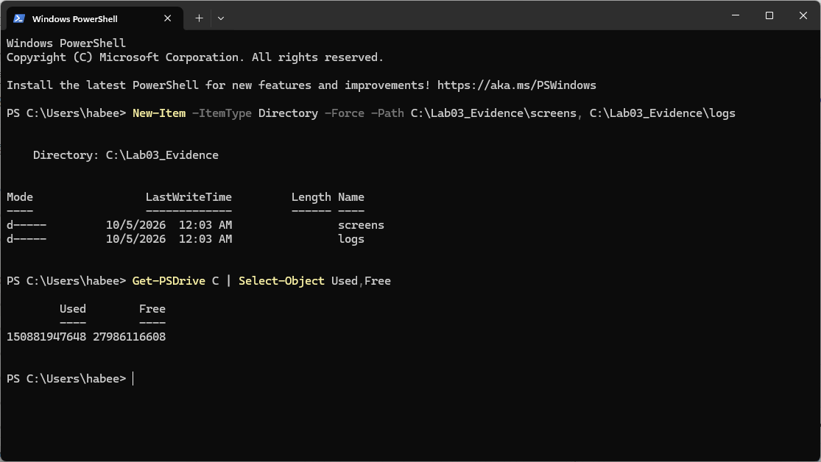
Figure 2. Host PowerShell: VBoxManage showvminfo for VM "windows11". NIC 1-8 disabled; Clipboard Mode, clipboard file transfers and Drag and drop disabled; Shared folders none; USB Device Filters none.
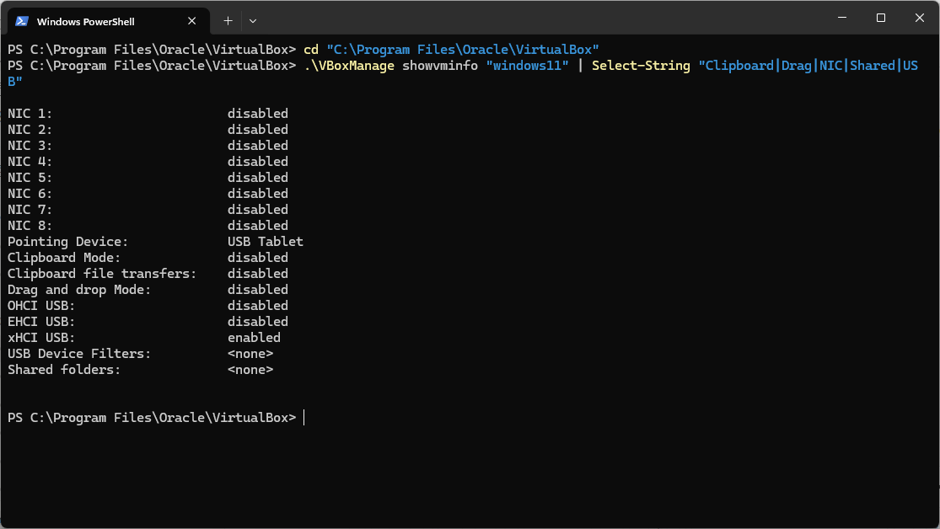
Figure 3. Host PowerShell: setlinkstate2 off, NIC 2 confirmed disabled, snapshot "Lab03_Clean_ArchiveOnDisk" taken (UUID 2d3d8812-f33d-42a1-bff3-6ed0a463a72b) and snapshot tree listed.
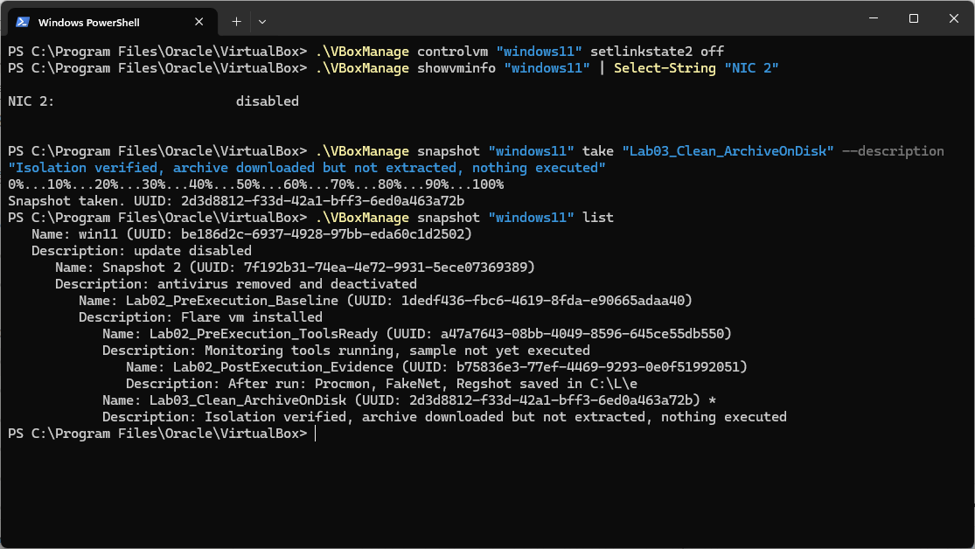
Figure 4. FLARE-VM guest PowerShell: hostname "flare", Windows version 10.0.22621.1555, date Monday 5 October 2026 12:25:38 AM. Analyst account: habee.
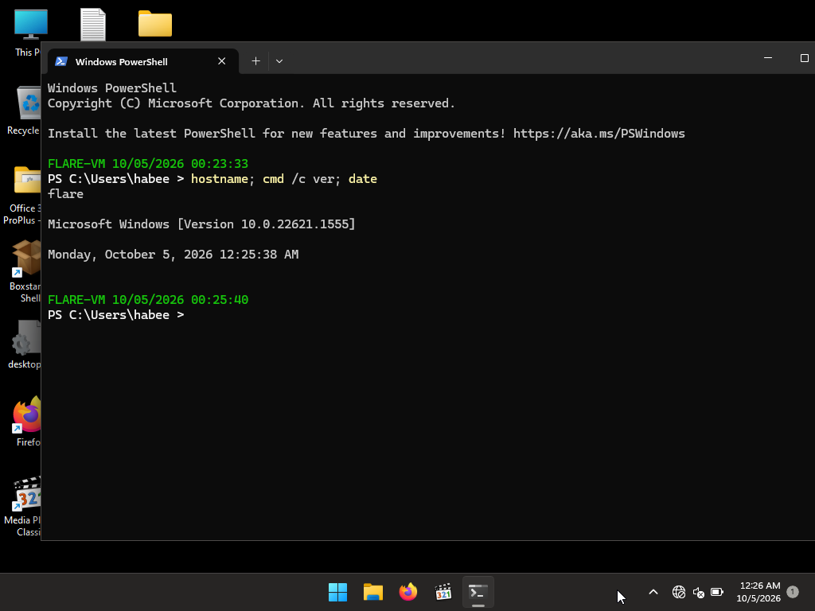
Figure 5. File Explorer, C:\L\o: extracted demo1_ransomware.bin (360 KB). Clock 12:32 AM.
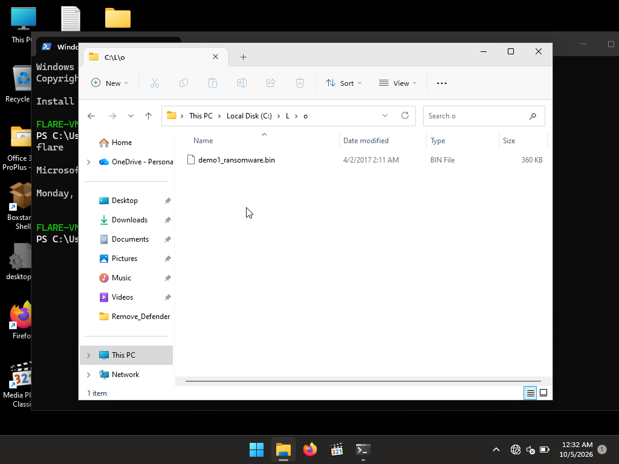
Figure 6. FLARE-VM PowerShell: Get-FileHash (SHA-256) of Sample4_TeslaCrypt_Ransomware.zip (00:25:40) and C:\L\o\demo1_ransomware.bin (00:38:22), both before any analysis tool was opened.
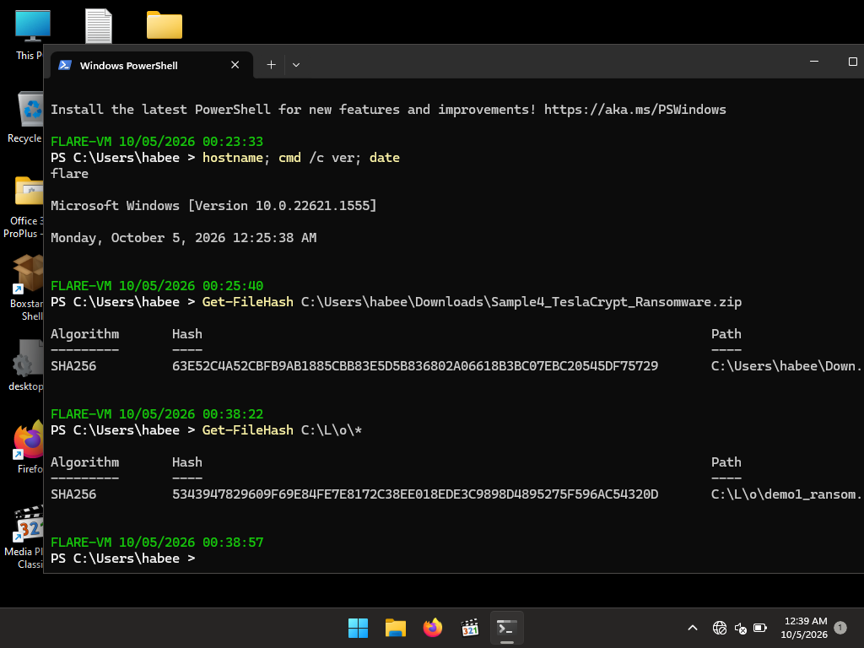
Figure 7. PEStudio 9.61, sections view (section[0]-[2]): .text, para, .rdata with entropy, raw and virtual sizes, characteristics. Entry point 0x00003C40. Clock 1:02 AM.
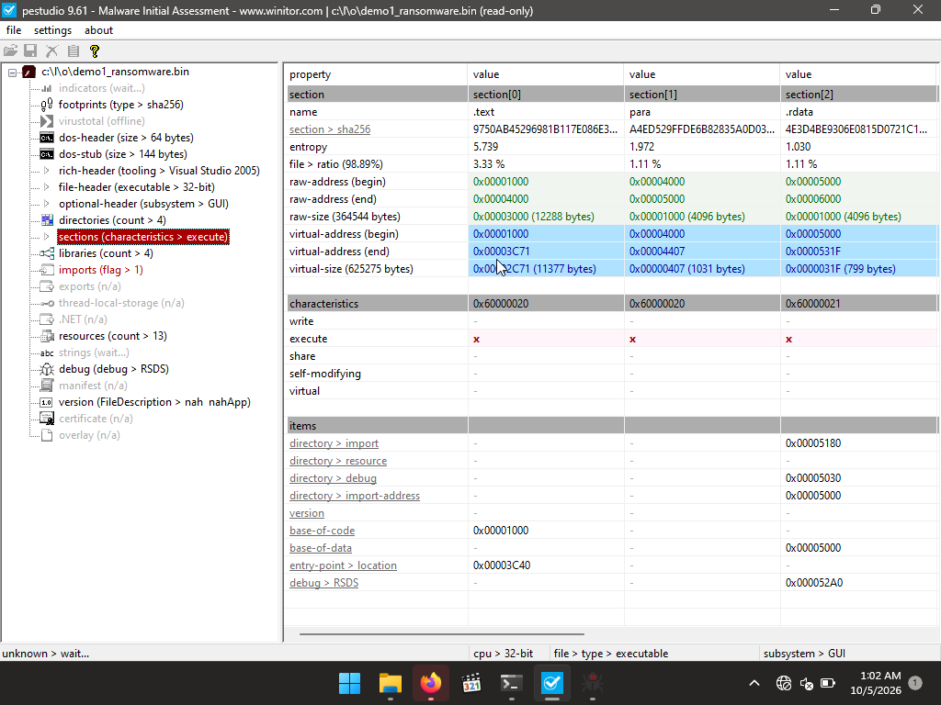
Figure 8. PEStudio 9.61, imports view: 6 imports across 4 libraries. Clock 1:04 AM.
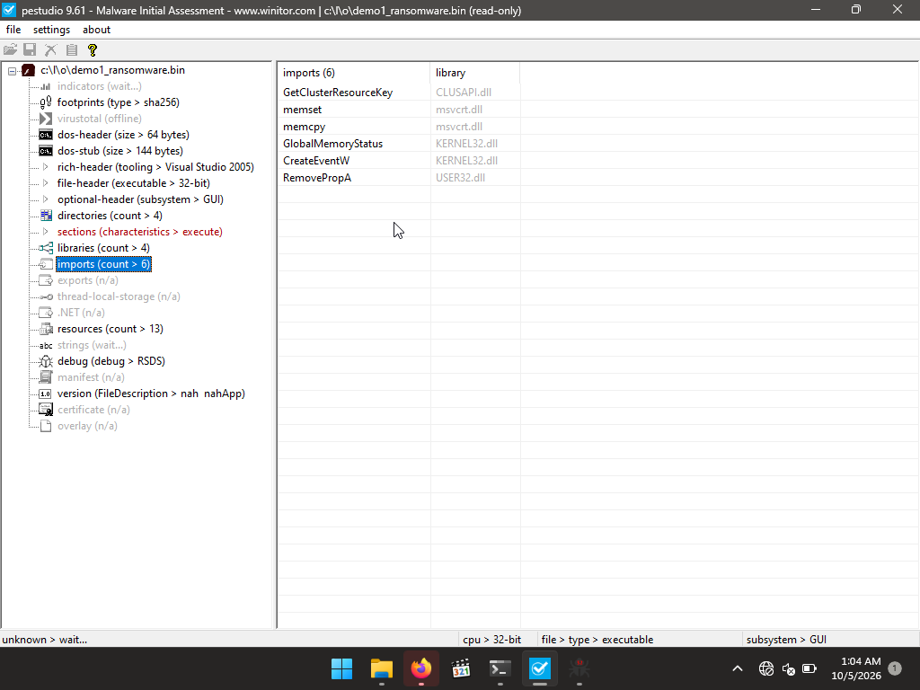
Figure 9. Detect It Easy v3.10: PE32, 360.00 KiB, base 00400000, entry point 00403c40, 8 sections, timestamp 2016-02-28 19:15:11, size of image 0009e000. Clock 1:06 AM.
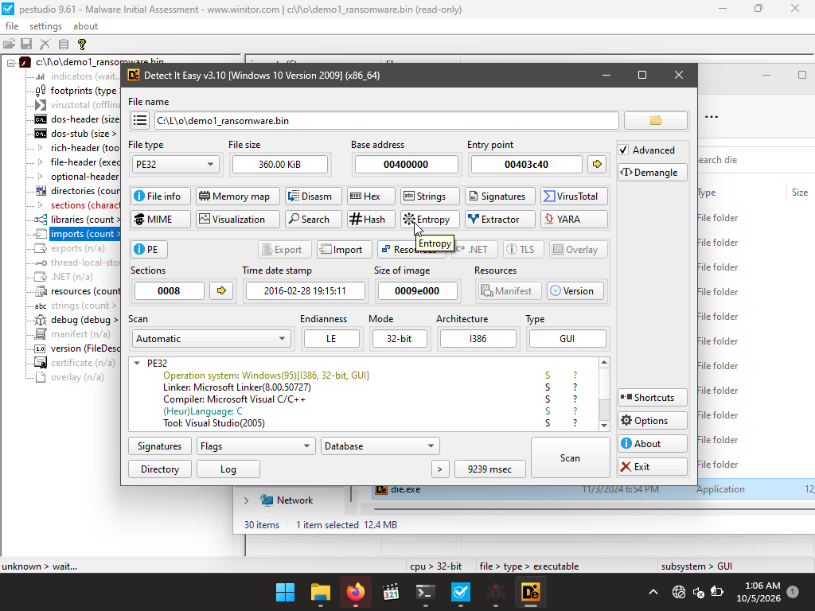
Figure 10. Detect It Easy v3.10, entropy view: total entropy 7.62913, "packed (95%)". Clock 1:07 AM.
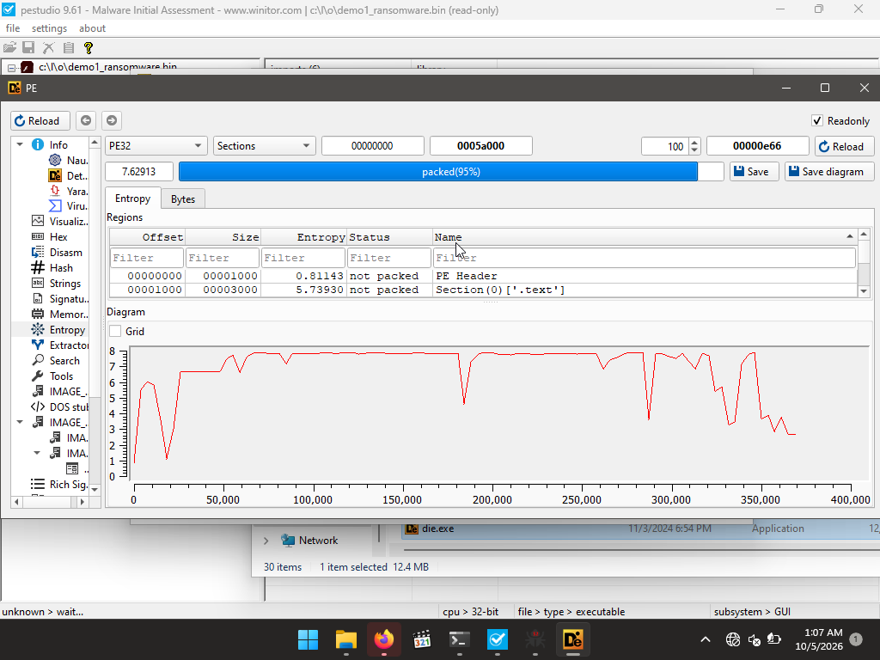
Figure 11. x32dbg [Elevated] launched with no target loaded (May 27 2026 / TitanEngine build). Clock 1:08 AM.
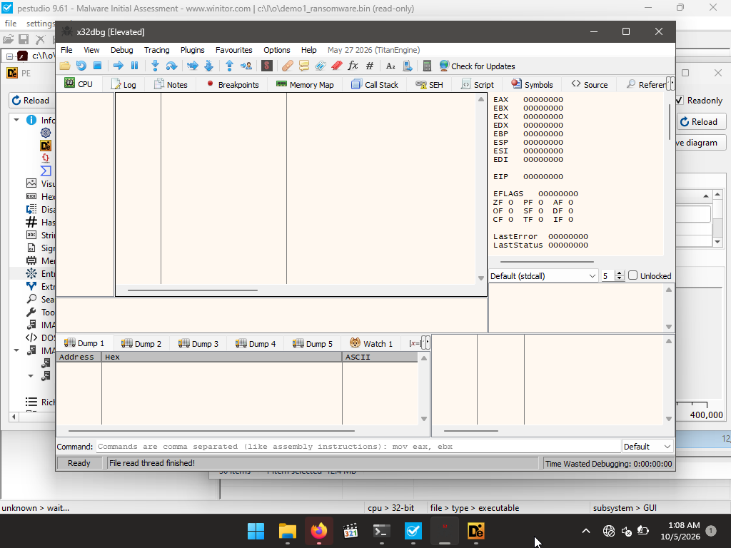
Figure 12. PEStudio 9.61, file-header view: characteristics 0x0307, compiler stamp Sun Feb 28 18:15:11 2016 (UTC), machine Intel-386, 8 sections. Clock 1:26 AM.
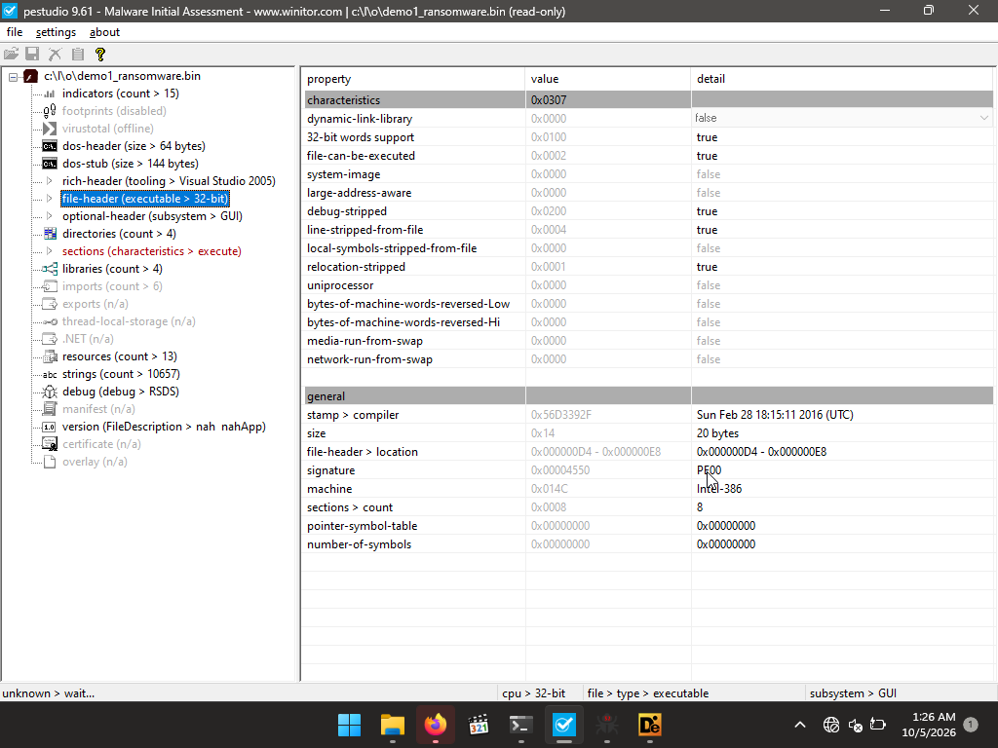
Figure 13. PEStudio 9.61, sections view (section[3]-[6]): .data, .crt, CODE, .erloc with entropy, file ratio, raw and virtual sizes. Clock 1:33 AM.
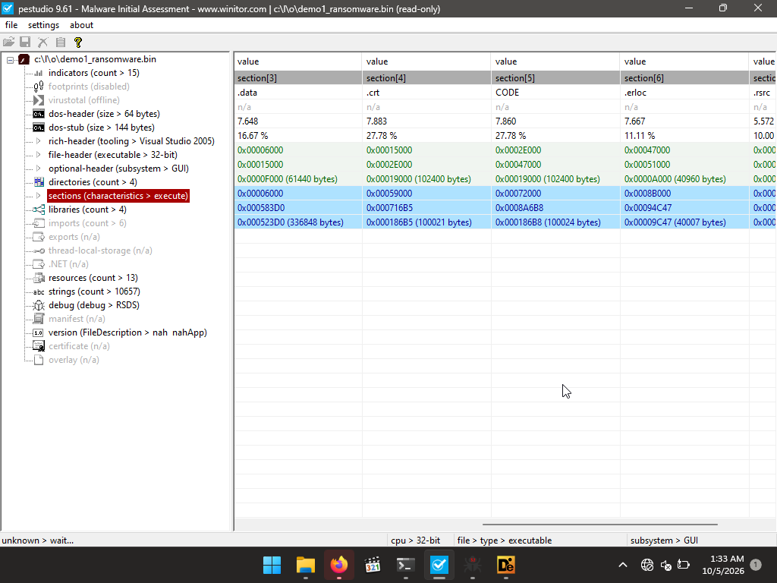
Figure 14. x32dbg: demo1_ransomware.exe, PID 4516, main thread 752. System breakpoint reached at ntdll.775B7568. Session time 0:00:00:14. Clock 2:03 AM.
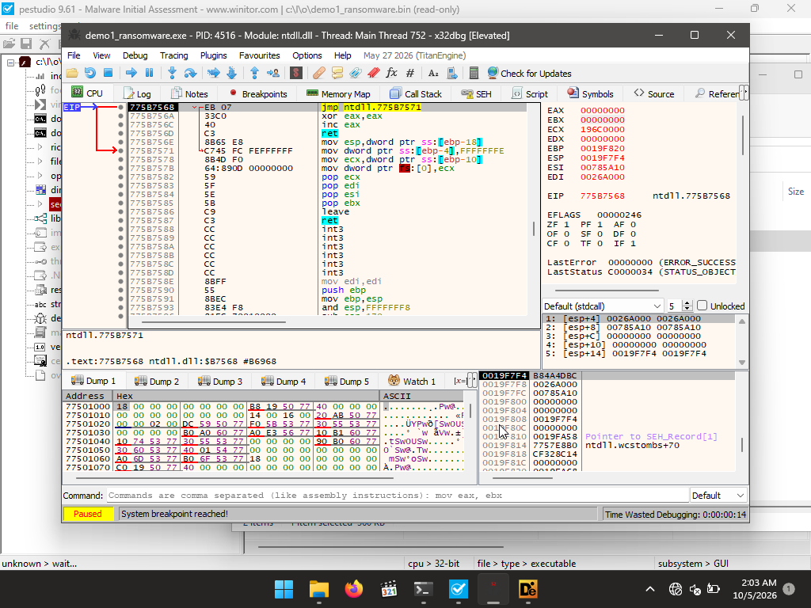
Figure 15. File Explorer, C:\L\o: demo1_ransomware.bin and the executable copy demo1_ransomware.exe (360 KB each). Clock 2:04 AM.
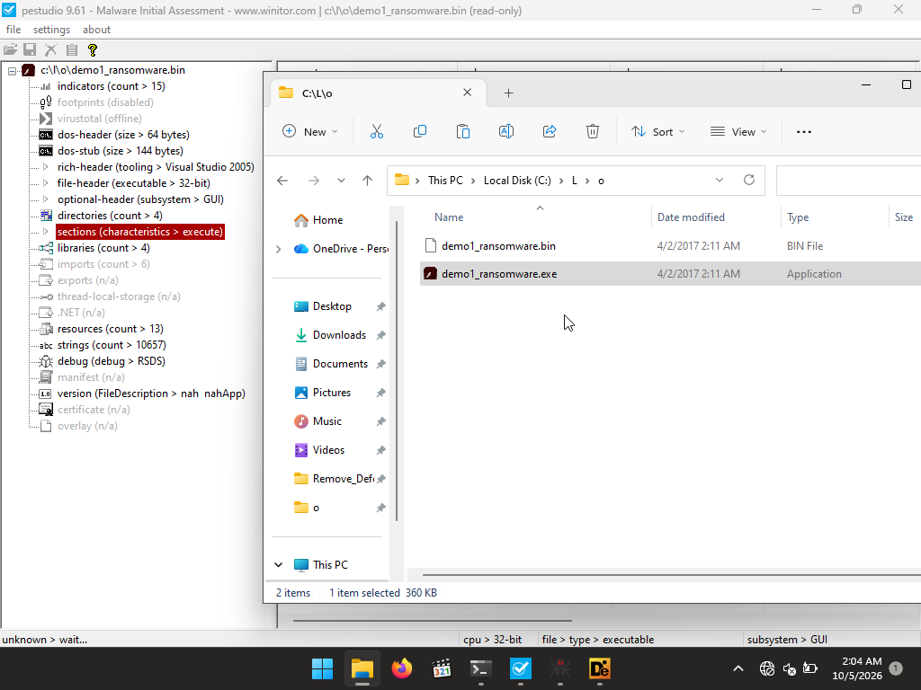
Figure 16. x32dbg: INT3 breakpoint "TLS Callback 1 (gdi32full.dll)" at gdi32full.76B51E80. EIP and ECX 76B51E80. Session time 0:00:02:42. Clock 2:06 AM.
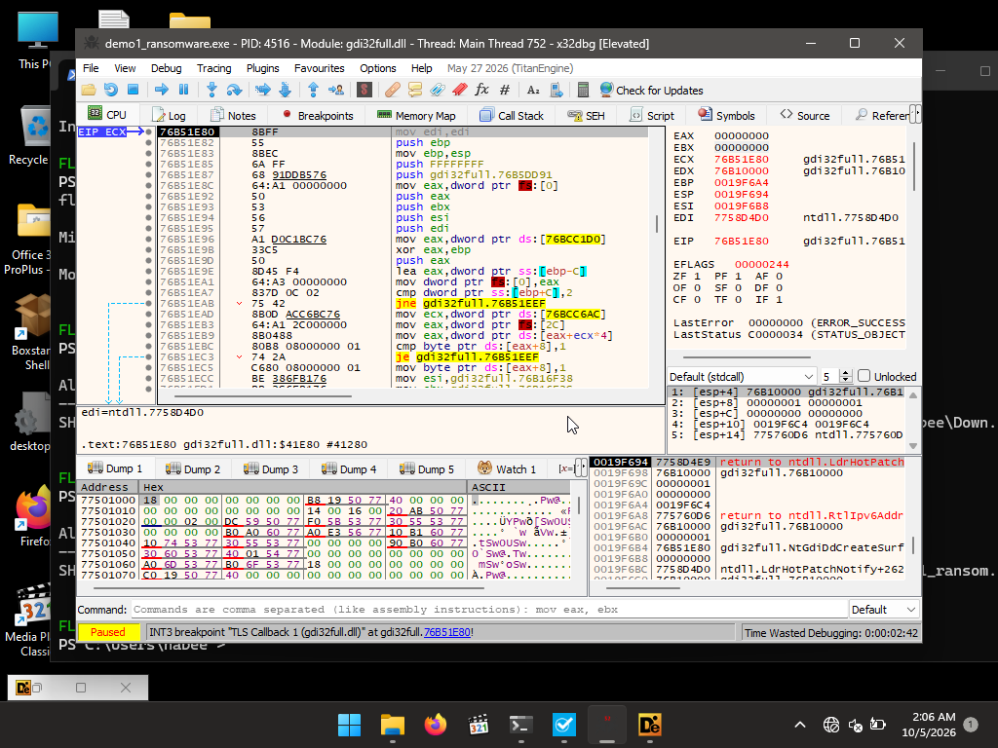
Figure 17. x32dbg Memory Map (user regions): demo1_ransomware.exe image at 0x00400000 with sections .text, para, .rdata, .data, .crt, CODE, .erloc, .rsrc; WOW64 TEB and PEB entries. Clock 2:06 AM.
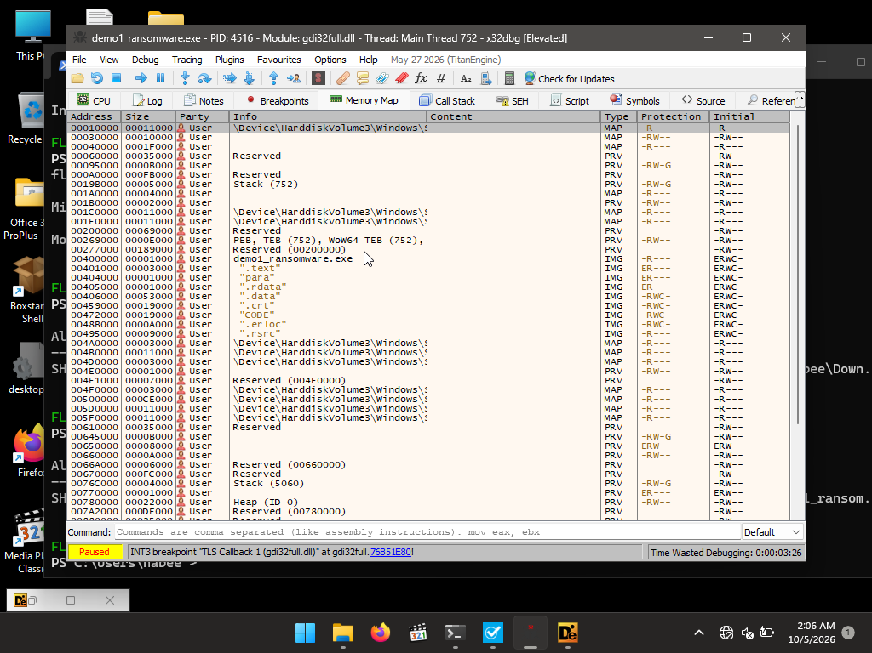
Figure 18. x32dbg Memory Map (system modules): kernel32, user32, gdi32full, msvcrt images and their sections. Session time 0:04:42. Clock 2:08 AM.
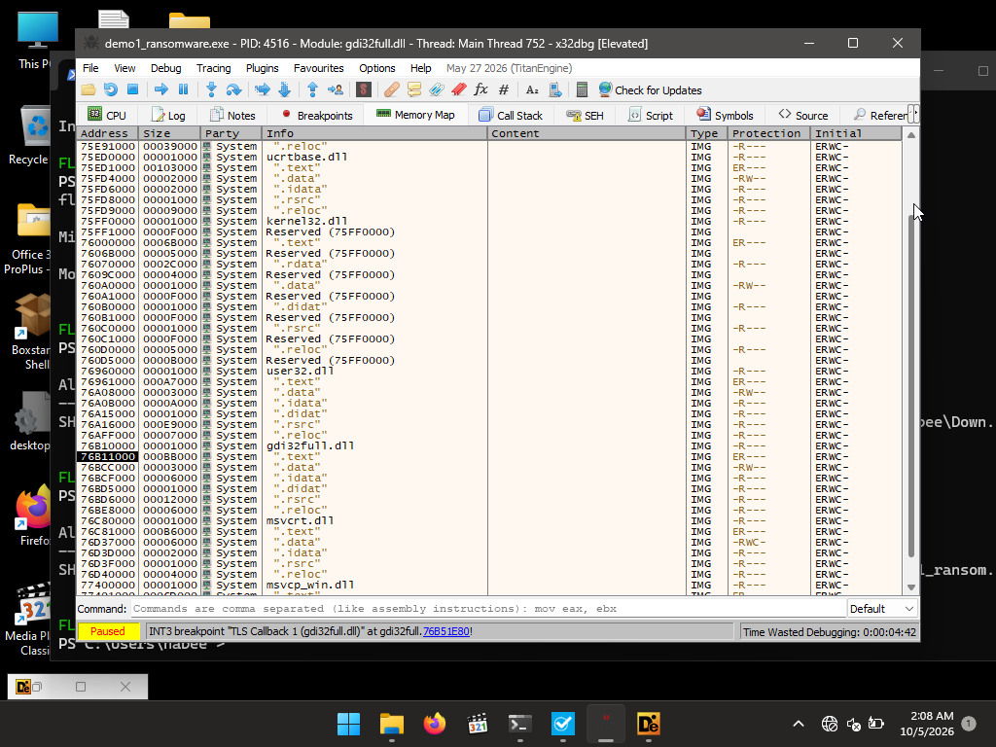
Figure 19. x32dbg Preferences, Events tab (Entry Breakpoint enabled), debugger state Terminated with "Could not open file!". Clock 2:20 AM.
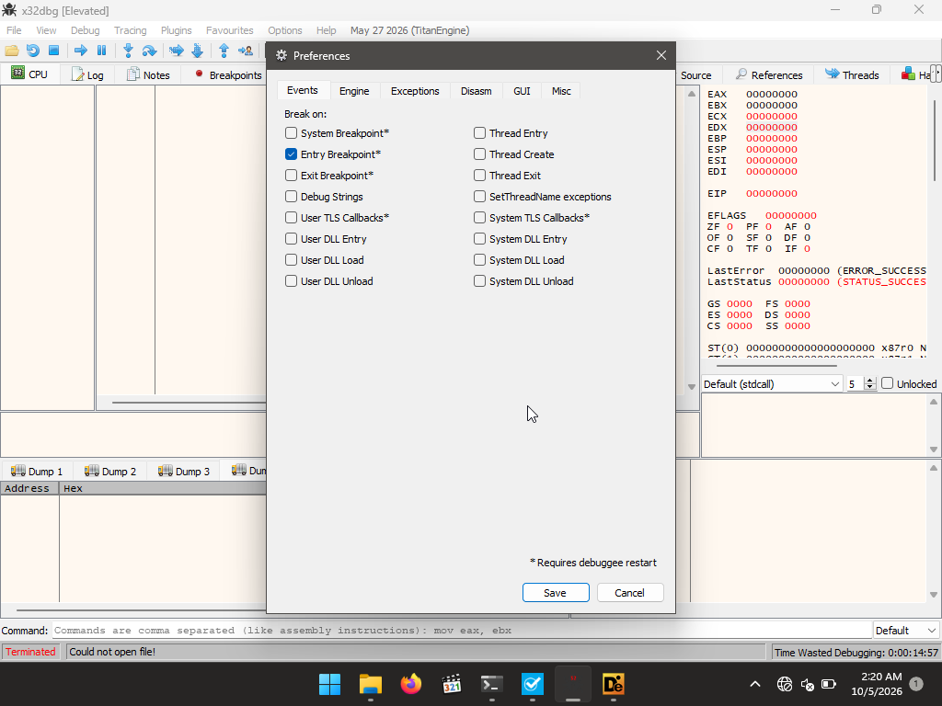
Figure 20. Notepad: ransom note text file (1,930 characters, 1.91 KB) produced by the sample; x32dbg status "Terminated / Debugging stopped!". Clock 2:25 AM.
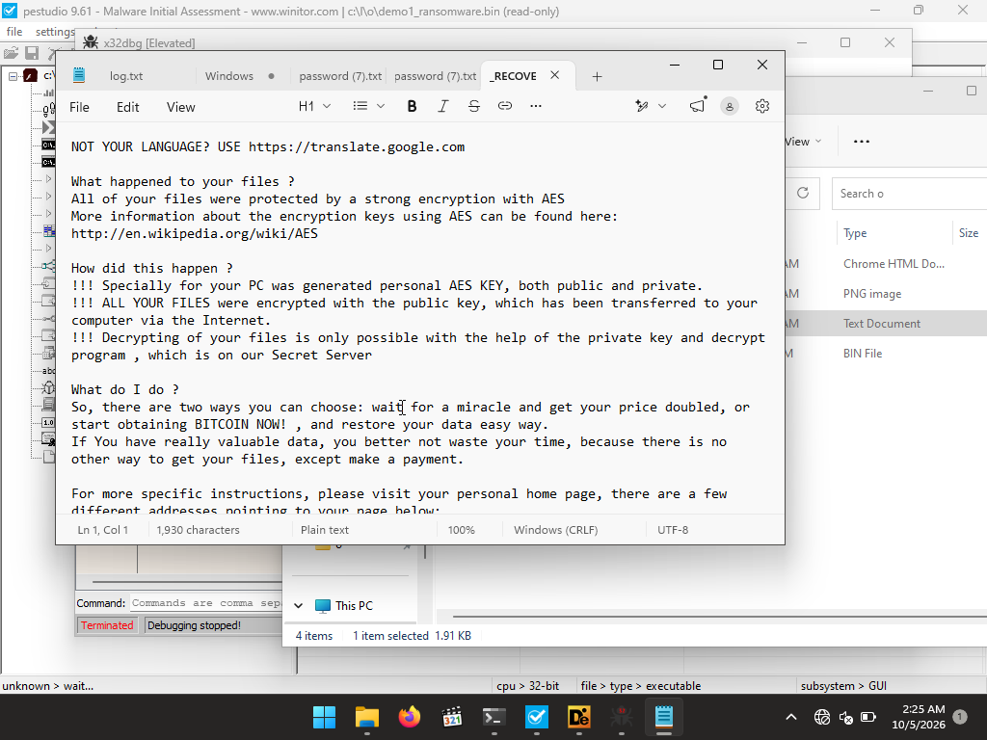
Figure 21. Notepad: recovery file created by the sample in the Documents folder (254 bytes) containing a Bitcoin address and hexadecimal strings. Clock 2:27 AM.
