E-commerce Sales Transactions Analysis – Project Report
1. Project Overview
The objective of this project is to analyze e-commerce sales transaction data to understand revenue performance, profitability drivers, customer behavior, and operational efficiency. An interactive Power BI dashboard was developed to support data-driven decision-making for business stakeholders.
This project focuses not only on visualization but also on deriving actionable business insights related to pricing strategy, logistics performance, and customer segmentation.

2. Business Objectives
- Evaluate overall revenue and profit performance
- Identify the most profitable product categories
- Analyze the impact of discounts on profitability
- Understand return behavior in relation to delivery time
- Examine customer demographics and regional performance
- Track short-term performance using Month-over-Month (MoM) growth

3. Dataset Description
The dataset contains e-commerce transaction-level data with the following key attributes:
- Order details: order_date, order_id, total_amount, price, discount, quantity, shipping_cost, profit_margin
- Product information: category, product_id
- Customer attributes: customer_gender, customer_age, customer_id
- Operational data: delivery_time_days, returned
- Geographic data: region
- Payment information: payment_method
The analysis period covers 9 December 2023 to 9 November 2025.

4. Tools & Technologies
- Python: Data cleaning and EDA
- MySQL: Data Analysis with SQL
- Power BI: Dashboard development and visualization
- DAX: KPI calculations and time intelligence measures

5. Data Preparation & Modeling
Data Cleaning
- Loading data: Imported the dataset using pandas
- Column Standardization: Standardize column names
- Initial exploration: Used df.shape to check the size of dataset and df.head() to look at the first rows (the sample subset of dataset). 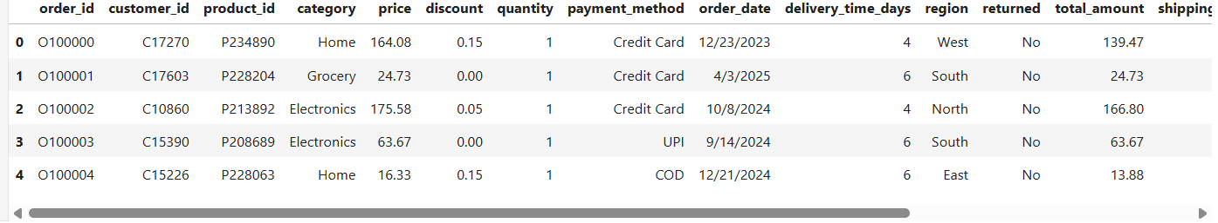

- Used df.info() to check structure and df.describe(include="all") for summary statistics.
- 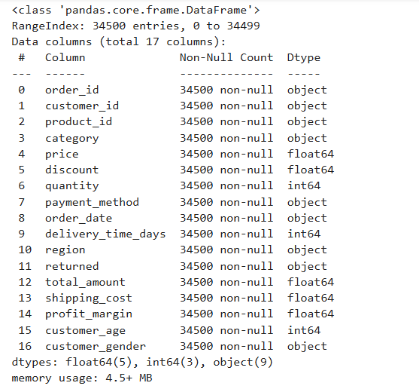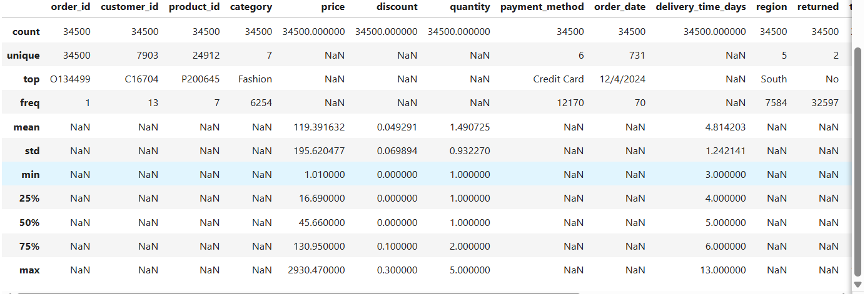
- Check duplicate records, missing values and data types
- Standardized data formats with df.convert_dtypes() and date formats with pd.to_datetime(df['order_date'])
- Strip the string data columns to avoid leading and tailing spaces
- Check the invalid data values (whether customer age is valid or not for dataset). And check the distinct values in category columns.
- Feature Engineering:
Created profit column by multiplying total_amount with profit_margin
- Export data: Exporting the cleaned data, using df.to_csv()
6. Data Analysis with SQL
Sales & Revenue Performance: Key business summary of Total Revenue, Total Profit, Total Orders, Average Order Value (AOV)


Monthly Revenue and Profit trend: Total revenue and total profit comparison over month
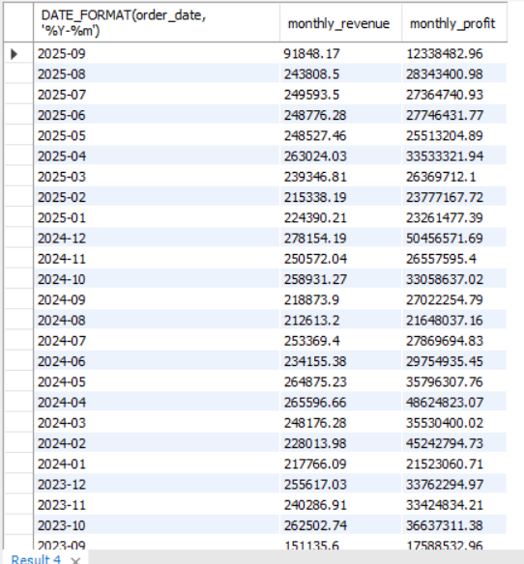

Category Performance: Revenue & Profit by Category, Profit Margin % by Category
Revenue & Profit by Category: Compared total revenue and total profit across category.
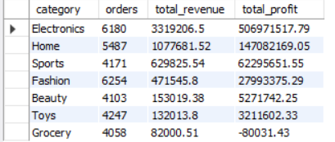

Profit Margin % by Category: Compared profit margin percent across category.
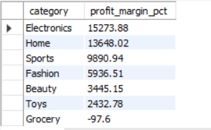

Discount Impact Analysis: Evaluated the discount impact on profit.
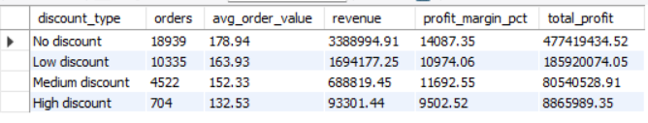
Customer Demographics: Investigated age group and gender patterns to uncover dominant customer segments and inform targeting strategies.
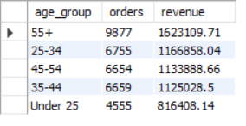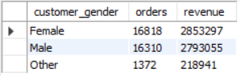

Payment Method Analysis: Evaluated customer payment preferences by analyzing order volume, average order value, revenue, and profit across different payment methods.
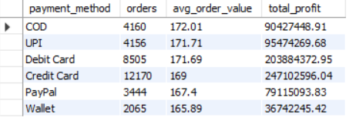

Regional Performance Analysis: Assessed regional performance by comparing order volume, revenue, profit, delivery efficiency, and shipping costs across regions.
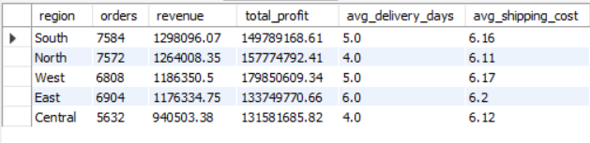

Logistics & Delivery Impact Analysis: Evaluated delivery performance to identify its effect on customer satisfaction, using return rate as a key outcome metric.
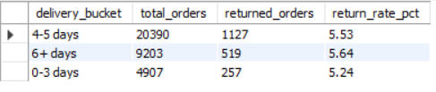

Returns by Category: Compared return rates across product categories.
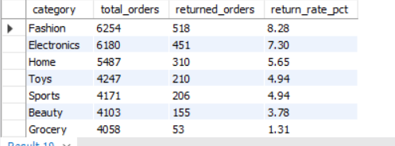

Top Customers Analysis: Evaluated customer value to identify key customers for retention and loyalty strategies.
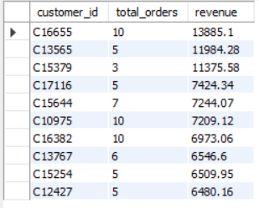

High-Revenue, Low-Profit Order Analysis: Analyzed loss-making orders with high sales value to diagnose profitability leakage across product categories.
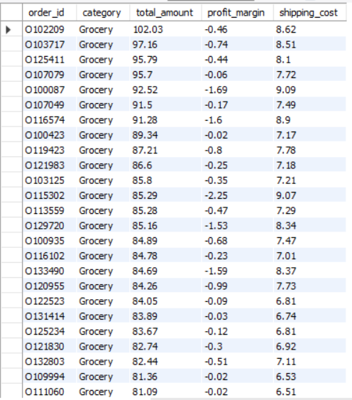

Business Summary: Provided a category-level performance overview by analyzing order volume, revenue, profitability, profit margin, and average delivery time to support strategic decision-making.
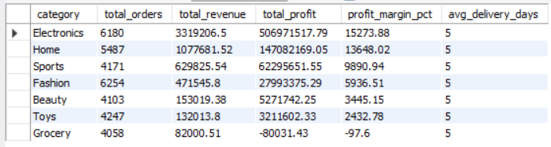

7. Key Metrics (KPIs)
- Total Revenue
- Total Profit
- Average Profit Margin (%)
- Return Rate (%)
- Revenue Month-over-Month (MoM) Growth (%)
- Average Order Value (AOV)
- Average Delivery Time (Days)
MoM growth was used instead of YoY due to partial-year data coverage, ensuring accurate performance comparison.

8. Dashboard Analysis & Insights
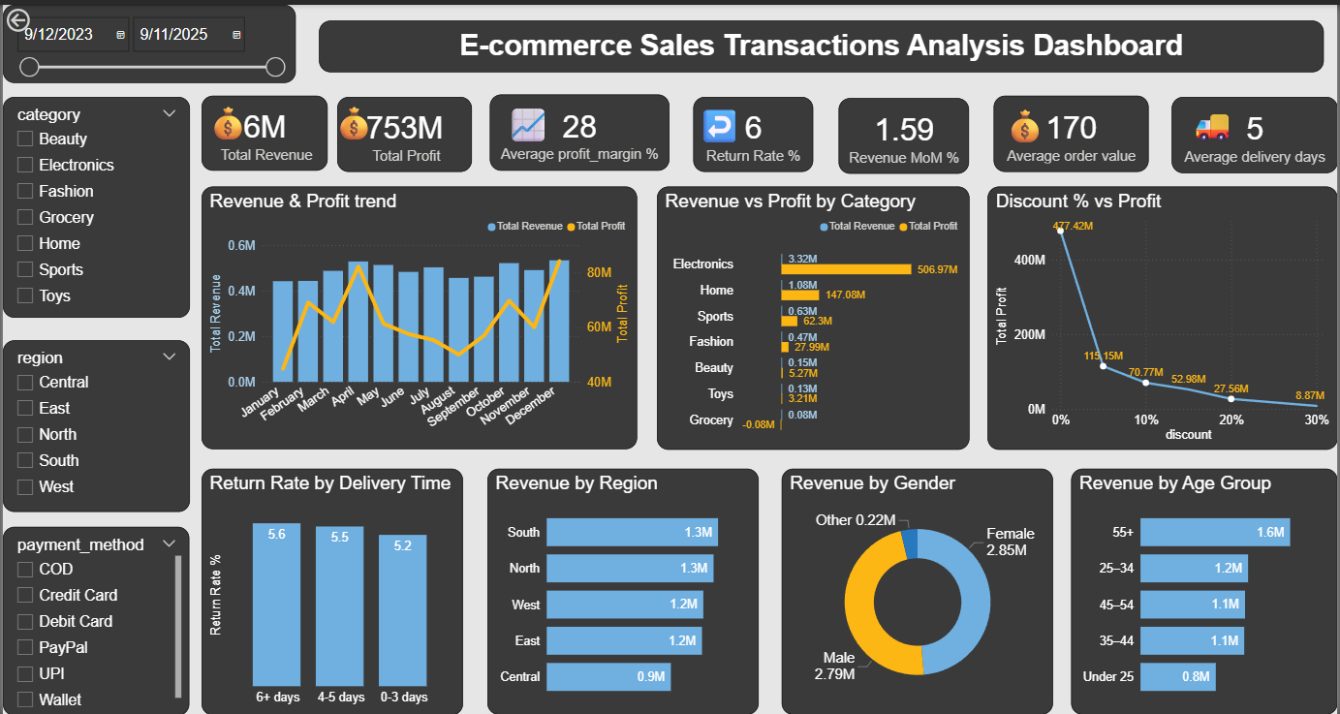
Revenue & Profit Trends
- Revenue and profit show noticeable monthly fluctuations, indicating seasonality
- Month-over-Month analysis provides clearer short-term performance tracking
Category Performance
- Electronics is the highest contributor to both revenue and profit
- Some categories generate revenue but contribute minimal or near-zero profit, indicating potential pricing or cost inefficiencies
Discount Impact Analysis
- Higher discount levels are associated with lower profit, with a noticeable decline in average profit as discounts increase.
Returns & Delivery Performance
- Orders delivered within 0–3 days have the lowest return rate
- Longer delivery times are associated with higher return rates
Customer & Regional Insights
- Customers aged 55+ generate the highest revenue
- Revenue distribution across regions is relatively balanced, with South and North regions leading
- Gender-based revenue distribution is fairly even

9. Business Recommendations
- Limit discounts to protect profitability
- Improve delivery speed to reduce return rates
- Focus marketing and retention efforts on high-value customer segments
- Reassess pricing and cost structures for low-profit categories

10. Future Enhancements
- Add New vs Returning Customer analysis
- Include Customer Lifetime Value (CLV)
- Apply predictive analysis for demand and returns forecasting

11. Conclusion
This project demonstrates how transactional e-commerce data can be transformed into actionable insights through effective data modeling, data analysis, KPI design, and visualization. The dashboard supports strategic decision-making related to pricing, logistics optimization, and customer targeting, showcasing practical skills relevant to Data Analyst and BI roles.

