
Al Maaref University

Faculty of Sciences
Department of Computer Science
CSC 470 – Software Engineering

SmartSchool

Prepared by:
Nour fakher aldien – 10221112
Mohamad ali sbayte - 10121897

Presented to:
Dr. Abed EL Safadi
[Date]

Table Of Contents
Phase 0: Information System Service | 1.Company background and history  2.statement of problems, opportunities or directive  3.description of your expected
Phase I: Problem Statement | 1.Problem table  2.stakeholder
Phase II: Project Management | 1.schedule representation  2.gantt chart
Phase III: Requirements Analysis | 1.functional requirement  2.non functional requirement
Phase IV: Modeling system requirements | 1.use case glossary  2.use case diagram  3.scenarios  4.class diagram  5.sequience diagram

Table Of Figures

Use case diagram of the new system
Two different scenarios
Class diagram
Sequence diagrams of the described scenarios

Table Of Tables
Table1 page 12
Table2 page 14
Table 3 page 16
Table 4 page 17
Table 5 page 19
Table 6 page 20
Table 7 page 21
Table 8 page 22
Table 9 page 23
Table 10 page 24

Phase 0

Information System Service

Company name: Al Amal Private School
Title: SmartSchool: Mobile App for Student-Teacher Interaction and Academic Management

Type of service requested:
- New Development
- Existing Application Enhancement

Company Background and History:

Al Amal Private School, established in 2005, is a K-12 educational institution located in Beirut. The school serves over 800 students and employs around 75 faculty and administrative staff. It aims to offer a modern, technology-enabled learning environment.

Statement of Problems, Opportunities, or Directives:
Currently, the school relies on outdated methods such as paper-based attendance, manual grading, and fragmented communication through WhatsApp and emails. This results in miscommunication, lost data, and inefficiencies in academic and administrative processes.

Description Of Your Expected Solution:
We propose a mobile application—SmartSchool—to centralize student records, grades, schedules, attendance tracking, announcements, and internal messaging. The app will enhance parent-teacher-student communication, automate grading and attendance, and offer real-time academic updates.

Phase I

Problems Statement

Part 1 - Problems Statement
(Add problems/solutions as much as you want)

Problem or Opportunity | Causes and Effects | System Objective
Manual attendance tracking  Lack of centralized communication | Delays in record keeping, errors  Fragmented messaging apps (WhatsApp, email) | Digitize attendance with real-time syncing  Unified communication module within the app
Grade management is manual | Time-consuming, risk of errors | Enable digital grade entry and calculation
No parental oversight | Parents uninformed about performance, behavior | Provide parent portal with alerts and reports

Stakeholders
Name | Responsibility
School Admin | Manage users, schedules, and announcements
Teachers | Input grades, take attendance, communicate with parents
Students | View schedules, assignments, and grades
Parents | Monitor child's academic progress
Developer Team | Design, develop, and maintain the app

Phase II

Project Management
Part 1 - Schedule Representation
- Deliverability Period (From Scope Definition till System Installation):
- Project Tasks:
(add/remove tasks depending on your project)
Task No. | Task Description | Task Duration  (days) | Dependencies
A | Requirements Gathering | 4
B | UI/UX Design | 6 | A
C | Backend Development | 10 | B
D | Frontend Development | 10 | C
E | Integration and Testing | 6 | D
F | Bug Fixing and Optimization | 4 | E
G | User Acceptance Testing | 3 | F
H | Deployment | 2 | G
I | Training and Documentation | 2 | H

Part 2 - Gantt Chart

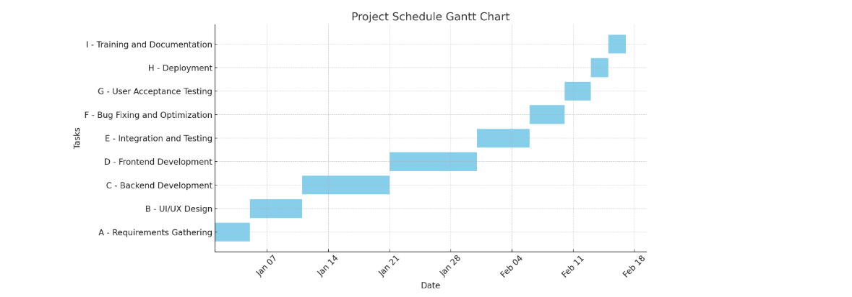

Phase III

Requirements Analysis
Part 1 – List of Functional Requirements (FRs)
(Add FRs as much as you want)
Requirements
- Teachers can take student attendance daily.
- Teachers can enter and update grades.
- Students can view their schedules and grades.
- Parents can log in to see their child’s academic record.
- Admin can manage users and send announcements.

Part 2 – List of Non-Functional Requirements (NFRs) –
(Add NFRs as much as you want)
Requirements
- The app must load within 2 seconds on standard devices.
- The system must be available 99.5% of the time.
- The app must be secure and compliant with data privacy regulations.
- The UI must support both Arabic and English.

Phase IV

Modeling System Requirements

Part 1 – Use Case Glossary

Use Case Name | Use Case Description | Participating Actors
Record Attendance | Teacher marks student presence/absence | Teacher
View Grades | Student views updated grades | Student
Send Announcement | Admin broadcasts messages | Admin
Parent Access Portal | Parent views child's performance | Parent

Part 2 – Use Case Diagram
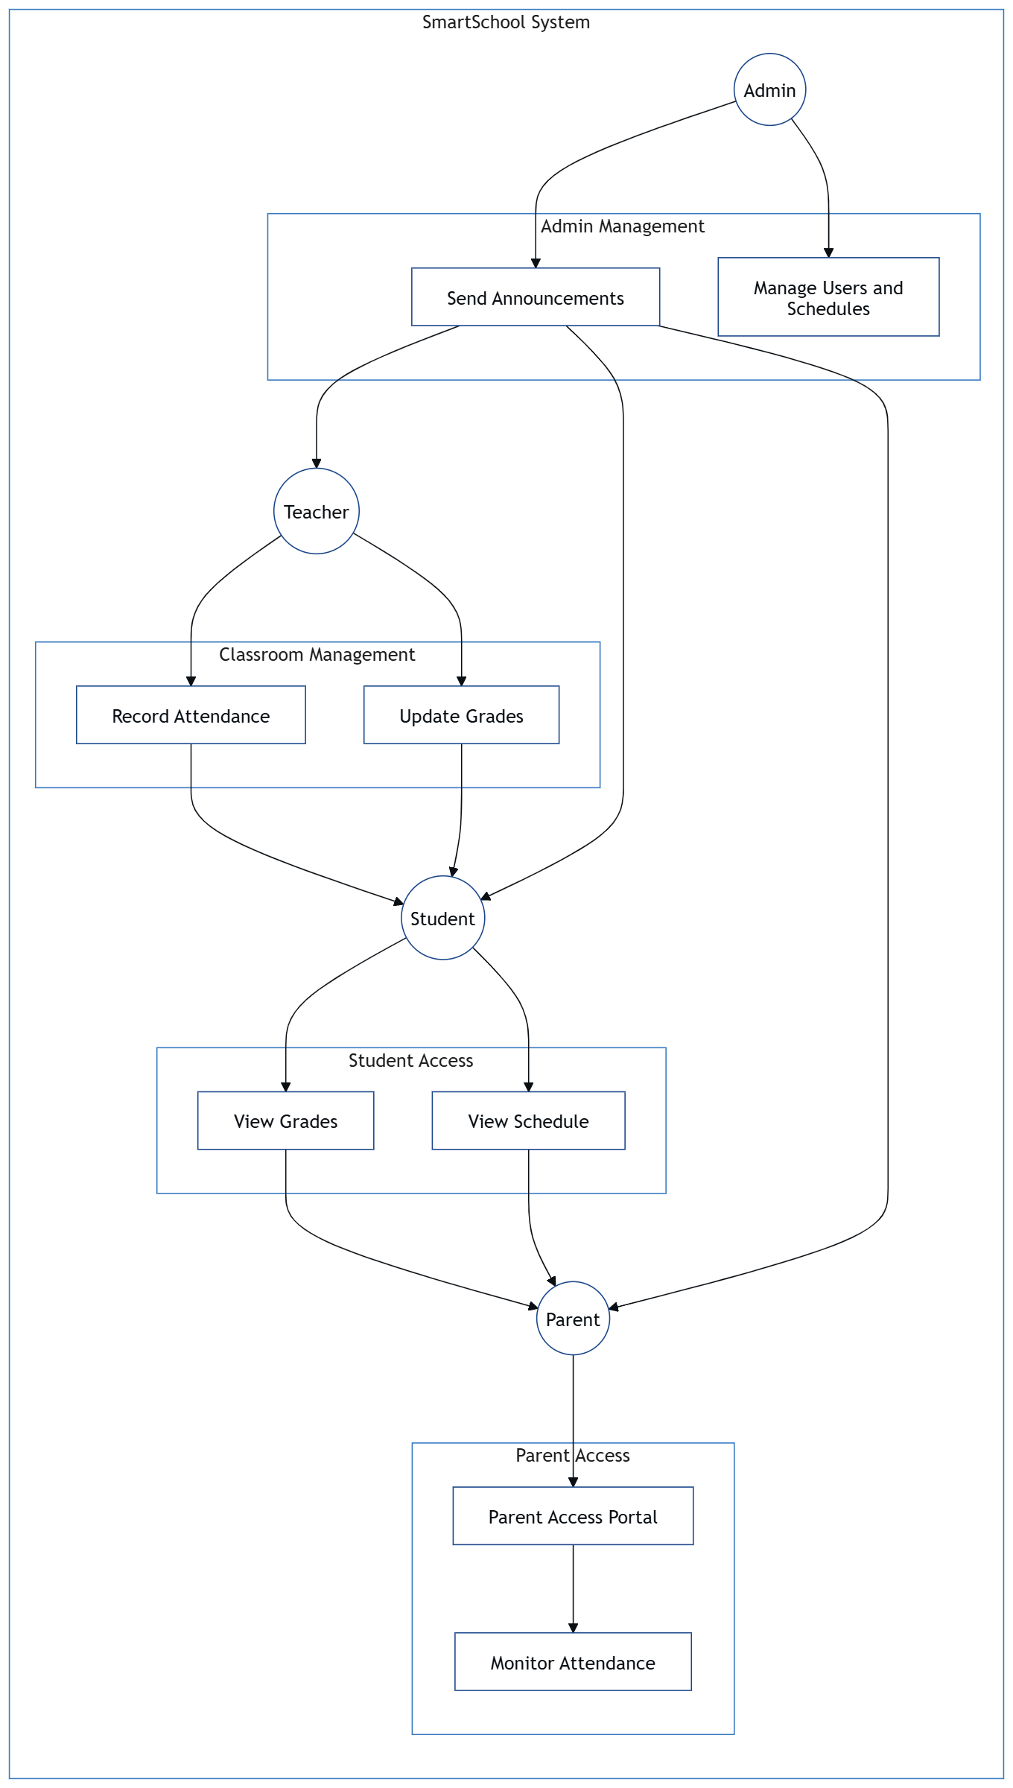
Part 3 - Scenarios (Use Case Narrative)
(Write the scenarios of two main use cases of your choice)

Scenario Name: | Teacher Records Attendance
Participating Actors: | Teacher
Description: | Marks present/absent status during class
Entry conditions:
Flow of events: | 1. Log in  Select class and session  2. Mark students  3. Submit
Exit conditions: | Records stored in database
Exceptions: | Network error → Retry prompt

Scenario Name: | Parent Views Grades
Participating Actors: | Parent
Description: | Views their child’s latest grades
Entry conditions:
Flow of events: | 1. Log in  2. Select student  3. Open grade report
Exit conditions: | Grades displayed
Exceptions: | No grade entered yet → Show placeholder

Part 4 - Class Diagram (Noun/Verb Analysis)
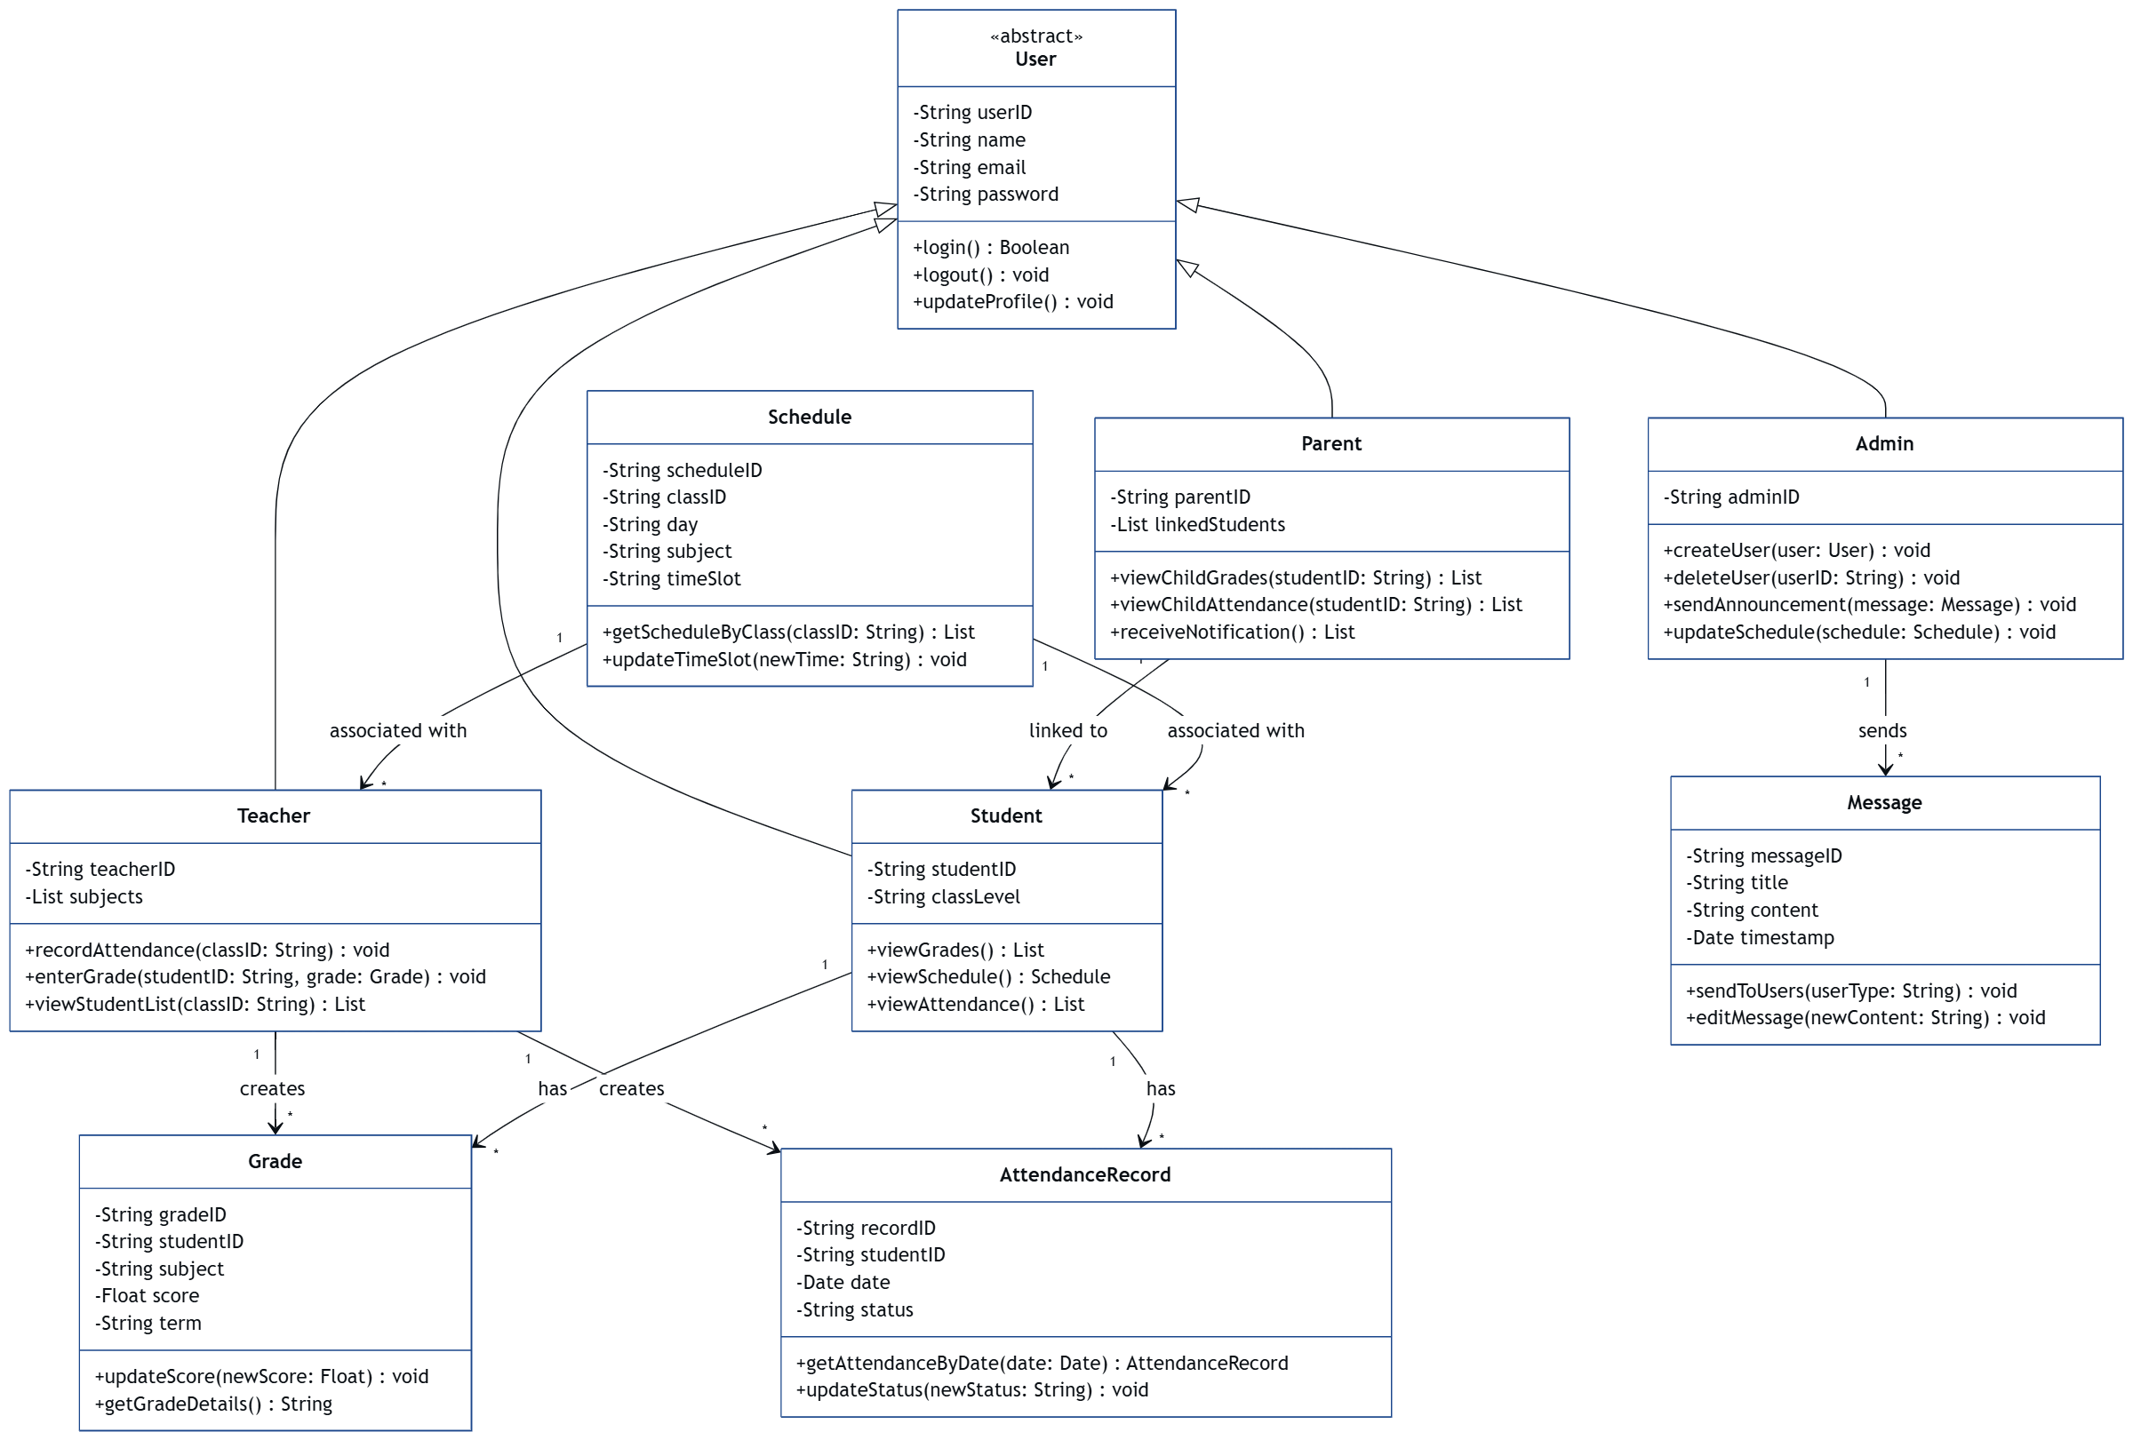

Classes: User, Student, Teacher, Admin, AttendanceRecord, Grade, Message

Relationships:

Teacher → AttendanceRecord

Student → Grade

Admin → Message

Part 5 - Sequence Diagrams
(Add the sequence diagrams of two main scenarios of your choice)
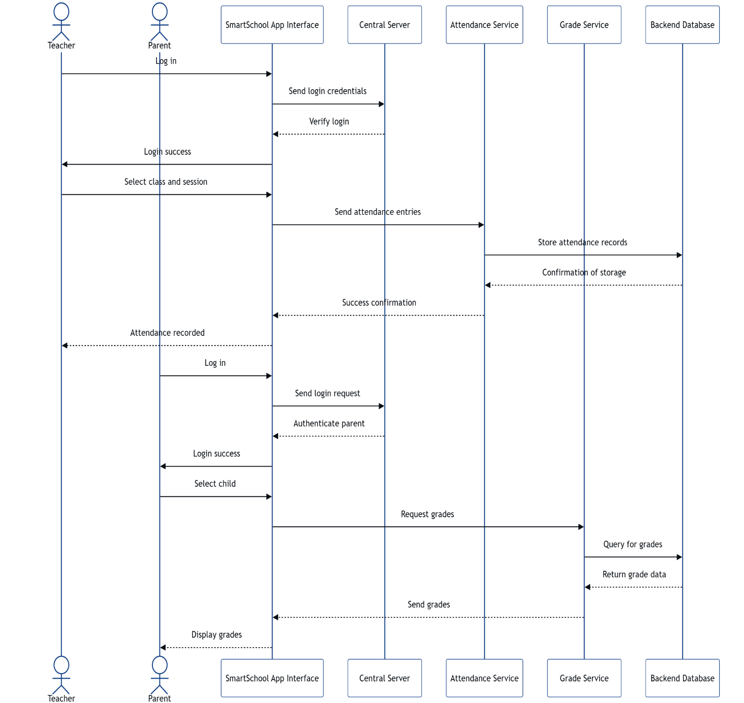
Sequence 1: Mark Attendance

Teacher -> App -> Server -> AttendanceService -> Database

Sequence 2: View Grades (Parent)
Parent -> App -> Server -> GradeService -> Database

Summary
This software engineering project aims to develop a mobile application called SmartSchool to improve communication, record keeping, and academic tracking in schools. The app addresses current inefficiencies and modernizes school operations through a user-friendly interface and robust backend system.

