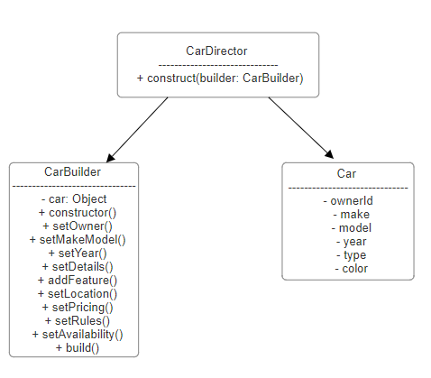
Implementation:
CarBuilder: This class provides methods to set the various attributes of a Car object incrementally. It includes methods for setting the owner, make, model, year, details, location, pricing, rules, and availability.
build(): This method constructs the final Car object and includes validation to ensure required fields are set.

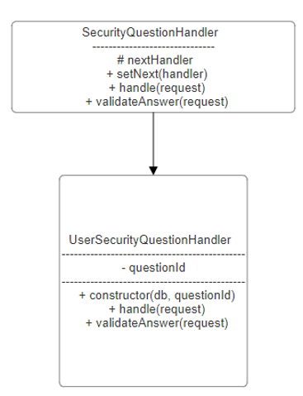
SecurityQuestionHandler: This is the base class that defines the structure for handling security questions. It includes a setNext method to chain handlers and a handle method to pass the request to the next handler in the chain.
UserSecurityQuestionHandler: This class extends the SecurityQuestionHandler and implements the validateAnswer method to verify the user's answer to a specific security question.

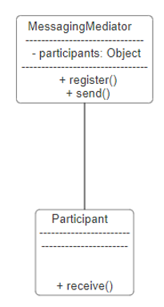
MessagingMediator: This class manages the communication between different participants. It includes methods to register participants and send messages between them.

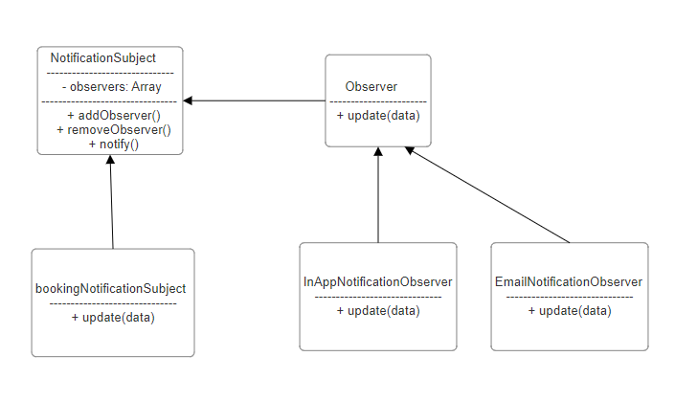
NotificationSubject: This class maintains a list of observers and provides methods to add, remove, and notify them of changes.
EmailNotificationObserver and InAppNotificationObserver: These classes implement the update method to perform specific actions when notified, such as sending an email or creating an in-app notification.

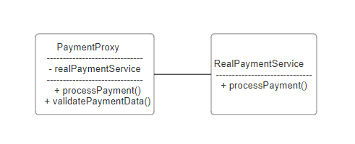
RealPaymentService: This class handles the actual payment processing logic.
PaymentProxy: This class acts as a proxy, validating payment data, logging payment attempts, and forwarding the request to the RealPaymentService.

REQUIREMENTS IMPLEMENTED IN THIS PROJECT

-User Registration and Authentication: using nextAuth

-Password Recovery

-Car Listing and Management: owners can manage cars, and renters can manage bookings

-Search and Booking: Car search function by availability, price, model, location

-Messaging and Communication: currently the messaging is one way

-Payment: simulated payment

-Notification: simulated in app alerts and email notifications

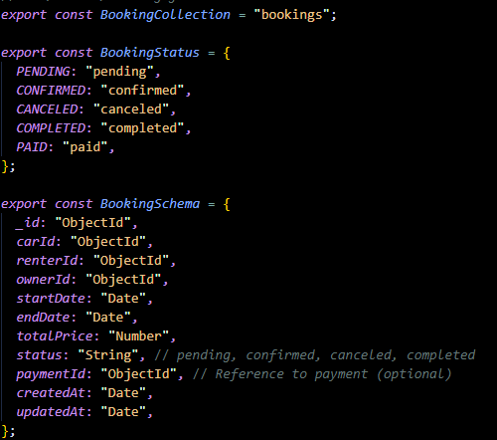

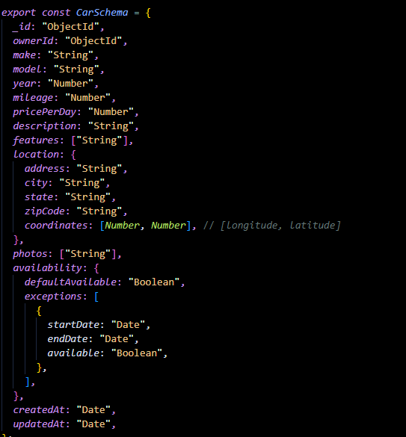

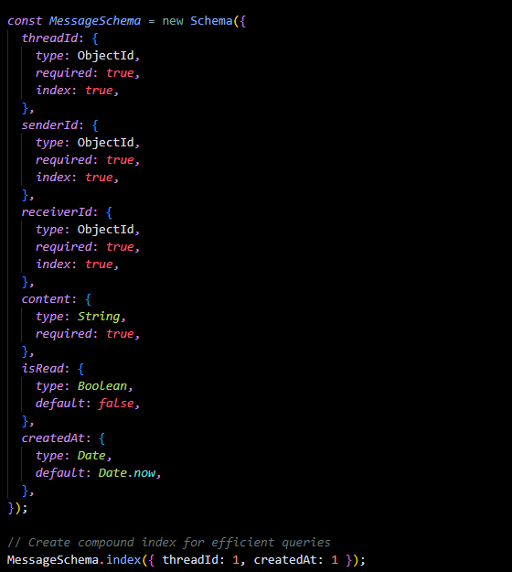

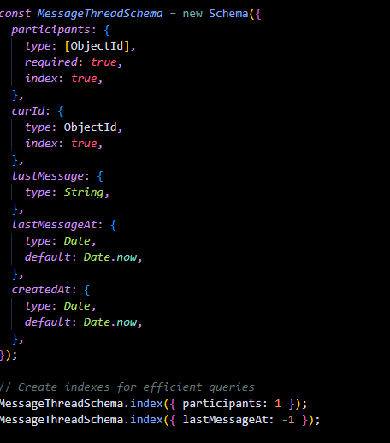

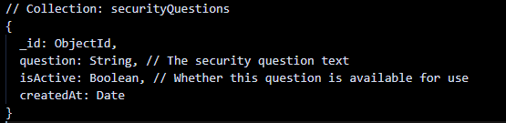
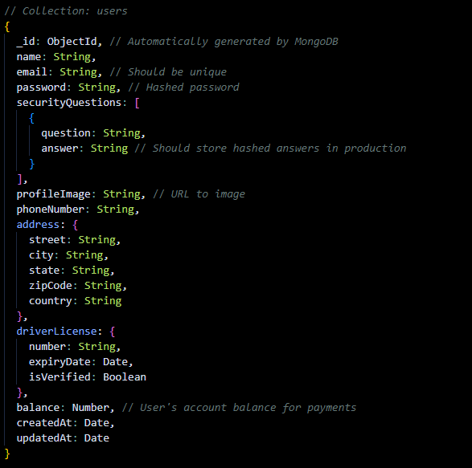

HomePage
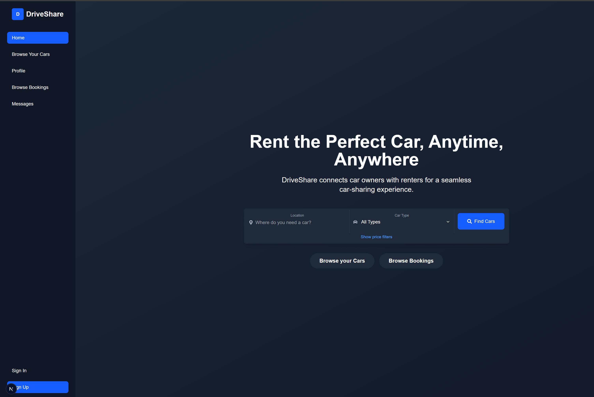
SignIn
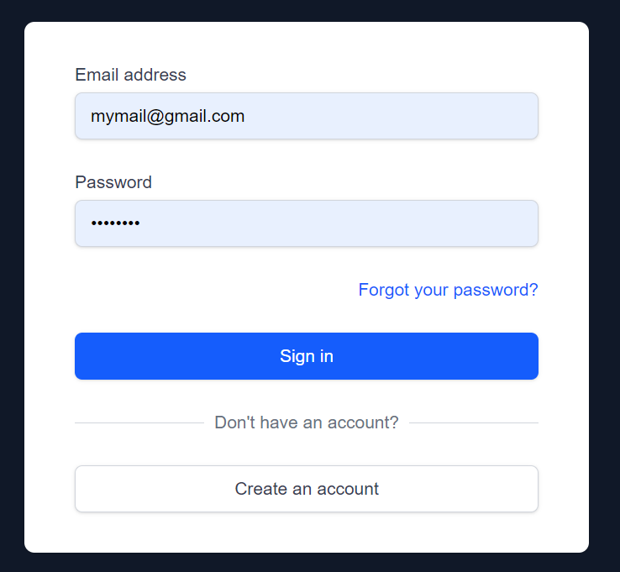

SignUp
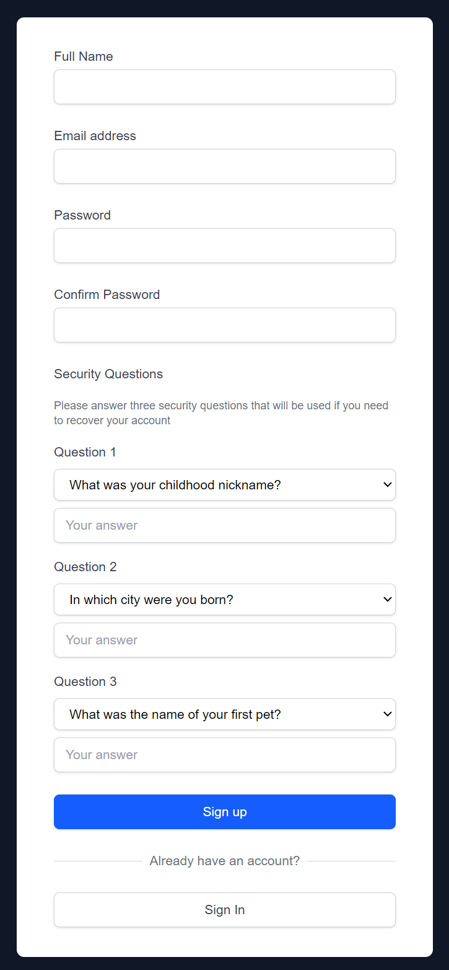

NavBar
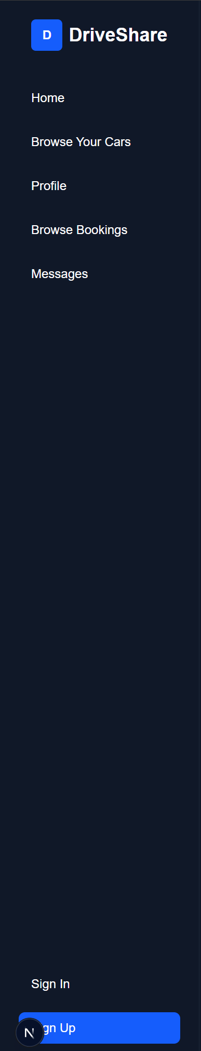

Manage Cars
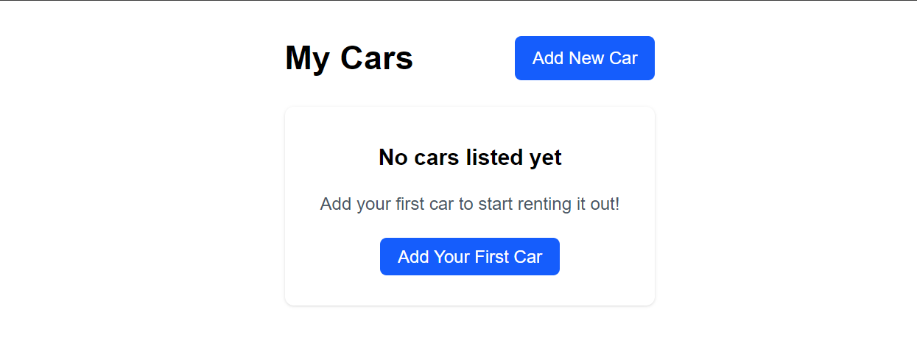

Manage Booking
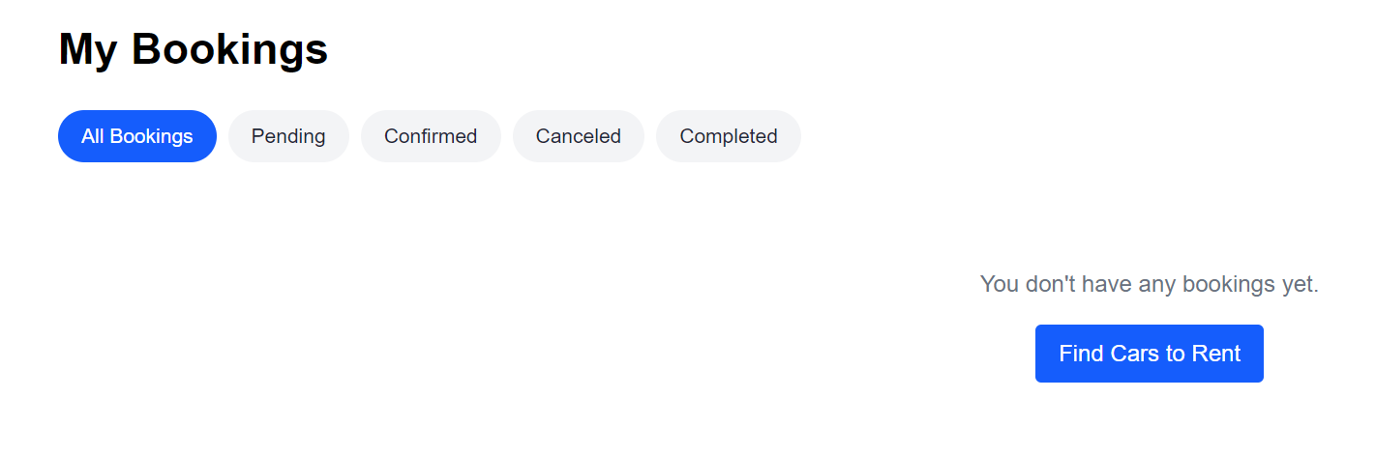
Messages
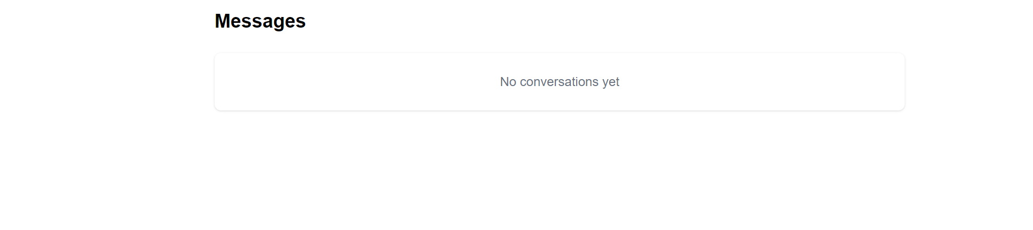

Car Search
