**Portfolio Stage 2 Report**

**Project Charter**

1447 (Summer 2025)

**UniStay** **– Students accommodation**

|  |
| --- |
| **NAME** |
| Abdulrahman Al-Fawzan |
| Abdulelah Al-Shehri |
| Mohammad Al-Omar |
| Meshari Al-Abdullah |

**Document Control**

Document Information

|  |  |
| --- | --- |
| **©** | **Information** |
| Document Owner | *[All Team Members]* |
| Issue Date | *2025/4/9* |
| Last Saved Date | *2025/4/9* |
| File Name | *[Project Charter]* |

Document History

|  |  |  |
| --- | --- | --- |
| **Version** | **Issue Date** | **Changes** |
| *[1.0]* | *04/09/2025* | *First draft* |
| *[1.1]* | *18/09/2025* | *Shortened the summary, made the key points clearer and more specified* |
|  |  |  |
|  |  |  |

Document Approvals

|  |  |  |  |
| --- | --- | --- | --- |
| **Role** | **Name** | **Signature©** | **Date** |
| Project Sponsor |  |  |  |
| Project Review Group |  |  |  |
| Project Manager© |  |  |  |
| Quality Manager  *(if applicable)* |  |  |  |
| Procurement Manager  *(if applicable)* |  |  |  |
| Communications Manager  *(if applicable)* |  |  |  |
| Project Office Manager  *(if applicable)* |  |  |  |

**1) Executive Summary:**

UniStay KSA connects relocating students in Saudi Arabia with safe, affordable, verified housing. It streamlines property searches, prioritizes female safety, and helps property owners efficiently reach students. Tackling fragmented listings, scams, and high costs, the MVP offers property discovery, in-app messaging, and features aligned with Vision 2030, ensuring faster searches and higher partner occupancy.

**2) Project Purpose and Vision:**

**2.1 Purpose:**

To provide a centralized, secure platform connecting relocating Saudi students with verified, affordable housing, addressing fragmented sources and new university admission policies. It enables property owners and hotels to efficiently market and manage student accommodations, creating a trusted student-friendly marketplace.

**2.2 Vision:**

To be Saudi Arabia’s most trusted, student-focused housing platform, simplifying the housing search with safe, affordable options, aligning with Vision 2030’s education goals, and fostering a reliable ecosystem for students and property partners. Tagline: From Relocation Stress to Seamless Settlement.

**3) Why Now / Problem Statement:**

Recent changes in Saudi Arabia’s university admission policies allow students to attend universities outside their home cities, increasing relocation. This creates an urgent need for reliable off-campus housing. Students rely on fragmented, unverified sources like social media, classifieds, or word-of-mouth, leading to time-consuming searches, higher costs, and risky or unsuitable accommodations. Landlords and hospitality providers lack efficient channels to reach student tenants, resulting in underutilized housing. UniStay’s verified, student-focused platform addresses this gap, enhancing safety and affordability for students while enabling property owners to meet rising demand during this market shift.

**4) Project Description:**

UniStay KSA is a responsive web platform helping relocating university students find safe, affordable, verified housing near campuses. With advanced search filters (price, campus distance), help finding a roommate, and in-app messaging, students quickly find suitable listings from landlords, hotels, or shared rooms. Property partners register, verify listings, and manage inquiries via a dashboard. Trust and safety are prioritized with verification badges, reporting tools, and clear standards, creating a reliable student housing marketplace in Saudi Arabia. Unlike general classifieds, UniStay offers student-focused features like campus proximity filters and female-only options.

**5) Project Goals and Objectives:**

**5.1 Goals:**

* **Align with Educational Transformations:** Support the evolving landscape of Saudi universities by adapting to policy changes like open-city admissions, ensuring seamless relocation for students and contributing to national education goals under Vision 2030.
* **Drive Growth in the Student Housing Sector:** Stimulate expansion and innovation in the KSA student housing market by connecting untapped supply (e.g., hotels and spare rooms) with demand, fostering economic opportunities for property owners and real estate partners.
* **Simplify Housing Management for Landlords and Providers:** Empower property owners, hotels, and real estate companies with user-friendly tools for listing, communication, and occupancy management, reducing administrative burdens and promoting efficient, long-term rentals.
* **Enhance Safety and Inclusivity for Female Students:** Prioritize secure housing options, such as female-only groups or suites, to create a safer environment for women, promoting gender equity and encouraging more female participation in higher education across regions.
* **Deliver Affordable and Diverse Housing Alternatives:** Provide students with cost-effective accommodations through discounts, roommate matching, and varied options (e.g., shared apartments or serviced stays), making university relocation accessible regardless of economic background.
* **Promote Scalable, User-Centric Technology:** Build a sustainable platform using accessible tools for long-term adoption and future integrations.

**5.2 Objectives:**

(Note: Metrics based on initial user surveys and pilot benchmarks; subject to refinement.)

* Enable transferred students to discover and secure suitable accommodation options (e.g., rooms or shared apartments near campuses) 40% faster than traditional methods, measured by average search-to-inquiry time in app analytics, within six months of launch.
* Increase occupancy rates for partnered hotels and serviced apartments by 25% during academic semesters through targeted student discounts and promotions, tracked via partner-reported data.
* Lower average annual rental expenses for students by 10% by facilitating roommate matching and access to discounted listings, quantified through pre- and post-adoption user cost comparisons via surveys.
* Develop roommate matching used by 15-25% of active students, enabling up to 50% cost savings via bill-splitting, measured by feature usage and user feedback within the first year.
* Secure partnerships with at least 5 accommodation providers offering 5-10% student discounts within 6 months post-launch, measured by signed agreements.
* Onboard at least 10 housing providers by the first two months of launch, each listing at least one verified property, tracked via platform admin dashboard.

**6) Project Scope: (might need some changes mostly with the wording and style)**

The UniStay KSA MVP will deliver a web/app platform focused on core functionality to connect transferred students with housing options in pilot cities (e.g., Riyadh or Jeddah).

**6.1 In-Scope Features:**

* Landlord & partner registration with required official documents (e.g., ID check, real estate deed) and admin approval before publishing listings.
* Property listing pages with filters (price, rating, city, availability, number of rooms, distance to campus, female-only, roommates, student discount tag) and features like bookmarking and comparison.
* Messaging system for direct communication between verified landlords/partners and students (terms to be finalized based on user testing).
* Landlord/partner dashboard to manage properties, update availability, and view tenant inquiries (no full tenant management in MVP).
* Roommate search & matching service with basic profiles, preference tags (e.g., same campus/program), and the ability to post roommate ads under defined rules.
* Safety & verification tools (phone/email verification, optional .edu badge, report listing/user, profile completeness scores).
* Bilingual interface (AR/EN) with RTL support for Arabic.
* Pilot rollout: Initial seeding of listings via outreach to owners/hotels and student communities, focused on one or two campuses.

**6.2 Out-of-Scope Features (for MVP):**

* Payment processing (rent deposits, transactions).
* Cleaning, maintenance, or utility management services.
* Transportation services for students or employees.
* Advanced roommate matching algorithms (AI-based compatibility scoring).
* Property management integrations (bulk import from PMS/ERP).
* In-app booking or contract signing.
* Full-scale expansions: Nationwide rollout beyond pilot cities, international support, or standalone native mobile app (responsive design only).
* Advanced analytics (e.g., AI-driven recommendations) or video tours.

**7) Assumptions and Dependencies:**

* Assumes free development tools (e.g., React, Firebase for backend) and no budget for MVP.
* Depends on team access to KSA student communities for pilot feedback and basic legal resources for compliance checks.
* Assumes a 3-month timeline with team availability; external dependencies like university partnerships are optional for MVP.

**8) Project Stakeholders and Roles:**

**8.1 Stakeholders:**

* **Internal Stakeholders**:
  + **Project Team Members:** The student developers, designers, and coordinators building the MVP, responsible for execution and gaining hands-on experience.
  + Academic Advisors/Mentors
* **External Stakeholders**:
  + **Transferred Students (End-Users):** Saudi students relocating for university, who benefit from easier access to affordable, safe housing near campuses.
  + **Property Owners/Landlords:** Individuals renting out rooms or apartments, interested in filling vacancies with reliable student tenants via discounts and in-app tools.
  + **Hotels and Serviced Apartment Providers:** Businesses offering short-term or student-friendly stays, aiming to boost occupancy during academic periods.
  + **Real Estate Offices and Companies:** Agencies listing properties, seeking expanded reach and partnerships for commissions or visibility.
  + **Universities and Housing Offices:** Educational institutions providing or endorsing verified listings, supporting student welfare and relocation.
  + **Transferred Workers/Expatriates:** Relocated professionals (e.g., those assigned outside their home regions), who may use the platform secondarily for housing needs.
  + **Regulatory Bodies/Government Entities:** Saudi authorities (e.g., Ministry of Housing or Education), ensuring platform compliance with local rental laws.
  + **Student Communities and Clubs:** Campus or online groups aiding user acquisition, feedback, and promotion.
  + **Instructors/Tutors:** Course facilitators offering guidance, evaluation, and resources for project success.
  + **Potential Investors/Partners:** Future backers like tech incubators, interested in scaling the platform post-MVP.

**8.2 Team Roles:**

|  |  |  |
| --- | --- | --- |
| Role | Assigned To (Example) | Responsibilities |
| Project Manager | Abdulrahman | Oversees overall planning, timelines, and progress tracking; coordinates meetings; ensures alignment with course goals and deliverables; manages risks and stakeholder communications. |
| Team Lead/Technical Architect | Meshari | Facilitates technical decisions on architecture (e.g., data models, geo-search); leads code reviews; ensures feasibility within 3-month timeline. |
| Developer (Frontend/Backend) | *Mohammad* | Builds core features like discovery filters, listings, and in-app chat; implements safety tools (e.g., verification badges); tests for bugs and usability. |
| Designer/UX Specialist | *Abdulelah* | Designs user interfaces for students and owners; creates wireframes for flows like roommate matching; focuses on mobile/web responsiveness and accessibility. |
| Quality Assurance Tester | Abdulrahman | Tests the MVP for functionality, security, and user experience; gathers feedback from pilot users; documents bugs and mitigations. |
| Marketing/Outreach Coordinator | *Mohammad* | Handles external outreach (e.g., to landlords/hotels for listings); plans pilot city seeding; collects user empathy data for iterations. |

**9) Project Risks:**

|  |  |  |
| --- | --- | --- |
| Risk | Description/Impact | Mitigation Strategy |
| Roommate Matching Misuse | Users providing false information in profiles, leading to mismatched or unsafe pairings and eroding trust (Medium likelihood/High impact). | Implement anonymized, opt-in feedback and rating system with comments; require profile verification (e.g., .edu email) before matching; include report/block features for quick resolution to comply with privacy laws. |
| Inadequate or Overpriced Listings | Accommodations may not meet affordability or fit needs, causing dissatisfaction and low adoption (High likelihood/Medium impact). | Negotiate pre-launch discounts with owners/hotels by promising targeted traffic; promote roommate matching to split costs and highlight budget options via filters and tags. |
| Low Student Engagement | Students may not sign up or use the platform, resulting in insufficient demand (High likelihood/High impact). | Launch promotions in student communities (e.g., university clubs, Telegram); offer incentives like early perks; gather feedback via pilot surveys to iterate UX. |
| Supply Cold-Start Problem | Difficulty convincing owners/hotels to list early, leading to limited inventory (High likelihood/High impact). | Start with a micro-pilot in one campus; conduct outbound invites; provide "early partner" badges and free listing credits to attract initial suppliers. |
| Limited Team Availability | Academic schedules may reduce working hours, causing delays (Medium likelihood/Medium impact). | Set realistic sprint goals; share workload; maintain weekly progress tracking with buffers. |
| Privacy Concerns in Feedback/Ratings | Feedback may risk personal privacy, leading to legal issues or user distrust (Low likelihood/Medium impact). | Use aggregated, anonymous ratings; avoid exposing details; include privacy disclaimers. |
| Trust and Safety Issues (e.g., Fraud/Scams) | Fraudulent listings or unsafe interactions could damage credibility (Medium likelihood/High impact). | Require phone/email verification for owners and .edu badges for students; add report/ban tools, profile scores, and house-rules templates. |

**10) Project Timeline:**

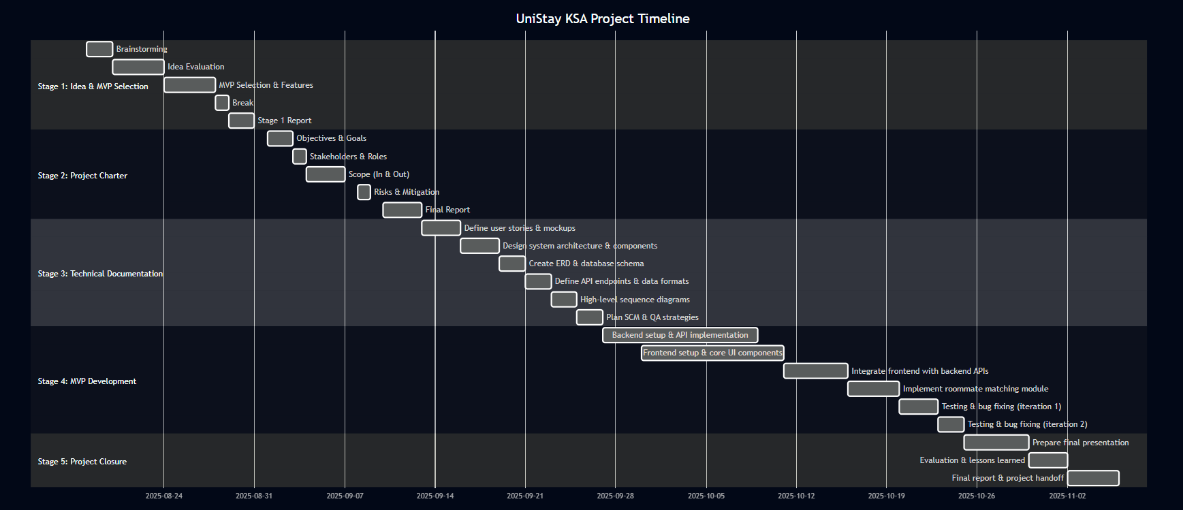

**11) Budget and Resources**

* **Budget:** $0 for MVP—relies on free/open-source tools (e.g., React, Firebase, Vercel hosting).
* **Resources:** Team laptops, free collaboration tools (e.g., Google Workspace, GitHub); no external funding needed.