Spring 2010 Make-Up Tips

Wherever you’re heading this spring, you want to look your absolute best. You’ve chosen the super-cute outfit, the matching shoes and a perfect amount of glitzy accessories – but you also want to make sure that your makeup is applied correctly and that you’re wearing just the right amount and shades. Below, you’ll find some makeup tips that even the celebrities swear by!

Mascara:

Fake lashes are popular right now because everyone wants those full, thick and beautiful eyelashes. However, many of us don’t have the luxury of our own personal stylists to apply them professionally and correctly so that they look great. You can create longer, fuller lashes with mascara using the following tips.

- When applying the mascara, wiggle the wand back and forth starting at the base of the lashes. This is how the mascara gets applied evenly and how the lashes get separated – preventing clumps.

- For fair-skinned girls, remember that black mascara and eyeliner can be very harsh during the day. Opt for a soft brown or even a colored mascara to match your shadow.

- For the bottom lashes, rather than trying to comb the brush through, wiggle it back and forth for the lashes to pick up the mascara. Rihanna has some of the most beautiful eyes in Hollywood – check out her perfect, pretty lashes.
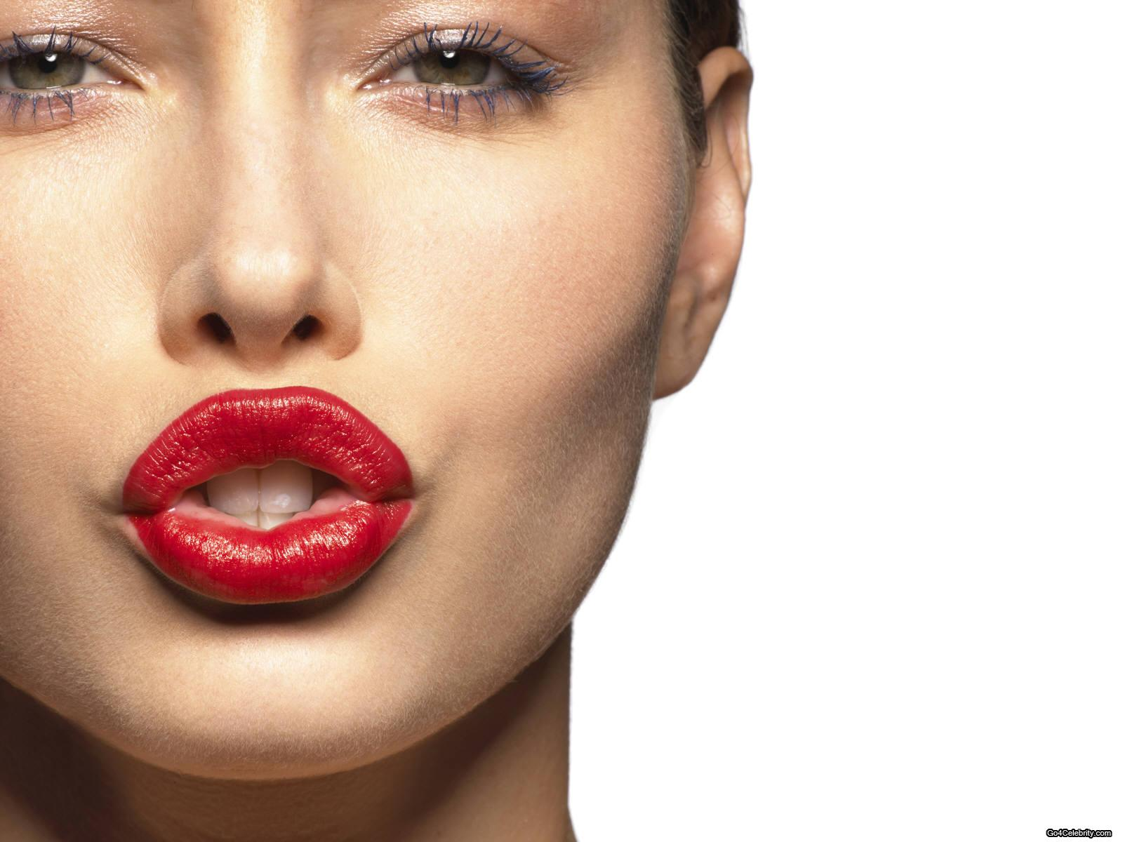
Lipstick:

Even heading into spring, red lipstick is hot. The trick is not to ‘overdo’ your look when you’re wearing that piping hot shade. Use only minimal eye makeup when wearing the red lipstick.

Here’s the rule – if you’re wearing a lot of shadow and mascara, your lips should be glossy or neutral-colored. If you’re wearing the cherry red lipstick, you should have only a tiny amount of eye makeup.

Neutral lips and glossy lips are always popular, and pretty much go with anything, so if you’re unsure, just use those. Lots of gloss comes with pretty tints that add color to the lips without overdoing it.

Blush:
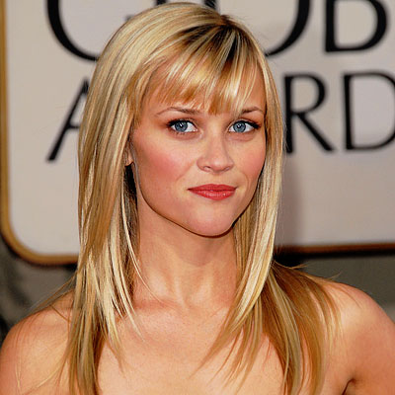
You’ve heard the rule – smile, and then apply the blush to the apples of your cheeks. This is a good rule, but don’t be afraid to experiment. When applying the blush, brush it across the bottoms of the ‘apples’ of your cheeks and then continue up into the hairline at an angle. Look at Reese’s fresh-faced look and see how she rocks the rouge.

Another great tip is to apply your blush in natural light – such as in front of a bright window. This will give you an accurate reading on whether you’ve applied too much or too little. In your bathroom light, the blush might look perfect but it’s too easy to add too much and end up looking like Bozo the clown.

With these great Spring 2010 makeup tips, you’ll look absolutely fabulous no matter what comes your way.

Image Credits: CDN.SheKnows.com, GraphicsHunt.com, BeautyCouch.Blogspot.com

