5-STAR SADDLE PADS – 100% Virgin Wool and Contoured

Wool has been around ever since there’s been sheep – and, that’s a very long time. Due to the characteristics of wool, even though it is a natural fiber it is considered a high tech material.
Saddle pads come in many different types of materials, thickness and colors but nothing beats a 5-Star 100% woolen, contoured saddle pad.

CHARACTERISTIC OF 5-STAR 100% WOOL SADDLE PADS
It has since been discovered that nothing replaces good ole, natural wool for heat regulation and all-around performance for protecting your horse. Mike Eaton, in his case study of using wool as the material of choice discussed that the secret of wool was contained within its “complex cellular structure. The hollow strands are naturally designed to trap heat while rejecting moisture buildup, due to the follicles’ constitution of their hydrophobic exterior shaft and hydrophilic, inner core. Due to these specs wool is able to absorb up to 30 percent of perspiration while cotton is only able to absorb 8 percent and synthetic materials no more than 5 percent.

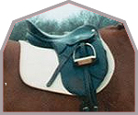
Contoured saddle pads are also manufactured for English saddles. (Picture courtesy of barnworld.com)
You may ask yourself “how come I can’t mop up water with wool yet it is able to absorb up to 30% of my animal’s perspiration?” When you combine both diameter and surface area of wool’s individual strands the result is the ability of the fibers to pick up great amounts of sweat and transpose such to the outer edge and surface of the saddle pad.
Because of wool’s composition the hydrophilic portion, which equates to “water loving”, is what sucks up the animal’s sweat and spreads it throughout the saddle pad. In addition, natural fibers have a higher moisture adjustment than man-made fibers or materials. That’s one of the reasons why the saddle pads manufactured from the NASA foam did not work out as well.

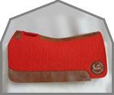
5-Star contoured saddle pads are also manufactured to fit mules. (Picture courtesy of barnworld.com)

Another reason to be careful on what type of saddle pad you purchase is for this articles may also affect the health of your horse or mule. One of the great characteristic of the 5-Star 100 percent woolen saddle pads is that they are able to reduce the harshness and pain from blisters caused by pressure and/or friction. Additionally, improperly fitted saddles are a major cause of sores. Add sweat to these sores and they will never heal. The 5-Star 100% wool saddle pads are not only able to absorb a greater quantity of sweat but, also remove the heat factor. Most saddle pads manufactured out of synthetic materials are able to pad the pressure points but do not effectively deal with the heat element caused by the friction.

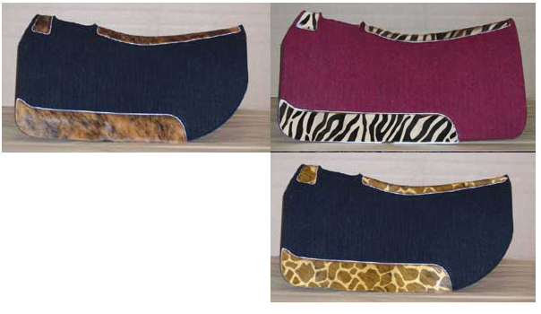
No longer does your saddle pad have to look like it belongs on Chester’s horse, on “Gunsmoke”. 5-Star 100% wool saddle pads now come in exciting color and pattern combinations. (Pictured courtesy of barnworld.com)

STUDIES PERFORMED
Dr. Joyce Harmon, Doctor in Veterinary Medicine and noted Washington, DC horse specialist, in conjunction with Michigan State University conducted studies regarding the correct fit for saddles as well as different saddle pad materials. In another study Oklahoma State University hired Dr. Michael Collier, DVM, to develop a saddle pad.
Both scientists used similar methods to include the Force Sensory Array machine. They both concluded that “pressed wool felt with high virgin wool content providing the best compression, wicking ability and heat protection (reduction) of all materials on the market today.” (barnworld.com) They both also found out that the need for the proper pad, along with a properly fitted saddle, were instrumental in preventing pressure point injuries.

SADDLE PAD / SADDLE COMBINATIONS
It is imperative that your saddle be properly fitted and, that such still fits properly even after having a saddle pad placed underneath it. There is no solution to saddles that are too narrow. Using a thicker pad will solve the problem if the saddle is a bit too wide.
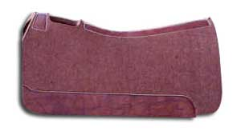
5-Star contoured, 100% wool saddle pads come with 40% more virgin wool than any other 100% woolen pad. (Picture and information courtesy of barnworld.com)

CONTOURED SADDLE PADS
Obviously, the beauty of contoured saddle pads is that they are made specifically for your animal. Normally, saddle pads that do not fit properly are due to the fact that they are too thick. Note that wood felt takes a little “warming up” time in order for the saddle pad to adapt to the animal’s form. Another plus for the 5-star 100% wool saddle bags is that they provide even weight distribution and impact absorption.
Double-padding is not recommended for under these conditions the saddle pad moves around and does not fit properly.

PAD THICKNESS
The thickness of saddle pads is determined by the activity being performed by your horse or mule. Below, is a chart provided by barnworld.com, outlining the recommended saddle pad thickness, according to the activity being performed.
1/2" Under Pad
Great for showing, reining, cutting or pleasure horses when you still need protection yet want to put a colorful blanket over the under pad for show purposes.
3/4" Regular Pad
An excellent all-around pad for those that need a daily exercise training pad and may also need to throw a blanket over for the show ring.
7/8" Thick Pad
The best all-around use pad recommended for trail riding, team penning, cutting, reining, and barrel racing. Cutting the 3/4" and 7/8" pad in a 28" length is ideal for barrel racing saddles.
1" Extra Thick Pad
Designed with ranch work in mind, for roping, performance, colt starting or heading to the mountains with lots of gear.
1-1/8" Supreme Roper Pad
Specially engineered for team roping, calf roping, steer stopping and performance

GIMMICK PRODUCTS
Always remember that not everything that shines is gold. Saddle pads that come in beautiful color combinations, promise state-of-the-art materials and other stuff you have never even heard of may not be the best product to purchase for your animal’s health, happiness and comfort.
Good ole common sense goes a long way. Have your animal measured and fitted for a saddle at a time when it is in its best form and weight. With regard to the saddle pad - as Mike Eaton stated, “if you wouldn’t wear the saddle pad you’re putting on your horse as a sock or underwear, then don’t buy it for your animals.” (barnworld.com)

SOURCES
Barnworld.com / Mike Eaton w/ content review by Dr. Joyce Harmon, DVM

