Introduction

Mission

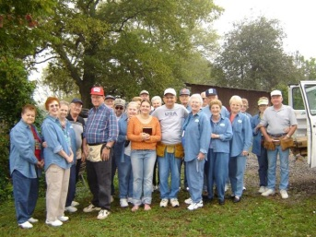

**Volunteer**

**Habitat For Humanity**

**Habitat For Humanity**

**Families**

**Habitat For Humanity**

**Staff**

North Collin County Habitat for Humanity works in partnership with God and His people to develop communities by enabling families to achieve the dream of homeownership with dignity.

Vision

Through God’s blessing and community wide support, we will enrich lives by building simple, decent, affordable, quality homes in partnership with families and the community, by obtaining great facilities, and by utilizing abundant funding.

History

Linda and Millard Fuller founded Habitat for Humanity International (HFHI), our parent organization, in 1976. It is a faith-based housing ministry that seeks to alleviate substandard housing and provide opportunities for low-income, working families to purchase homes through a self-help model of homeownership. NCC-Habitat was incorporated in 1992 in McKinney, Texas, as McKinney Habitat for Humanity, Inc. Our name was changed in 2002 to North Collin County Habitat for Humanity to reflect our expanding service area. Our affiliate serves the communities of McKinney, Frisco, Melissa, Celina, Princeton, Prosper, Farmersville, and Anna. Through partnerships with local government entities, churches, corporations, individuals and service organizations, we have been able to complete 64 houses for deserving families since 1992.

Our Core Values

* **God’s Love:** We strive to transmit God’s Love to others by our actions and our deeds. We build homes on faith.
* **Families:** We work to create homes where selected families can make a better life together as a result of our efforts.
* **Enabling those in need:** We strive to give families a hand-up, not a hand-out knowing that our families can succeed with a little help from us.
* **Partnerships:** We strive to build partnerships with all those that strive to build hope, lives and dreams within North Collin County.
* **Relationships with Community**: We strive to create and maintain positive and permanent relationships with all aspects of our community.
* **Quality homes:** We build simple, decent, affordable quality homes that our families are proud to call their own and that will serve the family for years into the future.
* **Help people achieve dreams** **with dignity**: Our families, staff and volunteers, working together, will achieve the families’ dream of home ownership resulting in a sense of pride and dignity as they create their new home through the hard work of all those willing to help.

Program

Families qualify on the basis of need, willingness to partner with the Habitat program and ability to make mortgage payments that average $500 monthly. Habitat offers a hand up, not a handout, to low-income working families. Our homeowners are required to contribute 300-500 hours of sweat equity by building on their own home and the homes of other Habitat families. Additionally, Habitat homeowners are prepared for homeownership success by attending classes where they learn budgeting and home maintenance skills.