**New York City’s 5 Best Wine Bars**

Not sure whether to pair your Cabernet with pork? Which white goes best with fish? Or prefer to drink a glass all by itself? If you’re into wine: whether it’s white, red, Rose or a blend, these New York City wine bars are sure to have something for everyone.

### Vino Vino

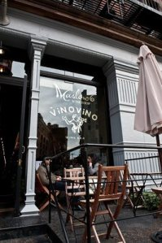

211 West Broadway  
New York, NY  
212-925-8510  
[vinovino.net](http://www.vinovino.net/)

This small Tribeca wine bar is fantastic if you’re looking to unwind in a quiet, intimate candlelit setting. Sip on wine, or order the cheese pairing. And if you really like your wine selection, you can purchase it at the retail store next door. Don’t miss the half-off any bottle on the menu 5pm to 7pm Monday through Friday, and all day Sunday and Monday.

### The Bourgeois Pig

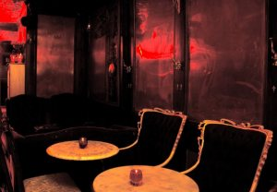

111 E 7th Street  
New York, NY  
212-475-2246  
[bourgeoispigny.com](http://www.bourgeoispigny.com/)

A massive wine selection, amazing sweet and savory fondue, and the funky shabby-chic decor make this East Village spot a must visit in our opinion.  Enjoy half-price bottles of wine Monday – Wednesday 5 p.m. – 2 a.m.

### City Winery

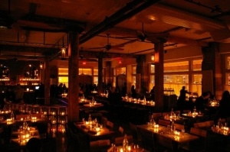

115 Varick Street  
New York, NY  
212-608-0555  
[citywinery.com](http://www.citywinery.com/)

The food on the menu at this massive, 21,000 square foot SoHo establish is created to compliment the wine, not the other way around. Wine stewards, not waiters, take your wine order first and then suggest food pairings to go with your vino. Get the picture? There are also daily performances, from bands to comics. City Winery sells their own wines so take a bottle or two home, or better yet–learn to make your own in one of their wine-making classes.

### Lelabar

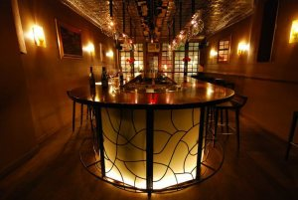

422 Hudson at Leroy Street  
New York, NY  
212-206-0594  
[lelabar.com](http://lelabar.com/)

This small and inviting wine bar in the heart of the West Village appeals to both the wine enthusiast and novice. There are more than 150 wines on the wine list — each available by the glass if you’re having a hard time choosing (minimum purchase of two glasses and per glass price is roughly 1/4 of bottle price). Daily wine specials, $1 oysters on Wednesdays and live jazz on Sundays add to Lelabar’s appeal. They also offer guided wine tastings twice per month.

### Winebar

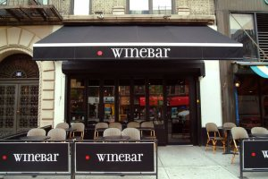

65 2nd Ave (between 3rd & 4th Street)  
New York, NY  
212-777-1608  
[winebarnyc.com](http://winebarnyc.com/)

The narrow space and shared tables make it easy to meet new people at this romantic East Village space dedicated to all things wine. From the seemingly endless number of bottles lining the wall, to the numerous and sometimes rare offerings on the wine list, if you’re into wine this is the place for you. A heavy focus is on the Mediterranean region (40 wines by the glass). Outdoor seating is very popular in the summer months.