Although most teens wear seat belts and learn to drive safely, some still make critical errors due to texting while driving. We all know that Technology in the form of a cellphone 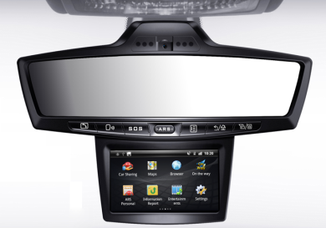has worsened the risks that teenagers face behind the wheel. How fitting, if technology could make them safer.

<http://www.youtube.com/watch?v=EqiAbQyT7eA>

A number of detection and monitoring products aim to do just that. Convenient all in one GPS systems or video equipment that records what's going on in the inside of the car while alerting teens and their parents to dangerous driving, and cellphone software that blocks drivers from using their phones when they're behind the wheel. With the new 2012 ARS Global Guiding multi-function interactive device for your car you now know that your teen is in safe hands with the including features of 911, SOS and Road Side Assistance just a tap of a button away getting a flat tire isn’t such of a nightmare for you teen. Your teen also gets 24/7 access to a live personal assistant that can help them in an emergency driving situation, Directions to anywhere across the USA, and even local movie times!

Chat with us on Facebook or twitter: **ARS GLOBAL GUIDING**

**By:**

ARS

arsgg.com