TOP 10 BEST BEACHES IN THE WORLD

Taking a beach vacation is both fun and relaxing no matter what your reasons are. The world is endowed with natural and beautiful beaches and the choice of which to go to is entirely up to you. You could sink your toes in soft sugary white or brown sands, have fun on a popular beach, enjoy serenity at a secluded beach or explore a lava rock beach. Here are the best 10 in the world, starting from 10.

10 – LOS CABOS MEXICO

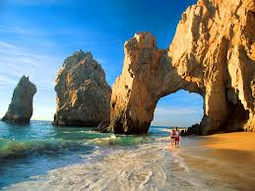

Located at the tip of the Baja peninsula, well know for its vibrant nightlife. Surrounded by beautiful turquoise waters, awesome underwater views, endless stretch of desert, quaint fishing and villages. Enjoy world class golf, water sports, shopping, fishing and luxury resorts to fit your needs.

9-LANGKAWI MALAYSIA

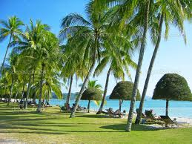

Located alongside Malaysia in the Andaman sea, this Asian tropical paradise has everything to offer. White sandy beaches, clear waters, vibrant nightlife, tasty cuisine, breathtaking underwater views, waterfalls and cozy hotels.

8- WHITEHAVEN AUSTRALLIA

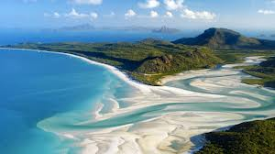

Located along Whitsunday Island with pristine white beaches and sparkling waters. Been called “Queenslands most Beautiful Beach”.

7-BORACAY PHILIPPINES

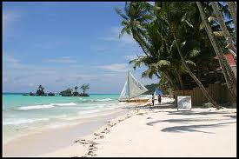

Located in the west of Philippines, known for rare white puka shells which are said to be the best in the world. Immerse yourself in the various activities here like windsurfing, searching for corals, snorkeling.

6- SEYCHELLES

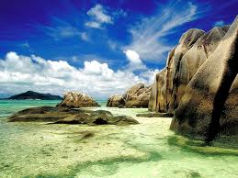 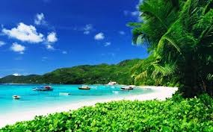

Located in the Indian Ocean, it offers you romantic sunsets, large expanse of white to cresent pink sands, hidden coves, big boulders, clear sparkling waters and breathtaking underwater views and reefs.

5-ZANZIBAR

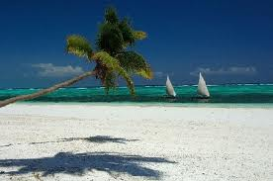

Here, it is called paradise. Located in the Indian ocean, surrounded by beautiful white sands and clear turquoise warm waters, cool breezes, unique sunsets, calm peaceful quiet and quaint fishing villages.

4- MALDIVES

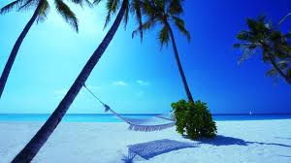

Off the coasts of Southern Asia, surrounded by top resorts, pristine white soft sands, sapphire blue waters, this is an ideal location for sailing, fishing, surfing and scuba diving.

3-LANIKAI HAWAII

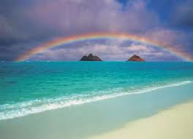

It means “heavenly sea”, located in Oahu, Hawaii, it is surrounded by dream line shores,lots of underwater gardens is a favorite for snorkelers and divers.

2- BORA BORA THAHITI

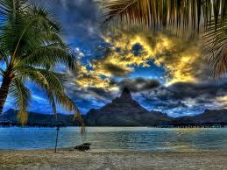 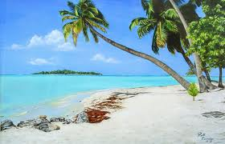

Surround yourself here with sugary white sandy beaches, clear, sparkling turquoise waters, lush green palms, it is Bora Bora.

1-ANGUILLA

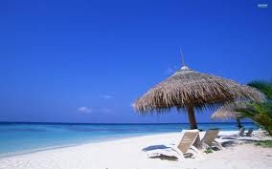

This is ranked as number one best all round the world. White powdery sand beaches calm beautiful waters with different shades of blue, offering dancing, great parties and hidden coves.