What Is Your Favorite Road Ride?

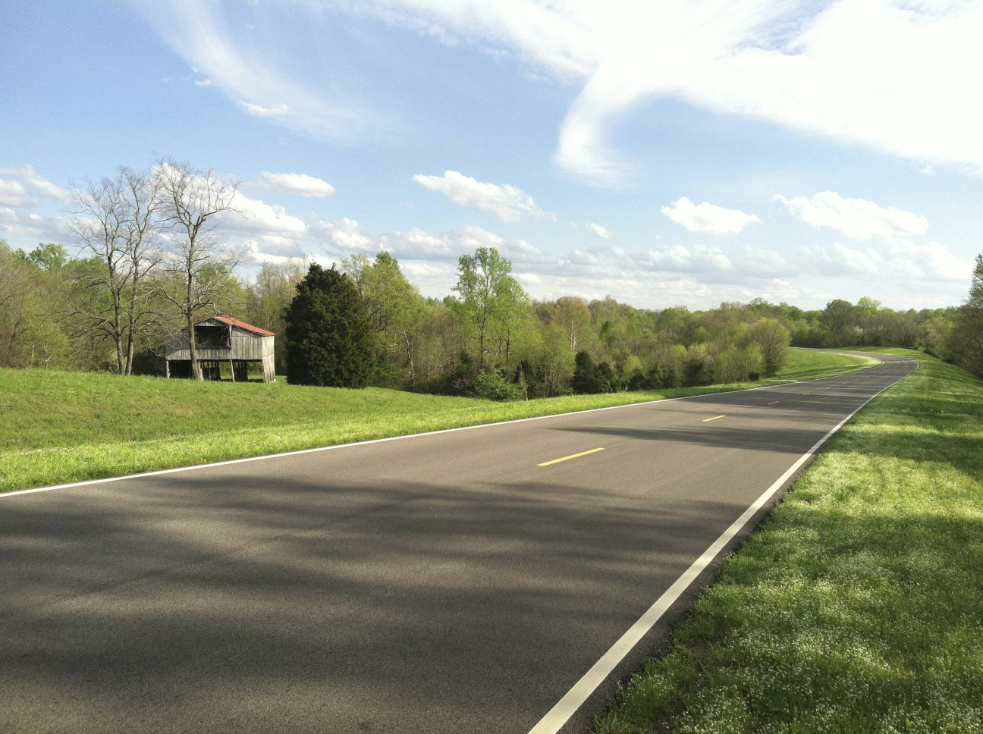

What determines a great road ride? Is it the weather on the day of the ride, the roads, the terrain, the scenery the ride passes through, a great pull during a group ride, or is it how you are feeling combined with all these other elements? California and Colorado and other areas in the west are highly desirable areas with great potential for rides, plus the fact that a lot of pro teams have their training camps in these locations. Having lived in California and ridden there as well as in Utah and Nevada, I can testify to the excellent riding conditions there. But are there other parts of the United States that offer great road riding? The answer, of course, is yes. There are many.

So, when thinking about a favorite ride, it is hard to select just one. It really becomes a question of personal preference. As bicyclists, our favorite places to ride seemingly become, over time, those places that are in close proximity to where we live, that we experience on a regular basis. Easy access to a ride can also make it a favorite. To find somewhere else to ride, perhaps in another state, is a little more difficult. Unless you hang around a local bike shop or subscribe to a bicycling publication or scour the Internet, you may not find them. One such place I read about was the Natchez Trace, a scenic parkway that is part of the National Park Service (NPS) and covers 440 miles from Nashville, Tennessee to Natchez, Mississippi. In fact, the parkway bisects three states: Tennessee, Alabama, and Mississippi

The Natchez Trace was originally used as an ancient salt lick by American Bison, then later was a commerce route for American Indians as a route between major villages in middle Mississippi to central Tennessee. Today a lot of the landscape along the trace has been designated as hiking trails and picnic areas along with various historical sites. \*

Because the Natchez Trace is part of the NPS, and like most national parks, it is very well maintained. These perfectly conditioned roads are clean of debris, trash, or animal carcasses in or on the side of the road. And it is not unlikely to see parkway employees out fixing a patch of road or tending to the rest areas along the route. In fact, I would go as far to say the parkway’s roads are pristine. If there were such as thing as a playground for a road bicyclist, the Natchez Trace would come close to being that place. The pavement is smooth, poured asphalt versus granulated concrete mixed with crushed rock, which means the road surface has no cracks, potholes, or uneven pavement that most roads are subject to.

One of the prime reasons the parkway is a favorite of mine, and for other bicyclists as well, is its overall low traffic pattern. Most of that traffic, of course, is tourist related. With the weekend being the busiest time on the parkway, you will encounter not only a slew of bicyclists but cars, motorhomes, and motorcycles. Local traffic, on the other hand, is minimal. Despite the fact the parkway is part of the NPS, it is easy to forget when riding that this is a popular road for locals who use it to access their homes or places of employment. Still, compared to the roads most bicyclists ride, you will see more bicyclists than cars on the parkway, especially during the week, no matter what time of day you elect to ride.

From a bicyclist’s perspective, the roads on the parkway offer solitude and challenge with false flats, mile long twisting climbs with 8% to 10% grades, scenic bridges and descents, and long flats. The Natchez Trace really is everything a bicyclist could want. No, it doesn’t have 7,000 foot climbs, ocean views, or high mountain summits like what could occur on rides in the western United States, but there is enough here to test your ability again and again. Of course, what I am describing here would be the first 50 miles of the parkway which starts in Nashville and is the hilliest part of the Trace. But the Natchez Trace appeals to a wide range of cyclists from the casual to the serious. The hard-core enthusiast or fitness rider is probably the most prevalent type of rider out on the parkway, though along with the occasional category 1 racer out for a training ride.

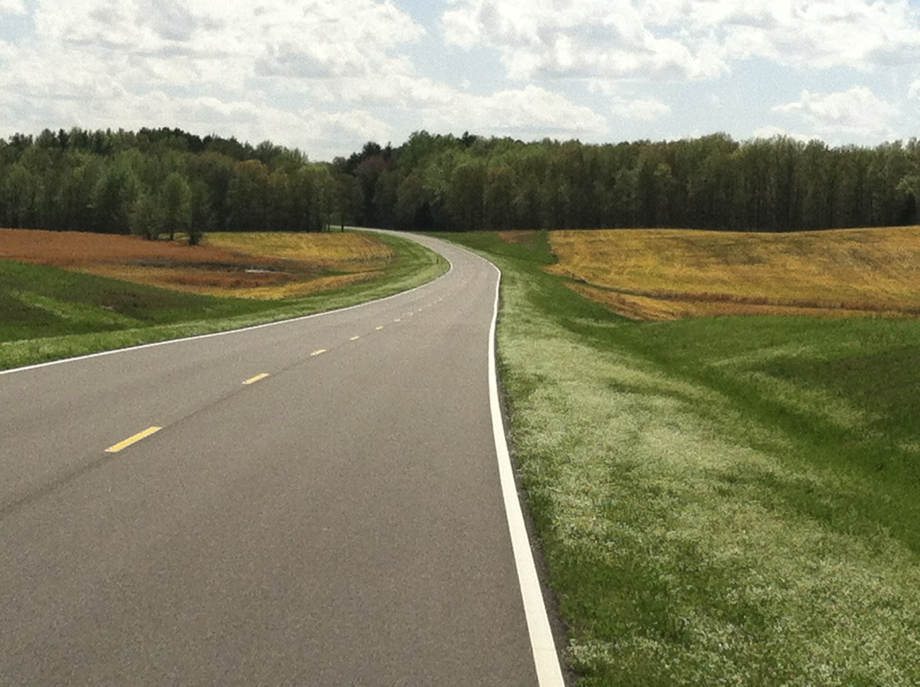 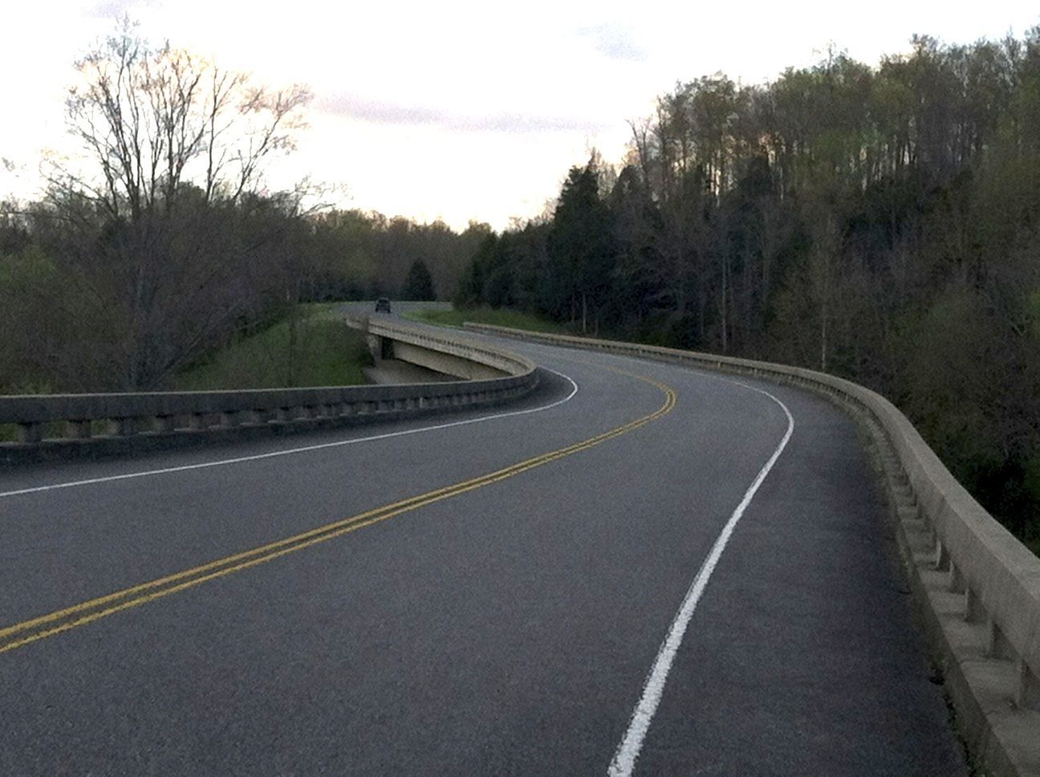

Because of the layout and nature of the parkway, on a weekday you can ride miles before you see another bicyclist or even a car on the road. The downside of that is it can also be miles before you see a place to use a bathroom or refill depleted water bottles. A really hot day on the parkway can do that quickly. And if lunch is on your mind, you’ll have to venture off the parkway at one of the exits along the way or have a good supply of energy gels and other snacks on hand.

Due to the expanse of the Natchez Trace, it is really impossible to cover big sections of the parkway unless you enjoy multi-day rides with panniers in tow. However, if started early enough in the day, a 100 mile out and back ride, for instance, will reveal the depth of character that is the Natchez Trace parkway. For me, the parkway is a favorite ride for the undulating roads mixed with real to false flats along with fast, straight descents into the valley, then how those traits are repeated. I would say the descents are my favorite because I never have to touch the brakes on the way down. Miles just tick away as you lose yourself in the silence and isolation of the parkway. Without realizing it or looking much at my bike computer, I had ridden 20 miles, then 40. When all you can see is rolling green terrain, thick forests, and crows flying overhead, and the only sound is the churn coming from your wheel bearings and the chain slipping over the gears, it is hard not to feel a real sense of peace.

Want to know more about bicycling the Natchez Trace? A Google search will show a few sources specific to bicycling the parkway. A good site I came across while writing this article offers not only information about riding the Natchez Trace, but also information about the surrounding areas and a way to make reservations at Bed & Breakfasts: <http://www.natcheztracetravel.com/biking-the-trace.html>. In addition to Internet resources, there’s also a book available by Glen Wanner titled *Bicycling the Natchez Trace : A Guide to the Natchez Parkway and Nearby Scenic Routes.*

\* Historical information about the Natchez Trace Parkway sourced from the Wikipedia.