More Bang for a few Dollars on Facebook Games

By James A Lund

If you have ever used Facebook then you have seen the countless scores of games available for “free” play. Of course the general idea on the part of the developer is to milk every dollar from your wallet they can. Don’t spend too much of your hard earned cash; instead utilize the following steps to get the most out of your game time!

## Play Multiple Games

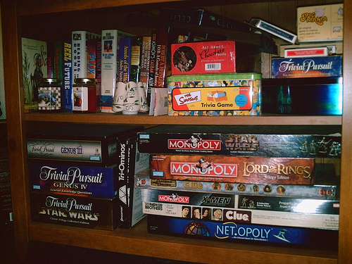

Image via [Flickr](http://www.flickr.com/photos/63111479@N00/303187498/in/photolist-sMV5E-25PtbV-2buQdc-4QeEZj-4TztKL-5E9akX-61D7sA-645MZE-69ybwh-6bPE1N-6cWeqs-6hw4LU-6oHLsR-6u86GR-6xbmyZ-6E21Tt-6ToW7c-7dxNVL-7dTKMr-7ePN7x-7eTGbu-7fHkHV-7k4yuy-7mh1MP-7CXHRC-agvcE9-7KwD5Z-bG7me4-btctSb-7JDcdk-e8xyTn-a3XDbS-9hbgKL-cVyFz9-a2tCRZ-eciWSc-9v5nkv-9v8oaq-asaYsG-aF6h2Z-ac8mba-8LPL9v-bJisqz-bvoEQE-bnP4Ch-cnLBvu-bt3rDg-dNDuYW-ed64T4-7ykv8g-9Uoacu) by Photos o’ Randomness

Select [multiple games](http://tomuse.com/top-facebook-games/) that you enjoy in general. This will allow you to go back and forth between them while waiting for recharge. Select different fields of games you may enjoy, much like having multiple options on one of the existing console systems. There are literally hundreds of titles on Facebook for you to choose from covering all the most popular genres.

## Keep Your Wallet Green



Image via [Flickr](http://www.flickr.com/photos/68751915@N05/6722569541/in/photolist-bf3VHp-8TKrCu-92FqFC-8WM3bV-bf3TAn-cqsDno-8WLLZc-9GWsX9-enRpJ6-bSXWDg-bSXUD2-dCPUH7-9jijMZ-9jikdv-9jikbK-9jmsgf-9jijcV-9jmrbh-9jijeP-9jij8Z-eKvrkq-dmHSd4-bf3LvP-aBBK7C-7CFA5h-esnAP1-9GXe2J-bAddSX-dAfapY-8uxHAQ-8WM3bM-9nCNwo-dGgaSq-bKLFV4-crGEhS-8WM3bH-a559YN-9jmrFu-9jijz8-9jikhM-dAowJH-drRjwM-ebPxgG-aLQGCM-aLQFR2-egzDnU-8WM3bX-abw7W1-8QoNGP-9jijBF-9jijqT/lightbox/) by 401 (k) 2013

It is quite tempting to buy the flashy new upgrades that can get you a quick win in many of these games. If you have the money, more power to you, but a little patience and several levels later the items are usually yours anyway. Instead of spending your hard earned currency on a quick new upgrade or a new in-game item, use it for extending the game play by renewing your energy and allowing you more active online game time.

## Use Your Friends

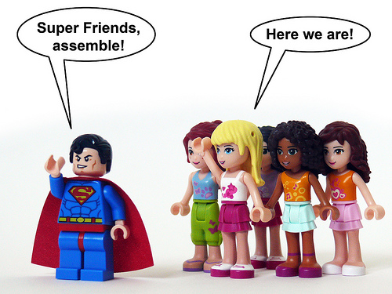

Image via [Flickr](http://www.flickr.com/photos/23397895@N08/8637684607/in/photolist-eahoGF-8jUxXH-7TBg2b-9qWP18-8ZPUiU-apV9Aj-efZ8uR-8hkFN5-aQb8MP-9fC94m-8Uq8QT-dsKKdx-bDKMHT-8ouEq2-aKf4va-cvThjQ-8LJuhq-9iGVm1-7xDind-ddzXh7-9oRd4W-aJyeQK-886Cg9-7GGo5a-apBQf4-cEzzBE-8DmjkD-byYDgo-bcyDEZ-855RYh-7L1nD7-evPiDY-b5gSN8-cfyMQh-93MWAo-8mdZx1-dxYL3f-aY9vki-dWzUgU-fo31Ri-8bRWge-a6UBD4-bFv25B-dxPt5N-8CMKKZ-exoqdV-bTPYzi-b5eYAK-a3VL9Y-bi9s1z-a2mLQC) by Oky- Space Ranger

You’re on Facebook, you have friends, and they are sending you requests for this and that every day, well return the favor. Utilizing your friends can help you restock [game points](http://www.ehow.com/how_8575772_use-facebook-points.html) or needed resources to lengthen your online active time instead of spending cash. Many games have their own forums where likeminded players will gladly join up with you in the interest of sharing resources to expand and extend the game. Your friends will also introduce you to even more titles they have explored thus opening up even more possibilities for you.

## Control the Devil of Temptation



Image via [Flickr](http://www.flickr.com/photos/25395215@N05/3488716563/in/photolist-6jhzTz-6k8Qu2-6kqPR3-6qtyxG-6rLF6W-6rLGbJ-6sukTx-6t361N-6trXkY-6u2EUg-6u6KVu-6uint5-6vwKj2-6wWH58-6xTcxG-6ywKFC-6ySvjz-6B1xw1-6DqUfh-6GpcGi-6HEc3o-6JaWJH-6Kwp92-6KAwwh-6KNjjq-6LUsFZ-6MTgDB-6NG8Yt-6QTbth-6SByn6-6SE4m6-6Ue5bE-6XWQRH-6YzU3j-71TNmL-72kNLL-73RVjh-753MEQ-76aW5j-775L2B-775L2M-78NuCi-79tkfA-79tkfN-7c6nRJ-7c9c4Z-7cPQwR-7dpDeY-7dREan-7eVzZa-7iR9S5) by rarebit_

Every so often you need to get up and get out! Sure these games can be fun and they are quite addicting, but you must change pace every so often and do something different. Your friends and family probably want to see you. You’re maxed out on the game until you recharge by either passing time or paying cash for a quick recharge anyway. Use this time to take care of a quick chore, grab some food and a drink, and get in some quality time with people that want to be around you. Get refreshed, and then get back in the game. It will save you money in the end.

These games on Facebook and other social sites are fun but they don’t need to cost a lot of money if you utilize the options right in front of you. Switch it up and alternate between games, advancing one while another recharges, help out your friends, and keep your money where it belongs: in your wallet.