Various Characteristics Affect SAT Scores in San Antonio Area?

Exit Paper

Submitted in Partial Fulfillment

Of the Requirements

For the Degree of

Master of Public Administration

Student name

Institution

Date

Table of Contents

|  |  |
| --- | --- |
| Abstract | 3 |
| Introduction | 4 |
| Literature Review | 5 |
| Research Design | 10 |
| Findings | 11 |
| Conclusion | 26 |
| References | 28 |

Abstract

This research studies various characteristics that affect SAT scores in San Antonio area and among these various characteristics which one has the most significant. The characteristics include race, percentage of economically disadvantaged students, attendance rate, and the number of students per teacher. In San Antonio, students from high income families perform better than their low income counterparts. This paper analyzes the relationship between each characteristic and the average high school SAT of every school. The findings demonstrate that among the characteristics, the percentage of economically disadvantaged students is most significant one on affecting SAT scores in San Antonio area. The research concludes that federal, state, and local, efforts should improve equitable accessibility to education.

**Introduction**

The Scholastic Assessment Test (SAT) tests students in three major areas math, reading comprehension and writing, its importance in determining a student’s future is debatable. The SAT has for a long time been considered as a tool to measure the aptitude or predict the success of a student in college studies. The SAT alone cannot be utilized as a predictor of student success but studies have proven that an SAT-College GPA correlation is more valid as a predictive tool for student aptitude (Fleming, 2002). Fleming (2002) also noted, that the predictability value is usually accurate in White test takers as opposed to Black students due to historically lower performances by the minority group. This analysis as proposed by Fleming is outside of the initial scope of the measurement standards of the SAT. According to the National Center of Fair and Open Testing (2007) the SAT I is designed to predict the grades of first year freshman college students and not any additional years.

A study conducted by Sackett (et al., 2012) praises the predictive value of the SAT as when used in conjunction with high school grades. Additionally, the use of the SAT has equal predictive accuracy for students from varying socioeconomic status’ (Sackett et al., 2012, p.1003-1005). Also proposed that SAT scores combined with high school grades are a good predictor of first-year academic success regardless of race or socioeconomic statuses. Additionally, the study claimed that the SAT adds predictive accuracy on top of grades for all demographic groups (Sackett et al., 2012, p.1006). According to Paul R. Sackett, (2012) "The finding that SAT scores provide incremental validity in predicting freshman grades, beyond the predictive validity contributed by high school grades, and that this is true even when controlling for [socioeconomic status] supports the usefulness of the SAT for predicting first-year academic performance." (Sackett et al., 2012, p.1006).

Regardless the predictive capacity of the SAT, it is a common tool utilized by high school students, and people with college-bound admirations through the nation. As such a fair, legitimate tool is required and much controversy surrounds the use of the SAT and its fairness for minorities and those of lower socioeconomic status. This research paper tries to answer the following question: How do various characteristics affect SAT scores in San Antonio area?

Factors associated with achievement gaps in SAT scores in San Antonio, TX include: race, percentage of economically disadvantaged students, attendance rate, and the number of students per teacher.

**Literature Review**

Previous research on SAT scores has identified a number of factors that are linked to the academic performance of minority students and those of lower socio-economic status. These factors include race, economic status, attendance rate, and class population. There is a strong relationship between race, economic status, school attendance, and a student’s SAT score (JBIHE, 2005). This score difference is often expressed in the persistent racial scoring gap between minorities and White students. The newly revised SAT adds a new writing component, as opposed to the previous exam, which only scored on a scale of 200 to 800 in the areas of verbal and mathematic reasoning. The changes were enacted to lessen the gap of scores achieved by minorities in Whites, while many fear it will increase the gap due to the less number of minority students taking English composition in comparison to Whites (JBIHE, 2005).

An analysis conducted by Wade (2012) shows a breakdown of SAT scores from 2009 reveal that SAT scores have a strong positive correlation with income. Wade (2012) provides two explanations for the correlation: the economic resources available to wealthier students to prepare for standardized tests and the test bias in favor of wealthier students.

According to the Journal of Blacks in Higher Education (2005) many Blacks and minorities attend schools that underfunded, inadequately staffed, and unable to prepare them to perform well on achievement tests such as the SAT, resulting in lower scores for those of lower economic status. Additionally, according to Wade (2012) the tests questions may be based on class-based knowledge that is not easily identifiable with minority test-takers.

According to Card and Rothstein (2007) segregation is often attributed to the achievement gap between Black and White students. Card and Rothstein utilized data from test cohorts covering a period from 1998 – 2001 to determine if segregation at the city and school level has an impact on increasing the test score gap between Whites and Blacks. The analysis conducted by Card and Rothstein (2007) show that the test gap between Whites and Blacks is larger in cities that are highly segregated, but the neighborhood segregation is more so based on economic status than race.

Additional findings on school segregation suggest that highly integrated schools have an increased incidence of within-school segregation with more White students enrolled in honors courses than their minority peers (Card & Rothstein, 2007). In integrated schools, within-school segregation limits the success of integration within schools. According to this study, a shift in SAT scores between highly segregated neighborhoods to more integrated neighborhoods closes the gap of White and Black SAT scores by one-quarter (Card & Rothstein, 2007)

Research suggests that income has a substantial effect on academic achievement and accounts for a meaningful proportion of the score gap between Black and White test-takers on achievement tests (Blau, 1999 & Bowen & Bok, 1998). Additional research to explain the link between income, race, and academic achievement was conducted by Mayer (1997) using data *from the Children of the National Longitudinal Study of Youth* (CNLSY) citing that those low-income parents may differ from parents of higher socio-economic status in areas of social adjustment, enthusiasm, dependability, academic skills, and motivation, contributing to a spurious income effect.

The Coleman Report is considered by many to be the most readily cited analysis of schooling in the last century (Hanushek, 1986). The Coleman Report of 1966 was used as a basis for several other school studies, but is highly controversial and considered flawed by many educations (Hanushek, 1986). Coleman “appeared to demonstrate that differences in schools had little to do with differences in students’ performance” (Hanushek, 1986, p. 1150). Coleman’s (1966) research indicated that family socioeconomic status and background produced the overriding statistical effects on the academic performance and attendance of students and that additional money and resources in schools would do little to change the achievement of students.

While the link between income and socioeconomic status is clearly correlated in SAT scores, it cannot bridge the gap between race difference and SAT scores. According to The Journal of Blacks in Higher Education (1998) differences in family income cannot explain the gap in SAT scores based on race. Blacks from a family income between $80,000 and $100,000 scored 141 points less than their White counterparts in the same economic bracket (JBIH, 1998). Differences in cultural attitudes and experiences towards education and achievements make the gap bigger. Black test takers in the family income bracket of $80,000 to $100,000 scored less than White test takers whose family income was less than $10,00 (JBIH, 1998).

The presence of a student in school actively learning has a great impact on their scholastic achievement and readiness to take and receive a successful score on the SAT. Students usually begin taking the SAT in the 10th and 11th grade, therefore the 9th grade year in high school is critical to obtaining the necessary math and verbal reasoning skills to take and receive a higher score on the SAT.

An increased number of absences during the 9th grade year have a great impact on future educational tendencies. Studies show that students in the 9th grade that miss 10 or more days in the school year represent a vast majority of high school dropouts (Neild & Balfanz, 2006). According to Allenswoth and Easton (2007) an absence of about one week during the 9th grade year reduces the probability of a student ever graduating from high school. Additionally, Romer (1993) linked student attendance in varying economic classes to overall student tests scores. Romer (1993) also noted that internal student motivation played a factor in overall school attendance. Romer (1993) also linked parental motivation, previous parental educational experiences, and parental attitude in different socioeconomic classes and cultures as have a direct impact on school attendance and student test scores.

According to Samuel Myers of University of Minnesota (as cited by NPR, 2001) higher attendance will increase math scores more significantly than reading, giving the sequential nature of math and the requirement to master one step before adding new operations and moving forward. While stricter attendance policies will not eliminate the racial achievement gaps it is a start.

A study conducted by Konstantopoulos (2008) used data spanning a 4-year period to create a randomized experiment to examine the effects of class sizes on the achievement gap between whites and minorities. Konstantopoulos (2008) utilized meta-analysis and quantile regression methods to examine the effects of small class sized on math achievement and SAT scores of nearly 11,000 students. The study realized that the reduction in the number of students in a given class will affect the achievement gap especially in the first two years of instruction. Therefore, small class sizes are of favorable conditions to elementary and early grade students but as age increases, the positive effects are limited and unremarkable (Konstantopoulos, 2008).  The results of the study found that higher-achieving students received greater benefited more from being in small classes in early grades than other students (Konstantopoulos, 2008).

Additionally, the study found that all student types, low-achieving and high-achieving can benefit from smaller class sizes, but it did not reduce the achievement gap between higher performing students and the lower performing students (Konstantopoulos, 2008). Konstantopoulos (2008) did note limitations within his study due to the limited understanding of the exact mechanism that causes the positive effects in smaller class sizes

**Research design**

This analysis studies if race, percent of economically disadvantaged students, number of students per teacher, and attendance rate affect SAT scores in San Antonio.

Data Sources:

Data was collected from Texas Education Agency for every school in all San Antonio school districts for the year of 2011.

The cases are all high schools in all school districts in San Antonio area as the following:

|  |  |
| --- | --- |
| DISTRICT | HIGH SCHOOL |
| Alamo Heights | Alamo Heights HS |
| Boerne  Boerne | Boerne HS  Samuel v Champion HS |
| Comal  Comal  Comal | Canyon HS  Smithson Valley HS  Canyon Lake HS |
| North East  North East  North East  North East  North East  North East  North East | Churchill HS  Lee HS  Mac Arthur HS  Madison HS  Johnson HS  Reagan HS  Roosevelt HS |
| Northside  Northside  Northside  Northside  Northside  Northside  Northside  Northside  Northside | Holmes HS  Jay HS  Marshall HS  Brandeis HS  Clark HS  O’Connor HS  Stevens HS  Taft HS  Warren HS |
| Judson  Judson | Judson HS  Karen Wagner HS |
| Schertz-Cibolo-u City  Schertz-Cibolo-u City | Byron P Steele II HS  Samuel Clemens HS |
| Edgewood  Edgewood | John F Kennedy HS  Memorial HS |
| Medina Valley | Medina Valley HS |
| South San Antonio | South San Antonio HS |
| Harlandale  Harlandale | Harlandale HS  Mccollum HS |
| East Central | East Central HS |
| Southwest | Southwest HS |
| Southside | Southside HS |
| Somerset | Somerset HS |

Choosing high schools as cases is the best choice for better understanding of the relationship between the dependent and independent variables because studying every high school in San Antonio allows me to be able to identify factors affecting SAT scores in every high school, and also it makes it easier for me to compare high schools.

**Findings**

First, I examined how race affects SAT scores in San Antonio through studying the relationship between the population of each race per school and the average SAT scores.

|  |  |  |  |  |  |
| --- | --- | --- | --- | --- | --- |
| **Correlations** | | | | | |
|  | | SATTOTAL | POPBLACK | POPHISP | POPWHITE |
| SATTOTAL | Pearson Correlation | 1 | -.014 | -.823** | .817** |
| Sig. (2-tailed) |  | .935 | .000 | .000 |
| N | 36 | 36 | 36 | 36 |
| POPBLACK | Pearson Correlation | -.014 | 1 | -.223 | -.136 |
| Sig. (2-tailed) | .935 |  | .192 | .430 |
| N | 36 | 36 | 36 | 36 |
| POPHISP | Pearson Correlation | -.823** | -.223 | 1 | -.930** |
| Sig. (2-tailed) | .000 | .192 |  | .000 |
| N | 36 | 36 | 36 | 36 |
| POPWHITE | Pearson Correlation | .817** | -.136 | -.930** | 1 |
| Sig. (2-tailed) | .000 | .430 | .000 |  |
| N | 36 | 36 | 36 | 36 |
| **. Correlation is significant at the 0.01 level (2-tailed). | | | | | |

In the table above, among the three independent variables, “POPHISP” has the strongest correlation to the dependent variable (SATTOTAL) with a value of -823 and a significance of .000. Then, (POPWHITE) comes second with a value of .817 and significance of .000. After that, (POPBLACK) does not have a correlation to the dependent variable with a value of -.14 and a significance of .935. For the first two variables (POPHISP and POPWHITE) we reject the null hypothesis that there is no correlation between them and accept the alternate hypothesis that there is a correlation between them. For the third variable (POPBLACK) we accept the null hypothesis that there is no correlation between them.

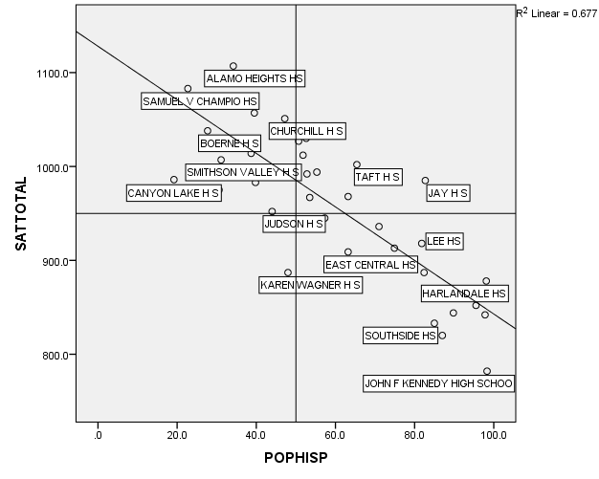

The graph above support the correlation table and proves that there is a strong negative relationship between SAT scores and Hispanic population, which means schools that have high population of Hispanic students, have lower SAT scores. The most interesting three schools for me are John F Kennedy, Alamo Heights, and Karen Wagner because all of them either extremely higher or lower than the average schools. John F Kennedy is extremely lower than the average because the average SAT scores of school is extremely below the average of San Antonio schools and almost all its students are Hispanic. Given that more Hispanics leads to lower scores and almost all of its students are Hispanic, JFK is the lowest school in San Antonio. What applies on John F Kennedy can be applied on Karen Wagner because the majority of its students are Hispanic and Black with very low SAT scores. Alamo Heights is highest SAT score school in San Antonio the majority of its students are White and more White students means higher SAT scores (as I will explain), and the Hispanic students there are unlike the norm with high SAT scores.

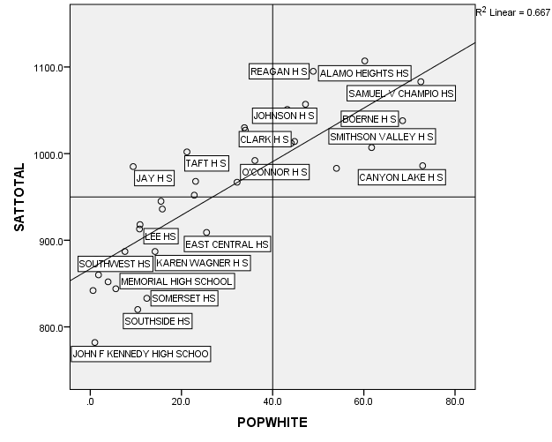

The graph above demonstrates clearly the strong positive relationship between SAT scores and White students population and also support the correlation table analysis. The graph proves that schools with more White students leads to higher SAT scores. The most interesting schools for me are Reagan and Canyon Lake because Reagan has much lower White students than Canyon Lake yet it has much higher SAT score, which made me look for another factor that might affect SAT score and I found that Reagan has less economically disadvantaged students than Alamo Canyon Lake because Reagan has only 9.8 while Canyon Lake has 36.1 which means the percent of economically disadvantaged students variable might be more important than the race variable.

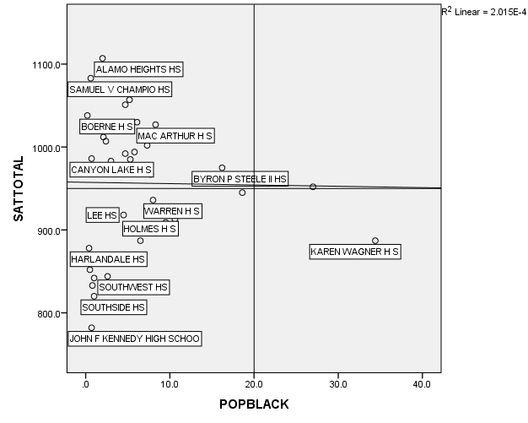

The graph above demonstrates the relationship between SAT scores and Black population and also supports the correlation table and proves that there is no relationship between SAT score and Black population because within the same population range, SAT scores differ from a school to another. In addition, the SAT scores for Black population depend on the majority race. In other words, SAT scores for Black students will be high if the school majority race is White and if the majority is Hispanic the Black students SAT score will be low. The most interesting schools for me are John F Kennedy and Alamo Heights because they are extremes in the graph. The majority in John F Kennedy is Hispanic and as explained more Hispanic students leads to lower SAT scores. Alamo Heights also as explained has a majority of White students and more White students leads to higher SAT scores.

Second, I examined how the percent of economically disadvantaged students affects SAT scores in San Antonio through studying the relationship between the percent of economically disadvantaged students per school and the average SAT score.

|  |  |  |  |
| --- | --- | --- | --- |
| **Correlations** | | | |
|  | | SATTOTAL | ECONDISAD |
| SATTOTAL | Pearson Correlation | 1 | -.909** |
| Sig. (2-tailed) |  | .000 |
| N | 36 | 36 |
| ECONDISAD | Pearson Correlation | -.909** | 1 |
| Sig. (2-tailed) | .000 |  |
| N | 36 | 36 |
| **. Correlation is significant at the 0.01 level (2-tailed). | | | |

The table above, the correlation between the dependent variable (SATTOTAL) and independent variable (ECONDISAD) is very strong with a value of -.909 and a significance of.000, which makes the percent of economically disadvantaged students the most effective variable among all. So we reject the null hypothesis that there is no correlation between them and accept the alternate hypothesis that there is a correlation.

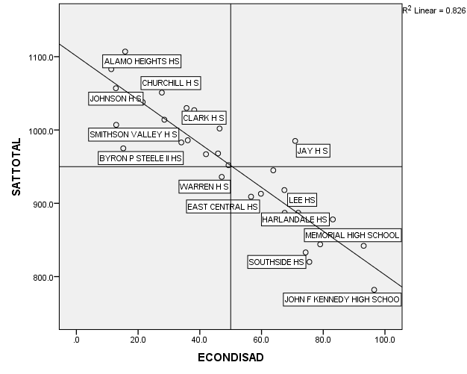

The graph above demonstrates the strong negative relationship between SAT scores and the percent of economically disadvantaged students and supports the correlation table analysis. Which means schools with high percent of economically disadvantaged students will have lower SAT scores. The most interesting schools are Alamo Heights, Jay, and John F Kennedy. Alamo Heights only 15.8 economically disadvantaged students and more 60 percent of its students are White so both factors support having high SAT scores. Jay is a very strange case because all the factors supposed to affect it negatively, but it has a very acceptable SAT score higher than the average of similar schools. John F Kennedy as always lower than any other school, but in this case the reason is because more than 96.5 of its students are Hispanic and economically disadvantaged.

Third, I examined how the number of students per teacher affects SAT scores in San Antonio through studying the relationship between the number of students per teacher in every school and the average SAT score.

|  |  |  |  |
| --- | --- | --- | --- |
| **Correlations** | | | |
|  | | SATTOTAL | #STU.PERTEACH |
| SATTOTAL | Pearson Correlation | 1 | .280 |
| Sig. (2-tailed) |  | .098 |
| N | 36 | 36 |
| #STU.PERTEACH | Pearson Correlation | .280 | 1 |
| Sig. (2-tailed) | .098 |  |
| N | 36 | 36 |

The table above, the correlation between the dependent variable (SATTOTAL) and independent variable (#STU.PERTEACH) is weak positive with a value of .280 and a significance of.098. So we accept the null hypothesis that there is a correlation between them and reject the alternate hypothesis that there is no correlation.

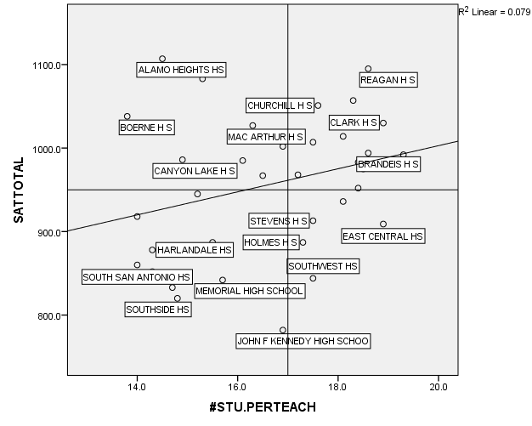

The graph above demonstrates the weak positive relationship between SAT scores and the number of students per teacher and supports the correlation table analysis. That means the number of students per teacher slightly affects students’ SAT scores. The most interesting schools are Reagan and South San Antonio because they are the total opposite to each other. Reagan has high number of students per teacher with 18.6 student per teacher while South San Antonio has much lower number with only 14, however, Reagan has much higher SAT scores. The reason for the difference SAT scores is Reagan has much lower Hispanic student population and much less economically disadvantaged students, on the other hand, the majority of South San Antonio students are Hispanic and the of economically disadvantaged students are much higher than Reagan’s.

Fourth, Third, I examined how attendance rate affects SAT scores in San Antonio through studying the relationship between the attendance rate in every school and the average SAT score.

|  |  |  |  |
| --- | --- | --- | --- |
| **Correlations** | | | |
|  | | SATTOTAL | ATT.RATE CAMP |
| SATTOTAL | Pearson Correlation | 1 | .767** |
| Sig. (2-tailed) |  | .000 |
| N | 36 | 36 |
| ATT.RATE CAMP | Pearson Correlation | .767** | 1 |
| Sig. (2-tailed) | .000 |  |
| N | 36 | 36 |
| **. Correlation is significant at the 0.01 level (2-tailed). | | | |

Based on the table above, the correlation between the dependent variable (SATTOTAL) and independent variable (ATT.RATE CAMP) is strong with a value of .767 and a significance of.000. So we reject the null hypothesis that there is no correlation between them and accept the alternate hypothesis that there is a correlation.

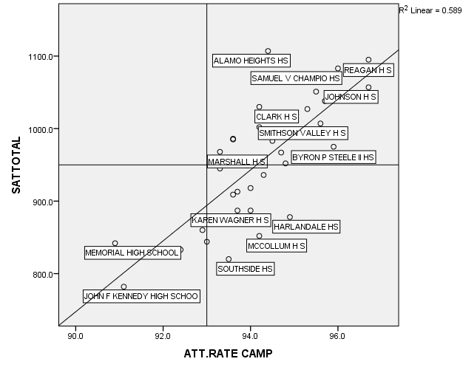

The graph above demonstrates clearly the positive relationship between SAT scores and attendance rate and also supports the correlation table analysis. The graph proves that mostly higher attendance rate leads to higher SAT scores. The most interesting schools are Harlandale and Alamo Heights because they have a very close attendance rate, but very different SAT scores. The reason is for the difference of SAT scores is Harlandale has high percent of economically disadvantaged and Hispanic students unlike Alamo Heights, and as explained before these two factors cause lower SAT scores.

Based on the previous analysis and graphs, the most effective two variables are the population of Hispanic students and the percent of economically disadvantaged students. In order to know if there is a relationship, I applied a correlation on both of them.

|  |  |  |  |
| --- | --- | --- | --- |
| **Correlations** | | | |
|  | | POPHISP | ECONDISAD |
| POPHISP | Pearson Correlation | 1 | .904** |
| Sig. (2-tailed) |  | .000 |
| N | 36 | 36 |
| ECONDISAD | Pearson Correlation | .904** | 1 |
| Sig. (2-tailed) | .000 |  |
| N | 36 | 36 |
| **. Correlation is significant at the 0.01 level (2-tailed). | | | |

Based on the table above, the correlation between the dependent variable (POPHISP) and independent variable (ECONDISAD) is a very strong with a value of .904 and a significance of.000. So we reject the null hypothesis that there is no correlation between them and accept the alternate hypothesis that there is a correlation.

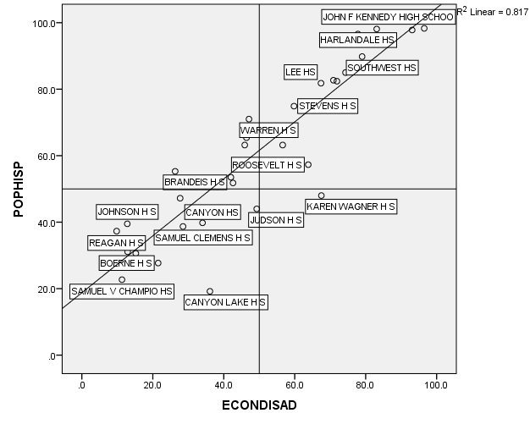

The graph above demonstrates clearly that there is a strong positive relationship between the population of Hispanic and the percent of economically disadvantaged students and also supports the correlation table analysis. The graph proves that most of the Hispanic students are economically disadvantaged, which explains why high population of Hispanic students leads to lower SAT score and also presents the percent of economically disadvantaged students as the most effective independent variable that affect SAT scores either negatively or positively. The most interesting schools are Canyon Lake and Karen Wagner because both are below the linear. The reason is both have much lower Hispanic and percent of economically disadvantaged student than the average of their counterparts schools in San Antonio area.

To be more accurate, a regression analysis must be applied to all independent variable.

|  |  |  |  |  |
| --- | --- | --- | --- | --- |
| **Model Summary** | | | | |
| Model | R | R Square | Adjusted R Square | Std. Error of the Estimate |
| 1 | .848a | .718 | .701 | 45.5197 |
| a. Predictors: (Constant), POPHISP, POPBLACK | | | | |

|  |  |  |  |  |  |  |
| --- | --- | --- | --- | --- | --- | --- |
| **Coefficientsa** | | | | | | |
| Model | | Unstandardized Coefficients | | Standardized Coefficients | t | Sig. |
| B | Std. Error | Beta |
| 1 | (Constant) | 1152.470 | 23.503 |  | 49.035 | .000 |
| POPBLACK | -2.333 | 1.063 | -.208 | -2.194 | .035 |
| POPHISP | -3.012 | .328 | -.869 | -9.176 | .000 |
| a. Dependent Variable: SATTOTAL | | | | | | |

The table above demonstrates that among the two independent variables, (POPHISP) has the most significance and t value, while (POPBLACK) has a lower significance and t value, which the population of Hispanic affects SAT scores much more than the population of Black. Furthermore, the R-Square helps to explain that 72% of the variance in SAT scores is the population of Hispanic and the population of Black.

|  |  |  |  |  |  |  |  |  |
| --- | --- | --- | --- | --- | --- | --- | --- | --- |
| **Model Summary** | | | | | | | | |
| Model | | R | R Square | | Adjusted R Square | | Std. Error of the Estimate | |
| 1 | | .853a | .727 | | .701 | | 45.5368 | |
| a. Predictors: (Constant), #STU.PERTEACH, POPBLACK, POPHISP | | | | | | | | |
| **Coefficientsa** | | | | | | | | | | | |
| Model | | | | Unstandardized Coefficients | | | | Standardized Coefficients | | T | Sig. |
| B | | Std. Error | | Beta | |
| 1 | (Constant) | | | 1069.281 | | 87.456 | |  | | 12.226 | .000 |
| POPBLACK | | | -2.547 | | 1.086 | | -.227 | | -2.346 | .025 |
| POPHISP | | | -2.932 | | .338 | | -.846 | | -8.663 | .000 |
| #STU.PERTEACH | | | 4.789 | | 4.850 | | .097 | | .988 | .331 |
| a. Dependent Variable: SATTOTAL | | | | | | | | | | | |

The table above demonstrates that when adding (#STU.PERTEACH), (POPHISP) and (POPBLACK) still have a higher significance and t value than (#STU.PERTEACH), which means the population of Hispanic and the population of Black affect SAT scores much more than the number of student per teacher. The R-Square explains that about 73% of the variance in SAT scores is the population of Hispanic, population of Black, and the number of student per teacher

|  |  |  |  |  |
| --- | --- | --- | --- | --- |
| **Model Summary** | | | | |
| Model | R | R Square | Adjusted R Square | Std. Error of the Estimate |
| 1 | .886a | .785 | .757 | 41.0753 |
| a. Predictors: (Constant), ATT.RATE CAMP, POPBLACK, #STU.PERTEACH, POPHISP | | | | |

|  |  |  |  |  |  |  |
| --- | --- | --- | --- | --- | --- | --- |
| **Coefficientsa** | | | | | | |
| Model | | Unstandardized Coefficients | | Standardized Coefficients | T | Sig. |
| B | Std. Error | Beta |
| 1 | (Constant) | -998.841 | 720.931 |  | -1.385 | .176 |
| POPBLACK | -2.198 | .987 | -.196 | -2.227 | .033 |
| POPHISP | -2.124 | .414 | -.613 | -5.128 | .000 |
| #STU.PERTEACH | 2.641 | 4.437 | .054 | .595 | .556 |
| ATT.RATE CAMP | 21.777 | 7.546 | .342 | 2.886 | .007 |
| a. Dependent Variable: SATTOTAL | | | | | | |

When adding (ATT.RATE CAMP), the significance and the t value change. Among these variables, the most affecting independent variables is (POPHISP) then (ATT.RATE CAMP) then (POPBLACK) and finally the least significance with (#STU.PERTEACH). That means that the population of Hispanic has the higher effect on SAT score followed by the attendance rate, then, the Black population and at last the number of student per teacher. The R-Square helps to explain that 78% of the variance on SAT scores is Hispanic, population of Black, the number of student per teacher, and attendance rate.

|  |  |  |  |  |  |  |  |  |
| --- | --- | --- | --- | --- | --- | --- | --- | --- |
| **Model Summary** | | | | | | | | |
| Model | | R | R Square | | Adjusted R Square | | Std. Error of the Estimate | |
| 1 | | .914a | .835 | | .807 | | 36.5554 | |
| a. Predictors: (Constant), ECONDISAD, POPBLACK, #STU.PERTEACH, ATT.RATE CAMP, POPHISP | | | | | | | | |
| **Coefficientsa** | | | | | | | | | | | |
| Model | | | | Unstandardized Coefficients | | | | Standardized Coefficients | | T | Sig. |
| B | | Std. Error | | Beta | |
| 1 | (Constant) | | | 1164.832 | | 961.171 | |  | | 1.212 | .235 |
| POPBLACK | | | .188 | | 1.181 | | .017 | | .159 | .875 |
| POPHISP | | | .196 | | .851 | | .057 | | .230 | .819 |
| #STU.PERTEACH | | | -5.453 | | 4.771 | | -.111 | | -1.143 | .262 |
| ATT.RATE CAMP | | | .299 | | 9.776 | | .005 | | .031 | .976 |
| ECONDISAD | | | -3.285 | | 1.087 | | -1.000 | | -3.023 | .005 |
| a. Dependent Variable: SATTOTAL | | | | | | | | | | | |

This table demonstrates clearly that when adding (ECONDISAD), the whole table changed, which means among all independent variables, (ECONDISAD) has strongest effect on the dependent variable. In another words, the percent of economically disadvantaged students is the most effective independent variable among all variables on SAT scores. Independent variables that used to have strong effect on the dependent variable such as population of Hispanic and attendance rate look very weak because they compete each other over higher effect, which weakens their numbers in the significance and the t value. Although, the number of student per teacher used to have the weakest effect on SAT scores, it has the second highest value not because of its strong effect, but because other strong independent variables are weakening themselves in competing each other. After adding the percent of economically disadvantaged students, the R-Square changed to be 83%, which means all independent variables explains 83% of the relationship between them the dependent variable.

**Conclusion**

Rising in income inequality has increased the achievement gap between high and low-income families (Reardon, 2011). According to Reardon (2011) children born in 2001 have an achievement gap that is 30 to 40 percent larger than children born 25 years ago. Public Administration initiatives have taken place since the 1960s to include the inception of the Federal Head Start Program, a part of the War on Poverty, to weaken the link between family poverty and a child’s social and cognitive development (Kagan 2002; Zigler and Muenchow 1992). While the historical identification and study of the achievement gap between white and minority students is present, initiatives to eliminate or lessen the gap are controversial and not seemingly effective.

According to the NAACP and the College Board, the creators and developers of the SAT, the SAT test is not the problem, but the problem lies in America’s unequal education system (CNN, 2001) through inequitable school funding to areas which serve minorities and those of lower socioeconomic status (NAACP, 2011). Public Administrative initiatives in the more recent decade include the No Child Left Behind Act (NCLB) of 2002. NCLB was signed by President George W. Bush as a U.S. Department of Education reform for greater accountability for results, increased flexibility and local control, expanded options for parents, and an emphasis on proven teaching methodology (U.S. Civil Rights, 2004). The NCLB seeks to provide the highest equal level of education to students who are low-income, minority, or have English as a second language (ESL) (U.S. Civil Rights, 2004).

Proposed administrative and legislation changes to ensure that the targeted groups of NCLB are addressed and properly educated include, the use of well-designed tools to assess students and determine appropriate learning interventions, better ways to disaggregate student data and performance based on varying characteristics such as race, income, language, socioeconomic status, gender or disability (U.S. Civil Rights, 2004). Additional recommended steps include the reduction in class size in schools with high minority and poverty levels to decrease the achievement gap.

The cause of the achievement gap between whites and minorities is often times blamed on racism, while others propose it is a problem of income. Black and minority students are more likely to be of a lesser socioeconomic status than their White peers, which leads to limited family and school resources (Rothman, 2002).

Federal, state, and local, efforts to improve equitable accessibility to education, adequately trained teachers and staff, and community programs to improve student and parent motivation is key to improve the SAT achievement of minorities, disabled students, and those of a lower socioeconomic status. Set perspective and standards that are closely monitored and audited are required to ensure that strict adherence is imposed and proper sanctions and corrective action taken to ensure that noncompliance educational organizational systems or institutions are quickly brought up to standard.

**References**

Allensworth, E., & Easton, J. Q. (2007). *What matters for staying on-track and graduating in Chicago Public High Schools: A close look at course grades, failures and attendance in the freshman year*. Chicago: Consortium on Chicago School Research.

Blau, D. M. (1999). The effect of income on child development. *Review of Economics and Statistics*, *81*(2), 261-276.

Bowen, W.G., and Bok, D. (1998). *The shape of the river.* Princeton, NJ: Princeton University Press.

Card, D., & Rothstein, J. (2007). Racial segregation and the black–white test score gap. *Journal Of Public Economics*, *91*(11/12), 2158-2184. doi:10.1016/j.jpubeco.2007.03.006.

Coleman, J. S., Campbell, E. Q., Hobson, C. J., McPartland, J., Mood, A. M., Weinfield, F. D., & York, R. L. (1966). Equality of educational opportunity (OE-38001). Washington, DC: U.S. Department of Health, Education, and Welfare.

CNN. (20011, April 1). *Schools Blamed for Racial Gap in SAT Scores.* Retrieved 22 February 2013 from: [*http://archives.cnn.com/2001/fyi/teachers.ednews/08/28/sat.scores/*](http://archives.cnn.com/2001/fyi/teachers.ednews/08/28/sat.scores/)*.*

Fleming, J. (2002). Who Will Succeed in College? When The SAT Predicts Black

Students' Performance. *The Review of Higher Education, 25(3).*  Retrieved 22 February 2013 from: http://muse.jhu.edu/journals/rhe/summary/v025/25.3fleming.html

Hanushek, E. A. (1986). The economics of schooling: Production and efficiency in public schools. *Journal of Economic Literature*, 24(3), 1141-1177.

Journal of Blacks in Higher Education. (1998). Why family income differences don’t explain the racial gap in SAT scores. *The Journal of Blacks in Higher Education*, *20*, 6-8.

Journal of Blacks in Higher Education. (2005). *The Widening Racial Scoring Gap on the SAT College Admissions Test*. Retrieved February 22, 2013 from: http://www.jbhe.com/features/49_college_admissions-test.html

Konstantopoulos, S. (2008). Do Small Classes Reduce the Achievement Gap between Low and High Achievers? Evidence from Project STAR. *Elementary School Journal*, *108*(4), 275-291.

Marklein, M.B. (2009 Aug 26). SAT scores show disparities by race, gender, family income. *USA Today.* Retrieved 24 February 24, 2013 from: http://usatoday30.usatoday.com/news/education/2009-08-25-SAT-scores_N.htm

Mayer, S. (1997). *What money can’t buy: Family income and children's life chances.*Cambridge, MA: Harvard University Press.

National Association for the Advancement of Colored People. (2011, April 1). *Education.* Retrieved 23 February 2013 from: *http://backup.naacp.org/programs/education/index.htm*

National Center for Fair and Open Testing. (2007, Aug 20). SAT I: A Faulty Instrument For Predicting College Success. *FairTest*. Retrieved 22 February 2013 from: http://www.fairtest.org/satvalidity.html

Neild, R. C., & Balfanz, R. (2006). *Unfulfilled promise:* *The dimensions and characteristics of Philadelphia’s dropout crisis, 2000-2005*. Baltimore: Center for Social Organization of Schools, Johns Hopkins University

Profile: School districts across the country who are using tougher attendance policies to *raise test scores*. (2001). *Washington, D.C., United States, National Public Radio.* Retrieved from http://search.proquest.com/docview/190128202?accountid=8289

Romer, D. (1993). "Do Students Go to Class? Should They?" *Journal of Economic Perspectives 1.* 167-74.

Rothman, R. (2002). Closing the Achievement Gap: How Schools Are Making It Happen. *Journal of the Annenberg Challenge*, 5(2).

Sackett, P.R., Kuncel, N.R., Beatty, A.S., Rigfon, J.L., Shen, W., & Kiger, T.B. (2012). The Role of Socioeconomic Status in SAT-Grade Relationships and in College Admissions Decisions. *Psychological Science.* doi:10.1177/0956797612438732

U.S. Commission on Civil Rights Office of the General Counsel. (2004, Jul 2). Closing the Achievement Gap: The Impact of Standards-Based Education Reform on Student Performance. Retrieved 22 February 2013 from: http://www.law.umaryland.edu/marshall/usccr/documents/closingachiegap.pdf

Wade, L. (2012, Aug 29). The Correlation BetweenIncome and SAT Scores. *The Society Pages.* Retrieved February 22, 2013 from: http://thesocietypages.org/socimages/2012/08/29/the-correlation-between-income-and-sat-scores/