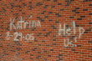Make It Right!

5140058-katrina-on-the-wall

Green building technology improves the lives of New Orleans residents.

In 2005, Hurricane Katrina slammed into the Gulf Coast, killing at least 1836 people and causing $81 billion in damage. New Orleans, its plight deepened by broken levees, was devastated. The floods washed away more than people's homes and property; it destroyed their businesses -- their means of making a living. The unique culture and spirit on New Orleans lives in exile; in the hearts and minds of its native sons and daughters. Without a place to call home; it will not do so for long.

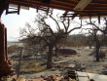More than five years after the hurricane, attempts to reclaim property and prosperity have failed catastrophically. Many New Orleans residents still live in temporary shelters. Many are displaced with no hope of rebuilding their homes after insurance companies failed to honour their responsibilities; claiming that damage due to flooding was not covered by resident's policies.

888474-big-window-view

The historic Lower 9th Ward was hardest hit. Two years after the flood, this area had still not been rebuilt. When actor Brad Pitt toured the area, the devastation affected him profoundly and he vowed to "Make it right." His pledge led to the inception of the Make It Right project which committed to building 150 new homes in Ward 9. Make it Right also endeavoured to improve infrastructure and prevent future catastrophes from affecting the community in such a devastating way.

305473

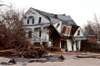Make it Right is the building of an extraordinary neighbourhood. 21 Award winning architects have collaborated to construct America's greenest community. The buildings have earned the highest distinction in sustainability -- a LEEDS platinum award. 26 Gauge roofs absorb less heat, reducing the need to cool the houses by 20 to 70%. Spray foam insulation in the floor, walls and roof increase the efficiency of the home envelope. Photovoltaic solar panels convert the abundance of New Orleans sunshine to energy; 2.7 to 3 KW per household. Most houses produce more than they consume which reduces reliance on fossil fuels. The homes are elevated by five to eight feet, ensuring their safety from rising flood waters and providing convenient shaded parking. Hurricane fabric windows, which are made from Kevlar, negate the need for boarding up homes during storms.

Reinforced framing enables homes to withstand winds of up to 130 km/h and are further reinforced by fibre cement board siding which is hail and termite resistant, thereby reducing maintenance and increasing longevity. Tankless water heaters and energy star appliances help reduce energy consumption.

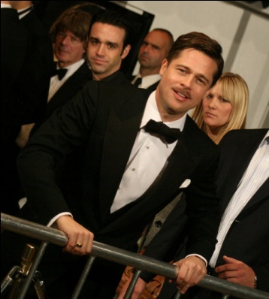Make it Right is not just building homes; they are creating communities. Rain gardens, community farms and even streets are contributing to the reconstruction of the 9th Ward. The project is made possible by generous contributions of time, money, expertise and building materials by people who want to see 9th Ward residents come home. You can help by donating, purchasing merchandise or adopting a Make It Right Home.

<http://www.makeitrightnola.org/>