Copyrighted © 2012 MasterSEM

Creating an Online Advertising Future   
For Your Company

Whitepaper Abstract:

The objective of this study is to understand the validity and benefits of online advertising in the forms of online campaigns, search engine rankings, websites, e-commerce, and contact forms and their connection, if any, to increased sales. A secondary purpose of the paper is to understand how an online campaign strategy can supplement traditional brick and mortar sales.

The objective of this study is to understand the validity and benefits of online advertising in the forms of online campaigns, search engine rankings, websites, e-commerce, and contact forms and their connection, if any, to increased sales. Zubin Jelveh (2010) of AOLnews asserts that “the mere presence of online ads has an influence on the products and services we buy, and that businesses that advertise online are probably getting a better bang for their advertising buck on the Web than in other media, like television, radio or print.”1 Consequently, this study seeks to answer the following questions within the following catagories:

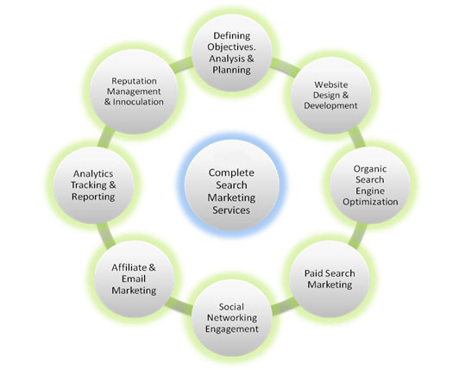**Online Campaigns:**

* Generally, does online advertising raise sales?
* Are specific markets seeing greater increases or room for increased sales as a result of marketing online? (e.g. Retail, service industries, professional services, etc.)

**Search Engine Rankings:**

* What are search engine rankings and how are they impacted? How Do Search Engine Rankings Vary in Results by Industry?

**Websites:**

* What role do websites play in corporate communication and branding?
* What role do websites play in presenting a strong, positive image of the company?

Source: Integrated Online Campaigns. (2011). <http://www.pozzani.us/seo-sem-smm.html>

**E-commerce:**

* Is the e-commerce format replacing brick and mortar stores?

**Contact Forms:**

* What is the validitiy and usefulness of online contact forms?

**Conclusion:**

* Do all of these online advertising components—online campaigns, search engine rankings, strong websites, e-commerce, and contact forms—provide measurable improvements in ROI, customer retention and satisfaction?

A passing observation of the last decade would suggest that Americans are becoming increasingly voracious for media in all forms. There is however, a distinct lean toward media in technologically advanced formats as a result of the increased 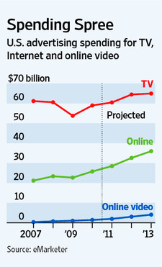accessibility through smart phones, tablets, computers, etc. In fact, researchers out of the University of California, San Diego published a study in December of 2009 asserting that on average Americans are consuming 34 gigabytes of data daily.2 At the time of the initial study, researchers indicated an average growth in consumption of media at a rate of 6% yearly. If that rate stayed constant and were applied to subsequent years, it would suggest that in 2012 we are consuming over 40 gigabytes of data daily across all marketing platforms. That level of media consumption provides infinite opportunities to advertise. The question becomes “In which basket do I put my advertising eggs?” The answer is invariably to avoid banking on any one solution and instead to invest in a multi-channel multi-modal approach.

While online ad campaigns, search engine rankings, website creation and renovation, e-commerce, and contact form utilization are the primary modes by which [MasterSEM](http://www.mastersem.com/) will revolutionize your online presence through interactive marketing; that is just the beginning. A multi-modal approach is necessary for a successful online campaign to see its full potential. Additionally, [MasterSEM](http://www.mastersem.com/) recognizes that all the interactive bells and whistles mean nothing without a focus on return on investment (ROI), customer retention and satisfaction; consequently, all are factors directly addressed in this study. A secondary purpose of the paper is to understand how an online campaign strategy can supplement traditional brick and mortar sales.

The point is to recognize the fact that across the board, internet advertising has a bright future and you just need to decide if your company will be a part of that future. 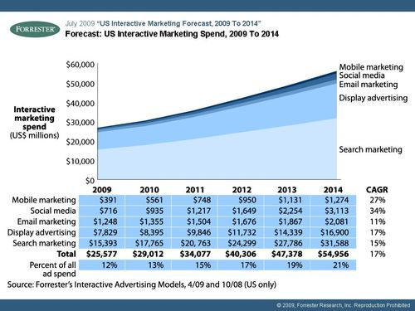The upward trend in interactive advertising seen in *Forrester’s Forecast: US interactive marketing Spend, 2009-2014* (2009) shows the market growing by leaps and bounds and in ever expanding modes, content, quality, and frequency. Interactive media is quick, trackable, and malleable to the audience and for those reasons it will only continue to grow in its influence.

**A Background on Internet Advertising & Marketing**

The ubiquitous term *internet advertising* (or *web marketing, online marketing/advertising, or e-marketing)* consists of an ever growing number of tactics but the most common break down into the following categories: Traditional online advertising, Email advertising, Display advertising, Affiliate marketing, Behavioral targeting, and Semantic/Contextual Advertising. All genres, in various instances, can have interactive marketing elements. (For detailed definitions of individual terms, see our *What’s What in Online Advertising*-*Glossary of Terms*).

**Traditional online ad types:**

* “Traditional online ads” is an extremely general term to describe the highly varied types of ads popular with large companies who have a matching budget. It capitalizes on high exposure and with that focuses on branding as opposed to actual conversion due to low click-thru-rates. Traditional online ads include any of the following formats: **floating ads, expanding ads, polite ads, wallpaper ads, trick banners, pop-ups, pop-unders, video ads, map ads, mobile ads, superstitials, and interstitial ads.**3 While many of these ad types—floating ads, expanding ads, polite ads, wallpaper ads, trick banners, pop-ups and unders—still pervade the internet, they are examples of the earliest types of online advertising. More recent modes of online advertising involve more interactive media like video ads, map ads, superstitials, and interstitials. **Interactive marketing** normally refers to advertising in the online format and which responds to the user’s actions by presenting content such as text, graphics, animation, video, audio, etc. 4

**Email advertising:**

* For the purposes of this study we do not consider SPAM as a legitimate form of advertising as regulations from the Federal Communication Commission (FCC) and the Federal Trade Commission (FTC) have been adopted that prohibit sending unwanted commercial messages to wireless devices and to computers without prior permission. This prior permission from the customer has created a new opportunity with the creation of opt-in email advertising and SMS messages.5

**Display advertising:**

* 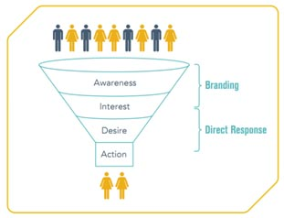The primary form of display advertising is web banners. “These banners can consist of static or animated images, as well as interactive media that may include audio and video elements.” 6 Display advertising is best known for its impact on branding. Branding includes the essential first steps in entering the “Purchase Funnel – the widely accepted marketing model that describes a series of stages (Awareness, Interest, and Desire) each consumer experiences on their way to ultimately purchasing a product or service (Action).”7
* 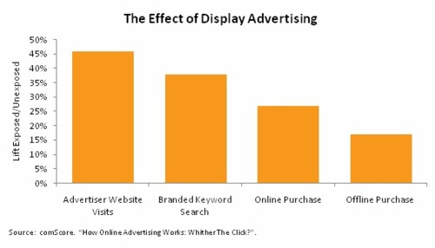While display ads currently represent roughly $13-14 billion annually in the United States, experts project that it will increase to $25 billion in the next 5 to 6 years.8 Another happy consequence of display advertising is its positive correlation to not only to online purchasing, as would be the obvious reason to advertising online, but also to offline purchasing executed up to one month after the campaign.9 This offline purchasing establishes the validity of “view-thru” value when “click-thru” seems to be less than inspiring.

**Affiliate marketing:**

* Affiliate marketing is a form of online advertising where advertisers place campaigns with a potentially large number of small (and large) publishers, whom are only paid media fees when traffic to the advertiser is garnered, and usually upon a specific measurable campaign result (a form, a sale, a sign-up, etc.). Today, this is usually accomplished through contracting with an affiliate network. The exemplar of affiliate marketing is Amazon.com with its Associate program, which was launched 1996. The online retailer used its program to generate low cost brand exposure and provided at the same time small websites a way to earn some supplemental income.10

**Behavioral targeting:**

* Behavioral targeting is a way of tracking a user’s online behavior and interests. “For example, if a user is known to have recently visited a number of automotive shopping / comparison sites based on clickstream analysis enabled by cookies stored on the user's computer, that user can then be served auto-related ads when they visit other, non-automotive sites.” 11 And specifically “when a consumer visits a web site, the pages they visit, the amount of time they view each page, the links they click on, the searches they make and the things that they interact with, allow sites to collect that data, and other factors, create a 'profile' that links to that visitor's web browser. As a result, site publishers can use this data to create defined audience segments based upon visitors that have similar profiles.” 12

**Semantic & Contextual advertising:**

* Semantic advertising applies technology to semantically analyze the every web page in order to understand what the main subject(s) of the page is in order to aide accurate ad placement. “Semantic advertising increases the chance that the viewer will click-thru because only advertising relevant to what they are viewing, and therefore their interests, should be displayed.” 13 For instance, semantic analysis of a certain webpage with prolific use of the word “pool” might reveal that it is a page about the history of billiards and its modern day expression in bar room pool as opposed to built-in, underground pools for swimming in. If all the ads on the page pop up in reference to pools for swimming then that company’s ad budget is not being used very effectively.
* “By comparison, contextual advertising   
  technology bases web page advertising on a keyword scan of the text of a website or Internet search”14 and therefore the accuracy of ad placement is less precise on average than is semantic advertising, but still a widely used method.

Each of these modes have specific advantages and target markets wherein they find the most success, however not all methods are appropriate or reasonable for all advertisers and this is primarily due to cost. Therefore, we need to

**Online Advertising’s Affect on Sales**

The following case study on the Rosetta Stone company’s use of “Rich Ads” is one of thousands of examples of just how much online advertising can raise sales. In a virtual environment, the way you communicate your message determines if anyone hears the message and that translates directly to your bottom-line. While “value-thru” rates are fantastic for branding and belated ROI, click-thru-rates (CTR) are undeniably pulse-quickeners when the rates are high and the profits match.

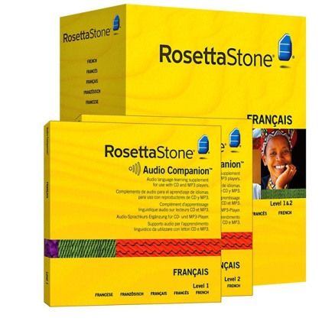Rosetta Stone, a leading language-learning company, saw a 400% increase in CTR through a recent Rich Ad campaign. These highly visual ads appear in both Yahoo! and Bing search results, and enable advertisers to display not simply text but images, links, logos, video and form fields, thus engaging users more intently.15 “With Rich Ads in Search, Rosetta Stone was able to quickly and cost-effectively build a powerful search marketing campaign that leveraged embedded video and other features to grab the attention of users, demonstrate for them the advantages of the company’s language-learning software, and motivate many of them to click through and make a purchase.”16 Hoan Tchen, Rosetta Stone’s online marketing manager said, “The results were phenomenal. The click-through rate was through the roof. I’d never seen anything like it before.”17 She attributes those higher conversion rates to people being drawn in by the video and gaining more knowledge of the product. Overall, this campaign which was begun in April of 2011 has exceeded the company’s expectations and has achieved a strengthening of its brand,   
“heightened user engagement, improved click-through rates, and significantly increased converstions.”18 What more proof do you need that online advertising works?

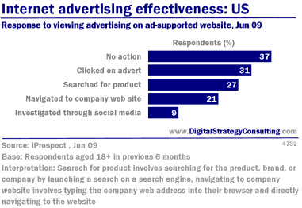Rosalind Resnik of Entrepreneur.com said, “The key is finding the advertising channel that best fits your company and your industry and use it to get the biggest bang for your buck. At the end of the day, it's not about how much you spend or how many eyeballs you reach. It's about how many customers you can bring in the door while still making enough money to float your boat. And, while no advertising strategy is foolproof (there's always going to be some initial trial and error before you figure out what works), you'll get better results and waste less money if you do your homework ahead of time.”19 The homework of online advertising is looking at your industry and what successful channels are currently used and what hidden gems may still be uncovered with a clever marketing team and one good campaign.

**How Specific Markets Respond to Online Advertising**

**(e.g. Retail, service industries, professional services, etc.)**

The results are clear that online advertising produces positive action out of a large percent of users, the trick is knowing your market and choosing the right channel in which to advertise—Rich media or contextual advertising, video pop-ups or takeover ads, etc. “For example, in the Tech industry image ads are the most effective ones however, in the Auto industry they are the least effective.”20

[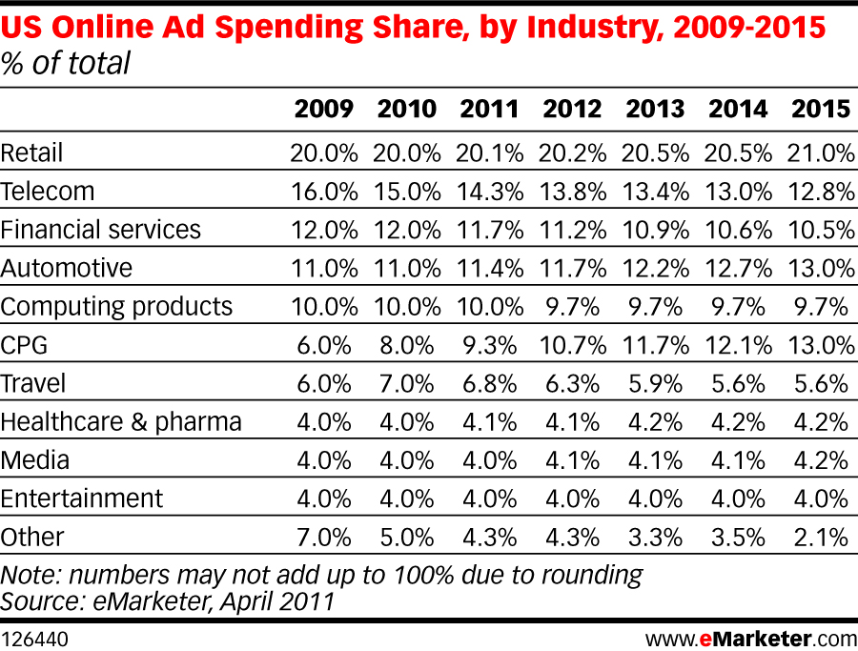](http://e-healthcaresolutions.com/blog/wp-content/uploads/2011/04/US-Online-Ad-Spending-share-April-2011.jpg)Knowing the lay of the land in terms of what money is being spent per industry provides a glimpse of the “Opportunities” and the “Threats” of any basic SWOT (Strengths, Weaknesses, Opportunities, and Threats) analysis. Once you know your competitors strategies you can exploit strengths and avoid weaknesses currently being employed from their marketing quiver.

Whether retail or travel, major industries are throwing money into online advertising, however, some industries are dominating the field. Retail clearly out spends other industries by averaging over 20% of the online advertising market share, but surprising opportunities lie within eMarketer’s April 2011 forecast.21 While it appears that Financial Services as a whole are on the decline for market share, might that just be big banks with big budgets pulling back? Could small local banks wisely invest in targeted advertising and win significant market share in their communities while confidence in large bank chains falters in the current recession? These are the questions that you should be asking about your industry and what part of the market share you think you could get your hands on with some clever campaigns.

Speaking of clever, Facebook is always pushing in new directions and most recently they have obliterated the idea that purchased advertising and earned advertising are separate entities. They have blended the two beautifully in a series of their highly customizable ad platforms. Through Advertising-based Ecommerce and Fan Marketing Ecommerce they are producing record numbers in ROI for niche product sales. Look at the following case studies assembled by Brian Carter, authorof*The Like Economy: How Businesses Make Money With Facebook* and co-author of *Facebook Marketing: Leveraging Facebook’s Features For Your Marketing Campaigns.*

## Advertising-Based Ecommerce Case Study

*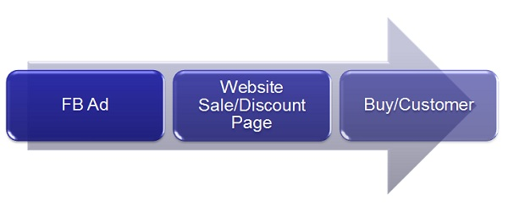Vamplets.com*, which sells plush vampire baby dolls, achieved a 300% ROI on ecommerce sales in its first month of advertising directly to the ecommerce site, according to a company representative.

Image Source: <http://mashable.com/2012/01/12/facebook-make-money/?WT.mc_id=obinsite>

## Fan Marketing Ecommerce Case Studies

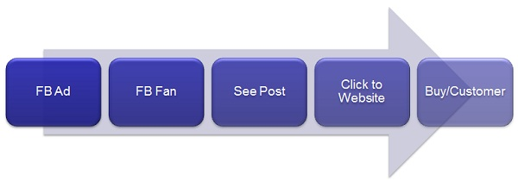The business *Baseball Roses* sells artificial roses made from real baseballs. Mark Ellingson—founder of the company—explained that they were unsuccessful with Google AdWords because no one was searching for their innovative product by name or even by genre. Instead they turned to Fan Marketing on Facebook. They achieved a 473% ROI from their spend on fan acquisition via Facebook ads.

Image Source: <http://mashable.com/2012/01/12/facebook-make-money/?WT.mc_id=obinsite>

*Rosehall Kennel* breeds and sells German Shepherds, and has achieved more than 4,000% ROI on its fan acquisition spend, according to owner Eliot Roberts. What’s more, Roberts confirmed with Carter that they have seen fewer requests for discounts and a shorter sales cycle.

*SuperHeroStuff.com*’s founder Ronando Long told Carter that when the company began to use Facebook in 2011, it was the only new thing they were doing, and their revenues increased 150%.21

Success in internet advertising strategy always comes back to a willingness to do the research, assess your field for opportunities and classic strategies currently being employed, and then being willing to chuck it all when a brilliant idea comes out of the woodworks!

**What are Search Engine Rankings?**

Search engine rankings are a tricky business because what defines them is constantly changing on top of being proprietary per each search engine. Basically, search engines follow a set of rules, called an algorithm, which determine how “relevant” your website and its content is in relation to what is searched for by a user. The result of a user’s search includes both paid advertising related to the search and then below those are the “organic listings”. Organic listings are those that come up in response to the search engines algorithm. Search engine rankings are the rank at how relevant they deem your website and its content based on their algorithm. In order to stay cutting edge and ensure continued use of their engine, companies like Google, Yahoo!, and Bing constantly update their algorithms to improve the relevancy of their searches.

If you think the term constantly is too generous then let’s turn to Google as a prime example. Eric Schmidt, executive chairman of Google, testified before a Senate subcommittee on Sept 21, 2011 that in “2010 we [Google] conducted 13,311 precision evaluations to see whether proposed algorithm changes improved the quality of its search results, 8,157 side-by-side experiments where it presented two sets of search results to a panel of human testers and had the evaluators rank which set of results was better, and 2,800 click evaluations to see how a small sample of real-life Google users responded to the change. Ultimately, the process resulted in 516 changes that were determined to be useful to users based on the data and, therefore, were made to Google’s algorithm.”23 With the 500+ changes made, that averages out to over 1.5 changes a day for 2010. That is a lot of changes and refinements.

**How Are Search Engine Rankings Impacted?**

While each search engine has their own algorithm to determine relevancy, common attributes do tend to determine aspects of the site valuation. Particularly, keyword usage, back links (hyperlinks on other pages that link back to your page), and quality of content are among those valuations. One common encouragement from search engine vendors was to write real content for real people so that you are constantly improving your customers’ experience on your site and the vendors will do their job to find you, but it doesn’t hurt to optimize your page with those key factors as well.

While optimizing your site includes the positive aspects of keywords, backlinks, etc. there are many factors that can negatively affect the ranking of your site. Your website may not be showing up in search engines currently because of these factors, or at least not in a position that does anything for you. “Some factors could be: (1) your website design may not be search engine friendly (2) some code and scripts can prevent search engines from crawling your website (3) your site has not been properly submitted or (4) your site has very little authority for non-branded keywords.”24 These issues are remedied through well crafted website infrastructure and quality content that shows off the knowledge and expertise that collectively resides in the resources of your company, specifically those you’ve shared on your site. Press releases, guides to buying, FAQs, relevant blogs and more help build the content and offer information to your customers that make you not only a source to buy the good/service, but in this information age it makes you more importantly an expert source of information about that good/service. Being that expert means that other pages may point at your site as a quality reference and then others are helping bring traffic to your site.

**How Do Search Engine Rankings Vary in Results by Industry?**

Every industry has its own demographic for the type of clientele it attracts, the geographic location those users come from and a myriad of other factors that determine the scope of those whom are interested. Accordingly, search engines also vary in who uses them and for what purposes. This is why if you do a search for Chevy impala car parts on Google, Yahoo, and MSN you will come up with a different strata of page one paid and organic listings. Each search vendor caters to their clientele and depending on the user preferences it is common for preference of certain engines over others to occur. This then requires that SEO managers know the demographic of each engine and how to position the client’s website within its distinct atmosphere.

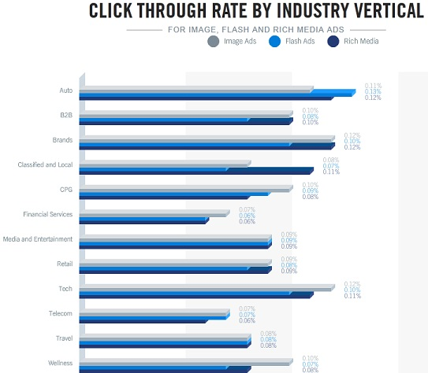“If you conduct a research on using different search engines, you’ll find that some keywords get huge click-through rates in Google. But at the same time they may not get the same on Bing and Yahoo!. Likewise what works well in Bing may not get the same amount of click through rate in Google. Every search engine has changeable amount of searchers searching objective, search value and search extent. This is why rankings of Bing always appear different from Google and Yahoo! Or the sites that appear on the top may not get the same rankings on Bing and Yahoo! It varies from search engine to search engine.”25 SEO companies make it their business to know not only what engine supports what industry, but also what type of online advertising gets the best click through rates (CTR) for each industry. Look to the data on the *Click Through Rate By Industry Vertical* chart from a 2010 Google study that shows 12 major industries and their click through rates on pay-per-click advertising. A major advantage of SEO management is how quickly it can be altered for improved rankings.

Image Source: <http://www.workinghomeguide.com/index.php/7069/choosing-effective-rich-media-ads-by-clickthrough-rate>

**The role websites play in corporate communication and branding**

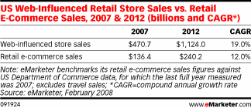Just like a suit and tie once represented the height of professionalism, now a strong website means that you are here in the global marketplace and ready to do business. It’s a fact—if your company isn’t online, you are missing out on a significant share of business. In 2007, eMarketer “estimated that store sales influenced by online research totaled $471 billion. Comparatively, retail e-commerce sales were only $136 billion. Looked at another way, for every $1 in online sales, the Internet influenced $3.45 of store sales.”26 In this same study, indications are that consumers will gain confidence in purchasing online as time goes by but more than anything websites are used predominantly for pre-purchase comparative research. If your website doesn’t exist or isn’t contributing to the online conversation about your products then you will likely miss out on being part of the purchasing cycle.

Blogs, review sites, and social media have become rich sources of information as product and services research occurs by the consumer. A corporate blog can become your foot in the door for communicating multiple vital things about your company:

* you are experts
* you stay abreast of current trends and innovations and/or are creating them
* you want your customers to be informed whether or not they purchase with you
* you are a trusted source they can look to for credible information
* you want to be their source for information and ultimately purchases

a corporate blog isn’t just about publishing useful information on the internet (though it helps you be a part of the conversation); it is about making and exploiting one more opportunity for your company to be front and center before the consumer. A multi-channel (i.e. cross-fire) approach in advertising has long been a standard practice in marketing and that approach is the essence of branding a company.

Brand marketing is about having your corporate name, logo, or slogan be the one that stands out in consumers’ minds when they consider purchasing the product or service that you sell. While your strategic brand marketing may have your logo or name popping up on various review sites or other sources, which helps foster credibility and breed confidence in your company; ultimately all those references point back to your corporate website.

Image Source: <http://action-marketing-corp.com/Brand-Marketing.html>

**A Website’s Role in Presenting a Strong, Positive Image of the Company**

Often, the corporate website is the first direct impression a consumer receives of a company and if it is dated, difficult, or frustrating what makes you think they will pick up the phone or fill out the contact form? You may have done all the hard work of bringing customers to your site and then if let them down when they get there you’ve wasted your time and marketing budget. A corporate site is the most direct opportunity a company has to “speak” for themselves in the online environment. Just like if you were going to give a speech to a room full of potential customers, your website also needs be communicating clearly; feel engaging to the customer; must to address their needs, concerns, and questions directly; and make it as easy to purchase from you as possible by giving them the tools to do so. Collectively, the branding you do and how your website plays into that creates enormous potential to impact your bottom line.

**E-Commerce vs. Brick & Mortar Stores**

While every study referenced throughout this whitepaper indicates that e-commerce is trending upward and will continue to see growth year after year, the studies also show that online advertising leads to offline purchasing.27 Specifically, comScore (2008) performed a study on the *Lift in Retailers’ Online and Offline Sales among Internet Users Exposed to Display Ads* and found that their data provided “compelling empirical support for the belief that there is a quantifiable view-thru impact of online ad exposures on brand value and sales. For the studies in which both retailers’ online and offline sales were analyzed, for periods ranging from two weeks to three months after the initial exposure to an online display ad, the incremental online sales lift was 27 percent and offline sales lift was 17 percent.”28

|  |  |  |  |
| --- | --- | --- | --- |
| **Lift in Retailers’ Online and Offline Sales among Internet Users Exposed to Display Ads** **Total U.S. – Home/Work/University Locations** **Source: comScore Brand Metrix, Norms Database** | | | |
|  | **Monthly Sales ($) per Thousand Exposed Consumers** | | |
| **Control** | **Test** | **Lift** |
| Online Sales | $994 | $1,263 | 27% |
| Offline Sales | $9,905 | $11,550 | 17% |

“Online ad exposures also yield a lift in various important online behaviors, such as brand site visitation and trademark searches. For example, a substantial lift in visitation to the advertiser’s Web sites can be observed in the weeks following an exposure to a display ad, even though click rates are less than 0.1 percent. Specifically, there was a 65 percent increase in lift in the week following the first ad exposure and a 46-percent increase over the four weeks following the first exposure, underscoring the latent branding effect.”29

Study after study shows that online advertising, websites, and branding all contribute to the general success of the brick and mortar store and yet Chris Brogan (2011), at the Human Business Works at Milken Institute Global Conference, said “60% of U.S. businesses are not online in any fashion.”30 How can a business justify not being on the internet when such a vast margin of opportunity presents itself? The answer is that there is no excuse. An online presence may change aspects of how you do business in your brick and mortar store, but so far the data shows that there is no need to close up the shop just yet.

**What is the validity and usefulness of online contact forms?**

While it seems like a no-brainer to use a contact form, many websites neglect to use them even when the benefits are significant. Contact forms are easy to build into your website and because they are commonly used to sort information into general feedback, service requests, and questions users don’t shy away from their use even when some of the information gathered does not directly relate to their query. It is that additional data that can yield many benefits. The fields you choose to use in the form builds a database of the demographics of your clientele; that kind of information can be invaluable when planning your next marketing campaign—whether it is online or not.

Brad Markle, of webhostinghub.com, points out that another great benefit of contact forms include is simply receiving less spam.31 If you have an email address (i.e. *info@mycompany.com*) posted somewhere on your website, then there is every possibility that you’ve been spammed with unwanted email every day since the day you put it up. One way to avoid that unsolicited email is to use a contact form in place of the lists of email addresses where the user still has full access to you but it is their information that they have to offer in order to do so.

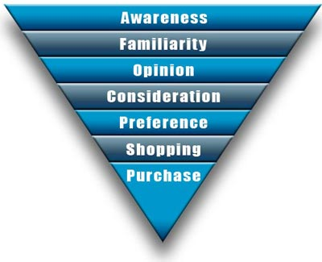 Additionally, a benefit that is often undervalued but shouldn’t be is the consistency in response to customers. Just like branding let’s your customers know who you are at a glance, consistent online response practices allow your customers to know what to expect. Familiarity doesn’t in this case breed contempt, it breeds confidence. And if a customer is on your website, using your contact form and they have enough confidence in you that they are in the shopping phase of the purchase funnel, then you are in the last stages before winning their business. In that case, the contact form is the home stretch but still needs to be handled with professionalism to ensure that all is smooth sailing into the purchasing phase.

Source: <http://www.kcwi23.com/newsletter.php?num=90>

Whether the purpose of integrating online contact forms is to build a database of demographics about your clientele, to minimize spam, or to ensure high quality customer service through consistency and professionalism it doesn’t matter; they are all good reasons to use contact forms. The information generated can be invaluable and should lead to future sales through engagement with both the curious and customers alike as you convert them all to consumers of your goods and services.

**Return on Investment (ROI)**

New customers notoriously require a higher investment to win their business. Consequently, you need to determine what the value of a new customer represents to you in order to evaluate what constitutes a return on your investment (ROI). Once you know how to value new clients you can measure what parameters would determine your internet advertising effectiveness. Try to answer Ian Lurie of Conversation Marketing questions to determine your online advertising effectiveness and ROI:34

1. What's the goal of your web site? Or SEO campaign?
2. What's that goal worth? What's the value each time you accomplish that goal?
3. How many times did you achieve that goal?
4. What did it cost to achieve it?

Answering these questions will start you down the right path to getting your head in the game and realizing what cost is worth the reward and effort.

**Customer Retention & Satisfaction**

A great way to stretch your advertising dollar is to satisfy and retain the customers you already have. Respectively, it takes less effort and less money to keep customers coming back again and again if only you can keep them happy. The following ten customer retention strategies integrate wonderfully with the strategies outlined in this study (e.g. online campaigns, search engine optimization for improved rankings, strong websites, the utilization of e-commerce and contact forms) and all directly contribute to increased sales.35

1. **Welcome the complaints you receive.**
2. **Instigate loyalty programs.**
3. **Send out questionnaires and surveys to existing customers.**
4. **Check for repeat** **sales** **often to instill your company’s brand.**
5. **Reactivate dormant customers.**
6. **Have you scheduled a frequent communications plan to your customer base?**
7. **Provide exceptional** **customer service.**
8. **Make a good first impression.**
9. **Make courtesy top priority with all customer-facing staff.**
10. **Do regular reviews.**

In some form or another, all ten of these strategies relate back to using several of the strategies outlined in this study—online campaigns, strong websites, and the information generated from contact forms—which further proves the point that if you want to win new customers and retain old ones in order to positively impact your bottom line, you must engage in the methods of business as it is happening today and tomorrow and not just cling to the past. Everything is moving forward, is your company coming along?

**Conclusion: What it Means to Engage in the Online Market**

The opportunity for wider exposure in the marketplace at less cost virtually demands participation in online advertising. Specifically, online campaigns, search engine optimization for improved rankings, strong websites structured to be search engine friendly, the utilization of e-commerce, and contact forms are necessities to be competitive. “It is well known that advertising increases awareness, purchase intention, and ultimately sales.”32 These among other tactics are vital for embracing an online advertising strategy.

Often business owners who are new to the process of advertising online will think about their new SEO campaign or new website like they do the printed catalogue that they’ve published for years. They think “Wow, I’ve got that off my back for a whole year.” The misperception is that the site or the campaign is something they launch and leave alone and the money should just come in, but that isn’t how online advertising works and *that* is the good news. A massive virtue of online advertising is how quickly you can change it, alter it, adapt it to the market and market needs. When the economy hits a down turn different words are on the minds and hearts of the populace and that comes out in what they search for online. For example, if you are in a real time bidding war for pay per click search terms and you can’t afford top placement but want a term that will still be successful, you might want to go with *cheap* versus *sale or free* as a qualifier to your product. The word cheap is the 3rd most often searched term out of the terms *free, sale, discount, value, and cheap*.33

Waiting a year to change anything in this quick paced global market is not a good idea. Online advertising is highly responsive and because of the ever changing criteria of search engines, SEO campaigns require constant tinkering with and adjustment to stimulate or maintain consistently high exposure in the organic (and paid listings) across search engines. You want that flexibility because it means that you don’t waste a year and countless dollars on avenues that aren’t producing revenue.

The management of what seems like a very complicated system of variables is what SEO management companies do and [MasterSEM](http://www.mastersem.com/) will help you shape the future of your company with confidence. Don’t delay any further and be behind the curve of your competitors because the pie will only slice up so many ways and you need to make an effort for as big a slice as you can get, but you need the right tools and the right company—[MasterSEM](http://www.mastersem.com/)—to help you make it happen!

**References**

1. Jelveh, Zubin. (2010, Jan 12). *Does Online Advertising Really Work?* Retrieved on January 3, 2012 from *AOLnews.com:* <http://www.aolnews.com/2010/01/12/does-online-advertising-really-work/>

2. Bilton, Nick. (2009, Dec 9). *Part of the Daily American Diet, 34 Gigabytes of Data.* Retrieved on January 5, 2012 from *NYTimes.com*: <http://www.nytimes.com/2009/12/10/technology/10data.html?src=twt&twt=nytimestech>

3. *Online advertising*. (2012, Jan 5). Types. Retrieved on January 5, 2012 from <http://en.wikipedia.org/wiki/Online_advertising#cite_note-8>

4. *Interactive media*. (2012, Jan 2). Retrieved on January 6, 2012 from <http://en.wikipedia.org/wiki/Interactive_media#cite_ref-Dix_0-0>

5. FCC. (n.d.). *Spam: Unwanted Text Messages and Email.* Retrieved on January 5, 2012 from the Federal Communications Commission, *FCC.com*: <http://www.fcc.gov/guides/spam-unwanted-text-messages-and-email>

6. *Online advertising*. (2012, Jan 5). Display advertising. Retrieved on January 5, 2012 from <http://en.wikipedia.org/wiki/Online_advertising#cite_note-8>

7. Huff, Richard. (2009). *The Planner’s Digital Dilemma: Traditional Brand Metrics for Digital Media.* Redmond, VA: Microsoft’s Atlas Institute a division of Microsoft Corporation. Retrieved on January 6, 2012 from <http://www.atlassolutions.com/uploadedFiles/Atlas/Atlas_Institute/Digital_Marketing_Insights/Published_Assets/ThePlannersDigitalDilemmaDMI.PDF>

8. Morgan, Dave. (2011, Sept 7). *What is the Future for Display Advertising?* Retrieved on January 6, 2012 from AdExchanger.com: <http://www.adexchanger.com/one-question/what-is-the-future-for-display-advertising/>

9. *Whither the Click? comScore Brand Metrix Norms Prove “View-Thru” Value of Online Advertising.* (2008). Retrieved on January 10, 2012 from ComScore.com:

<http://www.comscore.com/Press_Events/Press_Releases/2008/11/Value_of_Online_Advertising>

10. *Online advertising*. (2012, Jan 7). Affiliate Marketing. Retrieved on January 10, 2012 from <http://en.wikipedia.org/wiki/Online_advertising#Affiliate_marketing>

11. *Online advertising*. (2012, Jan 7). Behavioral Targeting. Retrieved on January 10, 2012 from <http://en.wikipedia.org/wiki/Online_advertising>

12. *Behavioral Targeting*. (2011, Dec 27). Retrieved on January 10, 2012 from <http://en.wikipedia.org/wiki/Behavioral_targeting>

13. *Semantic Advertising.* (2011, Nov 28). Retrieved on January 10, 2012 from <http://en.wikipedia.org/wiki/Semantic_advertising>

14. *Semantic Advertising.* (2011, Nov 28). The Evolution of Online Advertising. Retrieved on January 10, 2012 from <http://en.wikipedia.org/wiki/Semantic_advertising>

15. *Search Advertising that Speaks to People.* (2012). Retrieved on January 12, 2012 from Yahoo! Advertising Solutions: <http://advertising.yahoo.com/article/search-advertising-that-speaks-to-people.html>

16. ibid.

17. ibid.

18. ibid.

19. Resnik, Rosalind. (2009). Which Ad Strategy Works for You? Rev up your ROI by choosing the best medium for your message. *Entrepreneur.com.* Retrieved on January 2, 2012 from <http://www.entrepreneur.com/article/203050>

20. Choosing Effective Rich Media Ads (By Click through Rate). (2011, August 20). Retrieved on January 13, 2012 from Workinghomeguide.com: <http://www.workinghomeguide.com/index.php/7069/choosing-effective-rich-media-ads-by-clickthrough-rate>

21. Carter, Brian. (2012). *5 Proven Ways to Generate Revenue From Facebook.* Retrieved on January 13, 2012 from Mashable.com: <http://mashable.com/2012/01/12/facebook-make-money/?WT.mc_id=obinsite>

22. How Search Engines Rank Webpages. (2007). Retrieved on January 13, 2012 from <http://searchenginewatch.com/article/2064539/How-Search-Engines-Rank-Web-Pages>

23. McGee, Matt. (2011, Sept 21). *13,000 Precision Evaluations: Schmidt’s Testimony Reveals How Google Test Algorithm Changes.* Retrieved on January 13, 2012 from Searchengineland.com: <http://searchengineland.com/13000-precision-evaluations-schmidts-testimony-reveals-how-google-tests-algorithm-changes-93740>

24. SEO—Frequently Asked Questions. (n.d.). *Why is my Site Not Showing up in Search Engines?* Retrieved on January 15, 2012 from <http://www.seoservicescanada.ca/seo-faqs/>

25. Aakansha. (2011, Sept 11). *Importance of Keywords in Search Engine Rankings.* Retrieved on January 17, 2012 from <http://www.kpmrs.com/blog/2011/09/seo-tools/search-engine-ranking-seo-tools/importance-of-keywords-in-search-engine-ranking/>

26. Online Research Drives Offline Sales. (2008). *eMarketer.com*. Retrieved on January 19, 2012 from <http://www.emarketer.com/Article.aspx?id=1005971&R=1005971>

27. *Whither the Click? comScore Brand Metrix Norms Prove “View-Thru” Value of Online Advertising.* (2008). Retrieved on January 10, 2012 from ComScore.com: <http://www.comscore.com/Press_Events/Press_Releases/2008/11/Value_of_Online_Advertising>

28. ibid.

29. ibid.

30. Brogran, Chris. (2011). Human Business Works at Milken Institute Global Conference [Speech]. As cited in Building a Web Site Will Enhance Your Bottomline. (2011). *Comcast-Business Class: Productivity@work series.* Retrieved on January 19, 2012 from <http://business.comcast.com/Libraries/SMB_PDFs/Comcast-Whitepaper-Building-A-Website-Will-Enhance-Your-Bottom-Line.sflb.ashx>

31. Markle, Brad. (2011). *The Benefits of Using a Contact Form.* Retrieved on January 19, 2012 from Webhostinghub.com: <http://www.webhostinghub.com/support/edu/website-design/202-contact-form/-the-benefits-of-using-a-contact-form->

32. Kim, Ho & Hanssens, Dominique M. (2011). *Pre-Launch Advertising, Online Buzz and New-Product Sales.* Los Angeles: Anderson School of Management: UCLA. Retrieved on January 3, 2012 from <http://www.anderson.ucla.edu/faculty/dominique.hanssens/content/Prelaunch%20Ad_Working%20Paper_09222011.pdf>

33. Web Search Interest: Free, Sale, Discount, Value, Cheap. (2012). *Google – Insights for Search, beta.* Retrieved on January 20, 2012 from <http://www.google.com/insights/search/#q=free%2Csale%2Cdiscount%2Cvalue%2Ccheap&cmpt=q>

34. Lurie, Ian. (n.d.). *Measuring Internet Marketing—Measuring ROI: The Four Questions.* Retrieved on January 19, 2012 from <http://www.conversationmarketing.com/roi/roi_1.htm>

35. *10 Best Customer Retention Strategies Proven to Increase Sales*. (2010). Retrieved on January 19, 2012 from Product-ivity.com: <http://product-ivity.com/customer-retention-strategies/>