**Report on Methodological Approaches of Multisensory Integration**

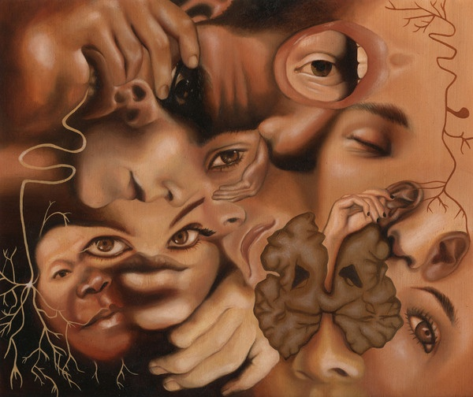

|  |  |  |
| --- | --- | --- |
| **Table of Contents** | | |
| **Sr.#** | **Headings** | **Page#** |
| **1** | Introduction | **3** |
| **2** | Multisensory Integration | **4** |
| **3** | Neuroimaging Techniques | **10** |
| **4** | Paradigms and Analytic Strategies of Neuroimaging | **13** |
| **5** | Crossmodal Brain Areas Implicated To Date | **18** |
| **6** | Crossmodal Attention and Sensory Integration | **19** |
| **7** | Specialty of Crossmodal Processing | **20** |
| **8** | Future Directions | **20** |
| **9** | Conclusions | **21** |
| **-** | References | **23** |

**Report on Multisensory Integration**

The aim of the present paper is to investigate the opportunities of using modern techniques of imaging in detecting multisensory processes. The trend of studying the sensory impression in isolation has long been taken place by the unique coordination of multiple neurons on human sensory perception. This change in study of senses evolved as a result of enormous technological and sensory neurophysiologic developments. This paper would discuss the presently recognized multisensory integration based on behavioral, neuroanatomical and electrophysiological studies. The main focus of paper would be on the neuroimaging techniques as well as paradigms of different imaging and analytical strategies used for the investigation multisensory phenomenon. So, the present research paper is exploring the multisensory integration in reference to its methodological approaches and various principles emerging in the study of human brain.

**1.0 Introduction** Brain combines information of different sensory systems in the formation of rational percept and successful contacts with the surroundings as most of the objects and events are believed to be detected through multisensory integration. The sensory systems have certain basic components namely sensory receptors, sensory afferent neurons and mounting passageways, and sensory centers of central nervous system (including thalamus and sensory regions of cerebral cortex). These sensory systems perform certain basic functions which consist of stimulus detection, transmission of information to central nervous system and further conveyed to the brain, and then the processing and analysis of information. When these functions of the sensory system are performed in combination, the responses of stimuli are quite different and this blend of sensory systems is known as ‘*Multisensory Integration’*.

The multisensory integration evolved as a result of developments in technology as well as sensory neurophysiology. During the end of 1980s and 1990s, the brain imaging techniques were introduced like positron emission tomography (PET), magnetoencephalography (MEG), functional magnetic resonance imaging (FMRI) and others, which started a trend to study human brain. This development opened new horizons to study how nervous system interacts rather than how it behaves in seclusion. These technological advancements have increased knowledge about the brain functioning as well as the mechanism of primary sensory systems. With a passage of time, engineers and researchers of different fields are showing their interests in understanding the perceptual systems to fullest as it would give an understanding how senses integrate or adapt inputs coming from various sensory systems.

Now, the evolutionary basis of multisensory capabilities is quite clear and integration of inputs from two or more sensory sources undoubted the bias of external stimuli which can speed up responsiveness. Multisensory integration is now an emerging area of research and it has been explored extensively and is still under research by using different imaging techniques to see how nervous system works. Present paper is also an in-depth study on multisensory integration which would clear many ambiguities through research support and would extensively talk about the neuroimaging techniques and the analytical strategies as well. The later section of the paper would discuss the key parts of paper dealing with different issues of multisensory integration in broader way.

**2.0 Multisensory Integration**

Lewkowicz and Ghazanfar (2009) referred multisensory integration as a rational demonstration of objects because it is essential to adaptive behavior which allows us to see a world of coherent perceptual things/beings. According to Calvert, Spence, and Stein (2004), the combination of multiple sensory modalities information provides everlasting behavioral advantage over unisensory states as it allows perceptually accurate judgments as well as quick responses for stimuli detection, discrimination or grouping. This combination of sensory systems also deals with interaction between different modalities as well as their role in alteration of each other’s actions. Multisensory integration occurs when the reaction of combination of two different modalities, in reference to their neural, perceptual or behavioral reaction, significantly differ in their responses when presented independently.

Multisensory integration is one of the main interests from engineering like video games, sensory synthesis in robots. In MI the information is considered to move from different sensory neurons to and individual neuron. One of the important examples of multisensory system is the integration between vision and auditory sensory systems which is ‘bimodal’ in nature. This audio-visual perception is also presented as a McGurk and MacDonald effect which is really famous as well as one of the striking effects of multisensory stimulus on perception. This effect demonstrates the interaction among hearing and vision in the perception of speech as the visual information changes the way of hearing sound (Calvert, Spence, & Stein, 2004) as shown in figure.

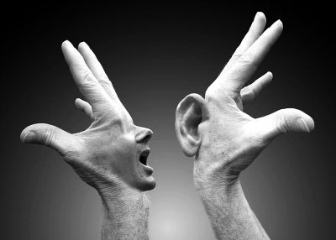

The ***behavioral studies*** of multisensory integration study the reaction of sensory systems in collaboration as well as solitary to carry out the efficiency of multisensory integration. Redundant-target effect (RTE) was measured in the studies of multisensory integration as it has been observed that reaction times to the arrival of one stimulus is slower than that of multiple targets, where reduction in reaction times is called redundancy gain. RTE is comprised of swift bottom-press reaction in a bimodal target (audio-visual) case when compared to responses of unimodal targets (audio or visual). Furthermore, the early studies of cross modal phenomenon displayed that reaction time in a task of target detection can be speed up through nonspecific accessory stimulus presence in other modality (Todd, 1912). This shows that the increase in contrasting stimulus decreases reaction time. Time and space are two sensory binding as when two or more stimuli arise at the same time and place, they work together faster than when alone but gap time among two sensory systems was measured more than 500ms.

Between 1960-1970, the hierarchical fashion of cortical sensory processing was developed through ***neuroanatomical findings*** and widely accepted, ranging from primary to secondary, sensory-specific cortices to the sections of ‘associations’ or ‘heteromodal’ zone. Many studies were conducted during that period of time, which identified many areas like superior temporal sulcus (STS), temporo-parietal association cortex, parietal cortex, as well as premotor and prefrontal cortex. Furthermore, the multisensory zones of convergence are also identified like superior colliculus, claustrum, suprageniculate, medial pulvinar nuclei of thamaus and even in amygdaloid complex. The cerebral cortex has been marked as a neural base of multisensory integration because various parts of cortex respond to stimuli from diverse senses by receiving visual, auditory, touch and other information. These areas seem to be responsible for our perception of world through multisensory integration as this sensory information at first process in principally sensory-specific cortices. The multisensory area for visual-somatic sensory is parietal lobe, auditory-visual sensory is temporal lobe and auditory-somatic as well as visual-motor sensory s frontal lobe. The insular cortex is a partition of cerebral cortex which is folded deep inside the lateral sulcus among temporal and frontal lobe and plays important functions of perception, self-awareness, motor control, cognitive functioning as well as interpersonal experience. The recent studies of neuroanatomyon monkey showed that multisensory integration can be achieved at early and late stages of cortical processing. 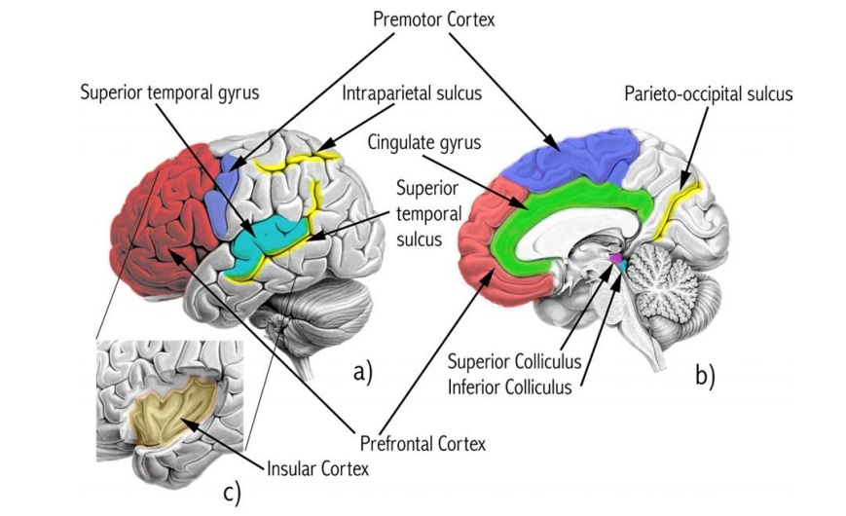

Figure. Human brain view showing heteromodal brain areas including Lateral view (a), mid-sagittal view (b) and view of insular cortex after temporal lobe dissection (Calvert & Thesen, 2004).

There is an extensive debate on the late and early occurrence of multisensory integration which has become significant and most of the neuroanatomical studies on monkey showed that multisensory integration can be achieved at different levels of hierarchy of cortex. At first it was believed that the multisensory integration occurs at late stage of processing but the many studies showed the early onset of integration in the sensory processes. One of the study revealed that interaction effects as soon as 40ms before the onset of stimulus which is consistent with the early interaction of two sensory modalities while processing (Giard & Peronnet, 1999). So, it has been seen that integration of sensory processes can occur at both early and late stages intervened by a parallel network of connections, feedback and feedforward.

The ***multisensory integration at cellular level*** showed that superior colliculus (SC) neurons acquire converging participation from diverse sensory sub-regions of associated cortex. The initial advances in understanding the phenomenon of multisensory integration occurred from the recordings of cellular in superior colliculus (SC) containing neurons responsive to tactile, optical and acoustic inputs (Meredith & Stein, 1983). Superior colliculus is detectable near the center of optic nerves and is a structure with a number of layers that vary in kinds. Superficial layers which are sensory-related and obtain inputs from different sensory systems. Deep layers are motor related which are capable of activating different responses. Intermediate layers are related to multisensory cells as well as motor properties.

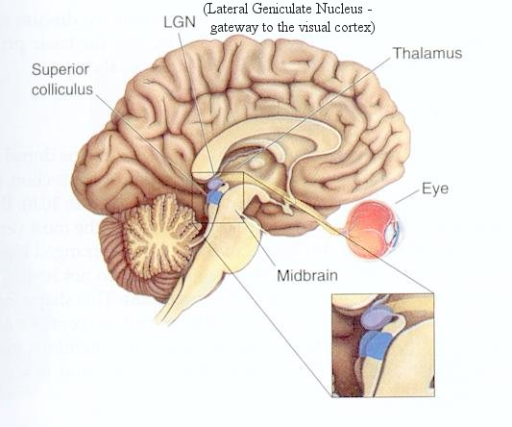

The early electrophysiological findings showed that multisensory interactions in SC are managed by unyielding principles of spatial and temporal lobes having non-linear response augmentation that signals co-localization and co-incidences of multisensory stimulus. These results verified the instinctive belief that the brain should only assimilate inputs originated from the similar stimuli when independent sensory resources are represented individually (Stein & Stanford, 2008). The other significant principle of integration demonstrated efficiency of sensory inputs in contrary as it was supported by the observation that non-linear enhancements of multisensory are at peak during the weakness of individual sensory cues. Spontaneity of this principle is prominent as this combination should be valuable while there is no ambiguity of sensory cues by a sense but by a sensory combination (Stanford & Stein, 2007). These principles guided researches for almost two decades in characterizing multisensory neurons in SC as well as cerebral cortex.

In the field of neuroscience, understanding the conditions of brain integration through different streams of sensory system as well as mechanism supporting it is one of the most fundamental question now a days. The emergence of multisensory integration as well as its importance has been mentioned in the present section along with behavioral and neuroanatomical studies and the multisensory integration at cellular level has also been taken into consideration. The modern techniques used in the investigation of multisensory processes would be discussed in the subsequent section.

**3.0 Neuroimaging Techniques**

The techniques of human neuroimaging offer the exploration of paths and systems of multisensory integration and also investigate the cross-modal phenomena. The neuroimaging techniques to explore multisensory areas of human brain have two main categories: Haemodynamic/metabolic and Electrical/magnetic, both techniques differ n their temporal and spatial resolution as well as their signals detection.

**3.1 Haemodynamic/Metabolic Methods:** These methods rely on supposition that task related neuronal activity is connected to changes in cerebral blood flow and metabolism of oxygen. So, the changes occurring in the circulatory system of neurons in activated region are used to make inferences about the activity of neurons and are indirect processes of the activity. PET and BOLD fMRI are commonly used methods in imaging the multisensory processes in the person brain.

1. ***Positron Emission Tomography (PET) Scan*** measures the changes in neural activity by screening the changes in regional cerebral blood flow (RCBF) or regional cerebral blood volume (RCBV) related to the task. It utilizes short lived substances of radioactive which produces colored images of three dimensions functioning at the moment.

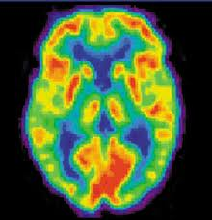

1. ***Functional Magnetic Resonance Imaging*** has go beyond the PET scan in last two decades as it does not inject any radioactive substance but rely on natural contrast agent namely blood oxygen dependent level (BOLD) effect. It uses the magnetic properties of oxygenated and deoxygenated blood when a person is placed in MR scanner then task stimulating changes in brain functioning changes the oxy and deoxy-hemoglobin and it results in changes in signal intensity. FMRI detects brain areas that process the information aroused from stimulus but not neurons.

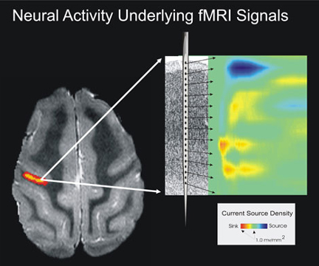

Arrival of functional magnetic resonance imaging (fMRI) showed that the processes of multisensory integration were not restricted to structures of sub-cortical structures and prefrontal areas but it can also be found in visual sensory cortices (Calvert, Bullmore, Brammer, Campbell, Williams, McGuire, Woodruff, Iversen, & David, 1997; Driver & Noesselt, 2008).

**3.2 Electrical Recording Methods:** The methods of electrical recordings give direct process of electromagnetic fields created by activity of neurons. The neuronal signals are recorded from the surface of skull by placing electrodes. The electrical recording methods are superior to haemodynamic techniques in temporal resolution detection, whereas it has limitation in detection of spatial resolution. The method of electroencephalography (EEG) and magnetoencephalography (MEG) are widely used imaging techniques through electrical recordings. EEG and MEG provide the temporal resolution on a timescale of milliseconds.

1. ***Electroencephalography (EEG)*** is a measurement of constant patterns of brain-wave, recorded by placing electrodes in the standardized way on the scalp. The tracing as a result shows the total activity of millions of neurons of an individual as it interprets voltage and frequency.

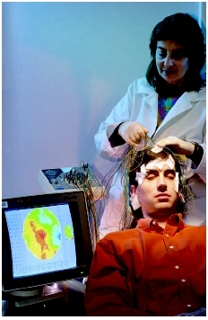

1. ***Magnetoencephalography (MEG)*** figure out the brain activity through magnetic fields recording which is produced by electrical currents that occurs naturally in the brain by using superconducting quantum interference devices (SQUIDS). It basically measure the perceptual and cognitive brain processes as well as determine the functions of different parts of brain.

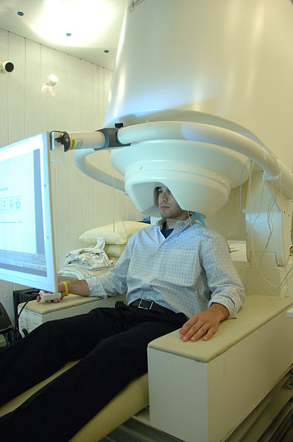

The human electroencephalography (EEG) studies showed the early interactions of audiovisual cortex as compared to visual cortex (Giard & Peronnet, 1999). Similarly, EEG of monkeys by Schroeder and Foxe (2005) displayed that thalamocortical establishment report shows multisensory integration in the auditory cortex. This revolutionary discovery of feedforward multisensory communications in auditory cortex started a new horizon in science of multisensory (Foxe, 2008), although it also inquired the specificity of functions of early regions of senses that leads to the challenging affirmation of entire neocortex as ‘multisensory’ (Ghazanfar & Schroeder, 2006).

**4.0 Paradigms and Analytic Strategies of Neuroimaging**

Areas of brain involved in crossmodal interactions in human are identified through different strategies. In present scenario it is believed that such tasks can be usefully divided by their patterns and approaches of analysis. Three strategic approaches of neuroimaging are:

* An approach in which subject is asked to make physical adjustments of one stimulus to match the intensity of another such tasks are know as ‘*crossmodal matching’.* A study used functional MRI to tested human anterior intraparietal cortex on sample matching task and the results revealed that though it is tactile or visual object anterior intraparietal cortex is activated. Study also showed that neural activity improved when the information of objects are transferred between modalities (Grefkes, Weiss, Zilles, & Fink, 2002).
* An approach where ‘*superimposition’* of two records exposes areas of common activations, it compares brain activity that has been evoked during the appearance of information in single modality (e.g. auditory) toward that was evoked by the similar or related task done in another modality (e.g. visual). The study by Bushara, Weeks, Ishii, Catalan, Tian, Rauschecker and Hallett (1999) showed that like visual system, the auditory system’s hierarchical organization expands beyond the temporal lobe for including areas in lateral parietal and prefrontal region that specialized in the processing of auditory-spatial.
* Another approach of researchers uses models that were clearly generated to tap the ‘*crossmodal integration*’ as information from two different modalities was identified as radiating from a common event, which is combined in an incorporated percept. A research conducted by Calvert, Campbell and Brammer (2000) used fMRI to investigate crossmodal integration detection in cerebral cortex of human as well as stimulus identification an concluded the crossmodal binding junction in heteromodal cortex of human.

These finding of studies have challenged the point of view of Ettlinger (1990) which showed that every crossmodal phenomenon requires just one basic process. Although many recent studies showed that various networks of brain spots performs different crossmodal tasks and they can be then distinguished on the basis of variables under manipulation like spatial, featural or temporal connection and the combination of particular senses as well. There are many advantages and disadvantages of the techniques used for identification of multisensory convergence of sites. So the next section of the report would highlight the assumptions and warnings related to each approach as well as the questions of multisensory processing would also get answers in the later section.

* 1. **Haemodynamic Studies (PET/fMRI)**

The advanced temporal resolution of PET and fMRI are tied with their poor timing information that makes these techniques to more suitably focus on acknowledgement of such multisensory convergence sites. Both methods provide a great deal of information concerning course of time and a direction of multisensory communications. For the localization of integrating sites, several strategies have been adopted some of them are as follows:

**4.1.1** ***Superimposition of Two Unimodal Tasks***

One of the strategies in identification of multisensory brain areas is the exposure of subjects to stimuli in one or more modalities and then identifies the areas of brain responsive to both of them. In fMRI and PET experiments, this superimposition of two singular sensory activation plots in average stereotactic space which subsequently determine the overlapping area.

This approach has certain advantages: firstly such experiments are straight forward to design as long as the relevance of task in two different domains is equal. Secondly, such experiments have face validityand in several studies of human imaging**,** sites of multisensory co-responsiveness have been identified. These areas are believed to be homologous to those sites previously identified as bimodal (by using electrophysiological techniques in non-humans).

Some of the disadvantages of the superimposition are also detected like it can not draw conclusions in the presence of bimodal cells located in co-activated areas. Even it does not demonstrate the assurance that these areas play a part in integration of multisensory cues. The studies of electrophysiology in the superior colliculus found that many neurons are co-responsive to many modalities in this structure, but not necessarily all of them integrate this information.

**4.1.2 Bimodal versus unimodal contrast**

The most possible improved method on superimposition is to make comparison on the activation obtained during the unimodal task and response of the concrete bimodal stimulus as well as try to discover areas where bimodal stimulation displays a greater response that these modalities in isolation. The main idea of this approach is to expose individual to bimodal stimulus and then compute the combination by but this approach can not afford any actual improvement over computation of simple intersection 

A more vigorous methodology for the identification of integration responses includes the addition of a reference condition in 2x2 design, which consists of A, V and AV situations are at hand and allow the calculation of interaction effects [{AV-rest} - {(A-rest) + (V-rest)}]. Such interaction effect is commonly used in statistical analysis for the identification of changes, which occurs by altering two factors altogether and this interaction can not be carried out by altering factors in isolation. In multisensory integration process, use of interaction effects gives clear expression that these effects can not be gained by the sum of unimodal responses.

This strategy enjoys certain advantages over the analytical techniques. Firstly, strategy is based on electrophysiological behavior of cells that carry out signal integration. Secondly, it allows the detection of integrative behavior when the responses of unimodal are weak. Finally, as the calculation of interaction effects needs to include both unisensory, multisensory and rest conditions, and it is also possible to compute superimpositions and combination for comparison. Although, it is believed that communication effects presently allow the strongest results which are concerned with multisensory convergence as they are also affected by the issues of interpretation. As the research of Laurienti, Burdette, Wallace, Yen, and Field (2002) demonstrated that recognized multisensory assimilation responses (AV >A+V) can arise as a result of summation of positive and negative BOLD reactions to a stimuli in single modality. Such methods of responding to such substitute analysis have paid attention on the manipulation of the tentative plan, but not merely analytic approach.

**4.1.3 Manipulation of crossmodal congruence**

There are two different approaches used in the identification of multisensory meeting zones including one or more parameter’s systematic manipulation on which the interaction of two modality-specific stimuli are combined as well as precise modeling of the aspects of multisensory integration are observed at the level of neurons. The advantage of this method lays in its interpretation of crossmodal interaction effects as the attention is properly distributed across the conditions of different senses. Another advantage of crossmodal consistency manipulation and modeling the already recognized reactions of multisensory assimilation at a cellular level depicts that the detection of opposing effects in spite of the equal intensity of informational channels of audition and vision are less vulnerable to the question of interpretation in regards to the information level differences in attention within different situations.

The other method of segregating multisensory interactions is to change the perceptibility of the channels of audition and vision and then show opposite effectiveness. The present principal though observed at behavioral or electrophysiological levels, displays that utmost crossmodal facilitation responses should be taken into consideration when two separate stimuli are minimal at being effective. Callan, Callan, Kroos, and Bateson (2001) in their study adopted almost similar approach while looking for sites of integration for the auditory ad visual speech. So the responses of multisensory integration under such conditions are not much likely to show differences in the comprehension of speech as both ways are available as the direction of profit is orthogonal to the perception level. **4.2 Electromagnetic Techniques (EEG/MEG)**

The electromagnetic techniques locate high temporal resolution which makes it ideal for its time detection and also answers the question of multisensory integration occurrence, it also discloses that whether convergence arouse through the connections of feedforward or feedback. Recently various laboratories found the proof of early interaction effects i.e. 40-46ms and the later occurrence of interactions i.e. 120-130, as well as post-stimulus epochs i.e. 280 ms. These differences in time course of neuroimaging shows that stimuli and requirements of task have noteworthy effects on detection of integrative activity.

The detection of bimodally induced responses exceeds the sum of algebra by using fMRI and PET, as two different contributing components are also used in the context of averaged Event-Related Potential (ERP) studies. ERP is known as any measured brain response which is a direct result of thought or perception. The Event-Related Potential is accurately measured through EEG and Event-Related Field (ERF) is measured with MEG. The amplitude values of components of ERP are measured in respect to the both modalities stimulation separately and also bimodal stimulation concurrently.

**5. Crossmodal Brain Areas Implicated To Date**

Although there is a wide difference in the designs and analytical strategies of imaging techniques, several areas of brain are consistently associated with the multisensory synthesis of different factors like time, space and content. This sensitivity to temporal onset across diverse sensory cues is shown in the superior colliculus and insulaclaustrum. It has been proved through the detections over time that different inferior and superior parietal lobe regions especially intraparietal sulcus appears to detect and integrate multisensory signals based on their spatial location. In the end, the superior temporal sulcus’s fundus has been increasingly connected in the interaction of audio-visual speech based on shared phonetic features detection. Certain recent studies in the putative sensory-specific cortex shows that multisensory integration also takes place in early stages. Similarly, Macaluso, Frith, and Driver in 2000 showed that unexpected contact on one hand can improve visualization near that hand, which reveals crossmodal links in attention of space. The effect of concurrent visuo-tactile stimulus on the action of the human visual cortex was measured and showed that tactile stimulation improved activity in the visual cortex, but only with presence at the same side of visual target. Overall analysis of brain areas connectivity suggests that touch manipulates unimodal visual cortex by back-projections from the areas of multimodal parietal.

**6. Crossmodal Attention and Multisensory Integration**

In recent times the connection between multisensory integration and attention has been given immense importance. This query has been further divided in the questions concerning exogenous (involuntary and stimulus-driven) as well as endogenous (top-down or voluntary). The debate on exogenous shifts in spatial attention or multisensory integration argued that the distinction among crossmodal endogenous attention and the integration of multisensory processes might be a similar terminology. The alternative explanation can be the involuntary shifts of attention of space can arise as a result of multisensory integration. Many researches give evidences and suggest that multisensory integration in humans is sensitive in voluntarily directed attention as well as the crossmodal cues are incorporated on the basis of most persuasive point of association between them.

**7. Specialty of Crossmodal Processing**

The neurophysiology and behavioral studies have a mount of evidence through researches showing that a different sensory system affects the performance in interactive manner. As behavioral studies have displayed the RTE can also be observed in unimodal studies. As the study by Miniussi, Girelli, and Marzi (1998) showed that two visual stimuli concurrently presented and even in isolation. The similar effect has been seen to be applicable to crossmodal effects that are intervened by multisensory neurons within superior colliculus (Stein & Meredith, 1993).One of the distinguishing differences among unisensory and multisensory interaction at physiological and behavioral levels is the time window used for integration. As the integration of different visual dimensions like color and form are supposed to measure in 40ms. Whereas, the effect of McGurk effect continues in spite of the onset asynchronies of about 180 ms. Recently, a study by Naturwissenschaften and Werner (2010) explored the similarities, differences and limitations of the functions directing the integration of information concerning the audition and vision in cerebral cortex’s different regions by using fMRI and psychophysical methods. This study separated the contributions of sensory-specific, higher alliance as well as prefrontal areas to audiovisual assimilation in the brain of human which one of the new area of attention as well.

**8. Future Directions**

After reviewing the paper and recent researches the future directions are as follows:

* While using the neuroimaging techniques, their benefits and hazards should be taken into consideration to avoid the inconvenience.
* In order, to better understand the brain processes and the integration of different senses, high-resolution as well as spatio-temporal imaging of the brain is required.
* To understand the neuroimaging techniques better, the integration of multiple imaging modalities and using the techniques in interrelation is important for future in the guidance of analysis.
* Many basic questions related to relationship among BOLD signals as well as activity of neurons and even relationships between BOLD and electromagnetic signals are remained unanswered and need answer.
* Highlighting the neuronal activity along with haemodynamic and the networks of large-scale responses make the relationship possibly related to spatially sensitive fMRI signals that are temporally sensitive to the EEG and MEG signals.

**9. Conclusions**

The present report was the in-depth and deep investigation of certain core concepts along with the research base to make the work more authentic and empirically valid. The paper basically talked about the sensory processes in collaboration as well as isolation. The rise in the investigation of multisensory integration has been seen as there are bulks of researches on the neural processes by using the neuroimaging techniques. This advancement in the exploration of sensory processes and their actions in collaboration are due to the growth of technology. This growth has made us question about things in different manner as our questions have changed from how the person behaves in isolation and it has reached the place of question that why and what makes an individual do as he do. The multisensory integration has been investigated different phenomenon from basic to deep. The evaluation of sensory stimuli started from behavioural studies, neuroanatomy and then the multisensory process at cellular level. In the late period of 1980 to 1990s the neuroimaging was introduced and to neuroimaging techniques. Now by the use of such techniques in the present paper, following points of conclusion have been carried out:

* The researches have supported the view that multisensory integration occurs best when the stimuli arises from the same place & occur at the same time.
* The multisensory integration has been proved to fasten the sensory of measures and time is less likely to consume. , but thus occurrence of stimulation is confused in minds,
* The superior colliculus has been found to be the best-studied model of multisensory integration.
* In primates, many areas of the cortex are multisensory; leading some to suggest that the whole brain is fundamentally multisensory.
* RTE confirm when two unimodal presented together (simultaneously), they rapidly stimuli more than the sum of the two separate unimodal.
* MI has been empirically proved to occur in “late” as well “early” stage of multisensory responses as they depends on stimulus, time and space.
* Access to MI circuits is determined by *the spatio-temporal relationships* of the stimuli.

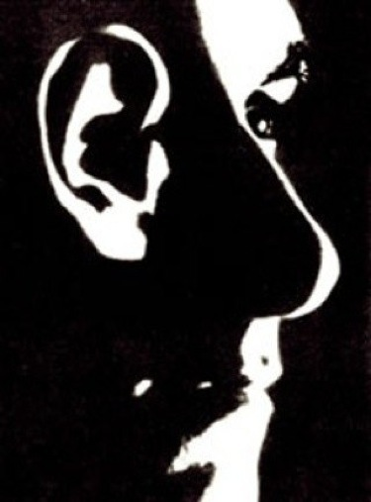

**References**

Bushara, K. O., Weeks, R. A., Ishii, K., Catalan, M. J., Tian, B., Rauschecker, J. P., & Hallett, M. (1999). Modality-specific frontal and parietal areas for auditory and visual spatial localization in humans. *Nature Neuroscience, 2,* 759–766.

Callan, D. E., Callan, A. M., Kroos, C., & Bateson, E. V. (2001). Multimodal contribution to speech perception revealed by independent component analysis: A single-sweep EEG case study. *Cognitive Brain Residual, 10,* 349–353.

Calvert, G. A., & Thesen, T. (2004). Multisensory integration: Methodological approaches and emerging principles in the human brain. *Journal of Physiology-Paris, 98,* 191-205.

Calvert, G. A., Bullmore, E.T., Brammer, M. J., Campbell, R., Williams, S. C., McGuire, P. K., Woodruff, P. W., Iversen, S. D., & David, A. S. (1997). Activation of auditory cortex during silent lipreading. *Science, 276,* 593-596.

Calvert, G. A., Campbell, R., & Brammer, M. J. (2000). Evidence from functional magnetic resonance imaging of crossmodal binding in the human heteromodal cortex. *Current Biology, 10,* 649–657.

Calvert, G. A., Spence, C., Stein, B. E. (2004). *The handbook of multisensory processes.* Cambridge, Massachusetts: MIT Press.

Driver, J., & Noesselt, T. (2008). Multisensory interplay reveals crossmodal influences on 'sensory-specific' brain regions, neural responses, and judgments. *Neuron, 57*, 11-23.

Ettlinger, G. (1990). Object vision and spatial vision: the neuropsychological evidence for the distinction. *Cortex, 26,* 319–341.

Foxe, J. J. (2008). Toward the end of a "principled" era in multisensory science. *Brain Research, 1242*, 1-3.

Ghazanfar, A. A., & Schroeder, C. E. (2006). Is neocortex essentially multisensory? *Trends in Cognitive Sciences, 10,* 278-285.

Giard, M. H., & Peronnet, F. (1999). Auditory-visual integration during multimodal object recognition in humans: A behavioral and electrophysiological study. *Journal of Cognitive Neuroscience, 11,* 473-490.

Grefkes, C., Weiss, P. H., Zilles, K., & Fink, G. R. (2002). Crossmodal processing of object features in human anterior intraparietalcortex: An fMRI study implies equivalencies between humans and monkeys. *Neuron, 35,* 173–184

Laurienti, P. J., Burdette, J. H., Wallace, M. T., Yen, Y. F., Field, A. S., & Stein, B.E. (2002). Deactivation of sensory-specific cortex by cross-modal stimuli. *Journal of Cognitive Neuroscience, 14,* 420–429.

Lewkowicz, D. J., & Ghazanfar, A. A. (2009). The emergence of multisensory systems through perceptual narrowing. *Trends in Cognitive Sciences*, *13* (11), 470-478.

Macaluso, E., Frith, C., & Driver, J. (2000). Selective spatial attention in vision and touch: unimodal and multimodal mechanisms revealed by PET. *Journal of Neurophysiology, 83,* 3062–3075.

Meredith, M. A., Stein, B. E. (1983). Interactions among converging sensory inputs in the superior colliculus. *Science, 221,* 389-391.

Miniussi, C., Girelli, M., & Marzi, C. (1998). Neural site of the redundant target effect electrophysiological evidence. *Journal of Cognitive Neuroscience, 10,* 216–230.

Naturwissenschaften, D. D., & Werner, S. (2010). The neural correlates and mechanisms mediating the integration of auditory and visual information in the human brain. *Arbeit*, 1-37.

Schroeder, C. E., & Foxe, J. (2005). Multisensory contributions to low-level, 'unisensory' processing. *Current Opinion in Neurobiology, 15,*454-458.

Stanford, T. R., Stein, B. E. (2007). Superadditivity in multisensory integration: Putting the computation in context. *Neuroreport, 18*, 787-792.

Stein, B. E., & Meredith, M. A. (1993). The merging of the senses. Cambridge, MA: MIT Press.

Stein, B. E., & Stanford, T. R. (2008). Multisensory integration: Current issues from the perspective of the single neuron. *Nature Reviews Neuroscience,* 9, 255-266.

Todd, J. W. (1912). Reaction to multiple stimuli. *Archives of Psychology, 3,* 1-65.