**Angel Food Dream Recipe**

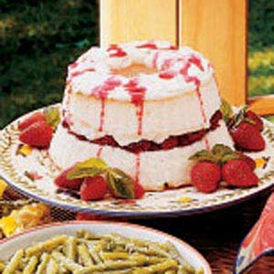

No one can resist a slice of this dreamy dessert. If you'd like a switch from the strawberry filling, try blackberries, blueberries or even peaches. And, when I serve this cake on a holiday, I've been known to put food coloring in the topping—green works well for Christmas or St. Patrick's Day.—Leah Carrell, Quitman, Texas

* Prep/Total Time: 10 min.
* Yield: 8-10 Servings

**Ingredients**

* 1 package *(16 ounces) frozen sliced strawberries in syrup*
* *1 prepared angel food cake (8 to 10 ounces)*
* *1 carton (8 ounces) frozen whipped topping, thawed, divided*
* *Fresh strawberries and mint, optional*

**Directions**

* Drain strawberries, reserving 1/3 cup of syrup. Split cake horizontally into two layers; place bottom layer on a serving plate. Spoon strawberries over bottom layer; spread with 3-1/4 cups whipped topping. Replace top layer. Drizzle with reserved syrup. Garnish with remaining whipped topping, and strawberries and mint if desired.**Yield:**8-10 servings.

# Lemonade Pie Recipe

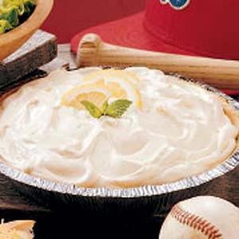

The pie recipe is a refreshing dessert perfect for a summer meal. This cool, creamy sweet/tart pie hits the spot on a hot day...and you don't have to heat the oven to make it! With its easy of preparation, this recipe is a great way to get kids helping in the kitchen.—Wilma Rusk, Bringhurst, Indiana

* Prep: 5 min. + chilling
* Yield: 6-8 Servings

5 5

## Ingredients

* 1 can *(14 ounces) sweetened condensed milk*
* 3/4 cup *partially thawed lemonade concentrate*
* 2 to 3 drops *yellow food coloring, optional*
* 1 carton *(8 ounces) frozen whipped topping, thawed*
* *1 graham cracker crust (9 inches)*
* *Lemon slices and fresh mint, optional*

## Directions

* In a large bowl, combine milk, lemonade concentrate and food coloring if desired. Fold in the whipped topping; spoon into crust. Chill until ready to serve. Garnish with lemon slices and mint if desired.**Yield:**6-8 servings.

**Quick OREO Cheesecake**

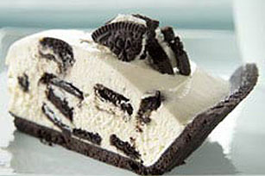

Put the coffee on, and by the time it's done dripping you've got an **Oreo** Cookie-studded, lusciously creamy cheesecake for the guests you forgot you invited.

prep:10 min total:10 min servingstotal: 8 servings, one slice each

**What You Need**

1

tub (24.2 oz.) PHILADELPHIA Ready-To-Eat Cheesecake Filling

12

 OREO Cookies, coarsely chopped, divided

1

 OREO Pie Crust (6 oz.)

**Make It**

**SPOON** cheesecake filling into large bowl. Remove 1/3 cup of the chopped cookies; set aside. Add remaining chopped cookies to filling; stir just until blended.

**SPOON** into crust. Smooth top lightly with back of spoon to form even layer. Sprinkle with the reserved chopped cookies.

**SERVE** immediately. Or cover and refrigerate until ready to serve.

**Kraft Kitchens Tips**

Size-Wise

Since this indulgent cheesecake makes 8 servings, it's a perfect dessert to serve at your next party.

Substitute

Prepare as directed, using OREO Cool Mint Creme Cookies.

# Molten Chocolate Cakes

[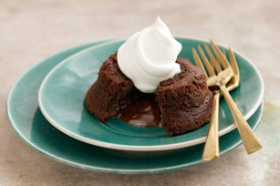](http://www.kraftrecipes.com/recipes/molten-chocolate-cakes-69182.aspx)Think digging into a rich and delicious chocolate cake is awesome? Cue the ooey-gooey center. Seriously, this thing just keeps getting better.

prep:15 min

total:30 min

servings8 servings, 1/2 cake each

## What You Need

4squares BAKER'S Semi-Sweet Chocolate

1/2cup butter

1cup powdered sugar

2whole eggs

2egg yolks

6Tbsp. flour

1/2cup  thawed COOL WHIP Whipped Topping

## Make It

**HEAT** oven to 425°F.

**BUTTER** 4 small custard cups; place on baking sheet.

**MICROWAVE** chocolate and butter in large microwaveable bowl on HIGH 1 min. or until butter is melted; whisk until chocolate is completely melted. Stir in sugar. Add whole eggs and egg yolks; mix well. Stir in flour. Spoon into prepared cups.

**BAKE** 13 to 14 min. or until sides of desserts are firm but centers are still soft. Let stand 1 min. Carefully run small spatula or knife around cakes to loosen; invert into dessert plates. Serve warm with COOL WHIP.

## Kraft Kitchens Tips

How to Bake Cakes in Muffin Cups

Prepare batter as directed; pour into 10 paper-lined muffin cups. Bake at 425ºF for 10 min. or until sides are firm but centers are still soft. Let stand 1 min. Makes 10 servings.

Make Ahead

Prepare batter as directed; pour into prepared custard cups. Refrigerate up to 24 hours. Let stand at room temperature 1 hour before baking as directed.

# Strawberry Angel Food Dessert

By: TABKAT

"Angel food pieces are topped with sweetened cream cheese, whipped topping and strawberries in glaze in this chilled, layered dessert."

**Prep Time:**15 Min

### Servings  ([Help](http://allrecipes.com/help/recipeinfo/scaling.aspx))



Original Recipe Yield 1 - 9x13 inch dish

### Ingredients

* 1 (10 inch) angel food cake
* 2 (8 ounce) packages cream cheese, softened
* 1 cup white sugar
* 1 (8 ounce) container frozen whipped topping, thawed
* 1 quart fresh strawberries, sliced
* 1 (18 ounce) jar strawberry glaze

### Directions

1. Crumble the cake into a 9x13 inch dish.
2. Beat the cream cheese and sugar in a medium bowl until light and fluffy. Fold in whipped topping. Mash the cake down with your hands and spread the cream cheese mixture over the cake.
3. In a bowl, combine strawberries and glaze until strawberries are evenly coated. Spread over cream cheese layer. Chill until serving.

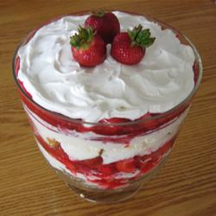

# Double-Chocolate Mousse

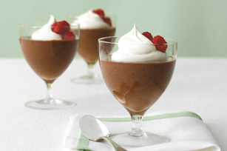

Think the foamy perfection of chocolate mousse can only be achieved at a restaurant? Think again. Top ours with Cool Whip and fresh raspberries for an elegant dessert.

prep:15 mintotal:35 minservings6 servings

**What You Need**

1-1/2cups fat-free milk, divided

2squares BAKER'S Semi-Sweet Chocolate

1pkg. (1.4 oz.) JELL-O Chocolate Fat Free Sugar Free Instant Pudding

2cups thawed COOL WHIP FREE Whipped Topping, divided

1/2cup fresh raspberries

**Make It**

**MICROWAVE** 1 cup milk and chocolate squares in large microwaveable bowl on HIGH 2 min.; whisk until chocolate is melted. Add remaining milk and dry pudding mix; beat 2 min. Refrigerate 20 min.

**WHISK** in 1-1/2 cups COOL WHIP; spoon into 6 dessert dishes.

**TOP** with remaining COOL WHIP and berries.

**Tips**

Storage Know-How

Once thawed, refrigerate COOL WHIP Whipped Topping for up to 2 weeks or re-freeze.

Quick Coconut Cream Pie

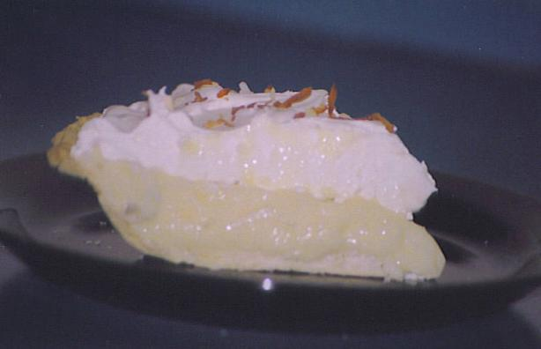

### Total Time: 15

Prep Time 5

Cook Time: 10

#### [MizzNezz](http://share.food.com/community/MizzNezz/style.esi?member_id=27643)'s Note:

Great home made flavor. Tastes like what you get in restaurants. I once had to make 10 of these for a family reunion!

Save this recipe in your online cookbook to access when you need it.

Add this recipe's ingredients to your weekly shopping list.

## Ingredients:

Serves: 8

* 2/3 cup [sugar](http://www.food.com/library/sugar-139)
* 1/3 cup [flour](http://www.food.com/library/flour-64)
* 2 cups [milk](http://www.food.com/library/milk-360)
* 2 egg yolks
* 1 cup [coconut](http://www.food.com/library/coconut-107)
* 1 teaspoon [vanilla](http://www.food.com/library/vanilla-350)
* 1 teaspoon [butter](http://www.food.com/library/butter-141)
* 1 prepared pie crust
* 1 (8 ounce) container [Cool Whip](http://www.food.com/library/cool-whip-648)

## Directions:

1. In medium saucepan mix flour,sugar,milk,and egg yolks.
2. Cook and stir until mixture comes to a boil.
3. Boil for 1 minute.
4. Remove from heat and add coconut, vanilla, and butter.
5. Pour into crust.
6. Cover with plastic wrap and refrigerate for 3 hours.
7. Top with Cool Whip and toasted coconut (if desired)

# Cheesecake-Stuffed Strawberries

Sponsored by: [http://adimages.scrippsnetworks.com/1x1.gif](http://adsremote.scrippsnetworks.com/event.ng/Type=click&FlightID=2008326&AdID=2011270&TargetID=2094963&Values=DECBHHicNZNZEsMwCEMvlA92zP0vViy57SRvSGQZA7H8XL_wL_Ur-dq-U9_op7KXyqd5r_xM88uu1fjXcT4131tA0fKZ7M8TVA-wJR_PpWoOmGHgOfrIeBw-JpZkNjgOnbfivR9p0vwybmrgFOiO_SLk8b0PbdJebPX4f_70NmTJoz1yv2jqmkyLeGScDl0JfcuF8cun2qCvEfh3c9-1g-644v0JL_K8mOc7eeQReZ5iHkvEE3Gp9_8YJPbRTYBxw19lDp6rVZJNuhiZDsZAZ1LwtWiS-dzlRR6st-dvTX870-DQd_lirnNHf9VPIA7FPC2TdNRXIwO6rT_OGQf92kE1Jfk8k3XIKZy39uBgxuPAp4r5VAXW1zjWtVDX25mlCftm6qjjso0cB8PIOtR1Kjjok-23Ap_UIQ37LFFHD4XPumJ-fcvyiO_r8upCEt9LhM-AB-eLVMzrTinyiBr0JcWRdwrrkTuYd_98fb0MEv53jEFXxqdRh2XefGoHqcGdhMvbwsvosh-BCtdW&RawValues=NGUSERISD%252Ca3d00e0-19896-1469518761-1327377300&Redirect=http%3A%2F%2F)

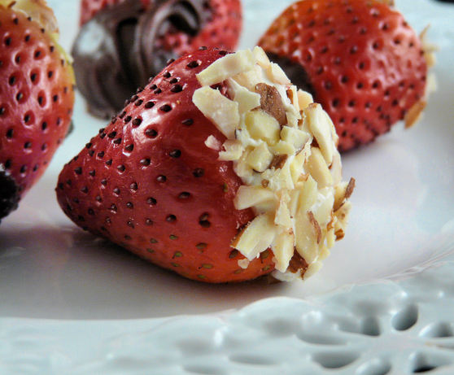

### Total Time: 30

Prep Time: 30

## Ingredients:

Servings:24

### Servings Size

* 24 large [strawberries](http://www.food.com/library/strawberry-304) , hulls removed
* 12 ounces [cream cheese](http://www.food.com/library/cream-cheese-506) , at room temperature
* 1 teaspoon [vanilla](http://www.food.com/library/vanilla-350)
* 3 tablespoons [confectioners' sugar](http://www.food.com/library/powdered-sugar-140)
* 1/2 cup almonds , chopped fine in the blender

## Directions:

1. Place cream cheese in a bowl, and microwave for 30 seconds, so that it's soft.
2. Whip together the cream cheese, vanilla, and sugar.
3. In the center of each strawberry, using a sharp knife, make a hole in each one, as deep as you can without going out the bottom.
4. Spoon or pipe the filling into each hole.
5. Dip cheesecake end of strawberry into chopped almonds, making sure you completely cover the cheesecake filling with the nuts.
6. Lay strawberries in a pretty serving dish.
7. Sprinkle with any leftover nuts around the dish.
8. Chill, and serve.

## Easy Key Lime Pie

## Nummy Easy Key Lime Pie. Photo by Pismo

## Total time: 25 min

## Prep: 5

## Cook: 20

## Ingredients:

Servings:8

### Servings Size

Update

Units: US | [Metric](http://www.food.com/recipe/nummy-easy-key-lime-pie-41575?mode=metric&scaleto=8.0&st=null)

* 1 (14 ounce) can [sweetened condensed milk](http://www.food.com/library/sweetened-condensed-milk-146)
* 4 egg yolks
* 2 teaspoons key [lime zest](http://www.food.com/library/lime-260) (optional)
* 1/2 cup [key lime juice](http://www.food.com/library/lime-260)
* 1 drops food coloring (optional)
* 1 [graham cracker crust](http://www.food.com/library/graham-cracker-376)

## Directions:

1. Beat egg yolks with food coloring.
2. Then mix in sweetened condensed milk.
3. Then mix in key lime juice and zest.
4. Pour into graham cracker crust and bake at 325 for about 20 minutes (check after about 13 minutes) or center is jiggly when shaken slightly, or when knife inserted in center leaves mark.
5. Chill in freezer for 10-15 minutes.

Fruit Frozen Yogurt

Total: 15-45 (prep 15)

By using frozen fruit you don’t have to freeze for 30 min.

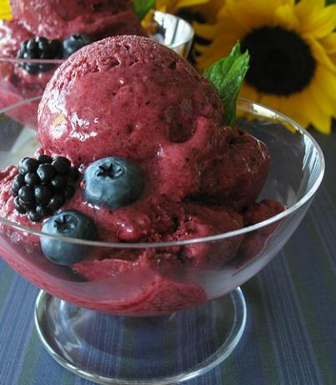

## Ingredients:

Servings:4

### Servings Size

Update

Units: US | [Metric](http://www.food.com/recipe/fruit-frozen-yogurt-35079?mode=metric&scaleto=4.0&st=null)

* 3 cups frozen mixed fruit
* 1/3 cup superfine sugar (berry)
* 1/2 cup [nonfat yogurt](http://www.food.com/library/yogurt-315)
* 1 tablespoon [fresh lemon juice](http://www.food.com/library/lemon-juice-55)

## Directions:

1. In a food processor combine the fruit and sugar.
2. Using on-off coarsely chop the fruit.
3. Stir together the yogurt and the lemon juice.
4. With the machine running slowly pour in the yogurt.
5. Process until smooth and creamy; scrape down the sides once or twice.
6. Scoop into serving dishes.
7. Cover and freeze for 30 minutes to firm up slightly.

Peanut Butter Pie

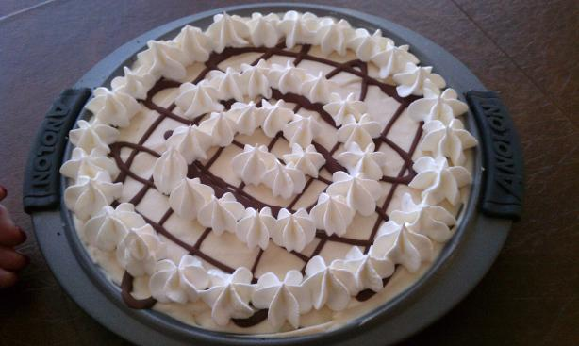

Total: 10 min

## Ingredients:

Servings:8

### Servings Size

Update

Units: US | [Metric](http://www.food.com/recipe/peanut-butter-pie-33009?mode=metric&scaleto=8.0&st=null)

* 1/2 cup [peanut butter](http://www.food.com/library/peanut-butter-460)
* 8 ounces [cream cheese](http://www.food.com/library/cream-cheese-506) , softened
* 1 cup [powdered sugar](http://www.food.com/library/powdered-sugar-140)
* 1/2 cup [milk](http://www.food.com/library/milk-360)
* 8 ounces whipped topping
* 1 [9-inch graham cracker crusts](http://www.food.com/library/graham-cracker-376) or 1 9 inch pie shell

## Directions:

1. Mix cream cheese until fluffy.
2. Blend in peanut butter and powdered sugar, mix well.
3. Slowly add milk.
4. Fold in topping.
5. Put in prepared 9 inch graham cracker crust or 9 inch pastry shell.
6. Freeze until set and serve.

White Chocolate Eggnog Fudge

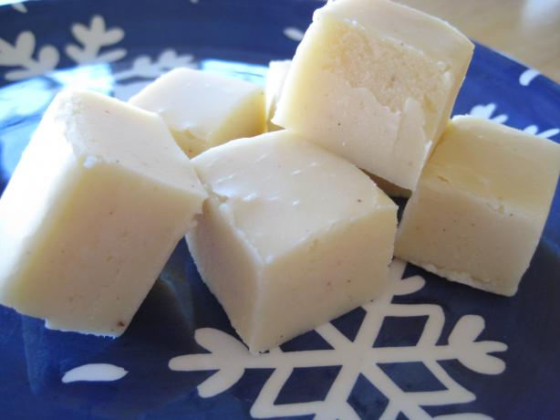

## Total: 30min

## Ingredients:

Servings:40 or 2 ½ lbs

### Servings Size

Update

* 2 cups [sugar](http://www.food.com/library/sugar-139)
* 1/2 cup [butter](http://www.food.com/library/butter-141)
* 3/4 cup dairy eggnog
* 3 (3 1/2 ounce) packages [white chocolate](http://www.food.com/library/white-chocolate-225) , confectionery bars broken into pieces or chips
* 1/2 teaspoon grated [nutmeg](http://www.food.com/library/nutmeg-333)
* 1 (7 ounce) jar [marshmallow creme](http://www.food.com/library/marshmallow-358)
* 1 cup chopped [pecans](http://www.food.com/library/pecan-276)
* 1 teaspoon rum extract OR 1 tsp Vanilla

## Directions:

1. Combine sugar, butter and eggnog in a heavy 2-1/2 to 3 quart saucepan;.
2. bring to a full boil, stirring constantly.
3. Continue boiling 8 to 10 minutes over medium heat or until a candy thermometer reaches 234 deg F, stirring constantly to prevent scorching.
4. Remove from heat;
5. stir in white chocolate pieces and nutmeg until chocolate is melted.
6. Add marshmallow creme, nuts and rum extract.
7. Beat until well blended.
8. Pour into buttered 8 or 9 inch square pan.
9. Cool at room temperature;
10. cut into squares.

* If fudge is too soft after cooling, chill.

Peanutty Apple Trifle Dessert

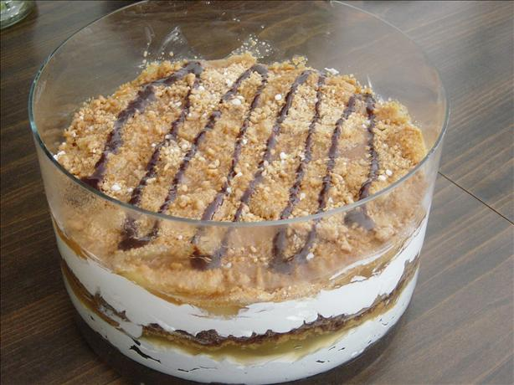

## Total: 30 min (prep)

## Ingredients:

Servings:20

### Servings Size

* 1 1/2 cups [graham cracker crumbs](http://www.food.com/library/graham-cracker-376) (about 24 squares)
* 1/2 cup packed [brown sugar](http://www.food.com/library/brown-sugar-375)
* 1/2 cup [peanut butter](http://www.food.com/library/peanut-butter-460)
* 1/3 cup [peanut butter](http://www.food.com/library/peanut-butter-460)
* 1/4 cup [butter](http://www.food.com/library/butter-141) or 1/4 cup [margarine](http://www.food.com/library/margarine-421) , melted
* 1 (8 ounce) package [cream cheese](http://www.food.com/library/cream-cheese-506) , softened
* 3/4 cup [sugar](http://www.food.com/library/sugar-139)
* 1 (16 ounce) container [Cool Whip](http://www.food.com/library/cool-whip-648) , thawed
* 2 (21 ounce) cans apple pie filling
* 3/4 cup [powdered sugar](http://www.food.com/library/powdered-sugar-140)
* 1 teaspoon [ground cinnamon](http://www.food.com/library/cinnamon-324)

## Directions:

1. In bowl, combine cracker crumbs, brown sugar, 1/2 cup peanut butter and butter and spoon 1/2 of mixture into 3 qt bowl.
2. In a mixing bowl, beat cream cheese and sugar until smoothed and fold in the whipped topping.
3. Spread 1/2 of this mixture into the trifle bowl or deep dish bowl.
4. Top w/one can apple pie filling.
5. Then combine powdered sugar, cinnamon and the remaining peanut butter until crumbly and sprinkle half over pie filling.
6. Repeat the layers and refrigerate until serving.

## Toffee Fondue

## Toffee Fondue. Photo by gailanng

## Prep: 15 min

## Ingredients:

Servings:4-8

### Servings Size

* 1/2 cup [butter](http://www.food.com/library/butter-141)
* 2 cups [dark brown sugar](http://www.food.com/library/brown-sugar-375)
* 1 cup [white corn syrup](http://www.food.com/library/corn-syrup-138)
* 2 tablespoons [water](http://www.food.com/library/water-459)
* 1 (14 ounce) can [sweetened condensed milk](http://www.food.com/library/sweetened-condensed-milk-146)
* 1 teaspoon [vanilla](http://www.food.com/library/vanilla-350)
* [apple](http://www.food.com/library/apple-186) , sliced
* [banana](http://www.food.com/library/banana-61) , sliced
* [pear](http://www.food.com/library/pear-275) , sliced

## Directions:

1. Melt the butter in a bowl over a pan of hot water, and add all the other ingredients except the vanilla.
2. Stir until thick, then add the vanilla.
3. Place in a fondue pot to keep warm, and serve with pieces of fruit.

Dip in strawberries, apples, coconut maccarrons, marshmallows, bananas, oranges. Serve with flaked coconut and chopped nuts fro rolling after dipping.

May also melt butter in microwave and put in crockpot. Add rest of ing and stirred. Put crockpot on low and turn to warm when reached desired consistency.

# Two-Minute Tiramisu

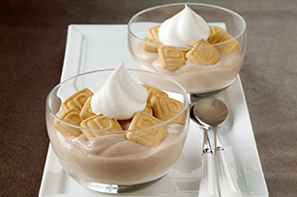

total:2 min

total:2 servings

http://www.kraftrecipes.com/assets/images/logo/US_HealthyLiving.jpg

## What You Need

2tsp. MAXWELL HOUSE INTERNATIONAL CAFÉ Sugar Free Suisse Mocha Café

2JELL-O Vanilla Sugar Free Pudding Snacks

1pack  (0.74 oz.) NABISCO 100 CAL LORNA DOONE Shortbread Cookie Crisps

2Tbsp. thawed COOL WHIP Sugar Free Whipped Topping

## Make It

**STIR** 1 tsp. flavored instant coffee into each pudding snack.

**TOP** with cookies and COOL WHIP.

## Kraft Kitchens Tips

Substitute

Prepare using 1 pack (0.81 oz.) NABISCO 100 CAL OREO Thin Crisps.

No-Fry Fried Ice Cream

[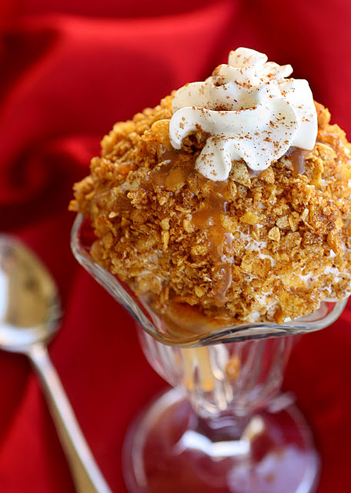](http://www.tablespoon.com/recipes/no-fry-fried-ice-cream-recipe/1/)

Prep: 10 (total)

Servings 8

Ingredients

6 C honey coated corn flakes cereal, crushed

2 TB white sugar

3 TB butter, melted

5 TB corn syrup

2 tsp ground cinnamon

1 gallon vanilla ice cream, softened

Optaionl toppings: caramel syrup, chocolate syrup, whipped cream, cinnamon.

Directions:

* 1. Combine crushed cereal, sugar, butter, corn syrup, and cinnamon in small bowl. Set aside.
  2. Shape ice cream into 3-inch balls and roll in the cereal mixture, pressing lightly to ensure the ball is fully coated.
  3. Place ice cream balls in muffin tins and freeze until ready to serve
  4. To serve, top with syrup, whipped topping and a sprinkle of cinnamon.

**Mini Pineapple Upside down cakes**

[](http://www.grouprecipes.com/12621/mini-pineapple-upside-down-cakes.html)

**Total: 25 min Servings 12**

**Slightly lighter and mini version of the traditional upside down cake. Great for dinner parties.**

**Ingredients**

* 2/3 cup packed [brown sugar](http://www.grouprecipes.com/12621/mini-pineapple-upside-down-cakes.html) [shopping list](http://www.grouprecipes.com/12621/mini-pineapple-upside-down-cakes.html)
* 1/3 cup [butter](http://www.grouprecipes.com/12621/mini-pineapple-upside-down-cakes.html), melted [shopping list](http://www.grouprecipes.com/12621/mini-pineapple-upside-down-cakes.html)
* 2 (20 ounce) cans sliced [pineapple](http://www.grouprecipes.com/12621/mini-pineapple-upside-down-cakes.html) [shopping list](http://www.grouprecipes.com/12621/mini-pineapple-upside-down-cakes.html)
* 1 (18.25 ounce) package [butter](http://www.grouprecipes.com/12621/mini-pineapple-upside-down-cakes.html) [cake mix](http://www.grouprecipes.com/12621/mini-pineapple-upside-down-cakes.html) [shopping list](http://www.grouprecipes.com/12621/mini-pineapple-upside-down-cakes.html)
* 1 (355mL) can Mountain Dew (can use diet) [shopping list](http://www.grouprecipes.com/12621/mini-pineapple-upside-down-cakes.html)
* 1 Tbsp [applesauce](http://www.grouprecipes.com/12621/mini-pineapple-upside-down-cakes.html) [shopping list](http://www.grouprecipes.com/12621/mini-pineapple-upside-down-cakes.html)
* 12 [maraschino cherries](http://www.grouprecipes.com/12621/mini-pineapple-upside-down-cakes.html), halved (optional) [shopping list](http://www.grouprecipes.com/12621/mini-pineapple-upside-down-cakes.html) **How to make it**

1. Preheat oven to 350 F
2. In a small bowl, combine the brown sugar and butter; mix well.
3. Spoon into 12 greased Jumbo muffin cups (do not line).
4. Drain pineapple, reserving the juice.
5. Place one ring in each muffin cup, pressing and trimming if necessary.
6. Combine the cake mix, soda, applesauce and the reserved pineapple juice as needed. Mix well.
7. Pour over pineapple, up to 3/4 of the tin.
8. Bake 20-25 minutes or until a toothpick comes out clean.
9. Immediately invert on a wire rack to cool.
10. GArnish with cherry halves, if desired.

**Fluffy Easy Donuts**

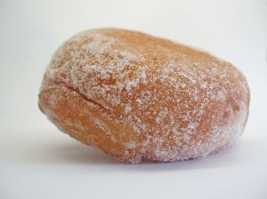

**Recipe also works well for funnel cakes.**

**Time: 5 min**

**Servings 56**

**Ingredients**

* 1 (18.25 oz.) package moist [cake mix](http://www.grouprecipes.com/45552/fluffy-easy-donuts-surprise.html), any flavor [shopping list](http://www.grouprecipes.com/45552/fluffy-easy-donuts-surprise.html)
* 1/2 C. [flour](http://www.grouprecipes.com/45552/fluffy-easy-donuts-surprise.html) [shopping list](http://www.grouprecipes.com/45552/fluffy-easy-donuts-surprise.html)
* 4 [eggs](http://www.grouprecipes.com/45552/fluffy-easy-donuts-surprise.html) [shopping list](http://www.grouprecipes.com/45552/fluffy-easy-donuts-surprise.html)
* 1 1/4 C. [water](http://www.grouprecipes.com/45552/fluffy-easy-donuts-surprise.html) [shopping list](http://www.grouprecipes.com/45552/fluffy-easy-donuts-surprise.html)
* 3 C. [oil](http://www.grouprecipes.com/45552/fluffy-easy-donuts-surprise.html) for frying, or as needed [shopping list](http://www.grouprecipes.com/45552/fluffy-easy-donuts-surprise.html)
* 1/4 C. [confectioners' sugar](http://www.grouprecipes.com/45552/fluffy-easy-donuts-surprise.html) for dusting [shopping list](http://www.grouprecipes.com/45552/fluffy-easy-donuts-surprise.html)

**How to make it**

* In a large bowl, combine the cake mix, flour, water, and eggs. Beat with an electric mixer on low speed for 5 minutes, or until batter is free of lumps.
* Heat oil in a large, deep skillet until it reaches 375 degrees F (190 degrees C).
* Using a small scoop equal to about 2 Tbs., carefully drop batter into hot oil in batches so as not to overcrowd.
* Cook donuts in hot oil for 5 minutes, or until golden brown, flipping once with a fork mid-way through for even cooking.
* Carefully remove donuts from oil with slotted spoon or tongs, and drain on paper towels.
* Dust with confectioners' sugar before serving, drizzle with chocolate or dress up any way you want.

Oreo Truffle Balls

[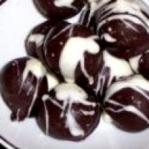](http://www.grouprecipes.com/13997/oreo-truffle-balls.html)

30 min

Serves 24

**Ingredients**

* 1 package [Oreo cookies](http://www.grouprecipes.com/13997/oreo-truffle-balls.html), crushed [shopping list](http://www.grouprecipes.com/13997/oreo-truffle-balls.html)
* 8 ounces [cream cheese](http://www.grouprecipes.com/13997/oreo-truffle-balls.html), softened [shopping list](http://www.grouprecipes.com/13997/oreo-truffle-balls.html)
* 1 package white [almond](http://www.grouprecipes.com/13997/oreo-truffle-balls.html) bark [shopping list](http://www.grouprecipes.com/13997/oreo-truffle-balls.html)
* 1 package [chocolate](http://www.grouprecipes.com/13997/oreo-truffle-balls.html) [almond](http://www.grouprecipes.com/13997/oreo-truffle-balls.html) bark [shopping list](http://www.grouprecipes.com/13997/oreo-truffle-balls.html)

**How to make it**

* Using a blender or hand held mixer, mix Oreos and cream cheese together.
* Roll into walnut size balls. Chill.
* Melt approx 3/4 package of white almond bark.
* Stick a toothpick in an Oreo ball and dip it in the melted white almond bark.
* Allow to harden on wax paper. Takes about 15 min.
* While waiting, melt about 1/4 package of chocolate almond bark.
* Decorate with drizzles of chocolate and white almond bark.

Mud Pie Cookies

[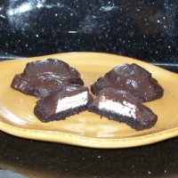](http://www.grouprecipes.com/6279/mud-pie-cookies.html)

15 min

Serves 36

**Ingredients**

* ¼ cup [butter](http://www.grouprecipes.com/6279/mud-pie-cookies.html), at room temperature [shopping list](http://www.grouprecipes.com/6279/mud-pie-cookies.html)
* ¼ cup solid [Crisco shortening](http://www.grouprecipes.com/6279/mud-pie-cookies.html) [shopping list](http://www.grouprecipes.com/6279/mud-pie-cookies.html)
* 1 cup white [sugar](http://www.grouprecipes.com/6279/mud-pie-cookies.html) [shopping list](http://www.grouprecipes.com/6279/mud-pie-cookies.html)
* 1 [egg](http://www.grouprecipes.com/6279/mud-pie-cookies.html) [shopping list](http://www.grouprecipes.com/6279/mud-pie-cookies.html)
* 1 teaspoon [vanilla extract](http://www.grouprecipes.com/6279/mud-pie-cookies.html) [shopping list](http://www.grouprecipes.com/6279/mud-pie-cookies.html)
* ½ cup [whole milk](http://www.grouprecipes.com/6279/mud-pie-cookies.html) or half and half (I prefer half and half) [shopping list](http://www.grouprecipes.com/6279/mud-pie-cookies.html)
* 1¾ cups [flour](http://www.grouprecipes.com/6279/mud-pie-cookies.html) [shopping list](http://www.grouprecipes.com/6279/mud-pie-cookies.html)
* ½ cup [cocoa](http://www.grouprecipes.com/6279/mud-pie-cookies.html) (use the Special [dark cocoa](http://www.grouprecipes.com/6279/mud-pie-cookies.html) for a richer [chocolate](http://www.grouprecipes.com/6279/mud-pie-cookies.html)) [shopping list](http://www.grouprecipes.com/6279/mud-pie-cookies.html)
* ½ teaspoon [salt](http://www.grouprecipes.com/6279/mud-pie-cookies.html) [shopping list](http://www.grouprecipes.com/6279/mud-pie-cookies.html)
* ½ teaspoon [baking soda](http://www.grouprecipes.com/6279/mud-pie-cookies.html) [shopping list](http://www.grouprecipes.com/6279/mud-pie-cookies.html)
* 18 [marshmallows](http://www.grouprecipes.com/6279/mud-pie-cookies.html) cut in half [shopping list](http://www.grouprecipes.com/6279/mud-pie-cookies.html)
* Chocolate Frosting: [shopping list](http://www.grouprecipes.com/6279/mud-pie-cookies.html)
* 3 tablespoons [butter](http://www.grouprecipes.com/6279/mud-pie-cookies.html), melted [shopping list](http://www.grouprecipes.com/6279/mud-pie-cookies.html)
* 4 tablespoons [cocoa](http://www.grouprecipes.com/6279/mud-pie-cookies.html) [shopping list](http://www.grouprecipes.com/6279/mud-pie-cookies.html)
* dash of [salt](http://www.grouprecipes.com/6279/mud-pie-cookies.html) [shopping list](http://www.grouprecipes.com/6279/mud-pie-cookies.html)
* 2 cups [powdered sugar](http://www.grouprecipes.com/6279/mud-pie-cookies.html) [shopping list](http://www.grouprecipes.com/6279/mud-pie-cookies.html)
* 4 or 5 tablespoons [milk](http://www.grouprecipes.com/6279/mud-pie-cookies.html) or half and half [shopping list](http://www.grouprecipes.com/6279/mud-pie-cookies.html)

**How to make it**

* Cream together butter, shortening and sugar.
* Beat in egg, vanilla and milk.
* Add flour, cocoa, salt and baking soda; mix well.
* Drop by spoonfuls onto greased cookie sheet; flatten dough just a bit with your fingertips.
* Bake at 375 degrees for 8 minutes.
* Remove cookies from oven, press half a marshmallow - cut side down - into center of each cookie and return to oven to bake an additional 2 minutes.
* Remove cookies from oven and gently press down on marshmallow with your fingertips.
* Cool cookies on waxed paper or rack.
* When completely cooled, frost over the marshmallow topping with the chocolate frosting.
* For frosting, beat all ingredients together, adding enough milk or half and half to make mixture spreadable.

Banana Cupcakes

[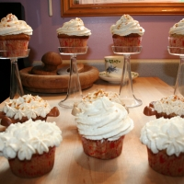](http://www.grouprecipes.com/10342/banana-cupcakes.html/photos)

20 min

Serves 18

**Ingredients**

* ¼ cup [butter](http://www.grouprecipes.com/10342/banana-cupcakes.html) [shopping list](http://www.grouprecipes.com/10342/banana-cupcakes.html)
* ¼ cup solid [Crisco](http://www.grouprecipes.com/10342/banana-cupcakes.html) [shopping list](http://www.grouprecipes.com/10342/banana-cupcakes.html)
* 1 cup [sugar](http://www.grouprecipes.com/10342/banana-cupcakes.html) [shopping list](http://www.grouprecipes.com/10342/banana-cupcakes.html)
* 1 teaspoon [vanilla extract](http://www.grouprecipes.com/10342/banana-cupcakes.html) [shopping list](http://www.grouprecipes.com/10342/banana-cupcakes.html)
* 2 [eggs](http://www.grouprecipes.com/10342/banana-cupcakes.html) [shopping list](http://www.grouprecipes.com/10342/banana-cupcakes.html)
* 2 cups plus 2 tablespoons [flour](http://www.grouprecipes.com/10342/banana-cupcakes.html) [shopping list](http://www.grouprecipes.com/10342/banana-cupcakes.html)
* 2½ teaspoons [baking powder](http://www.grouprecipes.com/10342/banana-cupcakes.html) [shopping list](http://www.grouprecipes.com/10342/banana-cupcakes.html)
* ½ teaspoon [salt](http://www.grouprecipes.com/10342/banana-cupcakes.html) [shopping list](http://www.grouprecipes.com/10342/banana-cupcakes.html)
* ¼ teaspoon [baking soda](http://www.grouprecipes.com/10342/banana-cupcakes.html) [shopping list](http://www.grouprecipes.com/10342/banana-cupcakes.html)
* 1 cup [mashed bananas](http://www.grouprecipes.com/10342/banana-cupcakes.html) (about 3 medium bananas) [shopping list](http://www.grouprecipes.com/10342/banana-cupcakes.html)
* ¼ cup [buttermilk](http://www.grouprecipes.com/10342/banana-cupcakes.html) or [sour cream](http://www.grouprecipes.com/10342/banana-cupcakes.html) (I always use [sour cream](http://www.grouprecipes.com/10342/banana-cupcakes.html)) [shopping list](http://www.grouprecipes.com/10342/banana-cupcakes.html)

**How to make it**

* In a large bowl, cream together the butter, Crisco, sugar and extract.
* Beat in eggs, one at a time.
* Mix dry ingredients together and add to creamed mixture alternately with bananas and sour cream (or buttermilk).
* Grease 18 muffin tins (or line tins with cupcake liners); fill tins 3/4 full (I always get exactly 18 out of this recipe).
* Bake at 375 degrees for 20 minutes.
* Cool and frost. One frosting option is listed below, but the pictured cupcake is frosted with cream cheese frosting.
* Browned Sugar Frosting:
* 6 tablespoons brown sugar
* 4 tablespoons whole milk or half and half
* 4 tablespoons butter
* powdered sugar
* ½ teaspoon vanilla extract

Coconut Macaroons III

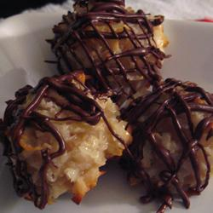

Prep 10

Ready in 25

Serves 12

### Ingredients

* 2/3 cup all-purpose flour
* 5 1/2 cups flaked coconut
* 1/4 teaspoon salt
* 1 (14 ounce) can sweetened condensed milk
* 2 teaspoons vanilla extract

### Directions

1. Preheat oven to 350 degrees F (175 degrees C). Line cookie sheets with parchment paper or aluminum foil.
2. In a large bowl, stir together the flour, coconut and salt. Stir in the sweetened condensed milk and vanilla using your hands until well blended. Use an ice cream scoop to drop dough onto the prepared cookie sheets. Cookies should be about golf ball size.
3. Bake for 12 to 15 minutes in the preheated oven, until coconut is toasted.
4. Optional: Dip bottoms or halfway in chocolate and cool, drizzle with chocolate or caramel syrup, top with cherries.

Four Layer Dessert

[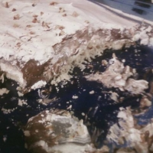](http://www.grouprecipes.com/6326/four-layer-dessert.html)

20 min

12 serves

**Ingredients**

* 1/4 lb. [margarine](http://www.grouprecipes.com/6326/four-layer-dessert.html) or [butter](http://www.grouprecipes.com/6326/four-layer-dessert.html) [shopping list](http://www.grouprecipes.com/6326/four-layer-dessert.html)
* 1 c. chopped [pecans](http://www.grouprecipes.com/6326/four-layer-dessert.html) [shopping list](http://www.grouprecipes.com/6326/four-layer-dessert.html)
* 1 c. [flour](http://www.grouprecipes.com/6326/four-layer-dessert.html) [shopping list](http://www.grouprecipes.com/6326/four-layer-dessert.html)
* 1/4 c. [sugar](http://www.grouprecipes.com/6326/four-layer-dessert.html) [shopping list](http://www.grouprecipes.com/6326/four-layer-dessert.html)
* 8 oz. pkg. [cream cheese](http://www.grouprecipes.com/6326/four-layer-dessert.html) [shopping list](http://www.grouprecipes.com/6326/four-layer-dessert.html)
* Lg. ctn. [Cool Whip](http://www.grouprecipes.com/6326/four-layer-dessert.html) [shopping list](http://www.grouprecipes.com/6326/four-layer-dessert.html)
* 1 c. [powdered sugar](http://www.grouprecipes.com/6326/four-layer-dessert.html) [shopping list](http://www.grouprecipes.com/6326/four-layer-dessert.html)
* 2 sm. pkgs. instant [chocolate pudding](http://www.grouprecipes.com/6326/four-layer-dessert.html) [shopping list](http://www.grouprecipes.com/6326/four-layer-dessert.html)
* 3 c. [milk](http://www.grouprecipes.com/6326/four-layer-dessert.html) [shopping list](http://www.grouprecipes.com/6326/four-layer-dessert.html)

**How to make it**

* First Layer: Melt butter; mix with 1/2 cup pecans, flour, and sugar. Spread in bottom of oblong pan and bake at 350 degrees for 12-15 minutes. Let cool completely.
* Second Layer: Cream together cream cheese, powdered sugar and 1 cup Cool Whip; spread over cooled First Layer.
* Third Layer: Two small boxes instant pudding mixed according to directions with 3 cups milk poured over Second layer.
* Fourth Layer: Spread remaining Cool Whip over Third later and sprinkle with remaining nuts.

Ambrosia Tarts Recipe

* 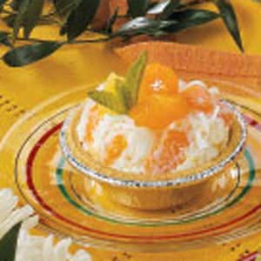Prep/Total Time: 10 min.
* Yield: 4 Servings

10 10

**Ingredients**

* 1 can *(11 ounces) mandarin oranges, drained*
* 1 can *(8 ounces) crushed pineapple, drained*
* 1/2 cup *miniature marshmallows*
* 1/4 cup *flaked coconut*
* 1 cup *whipped topping*
* *4 individual graham cracker shells*

**Directions**

* In a large bowl, combine the oranges, pineapple, marshmallows and coconut. Fold in whipped topping. Spoon into shells. Chill until serving.**Yield:**4 servings.

Glazed Pear Shortcakes

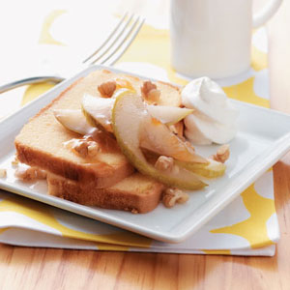

* Also try peaches!
* Prep/Total Time: 10 min.
* Yield: 4 Servings

5 5 10

**Ingredients**

* *2 medium pears, sliced*
* 2 tablespoons *butter*
* 4 teaspoons *apricot spreadable fruit*
* *8 thin slices pound cake*
* 4 teaspoons *chopped walnuts*
* 4 tablespoons *whipped topping*

**Directions**

* In a small skillet, saute pears in butter until tender. Remove from the heat; stir in spreadable fruit.
* Place cake slices on four dessert dishes; top with pear mixture, walnuts and whipped topping.

# Peach Creme Brulee

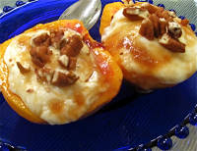

Peach Creme Brulee is a super quick and easy dessert recipe that uses just three ingredients. Remember, sugars, salt, water, oil, and vanilla and other seasonings don't count in the three ingredient amount!

**Prep Time:** 5 minutes

**Cook Time:** 8 minutes

**Total Time:** 13 minutes

**Ingredients:**

* 3 fresh peaches, or 6 canned peach halves, drained
* 2 tablespoons lemon juice
* 1 cup sour cream
* 3 tablespoons sugar
* 1 teaspoon vanilla
* 1/3 cup brown sugar
* 1/2 cup chopped pecans, if desired

**Preparation:**

If using fresh peaches, peel, cut in half, and remove pie. Place drained peach halves in a shallow glass baking dish, cut side down. Sprinkle with lemon juice. Broil 4-6" from heat until fruit begins to brown in spots.

In small bowl, combine sour cream, granulated sugar, and vanilla and mix well. Turn peaches over and spoon sour cream mixture over the fruit; sprinkle evenly with brown sugar. Broil 4-6" from the heat until sugar melts and caramelizes. Sprinkle with pecans, if desired, and serve.

To cook on the grill, grill peaches, cut side down, for 2-3 minutes. Turn peaches, top with sour cream and brown sugar, and grill for 2-3 minutes until peaches are hot. Serves 6