A Beginner’s Guide to

Researching Your Ancestors



Linda Verma

Table of Contents

Introduction v

Research Steps vi

Research Tips vii

Chapter 1-Records of Interest 3

Chapter 2-Records of Particular Groups 13

Index 23

Introduction 

Have you ever wondered about your distant relatives? Who they were? What did they do? What did they look like? Finding the answers to these questions can be a rewarding experience. When you discover your ancestors, you will discover more about yourself as well. Your family and their experiences are part of what makes you who you are today.

Searching for your ancestors opens up a door into your family’s past. Once you step through this door you may find unknown triumphs and tragedies experienced by your family members. This journey into the past involves putting pieces of a puzzle together. You start with a framework then fill in the blank areas with linking pieces.

What you already know about your family is your framework. Relatives and family records are a treasure trove of missing pieces. More pieces of the puzzle may be found in the National Archives since it holds the records of when people interacted with the Federal Government. Each linking piece will either lead to another interesting piece or a dead end. Hopefully, when you use the following guidelines you will find more pieces of the puzzle instead of missing links.

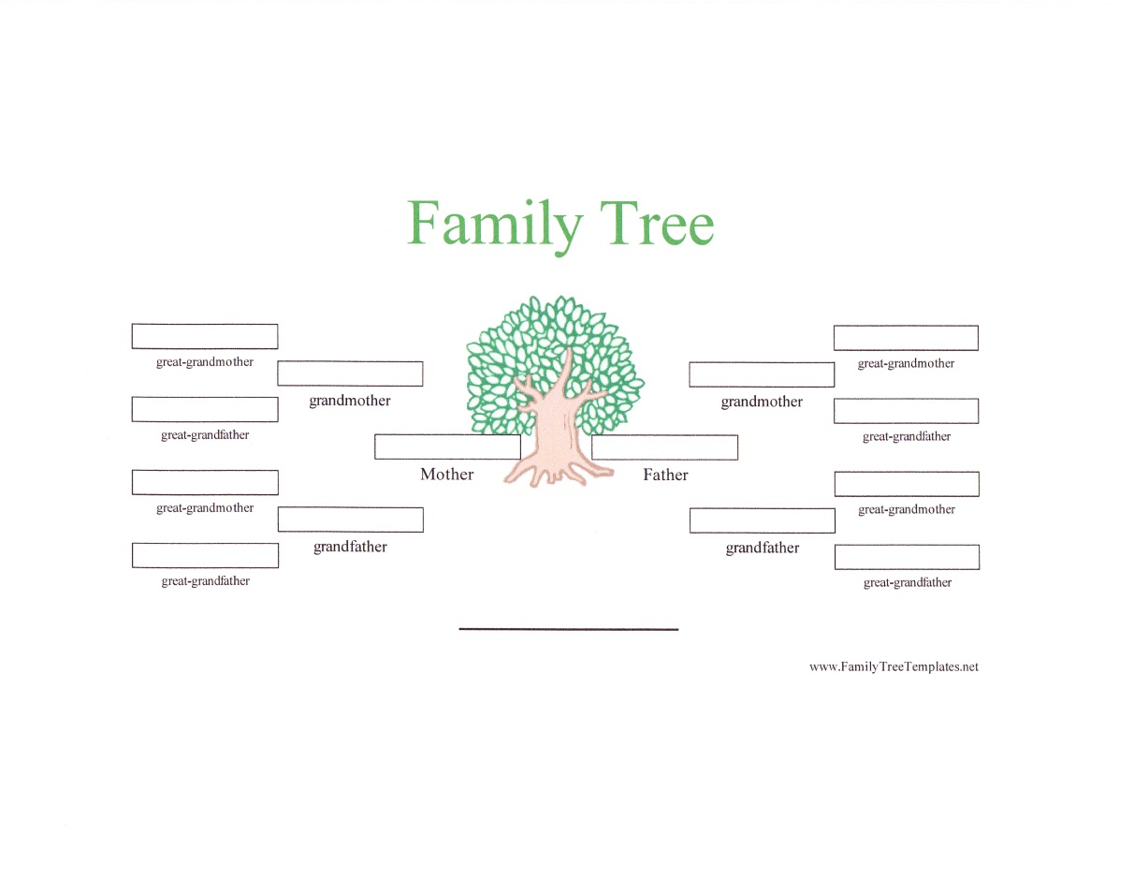

Research Steps:

1. Begin with yourself, parents and grandparents then work backwards. Gather as much information as you can about your family.
2. Ask your relatives about your family history.
3. Look in family records that could include letters, family Bibles, scrapbooks, diaries, photographs, baptismal certificates and newspaper clippings.

1. Think of ways your ancestor interacted with the Federal Government.
2. Search state, county and local (city or town) records for birth, marriage and death certificates. Deeds and wills may be found in state or county archives.
3. Record names, dates of births, marriages and deaths, and their relationships to other family members in your family tree template or chart.
4. Organize research information in a journal and/or binder.

Research Tips:  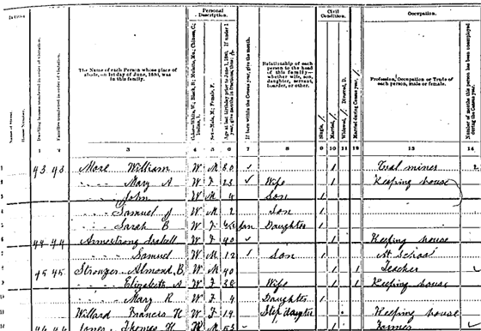

* The 1790 Federal Census lists only the head of household.
* The 1880 Federal Census lists everyone in the household and their relationship to the head of the household.
* Almost all of the 1890 Federal Census was destroyed in a Department of Commerce fire in 1921.
* 72-year restriction on access to population census information.
* Only federal records are stored in the National Archives Records Administration (NARA).
* Records that predate the Revolutionary War are rare in NARA facilities.
* Most of the records are arranged geographically such as the Census. Records in NARA are not arranged alphabetically so it is impossible to find information on someone if you only know their name.
* Libraries, historical and genealogical societies are also good sources for family history.
* Useful websites:

1. http:// www.ancestry.com

2. http://www.archives.gov

3. http://www.cyndislist.com (a list of genealogy sites on the internet)

4. http://www.FamilySearch.org

5. http//www.footnote.com

6. http://www.Genealogy.com



Chapter One

Records of Interest

Records of Interest

Once you have recorded all the information you gathered from relatives about your family, the next step is to start researching records. The main records, which are located in the National Archives Records Administration (NARA), that will help in your search are the Federal Census, Passenger Arrival Records (Immigration), Naturalization Records, Land Records and Military Records. The National Archives also stores records related to Native Americans, African Americans, Japanese Americans, Chinese Americans and Hispanic Americans. These groups interacted with the Federal Government more frequently than others due to their unique circumstances.

Census Records

During the years, 1790-1870 the Federal Census was arranged by state, county, township or city. Beginning with 1880 and continuing through 1930, the census was arranged by enumerator district. The 1790 Federal Census lists only the head of the household. In contrast, the 1880 census lists everyone in the household and their relationship to the head of the household. Most of the 1890 census was destroyed in a fire at the Department of Commerce in 1921. The population census information cannot be accessed for 72 years. The National Archives currently has open records on microfilm of the Federal Census from 1790 to 1930. These records can be viewed at the National Archives in Washington, DC and NARA’s regional facilities.

Passenger Arrival Records (Immigration)

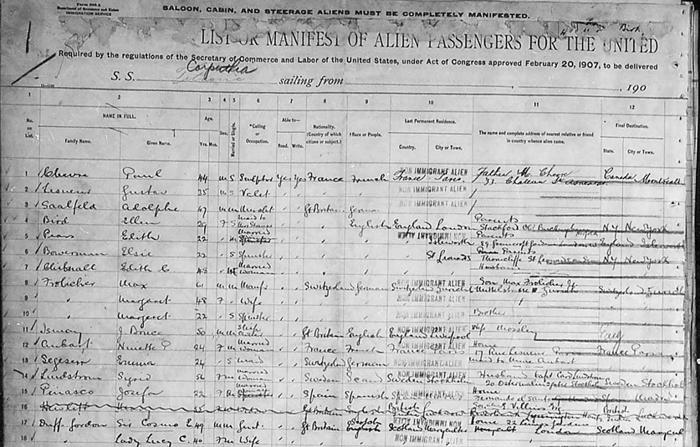

The following are the different types

* U.S. Customs Service arrival lists, 1820-1890
* Immigration and Naturalization Service (INS) arrival lists, 1891-1957 (Arrival lists are arranged by port of entry and date of arrival)
* Philadelphia passenger lists begin in 1800. Most other lists begin in 1820.
* Pre-1820 records may be on file at the port of entry, or the States Archives, in the state where the port is located.
* New York arrival lists are not indexed from 1847 to 1896.
* Canadian border crossings, also called St. Albans lists, begin in 1895.
* Mexican border crossings records, 1924-1954 are arranged by port of arrival.

NARA in Washington, DC contains a complete set of available arrival lists. The regional facilities of NARA hold microfilm copies of passenger arrival lists from the ports in their areas.

Naturalization Records

Naturalization involved a two-step process, usually with a five-year minimum U.S. residency requirement.

* First step: Declaration of Intention (First Papers)
* Second Step: Naturalization Petition (Granted Citizenship)

A federal naturalization record consists of a declaration of intention, petitions, depositions and a record of naturalization. The applicant received the only copy of the Naturalization certificate. Naturalization records are held by the district Federal courts or they may have been transferred to NARA. The district court records are held in the courts and /or the regional facilities of NARA. You may request a search of the Federal court records from the NARA regional facility that holds the records for the state where the naturalization took place. You may also request a search of the court records in the State Archives for the state, county and local naturalizations.

Land Records

The federal government originally owned most of the land in the United States. The public land states were divided into two geographical areas, Eastern and Western States. The states are listed below in their respective areas. Deeds are found at the state, county and local levels but NARA holds land records of the transfer of public lands from the U.S. Government to private ownership.

The records at NARA are found in the Bureau of Land Management, Record Group 49. Only the first transfer of title is recorded in the land patent certificates. Later transfer records are held in state or county records. Tract Books and Patent Books are two types of land records. Tract Books document land transactions in the two geographical areas, Eastern and Western States. Patent Books document the official transfer from the Federal Government to the individual. A patent is a document that guarantees title to the land.

**Eastern States**

Alabama, Arkansas, Florida, Illinois, Indiana, Iowa, Louisiana, Michigan, Minnesota, Mississippi, Ohio, and Wisconsin.

Address:

Eastern States Office

Bureau of Land Management

7450 Boston Boulevard

Springfield, VA22153-3121

**Western States**

Alaska, Arizona, California, Colorado, Idaho, Kansas, Montana, Nebraska, Nevada, New Mexico, North Dakota, Oklahoma, Oregon, South Dakota, Utah, Washington, and Wyoming.

Address:

NARA

700 Pennsylvania Avenue, NW

Washington, DC 20408-0001

NARA in Washington, DC also holds the case files records for

* Land patent
* Mineral entry, 1800-1908
* Railroad land
* Mineral patent
* Timber patent

States that belonged to the original thirteen colonies were not considered public land states. The State Archives holds records for Connecticut, Delaware, Georgia, Maryland, Massachusetts, New Hampshire, New Jersey, New York, North Carolina, Pennsylvania, Rhode Island, South Carolina, and Virginia. Other states in this category include Hawaii, Kentucky, Tennessee, Texas, and West Virginia.

Military Records

You need to know the following information about the soldier in order to locate military records

* Dates of service
* Branch of service
* Conflict served in
* Volunteer unit
* Regular Army (Officer or enlisted personnel)

Federal Records of military service are held in two locations  

1. National Archives in Washington, DC (Revolutionary War-1912)
2. Volunteer enlisted men and officers who served during a war or emergency. (1775-1902)
3. Regular Army

(Officers, 1789-June 30, 1917; enlisted personnel, 1789-October 31, 1912)

1. U.S. Navy (Officers, 1798-1902; enlisted personnel, 1798-1885)
2. U.S. Marine Corps (some Officers, 1798-1895; enlisted personnel, 1798-1904)
3. The Revenue Cutter Service (Revenue Marine), Life-Saving Service, and the Lighthouse Board were all predecessor agencies of the U.S. Coast Guard.

(1791-1919)

1. National Military Personnel Records Center, St. Louis, MO (WWI-present)
2. U.S. Army (Officers separated after June 30, 1917 and enlisted personnel separated after October 31, 1912)
3. U.S. Air Force (Officers and enlisted personnel separated after September 1947)
4. U.S. Navy (Officers separated after 1902 and enlisted personnel separated after 1885)
5. U.S. Marine Corps (Officers separated after 1895 and enlisted personnel separated after 1904)
6. U.S. Coast Guard (Officers separated after 1928 and enlisted personnel separated after 1914)
7. Civilian employees of the Revenue Cutter and Life-Saving Services, and the Lighthouse Board (1864-1919)

NARA in Washington, DC holds the following categories of records about military service

1. Compiled Military Service records
2. Regular Army
3. Pensions
4. Navy and Marine Corps
5. Coast Guard and Predecessor Agencies

Compiled Military Records

[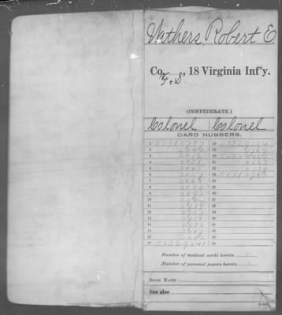](http://www.footnote.com/image/#14013696) [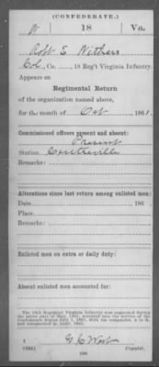](http://www.footnote.com/image/#14013766)

The jacket-envelope containing one or more documents of a particular soldier is called a compiled military service record. Some of the documents included in the record are abstracts of muster and pay rolls, rank rolls, returns, hospital records, and prison records.

A compiled military service record contains some of the following information

* Name of soldier
* Rank
* Unit
* Date mustered in and mustered out
* Other military information
* Some files may contain biographical and medical information

Types of compiled military service records

1. State Militia Records-contact the State archives
2. Confederate Records
3. The National Archives holds compiled military service records for soldiers and sailors who served in the Confederate Army, Navy and Marine Corps.
4. NARA does not hold Confederate pensions; you may find them in the State archives.
5. Records of Confederate prisoners are located in NARA.
6. Volunteer men and officers
7. Revolutionary War
8. War of 1812
9. Early (pre-Civil War) Indian Wars
10. Mexican War
11. Civil-War (Union and Confederate)
12. Later (post-Civil War) Indian Wars
13. Spanish-American War
14. Philippine Insurrection

When researching volunteers always start with the compiled military service records, begin with the appropriate name indexes on NARA microfilm. If the records have not been reproduced on microfilm you may request to see the original records (1775-1912) at the National Archives Building in Washington, DC.

Regular Army

Regular Army records consist of those for personnel enlisted for a specific time of duty (3 months or 3 years). They serve during peacetime. The War Department did not compile military service records for the Regular Army. You will need to start your research for these records with

* Register of Enlistments in the U.S. Army, 1798-1914
* Enlisted Men-Regular Army Enlistment Papers, 1798-1894

**Officers**

* Francis B. Heitman’s, *Historical Register and Dictionary of the United States Army, From Its Organization, September 29, 1789 to march 2, 1903 (2 Volumes)*
* Adjutant General’s Office (AGO)
* AGO letters received, 1805-1889
* AGO document file, 1890-1917
* Commission Branch, 1863-1870
* Appointment, Commission and Personal (ACP) files, 1871-1894

Pensions

Records of pension payments for veterans, their widows, and other heirs and the applications are stored in the National Archives. Pension records may consist of documents such as discharge papers, affidavits, depositions of witnesses, accounts of events during service, marriage certificates, birth records, death certificates, pages from family Bibles, and other supporting documents. Pension records include both applications and pensions granted. Payment is based on service in the United States between 1775 and 1916 but does not include service in the Confederate States of America during the Civil War.

Navy

You need to search the following records for

**Navy Enlisted Men**

* Pension files
* Rendezvous Reports
* Register of Enlisted Returns, 1846-1902
* Jackets of Enlisted Men, 1842-1885 (1885- 1941 in St.Louis, MO)
* Muster Rolls
* Deck Logs
* Court Martial Records

**Officers**

* Edward W. Callahan’s *List of Officers of the Navy of the United States and Marine Corps*
* Abstracts of Service(M330)
* Examining Board and Retirement Board
* Pension Files
* Court-Martial Records
* Deck Logs

**Marine Corps Enlisted Men**

* Case Files (prior to 1905, after 1905-St. Louis, MO)
* Muster Rolls, 1789-1940
* Pension Files

**Officers**

* Edward W. Callahan’s *List of Officers of the Navy of the United States and Marine Corps*
* Various Registers from 1819-1904 (with gaps)
* Muster Rolls, August 1798-December 1940

Coast Guard and Predecessor Agencies

The U.S. Coast Guard was formed by consolidating the Revenue Cutter Service and the Lifesaving Service by the Department of the Treasury in 1915. The Coast Guard operates as part of the Navy during times of war or when the President directs. Search for these records in

* Registers of Lighthouse Keepers, 1845-1912; and correspondence concerning Keepers and Assistant Keepers, 1821-1902
* Revenue Cutter Service, Records of Officers, 1791-1919; enlisted crew, muster rolls and payrolls, 1833-1932; and shipping articles, 1863-1915.
* Life-Saving Service, registers, 1866-1913; service record cards, 1900-1914; and articles of engagement for surfmen, 1875-1914

Records Relating to Military Service

You could also check into the records of soldier’s homes for aged and needy veterans, records of burials at soldier’s homes and in military cemeteries, applications for headstones, and records of soldiers who died overseas or were listed missing in action.



Chapter Two

Records of Particular Groups

Native Americans

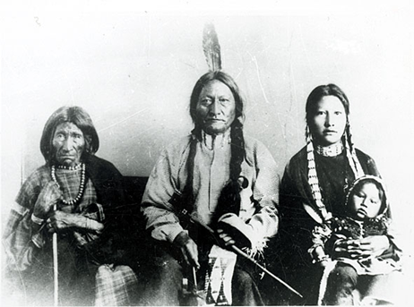

The National Archives holds information about Native Americans who maintained their ties to federally recognized tribes (1830-1970). Most records are arranged by tribe. You need to know the tribe’s name in order to research a particular person since it is difficult to determine a person’s tribal affiliation. Determine the following before starting your research of documents

* Name of the federally recognized tribe
* Name of person
* When they were alive
* State where they lived

The majority of the records about Indians in the National Archives are in the Records of the Bureau of Indian Affairs (BIA). Eastern tribes are under state authority instead of federal so you will have to contact the state archive. The National Archives’ regional facilities hold records created by the BIA field offices and Indian schools at the regional level.

The National Archives’ regional facility in Fort Worth holds many records relating to the

Five Civilized Tribes (Choctaw, Chickasaw, Seminole, Cherokee and Creek). Congress directed the Dawes Commission in 1893 to prepare final rolls of the Five Civilized Tribes in order to end tribal title to their lands in Indian Territory and to allot land to individual members of the tribes. The original enrollment cards prepared by the commission are located in the Southwest Regional facility. For more information on the Dawes Commission, contact NARA’s regional facility in Fort Worth, Texas at www.archives.gov/southwest.

African Americans Civil War records such as pensions and Military Service Records are found in the National Archives. The Military Service Records include the United States Colored Troops (USCT) and the Regular Army (9th & 10th Cavalry, 24th & 25th Infantry).



Post-Civil War records of interest are the Southern Claims Commission, Freedman’s Savings and Trust Company (Freedman’s Bank) and the Freedman’s Bureau (no indexes). The Southern Claims Commission files may contain names, ages and residences of former slaves; names of slave owners; slave manumissions (emancipations).

The census, military and Freedman’s Bureau records are the most useful for genealogical research of African Americans. Before the Civil War years (1790-1860), slave records are difficult to locate and rarely found at NARA. The 1850 and 1860 slave schedules list the slave owner’s name and the number of slaves by sex, age and black or mulatto. The names of free African Americans could be in the 1790-1860 Federal censuses. Beginning in 1870, the Federal census listed the names of African Americans including former slaves.



[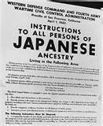](http://rds.yahoo.com/_ylt=A0PDoX81qJpN72UA4XmJzbkF;_ylu=X3oDMTBxb3JzbzcxBHBvcwMyNARzZWMDc3IEdnRpZANJMTM1Xzg1/SIG=1ps7on9ee/EXP=1302010037/**http:/images.search.yahoo.com/images/view?back=http://images.search.yahoo.com/search/images?_adv_prop=image&b=22&ni=21&va=images+of+Japanese+americans+during+WWII&xargs=0&pstart=1&fr=mcsaoff&w=492&h=600&imgurl=thesocietypages.org/socimages/files/2011/03/tumblr_lfcuwp52ri1qfu6z3.jpg&rurl=http://thesocietypages.org/socimages/2011/03/05/life-in-world-war-ii-japanese-american-internment-camps/&size=281KB&name=Life+in+World+Wa...&p=images+of+Japanese+americans+during+WWII&oid=b8338217ea2e1e31721f025ce528667b&fr2=&no=24&tt=23600&b=22&ni=21&sigr=138nknata&sigi=128sttrtl&sigb=14fca1fpm&.crumb=pg7GWimJqpz) 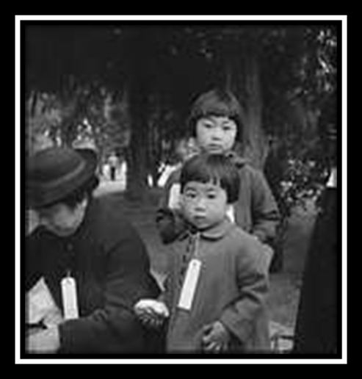

Japanese Americans

Japanese Internments

* During World War II, about 110,000 Japanese Americans were evacuated from designated military areas in Alaska, Arizona, California, Hawaii, Oregon and Washington.
* The War Relocation authority (WRA) was set up to carry out the removal, relocation, maintenance and supervision of those excluded from military areas.

The Wartime Civil Control Administration (WCAA) established ten assembly centers in 1942.

|  |  |
| --- | --- |
| 1. Central Utah, Topaz, UT | 6. Jerome, Denson, AR |
| 2. Colorado River, Poston, AZ | 7. Manzanar, Manzanar, CA |
| 3. Gila River, Rivers, AZ | 8. Minikoda, Hunt, ID |
| 4. Granada, Amachie, CO | 9. Rohwer, McGehhe, AR |
| 5. Heart Mountain, WY | 10. Tule Lake, Newell, CA |

You will find the Japanese American Internee Files, 1942-1946 as an automated data file at http://aad.archives.gov. Some of the data included are name, age, race of internee and spouse, year and place of birth, and occupation of father. Another series of records to use for research is the Final Accountability Rosters of Evacuees at Relocation Centers, 1944-1946. These records are arranged by relocation center, followed by an alphabetical list of evacuees at the center. You may also use the Evacuee and Excluded Files, 1942-1946. The files may provide name of evacuee, individual and family numbers, birthplace, birth date, religion, marital status, linguistic ability, educational accomplishments, employment history and military service records. There are access restrictions on these files.

Chinese Americans

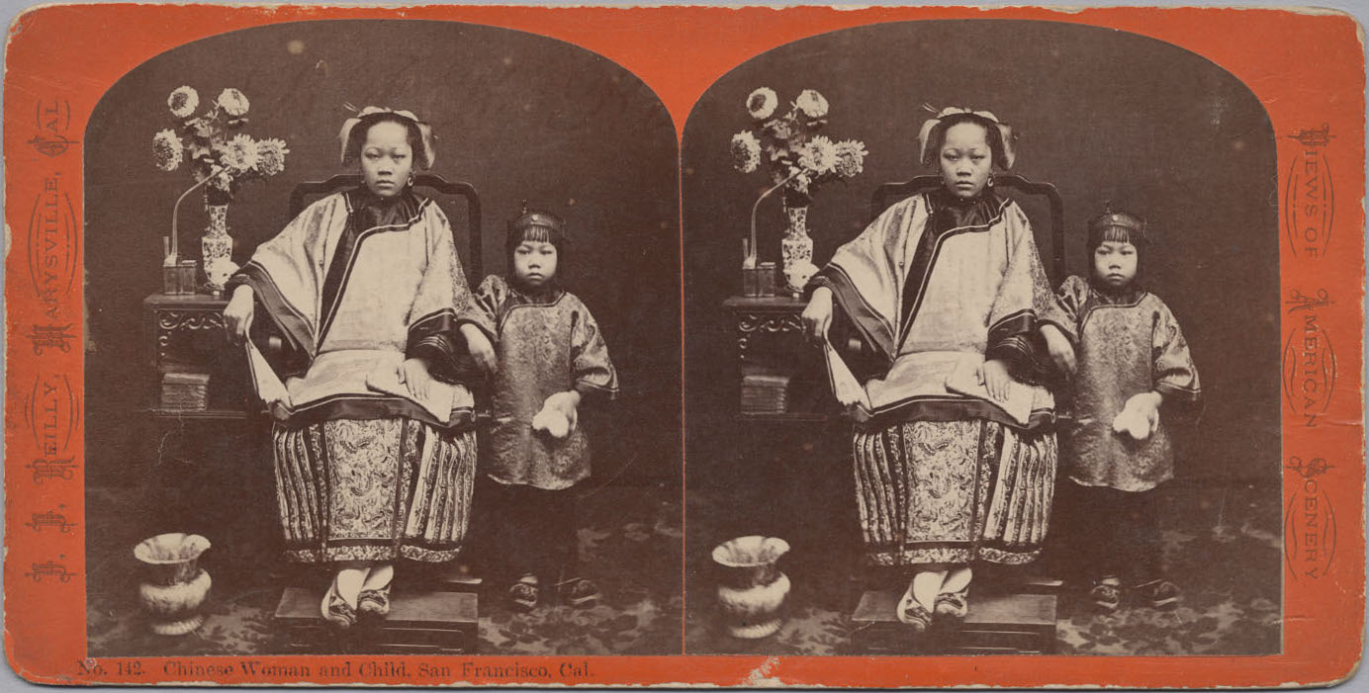

The U.S. Government restricted immigration from China during the years 1882-1943. Access to the records during this time period may be restricted by the Freedom of Information Act but the majority is open to the public. Many of the records created to implement the Chinese exclusion laws are now in the custody of NARA’s regional facilities. To locate the records, contact the regional facility closest to where the person first entered or left the country.

A Chinese immigration case file from the Immigration and Naturalization Service may contain information such as subject’s name, date and place of birth, physical appearance, occupation, names and relationships of other family members, and family history.

To find a case file the researcher must know the name the immigrant used on his or her papers, as well as the first port at which the person entered or left the country. A master index has not been created. However, individual INS and NARA regional facilities may have compiled their own indexes for their records.

Records of the District Courts of the United States contain thousands of case files relating to habeas corpus actions in the district courts during the late 1800s and early 1900s involving Chinese immigrants.

Hispanic Americans

[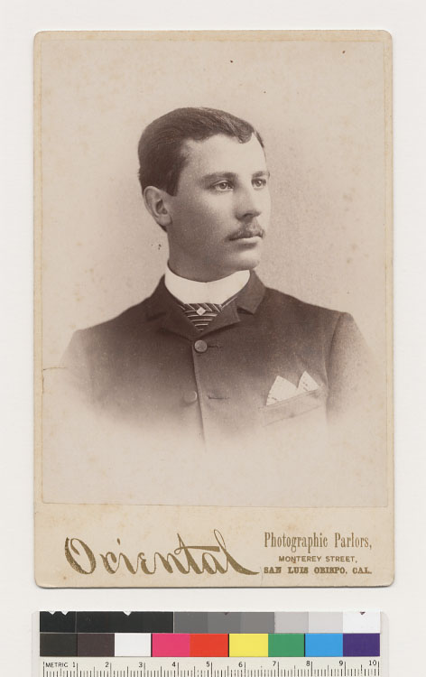](http://content.cdlib.org/ark:/13030/hb6290082w/FID4)

Records of Mexican border crossing lists are arranged by the port of entry into the United States. The years that are available are 1924-1954. In many cases, the information is compiled on a manifest card rather than the traditional manifest sheet.

Ports of entry

* Naco and Sasabe/San Fernando, AZ
* San Ysidro, CA
* Columbus and Nogales, NM
* El Paso, Rio Grande, Laredo, Eagle Pass, Brownsville, and Houston, TX

Conclusion

Searching for your ancestors unlocks the door to your family’s past. You may discover relatives you never knew about and their interesting stories. Sometimes you find parallels between an ancestor’s life and your own. Talking to your older relatives is a great place to start your research. Relatives usually have many stories to tell about their own lives and those of the relatives that they interacted with during their lifetime.

The National Archives, state archives, libraries and newspaper archives contain a wealth of information which can help you locate your ancestors. Census records, passenger arrival lists, immigration records, military records, deeds, wills, birth and death certificates may reveal surprising facts about your family. If you enjoy putting puzzles together then you will enjoy the search as much as the final outcome. Each new discovery will help fill in the missing pieces of your family history puzzle.

You will find a lot of information on the internet since many documents have been digitized. Ancestry.com and the National Archives website (www.archives.gov) are excellent starting points for document research. These sites may also help you organize your research. Ancestry has family tree templates and the National Archives has free public access to Ancestry.com if you go to one of NARA’s regional centers.

Good luck on your journey into the past. The road may be filled with bumps, twists and turns but also insights into who you are. Your family’s past has helped to shape your present life in ways you may not have realized until you discover the missing pieces of family history.

Works Cited

National Archives Trust Fund Board, *Guide to Genealogical Research in the National Archives*, Library of Congress Cataloging in Publication Data, United States, Revised 1985.

The National Archives. Research Our Records, Research Your Ancestry, 2010.Web. 5 Apr.2011.

Index

ancestors, v, 19

ancestry, vii

archives, vi, vii, 7, 13, 15, 19

census, vii, 3, 19

county, vi, 3, 4

deeds, vi, 4

document, 4, 8, 19

enlisted men, 8, 9

family, v, vi, vii, 3, 8, 15, 16, 19

family records, v, vi

family tree, vi

Federal court, 4

Federal Government, v, vi, 3, 5

genealogy, vii

Hispanic Americans, 3, 17

history, vi, vii, 15, 16, 19

local, vi, 4

military records, 19

NARA, vii, 3, 4, 5, 6, 7, 8, 13, 16, 19

National Archives Records Administration, vii, 3

naturalization, 3, 4, 16

officers, 6, 8, 9

passenger arrival lists, 4, 19

patent, 4, 5

public land, 4, 5

record, vi, 4

records, v, vi, vii, 3, 4, 5, 6, 7, 8, 9, 13, 15, 16, 19

regional facilities, 3, 4, 13, 16

search, vi, 9

state, vi, 3, 4, 13, 19

Tract Books, 4

volunteers, 8