Hey Everyone!

Today I have a special post for all of you. I had the pleasure of interviewing Fab Over 40 Blogger, Kari Solyntjes. Kari is based out of the Twin Cities and her blog [http://www.faboverforty.com/](http://www.faboverforty.com/about/) gives women (particularly 40+ women)  practical but fabulous insights into maintaining their beauty without feeling like surgery or injectables are their only options. [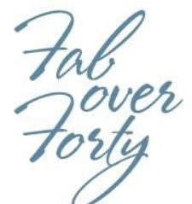](http://lovelobeauty.com/main/wordpress/wp-content/uploads/2012/03/Fab-Over-Forty-logo.jpg)[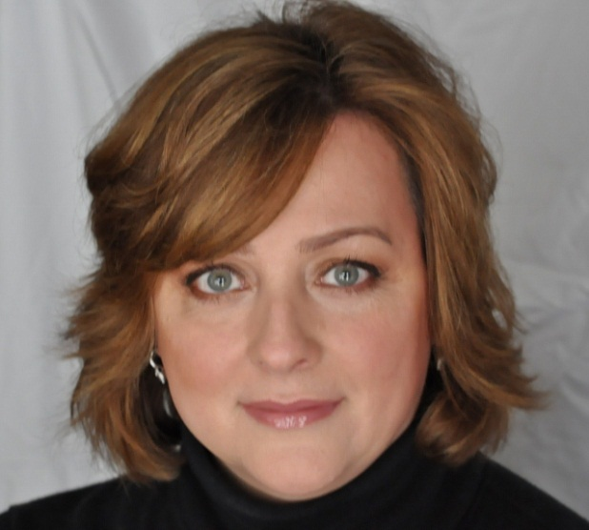](http://lovelobeauty.com/main/wordpress/wp-content/uploads/2012/03/Kari-Solyntjes.jpg)

I discovered Kari's blog about a year ago when searching for other beauty bloggers in the Twin Cities area. I was impressed with the content and beautiful layout and design. If you have not yet discovered Kari's beauty blog go over and [check it out!](http://www.faboverforty.com/)  Here are the questions and answers from our interview; enjoy!

**1. What inspired you to start a beauty blog for women over 40 and have you always enjoyed writing?**Funny thing is, before I started blogging I never wrote. I began my blog 4 years ago after reading them for about a year. I could never find anything that was for women over 40- who have different skin and beauty concerns than say a 20-year-old like most of the beauty bloggers were back then.  I thought if a 20 something can do a blog, why can't I?

**2. Who are your beauty and style icons??**  I love Ines de La Frassange and her book Parisian Chic: A Style Guide. She is the quintessential natural beauty who is happy with her looks and style.  My mother was an incredibly beautiful and fashionable woman, too. I think it's difficult to find a good role model of a natural looking beauty. Years ago many women used to try to emulate the looks and styles of many celebrities, but now it's more difficult to find as so many have altered their faces and some are even quite unrecognizable.

**3. Where do you get your inspiration for your blog posts?**  Really everywhere - from color in nature or a product or just seeing a new collection of beauty can get me going. I've always loved the colors and textures of beauty and have been obsessed with good skincare since I was a pre-teen.

**4. What are your must have beauty products?**  A good sunscreen is an absolute must, especially after having pre-melanoma twice I just don't mess with that. There are some good ones from Aveeno - Obagi, just depending on what you want to spend. My Clarisonic, Kate Somerville ExfoliKate is something I have been using for several years since she came out with her line about 4 or 5 years ago - nothing compares to it.  I'm obsessed with Dior's Capture Totale Night Cream, and Lancome Renergie Lift Volume Neck Cream. I always use a serum, eye cream and face moisturizer which can rotate quite a bit since I test a lot products.

 For makeup my favorite concealer is Le Metier de Beaute Classic Flawless concealer. It's a perfect combination of creaminess/coverage. I rotate my foundations quite a bit depending on what my skin is like that day, but one I go-to quite often is Chanel Perfection Lumiere. Can't live with out my Dior Universal Brow Styler. I don't have any specific favorites of the rest of my makeup, but there are a lot that I use and love.

**5. What types of things do you enjoy when you are not blogging?** Of course my family. I have two grown sons and my husband and for them to have this girly-mom/wife with all these beauty product, I think they just roll their eyes at me sometimes. Interior Design. I have worked in the interior design business in some form for nearly 30 years. Maybe that's why I have an obsession for makeup colors and textures!

 I really enjoyed the opportunity to interview Kari! Go check out [Fab Over 40](http://www.faboverforty.com/) and see the interview Kari did with me. :)

Love,

Lauren

(C)Lovelo Beauty 2012