- https://github.com/MoeHan-lab/inf1103-labs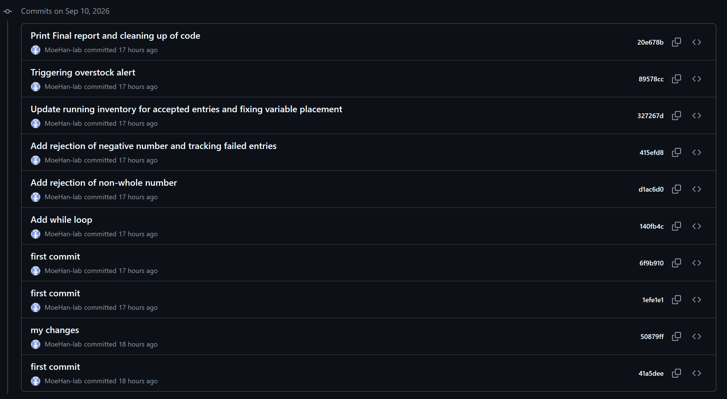
4.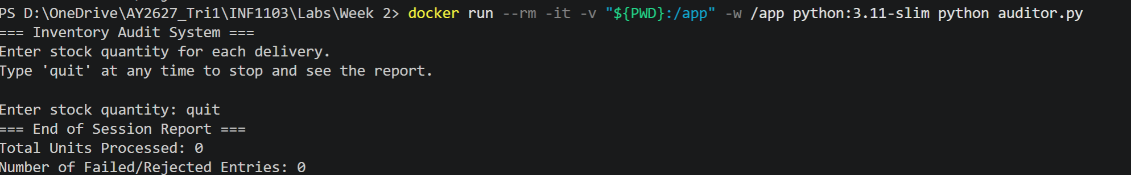
5.
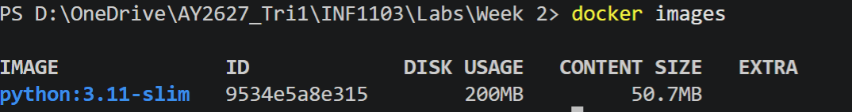
6.
