The Document Object Model (DOM)

Section 1: Introduction

Introduction to the DOM

- Javascript is used to manipulate the objects. Objects have properties (What they are) and methods (What they can do). For example the “Button” HTML object has the following properties and methods:
  - Properties: innerHTML, style, and firstChild
  - Methods: click(), appendChild(), SetAttribute()
- A method is something an object can do and it is not the same as a function. Even though they both have parentheses. A method is what the “button” object of html can do
- Definition: The DOM catalogues the web page from regular HTML page into objects that the developer can select and manipulate. The DOM represents all the objects and their content into a tree like structure. Everything in the tree is contained within the “document”. In the example image below, the “head” and the “body” are siblings and not one of them is descended from the other
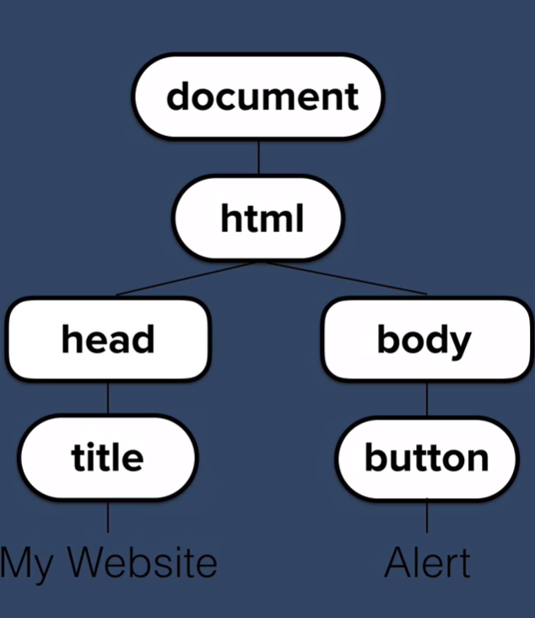
- Viewing the DOM through the Google Chrome Console
  - Typing document into the the google chrome’s console will show you the entire html file or the web page’s content
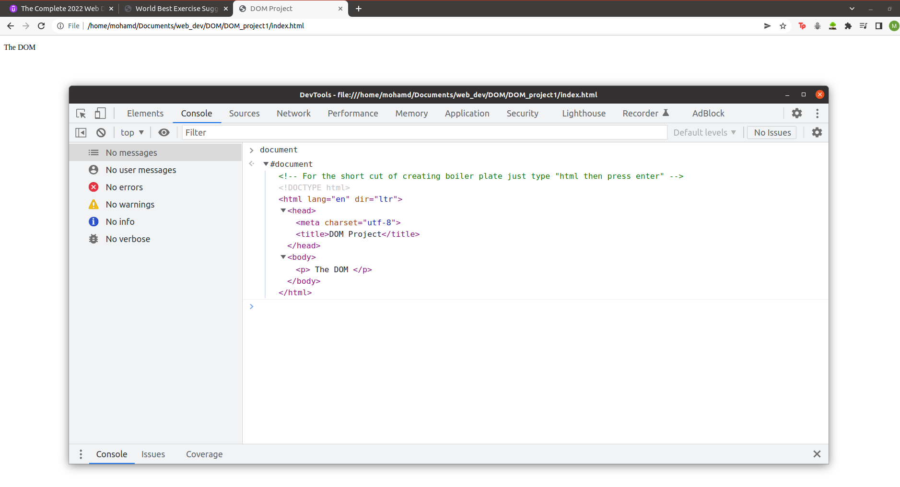
  - Typing document.firstElementChild will present the first child inside the DOM
  - Typing document.firstElementChild.firstElementChild will present the first child inside the first element within the DOM
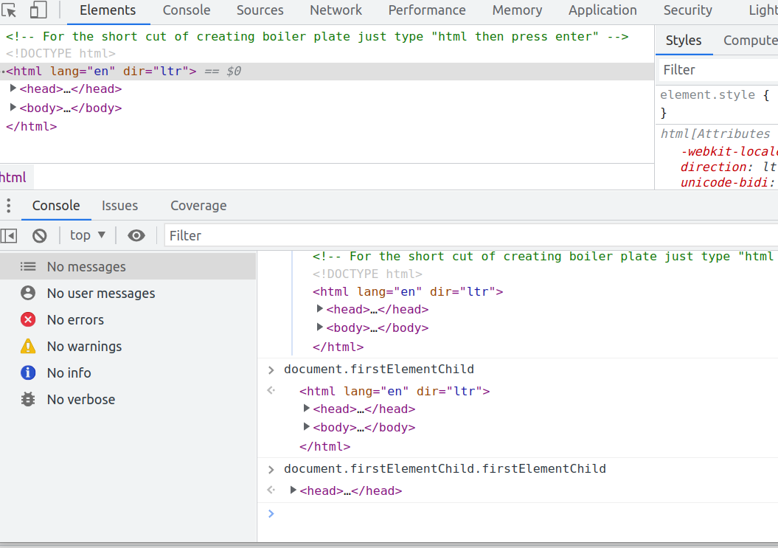
  - Typing document.firstElementChild.lastElementChild will present the last child inside the first element within the DOM

The DOT notation of the DOM

- The DOM enable us to select and manipulate specific parts of a web page using the DOT notation
  - The “Dot” notation is the notation that is used to call out a method or a property of an HTML file.
- Viewing an element inside the DOM example:
  - Typing document.firstElementChild.lastElementChild will present the last child inside the first element within the DOM
  - Referring to the image below. Typing the following: document.firstElementChild.lastElementChild.lastElementChild.previousElementSibling; will present the DOM as <p>​ The DOM ​</p>
  - The document -> the whole code
  - The firstElementChild -> HTML
  - The lastElementChild -> Body
  - The lastElementChild -> SCRIPT
  - The previousElementSibling -> to the SCRIPT -> <p>DOM</p>

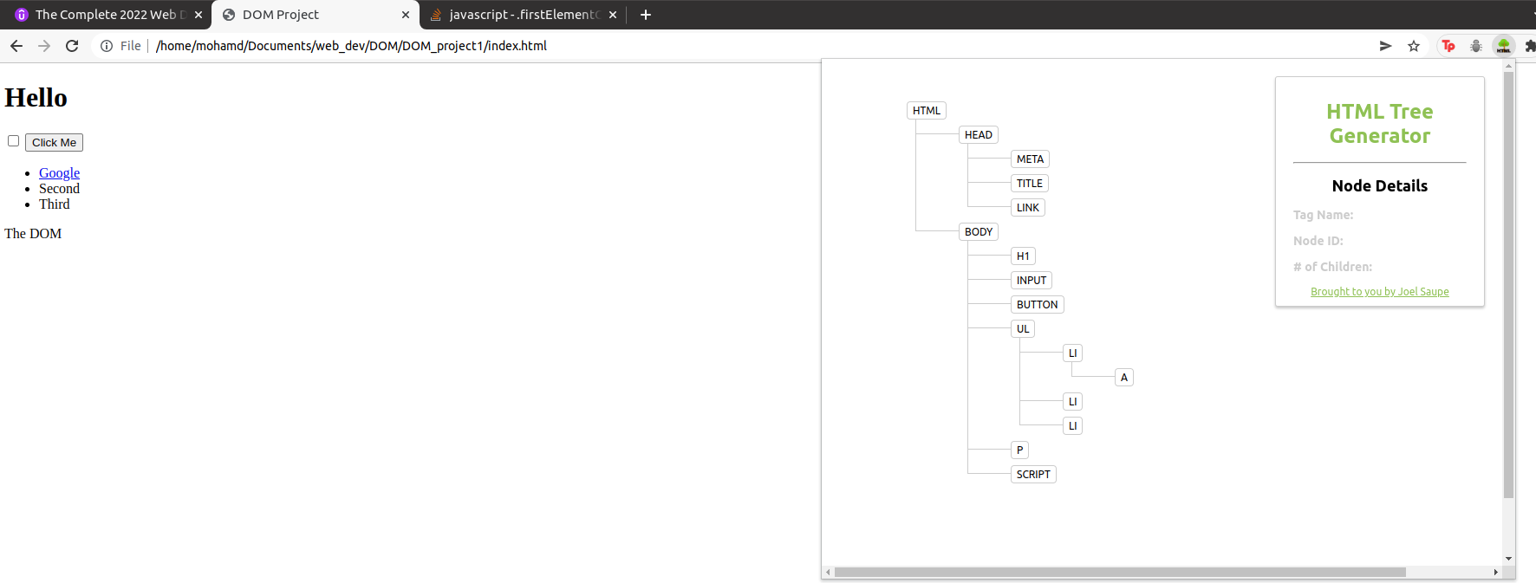
- Assigning HTML code to a variable
  - Saving the results of using the DOM’s dot notation inside a variable example:
    - var The_exp = document.firstElementChild.lastElementChild.lastElementChild.previousElementSibling;
      - Then if we type The_exp by it self it will result in the same output as document.firstElementChild.lastElementChild.lastElementChild.previousElementSibling; which was <p>DOM</p>
- Manipulating the assigned HTML to another feature
  - The_exp.innerHTML =”KOOL” this will make document.firstElementChild.lastElementChild.lastElementChild.previousElementSibling; = to KOOL
    - The .innerHTML is a property that we can change

The DOT notation - Selecting element(s) using different methods. These method are good to select an element. But do not use them for styling

- There are many methods to manipulate the content of a web page. This section covers only few including:

- The getElementsbyTagName method
  - Format: document.getElementsbyTagName(“The Element (e.g., li, p, h1)”)
    - This method will look through the whole web page and search for the elements with the specific tag
  - Example: document.getElementsByTagName("li")
    - The results will be a list with all the elements with the tag <li>. It is a list because we are asking for Elements not an Element
    - To view the length of the array we can use the .length property
  - To get a specific item within the list we must request it
    - Format: document.getElementsByTagName("li")[#]
      - This will provide you with the # item in that list
    - Example: document.getElementsByTagName("li")[2]
      - This will provide you with the second item in that list
  - To change the color of that element we must use the .style.color properties
    - Format: document.getElementsByTagName("li")[#].style.color = “the color”;
      - This will change the color of the # item in that list
    - Example: document.getElementsByTagName("li")[2].style.color = “blue”;
      - This will change the color of the # item in that list to blue
- The getElementsbyClassName method
  - Format: document.getElementsbyClassName(“The Class (e.g., Title)”);
    - This method will look through the whole web page and search for the elements with the specific class
  - Example: document.getElementsByClassName("Title");
    - The results will be a list with all the elements with the class “title”. It is a list because we are asking for Elements not an Element
    - To view the length of the array we can use the .length property
  - To get a specific item within the list we must request it
    - Format: document.getElementsByClassName("Title")[#];
      - This will provide you with the # item in that list
    - Example: document.getElementsByClassName("Title")[2];
      - This will provide you with the second item in that list
  - To change the color of that element we must use the .style.color properties
    - Format: document.getElementsByClassName("Title")[#].style.color = “the color”;
      - This will change the color of the # item in that list
    - Example: document.getElementsByClassName("Title")[2].style.color = “blue”;
      - This will change the color of the # item in that list to blue
- The getElementbyId method
  - Format: document.getElementById(“The Id (e.g., Title)”);
    - This method will look through the whole web page and search for the element with the specific Id. Note, Ids are not repeated within the document this is why you will get an item not a list
  - Example: document.getElementById("Title");
    - The results will be a single item that id contains
  - To change the color of that element we must use the .style.color properties
    - Format: document.getElementById("Title").style.color = “the color”;
    - Example: document.getElementById("Title").style.color = “blue”;
      - This will change the color of the # item that hold the Title Id
- The querySelector method
  - This method is able to return a single item. And it is differs from the other methods because it allows the user to select an element, an ID and a Class. Individually or combines them
  - A selector is used in the styles.css page
    - Selectors are the part that is specified before the curly braces in the css page
      - For elements, just add the name of the element(s) = (e.g., body, p)
      - For classes, a period must be added in front of the name of the class= (e.g., .nav-link, .nav-item)
      - For ids, you must add a pound sign to represent an Id = (e.g., #nav-bar)
    - Selectors can combine multiple classes or multiple elements or multiple ids or even multiple classes, elements, and ids all together
  - Format
    - document.querySelector(“The element = (“The_element”), class =(“.The_Class”) or id = (“#The_Id”);
    - This method will look through the whole web page and search for the content of the specific element, class or ID. In case where the element (e.g., h2) is repeated then the content of the first h2 will be the output of the DOM call. The search goes from top to bottom
  - Example For an Element(s):
    - document.querySelector("h1, p");
    - The results will be a single item that that element contained. If there are multiple then the content of the first parameter within that element will be presented
  - Example to change the color of that element we must use the .style.color properties
    - Format: document.querySelector ("h1").style.color = “the color”;
    - Example: document.querySelector ("h1").style.color = “blue”;
      - This will change the color of the content of h1. The first h1
  - Example For an Id(s): document.querySelector("#title");
    - The results will be a single item that that id contained
  - Example to change the color of that element we must use the .style.color properties
    - Format: document.querySelector ("#title").style.color = “the color”;
    - Example: document.querySelector ("#title").style.color = “blue”;
      - This will change the color of the the content inside the elements that contain #title Id
  - Example for an Class(es): document.querySelector(".title");
    - The results will be a single item that that class contained. If the class contains multiple items then this will be the first
  - Example change the color of that element we must use the .style.color properties
    - Format: document.querySelector (".item").style.color = “the color”;
    - Example: document.querySelector (".item").style.color = “blue”;
      - This will change the color of the first element that has the class .item class
  - There are two ways of calling out results for the querySelector mixed inputs
  - Both of these methods will always return the first item when the same selector method works for multiple items. In the case to over come this issue you must use the querSelectorAll method
    - The first way is a “Hierarchical way”.
      - The hierarchical way is when the two items or more we are calling are not on the same line of code.
    - The second way is on the “Same line way”.
      - the same line way is when the two items or more we are calling are on the same line of code
        - Items are on the same line of code when they are not separated by the code separators < and >
          - For example: The class item and the element li are on the same line in this line of code
            - <li class="item">Second</li>
  - Hierarchical way example:
    - document.querySelector("#list a");
      - In this DOM call out we are looking for the content of the element a which is inside the id #list. Both of them are not on the same line of code
      - The order of the DOM call out for the “Hierarchical way” matters. What ever close to the content we are seeking comes second in this case the a element
      - If the call out occurs in different lines of code there should be space between the inputs
  - Same line way example:
    - document.querySelector("li.item");
      - In this DOM call out we are looking for the content of the element li which is inside the class .item. Both of them are on the same line of code
      - The order of the DOM call out for the “Same line way” matters. What ever close to the content we are seeking comes second in this case the .item class
      - If the call out occurs in different lines of code there should be no-space between the inputs
- The querySelectorAll method
  - This method is ideally used when a single call out from the querySelector method is applicable for multiple returns. Therefore querySelectorAll returns its results in the form of a list. This allows the user to specify their output the item number from the list from the list
  - Example selecting a second item in a list: document.querySelectorAll("li.item")[1];
    - The usage of querySelectorAll and [1] are important, because document.querySelector("li.item") is applicable for three items

  - Example changing the color a second item in a list: document.querySelectorAll("li.item")[1].style.color=”red”;
    - This will change the color of the second element to red

Manipulating elements Using CSS properties with JS

- JS has its own method to manipulate the property of an element. However, JS can also manipulate the properties of elements using CSS
- The HTML DOM Style Object documentation is available at: https://www.w3schools.com/jsref/dom_obj_style.asp
  - The differences between using JS instead of CSS is presented in the above link.
- JS can be use the CSS methods to manipulate elements’ features but with slight differences:
  - In CSS there is no camel casing, there are dashes, and the actual properties are not written in the form of strings
    - For Example:
      - background-color: #85C1E9;
  - In JS there is Camel Casing (except for the first letter of the first word that stays lower case), there are no dashes, and the actual properties are written in the form of a string
    - For Example:
      - document.body.style.backgroundColor="#85C1E9";

The Separation of Concerns: Structure vs Style vs Behaviour.

- When properly designing websites you must separate the purposes of
  - HTML for structuring (e.g., for contenet only)
  - CSS for styling (e.g., add styles for elements, classes, and IDs)
  - JS for behaviour (e.g., control the reaction of elements)
- The classList
  - This is a property of every DOM object
  - The classList is used to view all the classes associated with an element. Then from knowing these classes we can use other JS methods to add classes to those elements. The classes will be controlled by CSS in the styles.css sheet but the act of adding classes to elements will be controlled by JS
  - For example viewing an element’s classes:
    - document.querySelector('li').classList;
  - Adding a class to that element
    - document.querySelector('button').classList.add("newclass");
      - After adding the class ‘newclass’ we can go to the style.css sheet and update that element or leave it alone if it already existed before and utilize its settings
      - Adding classes allow us to add different features to element at different operational stages of a website.
      - The class does not require a dot . before it
  - Removing a class to that element
    - document.querySelector('button').classList.remove("newclass");
      - removing classes allow us to add different features to element at different operational stages of a website.
      - The class does not require a dot . before it
  - Toggling a class to that element
    - document.querySelector('button').classList.toggle("newclass");
      - Toggling means if the class is already available on the element, then remove it and if the class is not available on the element then add
      - Personally I prefer using the classList.remove and classList.add methods
      - The class does not require a dot . before it

Manipulating HTML using JS

- Methods
  - The innerHTML method
    - The innerHTML is the HTML in between the element tags
    - For example in the following line of code:
      - <h1 id="title"><yo>hello</yo></h1>
    - Typing the following in JS
      - document.querySelector('h1').innerHTML;
    - Will produce the following
      - <yo>hello</yo>
        - This is produced because innerHTML provides everything between the called upon element (e.g., h1)
  - The textContent method
    - The textContent is the text in between the element tags
    - For example in the following line of code:
      - <h1 id="title"><yo>hello</yo></h1>
    - Typing the following in JS
      - document.querySelector('h1').textContent ;
    - Will produce the following
      - hello
        - This is produced because textContent provides only the text between the called upon element (e.g., h1)
- Attributes
  - Are all the things that get coloured orange in “Atom”. This includes type, class, href, src, charset. Everything that goes into the tag is an attribute expect the tag it self
  - To get a list of all the attributes that are attached to an element you must use attributes method
    - For example typing -> document.querySelector('h1').attributes; or document.querySelector('a').attributes;
      - This will produce a list of all the attributes attached to the selected elements
    - Change the website of an “a” element. From google.ca to bing.com. The setAttribute must be used, this method takes two inputs. The href (The actual attribute) and the output of that href which is 'https://www.bing.com'
      - Type the following -> document.querySelector('a').setAttribute('href', 'https://www.bing.com');

