How to Make a website people will love

Introduction
- A typeface is the design of lettering that can include variations in size, weight (e.g. bold), slope (e.g. italic), width (e.g. condensed), and so on. Each of these variations of the typeface is a font. There are thousands of different typefaces in existence, with new ones being developed constantly
- The four principals of web design are: Color Theory, Typography, User Interface (UI) Design, User Experience (UE) Design

Color Theory
- A good resources for colors is -> colorhunt.co
- The five moods of color theory:
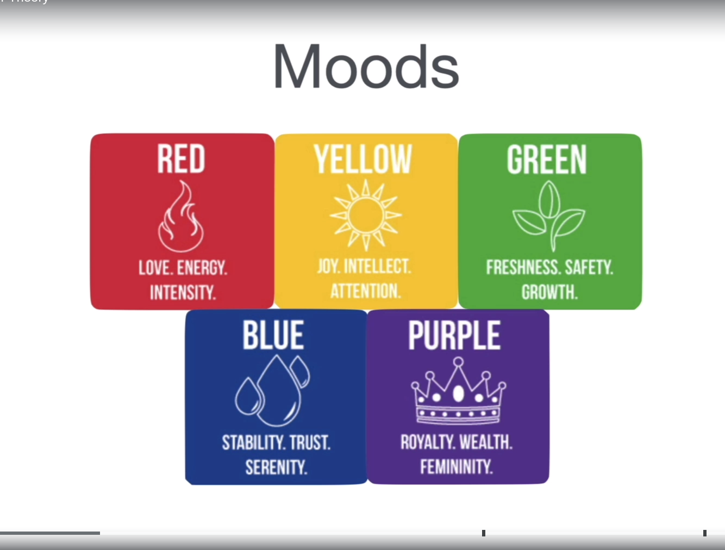
  - Red: is a lot of energy which is why a lot of car ads have red
  - Yellow: is a joy color, and it forces people to pay attention. It is good for a quick add not a long term item. Yellow might hurt the viewers eyes
  - Green: This healthy color. Which is why a lot of food delivery/grocery companies use this color
  - Blue: This color makes the user feel safe. This is why a lot of credit card companies who promotes that they are trust worthy use the color blue as one of their main colours
  - Purple: This color is used to target women or present wealth/royalty
- Colours Combinations
  - An analogous color pallet: is when the designers takes two or more colours of the a very similar color schemes (e.g., light and dark green)
    - This method allows for color homogeneity. Use mainly for text and its background
    - Tends to be used in websites background color and the websites navigation bar
    - Logo and its background sometimes
  - Complementary Color Pallet or Clashing Color Pallet: is when designers take two colors of a very different color schemes (e.g., green and red)
    - This method allows for the colours to stand out.
    - You should avoid using a complementary color pallet for text and text background. Mainly use for logos or icons
    - A real world example is uing the complementary color pallet in the grocery stores where they try to make things pop (i.e., the meal aisle in the super market, where plastic grass is placed beside the beef. This gives the customer the idea of freshness of the meat)

Typography (Fonts)
- Typography have four families or typefaces that are important: Serif, San-Serif, Script, Display, Modern ( A new family)
  - A typeface is the design of lettering that can include variations in size, weight, slope, width, and so on. Each of these variations of the typeface is a font.
- Serif: Used to make the design more serious and little bit of an older test. They are traditional, stable, and respectable type of fonts
- San-serif, They make the design look more sensible, simple, and straight forward.
  - They have 90 degrees in their fonts and they tend to be used by startups
- Script, They make the design more personal, creative, and elegant
- Display, They make the design more friendly, loud, and amusing
- Modern, it is not considered part of the four main typography families, but it can be looked at as the fifth. The modern typography make the design more stylish, chic, and smart
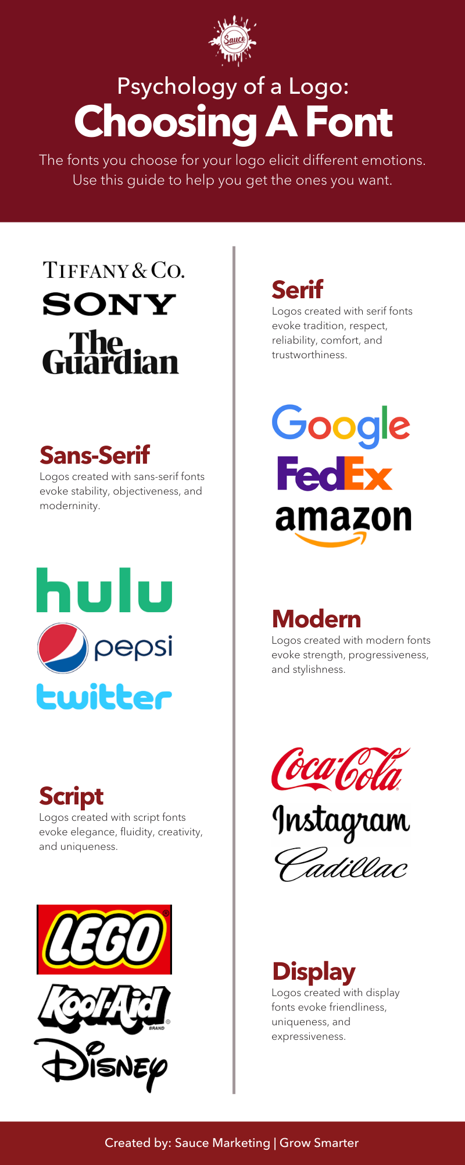
- Notes while designing a web application:
  - You should stick to 2 fonts
  - The 2 fonts should be of a similar mood instead of moods we can we use different weights
  - Avoid difficult to read fonts or typefaces

User Interface Design (UI) Design
- The UI design’s goal it to make the customer or the audience be interested in your web page for as long as possible. Therefore that are five important parameters to focus on and they are presented below:
- 1. The hierarchy of UI forces the brain always focuses on the bigger and the bolder text.
  - This is why titles differ from regular paragraph text and they tend to have one or any combo of the below or all of them:
    - A different color
    - The size of font. The larger the more attention is drawn into to that text
    - bolder

- 2. The layout of the UI is important because the more interesting the layout the more attention the brain will pay
  - One layout important parameter is the width of a paragraph on a web page. The perfect width is around 40-60 characters per line
- 3. The alignment or positioning each element on the screen relative to each other is extremely important. If the alignment between elements is consistent it makes the brain much more interested
- 4. The white space or empty space . The more empty space or white space you have the more rich and wealthy your design looks.
  - This is interesting because when things are spaced our they are given higher value
- 5. The audience, as a designer you must make the design based on the audience (i.d., who will be viewing your web application)

User Experience (UX) Design
- The UX Design, is the ability to allow the audience of your web page to use your website and feel like using your website is effortless and easy. There are five pillars of UX desingers must focus on.
- 1. The simplicity, keeping things simple is always better and makes the audience feel like they are in control and keeps the audience interested
- 2. Consistency, keeping thing consistent makes your design look professional and consistency reduces the confusing when the audience is using your website
- 3. The audience reading pattern. Humans tend to have the F pattern reading pattern. This is when users tend to start reading from the top left and from there go down line by line
  - Another common pattern is the Z pattern (e.g., the Facebook webpage)
- 4. UX must be useful in all platforms for example, a mobile site and a website
  - In the mobile version you should avoid many elements, because remember the user is using their hands
- 5. As a designer you must always remember to be good and be a good human. Do not use your design powers for evil.
  - Do not try to force users attention to use website so you can just steal their info or force them to pay for more money even they don’t need too
  - In the design world the evil patterns are known as the “Dark Patterns”

