Notes For SQL Boot Camp Course

Section 0: General Notes

Goals
- Your goal is to learn the SQL syntax and learn exactly what each SQL syntax do.
- You must keep in mind that all of the SQL syntax will be the same anywhere (with a GUI or on a command line).
- When you complete the course perform all the tasks that you did in pgAdmin in the command line

Definitions
- SQL: is a programming language that stands for (Structured Query Language). It is used to manage data in a relational database. A relational data base is a data base that has relationships between its data. The data is presented in the from of tables. Thus, a relational data base is a data base that has relationship between tables. SQL is used to get data out of a database or put data in a database
- PostgreSQL: also known as postgres it a relational data base management system.
  - PostgresSQL, is a platform option for SQL or which is also known as a SQL engine
  - PostgreSQL is the software used to store, manage, query, and retrieve data stored in a relational database is called a relational database management system (RDBMS). The RDBMS provides an interface between users and applications and the database, as well as administrative functions for managing data storage, access, and performance
  - RDBMS is a database management system. And SQL is the language used for communicating with data in an RDBMS
- PgAdmin: A GUI for connecting with PostgreSQL and perform queries
- NoSQL: Stands for “Not Only” SQL and it designed for web applications. It is better during the scaling out of the system (distribution of data into multiple hosts). It does not use SQL to query data.
- Database: A systematic collection of data. It enable users to access data, manipulate data, present data, and control the access to the data
- Host: In networking host is the computer we are working with. My pc is known as “localhost”. However, if I would like to connect to a server over a network. Then for the location of “localhost” I must type the IP address, which is the Internet Protocol Address. The number that is associated with a specific computer or a computer network
- Port in Networking: A port in networking is a software-defined number associated to a network protocol that receives or transmits communication for a specific service
  - For the specific service of PostgreSQL the port is 5432
- Port in Computer Hardware: A port in computer hardware is a jack or socket that peripheral hardware plugs into

Overview of Databases
- What are Databases:
  - Are systems that allow users to store and organize data. They are useful when dealing with large amounts of data
- Spread Sheets Vs. Databases
  - Spread Sheets are ideal for:
    - One time analysis
    - Ability to quickly chart something
    - Limited data set sizes
    - Good for untrained people to work with data
  - Databases are ideal for:
    - Data integrity, meaning that it is not easy for other people to quickly modify the data
    - Can easily handle massive amounts of database
    - Can quickly combine different data sets
    - Able to automate steps for re-usage
    - Able to provide support for data for websites and applications

- Transition From Spread Sheets to Databases
  - Databases tables can be looked at as the tabs in a spreadsheet.
  - A database is made up of multiple tables and each table contains vertical columns and horizontal rows that store the data in

Installation pgAdmin

- 1. From the pgAdmin webpage. Install the public key for the repository (if not done previously) by typing the following in the terminal ->
  - curl https://www.pgadmin.org/static/packages_pgadmin_org.pub | sudo apt-key add
    - You may want to add sudo before curl
- 2. From the pgAdmin webpage. Create the repository configuration file by typing the following in the terminal ->
  - sudo sh -c 'echo "deb https://ftp.postgresql.org/pub/pgadmin/pgadmin4/apt/$(lsb_release -cs) pgadmin4 main" > /etc/apt/sources.list.d/pgadmin4.list && apt update'
- 3. install pgAdmin for both desktop and websites
  - Type -> sudo apt install pgadmin4
- Please note: use either desktop mode or web mode and stick to it
- 4. install pgAdmin for seperate desktop and websites
  - 4.1 If you want to install pgAdmin for desktop only (You Do Not Need To Do This)
    - Type -> sudo apt install pgadmin4-desktop
  - 4.2 install pgAdmin for web mode (You Do Not Need To Do This)
    - Type -> sudo apt install pgadmin4-web
  - 4.2.0 If you installed the web server. You must configure it by typing sudo (You Do Not Need To Do This)
  - Type -> sudo /usr/pgadmin4/bin/setup-web.sh
    - You can access the pgAdmin web mode using -> http://127.0.0.1/pgadmin4/login?next=%2Fpgadmin4%2F

Features of PostgreSQL (Using The The GUI pgAdmin)

- Opening pgAdmin
  - 1. You will be asked to enter the password for pgAdmin
    - I setup that password to be *Ir......
  - 2. You must click on the server, which I setup to be local PG
    - I set it up to be the server to represent the root user of postgreSQL postgres. By specifying the following:
      - The host name as “localhost”
        - If we were connecting to a server over the internet we would type the IP address instead of “localhost”
      - Port as 5432
      - Username postgres
    - the password for that server is password

- Creating a Database on pgAdmin
  - 1. Below the server local PG, right click on Databases and click Create. Then select Database...
  - You can enter:
    - the name of the database
    - Specify the owner
    - Add comments
- Restoring a Database of .tar format on pgAdmin
  - 1. At the recently added database. Right click and select Restore...
  - 2. A window will open up. If the format of the file is Custom or tar. Make sure the Format section says “Custom or tar”
  - 3. Add a File name + its pwd and click restore
  - 4. Go to Data/Objects tab
  - 5. Change the following from Off to On in Sections
    - Pre-data
    - Data
    - Post-data

- Viewing the Tables in a DB
  - 1. Go to the database
  - 2. Within the database go to Schemas
  - 3. Go to Tables -> this will show you the number of tables and the number of columns wach table has

- Performing a Query on a DB
  - 1. Login to the DB
  - 2. Right click on the DB and select “Query Tool”
  - 3. This will open up the Query Editor window. In the Query Editor window type your SQL commands

Section 1: SQL Statement Fundamentals

Notes
- You do not need to capitalize the SQL code but you should do it fro readability
- Every SQL statement ends with semicolon “;”
- You want to execute the logic then you execute your ORDER BY and the LIMIT. Both of these Function/Keyword are useful but must go in the bottom. Because, they are less useful than other Functions/Statements

Data Types
- In SQL there are many different data types. Those data types are specific for each column in a table and are written right below the column’s name
- Data Types include:
  - biginit
  - init
  - smallinit
  - tinyinit
  - integer
  - numeric
  - timestamp without time zone
  - timestamp with time zone
  - date
  - time

SELECT Statement

- This statement allows us to retrieve information from a table
- Whenever comes after SELECT is what we are retrieving during the query

- Exp: SELECT <column_name> FROM <table_name>;

- Exp: SELECT <column_name>,<column_name> FROM <table_name>
  - A specific number of columns. The column names must be separated by a comma

- Exp: SELECT * FROM <table_name>;
  - To select all the columns use the * wild card

- Exp1:
  - Use the SELECT statement to grab the first and last names of every customer and their email address
    - SELECT first_name,last_name,email FROM customer;
      - The columns selected are: first_name,last_name,email
      - Table: customer

SELECT DISTINCT Statements

- This statement returns only the list of the unique/distinct values within a column. This can be used when a table that are calling contains a column(s) that has duplicate values

- Exp1: SELECT DISTINCT <column_name> FROM <table_name>;

- Exp2: SELECT DISTINCT<column_name>,<column_name> FROM <table_name>;
  - A specific number of columns. The column names must be separated by a comma

- Exp3: SELECT DISTINCT * FROM <table_name>;
  - To select all the columns use the * wild card

- Exp4:
  - Use the SELECT DISTINCT statement to grab all the unique types of ratings of movies we have in our database
    - SELECT DISTINCT rating FROM film;
      - The column selected is: rating
      - Table: film

SELECT COUNT Statement/ Aggregate Function

- This statement returns only the number of input rows that match a specific condition of a query (an inquiry)
- COUNT alone is a function that is acting on something. Therefore it requires the parenthesis ()

- Exp1: SELECT COUNT (<column_name>) FROM <table_name>;

- Exp2: SELECT COUNT(<column_name>),(<column_name>) FROM <table_name>;
  - A specific number of columns. The column names must be separated by a comma

- Exp3: SELECT COUNT (*) FROM <table_name>;
  - To select all the columns use the * wild card and it must be inside parenthesis

- Exp4: SELECT COUNT(DISTINCT<column_name>)FROM <table_name>;
  - This will select only the distinct rows in the columns and return their count

- Exp5:
  - Use the SELECT COUNT DISTINCT statements to grab all the amount of unique payment types
    - SELECT COUNT (amount) FROM payment;
      - The column selected is: amount
      - Table: payment
      - Explanation: FROM the payment table, SELECT the rows in the amount column, and then COUNT it their number
      - Note: because tables have equal number of rows for each column we could have put (*) instead of (amount)
- Exp6:
  - Use the SELECT COUNT DISTINCT statements to grab all the amount of unique payment types
    - SELECT COUNT(DISTINCT amount) FROM payment;
      - The column selected is: amount
      - Table: payment
      - Explanation: FROM the payment table, SELECT the DISTINCT rows in the amount column, and then COUNT it

SELECT WHERE Statements

- The WHERE statement allows us to specify conditions on columns for the rows to be returned
- Also, you might notice that when the SQL code get too long you can break them down into multiple lines
- The conditions:
  - are used to filter the rows returned from the SELECT statement
- Basic Syntax SELECT <column_name>,<column_name> FROM <table_name> WHERE <conditions> ;
  - In regards of the condition's If your inputs were words like: (Nancy, Red, etc). Then you must have them between single quotation marks ‘ ‘. If they are numbers you do not need too. But a good practice is to have everything conditional between singal quotation marks ‘ ‘
  - The filtration part of the <conditions> looks like the following after adding WHERE to it-> WHERE column> ’2’
    - Even though this is a number. If we add ‘ ‘ is a good practice
- Conditions Types:
  - 1. The comparison operators: compare a column’s value to something
    - Comparison operators: =, >, <, >=, <=, <> or !=
  - 2. The logical operators: allows us to combine multiple comparison operators or allows us to combine the effects of multiple comparison operators
    - Logical operators: AND, OR, NOT

- Exp1:
SELECT name,choice FROM colours
WHERE name =’David’;
  - From the colours table. Select the name and choice columns. Then filter out the rows (Where) the input of the name column is David

- Exp2:
SELECT name,choice FROM colours
WHERE name =‘David’ AND choice=‘Red’;
  - From the colours table. Select the name and choice columns. Then filter out for the rows (Where) the input of the name column is David and the input of the of the choice column is Red

- Exp3 (Challenge 1): A customer forget their wallet at our store! We need to track down their email to inform them. What is the email for customer with the name Nancy Thomas
SELECT first_name,last_name,email FROM customer
WHERE first_name = 'Nancy' AND last_name = 'Thomas' ;

- Exp4 (Challenge 2): A customer wants to know what the movie “Outlaw Hanky” is about. Please provide a description
SELECT title,description FROM film
WHERE title = 'Outlaw Hanky';
- Please note: if you wanted only the description in the results not the title and the description. Then beside select only have description but still filter out with title

- Exp5 (Challenge 3): A customer is late on their movie return, and we have mailed them a letter to their address at ‘259 Ipoh drive’. We should call them on the phone to let them know. Find the phone number for this customer
SELECT phone FROM address
WHERE address = '259 Ipoh Drive' ;
- Please note: The table’s name is address and a column inside that table has the name also the name address. Additionally, in the results if you wanted to view the address and phone number together along the same row you would have needed to type SELECT phone, address instead of only SELECT phone, because typing SELECT phone will only show you the phone number at the conditions that is stated by the WHERE filtration condition

ORDER BY Statements

- Using ORDER BY enable us to sort rows based on a column value. In either ascending or descending order.
- The ORDER BY must be added at the end of a query, since we want to do any selection and filtration first, before finally sorting.
- The basic syntax for ascending order :
SELECT <column_name1>,<column_name2> FROM <table_name>
ORDER BY <column_name1> ASC ;
- The basic syntax for descending order :
SELECT <column_name1>,<column_name2> FROM <table_name>
ORDER BY <column_name1> DESC ;
- If you do not put either ASC or DESC then ORDER BY will assume ASC by default
- ORDER BY may be used on multiple columns. This makes sense when one column has duplicate entries. The second ORDER BY will always be based on the results of the first ORDER BY

- Exp1: While selecting everything. Organize the results by the store ID in an ascending order. Then organize it by the user’s first name in an descending order
SELECT * FROM customer
ORDER BY store_id ASC, first_name DESC ;

LIMIT Keyword

- Using the LIMIT function limits the amount rows we get in our results. It is ex termly useful with the ORDER BY function. The LIMIT keyword goes at the very bottom end of a query request. Even below the ORDER BY functions
  - Essentially, all the LIMIT function does is limit the amount of rows you want

- Exp1: While selecting everything. Organize the results by the store ID in an ascending order. Then organize it by the user’s first name in an descending order. Then limit the results to 10 rows
SELECT * FROM customer
ORDER BY store_id ASC, first_name DESC
LIMIT 10 ;

- Exp2: (Challenge 1): We want to reward out first 10 paying customers . Find the customer ids of the first 10 customers who created payment ?
SELECT customer_id FROM payment
ORDER BY payment_date ASC
LIMIT 10;
- Please note: Filtered using payment_date ASC. However, our results were given for the customer_id, because that is the column we used SELECT for.

- Exp3: (Challenge 2): A customer wants to quickly rent a video to watch over their short lunch break. What are the titles of the 5 shortest views in length
SELECT title,length FROM film
ORDER BY length ASC
LIMIT 5;

- Exp4: (Challenge 3): If the previous customer can watch any movie that is 50 minutes or less in length. How many options does he have ?
SELECT COUNT(title) FROM film
WHERE length <= 50;

BETWEEN Operator

- The BETWEEN operator can be used to match a value against a range of values
- Basic syntax:
  - <value> Between <lower-limit> AND <upper-limit>
- Often the BETWEEN operator is a condition that maybe used with the WHERE statement
  - Both below SQL codes are the same:
    - <value> BETWEEN <lower-limit> AND <upper-limit>
    - <value> >= <lower-limit> AND <value> <= <upper-limit>
- The BETWEEN operator can be used with the NOT operator. Also, the below SQL codes are both the same:
    - <value> NOT BETWEEN <lower-limit> AND <upper-limit>
    - <value> < <lower-limit> OR <value> > <upper-limit>
- The BETWEEN operator can be used with dates. The dates must have a YYYY-MM-DD format. Therefore you may type the following SQL code
- For dates you do need a single quotation marks ‘ ‘
    - <date> BETWEEN ‘2007-01-01’ AND ‘2007-01-31’

- EX1: From a table. Figure out the payments between $8 and $9
SELECT * FROM payment
WHERE amount BETWEEN 8 AND 10;
- The column: *, which means all the columns must be returned that satisfy the query
- The table: payment
- Please note: The BETWEEN operator needed to be used with the WHERE statement

- Exp2: From a table. Select all the payment between two dates> Method 1
SELECT * FROM payment
WHERE payment_date > '2007-02-07' AND payment_date <'2007-02-15' ;
- Please note: SQL goes up to the 0:00 hour mark of the <upper-limit> aka end date. Therefore, whatever date you input as the end. SQL will show everything that happened up to the 0:000 of that date. Therefore. In the example about SQL will not return anything that happened at 5 pm on '2007-02-15', but it will return anything before at 2007-02-15' zero hours. Thus. To get everything that happened on 2007-02-15' our end date must be ‘2007-02-16'

- Exp3: From a table. Select all the payment between two dates> Method 2
SELECT * FROM payment
WHERE payment_date BETWEEN '2007-02-07' AND '2007-02-15' ;
- Please note: SQL goes up to the 0:00 hour mark of the <upper-limit> aka end date. Therefore, whatever date you input as the end. SQL will show everything that happened up to the 0:000 of that date. Therefore. In the example about SQL will not return anything that happened at 5 pm on '2007-02-15', but it will return anything before at 2007-02-15' zero hours. Thus. To get everything that happened on 2007-02-15' our end date must be ‘2007-02-16'

ON CONFLICT KEYWORD

- The ON CONFLICT keyword allows us to handle conflicts & errors
- Conflicts could be a value that is repeated etc but it has a constrain that it must be UNIQUE
- The ON CONFLICT keyword is usually followed by the ,DO NOTHING keyword. Therefore, an error is not presented
- Exp:
INERT INTO <table> (<column(s)>) VALUES (<row(s)>) ON CONFLICT (<column(s)>) DO NOTHING ;

  - The <column(s)> do not need to be added. But in a way whatever column you do not add there and if you do not get an error then you know that your query is good. Therefore, in a way it can act like a trouble shooting code

IN Operator (Best of list of specific numbers within a column)

- Using the IN keyword allows us to create a condition that checks to see if a <value> is included IN a list that contains multiple options . Also, IN is an operator that is often used with the WHERE statement
- The IN operator expects parenthesis ( ) and single quotation marks ‘ ‘ inside the parenthesis ( ‘ ‘ )
- When having multiple operations. The comma , acts as an OR statement
- The NOT operator may be used with the IN operator
- The general syntax:
<value> IN (option1, option2,......, optionn)
- Exp1:
SELECT colour FROM table1
WHERE colour IN (‘red’,’blue’)
  - We are checking for the colour condition that happens to be either red or blue
- Exp2: Return all the data from the payment table. That has an amount of 0.99, 8.97, and 8.99. The column that must be executed is the amount column
SELECT * FROM payment
WHERE amount IN (0.99,8.97,8.99) ;
- Please note: we are not using a single quotation ‘ ‘, because ti is a numerical value

- Exp3: Return all the data from the payment table. Except the data that has the amount of 0.99, 8.97, and 8.99. The column that must be executed is the amount column
SELECT * FROM payment
WHERE amount NOT IN (0.99,8.97,8.99) ;
- Please note: we are not using a single quotation ‘ ‘, because ti is a numerical value

LIKE and ILIKE Keywords and % and _ wildcard characters

- The LIKE or ILIKE operators only used for patterns. If you attempt to use the LIKE or ILIKE for a column of only one input (12 or 2006 or R) you will get an error, because SQL prefers if you use the = operator.
- The LIKE or ILIKE operators with wildcard characters of % _ helps us perform pattern matching against string data.
- LIKE and ILIKE are the same exact thing. However the results that LIKE produces is case sensitive meaning. If you put LIKE (J#). This means it will only look for capital J. While ILIKE is case insensitive meaning, if you put ILIKE (J#) it will return words with J and j.

- The percentage sign %
  - Matches any sequence. Acts similar to * in GUN/Linux
- Exp1: Find all the names that start with A
  - WHERE name LIKE ‘A%’;
- Exp2: Find all the names that end with j
  - WHERE name LIKE ‘%j’;
- Exp3: Find all the names that start with J in the table customer
SELECT * FROM customer
WHERE first_name LIKE 'J%';

- Exp4: Find all the names JK within the name the table customer
SELECT * FROM customer
WHERE first_name LIKE '%JK%';

- The underscore sign _
  - Matches any single character and does actions on it. Acts like the % sign in GNU/LINUX
  - Also, you may use multiple underscores
  - Each single _ represent a single character, while % in SQL represent anything
- Exp5: Get all the Mission Impossible Impossible films
  - WHERE title LIKE ‘Mission Impossible _%’;
    - Here, _ is represent Mission Impossible 1 or Mission Impossible 2, etc
- Exp6: Find all the names that are 5 letters but start with DAV a middle the table customer
SELECT * FROM customer
WHERE first_name LIKE 'DV__';

Section 1: SQL Statement Fundamentals

Challenge 1 Question:
- How many payment transaction were greater than $5.00 ?
SELECT COUNT(*) FROM payment
WHERE amount > '5.00';
Challenge 1 Answer:
- 3618

Challenge 2 Question:
- How many actors have a first name that starts with P ?
SELECT COUNT(*) FROM actor
WHERE first_name LIKE('P%');
Challenge 2 Answer:
- 3618
- LIKE works here because we are looking for a pattern. If it asked how many words are exact the letter P. Then we would need to use the = oparator

Challenge 3 Question:
- How many unique districts are our customers from
SELECT COUNT (DISTINCT district) FROM address;
Challenge 3 Answer:
- 378
- Please remember: You need to count the DISTINCT districts. Therefore you find the DISTINCT districts then you use the COUNT function on them

Challenge 4 Question:
- How many unique districts are our customers from ?. Then retrieve the list of names for those districts
SELECT DISTINCT district FROM address;
- Please remember: for anything you want COUNT you must have parenthesis around it. Otherwise SQL will assume that you want the full row
Challenge 4 Answer:
- A list of distinct 378 districts

Challenge 5 Question:
- How many films have a rating or R and a replacement cost between 5 and 15
SELECT COUNT(*) FROM film
WHERE rating = 'R'
AND replacement_cost > 5 AND replacement_cost <15 ;
Challenge 5 Answer:
- 57
- Note: I attempted to use LIKE ‘R’ but I got an error. This is mainly because LIKE is used for patterns like names or dates. Like would work perfectly for searching for a name -> LIKE (moham%)

Challenge 6 Question:
- How many films have the word Truman somewhere in the title
SELECT COUNT(*) FROM film
WHERE title LIKE ('%Truman%')
Challenge 6 Answer:
- 5

Section 2: GROUP BY Statements

Notes
- GROUP BY allows to aggregate (group or accumulate) data and apply functions to better understand how data is distributed per category
- The HAVING call. Allows to filter the GROUP BY data

Aggregation Functions

- The main idea of aggregate functions is to take multiple inputs and return a single output
- Aggregate functions are only carried on with the SELECT and the HAVING statements
- The most common aggregate functions:
  - AVG (<value-1>,<value-2>,....,<value-n>) -> returns the average value
    - The average value may be a floating number with many decimal places or decimal places. Therefore we could use ROUND ( <value-n>,<number-of-decimal-places>) to configure that
    - ROUND ( <value-n>,<number-of-decimal-places>) -> returns the rounded number to the exact indicated <number-of-decimal-places>
      - Exp: SELECT ROUND (AVG (replacement_cost),5) FROM film ;
        - This will find the AVG of replacement_cost. The ROUND or DOWN, depending on the values. Also we will get 5 decimal places, because <number-of-decimal-places> = 5
        - replacement_cost = The column for the AVG & film = The table
  - COUNT (<value-1>,<value-2>,....,<value-n>) -> returns the number of values
    - Exp: SELECT COUNT(*) FROM film;
      - This will count the number of rows
      - * = All the columns, because they have the same exact number of rows
      - film = The table
    - Exp: SELECT MAX (replacement_cost), COUNT(*) FROM film ;
      - This will first find the MAX value. Then it will COUNT the returned number of rows, which should be 1
      - replacement_cost = The column for the MAX
      - * = All the columns, because they have the same exact number of rows
      - film = The table
  - MAX (<value-1>,<value-2>,....,<value-n>) -> returns the maximum value
    - Exp: SELECT MAX(replacement_cost) FROM film;
      - replacement_cost = The column
      - film = The table
  - MIN (<value-1>,<value-2>,....,<value-n>) -> returns the minimum value
    - Exp: SELECT MIN(replacement_cost) FROM film;
      - replacement_cost = The column
      - film = The table
  - SUM (<value-1>,<value-2>,....,<value-n>) -> returns the sum of values
    - Exp: SELECT SUM(length) FROM film ;
      - This will SUM all the values of the length column
      - length = The name of the column
      - film = The table

GROUP BY Clause

- Allows us to aggregate columns per some category or it allows to group specific rows within the same column with each other. The columns we select must be non-continuous
- The GROUP BY clause must appear right after a FROM statement or a WHERE statement
- WHERE after a GROUP BY allows to add conditions to the result we want
- While performing a GROUP BY call. The columns we initially select. Must be included by in the GROUP BY statement or at least some of their components are
- The basic syntax:
SELECT <category-column>, Aggregate-Function(data-column) FROM <table>
WHERE <category-column> != ‘A’
GROUP BY <category-column>
- The basic syntax:
SELECT companies-net-worth, AVG(sales) FROM finance
WHERE != ‘Siemens’
GROUP BY companies-net-worth
- Here The column companies-net-worth had to appear in front of SELECT and GROUP BY. But, sales did not need to because it had an aggregated function doing work on it. Also we will ignore Siemens.
- The WHERE statements should not refer to the aggregation result. Therefore, Siemens, s not related to sales

- Exp 1:
SELECT customer_id FROM payment
GROUP BY customer_id
ORDER BY customer_id ASC;
- We selected the customer_id list and categorized its given results in an ASC order

- Exp2: Which customer is spending the most money ?
SELECT customer_id, SUM(amount) FROM payment
GROUP BY customer_id
ORDER BY SUM(amount) DESC ;
- We selected the customer_id. Then we took the SUM per category of customer_id using the amount column. Then we ordered by the sum

- Exp3: Which customer is spending the most money and count the number of transactions they are having ?
SELECT customer_id, SUM(amount), COUNT (customer_id) FROM payment
GROUP BY customer_id
ORDER BY SUM(amount) DESC ;
- We selected the customer_id. Then we took the SUM per category of customer_id using the amount column. Then we ordered by the sum

- Exp4: Group the customers and the staff into categories and calculate how much each customer spent with each staff member
SELECT customer_id, staff_id, SUM(amount) FROM payment
GROUP BY customer_id, staff_id
ORDER BY customer_id ASC;
- Note: The results order depends on how the statements are inputted in front of SELECT statement. The results of this statement will show customer_id then staff_id

- Exp5: Show the payments each customer made on each date in an order
SELECT customer_id, DATE(payment_date) FROM payment
GROUP BY customer_id, DATE(payment_date)
ORDER BY DATE(payment_date) ASC
- Note: To perform a GROUP BY on a date we must remove the time stamp(hours) to do that use the special DATE function

- Exp6: Show the sum of payments each day. And order by the amount
SELECT DATE(payment_date), SUM(amount) FROM payment
GROUP BY DATE(payment_date)
ORDER BY SUM(amount) ASC
- Note: To perform a GROUP BY on a date we must remove the time stamp(hours) to do that use the special DATE function

GROUP BY Clause – Challenges

- Challenge 1: We have two staff members, with staff IDs 1 & 2. We want to give a bonus to the staff member that handled the most payments (amount of payments not total value). How many payment did each staff member handle and who will get the bonus ?
SELECT staff_id, COUNT(staff_id) FROM payment
GROUP BY staff_id ;

- Challenge 2: Corporate HQ is conducting a study on the relationship between replacement cost and a movie MPAA rating (R, PG, ect...). What is the average replacement per MPAA rating
SELECT rating, ROUND(AVG(replacement_cost),2) FROM film
GROUP BY rating
ORDER BY ROUND(AVG(replacement_cost),2) ASC
- The way to read this FROM film table. SELECT the values in the rating column, and their AVG from the replacement_cost column. Then GROUP BY everything in terms of the inputs of the rating column. Finally, ORDER them based on AVG replacement_cost.
- The GROUP BY must include at least one item from the SELECT items

- Challenge 3: We are running a promotion to reward our top 5 customers. Whom are the top 5 customer ids based on the total spending
SELECT customer_id, SUM(amount) FROM payment
GROUP BY customer_id
ORDER BY SUM(amount) DESC
LIMIT 5;
- The way to read this FROM payment table. SELECT the values in the of the customer_id and their corresponding SUM from the amount column. Then GROUP BY (organize) the results in terms of the customer_id. To get the highest spenders ORDER BY the results using the amount column. Then LIMIT the results to 5.
- Whatever is next to SELECT will be presented in the results

HAVING Clause

- This clause allows us to filter after an aggregation has already taken place. The HAVING clause allows us to use the aggregated results as a filter along with the GROUP BY

Using WHERE as a filter only
- Using WHERE as a filter. This works perfectly fine however using WHERE as a filter can not be based on the aggregate results
SELECT company, SUM(sales) FROM finance_table
WHERE company != ‘Google’
GROUP BY company ;
- This SQL code says: FROM the finance_table, SELECT the columns company and SELECT the sum of the sales column. Do not include ‘Google’ from the company column. Then execute the query by grouping GROUP BY based on the company

Using HAVING as filtration
- Using HAVING as a filter. Can apply the filtration on the aggregated results. HAVING may be used with WHERE
SELECT company, SUM(sales) FROM finance_table
WHERE company != ‘Google’
GROUP BY company
HAVING SUM(sales) > 1000 ;
- This SQL code says: FROM the finance_table, SELECT the columns company and SELECT the sum of the sales column. Do not include ‘Google’ from the company column. Then execute the query by grouping GROUP BY based on the company. After the completion of grouping. The query must only include the items of SUM(sales) that are larger > than 1000.
- The SUM(sales) is a column with aggregated function. Only the clause HAVING works on it. We can not use WHERE on columns that experience aggregated functions

- Exp1: Filter by using the customer_id column and exclude the id’s of customers (100, 150, and 87). Prior to the execution of the query
SELECT customer_id, SUM(amount) FROM payment
WHERE customer_id =! (100,150,87)
GROUP BY customer_id
- The way to read this FROM payment table. SELECT the values in the of the customer_id and their corresponding SUM from the amount column. Then GROUP BY (organize) the results in terms of the customer_id.
- The WHERE function can not be executed on SUM(amount), because it s a column with a aggregated operator

- Exp2: Filter by using the customer_id column and only present the IDs that have a sum larger than 150. Therefore filter after the query has been executed.
SELECT customer_id, SUM(amount) FROM payment
GROUP BY customer_id
HAVING SUM(amount) > 190 ;
- The way to read this FROM payment table. SELECT the values in the of the customer_id and their corresponding SUM from the amount column. Then GROUP BY (organize) the results in terms of the customer_id. Finally, we limit the SUM(amount) by values only above 190
- Note: SELECT and HAVING both must have the same exact statement

HAVING Clause – Challenges

- Challenge 1: A new service is being launched. We will assign the platinum status to customers that have had 40 or more transaction payments. What are the customer_ids that are eligible ?
SELECT customer_id, COUNT(customer_id) FROM payment
GROUP BY customer_id
HAVING COUNT(customer_id) >= 40;
- We would like to see the customer_id and COUNT(customer_id) in our results Therefore we show them with the SELECT statements. Then we used GROUP BY to group the results. Finally we utilized the HAVING clause

- Challenge 2: What are the customer_ids of customers who have spent more than $100 in payment transactions while excluding all staff_id expect member 2
SELECT customer_id, SUM(amount), staff_id FROM payment
WHERE staff_id =2
GROUP BY customer_id, staff_id
HAVING staff_id = 2 AND SUM(amount) >100
ORDER BY customer_id ASC ;
- The results will include the customer’s id, the sum for each customer, and the staff id, this is why SELECT was used with them.
- Also, we grouped the results using customer_id and the staff_id using GROUP BY
- Then after we grouped the results and executed the query we used the HAVING clause to make sure we only get the results of staff_id 1 and the sum of 100,150,8
- The WHERE statement was very important, because it excluded everything of the other staff_ids. Thus the SUM(amount) wont include anything from stuff_id other than 2
- The HAVING clause needed to include an already mentioned inputs in the SELECT statement

Section 3: Main Assessment 1

- Challenge 1: Return the customer IDs of customers who have spent at least $110 with staff member ID 2
SELECT customer_id, staff_id, SUM(amount) FROM payment
WHERE staff_id = 2
GROUP BY customer_id , staff_id
HAVING SUM(amount) >= 110;

- Challenge 2: How many films start with the letter J ?
- You must use LIKE. I attemped to use = but it did not work
SELECT COUNT(title) FROM film
WHERE title LIKE ('J%') ;

- Challenge 3: What customer has the highest ID number and whoes name start with E and have an address lower than 500
- I forgot to add the LIMIT, which only shows one column
SELECT MAX(customer_id), first_name, last_name FROM customer
WHERE address_id < 500 AND first_name LIKE ('E%')
GROUP BY customer_id, first_name, last_name
ORDER BY customer_id DESC
LIMIT 1 ;

Section 4: JOIN Clause

Notes

- JOIN allow us to combine multiple tables together in our database
- Definition from Wikipedia: A join clause in SQL – corresponding to a join operation in relational algebra – combines columns from one or more tables into a new table.
- The following link provides a visual explanation on JOINS:
  - https://blog.codinghorror.com/a-visual-explanation-of-sql-joins/
- Types of JOINs covered in the SQL course:
  - INNER JOINS
  - OUTER JOINS
  - FULL JOINS
  - UNIONS
- The main reason behind the different types of JOIN types is to decide how to deal with information only present in only one of the joined tables

AS Clause

- This clause is useful to work with aliases (renaming columns/results to whatever you want)
- The AS operator gets executed at the very end of a query, meaning that we can not use the AS aliases inside a WHERE operator or a GROUP BY call. The AS ales is only used in the SELECT statement
- The AS clause was added at the beginning within the SELECT line. This makes sense, because it renames the results and all the results must be included within the SELECT statement
- We can not type GROUP BY <New_name_of_Columns> instead of <Original_name_of_Columns>, because GROUP BY or HAVING only relates to the original names of the data set. Also, this happens mainly because, the AS aliases are assigned the very end of the query
- Syntax:
SELECT column AS new_column FROM payment ;

- Exp1:
SELECT MAX(customer_id) AS The_Max_Customer_ID, first_name AS first, last_name AS last FROM customer
WHERE address_id < 500 AND first_name LIKE ('E%')
GROUP BY customer_id, first_name, last_name
ORDER BY customer_id DESC
LIMIT 1 ;
- The AS clause was added at the beginning within the SELECT line. This makes sense, because it renames the results and all the results must be included within the SELECT statement
- The AS clause renamed the customer_id column to The_Max_Customer_ID
- Also, we renamed the first_name and last_name columns to first and last, respectively
- This is just for representation purposes. It does not change the original name
- We can not type GROUP BY The_Max_Customer_ID instead of customer_ID, because GROUP BY only relates to the original names of the data set
- Also, this happens mainly because, the AS aliases are assigned the very end of the query
INNER JOIN

- An INNER JOIN will results will be Two columns [<column-name1-new> and <column-name2-new> ] of the same exact data, which is whatever was shared between [<table-1>.<column-name1-original> and <table-2>.<column-name2-original> ].

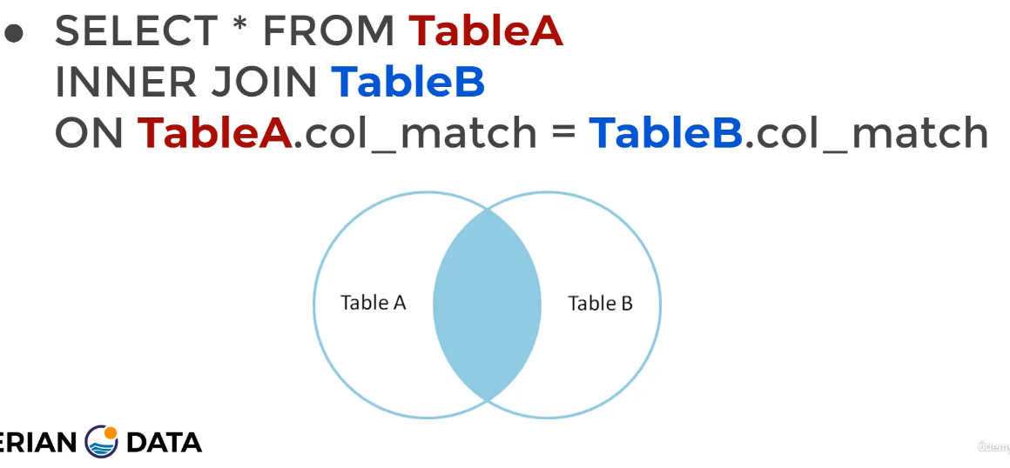
- An INNER JOIN will result with set of records from both tables that matches in both tables.
- PostgreSQL will assume that we are intending to execute INNER JOIN if we only type JOIN. However avoid typing JOIN only.
- In simpler words INNER JOIN present the shared column between two tables. The column must have the same exact name in both tables. In addition, to the columns having the same exact name. The INNER JOIN will present only the records of data that is the exact same in both columns
- Grab TableA and then grab TableB. Then, because this is INNER JOIN only grab the rows of the columns that have the same row names. Therefore, as shown in the figure below the resultant columns included the same column from both original tables. But, only the shared data was given. Look at the figure below:
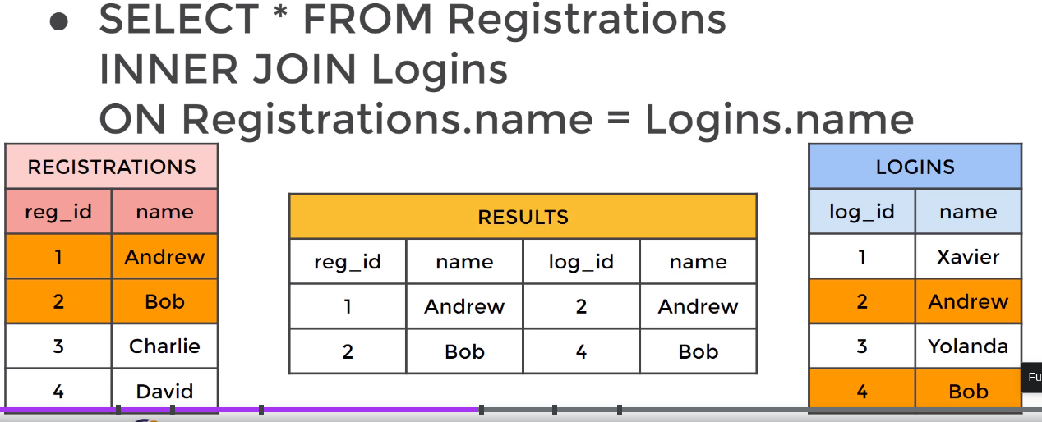
- In INNER JOIN we can switch the orders of the tables and columns
- syntax:

SELECT <columns> FROM <table-1> INNER JOIN <table-2>
ON <table-1>.<column-name> = <table-2>.<column-name>

- The name of <column-name> in both tables must be the same
- Whatever is next to SELECT before FROM will present the results
- The order of <table-1> and <table-2> or <table-1>.<column-name> or <table-2>.<column-name> does not matter while using INNER JOIN
- ON <table-1>.<column-name> = <table-2>.<column-name> will result in a column that has the same exact results. Therefore, if a condition not specified after SELECT and before FROM, you will have two columns of the same exact data. To over come having two columns of the same exact data in your results. Add the following <table-1>.<column-name> or <table-2>.<column-name> after SELECT and before FROM
- The results will be Two columns [<column-name1-new> and <column-name2-new> ] of the same exact data, which is whatever was shared between [<table-1>.<column-name1-original> and <table-2>.<column-name2-original> ].

- Exp1:

SELECT payment.customer_id AS customer_id_payment, customer.customer_id AS customer_id_customer, amount
FROM payment INNER JOIN customer
ON payment.customer_id = customer.customer_id;

- We did not type payment.amount between SELECT and FROM. This is because PostgreSQL is smart enough to know what we are calling on the amount column from the payment table.
- However we need to specify which customer column we want.
- We could have chosen their payment.customer_id or customer.customer_id. This is because the results of using INNER JOIN is two new columns that share the same exact values in their rows. Therefore any difference between these original two customer_id columns is not presented in the results
- The results will present two identical columns but both of them from two different tables

OUTER JOIN

- An OUTER JOIN allows us to deal with row values only present in one of the tables that are being joined.
- OUTER JOIN are broken down to
  - FULL OUTER JOIN, LEFT OUTER JOIN, RIGHT OUTER JOIN

FULL OUTER JOIN

- A FULL OUTER JOIN will results will be Two columns [<column-name1-new> and <column-name2-new> ] & For each of the new-version columns.
      - For example for <column-name1-new>
        - Everything in <column-name1-original> will be showing in <column-name1-new>
        - Everything shared between <column-name1-original> and <column-name2-original> will be showing in <column-name1-new>
        - Everything that is in <column-name2-original> and not in<column-name1-original> will be showing as null in <column-name1-new>

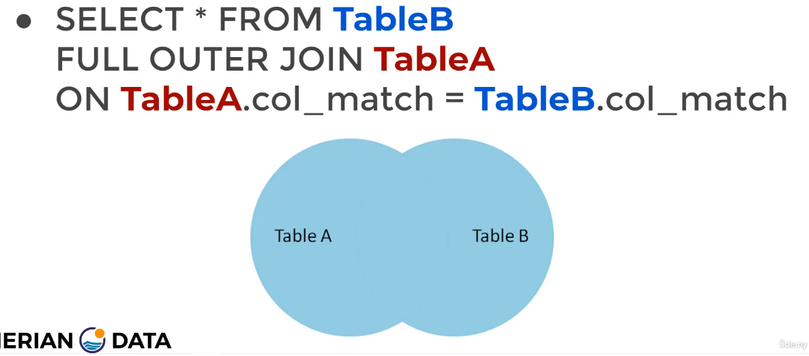

- The figure below represents the results of using OUTER JOIN, few important things to note:
  - The order of [<table-1> and <table-2>] does not matter
  - The order of [<table-1>.<column-name1> and <table-2>.<column-name2>] does not matter
  - Using FULL OUTER JOIN on two columns of the same name [<table-1>.<column-name1> and <table-2>.<column-name2>] FROM two different tables [<table-1> and <table-2>]. Will produce the following:
    - Two columns representing the new versions of the original columns
      - <column-name1-new> and <column-name2-new>
    - For each of the new-version columns.
      - For example for <column-name1-new>
        - Everything in <column-name1-original> will be showing in <column-name1-new>
        - Everything shared between <column-name1-original> and <column-name2-original> will be showing in <column-name1-new>
        - Everything that is in <column-name2-original> and not in<column-name1-original> will be showing as null in <column-name1-new>
    - Note: <column-name1-original> and <column-name2-original> have the same exact column name

- The syntax:

SELECT <columns> FROM <table-1> FULL OUTER JOIN <table-2>
ON <table-1>.<column-name> = <table-2>.<column-name>

- The figure below explained:

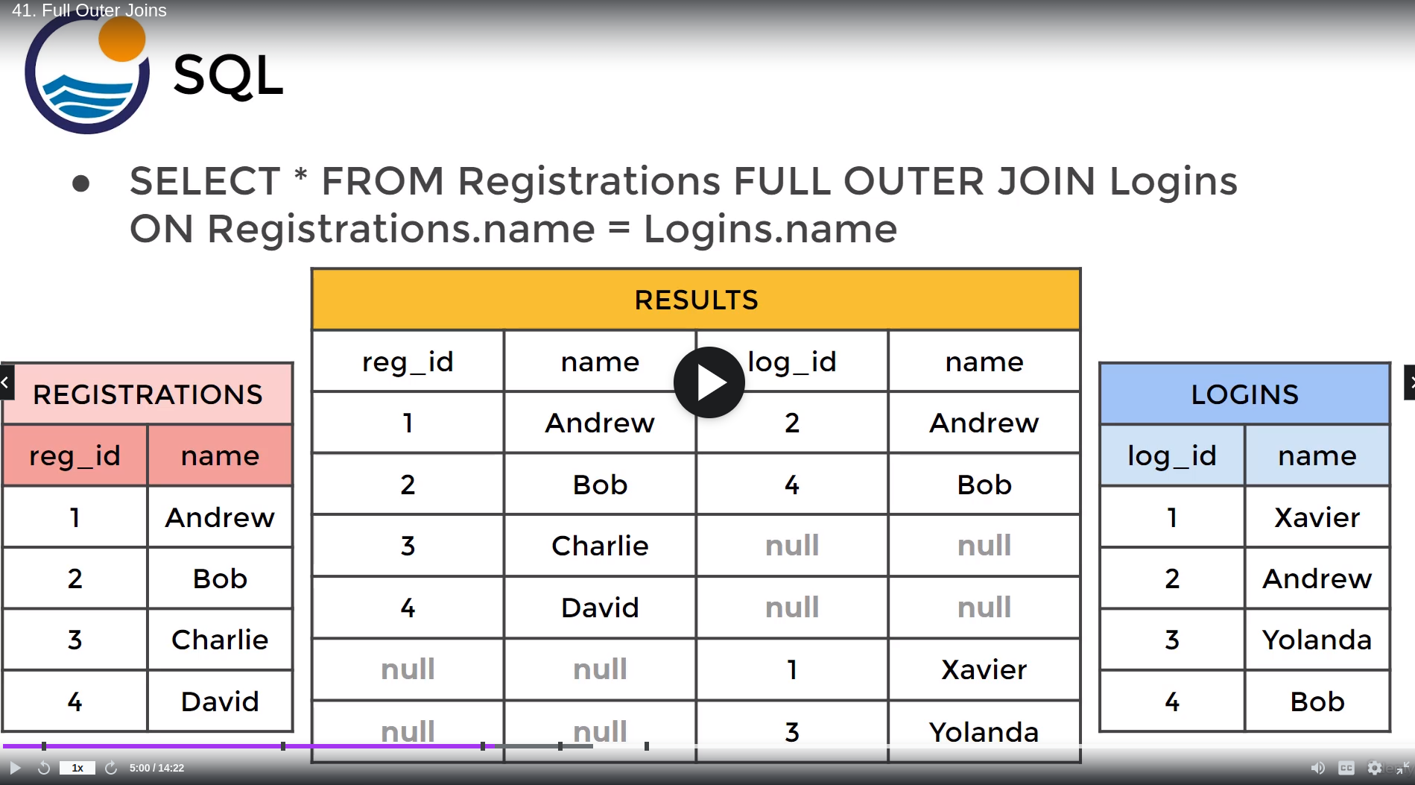
  - Two new columns that are called “name” will produced
  - For each of the new columns the results contained:
    - Everything from the previous column
    - Everything from the previous column that is shared with the other previous column
    - Anything that is not shared between the two previous columns was shown in null

- Exp1: Using a FULL OUTER JOIN join the customer and payment tables & organize via customer_id
SELECT payment.customer_id AS customer_id_payment, customer.customer_id AS customer_id_customer, amount FROM customer
FULL OUTER JOIN payment
ON customer.customer_id = payment.customer_id;

- This will join every row with every column and for the columns of the same name it will only show the shared rows
- The results will show two columns. New versions of the customer_id columns from the customer and payment tables. Each one of those columns will include: 1. everything from their respectable original column. 2. everything shared between their original respectable column and the original version of the other column. 3. Also, everything that is in the other original version of the other column and not their respectable column version will be shown as null

A FULL OUTER JOIN with a WHERE statement

- A FULL OUTER JOIN with a WHERE will results will be Two columns [<column-name1-new> and <column-name2-new> ] of the same exact opposite data, which is whatever was un-shared between [<table-1>.<column-name1-original> and <table-2>.<column-name2-original> ].
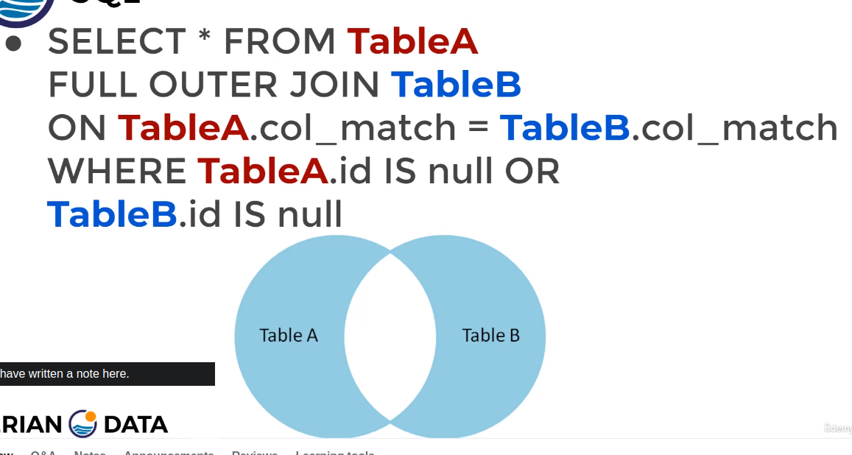
- Adding a WHERE statement to the OUTER JOIN clause will allow us to get rows unique to either table (rows that are not found in both tables)
- A FULL OUTER JOIN with a WHERE statement is the exact opposite to INNER JOIN

- The WHERE statement means the following:
  - We are looking for the values that are returned as null. Meanings, grab anything that is not shared between the columns of the tables
  - Therefore as showing in the two figures below. We go from left to right. The final results is on the right, where it only contains the un-shared results between [<table-1>.<column-name1> and <table-2>.<column-name2>]
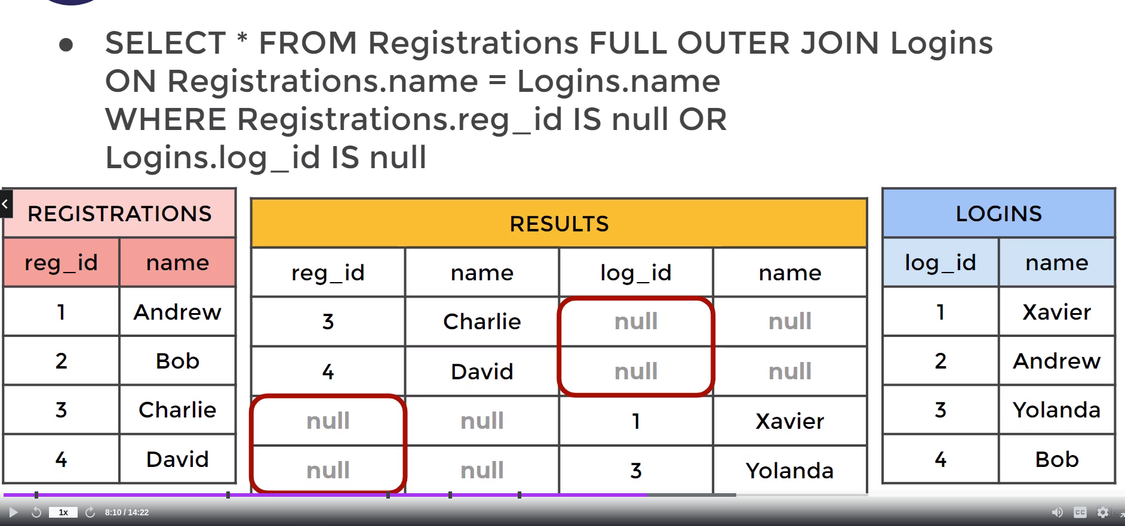
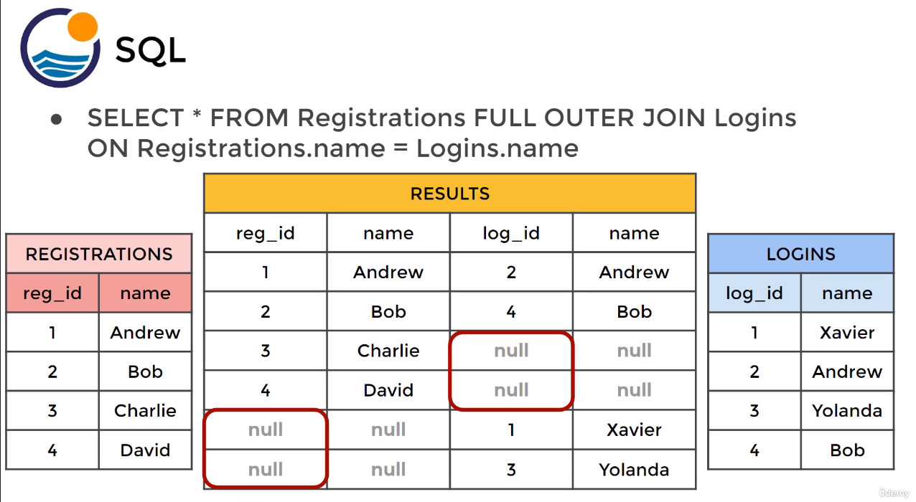

- Exp2: Imagine the following: a new privacy rules have been implemented and we want the following:
  - We want to make sure that all the customers we have on record have made payments.
  - All the payments we have on record have been made by verified customers

SELECT payment.customer_id AS customer_id_payment, customer.customer_id AS customer_id_customer, amount FROM customer
FULL OUTER JOIN payment
ON customer.customer_id = payment.customer_id
WHERE customer.customer_id IS null
OR payment.payment_id IS null;

- SELECT the customer table and SELECT the payment table. Then perform a FULL OUTER JOIN
- The FULL OUTER JOIN will be on the column customer_id from both tables
  - This will show all their shared information between customer.customer_id = payment.customer_id
- Then, show the unique results from customer.cutomer_id. This results was not shared between customer.customer_id = payment.customer_id. But from the customer.cutomer_id side
- Then, show the unique results from the payment.payment_id. This is the results that was not shared between customer.customer_id = payment.customer_id. But from the payment.cutomer_id side
  - The reason why we are saying payment.payment_id is because we want to see the left out payments that was not attached to a known customer id
- If the results is empty then we do not have a privacy breach
  - Another way to confirm the results is to count the number of rows in both tables
  - The two SQL code lines must be equal
    - SELECT COUNT(DISTINCT customer_id) FROM customer
    - SELECT COUNT(DISTINCT customer_id) FROM payment
  - Both lines show the number of unique customer_ids
- Adding the below, will show the results that are unique and if we had FULL OUTER JOIN only without the WHERE. Then we would only see the similar results and if there is any unique results we would have null in their location
  - WHERE customer.cutomer_id IS null
  - OR payment.payment_id IS null;

LEFT OUTER JOIN or LEFT JOIN (Order Matters)

- A LEFT OUTER JOIN will results will be Two columns [<column-name1-new> and <column-name2-new> ] & For The Column of the Left Table: .
      - For example for <column-name1-new>
        - Everything in <column-name1-original> will be showing in <column-name1-new>
        - Everything shared between <column-name1-original> and <column-name2-original> will be showing in <column-name1-new>
        - Everything that is in <column-name2-original> and not in<column-name1-original> will be showing as null in <column-name1-new>
- We can type type either LEFT OUTER JOIN or LEFT JOIN
- This type of join results are based on the left table (the first table after SELECT).
  - If there is no match between the left table and the right table the results will be a null.
  - However, any match between the left table and right table will be presented in the results.
  - Regardless if there is a match or no match all the results from <column-name1-original> will be at <column-name1-new>
  - Below figure, shows TableA as the left table. Therefore the results will include everything from TableA and whatever is shared between TableA and TableB
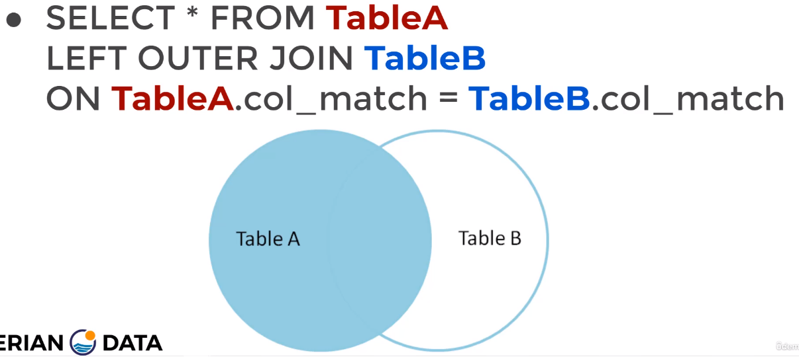

- The left table is the first table mentioned after SELECT.
- Clearly whatever is the left table matters. Therefore, the order of which table goes right after SELECT matters for the LEFT OUTER JOIN . The below example

- The figure below represents the results of using LEFT OUTER JOIN or LEFT JOIN, few important things to note:
  - The order of [<table-1> and <table-2>] does matter
  - The order of [<table-1>.<column-name1> and <table-2>.<column-name2>] does matter
  - Using LEFT OUTER JOIN on two columns of the same name [<table-1>.<column-name1> and <table-2>.<column-name2>] FROM two different tables [<table-1> and <table-2>]. Will produce the following:
    - Two columns representing the new versions of the original columns
      - <column-name1-new> and <column-name2-new>
    - For the “Left Table” or the “Table Right After SELECT” of the new-version columns.
      - For example for <column-name1-new>
        - Everything in <column-name1-original> will be showing in <column-name1-new>
        - Everything shared between <column-name1-original> and <column-name2-original> will be showing in <column-name1-new>
        - Everything that is in <column-name2-original> and not in<column-name1-original> will be showing as null in <column-name1-new>
    - Note: <column-name1-original> and <column-name2-original> have the same exact column name
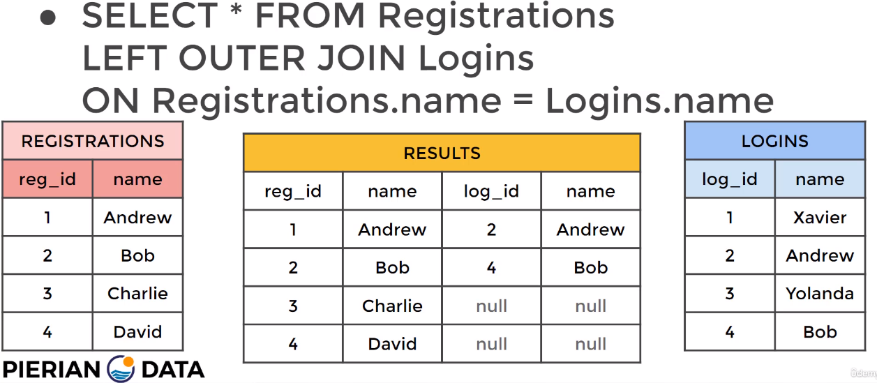

- Exp 1: Show all the films that are in the film table. Do not show the films that are only in inventory table. But, show the shared films

SELECT film.film_id, inventory,film_id, title, inventory_id, store_id
FROM film
LEFT OUTER JOIN inventory ON
inventory.film_id = film.film_id;

- Only the rows under film_id from the film table and are available in the inventory table will be shown. Any film_id only in the film table will not be shown
- Two film columns will be shown. The filled column is the column with the data only from the Left Table. While, the column that has filled data and null in its rows. This is the column that represent all the shared-data and the data that are not available in the column of the Left Table
- Please note: at the end and it will show us all the null rows first
  - we can add ORDER BY inventory.film_id DESC;

A LEFT OUTER JOIN with a WHERE statement (Order Matters)

- A LEFT OUTER JOIN with a WHERE will results will be Two columns [<column-name1-new> and <column-name2-new> ] of only the unique data from <column-name1-original>. This data is not shared between [<table-1>.<column-name1-original> and <table-2>.<column-name2-original> ]. Any other spot that remains and it represent a shared data will be given a null.
- Adding a WHERE statement to the LEFT OUTER JOIN clause will allow us to get rows unique to only the “Left Table” or the “First Table After SELECT”
- The WHERE statement means the following:
  - We are looking for the values that are only available in the “Left Table”, anything else will be returned as null.
  - The below figure, shows how we must only add a single condition after the WHERE statement

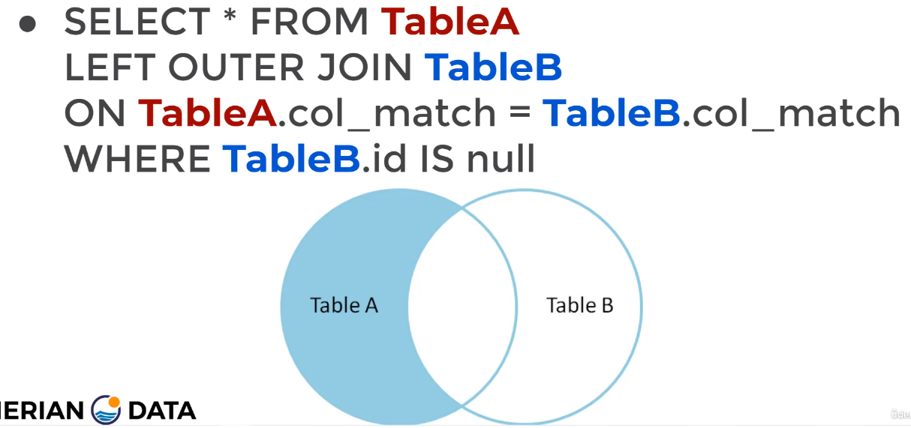

    - Therefore as showing in the two figures below. We go from left to right. The final results is on the right, where it only contains the un-shared results between [<table-1>.<column-name1> and <table-2>.<column-name2>] plus the results from <table-1>.<column-name1>

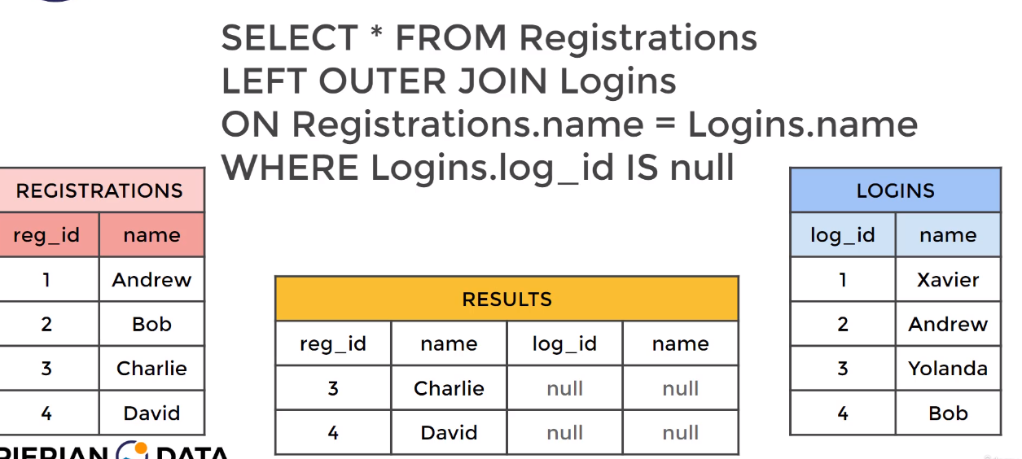

Exp 1: Consider that you have showed all the films that are in the film table and did not show the films that are only in inventory table. However, now show all the films are are from the inventory_id that are are not shared , show the shared films. Also,

SELECT film.film_id, inventory.film_id, title, inventory_id, store_id
FROM film
LEFT OUTER JOIN inventory ON
inventory.film_id = film.film_id
WHERE inventory.film_id IS null ;

- Two film columns will be shown. The filled column is the column with the data only from the Left Table. While, the column that has null in its rows. This is the column that represent all the shared-data and the data that are not available in the column of the Left Table

A RIGHT OUTER JOIN & RIGHT OUTER JOIN with a WHERE statement

- A RIGHT JOIN is the same exact thing as LEFT JOIN, expect the tables are switched.
- This would be the same as switching the tables order in a LEFT OUTER JOIN
- Note: work with LEFT OUTER JOIN but switch the tables order
UNION operator

- The UNION operator is not the same as the JOIN clause it enable us to concatenate the results of two or more SELECT statements.
- In simpler terms: This operator basically paste the results of two or more SELECT statements together
- Using the UNION operator must be logical
- Ideally, UNION is used to combine the results of two different versions of the same column. Basically combining the column’s results of 2021 and the same columns results of 2022
- Also, you can add an ORDER BY after the results to order it via a specific column
The syntax:
SELECT <column-names#> FROM <table-#>
UNION
SELECT <column-names#> FROM <table-#>

JOIN Clause Challenge

- Challenge 1: Cali sales tax laws have changed and we need to alert our customers through email. What are the emails of the customers that live in California
- Both the customer and the address tables have address_id. From the customer table we can get the emails and from the address table we can get the address based on the district
My solution:
SELECT address.address_id,customer.address_id, district, email FROM address
INNER JOIN customer
ON address.address_id = customer.address_id
GROUP BY address.address_id, customer.address_id, district, email
HAVING district = 'California;

Course’s solution:
SELECT address.address_id,customer.address_id, district, email FROM address
INNER JOIN customer
ON address.address_id = customer.address_id
WHERE district = 'California'
- Notes in regards of Challenge 1’s courses solution: The INNER JOIN with the WHERE statement was used. WHERE acted as a filter in this case

- Challenge 2: We would like to all of the movies that the actor ‘Nick Wahlberg’ is part of
- We do not have a common column between the film & actor tables
- From the actor table we can get the actor_id and the first_name & last_name of the actors
- From the film table we can get the film_id and the titles of the films
- From the film_actor table we can get the actor_id and the film_id
- This is a unique case the actor and film tables do not have any common columns. However, they both have a common column with the film_actor table
  - This is why we type film_actor right after FROM, because it has commonality with the other tables
- Therefore, we need to perform a double INNER JOIN. However, you need to always keep in mind for any query it can have any statement multiple times expect the SELECT and the FROM statements
  - I required assistance to complete this, because I made the mistake of typing SELECT twice
  - I was able to get the answer by performing multiple queries. However, the solution below is got the results while performing a single query
My solution:
SELECT film_actor.actor_id,film_actor.film_id, first_name,title FROM film_actor
INNER JOIN actor
ON film_actor.actor_id = actor.actor_id
INNER JOIN film
ON film_actor.film_id = film.film_id
WHERE actor.first_name = 'Nick' AND last_name = 'Wahlberg'

Section 5: Advanced SQL Command

Information Extracting: Extracting time data from DB

- Different functions (TIMEZONE, NOW(), TIMEOFDAY(), CURRENT_TIME, CURRENT_DATE) will return different output in different output styles (text, timestamp with time zone, time with time zone, date)

- TIMEZONE:
  - This will show you the current time zone of your computer that you are working on. Also, if you type SHOW ALL. It will show you around 300 different outputs in regards of your database & the machine you are working on. One of those outputs was the TIMEZONE. The day will be returned as a “text” style
  - Exp for TIMEZONE
SHOW TIMEZONE

- NOW():
  - This will show you the current time stamp of your computer that you are working on in a GMT . Also, it will return the data as a “timestamp with time zone” style not text style.
  - Exp for NOW()
SELECT NOW()

- TIMEOFDAY():
  - This will show you the current time stamp of your computer that you are working on in a “text” format. Therefore, unlike NOW() the data of TIMEOFDAY() will be returned as a “text “style
  - Exp for TIMEOFDAY()
SELECT TIMEOFDAY()

- CURRENT_TIME:
  - This will show you the current time stamp of your computer that you are working on in a “time with time zone” format
  - Exp for CURRENT_TIME
SELECT CURRENT_TIME

- CURRENT_DATE:
  - This will show you the current date of your computer that you are working on in a “date” format.
  - Exp for CURRENT_DATE
SELECT CURRENT_DATE

Information Extracting: Extracting data from “time-based” Data typed columns & Converting data types to “text”

- Different functions (EXTRACT(), AGE(), TO_CHAR()) will return different outputs when using it with “time-based” data type

- EXTRACT():
  - This function allows you to extract sub-components of “time-based” data types
  - Including: SECOND, HOUR, DAY, WEEK, MONTH, QUARTER,YEAR
  - The syntax will be: SELECT EXTRACT(<sub-component> FROM <time-based-column>) FROM <The Table>
  - Exp: Extracting a YEAR FROM a date_column
SELECT EXTRACT(YEAR FROM payment_date) FROM payment
  - Note: The column payment_date is a “time-based” data type

- AGE():
  - This function calculates and return the time difference between what is written in the column and the current time the computer is running at. The column must be of “time-based” data type
  - The syntax will be: SELECT AGE(<time-based-column>) FROM <The Table>
  - Exp: Compare the current time against a “time-based” data typed column
SELECT AGE(payment_date) FROM payment
  - Note: The column payment_date is a “time-based” data type

- TO_CHAR():
  - This function converts data types ( timestamp with time zone, time with time zone, date) to (text). This is not specific for “time-based” data type . TO_CHAR stands for to character.
  - The syntax will be: SELECT TO_CHAR(<time-based-column>, ‘<The Text Format>’) FROM <The Table>
  - Exp: Convert a ‘time-based’ data type to text
SELECT TO_CHAR(payment_date, ‘MONTH’) FROM payment
  - ‘MONTH’ could be ‘MONTH-Y’ or ‘'MM-dd-YYYY' or another text format. Please read the documentations
  - The documentation available at: https://www.postgresql.org/docs/12/functions-formatting.html
  - The column payment_date is a “time-based” data type. However, we can use TO_CHAR for any other data type to “text” data type. Check out the documentation for more information
  - In the documentations you can also use TO_DATE, TO_NUMBER, TO_TIMESTAMP to convert to date, numeric, timestamp with time zone, respectively from “text” data type
  - When using TO_CHAR, some options are "blank padded to 9 characters", which means instead of returning 'Monday' it returns 'Monday ' with extra spaces to fill up at least 9 spaces.

Information Extracting: Assessments

- Challenge 1: During which months did the payments occur ?. Format your answer to return the full month name
- My solution:
SELECT DISTINCT TO_CHAR(payment_date,'MONTH') FROM payment

- Challenge 2: How many payments occurred on a Monday
- I used a stack overflow search

- My solution:
SELECT TO_CHAR(payment_date, 'DAY'), COUNT(TO_CHAR(payment_date, 'DAY')) FROM payment
WHERE TO_CHAR(payment_date, 'DAY') = 'MONDAY '
GROUP BY TO_CHAR(payment_date, 'DAY')
- The days are returned in 9 characters long. Therefore to get a da like MONDAY you must as for it with 3 additional characters to make the total number of characters = 9.
- When using TO_CHAR, some options are "blank padded to 9 characters", which means instead of returning 'Monday' it returns 'Monday ' with extra spaces to fill up at least 9 spaces.

- Course’s solution:
SELECT COUNT (*) FROM payment
WHERE EXTRACT(dow FROM payment_date) =1
- This solution did not need to change the data type
- https://www.postgresql.org/docs/8.3/functions-datetime.html

Mathematical Functions and Operators

- The documentations for mathematical functions & operators can be found at: https://www.postgresql.org/docs/9.5/functions-math.html
- These mathematical functions and operators occur on a single or multiple columns

- Exp1: Calculate the percentage of rental rate to the replacement cost from the film table and round the numbers to 3 decimal places
SELECT ROUND((rental_rate/replacement_cost)*100, 3) FROM film

- Exp2: Create a new column that is called “deposits” and it is equal to 10% of the replacement cost. ? Use Aliases
SELECT 0.1*replacement_cost AS deposits FROM film

String Functions & Operators

- The documentations for string functions & operators can be found at: https://www.postgresql.org/docs/9.1/functions-string.html
- There are many functions available. Functions include : “string | | string” which is used for string concatenation and returns a text data type.
- Exp1: concatenate two columns and return them in the form of strings and have a + sign between them
SELECT film_id ||'+'||title FROM film
- Exp2: create a hotmail email with the first letter of the first name the full last name. Then make sure that new column is called ‘new_emails’
SELECT LEFT(first_name,1)||'.' || last_name||'@hotmail.com' AS new_emails FROM customer
- Note: from the documentations I searched and I found the function LEFT

Sub-queries (Very useful & require practice)

- A sub-query: It allows us to construct complex queries
- Essentially performing query on the results of another query. It involves two SELECT statements
- Syntax:
SELECT <column(s)> FROM <Table>
WHERE <column(s) > > (SELECT <column(s)> FROM <Table>)
- Note:
  - The second SELECT must be in parenthesis and it is the sub-query. Also, it is performed first
  - You do not need WHERE. The WHERE function was used to help write the example in this syntax
  - <column(s) > can be any column and they do not have to exactly match the other of the same <Table>

- Syntax, when using different tables by applying the IN function:
SELECT <column(s)> FROM <Table1>
WHERE <column(s) > IN (SELECT <column(s)> FROM <Table2>)
- Note:
  - The second SELECT must be in parenthesis and it is the sub-query. Also, it is performed first
  - The IN operator must be used when the sub-query returns back multiple rows not a single row

Exp1: Return back a list of films that have a rental rate higher than the average rental rate

SELECT title, rental_rate FROM film
WHERE rental_rate > (SELECT AVG((rental_duration*rental_rate)/rental_duration) FROM film)
- Steps:
  - 1. Calculate the average rental rate of all the films as the sub-query
  - 2. Then, the main query will calculate all the films that have a higher rate than the average rental rate
  - 3. The sub-query returned back a single row results. Therefore, we did not need to use the IN operator

Exp2: What are the film titles that have been returned between two sets of dates ?
SELECT film_id, title FROM film
WHERE film_id IN
(SELECT inventory.film_id FROM rental
INNER JOIN inventory ON
inventory.inventory_id = rental.inventory_id
WHERE return_date BETWEEN '2005-05-29' AND '2005-05-30')

- Steps:
  - 1. Return all the film ids that have been returned between two specific dates. This will be the sub-query
  - 2. Then, the main query will match the titles to those returned from the sub-query. While, using the IN operator
  - 3. The sub-query returned back a multiple row results. Therefore, we must use the IN operator

The EXISTS Function (needs a lot of practice)

- The EXISTS operator is used to test for the existence of rows in a sub-query.
- Typically, sub-query is passed in the EXISTS() function to check if any rows are returned with the sub-query
- Syntax:
SELECT <column(s)> FROM <Table>
WHERE EXISTS(SELECT <column(s)> FROM <Table> WHERE <condition>);

Exp1: Find all the customers (fist_name & last_name) who has at least one payment whose amount above or equal to 11
SELECT first_name, last_name FROM customer
WHERE EXISTS (SELECT * FROM payment
WHERE payment.customer_id = customer.customer_id AND payment.amount > 11 )

- In the sub-query we check if the condition where the customer_id from the payment table matches the customer_id from the customer table AND if their amount column was above 11 we return them if they EXISTS

Self-Join

- A self-join is a query in which a table is joined to it self. This is useful when you are comparing values in a column of rows within the same table
- There is no special keyword for self-join. It is basically the standard JOIN command however it is with the same table
- You must uses aliases within the tables, because things can easily get confusing

- The syntax of self-join:
SELECT <name1-for-table1>.<column-name>, <name2-for-table1>.<column-name>
FROM <table-1> AS <name1-for-table1>
JOIN
<table-1>AS <name2-for-table1>
ON <name1-for-table1>.<column-name> = <name2-for-table1>.<column-name>
  - <column-name> does not have to be the same exact column

- Below an example of comparing two columns of the same table with the syntax

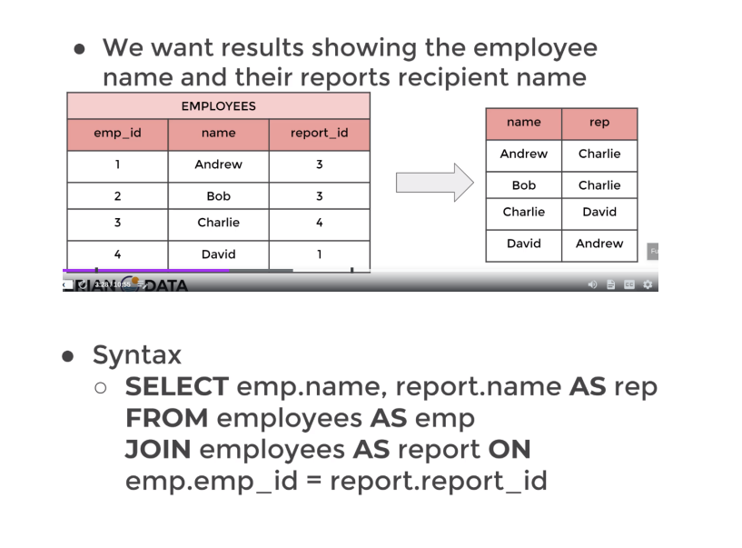
- Exp: Find all the pairs of films that have the same length
SELECT a.title, a.length, b.title, b.length FROM film AS a
JOIN film AS b
ON a.length = b.length AND a.title != b.title
- We need to make sure that we do not compare the same exact movie to it self. Therefore we added a.title != b.title

Section 6: Main Assessment 2

Notes

- This assessment will use a DB that has two schemas a public and a cd schema. cd schema is the name of the schema. Therefore the queries of the cd schema will look like the following:
SELECT <Column(s)> FROM cd.<Table-1>
- If the DB was in the public schemas. Then it is not necessarily to type public.<Table-1> in front of each table. Therefore the queries of the public schema will look like the following:
SELECT <Column(s)> FROM <Table-1>
SELECT <Column(s)> FROM public.<Table-1>
- This is the link to the Google Doc with the questions and the expected results: https://docs.google.com/document/d/1wiuYbTQslmfolQWgeVPB356csjK6yqOUBhgC7fM44o8/edit?usp=sharing

- Challenge 1: How can you retrieve all the information from the cd.facilities table?
SELECT * from cd.facilities

- Challenge 2: You want to print out a list of all of the facilities and their cost to members. How would you retrieve a list of only facility names and costs?
SELECT name AS facilities_name, membercost from cd.facilities

- Challenge 3: How can you produce a list of facilities that charge a fee to members?
SELECT * from cd.facilities
WHERE membercost >0

- Challenge 4: How can you produce a list of facilities that charge a fee to members, and that fee is less than 1/50th of the monthly maintenance cost? Return the facid, facility name, member cost, and monthly maintenance of the facilities in question.
SELECT * from cd.facilities
WHERE membercost>0 AND membercost <(monthlymaintenance) * (0.02)
- Note:
- SQL requires the numbers to change to a float if you are dividing by anything less than 0
- To make a float division type -> (1.0/50.0) instead of (1/50)

- Challenge 5: How can you produce a list of all facilities with the word 'Tennis' in their name?
SELECT * from cd.facilities
WHERE name LIKE '%Tennis%'

- Challenge 6: How can you retrieve the details of facilities with ID 1 and 5? Try to do it without using the OR operator ?
SELECT * from cd.facilities
WHERE facid < 6 AND facid > 0 AND facid NOT BETWEEN 2 AND 4
- Note:
  - You can make a list using the IN operator -> WHERE facid IN (1,5)

- Challenge 7: How can you produce a list of members who joined after the start of September 2012? Return the memid, surname, firstname, and joindate of the members in question.
SELECT memid, surname, firstname, joindate from cd.members
WHERE joindate >= '2012-09-01'

- Challenge 8: How can you produce an ordered list of the first 10 surnames in the members table? The list must not contain duplicates.
SELECT DISTINCT(surname) from cd.members
ORDER BY (surname) ASC
LIMIT 10

- Challenge 9: You'd like to get the signup date of your last member. How can you retrieve this information.
SELECT * from cd.members
ORDER BY joindate DESC
LIMIT 1
- Note
  - You could have also written MAX(joindate)

- Challenge 10: Produce a count of the number of facilities that have a cost to guests of 10 or more.
SELECT * from cd.facilities
WHERE guestcost >= 10

- Challenge 11: Produce a list of the total number of slots booked per facility in the month of September 2012. Produce an output table consisting of facility id and slots, sorted by the number of slots.
SELECT facid, SUM (slots) from cd.bookings
WHERE starttime BETWEEN '2012-09-1' AND '2012-10-1'
GROUP BY facid
ORDER BY COUNT (slots) ASC
- COUNT will count the number of times were repeated by SUM will add them up
- It is better to use the >= AND <= operators than the BETWEEN operator

- Challenge 12: Produce a list of facilities with more than 1000 slots booked. Produce an output table consisting of facility id and total slots, sorted by facility id
SELECT facid , SUM(slots) from cd.bookings
GROUP BY facid
HAVING SUM(slots) > 1000
ORDER BY facid
- COUNT will count the number of times were repeated by SUM will add them up
- WHERE does not work with columns that have functions running on them. Therefore, we use HAVING

- Challenge 13: How can you produce a list of the start times for bookings for tennis courts, for the date '2012-09-21'? Return a list of start time and facility name pairings, ordered by the time.
SELECT f.facid, b.facid, f.name, b.starttime FROM cd.facilities AS f
INNER JOIN cd.bookings AS b
ON f.facid = b.facid
WHERE b.starttime >= '2012-09-21' AND b.starttime <= '2012-09-22' AND f.name LIKE 'Tennis%'
ORDER BY b.starttime
- We could have also used the using the IN operator -> IN (1,2)

- Challenge 14: How can you produce a list of the start times for bookings by members named 'David Farrell'?
SELECT b.memid, m.memid, b.starttime FROM cd.members AS m
INNER JOIN cd.bookings AS b
ON b.memid = m.memid
WHERE firstname||' '|| surname ='David Farrell'
- We could have had WHERE firstname = ‘David AND surname =’Farrell’

Section 7: Creating DB & Tables

Data Types

- When creating a column we must choose the data type that column must be off. The below are few data types:
  - Boolean
    - True
    - False
  - Character
    - cha
    - carchar
    - text
  - Numeric
    - integer
    - floating-point number
  - Temporal
    - data
    - time
    - timestamp
    - interval
  - UUID
    - Universally Unique Identifiers
  - Array: Stores an array of string, numbers, etc.
  - JSON (JavaScript Object Notation)
  - Hstore types-value pair
  - Network address
  - Geometrical data
- The documentations available below, provides enough information about the limitations of data types:
  - https://www.postgresql.org/docs/current/datatype.html
- Data Types Selection:
  - When selecting the data type for a Phone #. We must look at the types in the Numeric table. We need a number of at least 10 digits and we should always to to focus on getting a storage size of as small as possible
  - Storage size is how much memory that column takes
  - You need to keep in mind that Numeric type of columns expect arithmetic to be performed on them. Therefore, it is better to use VARCHAR “variable character”
  - Search online for best practices of data type storage in SQL
    - https://www.guru99.com/postgresql-data-types.html
    - https://www.techrepublic.com/article/optimize-your-databases-with-postgresql-data-types/
  - Also, prior to storage a specific column. For exp email address. Search online what is the best data type to store an email address for in postgresql
  - Take your time when making table. You can always remove historical information you have decided you are not using anymore. But you can not go back in time to add information

Primary Keys & Foreign Keys

- Primary Key [PK]:
  - Is a column or a group of column used to identify a row uniquely in a table
  - It is identified by [PK] under its official name in PostgreSQL
  - Properties:
    - A primary key column must be distinct for each row
    - A primary key column can not be null
    - We can not add a Primary Key to an existing column if there are duplicates in its rows. The Primary key tends to be added at the beginning of the table. However, we can add it half way but all the rows of whatever column that becomes the Primary Key must be unique
  - Benefits:
    - Primary keys are ideal for tables joining
    - This maybe the customer_id that is unique for each customer. This is a value that can be grouped by -> GROUP BY

- Foreign Key:
  - Is a column or a group of columns in a table that uniquely identifies a row in another table
  - A foreign key is defined in a table that is references to the primary key of the other table
  - A table may have multiple foreign keys
  - You do not need to add the values to the Primary Key, because they will automatically get filled. However, for the Foreign Key you must add the values. Then this is how you can relate a Foreign Key into a Primary Key
  - Properties:
    - A foreign key column does not need to be distinct for each row
    - A foreign key column can be null
  - Exp:
    - In the “payment” table the column customer_id was available. The column customer_id is referenced from the ‘customer’ table
    - The column of customer_id in the ‘customer’ table is a primary key
    - The column of customer_id in the ‘payment’ table is a reference key
      - This makes the ‘payment’ table a ( referencing or a child table) when compared in terms of the column customer_id
      - This makes the ‘customer’ table a (referenced or a parent table) when compared in terms of the column customer_id

- Primary & Foreign Keys Distinguished
  - To view the tapes of keys in a table. You must look at the table’s constrains.
    - A primary key will have a pkey as as the last term of its name
    - A foreign key will have “fkey” as last term of its name

Constraints

- Constrains: are the rules enforced on data columns in the tables
- Main usage:
- Preventing invalid data from entering the data base
- Ensuring the accuracy and reliability of the data in the database
- Two types of constrains categories
  - 1. Column Constrains
    - These are the constrains that ensure that specific columns adhere to certain conditions
  - 2. Table Constrains
    - These are the constrains that ensure that the constrain is applied to the whole table (every column in the table) not individual columns

- Most Common Used Column Constrains
  - 1. NOT NULL constrain
    - Ensures that a column can not have NULL values
  - 2. UNIQUE Constrain
    - Ensures that all values in a specific column are unique from each other
  - 3. PRIMARY KEY constrain
    - Uniquely identified each row and can not be NULL
  - 4. FOREIGN KEY constrain
    - Reference other tables and do not have to be unique and could be NULL
  - 5. CHECK constrain
    - Ensures that all values in a specific column satisfy a certain condition
      - For exp: All values must be larger than 5
  - 6. EXCLUSION constrain
    - This constrains ensures that any two rows that are compared against each other (two rows must be be coming from specified columns) and are compared using a specific operator will not return TRUE for the results of these comparisons

- Most Common Used Table Constrains
  - 1. CHECK (<The-condition>)
    - This constrains is used to check a specific condition when inserting or updating the data across the entire table
  - 2. REFERENCES
    - This constrain makes sure that a column in your specific table references another column in another table
  - 3. UNIQUE (<column-list>)
    - Forces any <column-list> to be unique. Each <column-list> represents a column in a unique in a table. This forces that each row in each <column-list> to be unique in the entire table not just its own column
  - 4. PRIMARY KEY (<column-list>)
    - Allows you to define the primary key that may consist of multiple columns within a table

Creating DB in PgAdmin

- The steps to create a database in PostgreSQL in PgAdmin 4 are:
- 1. Right click on Databases and select Create, Then Database
- 2. Give the Database a name by filling the Database entry
- 3. Leave the owner as Postgres, which is the name of the superuser you set when installed PostgreSQL
- 4. Once the Database is added, you should refresh if you can. Then right-click on it and select PSQL Tool, to open the Query Editor Window. This will let you add tables and data

Creating Tables Using The CREATE Keyword

- The CREATE keyword is used to create tables in SQL
- CREATE TABLE is used to create a table and it used for each specific table once
- General Syntax of table creation using the CREATE keyword
CREATE TABLE <table-name> (<column-name1> <column-datatype> <column-constrain>, <column-name2> <column-datatype> <column-constrain>, <table-constraint>) INHERITS <existing-table-name> ;
- Common Simple Syntax of table creation using the CREATE keyword
CREATE TABLE <table-name> (<column-name1> <column-datatype> <column-constrain>, <column-name2> <column-datatype> <column-constrain>) ;

- SERIAL datatype:
  - The SERIAL datatype is broken down to SMALLSERIAL, SERIAL, and BIGSERIAL. Checkout the documentation for an explanation
  - The SERIAL datatype automatically creates a sequence object and set the next value generated by the sequence as the default value for the column
  - SERIAL is commonly used for primary key column, because it logs unique integers entries automatically upon insertion without. Therefore, it eliminates the changes of data duplication for the primary key column
  - If column TYPE SERIAL has a row removed during the life time of the database. SERIAL will make sure not to adjust the column to indicate a change occurred and not cause faulty data presentation
    - If your column has the following sequence 1,2,3,5,6,7
      - This means at some point the row 4 was deleted
    - The SERIAL data keeps all the inputs, even if a failed attempt is not added to the table SERIAL will keep that failed attempts as an order, look at lecture 69. CHECK Constraint from the Udemy course
    - However, if you want to reset the sequence you must type -> ALTER SEQUENCE <table>_<PRIMARY KEY>_seq RESTART WITH <value>
    - The <value> is what you can restart with. Look at 3:56:00 of the YouTube video
    - <value> must be larger than the largest value in the table, You can test this. I did not test this the accuracy of this statement yet.

- Common practices for table’s creation in a database
  - 1. Each table should have at least one primary key and the datatype for a the primary key should be SERIAL
  - 2. For the primary key column type PRIMARY KEY as the constrain

- Common simple example of table creation, using CREATE TABLE, which is only used once for each table
CREATE TABLE players (player_id SERIAL PRIMARY KEY, age SMALLINT NOT NULL) ;
  - The table’s name is players
  - The first column’s name is player_id
  - The type of the first column is SERIAL
  - The first column is a primary key column because it has a PRIMARY KEY constraint
  - The second column’s name is age
  - The type of the first column is SMALLINT
  - The second column is a regular column that can not have a null entry, because it has a NOT NULL constraint

- Example 1:
  - CREATE TABLE in a database, using CREATE TABLE, which is only used once for each table
CREATE TABLE account
(user_id SERIAL PRIMARY KEY, username VARCHAR(50) UNIQUE NOT NULL,
password VARCHAR(50) NOT NULL, email VARCHAR(250) UNIQUE NOT NULL, created_on TIMESTAMP NOT NULL,
last_login TIMESTAMP);
    - The table’s name is account
    - The first column’s name is user_id
    - The type of the first column is SERIAL
    - The first column is a primary key column because it has a PRIMARY KEY constraint
    - The second column’s name is username
    - The type of the first column is VARCHAR(50), which can be any 50 characters
    - The second column is a regular column that can not have a null entry, because it has a NOT NULL constraint. Also, no rows in the second column can be repeated there for it also has the UNIQUE constraint
    - The last column does not have any constraints expect the fact that it is a TIMESTAMP datatype

- Example 2:
  - Based on example 2. Create another table and link it to the table in example 1 using a Foreign Key and REFERENCING
CREATE TABLE account_job( user_id INTEGER REFERENCES account(user_id), hire_date TIMESTAMP);
    - The table’s name is account_job
    - The first column’s name is user_id, because it is referencing the column in the account table of example 1
    - The type of the first column is INTEGER not SERIAL, because SERIAL is only used to represent a primary key column. And this column is being referenced at this table. Therefore, it is not a primary key at the account_job table. We typed integer, because the actual data of the user_id’s column will shown as integers . Also, the referenced column at the account_job will be considered a FOREIGN KEY, because it is a PRIMARY KEY in another table
    - After we type the type of the new table’s first column we must reference it to another table, because this is a column that is referencing its results from another table therefore we followed this syntax REFERENCES <The-referenced Table>(<The-Referenced-Column-Name>)
    - A second column unique to the account_job table was added
    - You do not need to add the values to the PRIMARY KEY, because they will automatically get filled. However, for the FOREIGN KEY you must add the values. Then this is how you can relate a FOREIGN KEY into a PRIMARY KEY

Inserting Information into Tables Using The INSERT command (Add Row)

- The INSERT command allows you to add or insert rows into a table
- The general syntax is of inserting into a table directly:
INSERT INTO <table-name> (<column1>, <column2>,.....) VALUES (value1-column1,value1,-column2,....), (value2-column1,value2,-column2,....)., ....;
- The general syntax is of inserting into a table from another table:
INSERT INTO <Table-that-references-the-column-”NOT REFERENCED TABLE”-We are inserting into this table>(<The-referenced-column>, <Other-columns>
VALUES (<row-number-of-the-referenced-column>, <value1- Other-columns>) ;
  - Notes:
    - When inserting row values. The values must match up for the table including the constraints
    - If a columns were given as type SERIAL. Those columns do not need to be provided when typing INSERT INTO, because SERIAL is a sequence, which means it will automatically update

- Exp1: Insert a single row to each single column of a table. Please use the CURRENT_TIMESTAMP to show the current time
INSERT INTO account (username,password, email, created_on)
VALUES ('Mohamd', 'password', 'medoimad@hotmail.com', CURRENT_TIMESTAMP)

- Exp2: Insert a multiple rows a single column of a table.
INSERT INTO job(job_name)
VALUES
('Doctor'), ('Engineer'), ('Professor')

- Exp3: Insert a multiple rows into multiple columns of a table.
INSERT INTO account (username,password, email, created_on)
VALUES ('shosho', 'password', 'shosho@hotmail.com', CURRENT_TIMESTAMP), ('ali', 'password1', 'ali@hotmail.com', CURRENT_TIMESTAMP)
- We did not need to add the SERIAL data typed columns, because they are automatically updated
- The constrains of the columns must be satisfied. Therefore if we have a column that has a NO NULL constraint we must fill it
- IF we have a column that expect an integer we can not give it a text
- The above example the columns can not be empty this is why they must be filled
- The first parenthesis are for the first row. The second parenthesis are for the second row

- Exp3 + Syntax: Insert a row into multiple columns from a column that we reference. Which makes both table’s referenced to each other

- The syntax:
INSERT INTO <Table-that-references-the-column-”NOT REFERENCED TABLE”>(<The-referenced-column>, <Other-columns>
VALUES (<row-number-of-the-referenced-column>, <value1- Other-columns> ;

- The Example:
INSERT INTO account_job(user_id, hire_date)
VALUES
(1,CURRENT_TIMESTAMP), (2,CURRENT_TIMESTAMP);
  - Notes:
  - The column user_id is a column that we referenced from the account table. However we are adding its data into the account_job table
  - We are adding data of rows numbered 1 and 2 from the user_id from the account table into the account_job table

Updating Information of Tables Using The Update command (Change Row Values)

- The Update command allows you to change the rows values for columns. The UPDATE command allows you to overwrite the data
- The General Syntax
UPDATE <table-name> SET <The column name> = <A-column or a condition> WHERE
<conditions>;

- Updating Specific Rows Within the Same Table Example :
UPDATE account SET last_login = CURRENT_TIMESTAMP WHERE last_login IS NULL;
  - The table we working on is called ‘account’
  - We set every row that meets our set conditions in the column ‘last_login’ of the ‘account’ table to the CURRENT_TIMESTAMP. The current set condition ensured that the UPDATE only applied WHERE the rows of the ‘column’ last_login were NULL

- Updating All the Rows Within the Same Table Example :
UPDATE account SET last_login = CURRENT_TIMESTAMP;
  - The table we working on is called ‘account’
  - We set every row in the column ‘last_login’ of the ‘account’ table to the CURRENT_TIMESTAMP. There was not set conditions. Therefore, the UPDATE applies to all the rows

- Updating All the Rows of a Column Then Set Column1 Data = the Data of Column 2. Within the Same Table Example :
UPDATE account SET last_login = created_on;
  - The table we working on is called ‘account’
  - We set every row in the column ‘last_login’ of the ‘account’ table to the every value of the ‘created_on’ column. There was not set conditions. Therefore, the UPDATE applies to all the rows

- Use an UPDATE join, which allows you to UPDATE the rows of a column from another table’s column
  - The General Syntax:
UPDATE <table-1> SET <The column name> = <table-2-column> FROM <table-2> WHERE
<A matching column name>.<table-1> = <A matching column name>.<table-2> ;
    - <A matching column name> does not need to match the <The column name>. However, <A matching column name>.<table-1> must match <A matching column name>.<table-2>
  - Example:
UPDATE account_job
SET hire_date = account.created_on
FROM account
WHERE account_job.user_id = account.user_id
    - The table we working/updating is called ‘account_job’
    - We set every row in the column ‘hire_date’ of the ‘account_job’ table to the every value of the ‘created_on’ column of ‘account’ table
    - The column ‘user_id’ in both tables was used to JOIN the tables

- Updating All the Affected Rows Example1 :
UPDATE account SET last_login = created_on
RETURNING account,last_login;
  - Using RETURNING will return the rows that were actually affected by the UPDATE command. To show you what was affected and how it looks like
  - The table we working on is called ‘account’
  - We set every row in the column ‘last_login’ of the ‘account’ table to the every value of the ‘created_on’ column. There was not set conditions. Therefore, the UPDATE applies to all the rows. Then, return them

- Updating All the Affected Rows Example2 :
UPDATE account SET last_login = CURRENT_TIMESTAMP
RETURNING email, created_on, last_login;
  - Using RETURNING will return the rows that were actually affected by the UPDATE command. To show you what was affected and how it looks like
  - The table we working on is called ‘account’
  - We set every row in the column ‘last_login’ of the ‘account’ table the CURRENT_TIMESTAMP. Then we RETURNED the columns of ‘email’, ‘created_on’, and ‘last_login’

- Updating a single row in a column
UPDATE <table-name>
SET <column-name> = <the-new-updated-data>
WHERE <another-column-name> = <a-data-from-another-column of the same table to reference>

- <another-column-name> It is preferred to have this column as the SERIAL PRIMARY KEY column

- Exp1 Updating a single row in a column
UPDATE table1
SET names = ‘Mona’
WHERE id = 3

- The id column must be unique for every row. Therefore, 3 is repeated only once. This will update the column names and set it equal to mona, where ever the id = 3.
- If id was not unique, then where every id=3. The respective rows of the column names will change to ‘Mona’

Deleting Information of Tables Using The DELETE Clause

- The DELETE command allows you to delete information from Dbs and tables
- Also, if you wish to see what was deleted you can always add a RETURNING call

- Delete all rows from a table
DELETE FROM <table1>

- Delete a column in a table
ALTER TABLE <table1>
DROP COLUMN <column>;

- Deleting a row from a table
DELETE FROM <table>
WHERE <column> = <the-column-input>
  - <the-column-input> can be a # or a text or a whatever is written inside that column

- Deleting multiple rows from a table. Then viewing what has been deleted
DELETE FROM <table>
WHERE <column> IN (<the-column-input1>,<the-column-input2>,..)
RETURNING *
  - <the-column-input> can be a # or a text or a whatever is written inside that column

- Deleting a row from a table. Then viewing what has been deleted
DELETE FROM <table>
WHERE <column> = <the-column-input>
RETURNING <the-column-input>
  - <the-column-input> can be a # or a text or a whatever is written inside that column

- Deleting a the matched rows between two columns of two different tables
DELETE FROM <table1>
USING <table2>
WHERE <table1> .<column> = <table2> .<column>
  - This will make sure that anything similar to <table2> .<column> in <table1> .<column> will be deleted from <table1> .<column>

Changing The Structure of Tables Using The ALTER Clause

- The ALTER clause allows for changes to an existing table structure. The changes may include:
  - Adding, dropping, or renaming columns
  - Changing the data type of columns
  - Set DEFAULT values for a specific column
  - Add CHECK constrains
  - Renaming tables
- The documentations are useful and can be found at: https://www.postgresql.org/docs/9.1/sql-altertable.html
- The general syntax
- ALTER cannot modify the datatype of:
  - Recently modified columns by ALTER
  - Columns used by a rule or view

ALTER TABLE <table-name> <action>
  - The <action> can be the:
    - Adding, dropping, or renaming columns
    - Changing the data type of columns
    - Set DEFAULT values for a specific column
    - Add CHECK constrains
    - Renaming tables

- Adding a column to a table
ALTER TABLE <table-name>
ADD COLUMN <the-column-name> <column-type>

- Removing a column from a table
ALTER TABLE <table-name>
DROP COLUMN <the-column-name>

- Rename a column from a table
ALTER TABLE <table-name>
RENAME COLUMN <the-old-column-name> TO <the-new-column-name>

- Modifying a column’s constrain & set a default value
ALTER TABLE <table-name>
ALTER COLUMN <the-name-column-name>
SET DEFAULT <The value>
- <The value> can be anything and that will make the while column be that

- Modifying a column’s constrain & drop a default value
ALTER TABLE <table-name>
ALTER COLUMN <the-name-column-name>
DROP DEFAULT

- Modifying a column’s datatype
ALTER TABLE <table-name>
ALTER COLUMN <the-name-column-name> TYPE <new-column-type>
  - The keyword TYPE must be used

- Modifying a column’s datatype with explicit typecast, Explicit typecast allows our existing data to be converted to our new type when the column type is updated. Helpful when the regular conversion does not work
ALTER TABLE <table-name>
ALTER COLUMN <the-name-column-name> TYPE <new-column-type>
USING <the-name-column-name>::<new-column-type>;
  - The keyword TYPE must be used

- Modifying a column’s constrain & set a constraint
ALTER TABLE <table-name>
ALTER COLUMN <the-name-column-name>
SET <constraint name>

- Modifying a column’s constrain & drop a constraint
ALTER TABLE <table-name>
ALTER COLUMN <the-name-column-name>
DROP <constraint name>
- Modifying a column and adding a constraint
ALTER TABLE <table-name>
ALTER COLUMN <the-name-column-name>
ADD CONSTRAINT <constraint name>

- Renaming table
ALTER TABLE <table-name>
RENAME TO <new-table-name>

- deleting a table basic syntax
DROP TABLE<table-name>

DROP KEYWORD for Tables Dropping

- The DROP clause allows for the complete removal of a column in a table
- However, the DROP clause will not remove the columns used in views, triggers, or stored procedures. To DROP a column and remove its dependencies of without the usage of the CASCADE clause

- Deleting a table basic syntax
DROP TABLE<table-name>

- Deleting a table basic syntax
DROP TABLE IF EXISTS <table-name> [CASCADE | RESTRICT]
  - [ IF EXISTS] is used so PostgreSQL does not throw an error if the table does not exist. A notice is issued in this case.
  - CASCADE this automatically will drop objects that depend on the table, such as views
  - RESTRICT this will refuse to drop the able if any objects depend on it. This is also a default option

- Removing a column from a table
ALTER TABLE <table-name>
DROP COLUMN <the-column-name>

- Removing multiple columns from a table
ALTER TABLE <table-name>
DROP COLUMN <the-column-name1>, DROP COLUMN <the-column-name1>

- Removing a column from a table with all of its dependencies
ALTER TABLE <table-name>
DROP COLUMN <the-column-name> CASCADE

- Removing a column from a table with all of its dependencies and avoiding getting an error
ALTER TABLE <table-name>
DROP COLUMN IF EXISTS <the-column-name> CASCADE

CHECK Constraint

- The CHECK constrain allows us to create a more customized constraints that adhere to certain conditions
- Certain conditions may include: A constrain that makes sure that all the inserted integer values fall between a specific limit or fall below a certain threshold
- General syntax of by using the CHECK constraint:
CREATE TABLE <table-name> (<column-name1> <column-datatype> <column-constrain>, <column-name2> <column-datatype> CHECK (<column-datatype> > <a-limit>));
- <a-limit> cold be a a value, or another column, or a mathematical multiplication by a column

- An example where a table is created and CHECK constraint is used
CREATE TABLE emplyees (
emp_id SERIAL PRIMARY KEY,
first_name VARCHAR(50) NOT NULL,
last_name VARCHAR(50) NOT NULL,
birthdate DATE CHECK (birthdate > '1900-01-01'),
hire_date DATE CHECK(hire_date > birthdate),
salary INTEGER CHECK(salary >0 )) ;

- The above table shows the CHECK constraint while it is used with a text, a column and a value

Section 8: Main Assessment 3

Notes

- Complete the following tasks:
- 1. Create a new database called "School" this database should have two tables: teachers and student
  - 1.1 The students table should have columns for student_id, first_name,last_name, homeroom_number, phone,email, and graduation year.

CREATE TABLE teachers (
student_id SERIAL PRIMARY KEY,
first_name VARCHAR(50) NOT NULL,
last_name VARCHAR(50) NOT NULL,
homeroom_number SMALLINT UNIQUE NOT NULL,
phone VARCHAR(50) UNIQUE NOT NULL ,
email VARCHAR(50) UNIQUE,
graduation_year INTEGER NOT NULL);

  - Each column has a single <data-types>
  - A column can have multiple <constraints>

  - 1.2 The teachers table should have columns for teacher_id, first_name, last_name, homeroom_number, department, phone, and email

CREATE TABLE teachers (
teacher_id SERIAL PRIMARY KEY,
first_name VARCHAR(50) NOT NULL,
last_name VARCHAR(50) NOT NULL,
homeroom_number SMALLINT UNIQUE NOT NULL,
department VARCHAR(50) NOT NULL,
phone VARCHAR(50) UNIQUE NOT NULL ,
email VARCHAR(50) NOT NULL UNIQUE );

- 2. Insert a student named Mark Watney (student_id=1) who has a phone number of 777-555-1234 and doesn't have an email. He graduates in 2035 and has 5 as a homeroom number.

INSERT INTO students (first_name, last_name, homeroom_number, phone, graduation_year)
VALUES ('Mark', 'Watnery', '5', '777-555-1234', 2035);

- 3. Insert a teacher names Jonas Salk (teacher_id = 1) who as a homeroom number of 5 and is from the Biology department. His contact info is: jsalk@school.org and a phone number of 777-555-4321.

INSERT INTO teachers(first_name, last_name, homeroom_number, department, email, phone)
VALUES ('Jonas', 'Salk', 5, 'Biology', 'jsalk@school.org', '777-555-4321') ;

Section 9: Conditional Expressions and Operators

Introduction
- This section covers: CASE, COALESCE, NULLIF, CAST, Views, Import & Export Functionality

CASE Keyword/Statement

- The CASE statement is used only when certain conditions are met. The CASE statement is similar to IF statements in other programming languages
- Utilization of CASE statement. Can be done either as a general CASE statement or an expression CASE statement

- 1. The General CASE Statement
  - This statement is able to produce a new column based on an existing column if specific conditions are met
  - The general CASE condition is more flexible than the CASE expression, The CASE expression mainly used to check the equality. However the general CASE condition can check other things other than equality

  - The Syntax For Generating a result’s < action column name>
SELECT <column name>,
CASE
WHEN <column name> = <specific condition1> THEN <specific action1>
WHEN <column name> = <specific condition2> THEN <specific action2>
ELSE <specific action3>
END AS < action column name>
FROM <table>;
    - If you remove <column name>, that comes after SELECT. Then, your query’s results will only have the < action column name>
    - This syntax will produce a new column called Case, which will represent the results of the <specific action1>, <specific action1>, ....
    - To rename the action column. You must type AS < action column name> after ELSE <specific action3>

  - The figure below is an example of using the general CASE statement. This will generate a new < action column name>

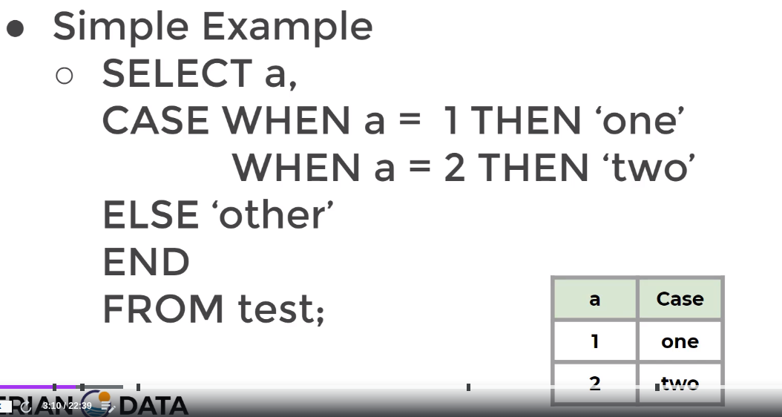
    - a is the <column name>
    - CASE WHEN a = 1 THEN ‘one’
      - This states when the column a has a row a row equal to 1. Then the equivalent row in a new column called case will equal to ‘one’,
      - The new column will be called case, because we did not rename the column

- Exp1: Have different conditions for different values within a column
SELECT customer_id,
CASE
WHEN customer_id < 100 THEN 'Premium'
WHEN customer_id BETWEEN 100 AND 200 THEN 'Plus'
ELSE 'Normal'
END AS customer_class
FROM customer;

  - If you remove customer_id, that comes after SELECT. Then, your query’s results will only have the customer_class
  - WHEN the customer_id is below 100. Then the results column that is called customer_class will put the text ‘Premium’ in respective rows that are below 100
  - WHEN the customer_id is between 100 and 200. Then the results column that is called customer_class will put the text ‘Plus’ in respective rows that are between 100 and 200.
  - WHEN the customer_id is not below 100 and not between 100 and 200. Then the results column that is called customer_class will put the text ‘Normal’ in respective rows

- 2. The CASE Expression Statement
  - This statement is able to produce a new column based on an existing column if specific conditions are met. However, it evaluates an expression then compares the result with each value in the WHEN clauses sequentially. Therefore, the CASE begins by evaluating an expression
  - The main difference between CASE expression statement and the CASE general. Is that the CASE expression saves the time and steps
  - The CASE expression mainly used to check the equality

  - The Syntax:
SELECT <column name>,
CASE <column name>
WHEN <specific condition1> THEN <specific action1>
WHEN <specific condition2> THEN <specific action2>
ELSE <specific action3>
END AS < action column name>
FROM <table>;

    - If you remove <column name>, that comes after SELECT. Then, your query’s results will only have the < action column name>

  - The figure below is an example of using the CASE expression statement

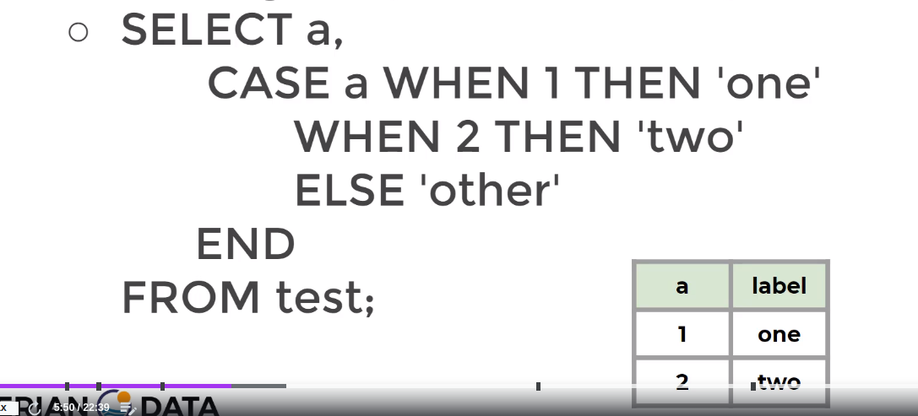

  - CASE expression statement is very similar to the general CASE. However it is only similar in the scenarios when we are checking for equality.
  - The CASE expression only checks for equality this is why no need for an = sign

- Exp1: Check for equality and inequality, have different conditions for different values within a column. For the row of the column that has an input of 2 then have the newly generated column to label that row as a ‘winner’. For the row of the column that has an input of 5, have the newly generated column to label that row as a ‘second place’.

SELECT customer_id,
CASE customer_id
WHEN 2 THEN 'winner'
WHEN 5 THEN 'second place'
ELSE 'normal'
END AS results
FROM customer ;

  - If you remove customer_id, that comes after SELECT. Then, your query’s results will only have the results
  - WHEN the customer_id column input is equal to 2 THEN set the input of the newly generated results column as ‘winner’
  - WHEN the customer_id column input is equal to 2 THEN set the input of the newly generated results column as ‘second place’
  - WHEN the customer_id column input is equal to 2 THEN set the input of the newly generated results column as ‘winner’
  - WHEN the customer_id column input is not equal to 2 or 5 THEN set the input of the newly generated results column as ‘normal’

- Exp2: Perform operations on the results column that is called < action column name>. Categorize the rental_rate. Then calculate how many $0.99 movies you & have that in a column. Then calculate how many $2.99 movies you & have that in another column.

SELECT
SUM (CASE rental_rate
WHEN 0.99 THEN 1
ELSE 0
END) AS bargains,
SUM (CASE rental_rate
WHEN 2.99 THEN 1
ELSE 0
END) AS regular
FROM film

  - We needed to remove the <column name>, that comes after SELECT., because your results is a single row. While <column name> is a full column
  - The bargains column will return the SUM of the number of rows that have their input as the value 1. Anything that is equal to 0.99 in the rental_rate column was equal to 1 in the bargains column. Then, all the rows that are equal to one were counted and their SUM is presented as a single row results
  - The regular column will return the SUM of the number of rows that have their input as the value 1. Anything that is equal to 2.99 in the rental_rate column was equal to 1 in the regular column. Then, all the rows that are equal to one were counted and their SUM is presented as a single row results

CASE Keyword/Statement Challenge

- Challenge1: Compare the various films available per rating using CASE keyword and have a unique new for each one of them
SELECT rating,
CASE
WHEN rating = 'NC-17' Then '1'
WHEN rating = 'PG' Then '2'
WHEN rating = 'G' Then '3'
WHEN rating = 'PG-13' Then '4'
WHEN rating = 'R' Then '5'
ELSE '6'
END AS results
FROM film
ORDER BY results ASC;

- Challenge1: Compare the sums of films available per rating using CASE keyword and have a unique new for each one of them
SELECT
SUM (CASE rating
WHEN 'NC-17'THEN 1
ELSE 0
END) AS PG,
SUM (CASE rating
WHEN 'PG'THEN 1
ELSE 0
END) AS PG,
SUM (CASE rating
WHEN 'G'THEN 1
ELSE 0
END) AS G,
SUM (CASE rating
WHEN 'R'THEN 1
ELSE 0
END) AS R
FROM film
COALESCE Function (Cover null rows)

- The COALESCE function accepts unlimited number of arguments (typically column names). It returns the first argument that is not null. If all arguments are null. Then the COALESCE function will return null.
- The purpose of the COALESCE function when null values of a table is being substituted with other none null values
- Commonly COALESCE is used to replace null rows with 0. In columns to allow for mathematical operations
- The Syntax:

- Exp1: Find the price after the discount of the table below
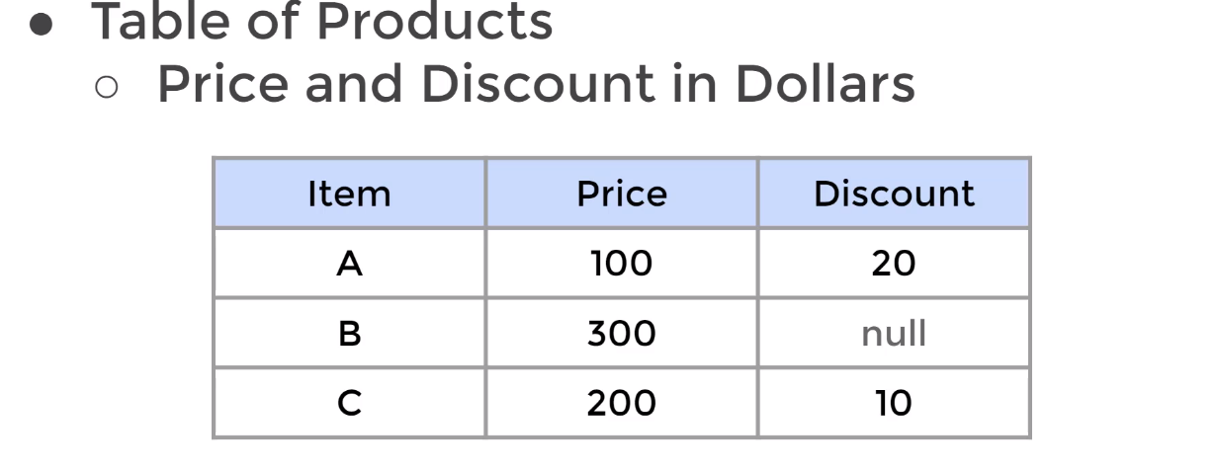
  - If you type whatever in the figure below. SQL will not know how perform the mathematical operation on null
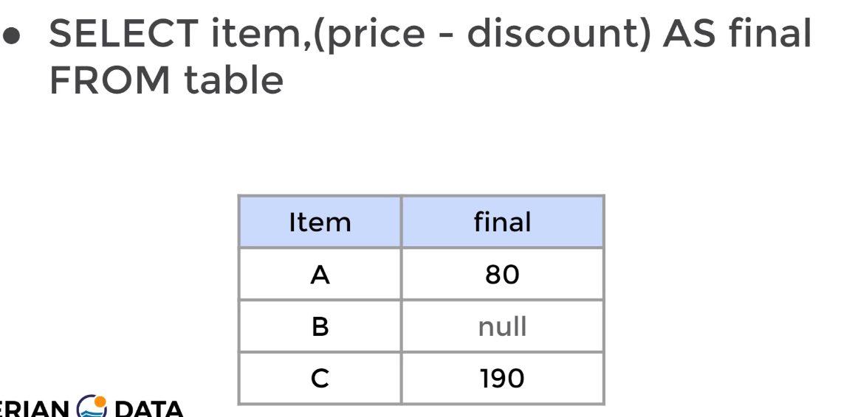
  - Therefore, similar to the blew code after adding COALESCE and convert any null value to 0. We can perform the mathematical operation properly and calculate for the final value (price-discount)
  - SQL will check the discount column and check. If it is a null value then it will return whatever the next value is after null, which we set as 0.
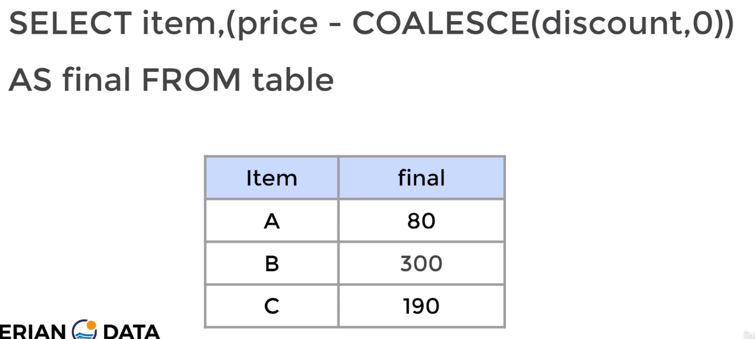
CAST Function & Operator (Modify Datatype)

- The CAST operator converts column’s data types from one data type to another
- The CAST operator converts data types within reason. You can not convert a text that says ‘five’ to an integer.
- The CAST function is able to convert the data type a single data entry to a full column
- CAST will result in an query. It will not change the original table’s data type. However, ALTER will change the original table’s data type . ALTER will change the type once and the type can not be changed again.
- ALTER cannot modify the datatype of:
  - Recently modified columns by ALTER
  - Columns used by a rule or view

- The CAST function: is a SQL syntax for a single data entry
SELECT CAST (<data-entry> AS <new-data-type> )

- The CAST function: is a SQL syntax for a column
SELECT CAST (<the-name-column-name> AS <new-column-type>
FROM <table-name>

- The CAST operator is only a PostgreSQL syntax. You do not need to type CAST you will type ::
SELECT <data-entry> :: <new-data-type>

- Other Methods to Modifying a column’s datatype but not a single entry. However, this method does not work all the time. CAST creates a rule and ALTER can not change the rule
ALTER TABLE <table-name>
ALTER COLUMN <the-name-column-name> TYPE <new-column-type>
  - The keyword TYPE must be used

- Exp1: Convert a single entry’s data type, and not from a table
SELECT CAST('5' AS INTEGER) AS new_int
  - ‘5’ is a text data type and we converted into an integer

- Exp2: Convert a column entry’s data type, and not from a table
SELECT CAST (inventory_id AS VARCHAR(20))
FROM rental
NULLIF Function

- The NULLIF function. This function takes in 2 inputs and returns NULL if both inputs are equal.
- The NULLIF function returns the first argument if both arguments are not equal
- The NULLIF is useful in cases where null may cause an error or an unwanted results

- Syntax for NULLIF in a single entry (This is not a general syntax, this is a specific syntax)
NULLIF(<entry1>, <entry2>)

SELECT
SUM (CASE <column-name> WHEN <condition2> THEN <value> ELSE <value> END) / NULLIF(SUM (CASE column-name WHEN <condition2> THEN <value> ELSE <value> END) , 0)
FROM <table>
  - The NULLIF is used after dividing the two statements.
  - The NULLIF attempt to say if (SUM (CASE column-name WHEN <condition2> THEN <value> ELSE <value> END) is equal to 0. Then return return NULL. If it is not equal to 0. Then return what ever (SUM (CASE column-name WHEN <condition2> THEN <value> ELSE <value> END) is
  - If (SUM (CASE column-name WHEN <condition2> THEN <value> ELSE <value> END) is equal to 0. Then we will get an answer of null instead of error. Because: SUM (CASE <column-name> WHEN <condition2> THEN <value> ELSE <value> END) / null = null

Views Function

- VIEW is used to access queries quickly. Without the need to continuously type them.
- The below figure shows how. We can transfer a lengthy code into a single view call.
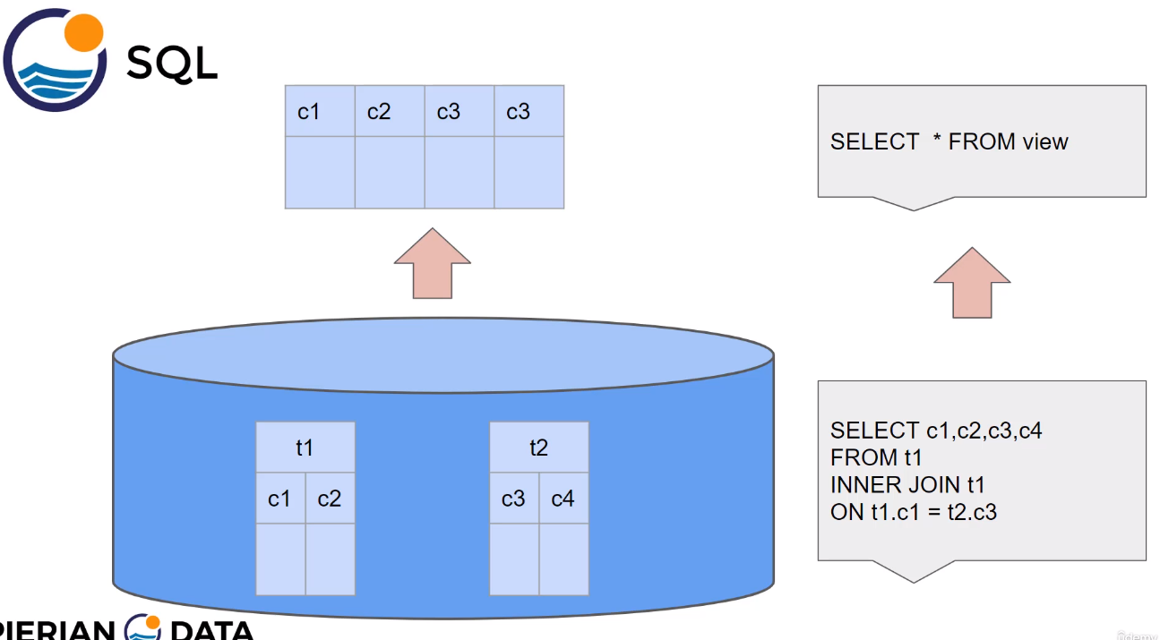
- VIEW is a database object that is a stored query. Also, it can be accessed as a virtual table in PostgreSQL
- VIEW only stores the query call. It does not store the data

- The syntax of creating a VIEW
CREATE VIEW <name-of-view> AS
<The query. Starting from SELECT>

- The syntax of calling an existing a VIEW
SELECT * FROM <name-of-view>

- The syntax of modifying a VIEW
CREATE OR REPLACE VIEW <name-of-view> AS
<The query. Starting from SELECT>

- The syntax of deleting/removing a VIEW
DROP VIEW <name-of-view>

- The syntax of renaming a VIEW
ALTER VIEW <name-of-view> RENAME TO <new-name-of-view>

Importing & Exporting Data (Using The The GUI pgAdmin).

- Notes about Importing and Exporting
  - Not all files can be imported
- Importing:
  - PgAdmin allows us to import data from a .csv file to an already existing table
  - When importation a .csv file or and excel file. PostgreSQL does not automatically create a table. It assumes that a table is already available at either the .csv file or the excel file

- Export:
  - 1. Find the table you created in PgAdmin and right click on its name. Then select Import/Export
  - 2. In the Import/Export data window. Click EXPORT, then place the file name and its PWD. Indicate its format. Select the Delimiter, usually ‘,’. Then choose the Quote and Escape. Both latter are usually kept as “ and ‘. Then click OK
- Exp: Importing a .csv file into PgAdmin
  - Steps to of importing:
    - 1. Create a database or use an existing database
    - 2. Create a table in the database that have the same structure. Meaning the same number of columns as the .csv file table. The name of the PostgreSQL table & columns does not have to match the .csv file’s table
    - 3. Use PgAdmin’s import/export functionality, to grab the .cvs file.
      - 3.1 Refresh the database
      - 3.2 Find the table you created in PgAdmin and right click on its name. Then select Import/Export
      - 3.3 In the Import/Export data window. Click IMPORT, then place the file name and its PWD. Indicate its format. Activate the Header. Select the Delimiter, usually ‘,’. Then choose the Quote and Escape. Both latter are usually kept as “ and ‘. Then click OK

Section 10: Execute SQL Queries with Python (psycopg2) library

The steps to execute SQL queries using Python

- Note: You can execute SQL queries using: The command line, PgAdmin 4, and Python
- 1. Install psycog2 library in python. Then open your Python’s IDE & create a new .py file
- 2. Import the psycopg2 library
  - import psycopg2
- 3. Create a connection with PostgreSQL via Python for the dvdrental database. Please note that the .py file is saved in the same folder as dvdrental
  - con = psycopg2.connect(host="localhost",database="dvdrental",user="postgres",password="password")
      - If we were connecting to a server over the internet we would type the IP address instead of “localhost”
- 4. Retrieve the cursor, which allows us to perform traversals over the database
  - cur = conn.cursor()
- 5. Execute from the database
  - cur.execute(‘<The Query>’)
- 6. Perform the query of the header row
- 7. Perform the fetching. This fetchone() or fetchmany(), or fetchall()
  - fetchone() returns the first row of data
    - Type -> print(cur.fetchone())
  - fetchmany(<# of rows>) returns The specific number of rows you specify
    - Type -> print(cur.fetchmany(5))
      - This will return the first 5 rows
  - fetchall() returns all the rows
    - Type -> print(cur.fetchall())
- 8. To save your changes you must commit them
  - Type -> cur.commit()
- 9. When does performing the queries. You can close the connection
  - Type -> conn.close

Section 11: Execute PostgreSQL With The Command Line

The .sql file
- A .sql file contains Structured Query Language (SQL), which is a language used to access and modify information in a database. It stores SQL statements for creating or modifying database structures, insertions, updates, deletions, or other SQL operations.
- .sql files are written in a plain text (ASCII) format and may contain different information defined in the code. It can contain statements that either create or modify a database or other SQL operations such as updates, deletions and the like. To be properly read and executed, the .sql file has to be opened in a database program that supports the Structure Query Language. However, any simply text editor can be used to write and edit an .sql file.
- Execution:
  - You can execute a .sql file by copying and pasting each line from the .sql file into the terminal while in a database
  - Or you can execute the full .sql from the terminal while you are in a database by typing -> \i <pwd of the .sql file>

Installation PostgreSQL
- Steps:
- 1. Type the following in the terminal -> sudo apt install postgresql
  - This will let you know the port # and the version and the owner default owner postgres
Configurations of PostgreSQL
- The first time Configuration of the PostgreSQL superuser
  - Setup the name as postgres and the password as password
  - The name postgres is by default the name of the superuser
    - 1. Type in the command line -> sudo -u postgres psql
      - The u is lower case
    - 2. Set up the password for the root user in the PostgreSQL interactive terminal type -> ALTER USER postgres PASSWORD ‘passowrd’
    - 3. You may exit by typing -> exit
      - To exit you can also type \q

Login to PostgreSQL As The root Superuser
- Login in to psql as a root user (postgres)
  - 1. Type in the command line -> psql -U postgres -h localhost
      - The U is upper case
  - 2. Type the password -> password
  - 3. You may exit by typing -> exit
    - To exit you can also type \q
- You can also type psql and you will login to the first user you created other than the root user -> psql

Setup A New User/Password to PostgreSQL
- Setup a new user name and password + creating a data base for that user
  - 1. You must be inside the PostgreSQL interactive terminal. of the superuser, which is postgres user
    - 1.1. Type in the command line -> psql -U postgres -h localhost
      - If we were connecting to a server over the internet we would type the IP address instead of “localhost”
    - 1.2. Type the password -> password
  - 3. In the PostgreSQL interactive terminal create the user by typing -> CREATE USER <username> WITH CREATEDB LOGIN ENCRYPTED PASSWORD ‘<The-Password>’;
    - CREATEDB is a privilege to the <username>, you can add more
    - You must receive the following back from the PostgreSQL interactive terminal -> CREATE ROLE
  - 3. Create a database for the user, with the same name as the <username> which will contain the user privileges by typing -> CREATE DATABASE <username>;
    - You must receive the following back from the PostgreSQL interactive terminal -> CREATE DATABASE
  - 4. You may checkout the databases by typing -> \du
    - This should show that the user postgres has all the privileges and the new <username> has only the CREATEDB privilege

Grant/Drop a Superuser Privileges to A User
- You must be in a super user:
  - Login in to psql as a root user (postgres)
    - 1. Type in the command line -> psql -U postgres -h localhost
        - The U is upper case
    - 2. Type the password -> password
- 2. To grant privileges Type -> ALTER USER <username> WITH SUPERUSER;
- 3. To remove privileges Type -> ALTER USER <username> WITH NOSUPERUSER;

Grant Access of A Database to A User
- To Grant access of a Database to a user
  - 1. You must be inside the PostgreSQL interactive terminal. of the superuser, which is postgres user
    - 1.1. Type in the command line -> psql -U postgres -h localhost
    - 1.2. Type the password -> password
  - 2. If the database is already made then ignore this step if not then make a data base
    - 2.1 Type -> CREATE DATABASE <database-name>;
  - 3. Grant the access of the data base to an existing user -> GRANT ALL PRIVILEGES ON DATABASE <database-name> TO <username> ;
    - You must receive the following back from the PostgreSQL interactive terminal -> GRANT
  - 4. To view the databases and who has access privileges-> \l

- Enter the PostgreSQL via a specific user and enter the PostgreSQL interactive terminal
  - 1. Type in the command line -> psql -U <username> -h localhost
  - 2. Type in the password -> <The-Password>
  - Note: if you just type psql in the terminal you will login as the mohamd user. Also to quit type \q

Key PostgreSQL interactive terminal Commands & Terminal Commands
- To view the most important general commands type \-> help
- To view what all the special commands do type -> \?
- While outside the PostgreSQL interactive terminal window and in the regular Linux command line to get help we can always type -> --help
- While outside the PostgreSQL interactive terminal window and in the regular Linux command line to get help on a specific command type -> <command_name> --help

Perform A Query
- Performing a query is similar to all the queries you have seen. However the query must end with a semi-colon ;

Create A Database
- 1. While logged in type -> CREATE DATABASE <database’s name>;
  - You must receive the following back from the PostgreSQL interactive terminal -> CREATE DATABASE
- 2. You may list the databases by typing -> \l
  - This should show the <username> of who ever was logged in and created the <database’s name>

Saving
- Once you create a database it is saved
- Once you execute a command on a table and you alter that table, whatever you changed is saved. Therefore, if you are unsure, try to copy the table and work on the copy

View All The settings of a Table in Database
- while inside the database. Type ‘list tables’ option which is the following -> \d <Table-name>
  - This will view all the columns, their type, and their constrains

Drop A Database
  - 1. You must be inside the PostgreSQL interactive terminal of the superuser, which is postgres user
    - 1.1. Type in the command line -> psql -U postgres -h localhost
    - 1.2. Type the password -> password
  - 2. If you are not a superuser or you do not have the privileges yo drop the database you wont be able to. Drop the database by typing -> DROP DATABASE <database-name>
    - You must receive the following back from the PostgreSQL interactive terminal-> DROP DATABASE
Connect to A Database
- Method 1, while inside the Linux terminal and not the PostgreSQL interactive terminal shell
  - Type the following -> psql -h <host-name> -p <port#> -U <username><database-name>
    - For <host-name>, you must type the the host address. For an external machine you need to type its IP address. However for your local machine type -> localhost
    - For <port#>, you must type the the connection port #. For an external machine you need to type the connecting port #. However for your local machine type -> 5432

- Method 2, while inside PostgreSQL interactive terminal shell
  - Type the following -> \c <database-name>
    - The user must have access to that database
  - You can also switch between data bases without the need to exit the PostgreSQL interactive terminal shell by typing the following inside a database - > \c <database-name>

View All The Tables of A Database
- Option1:
  - while inside the database. Type ‘list tables’ option which is the following -> \dt
- Option2:
  - while inside the database. Type ‘list of tables, views and sequences’ option which is the following -> \d

Importing a single Table of .sql format
- The steps:
  - 1. While inside the PostgreSQL interactive terminal create a table in PostgreSQL that has the same exact <table name> and <column(s) name(s)> as the downloaded .sql table
  - 2. While inside the PostgreSQL interactive terminal of the table you want to insert too, type the following -> \i ‘<pwd>’
    - The includes the file <pwd> and its extension

Importing a single Table of NOT .sql format. Format either .csv or .txt
- The steps:
  - 1. While inside the PostgreSQL interactive terminal create a table in PostgreSQL that has the same exact <table name> and <column(s) name(s)> as the downloaded .csv or .txt table
    - Note: PostgreSQL won’t import a .csv file if there are any empty columns to the left to the start of the table
  - 2. While inside the PostgreSQL interactive terminal of the table you want to insert too, type the following -> COPY <table name> (<column(s) name(s)>) FROM ‘<pwd>’DELIMITER; <’The delimiter’> <File extension mood> HEADER
    - ‘pwd’ must include the .csv extension at the end
    - DELIMITER <’The delimiter’>, a delimiter can be a comma ‘,’. It has to match the DELIMITER in the .csv or .txt file
    - <File extension mood> -> The mood should be CSV
    - The key word of HEADER is optional. Having it in your query will include the headers of the table
Importing a full Database of multiple tables
- The steps:
- 1. Create a database -> CREATE DATABASE < database_name>
- 2. To import the data of a .pgsql file. You must be in the regular Linux command line outside the PostgreSQL interactive terminal window
  - Type the following -> psql pwd <<database_name>
  - pwd must end with a name of your choosing and a .pgsql extension or .sql

Exporting a single Table to a .csv format
- The steps: You must use the \c or the \copy, which perform a SQL copy with data stream to the client host
- The Syntax
\copy (<The query>) TO ‘pwd’ DELIMITER <’The delimiter’> <File extension mood> HEADER
  - ‘pwd’ must include the .csv extension at the end
  - DELIMITER <’The delimiter’>, a delimiter can be a comma ‘,’ and it is optional
  - <File extension mood> -> The mood should be CSV
  - The key word of HEADER is optional. Having it in your query will include the headers of the table

Exporting a single Table of .txt format
- The steps: You must use the \c or the \copy, which perform a SQL copy with data stream to the client host
- The Syntax
\copy (<The query>) TO ‘pwd’ DELIMITER <’The delimiter’> <File extension mood> HEADER
  - ‘pwd’ must include the .txt extension at the end
  - DELIMITER <’The delimiter’>, a delimiter can be a comma ‘,’ and it is optional
  - <File extension mood> -> The mood should be CSV
  - The key word of HEADER is optional. Having it in your query will include the headers of the table

Exporting a full Database of multiple tables using pg_dump
- To export a data base as a .pgsql file. You must be in the regular Linux command line outside the PostgreSQL interactive terminal window
- Type the following -> pg_dump -U <username> <database_name> pwd
  - pwd must end with a name of your choosing and a .pgsql extension or .sql
- pg_dump:
  - The idea behind this dump method is to generate a file with SQL commands that, when fed back to the server, will recreate the database in the same state as it was at the time of the dump. PostgreSQL provides the utility program pg_dump for this purpose. pg_dump is a regular PostgreSQL client application (albeit a particularly clever one). This means that you can perform this backup procedure from any remote host that has access to the database. But remember that pg_dump does not operate with special permissions. In particular, it must have read access to all tables that you want to back up, so in order to back up the entire database you almost always have to run it as a database superuser.

Database Saving Locations View

- While inside the PostgreSQL interactive terminal window, type SHOW data_directory;
  - PostGreSQL database files are binary files

Save The JOIN tables as New Tables
- While creating a JOIN table. To change the view of the table you can turn on the expanded display by typing -> \x
- Create a new table based on the results of the JOIN query:
CREATE TABLE <new-table> AS
SELECT * FROM <table-join-1>
INNER JOIN <table-join-2>
ON <common-column1>. <table-join-1> = <common-column1>. <table-join-1>;

Extensions Functions
- Extensions are functions that are added to add functionality to your code
- To access the list of extensions on the PostgreSQL interactive terminal type -> SELECT * FROM pg_available_extensions;
- Utilization of an Extension Function for example the extension: uuid-ossp
  - 1. Install the extension if the extension is not installed yet > CREATE EXTENSION IF NOT EXISTS “uuid-ossp“ ;
    - A good practice to type IF NOT EXISTS. Thus PostgreSQL does not install the extension again
  - 2. To use an extension. You must view the ‘List of functions’ by typing -> \df
  - 3. Select a function from the ‘List of functions’ and invoke it. Say we invoked the function uuid_generate_v4. Therefore to run this extension function type -> SELECT uuid_generate_v4();

Notes on Backups
- As with any relational database platform, this begins with creating SQL dump files. In Postgres this is handled through the pg_dump process.
- For PostgreSQL, dump files can be stored in one of three formats: as a text file (.sql), compressed binary format (.bak), or as a tarball (.tar)
- In most cases, especially if you are using Postgres as a production server as part of your persistent backups, you will want to dump it as a binary backup, or if the database is particularly large, as a tarball.

