Section 2: Introduction
- Git is a VCS (Version Control System): it is a software that tracks and manages changes to files over time. You do not need the internet to use it
- Github is a web-service that hosts Git repositories (projects) on the cloud and makes it easier to collaborate with other people

Section 3: Installation & setup
- GitKraken is a GUI (Graphical User Interface). It is the software that visualizes the work your Git does. Avoid using it and focus only on the code
- Configuring the Git name and email:
  - The below procedure is what required to configure your name and email. To change your name and email just follow the procedure below again
  - Setting up the name git will know you by -> git config –global user.name “Mohamd Imad”
    - Now if you type -> git config user.name
      - Git will tell you the Git assigned user name
  - configure your email -> git config –global user.email “medoimad@hotmail.com”
  - Setting up the email git will know you by -> git config –global user.email medoimad@hotmail.com
    - Now if you type -> git config user.email
      - Git will tell you the Git assigned user name

Section 4: Basics of Adding & Committing
- The Git Repo
  - Repo stands for Repository. Git repo is a workspace of git that tracks and manages files within the folder
  - Any time we want to use Git within a project we need to create a new git repository and each repo has its own history
- Step 1 or 2 Creating a New Repo
  - A good practice is to check if there is already a git file before initiating your git repo
  - git init -> this command will initialize a new repository where ever we are in our system
  - initializing a git repo in a specific folder. Means a git repo will initiate in that folder and that folder will be the home for that git repo
  - This command is run once in each project to let git know that we might need to save files here
  - The repo is represented by a new hidden file named .git which, will appear in folder that git init was initialized in. To view the hidden files type ls -a or la
  - .git
    - If this file is deleted. Then the git history for what ever folder this .git file was on will be removed
    - to remove the .git folder you can use the rm -rf command which would delete the entire git history for the folder
  - Common errors
    - 1. Once initialized in a folder git will apply the git feature to tat folder and all the folders within it. Therefore, a common mistakes is initializing git at a major directory with my sub-directories. This would result in significant memory usage
    - 2. Creating a git repo within a folder that has a git repo might give git problems, because at that point we have git tracking git. Therefore, it is essential to always run git status prior to using git init to create a git repo
- Step 2 or 1 Checking up the status of your Git Repo
  - A good practice is to check if there is already a git file before initiating your git repo
  - git status -> reports back information about the git repo we are currently in
  - This command will let the user know which files are being tracked with git and which files are not
- Step 3 Committing workflow
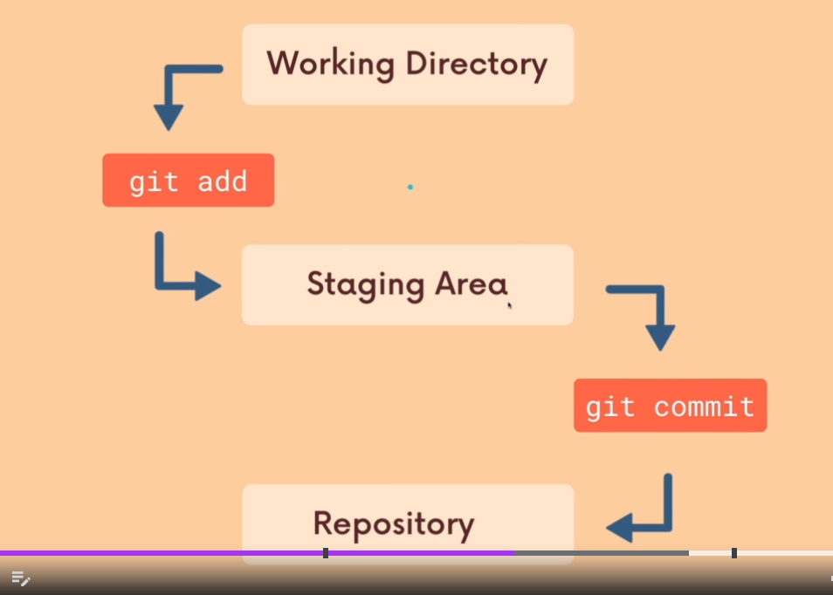
  - Committing is not the same as saving files, because you must make changes to the files before committing them, otherwise git will see no point in committing a file that has no changes from its previous version
  - Committing includes saving the specific version of multiple files & folders together. You can work on 10 files and decide to commit only 8 of them then you can save those at a specific commit. Then save the other 2 files with a different commit. Therefore two commands must be used to separate the executions of the commits
  - to make a commit after making changes to the files and folders need to use the git add then the git commit commands. Two commands are used, because this will allows us to separate the changes we made
    - the git add <file(s) name>
      - This command add changes by grouping specific changes together in the preparation for those specific changes’ commit. The selected files & folders will be added together in a staging area waiting for their commit
    - the git commit or git commit -m “Type a Message Here”
      - This command commits everything that was added to the staging area
      - Typing git commit alone will take you to a page where you will fill up the message and exit
      - including -m “Type a Message Here” will allow you to add a message with this specific commit
  - Step 3.1 work on stuff
    - Committing is not the same as saving files, because you must make changes to the files before committing them, otherwise git will see no point in committing a file that has no changes from its previous version
  - Step 3.2 git add
    - git add <file(s) name> -> In this command you can specify which files you would like to add into the staging area. You may want to only add 3 files/folders out of 10 or all the files/folders
      - you can type in git rm –cached <file(s) name> to remove a file from the staging area
    - git add . -> will add everything in that has been modified or new to the staging area. The dot “.” represent the current working directory
    - If we say this file has not been staged, then it is the same thing as saying this file has not been added
  - Step 3.3 git commit
    - git commit or git commit -m “Type a Message Here”-> Once executed the work will be committed to the repo folder. Which is the .git folder. Also, you will need to type a message with each commit, to let your future self or who every views this work what this commit saved
    - Typing git commit alone will take you to a nano file file page where you will fill up the message and exit
    - including -m “Type a Message Here” will allow you to add a message with this specific commit
    - Once a file is committed git will always keep an eye on it
- Step 4 (git log) viewing the history of your commits using
  - git log -> shows the log history of all of your commits
  - The commit hashes
    - Important to revisit a commit, view a commit, edit a commit
  - git log –abbrev-commit -> shows a shorter version of the hashes
  - git log --oneline -> shows you a single line of each commit message with a shorter version of the hashes as well

Section 5: Commits in Detail
- Navigating through git
  - Method 1 -> man git
    - This will display everything about git. Including the command commands
  - Method 1 (case specific example) -> man git add
    - presents an explanation of the add command of git
  - Method 2
    - The online reference manual
- Atomic Commits ”A good approach”
  - This is the idea that when you commit, you should try to keep each commit focused on a single thing. A thing like a feature, a change or a fix
  - This approach makes your code makes your code much easier to read
- Commits Messages
  - Git recommends messaged to be:
  - 1. Written in present tense
  - 2. Following an imperative style
    - For example:
      - make 123 do 654 (correct)
      - This commit makes 123 do 654 (incorrect)
      - I made this commit to make 123 to do 654 (incorrect)
  - 3. Written in a way that is seems like you are giving orders to the code base to change its behaviour
  - Note:
    - make sure you stay consistent either use only present tense or past tense. Also, you should always follow whatever the company you are working in recommends
    - In a case where you would like to write a paragraph. The first line of the message should be the summary. Thus if another user tried to view the log he just views it as one line and can understand your commit from the summary
- Amending to Commits Messages (Editing the latest commit made)
  - The ability to edit and modify the latest commit made
  - Steps after having already completed a commit:
    - 1. Type -> git add <file(s) name>
    - 2. Type -> git commit –amend
      - You will be requited t type your message again
  - If typed -> git commit –amend without any adding any new files. This should allow you to edit your message
- Ignoring Files (untrack Files using .gitignore)
  - Always created a .gitignore prior to creating the files
  - The ability to force git to not track specific files. This will tell git that the specified files are never to be committed
  - Steps force git not track specific files:
    - 1. create a file called .gitignore in the same directory that .git/ folder is created in, which is the main directory that you are tracking using git. NOT inside ./git
    - 2. in the .gitignore file type whatever you want git to ignore, similar to the examples below.
      - .UX_Store git will ignore the file hat is called .UX_Store
      - Folder1/ git will ignore the folder that is called Folder1/
        - For folder names “/” must be placed at the end
      - *.log git will ignore all the files that has a log extension
        - using wildcards
      - file1.txt git will ignore the file that is called file1.txt
      - *.txt git will ignore all the files that have a .txt extension
        - using wildcards
    - 3 commit the .gitignore file and type the changes that were made in it
      - It is up to you to add .gitignore as a commit or not. It is better to add it as a commits each time you add a file(s)/folder(s) to it to give your future self an ideas of the history
    - 4. If the files existed before the creation of .gitignore -> Type the following commands, every time you add a file
      - To remove all the files from being tracked type -> git rm -rf --cached .
      - Add all the files/folders to be tracked again inside the .gitignore file -> git add .
    - 5. go to https://www.toptal.com/developers/gitignore to see examples of what you should ignore based on the application you working in and you can add all the file(s) and folder(s) you should ignore, even if you do not have these applications yet

Section 6 Working with Branches
- Hashing
  - Each git commit has a hash that represent it,which is a long number that represent that specific commit
  - Each hash has many settings, including:
  - The indication if the current hash has a parent(s) hash(s). Usually only the first commit does not have a parent
  - The message that comes with this hash, which is the same message you type when you create a commit
- Branching (Essential when working with others)
  - They enable us to create separate contexts where we can try new things and work on multiple ideas at once
  - If changes occur on one branch, it does not impact the other branches, unless they are merged
- HEAD
    - HEAD
      - Is a pointer that reports back the user’s current location with respect to all branches
      - When we move between branches the HEAD pointer also moves
    - master
      - is the main or master branch that each git repo begins with
    - Additional branches
      - we can have other branches beside the master branch
      - if we are at one of the branches then the HEAD point will move there
    - Example: commit <The commit hashes> (HEAD -> master)
      - This indicates that we are currently at the master branch

- Viewing Branches git branch
    - git branch
      - This command is used to view your existing branches
      - * master
        - This means you are in the master branch. The * indicates the location
    - git branch -v
      - This command is used to view your existing branches. The -v option shows important information. Such as the commit number and the message of the last made commit

- Making a Branch git branch <branch-name>
    - git branch <branch-name>
      - This command creates a new branch based on what ever name you give it. You won’t be able create that branch until you have made a commit
      - Also, once you create a new branch you still going to be working in the latest branch. Therefore, we must switch to a branch using git switch <branch-name>
      - Creating then switching to a new branch at the same time git switch -c <branch-name>
      - The location where you make the branch is very important. Because any new branch will take all the files of the latest branch it was created from

- Renaming a branch
  - You can rename any branch, while being inside that branch using git branch -M <new name>
- Switching between branches git switch <branch-name>
    - git switch <branch-name>
      - This command switches between branches
      - You want to switch branches then make changes
    - You need to have a full knowledge on where you are starting your branch
    - Look at the diagram below. After he got to the last blue commit he made a new branch called branch 1 and did additional work there. Then he completed that he switched back to master and made a new branch called branch 2 and did his work there.
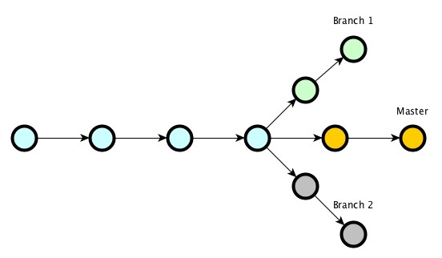
    - If he did not switch back to master branch 2 will be coming out of branch 1 instead of the master branch line
    - Creating then switching to a branch at the same time git switch -c <branch-name>
    - Before switching between branches, we must commit or stash our changes. Unless our changes have never been made in any other branch
      - For example if we made a file in a new branch and that is the first time that file is made. Then we can switch branches and that file will follow us to whatever branch we switch too
- git checkout <branch-name>
    - git checkout <branch-name>
      - This command is able to do the same exact thing as git switch, plus some more features
    - git checkout has many other additional features other than switching between branches features
    - Before switching between branches, we must commit or stash our changes. Unless our changes have never been made in any other branch
      - For example if we made a file in a new branch and that is the first time that file is made. Then we can switch branches and that file will follow us to whatever branch we switch too
- Deleting branches git branch -d <branch-name>
    - git branch -d <branch-name>
      - This command deletes branches. But you can not be inside the branch when it is requested to be deleted
- Renaming branches git branch -m <branch-name>
    - git branch -m <branch-name> <branch-new-name>
      - This command renames branches.
      - If you are inside the actual branch you can use git branch -m <branch-new-name>. Avoid using this method. I find it better to to use git branch -m <branch-name> <branch-new-name>
- How does Git stores HEAD & Branches
  - If you switch between branches. A file called HEAD inside .git folder, will constantly change to represent the branch you are switching too
    - The context of HEAD will constantly change to the pwd of the commit of the branch you are on. For example ref: refs/heads/cutting2022
  - Inside “.git”, there is a folder called“refs” and it contains two folders “heads” and “tags”. Inside the folder “heads”, you can find all of your files that represent the hashes of your branches.
  - A Hash is a long number that refer to a commit: 70f332f866e42a3a63e2b05005ef37d55d001f80
  - In the case of branches the commit the hash used is the last commit a particular branch have had

Section 7 Merging Branches
- Merging branches -> git merge <branch-name>
  - A common practice: work on feature branches and once you believe they are good merge them to the master branch
  - The master branch is the main branch that will show the work
  - We merge branches not specific commits
  - We always merge to where we are. To where the current HEAD branch is. Therefore, to merge to the master branch you must be in the master branch or switch to the master branch (git switch <master>) and then merge another branch to the master branch by typing git merge <branch-name>
- Method 1: The Fast forward merge
  - Use git merge <branch-name>
  - This is the simplest type of merging between branches. When you have two branches and you merge one branch to another.
  - The end of the branch you are merging (The BugFix branch) becomes the end of the branch we are merging too (The master branch)
  - The two imagoes below show the before and after of a fast forward merging. The branch BugFix branched off the master plan in the first imagine
  - In the second imagine all the work from BugFix was merged into the master plan and become the end of the master plan’s log
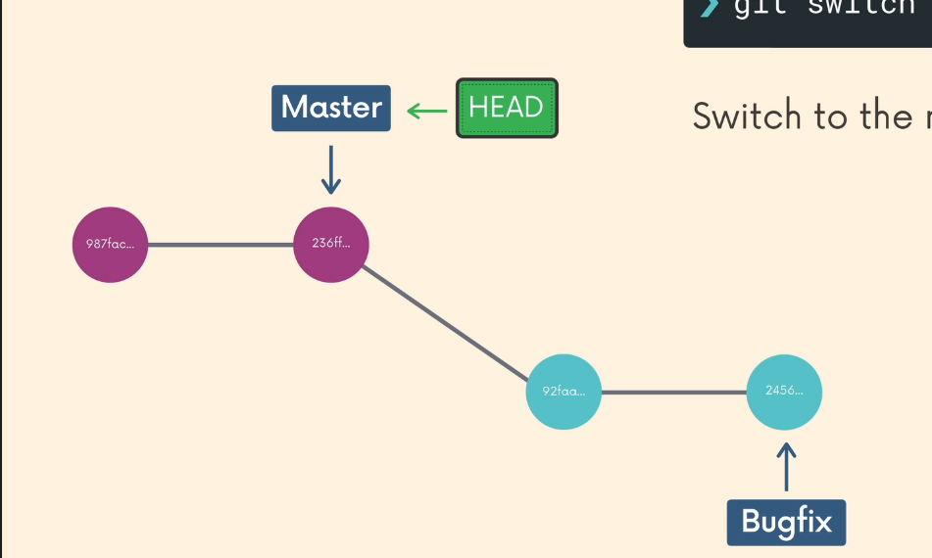
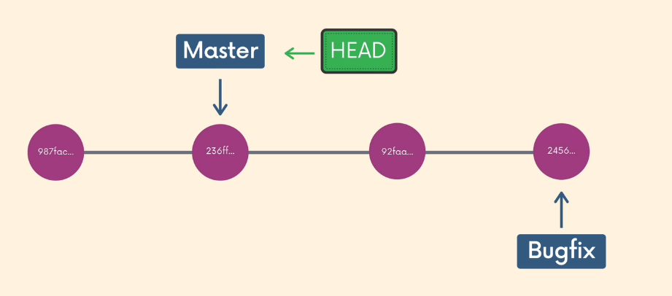
git
- Method 2: Merge Commit (No conflict Merges)
  - Use merge <branch-name>
  - You can have no conflicts if you try to merge a branch that contains new files or merge branch of the same files but do not have conflicts within them in comparison to the files in the other branch you merging into
  - In this merge the changes you made in the featured branch to a commit in the master branch (not the last commit). This occurs, because while you were working on the BugFix (feature branch). Someone worked on the master branch
  - This type of merging occurs all the time. In a very common scenario when one of your teammates added features or merged features from another branch to the master branch while you were working on your own featured branch
  - As a solution we use the merge commit method. Which means that git ends up making a new commit for us on the branch we are merging too (the master branch)
  - The newly made commit will have two parents. The master branch and the feature branch

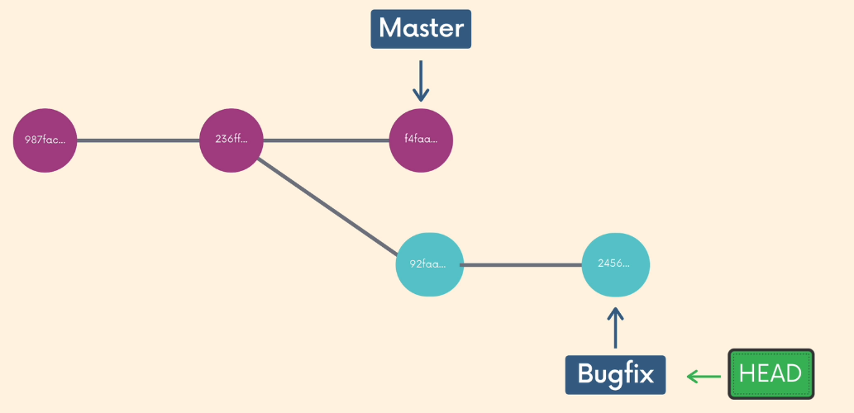
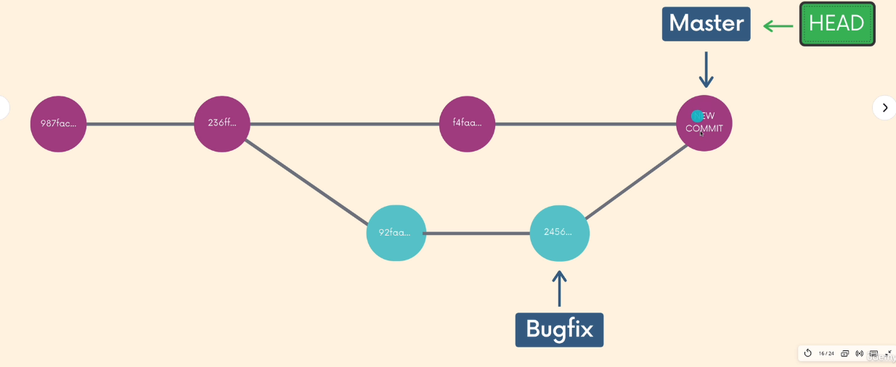

- Method 3: Merge Commit (With Conflict Merges)
  - Use merge <branch-name>
  - The error message from git
    - CONFLICT (content): Merge conflict in <file.txt>
    - Automatic merge failed; fix conflicts and then commit the result.
  - This tend to occur when:
    - On one branch someone modified a file and in another branch that file was deleted
    - On one branch someone modified a file and in another branch that file was was also modified in the same exact line
  - Git has an issue deciding on what to keep and what to get rid off in terms of the files that are being merged. Therefore, such errors or conflicts must be resolved manually
  - The solution:
    - 1. The files in which there are conflicts are edited by git to let you know where the conflicts are.
    - 2. If you open the file, which git indicated that there are conflicts. You will notice that the following:
<<<<<<<<<<HEAD
“Contest from the branch that I am trying to merge into, in most cases the <master branch>”
-----------------
-----------------
“Contest from the branch that I am trying to merge from and it is from <Feature branch>”
>>>>>>>>> <Feature branch>
    - 3. Then after you have opened the file.
    - 4. Edit the file, by removing or keeping what ever text you feel like you need
    - 5. Then remove any conflict symbols.
      - Both contents from the HEAD and from <Feature branch> are in conflict and these must be edited
      - The conflict symbols are in red below:
<<<<<<<<<<HEAD
“Contest from the branch that I am trying to merge into, in most cases the <master branch>”
-----------------
-----------------
“Contest from the branch that I am trying to merge from and it is from <Feature branch>”
>>>>>>>>> <Feature branch>
    - 6. save the file and close it
    - 7. git add the file -> git add <the edited file>
    - 8. git commit the file -> git commit <the edited file>
      - You will notice that git will suggest a message for you once you attempt to commit the edited file. It is up to you if you wish to keep it or not

Section 6: Comparing Changes git diff
- git diff
  - This command is used to show changes between commits, branches, master directory, between our local machine and github
  - git is an informative command and does nothing to the actual repo
- git diff
  - without any any additional options
  - This will compare the changes already committed files and “the same files” after they have been edited and not added & committed yet.
  - For Exp:
    - 1. File1.txt has been added and committed
    - 2. Then we will do additional changed to File1.txt
    - 3. Before adding and committing File1.txt again
    - 4. If we type git diff
      - Then, this will show the changes between the already add/committed File1.txt and edited and to be staged (to be added) File1.txt
- The guide to reading a git diff command’s results
  - After running a git diff command you can get the following between already committed files and “the same files” after they have been edited and not staged yet.
diff --git a/file1.txt b/file1.txt
index 1e4ff02..c88ce43 100644
--- a/file1.txt
+++ b/file1.txt
@@ -1 +1,4 @@
-this is file 1
+ file 1
+we have made a change now
+now we write file 1 here
+
hello world
my name is mohamd

  - diff --git a/file1.txt b/file1.txt
    - This line displays the files that are being compared by the git diff command
    - git will call those files a/ and b/ of the same file. Usually a/ is the file that is already committed and b/ is the file that has not been staged yet
  - index 1e4ff02..c88ce43 100644
    - The metadata line. This displays the hashes of the files that are being compared and the mode identifier number, which is an internal number
  - --- a/file1.txt +++ b/file1.txt
    - This tells you that the changes in a/ will be indicated with a – sign. While, the changes in b/ will be indicated with a + sign.
  - @@ -1,2 +1,4 @@
    - This known as the chunk header and it contains the chunk which is the changes that have been made.
    - -1,2
      - From a/. 2 changed have been made starting from line 1. It is a/ due to the – sign.
    - +1,4
      - From b/. 4 changed have been made starting from line 1. It is a/ due to the +sign
  - The + <Green > changes from file b/
  - The -<Red > changes from file a/
  - hello world <a text example, look at the code above>
    - any text that is not coloured that means it sexists in both files at the same location
  - my name is mohamd <a text example, look at the code above>
    - any text that is not coloured that means it sexists in both files at the same location

- Viewing Using git diff: git diff, git diff HEAD, git diff –staged or git diff –cached, git diff <file name/folder name>,git diff HEAD <file name/folder name>,git diff –staged <file name/folder nam>, git diff <branch1>..<branch2> or git diff <branch1> <branch2>, git diff <commit1>..<commit2>
  - git diff
    - without any any additional options
    - This will only compare
      - The changes between already committed files/folders and “the same files/folders” after they have been edited & saved but not added nor committed yet
    - Can not compare
      - new files/folders, that are not added yet
  - git diff HEAD
    - This will compare
      - The changes between already committed files/folders and “the same files/folders” after they have been edited but not added nor committed yet
      - Newly made files/folders after they have been edited and added but not committed yet.
    - Can not compare
      - new files/folders, that are not added yet
    - git diff HEAD, does whatever git diff does plus comparing Newly made files/folders after they have been edited and added but not committed yet.
    - git diff HEAD, does whatever git diff --staged & git diff –staged do plus comparing changes between already committed files/folders and “the same files/folders” after they have been edited but not added nor committed yet, not including new files/folders, that are not added yet
  - git diff --staged or git diff --cached
    - Both of these commands compare any files/folders in the staging area (added but not committed)
  - git diff <file name/ or folder name>
    - This command does the same exact things as git diff but for files/folders specific
  - git diff HEAD <file name/ or folder name>
    - This command does the same exact things as git diff HEAD but for files/folders specific
  - git diff --staged <file name/ or folder name>
    - This command does the same exact things as git diff --staged but for files/folders specific
  - git diff <branch1>..<branch2> or git diff <branch1> <branch2>
    - You can either separate the by “..” or “space”
    - This command compares all the files/folders between two branches. files/folders can be shared and not shared between branches
      - When the files/folders are not shared the git diff will show one the second where it writes the files/folders name from the branch as /dev/null
    - Comparisons are only done after the files/folders have been added and committed
    - The order of which you call on branches matter, The first branch will always be branch a/ and the second branch will always be branch b/
  - git diff <commit1>..<commit2> or git diff <commit1> <commit2>
    - You can either separate the by “..” or “space”
    - To compare the commits, use their short numbers using git log --oneline
    - Exp:
      - you can use compare the HEAD commit and the commit before it using git diff HEAD HEAD~1
      - you can use compare the HEAD commit and the commit three times before it using git diff HEAD HEAD~3
      - Note: The order of the commits & the order of everything matters

Section 7: Stashing Files git stash or git stash save, git stash pop
- Stashing Introduction git stash
  - Stashing allows you to “stash” files/folders without committing them so that you can move around and edited other other files/folders and come back to the stashed files later.
  - It is basically a time pause
  - git stash usage scenarios:
    - To avoid getting the below errors hen switching between branches while not committing files/folder you can utilize stashing (saving the changes on files/folder without committing them):
      - 1. Files/folder will move to the branch you switching too
      - 2. A conflict will occur and git will give you an error until you commit the files/folders
- git stash or git stash save
  - Running git stash or git stash save will take all the added but uncommitted changes (staged and un-staged), but they must be added. Then, takes these items and stash them, reverting the changes in your working copy (so we do not see the changes those files/folders did)
  - Note:
    - You usually have one item to stash and you pop one item
    - Once you stash the changes that you made. It will go away and will not show the changes. But the work must be added and not committed. Then once you go back and unstash the changes you can commit them
- git stash pop
  - This command will remove the most recently stashed changes in your stash and re-apply them to the working directory of your choosing (any branch). Then you can commit those files/folders
  - The changes can be reapplied to any branch of your choosing as long as you are in that branch
  - git stash pop brings back each set of stashed items from the stash in an order. Therefore, the last stashed set will be poped first and so on.
  - If you have stashed multiple stashes git stash apply stash@{2} -> this will get the item in the stashed list that has number 2
  - Note:
    - You usually have one item to stash and you pop one item
    - Once you stash the changes that you made. It will go away and will not show the changes. But the work must be added and not committed. Then once you go back and unstash the changes you can commit them
- git stash pop
- git stash apply
  - The git stash apply works similar to git stash pop but instead keeps a copy for the items in the stash
- git stash drop
  - The git stash drop stash@{2} -> this will remove the item in the stashed list that has number 2

Section 8: Undoing Changes & Time Travelling
- git checkout
  - Use git checkout <commit#>
    - The below message will be outputted
      - “You are in 'detached HEAD' state. You can look around, make experimental changes and commit them, and you can discard any commits you make in the state without impacting any branches by switching back to a branch.”
    - This will make you go back in time where <commit#> was the last commit you made
    - Also, we are making HEAD point the specific commit of <commit#> rather than pointing at a branch pointer
  - 1. git checkout <commit#> -> create a new branch that contains <commit#> + everything before it and nothing after it
    - You will not lose all the work you have prior to typing git checkout <commit#>. Instead you will move all the work that includes git checkout <commit#> and everything before it to a new branch. The steps are
      - 1.1.Go to the commit you wish to branch off from git checkout <commit#>
      - 1.2 Make a new branch using git branch <new-branch>
      - 1.3 Switch to your new branch and begin to do your work there git switch <new-branch>
  - 2. git checkout <commit#>
    - Examine the content of the old commit you chose the head to be detached at
    - After the examination. If you decided not to make any changes go to step 3
  - 3. git switch -
    - Leave and go back to wherever you were before aka reattaching the head, by by either entering branches name or using a dash”-”
    - You can type the branch’s name - > git switch <master>
    - You can use “-” - > git switch -
  - 4.1 use git checkout <HEAD~1>
    - This command will back to the commit to before the most recent commit
  - 4.2 use git checkout <HEAD~3>
    - This command will back to the third commit to before the most recent commit
  - 5.0 use git checkout HEAD <filename> or git checkout -- <filename> , to discard any changes to a file or many files
    - To remove additional work that have been doing on already existing files. Those files have been committed in the past, but the latest work in them has not been committed yet.
      - Therefore, using git checkout HEAD <filename> will revert the latest work and bring back the version of the files prior to that
- git restore
  - This is a new command as new as git switch
  - This command is an alternative to git checkout and it undo operations
  - Features of git restore:
    - 1. To discard any changes to a file or many files with git restore. Similar to git checkout HEAD <filename> or git checkout -- <filename>
      - To remove additional work that have been doing on already existing files. Those files have been committed in the past, but the latest work in them has not been committed yet.
        - Therefore, using git restore <filename> will revert the latest work and bring back the version of the files prior to that
    - 2. To restore the state of a file to whatever version it was at a specific commit time line.
      - git restore --source <the commit#> <filename>
        - <the commit#>
          - Can either be the hash number
          - Can also, be how far the commit from the HEAD commit
          - 3 commits from the HEAD -> HEAD~3
    - 2. To un-stage files that are currently in the staging area git restore --staged <filename>
      - git restore --staged <filename>
- git reset (Remove Work or Delete Work)
  - 1. The regular git reset <the commit#> this command rests the repo back to a specific command <the commit#>
    - However, the files will not change to the format they were at at the commit we are resting the repo too
      - The regular git reset <the commit#> is useful when you want to remove some commits but keep the changed work. Thus you can move the changed work to a different branch
  - 2. The hard git reset --hard <the commit#> this command rests the repo back to a specific command <the commit#> and changes the files to the format they were at at the commit we are resting the repo too
    - Also, the files will change to the format they were at at the commit we are resting the repo too
- git revert
  - git revert <the commit#> does similar work to git reset <the commit#> but undoing changes.
    - git reset <the commit#> eliminates the commits, as of these commits never existed. But keeps the latest files format
    - The hard git reset --hard <the commit#> this command rests the repo back to a specific command <the commit#> and changes the files to the format they were at at the commit we are resting the repo too
    - But git revert <the commit#> Also, eliminates the commits and restores the files to the format they were at the commit we are reverting too. However, while doing so it creates a new commit. By creating a new commit you will be required to enter a message, The purpose of this is to let other users know that at this specific commit some commit changes were made. Moreover, in that new commit the reverted file’s versions are saved there
      - The benefits of this is that if we decided to get rid of a commit while working without we going to have issues while merging. Therefore we use revert to keep the commit there and let people know of what we did

Section 9 Github: The Basics
- Introduction
  - Github is an online hosting platform for git repositories
  - If you have an issue with pushing git type
    - git remote set-url origin git@github.com:MoeHcci/TheRepo<.git
- git clone <URL>
  - git clone <URL> gets a remote repo hosted on GitHub or similar websites. All you need is the URL for that. make sure you do not have an already existing git repo. Also, make sure you go to the cloned git after using cd
  - git will initialize a new repo when running git clone <URL> on your machine, giving you access to the full git history of the cloned project
- SSH (Secure Shell) Protocol Configuration
  - SSH is an authentication of Github to do certain operations, without setting up SSH your terminal will prompt you every single time for your GitHub email and password
  - Therefore you must connect to GitHub with SSH, and to do that
    - 1. Go to https://docs.github.com/en/authentication/connecting-to-github-with-ssh
    - 2. Check if you have already and SSH key, if not then go to step 3
    - 3. Generate a new key
    - 4. Add the SSH key to the ssh-agent
    - 5. Configure on GitHub. You know if it works when you try to push code into GitHub

- Creating GitHub Repo
  - Options 1: Having an already existing Repo on your personal machine and want to upload that to GitHub. You must follow:
    - 1. Create a new repo on GitHub
    - 2. Connect to your local repo (add a remote)
      - Set up a destination which is a URL to tell git about the GitHub’s repo
      - Steps to step up a remote, while are at at the git repo in your local machine:
        - 2.1. View the existing remotes using git remote & to view the fetching/pulling URLS type git remove -v ( v for verbose)
        - 2.2. Add a new remote using git remote add <name> <url>
          - <name> a standard name commonly used is -> origin
          - <url> Copy the same exact URL from GitHub, which was produced after step 1
        - Notes:
          - You do not need to do this but, to rename a remote -> git remote add <name> <url>.
          - You do not need to do this but, remove a name of a remove -> git remove<name>
    - 3. Push up your changes on Github. The steps to push are:
      - 3.1. Rename the master branch to main -> git branch -M main
      - 3.2. Push the repo -> git push -u origin main
        - The pushing occurs on branch bases. So you push from the specific branch
        - origin is setup once and stays as origin the whole time even if your commit different branches other than main
        - Both the name of the branch in the local repo is “main” and the name in the GitHub branch is also “main”
      - Notes:
        - You can rename any branch, while being inside that branch using git branch -M <new name>
        - You can push any branch using -> git push -u <remote-name> <branch-name>. This will also create a branch with whatever name you give it in the Github repo.
          - The-u option : stands for “upstream”
            - It acts as a connection between the local branch and the GitHub branch
            - Therefore, once it is setup in the local machine once. It allows you to use git push instead of git push -u <remote-name> <branch-name> every time you want to push your work on the GitHub repo
        - Prior to using git push, always use git pull first to see if there are any changes and you can resolve an conflicts
          - If there is any conflicts, you must edit the conflicts, save the file, add it,commit it ,and push it to the GitHub repo
        - Not very common and avoid doing it: You can push from a local branch to a GitHub branch of different names using -> git push <remote-name> <git -local-branch-name>:<github -branch-name>:
  - Avoid doing it Options 2: When you do not have any local repo and you starting the work from scratch. You must follow:
    - 1. Create a new repo on GitHub
    - 2. Clone it down to your machine
      - 2.1 Copy the URL GitHub provides.
      - 2.2. Then run the clone command on that URL in the file you with to create a git repo in. However, before you do that make sure you do not have an already existing git repo
        - git clone <url>
    - 3. Work on the repo locally
      - 3.1 inside the folder you have made you have created a repo. This repo has the same name you have it in GitHub in step 1.
      - 3.2. To work on the local repo you must go inside it, because after running the clone command. You make the clone the repo but you don’t directly go in it
    - 4. Push up your changes to Github

Section 10: Fetching & Pulling git fetch & git pull (Collaborations)
  - Remote Tracking Branches – Viewing (Collaborations)
    - When cloning repo to your local machine. Two master or main branches are imported. The first one is the regular git master branch. The second one is GitHub pointer origin/master branch. Notes on the origin/master branch:
      - While working within your local machine the git master branch will move. However, the Github origin/master branch will not, because it an indicator of where our Github is at when we cloned the repo. You can view this by making changes and committing them on your local machine, then typing git status. Git will inform you that you are a number of commits ahead of the origin/main branch
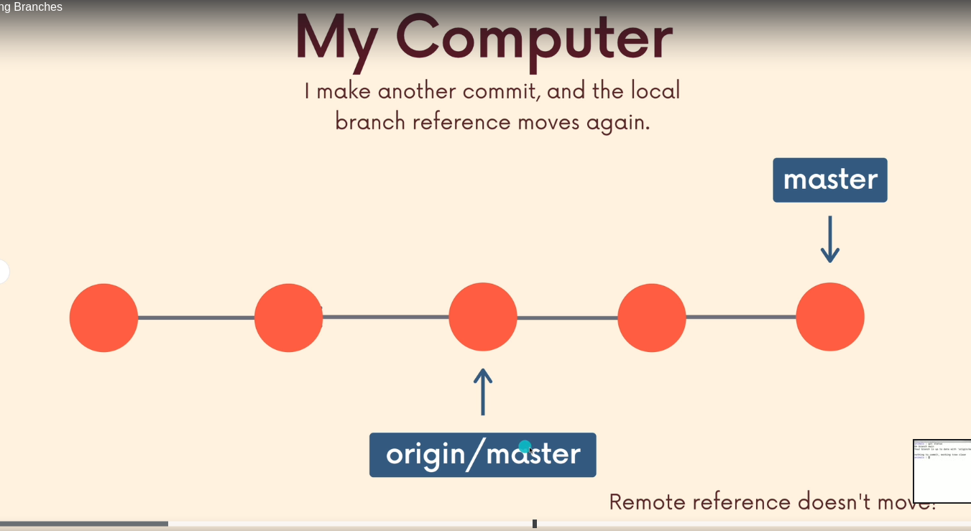
      - The second branch’s pattern is <remote>/<branch>
      - View the remote tracking branches using git branch -r
      - To view the work that has been done up to <remote>/<branch>, while ignoring the work you have done on your local machine prior to pushing it, type git checkout <remote>/<branch>, which is git checkout origin/main. This will make you go to a detached head, which is fine.
  - Working With Remote Branches (Collaborations)
    - When working with remote repo’s you can check that branches were added on GitHub by typing git fetch origin. Then to clone those branches type git clone them using git clone <URL>. Then you will only be able to work on the main or master branch. However to view the locations of the other branches type git branch -r
    - To work with a branch from the GitHub online repo that is not main or master and when we type git branch we only can see “master”. However, we know that there are other branches, because when we type git branch -r we can see them.
      - Therefore, to work with these branches on our local machine, we must type git switch <branch-name>.
        - The <branch-name> must be the exact name as the name of the branch we want to work on from the GitHub repo.
          - As a result git is smart enough to know what you are doing and will type the following message “Branch '<branch-name>' set up to track remote branch 'food' from 'origin'. Switched to a new branch '<branch-name>'”
      - Also, You will be able to push to GitHub’s <branch-name> by typing -> git push -u <remote-name> <branch-name>.
  - git fetch (Collaborations)- View collaborations
    - When working with collaborators and the Github repo is modified in comparison to the time you cloned it. Then if you want to get view what others were working on without impact your files, you will use git fetch. But you want to see what others were working on and also work on their work use git pull
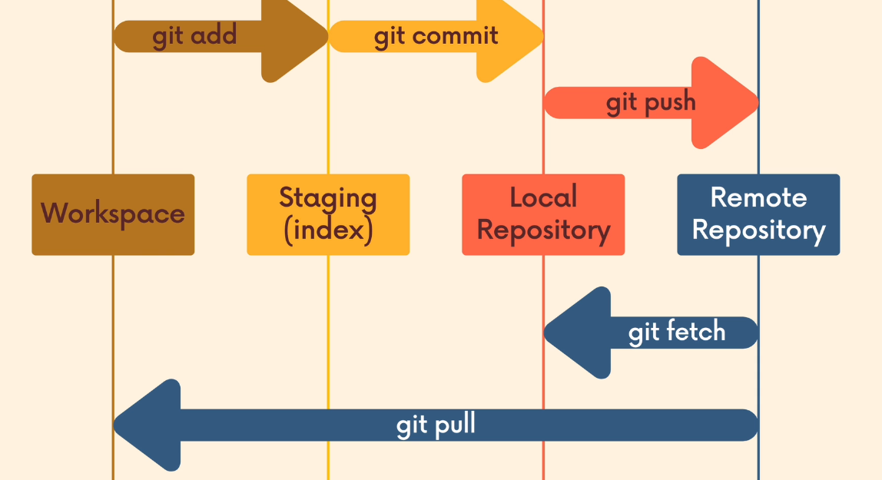
    - git fetch: Moves the data from the online repo on GitHub to the local repo on the machine. Therefore, those changes we download using git fetch <remote> <branch> are not merging with our working directory. git fetch allows us to see what others have been working on without screwing up our files
      - if <remote> is not indicated it will assume that it is the origin
      - if <branch> is not indicated it will assume that it is the main
    - git fetch will update the origin/main branch not the main branch. This way you can view the changes on that branch. Therefore to view the changes type git checkout <remote>/<branch> or git checkout origin/main

  - git pull (Collaborations) – Merging Online repo to local repo
    - This commands integrates or merges the changes from our global online repo to our local repo. The syntax is git pull <remote> <branch>
      - if <remote> is not indicated it will assume that it is the origin
      - if <branch> is not indicated it will assume that it is the main
    - git pull is similar to git merge, where it matters where this command is running from. Whatever branch we run this command from it is the location where the changes will be merged too
    - Always try to be in the main or master branch when using the git pull command
    - Prior to using git push, always use git pull first to see if there are any changes and you can resolve an conflicts
      - If there is any conflicts, you must edit the conflicts, save the file, add it,commit it, and push it to the GitHub repo
      - Merging a local branch to an online branch steps:
        - 1. Switch to the main branch in your local repo -> git switch
        - 2. Pull the changes from the Github repo -> git pull
        - 3. Merge the changes from your other local featured branch to the master branch locally. You must be inside the main branch -> git merge <Feature Branch>
        - 4. Push the work into the GitHub repo -> git push
          - Even though if yu push from the main local branch you should go to the main Github branch. But to be safe always type git push git push -u origin main

Section 11: GitHub Add-Ons
  - README.md
    - It should be done at the start of the of the project
    - README is a markown file, this is why it ends with .md
    - This file communicates the following information
      - What the project does
      - How to run the project
      - Why it’s noteworthy
      - Who mains the project
    - md -> markdown
      - It is a text to HTML type of a conversion tool for web writers. Markdown allows you to write down an easy to read and easy to write plain text format then convert it to HTML. md is two things a plan formatting syntax and a software tool.
      - The officially documentations for .md files -> https://daringfireball.net/projects/markdown/
      - A demo for .md file -> https://markdown-it.github.io/
        - This demo web page provides you with everything you need
        - To specify a programming language in .md files you can write ```<the programming language name>then lines of code then ```
```python
print(hello world)
```
  - GitHub Gists
    - It is a way to share code snippets and useful fragments with others
    - You can view it as manuals. Steps and specific code that must be followed
    - A lot of gits are markdown file ending with .md. You just need to type <The File name>.md in the Filename including extension box
    - To make new gits
      - 1. You must be in “Your gists” in GitHub. Then click on on the + sign
      - 2. Enter the file name and its extension. Most likely people use .md. Please note you can make it in different extensions including python
      - 3. publish your git by making it public or private

  - GitHub Pages (Online website, portfolio)
    - These are public web pages, that are hosted and published via Github. They allow you to create a website by pushing our code to Github
    - Only supports static websites. Therefore it does not support server-side languages like: Python , Ruby, etc. It only supports HTML/CSS/JS
    - You can change the Github URL and change it to your URL
    - GitHub supports User Sites and Project Sites.
      - User sites -> username.github.io
      - Project Site username.github.io/repo-name
    - Steps to making a project webpage:
    - 1. Create a git repo and push it to GitHub
    - 2. Add and commit the index.html file. The push that file with whatever branch if was made on. It is ok to make that file on the main branch.
      - It is common to create a branch called gh-pages and create the index.html file in it. Then push them both
    - 3. Go to Settings and in “Github Pages”. Pick a branch. The branch must have an HTML file. Also, you can make a special branch that contains the HTML file for website, while all the other work in other branches. The file must be called index.html
      - In regards of the folder selection. Select the root. If you have your file in the main folder
      - You can also have a .js and .css files in the same branch as the index.html file

Section 12: Collaboration Work Flows (Not Significant Yet)
  - Collaboration Work Flows – Centralized Workflow
    - This is when the whole team works on a single branch --> master or main branch.
    - Pros
      - Minimal number of branches
    - Cons
      - You always must use git pull then use git merge then use git push. Therefore, chances of conflicts are high
      - To collaborate or get any feedback on a problem with your work, you will end up pushing broken up code
  - Collaboration Work Flows – Feature Branches Workflok
    - This is the most common work flow. This is when the whole team works on different branches or known as feature branches. Then merge the work into a single branch --> master or main branch at the end of the project.
    - Pros
      - Easy to work with and organized
      - less conflicts
    - Cons
      - multiple branches

  - Pull Requests (PR)
    - In various companies during project the Github master or main branch is locked and only available to the people that approve pull requests. Therefore, locally you do not work on your main branch your work on a feature branch
    - Pull requests are not a native git feature. These are more a GitHub features.
    - Pull requests allow developers to inform the team that there is some new work that needs to be reviewed. The new work is available on a branch. This is a mechanism or a process to review then accept/reject the new work
    - The steps of merging your work while using pull reuqests:
      - 1. Work locally on your machine on a feature branch
      - 2. Push the local work into a featured Github branch
      - 3. Click on Comparison. To compare the changed between the branch you want to merge to the main branch main and main branch main
      - 4. Open a pull request using the feature branch that you just pushed to Github
      - 5. Wait for the pull request to be approved and merged. You may start a discussion on the pull request.
        - The pull request may be edited and merged to the main branch
        - There is always a chance where the branches might have conflicts
          - By viewing the command line instructions and following he steps on GitHub, to pull everything to your local machine and fix it there
  - Branch Protection Rules
    - In various companies during project the Github master or main branch is locked and only available to the people that approve pull requests
    - To add protection rules to whom ever can merge to the main branch you must:
      - 1. Go to settings
      - 2. Go to Branches
      - 3. Add rules
  - Forking & Cloning - Advanced Branches Workflow
    - Common in large open source projects
    - The fork & clone work flow: Instead of having one GitHub repo and multiple branches. In the fork & clone workflow, each developer has their own GitHub repo and many branches, including their own “main” branch. Therefore developers make changes and push their own forks before making pull requests.
    - This occurs mainly, because you can not add every person in the world as a contributor. Thus fork and clone allows any person in the world to try to make a contribution
    - General Forking:
      - Forking allows us to create personal copies of other peoples’ repo. These similar copies are called “the fork” of the original.
      - Similar to pull requests fork is not a native git feature. These are more a GitHub features.
      - The steps are:
        - 1. Fork a “public” repo, this will make a copy of whatever repo you forked in your GitHub page
        - 2. Then you can clone the repo from your GitHub page. This is better than cloning it from a “public” repo, because when you push changes from local git. It will not require any permission.
        - 3. If you wish you can create a pull request of your work and share it with the “public”’s repos owner. Note: you must try to share your work from a featured branch to the public’s repo master or main branch
      - The fork and Clone Workflow
        - Each developer works on their own forked version of the major project
        - Each developer will create a second remote called “upstream” that is connected to the “public” repo so each developer can pull updates from the “public” repo to their git local repositories. Also, developers will use that second remote to perform pull requests to merge their work with “public” repo
          - git remote add <name> <url>
          - <name> This tends to be called upstream
          - <url> This URL from the major public repo
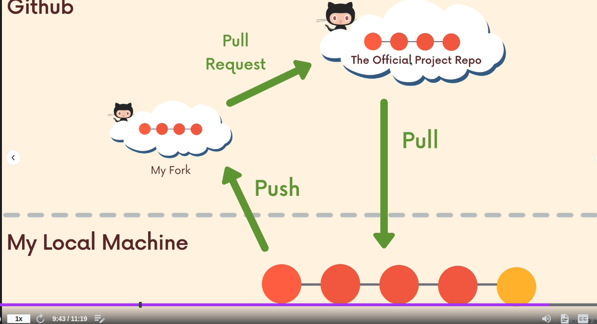
Section 13: Rebasing git rebase - Alternative to git merge
  - Main Note
    - For now try to use git merge instead of git rebase, because it is easier. But the more advanced you get the better you will get in git and then use rebase
  - git rabse
    - This command is an alternative to git merge to combine branches. In addition to that it is used as a clean up tool to clean up the git history
    - git rebase, when used it will move the location of all the commit you made to after the last commit of the master/main branch. Also, it will remove any history/commits in which you used git merge
    - git rebase vs git merge
      - git rebase, when used it will move the location of all the commit you made to after the last commit of the master/main branch. Also, it will remove any history/commits in which you used git merge
      - Unlike git merge git rebase, when we rebase a feature branch into the master/main branch. This moves the entire feature branch so that it begins at the tip of the master branch. Therefore all the work is there but the history has been re-written

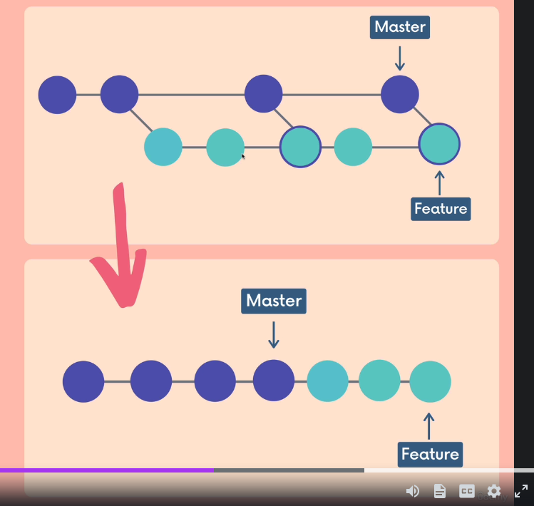
The above is git merge and the below is using git rebate
The whole <feature branch>‘s original point has been shifted. Therefore, history has been re-written

    - The steps of using git rebase
      - 1. Switch to the featured branch -> git switch <feature-branch>
      - 2. Rebase the feature branch to master/main -> git rebase <master_or_main>
        - You must be in the <feature-branch> while executing step 2
  - Why git rebase ?
    - We use git rebase to get a much cleaner project history. No unnecessary merge commits will be presented. This will make sure we end up with a linear project
  - Why not to use git rebase (The golden rule) ?
    - We use git rebase to get a much cleaner project history. No unnecessary merge commits will be presented. This will make sure we end up with a linear project
    - (The golden Rule) Never rebase commits that have been shared with others. If you have already pushed commits up to Github. DO NOT rebase them unless you are positive that no one on the team is using them. Because, this can cause confusing between collaborators. You must only use git rebase on commits that you have on your machine. The share the work and push it up
      - This just shows how complicated git rebase might get especially with beginners

Section 14: Interactive Rebasing git rebase (Modifying commits)
  - Rewriting history
    - We can use git rebase to rewrite, delete, rename, reorder (prior to sharing) commits
  - Editing commits steps:
      - This is the main step for all the steps below. All the steps below represent different situations
        - 1. specify how many commits you want to modify using the interactive rebase, starting from the top of the branch -> git rebase -i HEAD~<The number of commits to be modified from the HEAD>
        - A text editor will open up with all the commits you specified
      - 1. A. If you wish to edit the commit message or rename/reword the commit message. You must select r, reword instead of pick. This will keep the commit in history but it will change its message. However, the commit hash will change.
        - 1. A.1. instead of “pick” type “reword” in front of the commit(s) you want to reword or rename
        - 1. A.2. Close the the text editor. Then another text editor(s) for the commit(s) that you want to rename will open up
        - 1. A.3. In the commit’s text editor(s) you can edit the the commit message. Then close it
      - 1. B. If you wish to combine the content of two commits into one commit message. You will not be able to edit the message. The commits must be on top of each other. This will combine the bottom commit to the top commit/You must select f, fixup instead of pick for the bottom commit, and keep the top commit as pick. This will keep the work the commits did. However it will assume that the work that both commits did was done by a single commit. Also, it will use the top commit message as the new commit message
        - 1. B.1. instead of “pick” type “fixup” in front of the commit you want to combine with the commit on top of it
        - 1. B.2. Close the the text editor.
      - 1. C. If you wish to combine the content of two commits into one commit message. You will be able to edit the message. The commits must be on top of each other. This will combine the bottom commit to the top commit/You must select s, squash instead of pick for the bottom commit, and keep the top commit as pick. This will keep the work the commits did. However it will assume that the work that both commits did was done by a single commit. Also, it will let you type a new commit message to represent both commits
        - 1. C.1. instead of “pick” type “squash” in front of the commit you want to combine with the commit on top of it
        - 1. C.2. Close the the text editor.
        - 1. C.3.1. A commit’s text editor(s) will open up so you can edit the the commit message. Then close it
      - 1. D. If you wish to delete a content and its changes. You must select d, drop instead of pick in front of any commit you want to delete along with its content
        - 1. D.1. instead of “pick” type “drop” in front of the commit you want to combine with the commit on top of it
        - 1. D.2. Close the the text editor.

Section 15: git tag
  - git tag Introduction
    - git tag, act as a label to a commit. In the industry it is primarily used to mark version releases for projects
      - git tag, is used to specify specific points in repositories
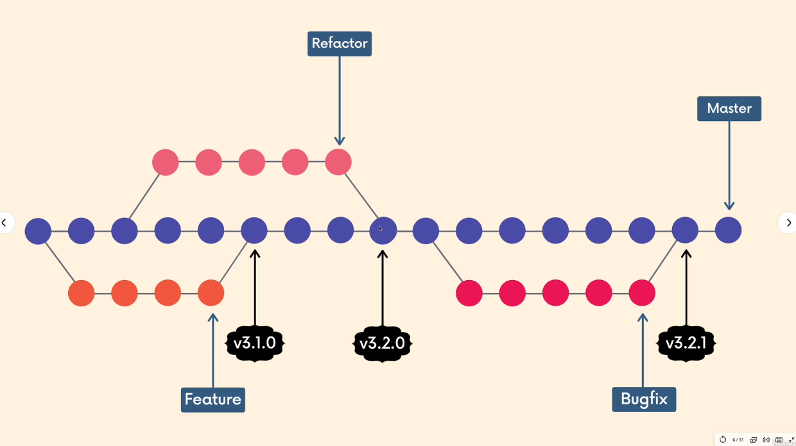
      - Belo
v3.1.0 and v3.2.0 and v3.21 each is a tag. Which will tell users that this is a version of the projects
  - Types of git tag: lightweight tag and annotated tags
    - Lightweight: They act as a name or a label that is pointing at a particular element
    - Annotated: They include more information than the lightweight tags information like: author’s name, email, date, and a tagging message(similar to a commit message)
  - Semantic Versioning
    - This is the spec/protocol that outlines a standardized versioning system for software releases. This provides a consistent way for developers to give meaning to their software releases. Each version of a software release consist of a v for version and three numbers v#.#.#
    - Three numbers #.#.# stand for Major Release, Minor Release, Patch Release, respectively.
      - The first release must be 1.0.0
      - Patch Releases: These represent small changes, such as big fixes and it does not impact how people use the code
      - Minor Releases: These represent new features or functionalities. These features and functionalities are optional. They do not impact how people use the code. When every there is a minor release, the Patch release must be reset to 0
      - Major Release: These represent impact changes that impacts users abilities to use the code. Once you have a new major release, both Path and Minor Releases must be rest to zero
    - #.#.#-beta -> the “-beta” stand for pending release
    - Often for any version software the letter v is included before the three numbers -> v#.#.#
  - Viewing Tags
    - To view all of the tags in a repo type -> git tag
    - To view all of the tags in a repo type that have specific naming using wild cards-> git tag -l “*<The naming>*”
      - The -l is essential, because it will list the tags
  - Checking out Tags git checkout
    - This is the same as checking out a commit, because a tag is just a pointer to a commit
      - 1. get the name of the tag you want to checkout from git tag
      - 2. checkout that specific tag using git checkout <The Tag Name>
  - Comparing Tags using git diff & git tag
    - This is the same as comparing out a commits, because a tag is just a pointer to a commit
      - 1. get the name of the tag you want to checkout from git tag
      - 2. compare specific tags using git diff <The Tag Name1> <The Tag Name2>
  - Creating a lightweight tag using git tag
    - This is a simple tag that just contains a message
      - 1. To create a tag type git tag <The New Tag Name>
        - By default this will reference to the commit that the HEAD is referring too at that specific moment
  - Creating an annotated tag using git tag -a
    - This is a more complex tag that contains a mixture of information
      - 1. To create an annotated tag type git tag -a <The New Tag Name>
        - By default this will reference to the commit that the HEAD is referring too at that specific moment
      - 2. You will be promoted into a text editor, in which you can add the following information: a tagging message(similar to a commit message)
        - The author’s name, email, and date will be shown by default when you show the annotated message using git show <The Tag Name>
    - To view the message of an annotated tag type -> git show <The Tag Name>
    - Note: if you type git show <The Tag Name> for a light weight tag you will not be able to see the “tagger” which is the author name, which by default is attached to the tag. The “tagger” is only displayed when you type git show <The Tag Name> for an an annotated tag
  - Tagging previous commits git tag
    - To add a git tag to a previous commit do the following
      - for a lightweight tag -> git tag <The New Tag Name> <A commit’s hash>
      - for an annotated tag -> git tag -a <The New Tag Name> <A commit’s hash>
  - Reusing an already used tag by “forcing” it using git tag -f
    - git will not allow you to use a tag that is already being used therefore you must force it through
        - By default this will reference to the commit that the HEAD is referring too at that specific moment
    - To force a tag through type -> git tag -f <The Tag Name>
      - This will move the tag’s name from a previous commit to the commit you are on
  - Deleting a tag, without impact the commit’s content git tag -d
    - To delete a tag type -> git tag -d <The Tag Name>
  - Pushing tags to Github git push --tags
    - When you push your local work to Github. It does not include the tags. Therefore you must push the tags using -> git push –tags
    - You can push a single tag using -> git push <remote> <The Tag Name>
Section 16: Behind the Scenes of Tags (How things actually work)
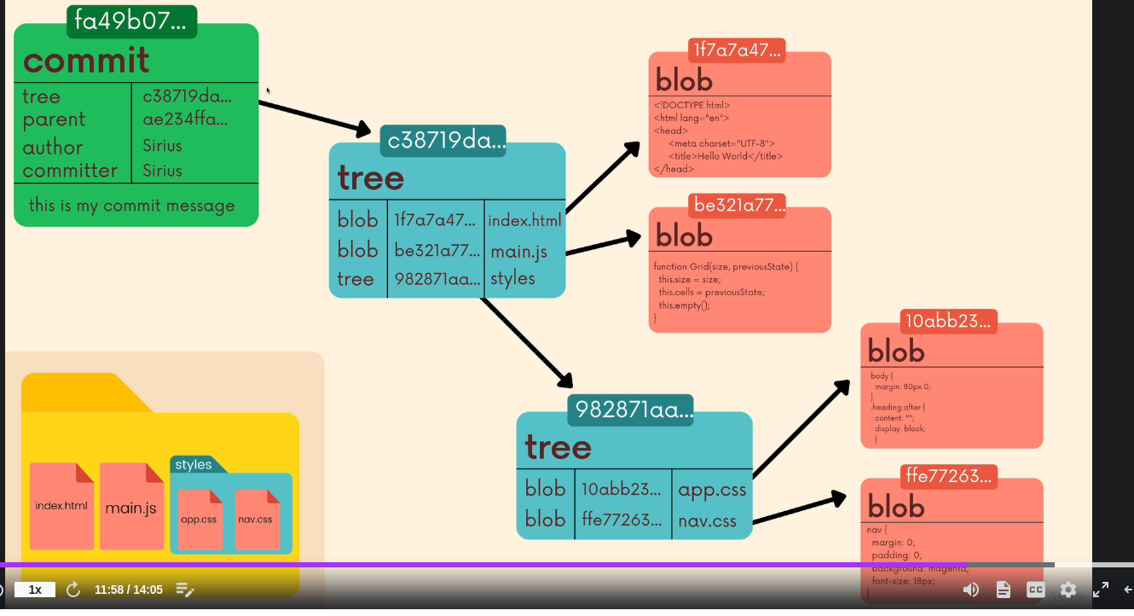
  - The local Config File inside the .git folder
    - The config file is the configuration file. This is changes the settings of the git repo you are located in but not the global config file.
  - The Refs folder inside the .git folder
    - The refs folder stands for references. Inside this folder you will find files that represent the heads, tags, and remotes. Each folder of these folders you will specific files that contain hashes. For example in the .git/refs/heads you will have a file for each branch. Inside that file you will have a line of the hash of that branch.
  - The HEAD File inside the .git folder
    - It is a file located in the .git folder. It contains a text file that contains texts that refer to the main branch last commit. Unless the HEAD is it cut off or if we switched the branch. Then the text inside the HEAD file will change
  - The objects folder inside the .git folder
    - This folder contains all of the repositories content, including the backups
    - The files are compressed and encrypted
    - Four type of git objects: commit, tree, blob, annotated tag
  - The Hashing Functions
    - Git uses the hashing function of SHA-1 : a hashing function that always generated 40-digits hexadecimal numbers, based on the the SHA-1 algorithm
    - Hashing maybe different in length, but in git we use SHA-1 which generated hex-decimal characters (base-16) and contain exactly 40 characters long
    - in git Hashing functions take inputs of arbitrary sized (any size) and outputs a fixed sized outputs (hex-decimals of 40 characters)
      - inputs maybe files, or folders and the outputs are always hex-decimals of 40 characters
    - Hash functions have multiple rules, which is why they are used in cryptocurency:
      - Each input has its own specific hash,
      - We can not view the inputs from an a hash,
      - It is unlikely to have two hashes of the same number.
      - Any change in the input file will results in a big change in the hash number
        - if we change our files slightly. This will generate an absolutely new hash
    - For anything we store in git we will get that thing’s unique git. Which is generated by a SHA-1 algorithm. This is why git is key-value data store
  - The (Blobs, Trees, Commits) folders inside the objects folder inside the .git folder
    - Blobs
      - Blobs are git objects that store the content of a file
      - Blobs stands for (Binary Large Objects). This is the type object that git uses to store the content of files in given repositories. Blobs are building blocks and do not include files names. They use store the content of attached.
      - git stores the content of files and their names separately
        - git stores the content of the file in a blob. And each blob gets its own hash (40 digits hexadecimal number)
        - git stores the file names in trees
      - Blob hashes are not the same as commits hashes
    - Trees
      - Trees are git objects that store the content of a directory that contains files names
      - Each tree contains pointers that refer to other trees (because we have nested folders) and its blobs (contains the actual data)
      - Each tree has its own hash
    - Commits
      - Commits are objects that combine a reference to the commit’s tree object along with reference information of:
        - a parent commit, the author of the commit, the committer, and the commit message
      - Commits have their own hashes
    - annotated tag
      - stores a reference to a commit
      - annotated tag has its own hash
      - Annotated tags are tags with meta data (author, email etc.)
    - Annotated tag has its own hash and stores info about a commit, a commit stores info about a tree, and a tree stores info about a blob. But not every commit required an annotated tag

Section 17: Retrieving “Lost Work” using git reflog
  - git reflog stands for (reference logs)
    - This command is used when you have really messed up. It is able to restore data that seems like it can not be restored. Because, the data is stored in the objects directory of the .git directory
    - You can view data based on the title or the UNIX time stamp using the (time qualifiers)
    - Limitations of git reflog
      - Reflog are only local. Therefore, it is not on GitHub
      - Reflogs are not permanent and they expire usually after 90 days. The expiry date may change
  - Record Keeping
    - Git keeps a record of every pointer (HEAD), and every branch, and many more. The track keeping is known as log. For example in regards of the HEAD pointer:
      - The HEAD is a pointer of our master branch. Therefore a record of every movement that this pointer undergo is stored by git in a file.
        - The file is located in .git/log/HEAD
        - Using this approach git can employ git reflog to restore data that is deleted, because these logs do not delete when you delete the data

  - Showing every point of history using git reflog -> git reflog show <branch>
    - Typing git reflog show <branch>
      - This shows the history of everything happened to <branch>
        - It presents in lines and each line is known as git reflog identifiers
      - This is not the same as git log, because git log just shows the changes between the commits. If you delete commits it will not be shown on git log. But, it will show on git reflog show <branch>
    - You can view data based on the title or the UNIX time stamp using the (time qualifiers)
  - Retrieving data of branches using git reflog
    - The steps to retrieve your lost work from a specific <branch> :
      - 1. Show a history of all the work that was done in <branch> by typing -> git reflog show <branch>
      - 2. To undo the work type -> git reset –hard <The Hash That You Want To Restore, Found From The reflog’s history>
  - Retrieving data of renamed commits using git reflog
    - You can rename commits using git rebase. However, with git reflog we can restore commits that we changed their name or editted
    - The steps to retrieve your lost work from a specific <branch> :
      - 1. Show a history of all the work that was done in <branch> by typing -> git reflog show <branch>
      - 2. To undo the work type -> git reset –hard <The Hash That You Want To Restore, Found From The reflog’s history>

Section 18: Creating Custom Aliases
  - Introduction to Aliases
    - Aliases are short cuts for git commands
    - Aliases are saved in the .gitconfig file or /home/mohamd/.gitconfig
    - Either:
      - In the local .git/config file of a specific repo
        - This applies only on the local repo
      - In the global config file /home/mohamd/.gitconfig (most common)
        - This applies on all the repos
        - If you open it you will see the user and name you of your git
        - To find this file I typed -> find ~ -name .gitconfig
      - ~/.config/git/config (not common)
        - This is a system config file, not commonly used but it is used when you have multiple users

  - Steps to creating an Alias or Aliases in /home/mohamd/.gitconfig
    - 1. open the global config file located at /home/mohamd/.gitconfig
    - 2. Adding the configurations in the .gitconfig file:
[alias]
<The New Short Cut> = <The Original Git Command>
    - <The Original Git Command> can be any git command
    - <The New Short Cut> can be anything

For example we can configure git status. By typing the below in the .gitconfig file
[alias]
s = status
    - Now if you type git s
      - It is the same as typing git status

  - Steps to creating an Alias or Aliases from the command line
    - Type -> git config --global alias.<The New Short Cut> <The Original Git Command>
    - For Example Configure git status
      - Type -> git config --global alias.s status

