**Exercise 1:**

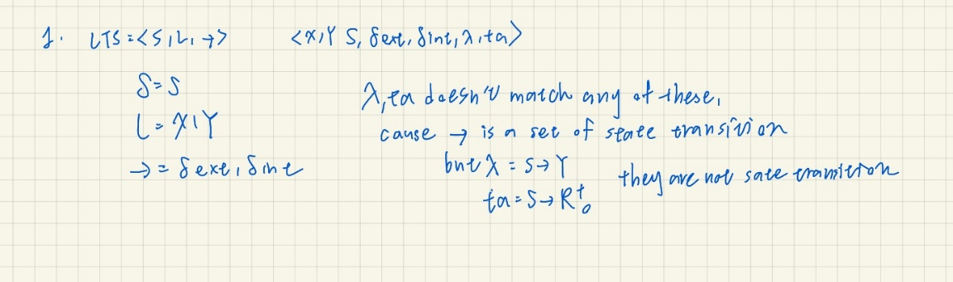

**Exercise 2: (a)**

**Exercise 2: (b)**

|  |  |  |  |  |
| --- | --- | --- | --- | --- |
| k | r1 | r2 | r3 | r4 |
| 0 | 1 | 2 | -2 | 1 |
| 1 | 2 | -2 | 1 | - $α^{3}$ |
| 2 | -2 | 1 | - $α^{3}$ | -2 $α^{3}$-2 |
| 3 | 1 | - $α^{3}$ | -2 $α^{3}$-2 | -3 $α^{3}$ |
| 4 | - $α^{3}$ | -2 $α^{3}$-2 | -3 $α^{3}$ | -4 $α^{3}$-1 |
| 5 | -2 $α^{3}$-2 | -3 $α^{3}$ | -4 $α^{3}$-1 | -4 $α^{3}$-1 |

**Exercise 3(a):**

**Primary States:**

phase: passive, active, respond

sigma: any positive real number including positive infinity

**Secondary States:**

count: any positive integer less than or equal to seven

**Parameters:**

stepTime: time unit for every single step

**Initialization:**

Phase = passive

Sigma = infinity

Count = 0

stepTime = 1

**External Transition Function:**

If (input == 1) set Phase = active

Else if (input == 0) set Phase = respond

**Internal Transition Function:**

If (Phase == active) count = count+1

**Output Function:**

If (Phase == respond) print out the output

**Exercise 3(b)**

|  |  |  |  |
| --- | --- | --- | --- |
| Time | Input | State | Output |
| 0 | 1 | (active,1.0,0) | ∅ |
| 1-- | ∅ | (active,1.0,1) | ∅ |
| 1- | ∅ | (passive,∞,1) | ∅ |
| 1 | 0 | (respond,1.0,1) | ∅ |
| 2-- | ∅ | (respond,1.0,1) | ∅ |
| 2- | ∅ | (passive, ∞,1) | 1 |
| 2 | 1 | (active,1.0,1) | ∅ |
| 3-- | ∅ | (active,1.0,2) | ∅ |
| 3- | ∅ | (passive, ∞,2) | ∅ |
| 3 | 1 | (active,1.0,2) | ∅ |
| 4-- | ∅ | (active,1.0,3) | ∅ |
| 4- | ∅ | (passive, ∞,3) | ∅ |
| 4 | 0 | (respond,1.0,3) | ∅ |
| 5-- | ∅ | (respond,1.0,3) | ∅ |
| 5- | ∅ | (passive, ∞,3) | 3 |

**Exercise 5**

Zcounter = <SZ,IZ,OZ,NZ,RZ>

SZ : {active,passive,respond}

IZ : {1,-1,2,0}

OZ : {0,1,2,3,4,5,6,7}

NZ : internal state transition deltint()

RZ : output function message out( )