# **Homework # 4**

**Assigned Date:** Nov. 03

**Due Date:** Nov. 16

**Posting ID** |4|2|9|3|-|1|6|4|

|8|0|7|7|-|4|1|8|

**1.** **[24 points] Exercise 1:** Develop a generator for the skateboard. Assume Consider the following:

​​· Produces desired speeds is not restricted to change by meters/minute (for example, the desired speed can change from 1 to 45 miles/hour in a time interval (see next bullet).

· The time interval between any two consecutive desired speeds can be set to be 1 and 2 minutes. For example, the desired speed at time is set to 3 miles/hour. At , the desired speed can be set to 6 miles/hour.

1. Specification

$S_{D}$ stands for the desired speed.

$AM_{G}=<X,S,Y,δ_{int},δ_{ext},ta,λ>$

$X = \{start, stop\}$

$Y = \{S_{D}|S_{D}∈N^{+}, 0≤S_{D}≤120 (meter/minute)\}$

$S = \{Phase, σ\}$

$Phase∈\{active, passive,busy\}$

$σ∈R_{0,∞}$

$δ_{int}: (active, σ)→(busy, ∞)$

$δ_{ext}: ((active, σ), e, ("in", start))→(active, σ-e)$

$((active, σ), e, ("in", stop))→(passive, σ-e)$

$λ:(busy,σ)→(active, S_{d})$

$ta(phase,σ ) = σ$ where $σ∈R_{0,∞}$

1. Implementation

Models/Component/Hw4/genr.java

*we created a new function "getValOnPort2" in src/model/modeling/message.java file in order to get value from the input message.*

**2.** **[24 points]** Develop a transducer for the Skateboard. It computes the following measurements independent every 5 minutes.

· Actual speed and average actual on an output port named ActualSpeed.

· Average desired speed on an output port named DesiredSpeed.

1. Specification

$S_{D}$ and $S_{A}$ stand for the desired speed and actual speed.

$AM_{T}=<X,S,Y,δ_{int},δ_{ext},ta,λ>$

$X = \{(S_{A}, S_{D})|S_{A}∈N^{+}, 0≤S_{A}≤160.934, S_{D}∈N^{+}, 0≤S_{D}≤120 (meter/minute)\}$

$Y =\{(S_{A},avg_{S_{A}},avg_{S_{D}})|S_{A}∈N^{+}, 0≤S_{A}≤160.934, {avg_{S_{A}}∈R^{+},}_{}$

${avg_{S_{D}}∈R^{+},S}_{D}∈N^{+}, 0≤S_{D}≤120(meter/minute)\}$

$avg_{S_{A}}$, $avg_{S_{D}}$ stand for $average of previous 5 values of S_{A},S_{D}.$

$S = \{Phase, σ\}$

$Phase∈\{active, passive,busy\}$

$σ∈R_{0,∞}$

$δ_{int}: (active, σ)→(busy, ∞)$

$δ_{ext}: ((active, σ), e, (("ariv", S_{D}), ("solved", S_{A})))→(active, σ-e)$

$λ:(busy,σ)→(active, {(avg_{S_{D}}}_{}, S_{A}))$

$δ_{conf}(s, ta(s), x)=δ_{ext}(δ_{int}(s),0,x)$

$ta(phase,σ ) = σ$ where $σ∈R_{0,∞}$

1. Implementation

Models/Component/Hw4/transd.java

*we created a new function "getValOnPort2" in src/model/modeling/message.java file in order to get value from the input message.*

**3.** **[24 points]** Develop an atomic model for the Skateboard described above.

· The maximum allowed speed is 6 miles per hour.

1. Specification

$AM_{S}=<X,S,Y,δ_{int},δ_{ext},ta,λ>$

$X = \{S_{D}|S_{D}∈N^{+}, 0≤S_{D}≤120 (meters/minute)\}$

$S = \{phase, σ, S_{A}\}$

$phase∈\{passive, increasing, decreasing, busy, equal\}$

$σ∈R_{0,∞}$

$S_{A}∈N^{+}, 0≤S_{A}≤160.934 (meters/minute)$

$Y=\{S_{A}|S_{A}∈N^{+}, 0≤S_{A}≤160.934 (meters/minute)\}$

$6mph≈160.934 meters/minute$

$δ_{int}: (equal, σ, S_{A})→(busy, ∞, S_{A})$

$(increasing, σ, S_{A})→(busy, ∞, S_{A}+1)$

$(decreasing, σ, S_{A})→(busy, ∞, S_{A}-1)$

$σ∈R_{0,∞}$

$δ_{ext}: ((passive, σ, S_{A}), e, ("in", S_{D}))$

$→(equal, σ-e, s_{A}) when S_{A}==S_{D}$

$→(increasing, σ-e, s_{A}) when S_{A}<S_{D}$

$→(decreasing, σ-e, s_{A}) when S_{A}>S_{D}$

$δ_{conf}(s, ta(s), x)=δ_{ext}(δ_{int}(s),0,x)$

$λ:(busy,σ, S_{A} )→(passive, S_{A})$

$ta(phase,σ, S_{d} ) = σ$ where $σ∈R_{0,∞}$

Since we designed internal function to call output function every minute, they change the phase at each time interval.

1. Implementation

Models/Component/Hw4/proc.java

*we created a new function "getValOnPort2" in src/model/modeling/message.java file in order to get value from the input message.*

**4.** **[16 points]** Develop a coupled model for the generator, skateboard, and transducer models. Name this model “GST”.

1. Specification

$N=<X,Y,D,\{{AM}_{d}|d∈D\},EIC,EOC,IC>$

$X=\{(p,v)|p∈IPorts,v∈Xp\}$

$IPorts=\{start, stop\}$

$Y=\{(p,v)|p∈OPorts,v∈Yp\}$

$OPorts=\{ActualSpeed, DesiredSpeed\}$

$Yp$ = $\{ActualSpeed, DesiredSpeed\}$

$Actualspeed=$ $\{{(S}_{A},avg_{S_{A}})|{avg_{S_{A}}∈R^{+},S}_{A}∈N^{+}, 0≤S_{A}≤160.934 (meters/minute)\}$

$avg_{S_{A}}$ stands for $average of previous 5 values of S_{A}$

$Desiredspeed= \{avg_{S_{D}}|avg_{S_{D}}∈R^{+}, S_{D}∈N^{+}, 0≤S_{D}≤120 (meters/minute)\}$

$avg_{S_{D}}$ stands for $average of previous 5 values of S_{D}$

$D=\{G,S,T\}$

$AM_{d}∈\{d|d∈D\}$

$EIC=\{((N,"start"),(AM_{G},"start")),((N,"stop"),(AM_{G},"stop"))\}$

$EOC=\{((AM_{T},"ActualSpeed"),(N,"ActualSpeed")),$

$((AM_{T},"DesiredSpeed"),(N,"DesiredSpeed"))\}$

$IC=\{((AM_{G},"out"),(AM_{S},"in")),((AM_{G},"out"),(AM_{T},"ariv")),((AM_{S},"out"),(AM_{T},"solved"))\}$

1. Implementation

Models/Component/Hw4/gpt.java

*we created a new function "getValOnPort2" in src/model/modeling/message.java file in order to get value from the input message.*

1. Simview screenshot

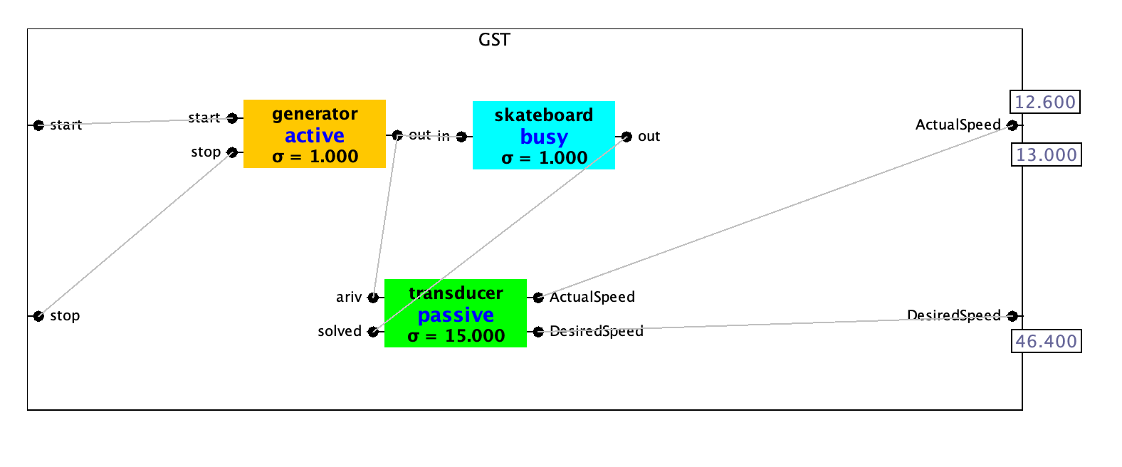

This figure shows the entire coupled model consists of three atomic models: generator, skateboard and transducer. Each component are connected by multiple couplings. The input port of GST is “start” and “stop”. The final output values are coming through two ports. Through “ActualSpeed” port, actual speed and average value of previous 5 actual speed are coming out. In the screenshot, floating number “12.6” is the average value and integer value shows the actual speed at that time. Average value of previous 5 desired speeds are coming out through “DesiredSpeed” port. The coupling between each component in the coupled model is defined in the specification as IC. Every minute, generator generate a desired speed and then they are fed into the “in” port of the skateboard and “ariv” port of the transducer. At the same time, actual speed is updated in skateboard and they are sent to transducer every minute. Every five minutes, transducer outputs the actual speed, average actual speed and average desired speed.

**5.** **[12 points]** Provide the trajectories (plots) for the skateboard’s phase, sigma, and actual speed variables given the simulation scenario below.

| Time (minutes) | Desired speed (meters/minute) | Phase | Sigma | Actual speed (meters/minute) |
| --- | --- | --- | --- | --- |
| 0 | 1 | Increasing | 1 | 0 |
| 3 | 4 | Increasing | 1 | 1 |
| 5 | 2 | Decreasing | 1 | 3 |
| 7 | 5 | Increasing | 1 | 2 |
| 11 | 0 | Decreasing | 1 | 5 |
| 16 | 0 | Passive | $∞$ | 0 |

