**Artificial Intelligence (InternshipDEP)**

**Submitted by:**

**ABDUL MOEED**

**TASK#4**

Build a natural language processing (NLP) model to perform sentiment analysis on social media posts or product reviews...

**Introduction**

To build an NLP model for sentiment analysis on social media posts or product reviews, we'll use a well-known dataset. For this example, we'll use the "IMDB Movie Reviews" dataset, which is available from the tensorflow_datasets library. This dataset contains 50,000 movie reviews labeled as positive or negative.

**Step 1: Import Required Libraries**

First, install the required libraries if you haven't already:

**Code Snip:**

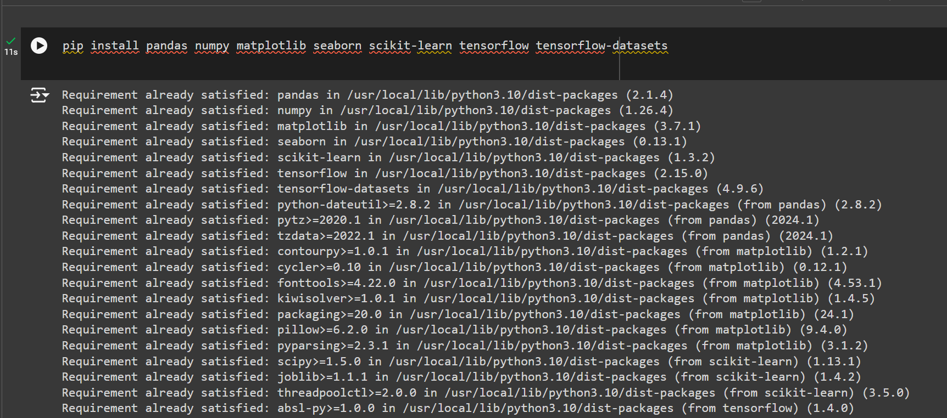

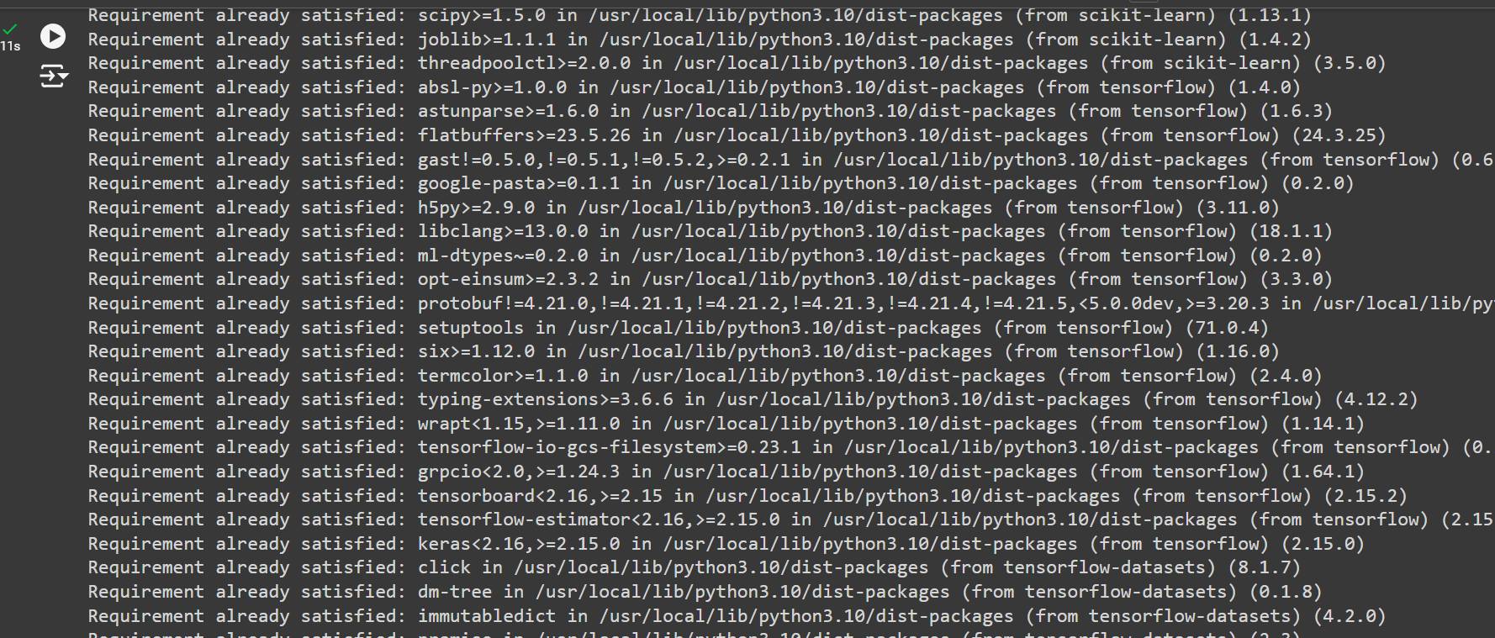

Now, import the libraries:

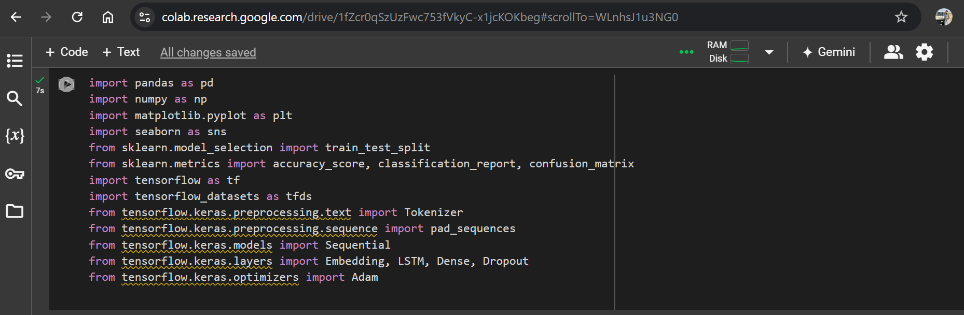

**Step 2: Load and Preprocess Data**

Load the IMDB Movie Reviews dataset and prepare it for training:

**Code Snip:**

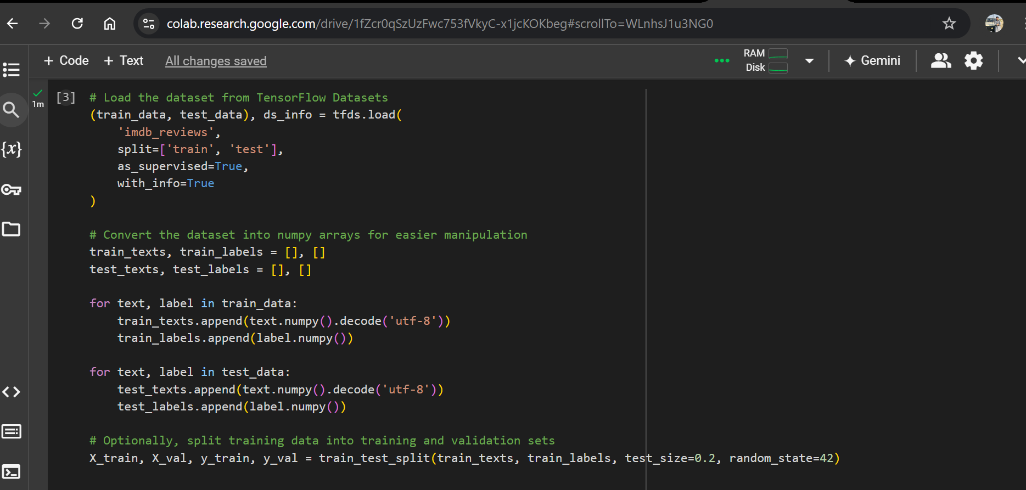

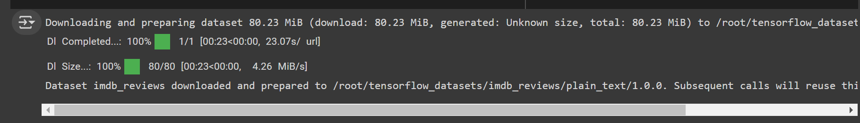

**Step 3: Text Vectorization and Tokenization**

Use Keras Tokenizer and pad_sequences for text vectorization and tokenization:

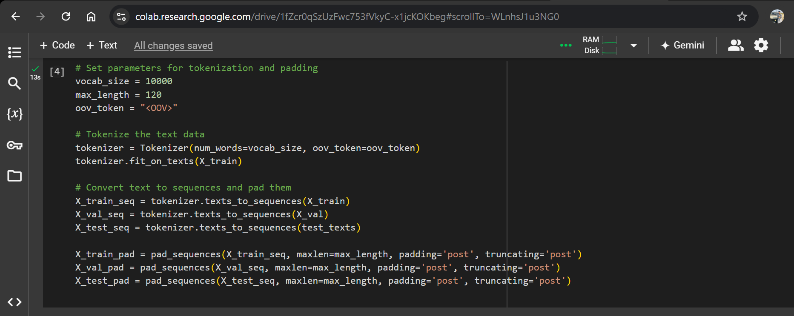

**Step 4: Building the LSTM Model**

Define and compile the LSTM model:

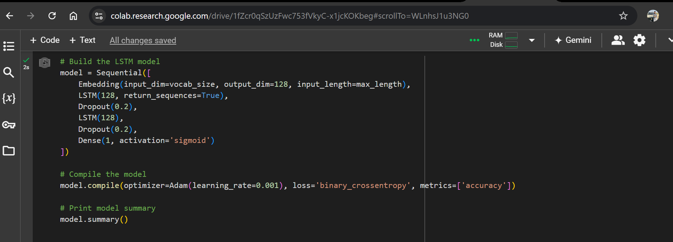

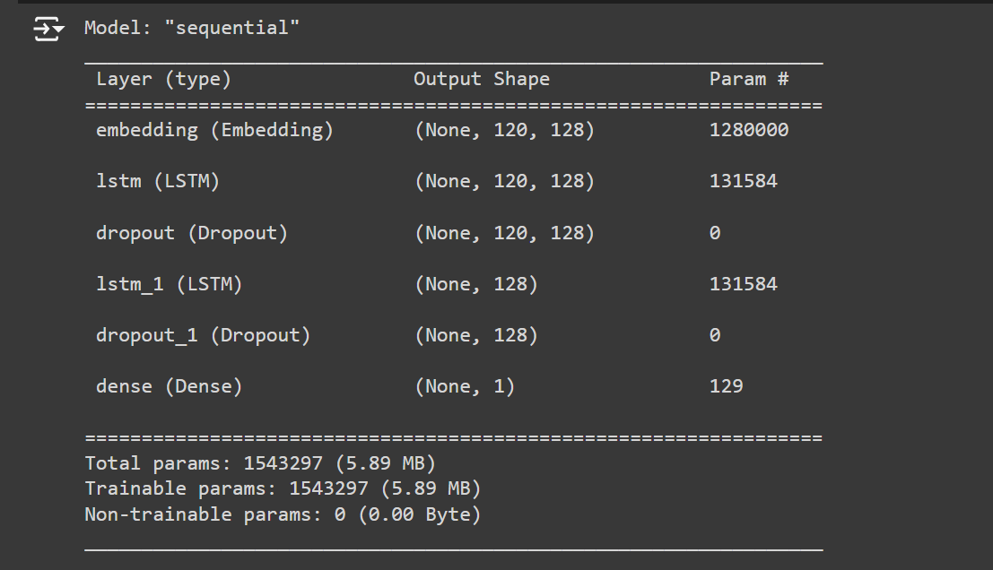

**Step 5: Training the Model**

Train the model using the training data:

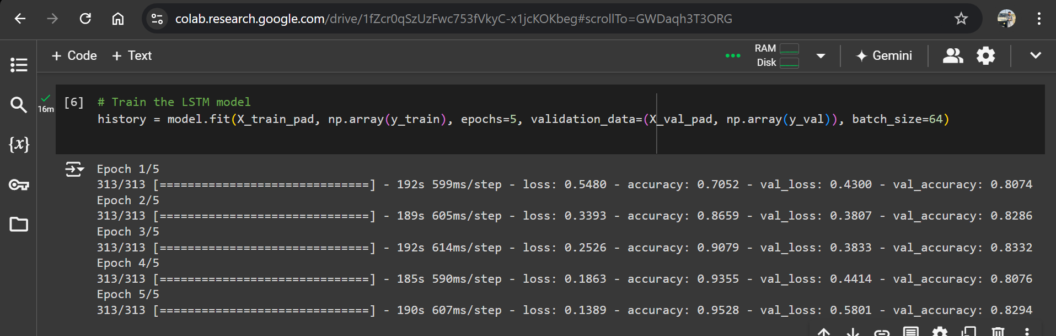

**Step 6: Evaluating the Model**

Evaluate the model's performance on the test set and generate relevant metrics:

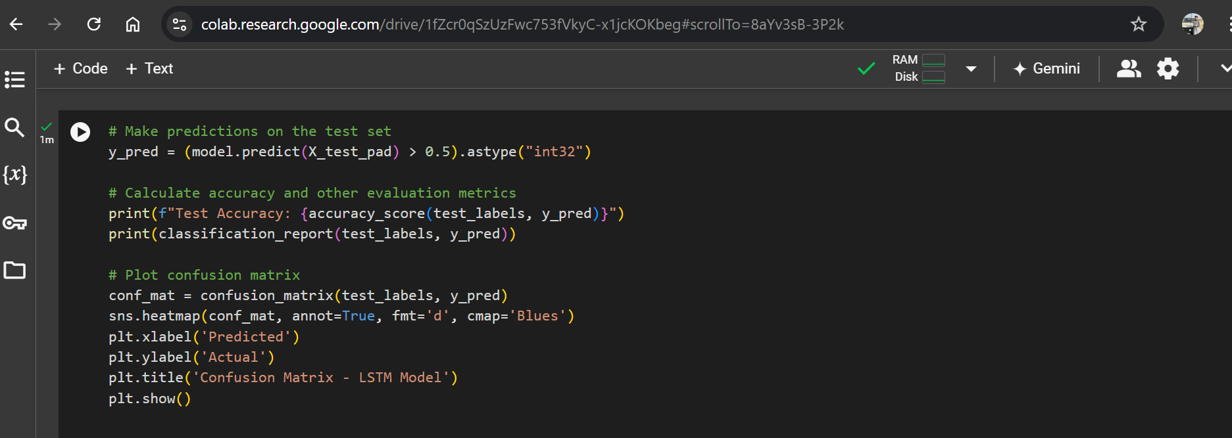

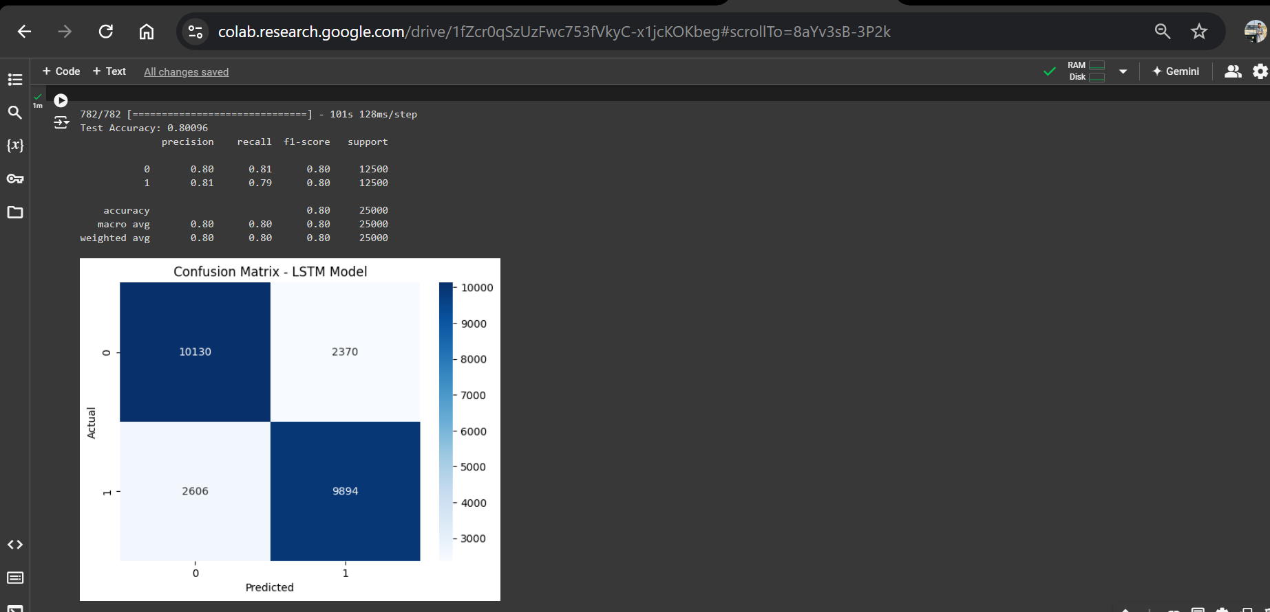

**Step 7: Visualization**

Visualize the training process:

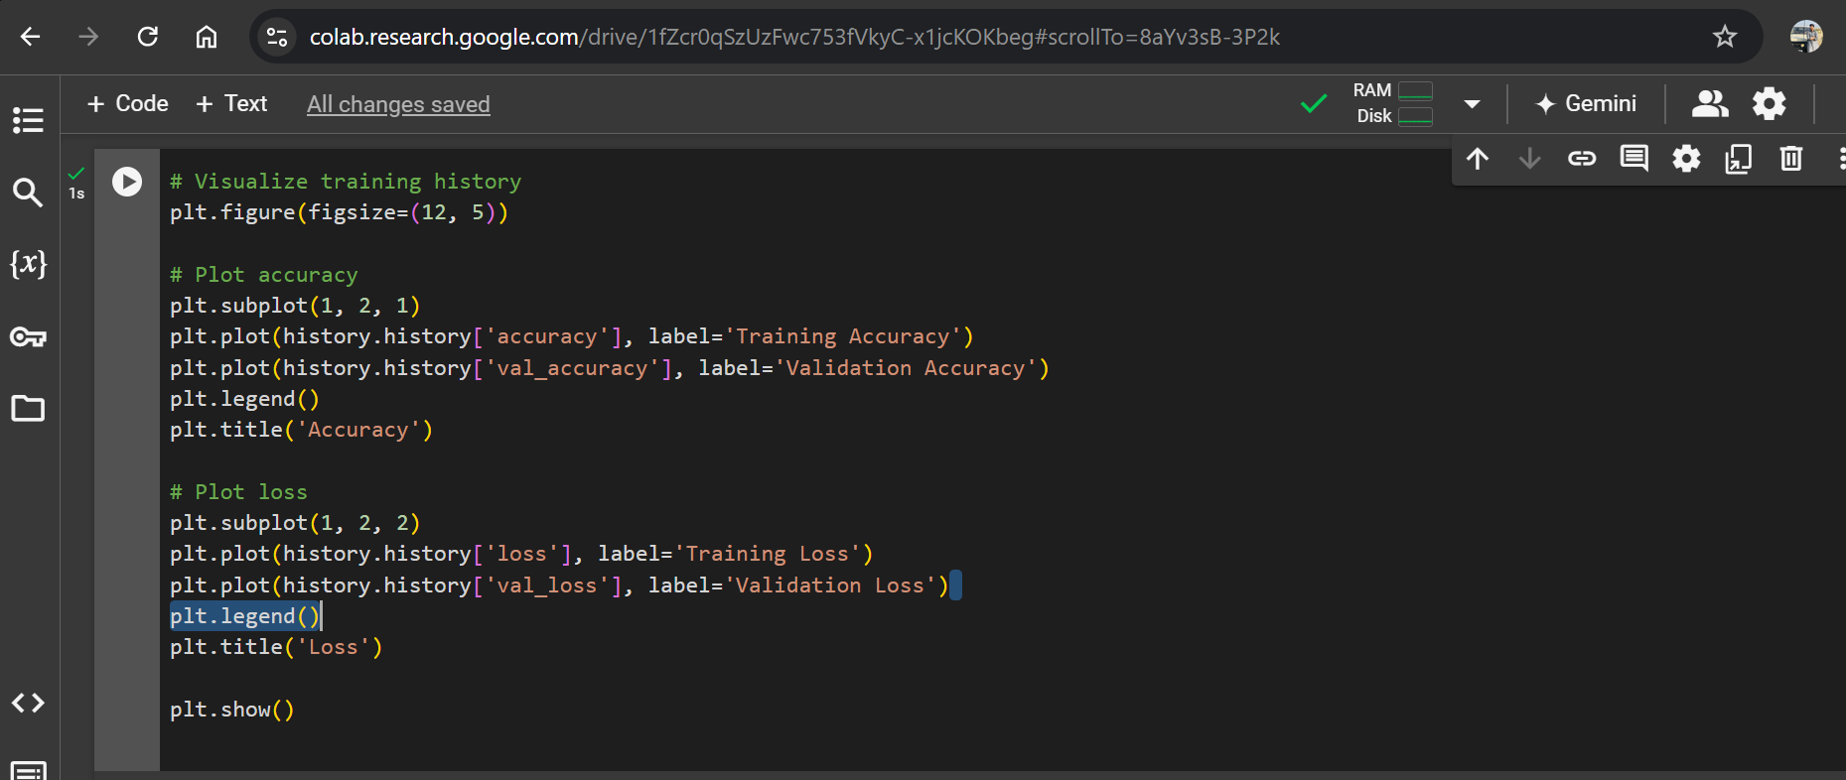

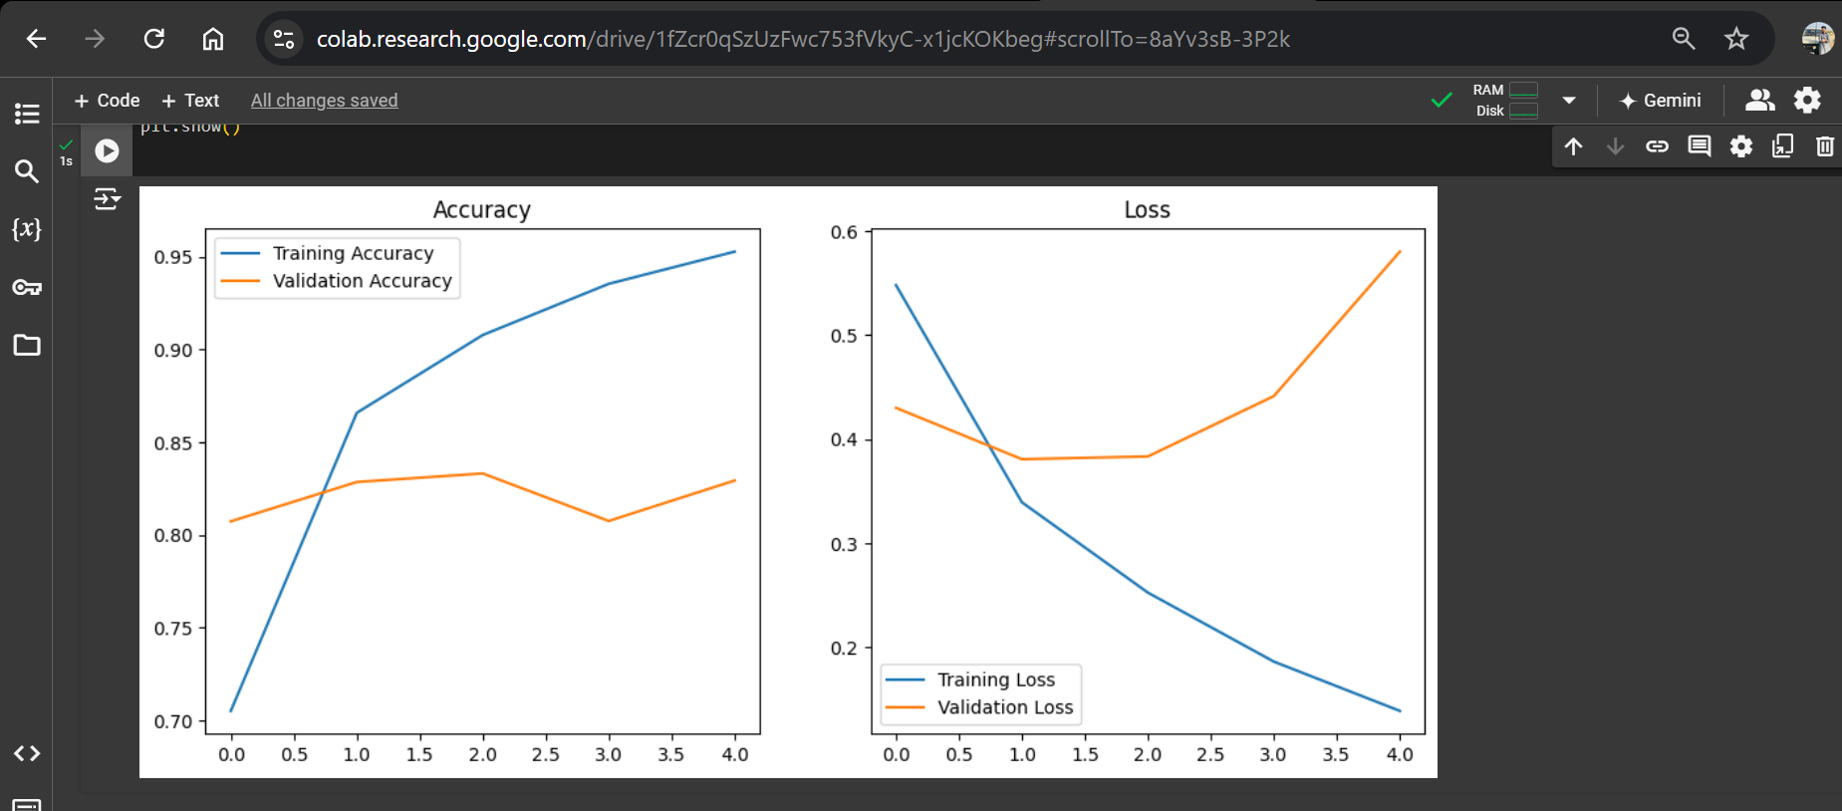

**Conclusion:**

This provides a complete pipeline for building an NLP model to perform sentiment analysis on social media posts or product reviews using the IMDB Movie Reviews dataset. You can experiment with different preprocessing techniques, model architectures, and hyperparameters to improve performance.

**GIT-HUB Repository Link:**