**ABDUL MOEED**

**The Spam Email Classifier**

The spam email classifier is a machine learning model designed to differentiate between spam (unwanted or junk) and ham (legitimate) emails. This classifier utilizes two popular algorithms: Naive Bayes and Support Vector Machines (SVM).

**Key Features:**

1. **Dataset**: The classifier uses the "Spam SMS Collection" dataset, which contains SMS messages labeled as 'spam' or 'ham'.
2. **Text Preprocessing**:
   * **Count Vectorizer**: Converts the text data into a matrix of token counts.
   * **TF-IDF Transformer**: Transforms the token count matrix into a TF-IDF (Term Frequency-Inverse Document Frequency) representation to weigh the importance of words in the messages.
3. **Machine Learning Algorithms**:
   * **Naive Bayes**: A probabilistic classifier based on applying Bayes' theorem with strong independence assumptions between the features.
   * **Support Vector Machine (SVM)**: A linear classifier that finds the hyperplane that best separates the classes in the feature space.
4. **Pipeline**: The classifier pipelines streamline the process of text transformation and classification. This ensures that the input text is preprocessed and classified in a single, seamless workflow.
5. **Model Training and Evaluation**:
   * The dataset is split into training and testing sets to evaluate the model's performance.
   * The models are trained on the training set and tested on the testing set.
   * Performance metrics such as accuracy, precision, recall, F1-score, and confusion matrix are used to assess the effectiveness of each classifier.

This implementation provides a robust approach to classifying spam emails, leveraging the strengths of both Naive Bayes and SVM algorithms to achieve high accuracy in distinguishing between spam and legitimate messages.

**IMPLEMENTATION:**

To implement a spam email classifier using machine learning, we can use algorithms like Naive Bayes or Support Vector Machines (SVM).

**Step 1: Import Required Libraries**

First, we need to import the necessary libraries.

python

import numpy as np

import pandas as pd

from sklearn.feature_extraction.text import CountVectorizer, TfidfTransformer

from sklearn.model_selection import train_test_split

from sklearn.naive_bayes import MultinomialNB

from sklearn.svm import SVC

from sklearn.pipeline import Pipeline

from sklearn.metrics import classification_report, accuracy_score, confusion_matrix

**Step 2: Load the Dataset**

For demonstration, we can use the popular "Spam SMS Collection" dataset.

# Load dataset

url = "https://raw.githubusercontent.com/justmarkham/pycon-2016-tutorial/master/data/sms.tsv"

df = pd.read_csv(url, sep='\t', header=None, names=['label', 'message'])

# Convert label to binary

df['label'] = df['label'].map({'ham': 0, 'spam': 1})

**Step 3: Split the Data**

Split the data into training and testing sets.

X = df['message']

y = df['label']

X_train, X_test, y_train, y_test = train_test_split(X, y, test_size=0.3, random_state=42)

**Step 4: Create a Pipeline**

Create a pipeline that includes vectorization and the classifier. We'll create two pipelines: one for Naive Bayes and one for SVM.

**Naive Bayes Pipeline**

nb_pipeline = Pipeline([

    ('vect', CountVectorizer()),

    ('tfidf', TfidfTransformer()),

    ('clf', MultinomialNB())

])

**SVM Pipeline**

svm_pipeline = Pipeline([

    ('vect', CountVectorizer()),

    ('tfidf', TfidfTransformer()),

    ('clf', SVC(kernel='linear'))

])

**Step 5: Train the Models**

Train both the Naive Bayes and SVM models.

**Train Naive Bayes**

nb_pipeline.fit(X_train, y_train)

**Train SVM**

svm_pipeline.fit(X_train, y_train)

**Step 6: Evaluate the Models**

Evaluate both models using the test data.

**Evaluate Naive Bayes**

y_pred_nb = nb_pipeline.predict(X_test)

print("Naive Bayes Classifier")

print(classification_report(y_test, y_pred_nb))

print("Accuracy:", accuracy_score(y_test, y_pred_nb))

print("Confusion Matrix:\n", confusion_matrix(y_test, y_pred_nb))

**Evaluate SVM**

y_pred_svm = svm_pipeline.predict(X_test)

print("SVM Classifier")

print(classification_report(y_test, y_pred_svm))

print("Accuracy:", accuracy_score(y_test, y_pred_svm))

print("Confusion Matrix:\n", confusion_matrix(y_test, y_pred_svm))

**Complete Code**

import numpy as np

import pandas as pd

from sklearn.feature_extraction.text import CountVectorizer, TfidfTransformer

from sklearn.model_selection import train_test_split

from sklearn.naive_bayes import MultinomialNB

from sklearn.svm import SVC

from sklearn.pipeline import Pipeline

from sklearn.metrics import classification_report, accuracy_score, confusion_matrix

# Load dataset

url = "https://raw.githubusercontent.com/justmarkham/pycon-2016-tutorial/master/data/sms.tsv"

df = pd.read_csv(url, sep='\t', header=None, names=['label', 'message'])

df['label'] = df['label'].map({'ham': 0, 'spam': 1})

# Split data

X = df['message']

y = df['label']

X_train, X_test, y_train, y_test = train_test_split(X, y, test_size=0.3, random_state=42)

# Naive Bayes pipeline

nb_pipeline = Pipeline([

    ('vect', CountVectorizer()),

    ('tfidf', TfidfTransformer()),

    ('clf', MultinomialNB())

])

# SVM pipeline

svm_pipeline = Pipeline([

    ('vect', CountVectorizer()),

    ('tfidf', TfidfTransformer()),

    ('clf', SVC(kernel='linear'))

])

# Train models

nb_pipeline.fit(X_train, y_train)

svm_pipeline.fit(X_train, y_train)

# Evaluate Naive Bayes

y_pred_nb = nb_pipeline.predict(X_test)

print("Naive Bayes Classifier")

print(classification_report(y_test, y_pred_nb))

print("Accuracy:", accuracy_score(y_test, y_pred_nb))

print("Confusion Matrix:\n", confusion_matrix(y_test, y_pred_nb))

# Evaluate SVM

y_pred_svm = svm_pipeline.predict(X_test)

print("SVM Classifier")

print(classification_report(y_test, y_pred_svm))

print("Accuracy:", accuracy_score(y_test, y_pred_svm))

print("Confusion Matrix:\n", confusion_matrix(y_test, y_pred_svm))

**“Screenshots”**

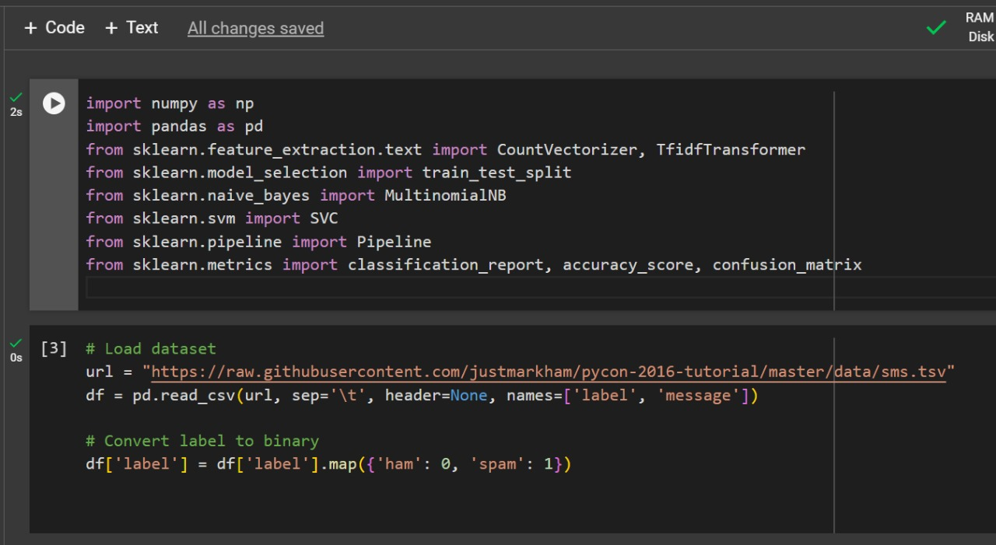

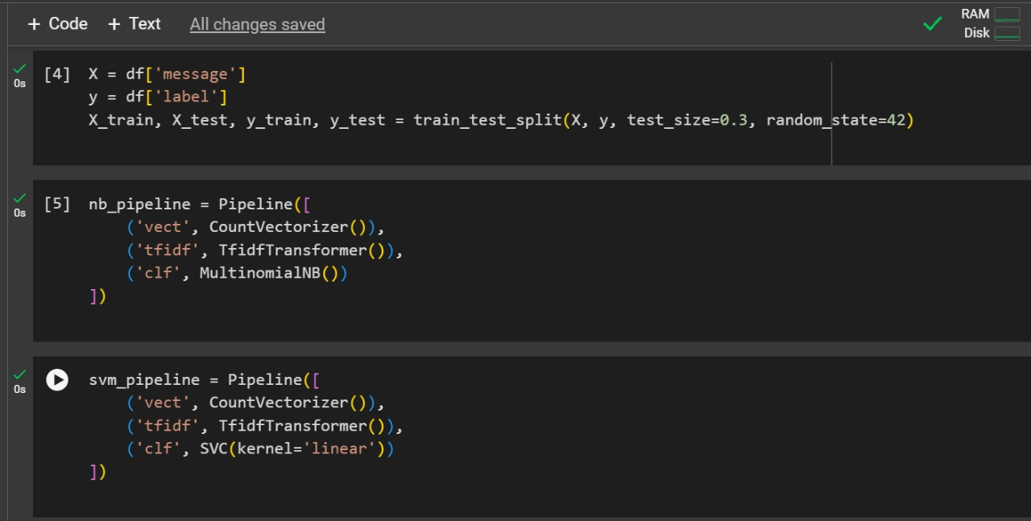

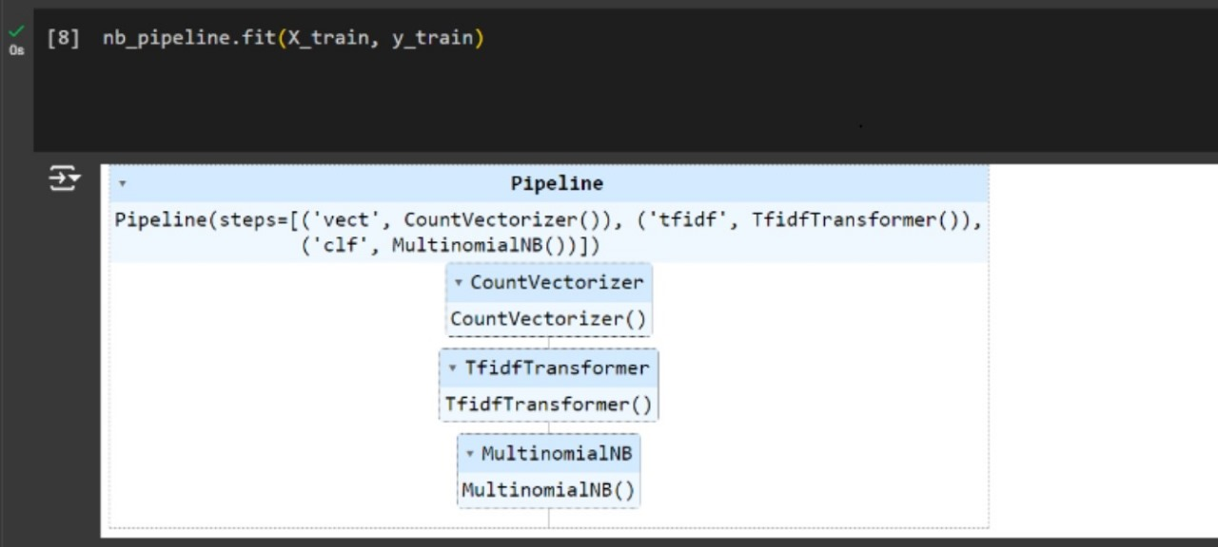

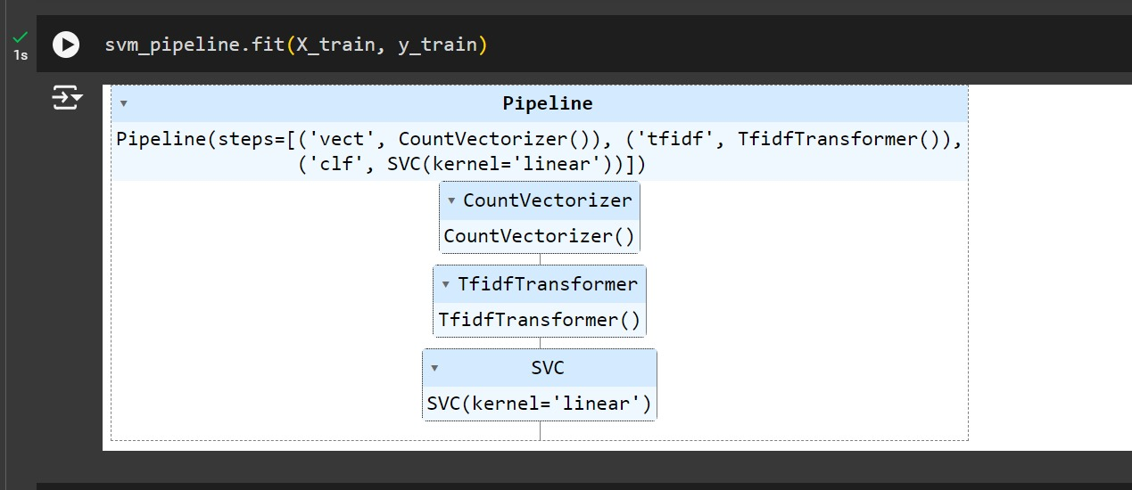

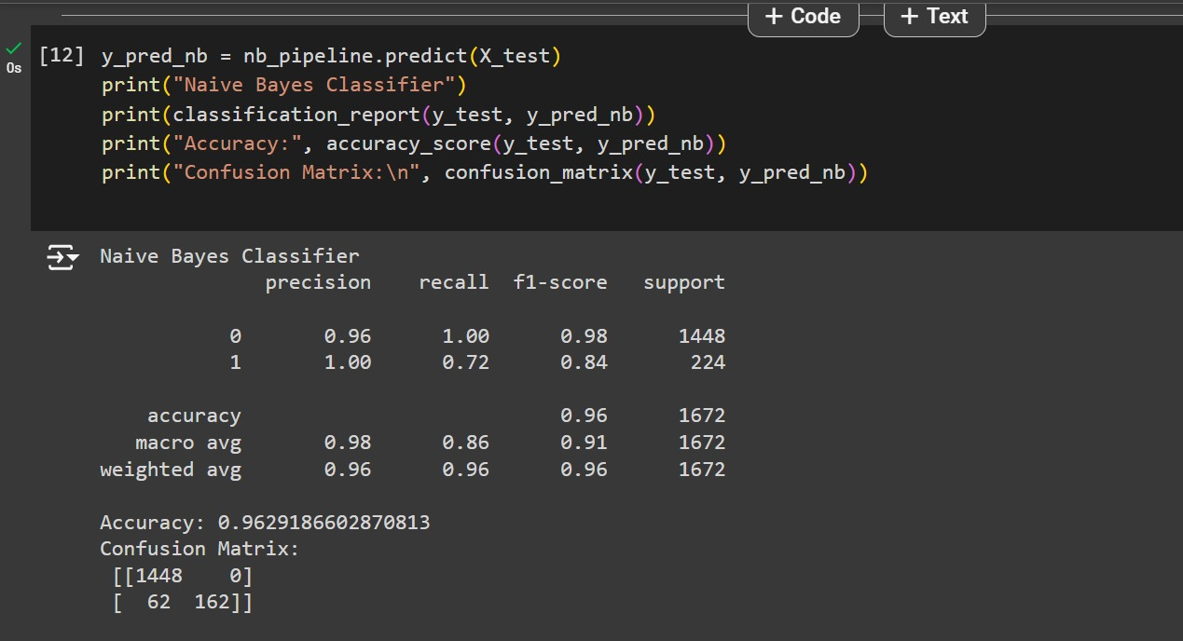

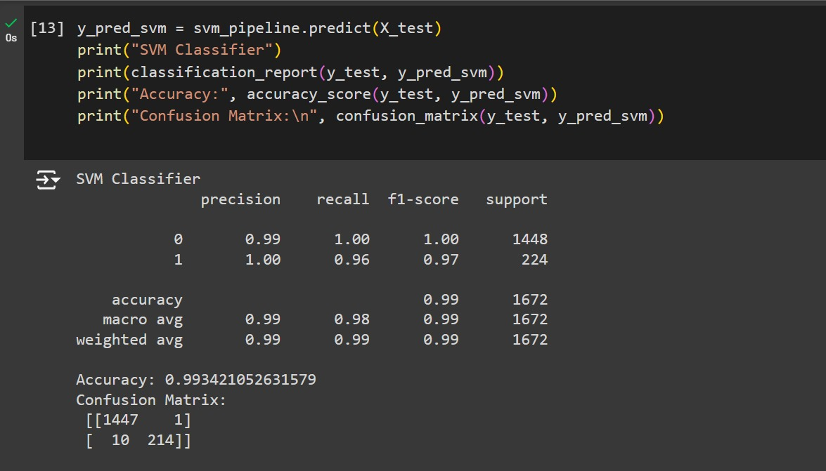

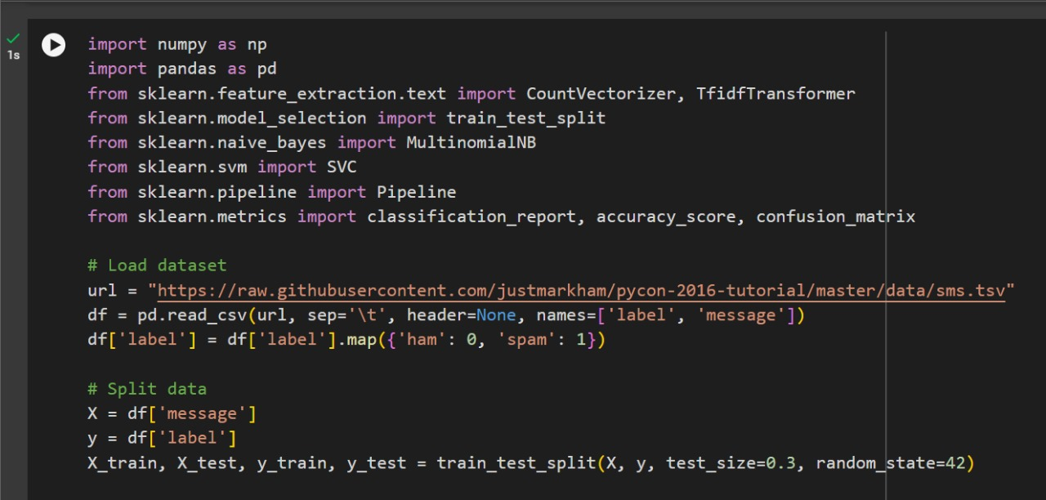

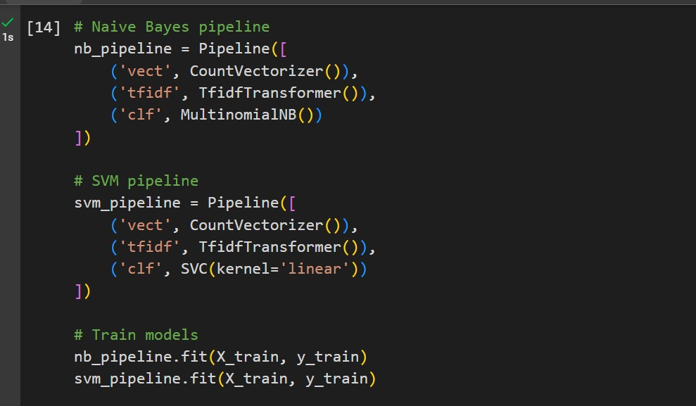

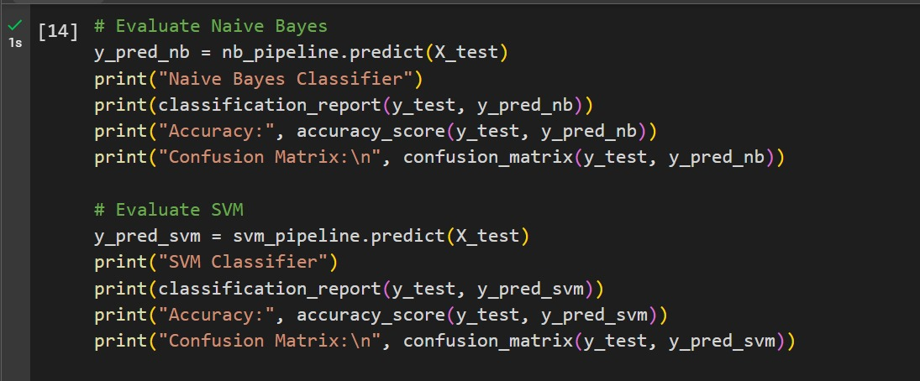

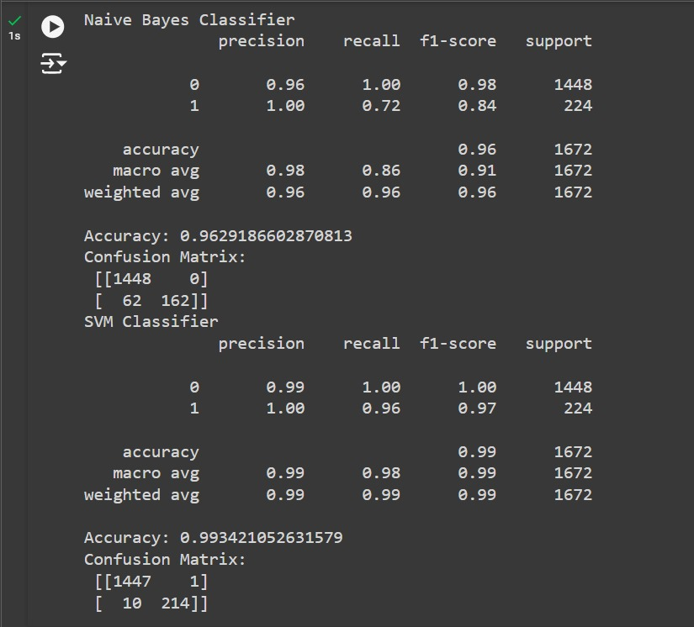

**“Github Link”**

[**https://github.com/Moeed-23/emailspam-classifier**](https://github.com/Moeed-23/emailspam-classifier)