Project Title: CineSync
(A Collaborative & Mood-Centric Redesign of IMDb)

Sr.No | Name | Roll Number
1. | Moeeed | 23L-0686
2. | Kharia Imran | 23L-0512
3. | Moiz Ahmad | 23L-2528
4. | Syed Ali Naqvi | 23L-2509
5. | M.Auon Naseer | 23L-0643

Main Features of the Product
This project is a pure UI/UX redesign. We are designing visual interfaces and interaction flows to solve usability issues.
  - Unified Sign-In & Profile Hub: Consolidates login flow and aggregates Watchlist, Ratings, and Reviews into a personalized dashboard.
  - Global Localization Menu: Prominent toggle for instant switching of content language and region-specific formats.
  - Homepage Overhaul: Prioritizes "Trending" and "Personalized Picks" using a clutter-free, card-based layout with negative space.
  - Title Page IA: Uses collapsible sections and data visualization to make key info (Cast, Runtime, Parents Guide) scannable in seconds.
  - Visual Sentiment Dashboard: Aggregates review keywords into graphical chips (e.g., "Slow Paced," "Great Acting") to replace text walls.
  - Watchlist 2.0: Upgrades the list to a visual "Library" interface with drag-and-drop sorting and poster views.
  - "Mood Ring" Filter: Visual search component allowing users to filter content by emotion via emojis or a color wheel.
  - Time-Available Filter: Filters content based on specific durations (e.g., "Under 90 mins").
  - Group Watch Lobby: Collaborative interface linking accounts to show overlapping movie interests via a "Venn Diagram" view.
  - Streaming Availability Row: Dedicated icons on movie cards showing platforms (Netflix, Prime) and "Free" vs. "Subscription" status.

Expected User Groups

We have identified four distinct user personas whose experience will be improved through these design changes.

Casual Movie Watchers (The "Scanners"):
    - Behavior: They visit IMDb only when they need an immediate answer. They scan for visual cues.
    - Pain Point: Current IMDb pages are too dense with text and trivia they didn't ask for.
    - Design Need: A "Less is More" interface with large, scannable cards and summarized data.

Movie Enthusiasts (The "Curators"):
    - Behavior: They treat their Watchlist like a collection. They rate everything they watch.
    - Pain Point: The current Watchlist UI is clunky—it lacks advanced sorting or visual customization.
    - Design Need: A "Library" style interface with drag-and-drop organization.

Social/Group Viewers (The "Compromisers"):
    - Behavior: Couples, families, or roommate groups trying to agree on a movie.
    - Pain Point: There is no visual tool to compare interests across different phones.
    - Design Need: A shared visual space (The "Lobby") that highlights common ground instantly.

Film Students & Industry Professionals (The "Researchers"):
    - Behavior: They need deep, accurate data about production credits and release dates.
    - Pain Point: Ads and "Suggested" content cluttering the research view.
    - Design Need: A "Focus Mode" toggle that hides promotional UI elements

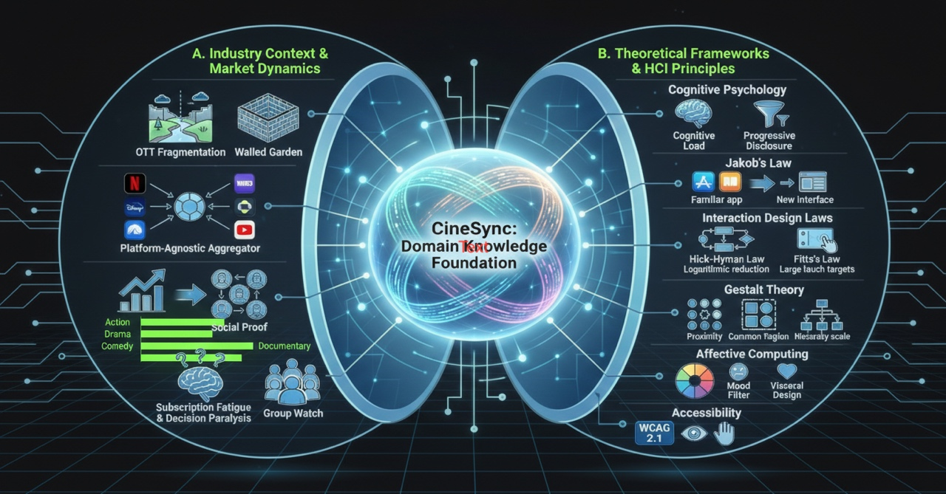

Domain Knowledge

To ensure the validity and effectiveness of the "CineSync" redesign, this project is grounded in established theories from Information Systems, Cognitive Science, and Interaction Design.
- Industry Context & Market Dynamics.
  - Unified Access: Counters "Walled Garden" fragmentation by leveraging IMDb as a centralized, platform-agnostic aggregator for all streaming content.
  - Social-First Discovery: Addresses "Subscription Fatigue" by shifting focus from algorithms to Social Proof via collaborative filtering (Group Watch).

- Theoretical Frameworks & HCI Principles
  - Cognitive Psychology: Mitigated Cognitive Load via progressive disclosure and applied Jakob’s Law by mirroring familiar UI patterns (Netflix) to reduce friction.
  - Interaction Design: Optimized navigation speed (Hick-Hyman Law) and enhanced touch target efficiency for key actions like "Add to Watchlist" (Fitts’s Law).
  - Gestalt Principles: Improved scan-ability through Proximity (grouping related metrics) and a distinct Visual Hierarchy to guide user attention.
  - Engagement & Access: Leveraged Visceral Design for emotional engagement and ensured full WCAG 2.1 AA compliance for inclusive accessibility.

Competitive Analysis
We analyzed the interface designs of four major competitors to identify visual gaps we can fill.
Competitor | Competitor Strength | IMDb Weakness | Design Opportunity

Rotten Tomatoes | The "Tomatometer" icon serves as an excellent visual shorthand that users understand instantly. | Relying heavily on small numerical text (e.g., "7.8/10")  which is difficult to scan quickly. | Design a new graphical "Score Ring" to make ratings instantly recognizable at a glance.
Letterboxd | A beautiful, minimalist "Dark Mode" aesthetic that feels premium and modern. | A dated, utilitarian look with excessive white space and small thumbnails. | Adopt a  "Poster-First" design language and native Dark Mode to match the premium aesthetic.
Netflix | Seamless,  auto-playing trailers and "Hero" banners that create an  immersive experience. | Static pages that feel passive and lack  energy. | Introduce  "Micro-Interactions" (e.g., hovering over a poster auto-plays a snippet) to make browsing dynamic.
JustWatch | Best-in-class filtering for "Where to Stream" content. | Streaming availability information is often buried or hard to find. | Elevate the "Where to Watch" UI to the top of the hierarchy, integrating it directly into search results.

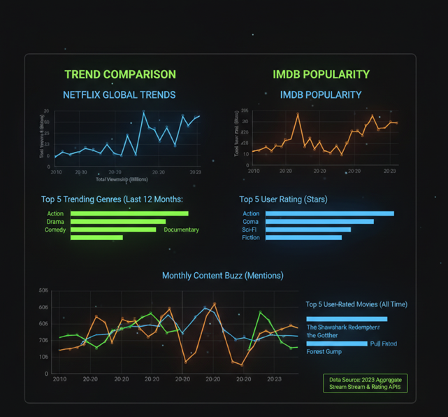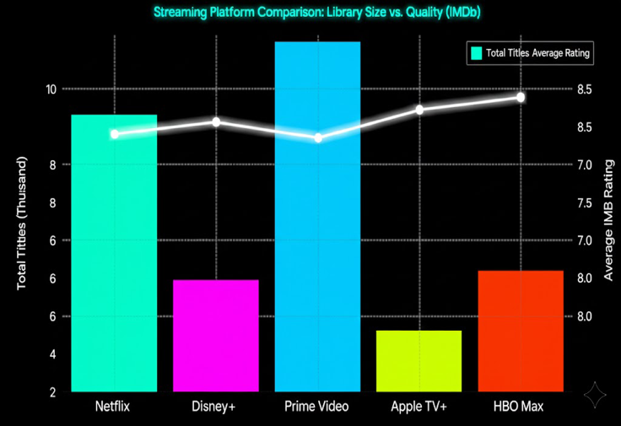
(new neon-highlighted data analysis graph comparing major streaming platforms (Netflix, Disney+, Amazon Prime Video, Apple TV+, and HBO Max) using IMDb rating data and title counts.)

Conclusion
The proposed "CineSync" redesign addresses the critical usability flaws of the current IMDb platform by shifting its focus from raw data storage to user-centric decision support. By combining deep industry knowledge of the streaming ecosystem with HCI principles like
Hick’s Law, we aim to reduce the cognitive load required to find a movie.
While competitors like Rotten Tomatoes excel at simplicity and Letterboxd at aesthetics, IMDb possesses the unique advantage of data depth. Our redesign leverages this depth but packages it in a modern, accessible interface.

IMDb Non-Commercial Datasets. IMDb, 2024, developer.imdb.com/non-commercial-datasets/.
Bansal, Shivam. Netflix Movies and TV Shows. Kaggle, 2021, www.kaggle.com/datasets/shivamb/netflix-shows.

