**OUTPUTS from API end points**

Home page

Sentiment Analysis using textBlob

Results

Sentiment Analysis using spacy

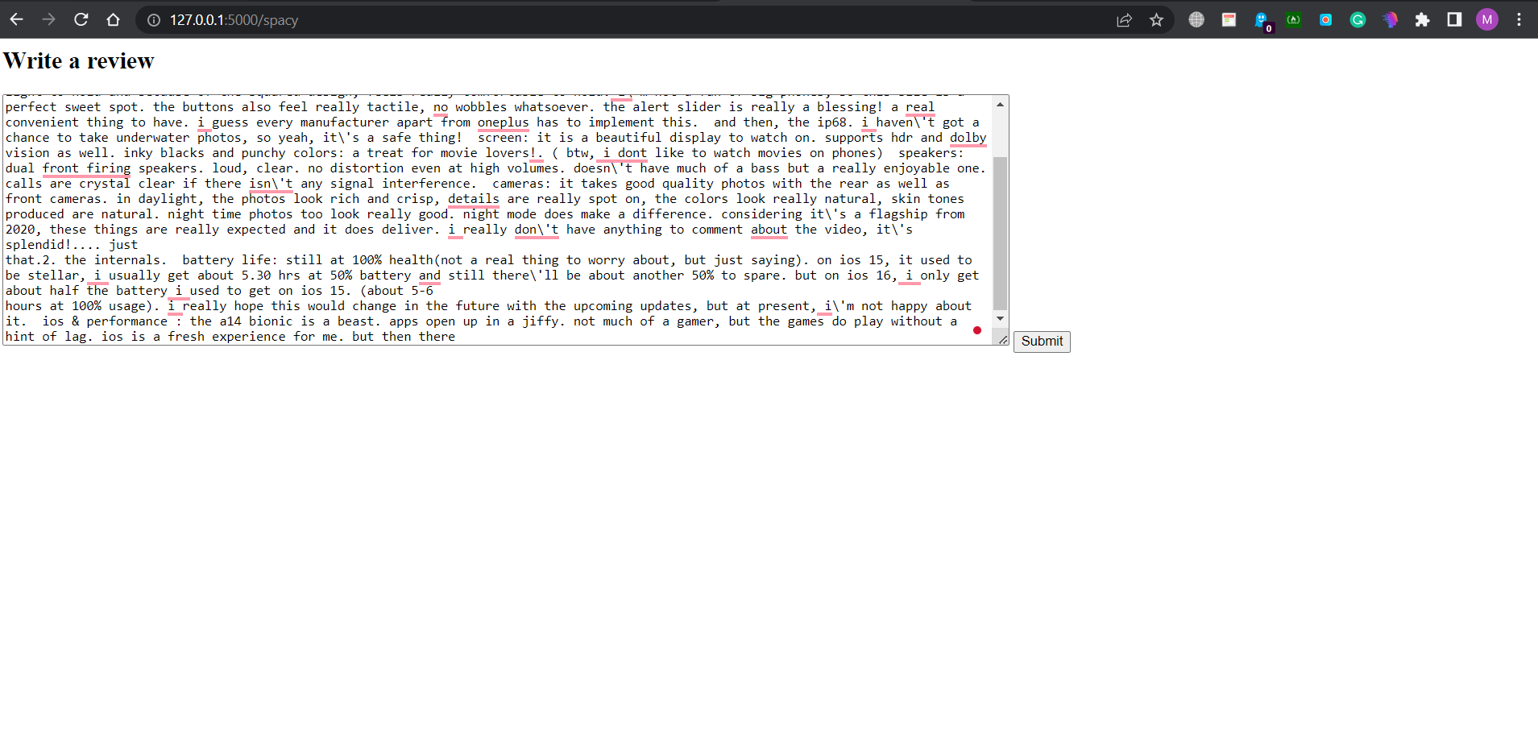

Results

Data fetched from database

Reviews being fetched for a particular color, storage and rating

Best and worst words analysis

