Moeen Arshad  
April 30, 2012  
IGN Code Foo

Question #1

How many ping pong balls would it take to fill an average-sized school bus? Describe each step in your thought process.

Before attempting to solve this problem, it must be understood, that this question is theoretical, and thus in turn, can only incite a theoretical response. Given the current state of the question, there cannot exist a single, correct, answer since key information about the necessary parameters is missing. One can only “solve” this by making approximations & assumptions when inputting one’s own parameters. Details such as the make & model of the bus, the country (or region) the bus is native to, heavily populated or rural areas, whether it’s an average short-bus or an average long-bus, the year the bus was manufactured, whether or not it’s following Industry Standardization Protocols or not, what size is the ping pong ball, whether or not the bus is empty… These all play a crucial role in solving this problem. And the first step to solving this problem would be to address this issue.

Next, approximations can only be made with further research.

According to the International Table Tennis Federation Hand Book, regulation states that the dimensions of a **ping pong ball** must include a diameter of 40mm ($d=40mm$). The weight & thickness of the ball can be considered negligible for this experiment.

And according to the National Transportation Library from the U.S. Department of Transportation, the “average” bus that’s most commonly used is known as Type C (or Conventional) that still ranges in dimensions; and the number of seats from bus to bus varies. The government standardization for Type C bus’ vehicle dimensions recommend:

$$Width=2.4m \left(8ft\right) \\ Length=11.1m \left(36.4ft\right) \\ Height=3.3m \left(10.9ft\right)*$$

The bus typically holds 55-65 people, but can hold over 80. Certain specifications are mandatory, such as the width of the aisle cannot be any less than 12”, and the maximum width of the bus cannot exceed 8ft. The *inner* dimensions may vary, as well. Often, the average *inner* height is roughly 6ft.*

And according to the National Association of State Directors of Pupil Transportation Services, “the typical school bus seat is 39 inches wide and is generally considered to have a maximum seating capacity of three.” This width is determined by the number 13, which represents the average 12.8” hip breadth of the 5th percentile adult female.

For our model, we will assume we are using a Type C related bus, with a maximum seating capacity of 61 people (including the driver). The only key components to be considered in the model are the dimensions of the seats. Further parameters have been acknowledged, but will not be present in the simplified model. Below is a schematic diagram of *our* model that includes the parameters we will be using. Keep in mind; I did not draw this diagram to scale.

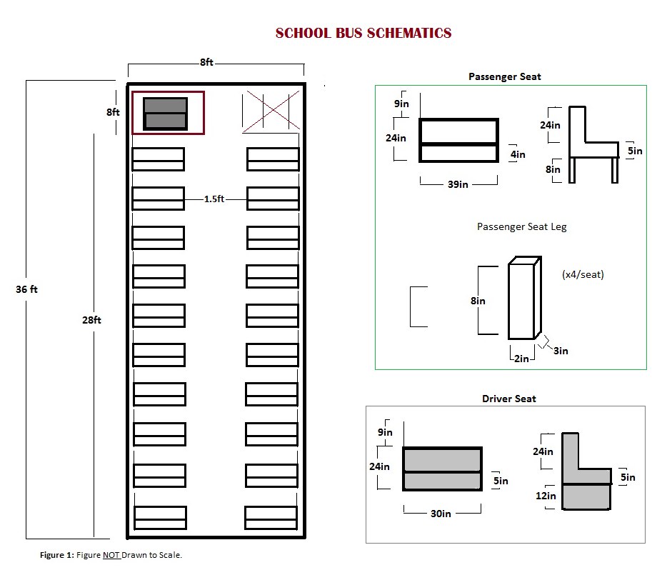

Let’s Begin.

For simplicity’s sake, and for lack of further parameters (remember, these numbers are only based on educated assumptions) let’s assume the bus has the following rectangular coordinates for its *inner dimensions*:   
lbus = 36ft,   
h bus = 6ft, &   
w bus = 8ft.   
Converting those specifications to cm and calculating the volume leads to:   
lbus = 1097.28cm,   
h bus = 182.88cm,   
w bus = 243.84cm, & $$V_{busTOT} = 48.931 x {10}^{6} {cm}^{3}$$  
  
  
Saying that we’ve calculated the total volume of our available space at this current point would be a little *too* oversimplified. Next up, is to calculate the next biggest thing that occupies our volume, the seat. In this particular example, the additional factors that better accurately describe the seat’s specifications will be considered negligible. Instead, we will use an educated simplified model that stands on four rectangular legs and still meets the national requirement of a minimum of 13” per person per seat. The seats will be able to seat 3 each according to these standards (with a width of 39”), and according to our model with inner dimensions of 8ftx36ft, it will hold exactly 20 passenger seats.

Now calculating the volume of our passenger seats, we break it up into 3 components: the actual seat, the backrest, and the 4 rectangular legs. These are the dimensions as follows:

**Passenger Seat Dimensions**

|  |  |  |  |  |  |
| --- | --- | --- | --- | --- | --- |
|  | **Length** (l) | **Width** (w) | **Height** (h) | **Volume** (V) | **Number of Components** |
| **Seat Backrest** | 39” (99.06cm) | 4” (10.16cm) | 24” (60.96cm) | 61.353 x 103 cm3 | X20 |
| **Seat Bottom** | 39” (99.06cm) | 24” (60.96cm) | 5” (12.7cm) | 76.691 x 103 cm3 | X20 |
| **Seat Leg** | 3” (7.62cm) | 2” (5.08cm) | 8” (20.32cm) | 786.58 cm3/leg | X80 |
| **TOTAL** | / | / | / | 14.1190 x 104 cm3 | **X20** |

This leads us to have a Total Seat Volume of $V_{TOTseat}= 28.23815 x {10}^{5} {cm}^{3}$

There is one more seat left to calculate (the Driver’s Seat). It is the same procedure as we have calculated for the passenger seats, except we will not use 4 rectangular legs; instead, we will use a solid base with dimensions 24”x30”x5”:

**Driver Seat Dimensions**

|  |  |  |  |  |  |
| --- | --- | --- | --- | --- | --- |
|  | **Length** (l) | **Width** (w) | **Height** (h) | **Volume** (V) | **Number of Components** |
| **Seat Backrest** | 30” (76.2cm) | 5” (12.7cm) | 24” (60.96cm) | 58.993 x 103 cm3 | X1 |
| **Seat Bottom** | 24” (60.96cm) | 30” (76.2cm) | 5” (12.7cm) | 58.993 x 103 cm3 | X1 |
| **Seat Base** | 30” (76.2cm) | 24” (60.96cm) | 12” (30.48cm) | 14.1584 x 104 cm3 | X1 |
| **TOTAL** | / | / | / | 25.9450 x 104 cm3 | **X1** |

Giving us $V_{DRIVEseat} = 25.9450 x {10}^{4} {cm}^{3}$

It’s important to remember that in our model, we are neglecting specific factors that would make a huge difference. Primarily, the steering wheel & dashboard, near the driver side, and the two feet of stairs at the entrance of the bus. Not to mention the overhead, and the slight curvature of the roof, the areas where the floor is raised (i.e. above the wheels, above the battery box), the exact dimensions of the windowpanes, the very likely possibility that there is that one seat in the back that’s super long… Basically, just a reminder, that although we are using a realistic dimensions, our model is still heavily oversimplified. Now continuing on with our calculations…

We have calculated all the necessary components of the bus, and the following step should be to calculate the negative space (i.e. the free space) in our model.

$${V }_{busTOT} - V_{TOTseat} - V_{DRIVEseat} = V_{FREE}$$

$$V_{FREE} = 45.847735 x{10}^{6}{cm}^{3}$$

Phew!  
Now on to the Ping Pong!  
First things first, let’s calculate the Volume of the Ping Pong! The diameter of a standard Olympic-issued ping-pong ball is approximately 40mm (or 0.4cm).

$$V_{BALL}=\frac{πd^{3}}{6}= \frac{π{(O.40cm)}^{3}}{6}=0.03351{cm}^{3}/ball$$

But, solving for the solution is not as simple as dividing VFREE by VBALL. If you think about it, a sphere’s longest length from point to point is a diameter (of length l); and a cube has dimensions of equal sides (also, of length l), so if a cube were to be superimposed upon a sphere (both sharing l) such that the Total Interface Area was determined to have all six points of contact with the cube, it would be clear that the Volume of the Sphere does not take up 100% of the Volume of the Cube. In other words, there would be an amount of space left uninhabited, also known as the Void Volume.

To have our calculations account for the Void Volume, the first step we would need to take is to actually calculate it. There are a number of methods that would lead us to that result, and among those methods, Porosity came to mind. By determining the porosity of the porous material (in this case, VFREE) that consists of uniformly distributed solid spheres (the ping pongs), Void Volume could be calculated as such:

$$Void Volume=V-\frac{πd^{3}}{6}N$$

Where V is the total volume of the porous material, and N is the total number of spheres in the material. This method would be perfect if it were not for one simple detail. The goal is to find out how many ping pong balls can *fill* the school bus; the balls would have to be packed in together to try achieving the maximum number of balls possible. In short, there is a more direct, simpler method at hand. It’s called Sphere Packing.

When trying to achieve efficiency, it’s important to understand that depending on how spheres are packed together, it directly affects the amount of space (or void volume) between them. Geometrically speaking, there are a number of sphere packing theories that are known to be efficient; a common and direct approach is the simple cubic packing theory in which spheres are placed directly next to and on top of one another. To determine the efficiency of any of the theories, the packing density (P) must be calculated.

$P \left(packing density\right)=\frac{Vsphere}{Vcube}$

$Vsphere=\frac{πd^{3}}{6}$ $Vcube=lwh=a^{3}=d^{3}$

Since the sides of the cube match the length of the sphere’s diameter, the equation can be simplified to P = 0.5236 or P = 52.36%; meaning only 52.36% of the VFREE is occupied and 47.64% is Void Volume.

Let’s see how many ping pong balls we have inside the bus now:

$$\# of Balls =\frac{{(V}_{FREE}*P)}{V_{BALL}}=\frac{\left(45.847735 x{10}^{6}{cm}^{3}* 0.5236\right)}{\frac{0.03351{cm}^{3}}{ball}}= 7.16379 x{10}^{8} balls$$

Almost done!  
There is one other sphere packing theory that’s much more accurate if done right. It is called the FCC, or the Face-Centered Cubic method. The spheres are placed diagonally, and the next layer on top is placed within those grooves. This drastically reduces the Void Volume. A typical cube has 1/8th spheres in each corner and ½ spheres on each side, and a cube’s length can be calculated from the right triangle the 2 diameters form, leaving $l=2√d$. The same packing density formula applies, which equals:

$$P=\frac{Vsphere}{Vcube}=\frac{\left[8*\left(\frac{1}{8}\right)*\left(\frac{πd^{3}}{6}\right)+ 6*\left(\frac{1}{2}\right)*\left(\frac{πd^{3}}{6}\right)\right]}{{\left(2\sqrt{d}\right)}^{3}}=0.7405$$

The packing density is 74.05%! Calculating the number of ping pong balls with this density yields:

$$\# of Balls =\frac{{(V}_{FREE}*P)}{V_{BALL}}=\frac{\left(45.847735 x{10}^{6}{cm}^{3}* 0.7405\right)}{\frac{0.03351{cm}^{3}}{ball}}= 1.01314 x{10}^{9} balls$$

So, in conclusion, limited to using the formula specifically to our oversimplified model that negates additional parameters, the number of ping pong balls that would fit in our Average-Sized School Bus depends entirely on how they are packaged in. If the balls are packaged efficiently, the number should fall somewhere between 716,379,000 balls to 1,013,140,000 balls.

It’s been fun!

Works Cited:

"Archive Menu." *International Table Tennis Federation*. International Table Tennis Federation, 2002.   
 Web. 30 Apr. 2012. <http://www.ittf.com/ittf_handbook/ittf_hb.html>.

"LARGE SCHOOL BUS DESIGN VEHICLE DIMENSIONS." *RITA*. US Department of Transportation. Web. 30   
 Apr. 2012. <http://ntl.bts.gov/DOCS/MBTC1054-1.htm>.

"School Bus Seat Capacity." *Nasdpts.org*. National Association of State Directors of Pupil Transportation   
 Services:. Web. Apr. 2012. <http://www.nasdpts.org/Documents/Paper-SeatingCapacity.pdf>.