Fundamentals of Programming

Lab Manual # 07

**Lab Instructor**: Muhammad Affan

Student Name: Muhammad Moeez Zafar

CMS Id: 456063

Date: 17-11-2023

1. Take 10 integer inputs from user and store them and store the in an array and print them.

# include <iostream>

using namespace std;

int main()

{

cout<<"Enter Enteries for your array"<<endl;

int a[10];

for (int i = 0; i <=9; i++)

{

cin>>a[i];

}

for (int i = 0; i <=9; i++)

{

cout<<a[i];

}

}

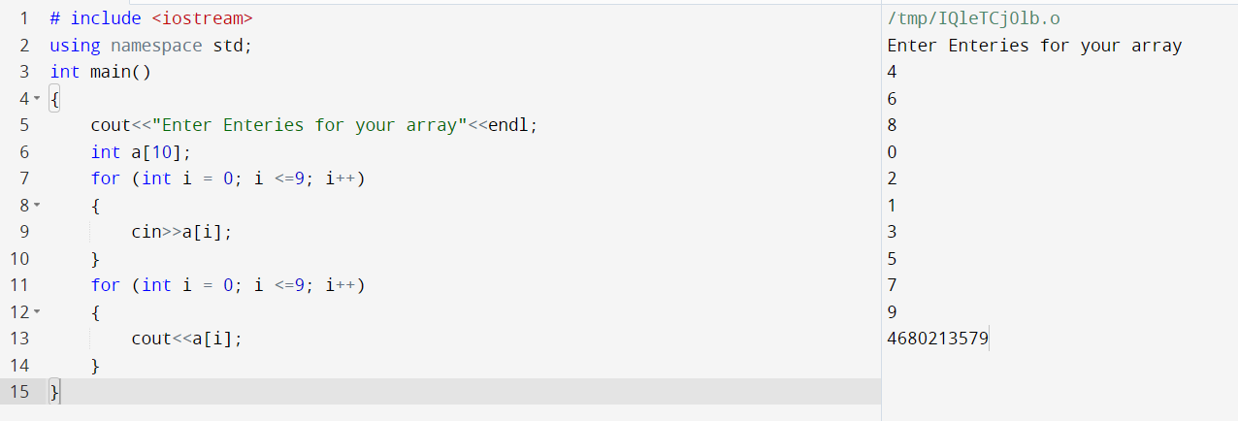

1. Write a program to find the sum and product of all elements of an array with 5 integer elements

# include <iostream>

using namespace std;

int main()

{

cout<<"Enter Enteries for your array"<<endl;

int a[5];

int sum=0,prod=1;

for (int i = 0; i <=4; i++)

{

cin>>a[i];

sum=sum+a[i];

prod*=a[i];

}

cout<<"The sum of elements of array a = "<<sum<<endl;

cout<<"The prod of elements of array a = "<<prod<<endl;

}

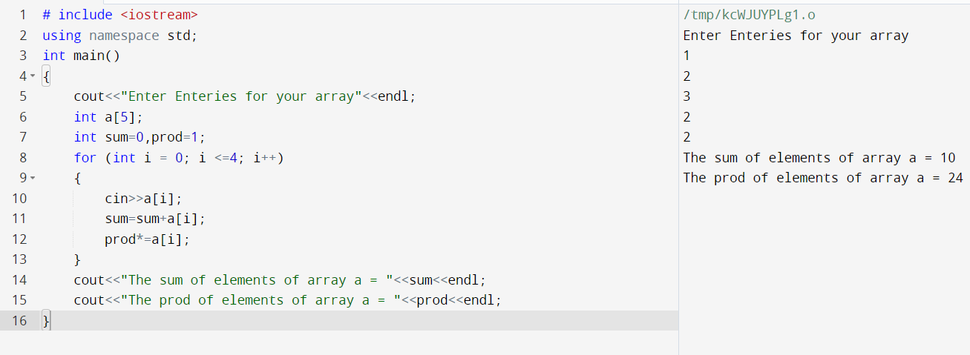

3.Print diamond pattern using a single array.

#include <iostream>

using namespace std;

int main()

{

int point = 5 / 2;

char Diamond[5];

int a_first = point;

int a_second = point;

for (int a = 0; a <=2; a++)

{

for (int b = 0; b < 5; b++)

{

if (b >= a_first && b <=a_second)

{

Diamond[b] = '*';

}

else

{

Diamond[b] = ' ';

}

}

for (int i = 0; i < 5; i++)

{

cout << Diamond[i];

}

a_first -= 1;

a_second += 1;

cout << endl;

}

a_first += 2;

a_second -= 2;

for (int j = 0;j <= 1; j++)

{

for (int b = 0; b < 5; b++)

{

if (b >= a_first && b <= a_second)

{

Diamond[b] = '*';

}

else

{

Diamond[b] = ' ';

}

}

for (int i = 0; i < 5; i++)

{

cout << Diamond[i];

}

a_first += 1;

a_second -= 1;

cout << endl;

}

return 0;

}

