**School Of Mechanical & Manufacturing Engineering**

NUST Department of Mechanical Engineering

Fundamentals of Programing

Lab Manual # 08

Lab Instructor: Muhammad Affan

Student Name: Mohammad Moeez Zafar

CMS ID: 456063

DATE: 1stDecember2023

1. Write a C++ program to calculate average of numbers of array.

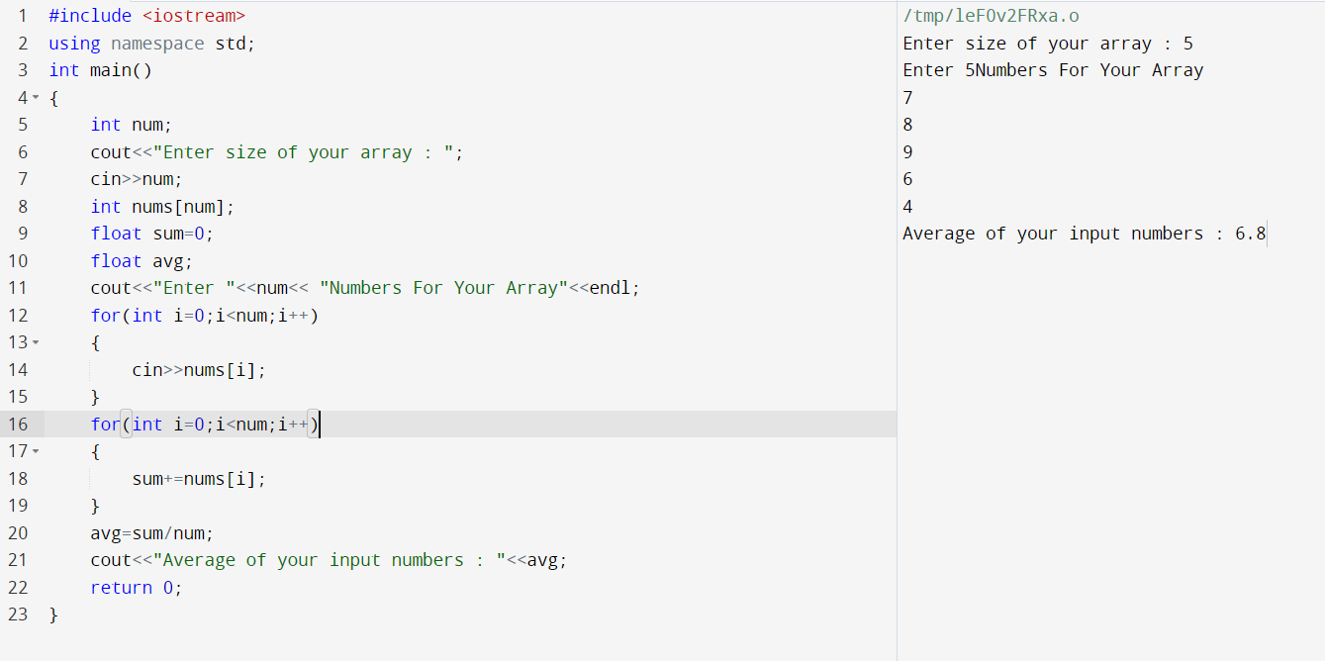

1. Implement Bubble sort on an array of 5 integers.

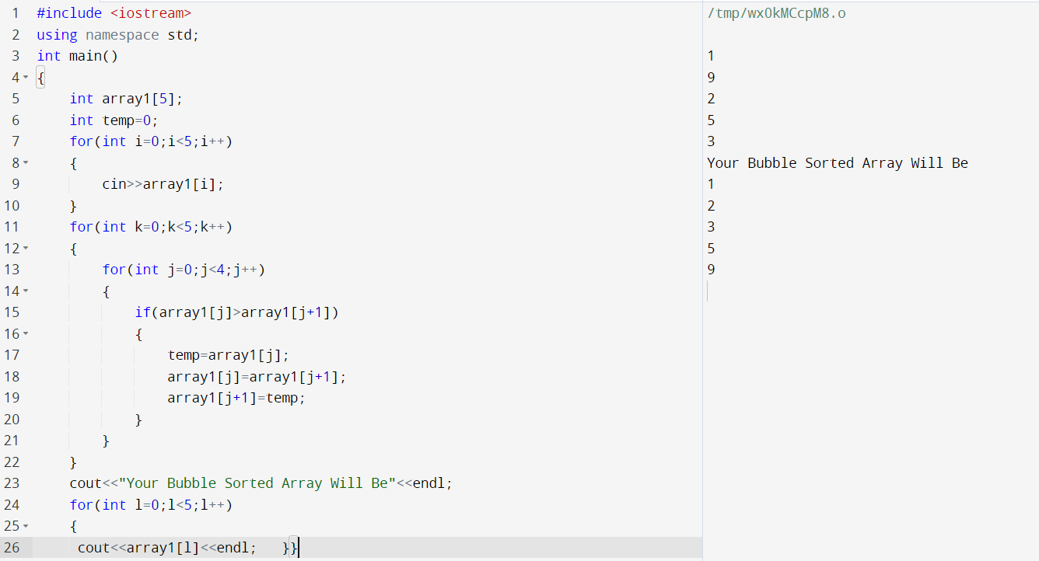

1. Implement Selection Sort on an array of 5 integers.

