CS-114 - Fundamental of Programing

Lab Manual # 05

Course Instructor: Dr. Talha

Lab Instructor: Muhammad Affan

Student Name: M. Moeez Zafar

CMS ID: DATE: 456063

Date: 02-11-2023

**1. Write a program in C++ to find LCM of any two numbers using HCF.**

#include <iostream>

using namespace std;

int main()

{

int num1=0,num2=0;

cout<<"Enter the first number"<<endl;

cin>>num1;

cout<<"Enter the second number"<<endl;

cin>>num2;

int numg,nums=0;

int m_c=0;

int hcf=1;

if (num1>num2)

{

numg=num1;

nums=num2;

}

else

{

numg=num2;

nums=num1;

}

while(m_c<=numg)

{

m_c++;

if(num1%m_c==0 && num2%m_c==0)

{

hcf=m_c;

}

}

cout<<"H.C.F. of "<<num1<<"& "<<num2<<" is "<<hcf<<endl;

int lcm=0;

lcm=(num1*num2)/hcf;

cout<<"L.C.M. of "<<num1<<"& "<<num2<<" is "<<lcm;

}

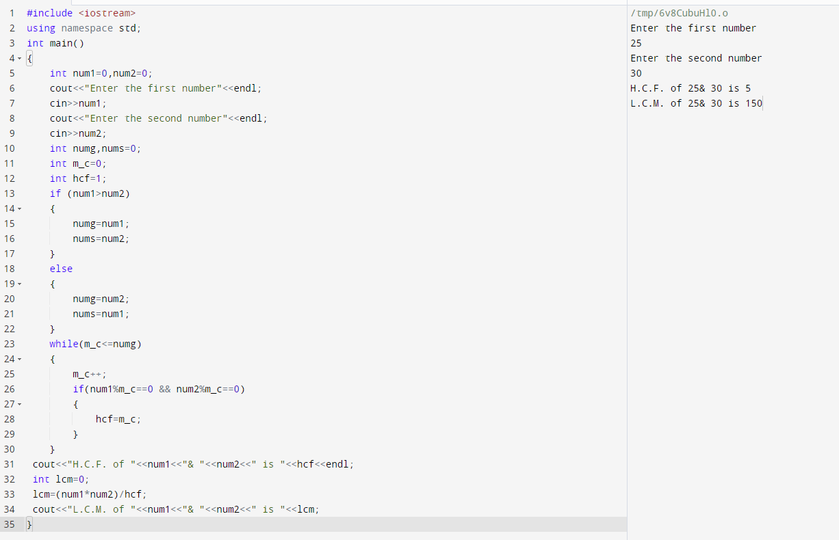

**2. Write a program in C++ to find out the sum of an Arithmetic progression series**

#include <iostream>

#include <math.h>

using namespace std;

int main() {

int a1=0,a2=0;

cout<<"Enter First Two Terms of an Arithmetic Progression"<<endl;

cin>>a1;

cin>>a2;

int diff=0;

diff=a2-a1;

cout<<"Enter the Extent of the Arithmetic Progression"<<endl;

int n=0;

cin>>n;

int an=0;

an=a1;

cout<<a1<<" ";

for(int i=0;i<n;i++)

{

an=an+diff;

cout<<an<<" ";

}

cout<<" "<<endl;

cout<<"The Sum of Your Arithematic Progression is ";

int sum=0;

sum=((2*a1)+((n-1)*diff))*(n/2);

cout<<sum;

return 0;

}

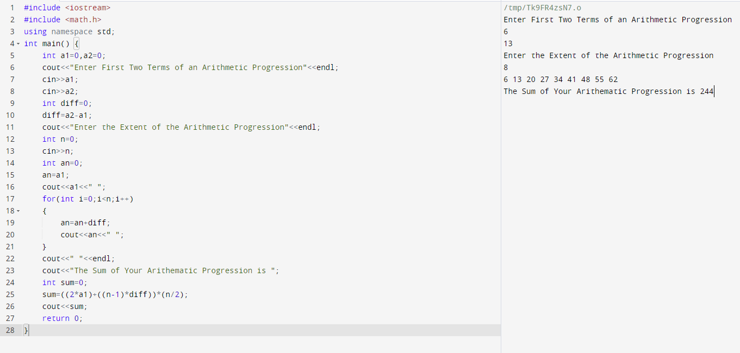

**3. Write a program in C++ to create a diamond**

#include <iostream>

using namespace std;

int main() {

int size;

cout<<"Enter the size of the diamond (odd numebr)"<<endl;

cin>>size;

for(int row=1;row<=size;row +=2)

{

for(int space=1;space<=(size-row)/2;space++)

{

cout<<" ";

}

for(int star=0;star<row;star++)

{

cout<<"*";

}

cout<<endl;

}

for(int row=size-2;row>= 1;row -= 2)

{

for(int space=1;space<=(size-row)/2;space++)

{

cout<<" ";

}

for(int star=1;star<=row;star++)

{

cout<<"*";

}

cout<<endl;

}

}

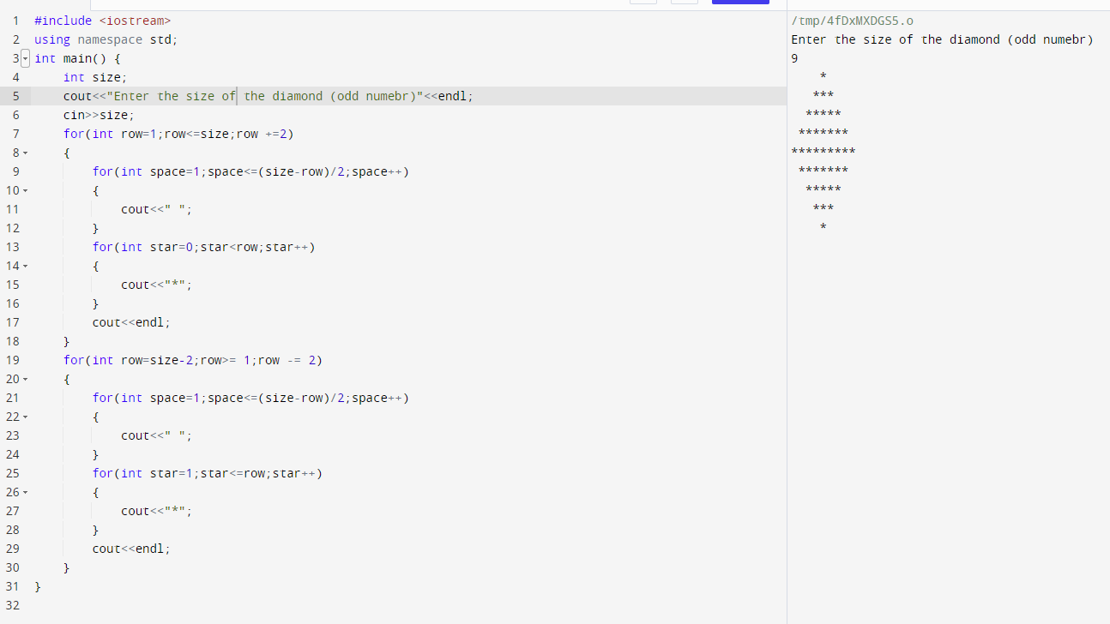

**4. Write a program in C++ to convert a decimal number to binary number**

#include <iostream>

#include <math.h>

using namespace std;

int main() {

int num=0,bin=0,binf=0,extent=0,bin1=0;

cout<<"Enter a non-negative number"<<endl;

cin>>num;

if(num>1)

{

while(num>1)

{

bin=num%2;

num=num/2;

bin=bin*pow(10,extent);

extent++;

binf=binf+bin;

}

}

bin1=1*pow(10,extent);

binf=binf+bin1;

cout<<binf<<endl;

return 0;

}

