# 综合实验报告

|  |  |  |  |
| --- | --- | --- | --- |
| 姓名 | 叶福伦 | 学号 | 21051331 |
| 专业 | 计算机专业 | 班级 | 21052313 |
| 指导教师 | 高志刚 | 课程名称 | 计算机组成原理课程设计（甲） |
| 实验序号 | 09 | 实验名称 | 实现LS型指令的CPU设计实验 |
| 实验时间 | 05.13 | 实验地点 | 一教223 |

# 成绩表

|  |  |  |
| --- | --- | --- |
| **考核项目** | **满分** | **得分** |
| **一、实验方案设计** | **30分** |  |
| **二、FPGA程序设计** | **20分** |  |
| **三、测试程序** | **10分** |  |
| **四、实验结果分析** | **20分** |  |
| **五、思考与探索** | **10分** |  |
| **格式** | **10分** |  |
| **合计** | **100分** |  |

# 一、实验方案设计

1. 实验目的与要求（5分）

掌握RISC-V I型取数指令和S型存数指令的数据通路设计；

掌握指令流和数据流控制的方法；

学习依据新增指令，修改多周期CPU系统结构的方法

具备连接各模块构建整机的能力

实现I型取数指令和S型存数指令的功能

要求

编写用于测试的汇编程序RIUS_test.s，可以自行设计，也可以采用前述范例程序；将其翻译成机器指令代码，写入RIUS_test.coe文件备用。

将实验8工程另存为一个新工程，用RIUS_test.coe重新生成指令存储器模块。

使用IP核新建一个数据存储器模块（64×32位），用COE文件初始化其内容，最好每个单元内容各不相同；新建一个MDR寄存器模块，改造W_Data的多路数据选择器为三选一数据选择器；修改二级指令译码模块ID2和控制单元CU；将它们与其他模块进行正确的连接，构建RIUS_CPU模块。

对RIUS_CPU模块进行仿真，在rst_n之后，每来一个clk，观察指令执行的每一步骤（状态）是否符合预期，确保RIUS_CPU能正确执行目标指令集上的测试程序。

针对使用的实验板卡，设计RIUS_CPU的板级验证实验方案，编写顶层测试模块，要求至少能观察PC、IR、W_Data、MDR、标志位。同样需要修改RIUS_CPU模块的输出端口，将内部模块的相应信号引出。

复位后，按clk按键，会按步骤执行指令，验证每条指令需要几个周期执行完，执行结果是否正确，将实验结果记录下来。

撰写实验报告，重点内容包括：

1）对仿真结果进行分析；描述你设计的板级验证实验方案、模块结构与连接；说明你的板级操作过程；记录板级实验结果。

2）针对以下有待验证的实验问题，给出证据与分析，得到有效结论：

①lw指令取出的内存数据与数据存储器初始化值一致；

②sw指令能将数据存入指定内存地址；

③sw指令存入某单元的数据，通过lw指令读出，数据保持一致。

3）请力所能及回答或实践本实验的“思考与探索”部分。

1. CPU的目标指令集（5分）

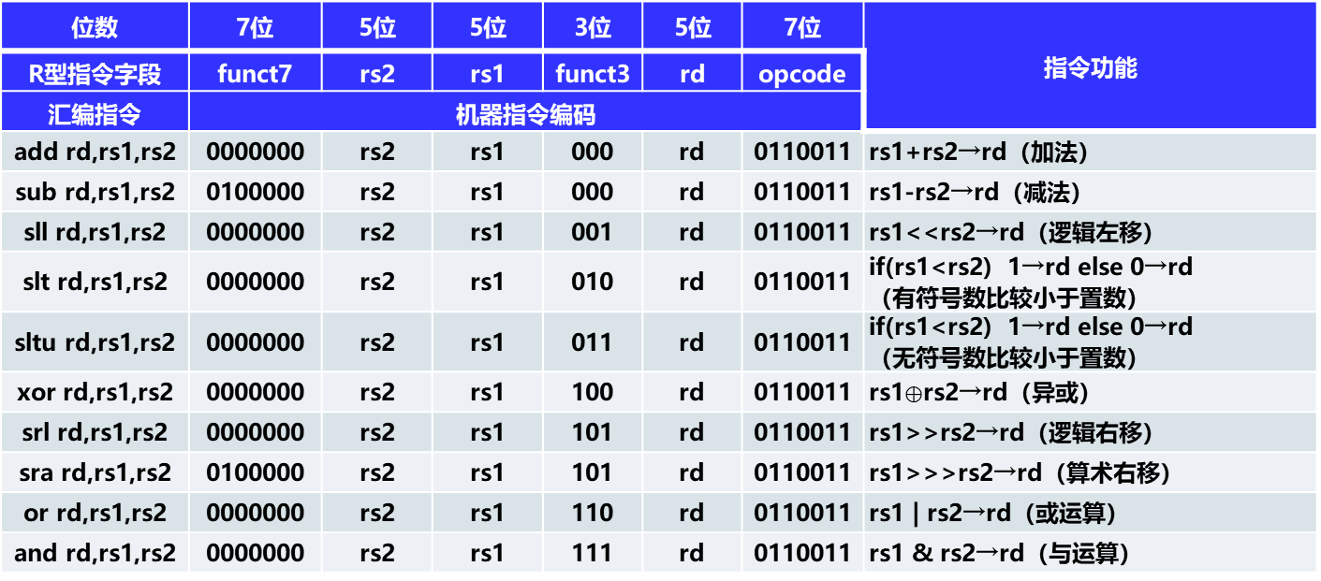

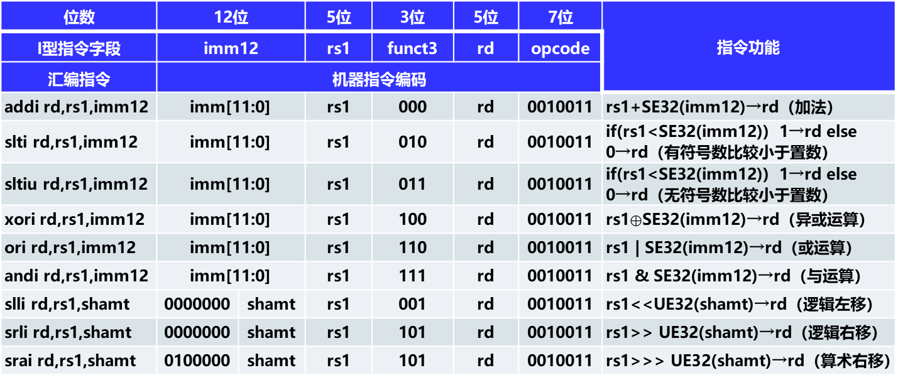

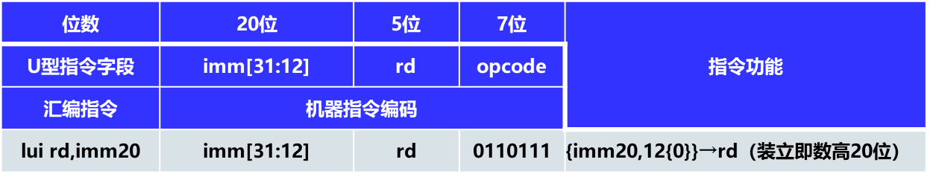

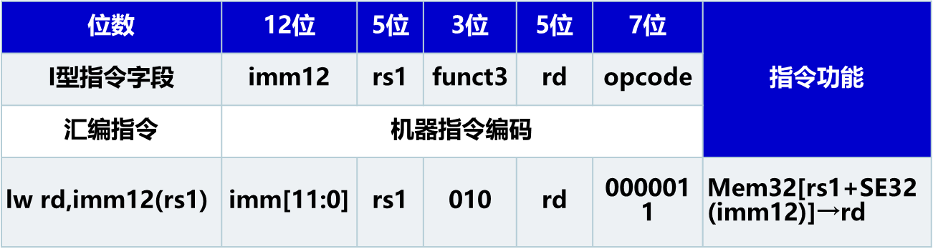

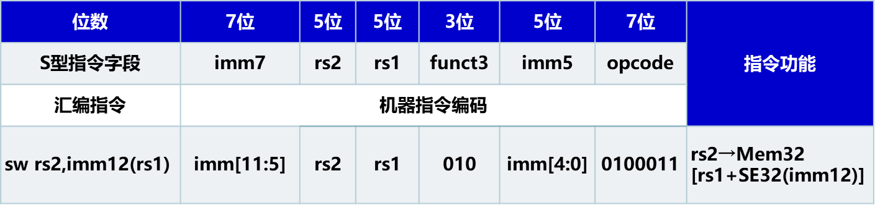

1. CPU的模块构成与连接（15分）

（请附图，并说明各模块的功能，以及模块间的连接关系。也可附开发工具中显示的电路模块连接图，加以说明。）

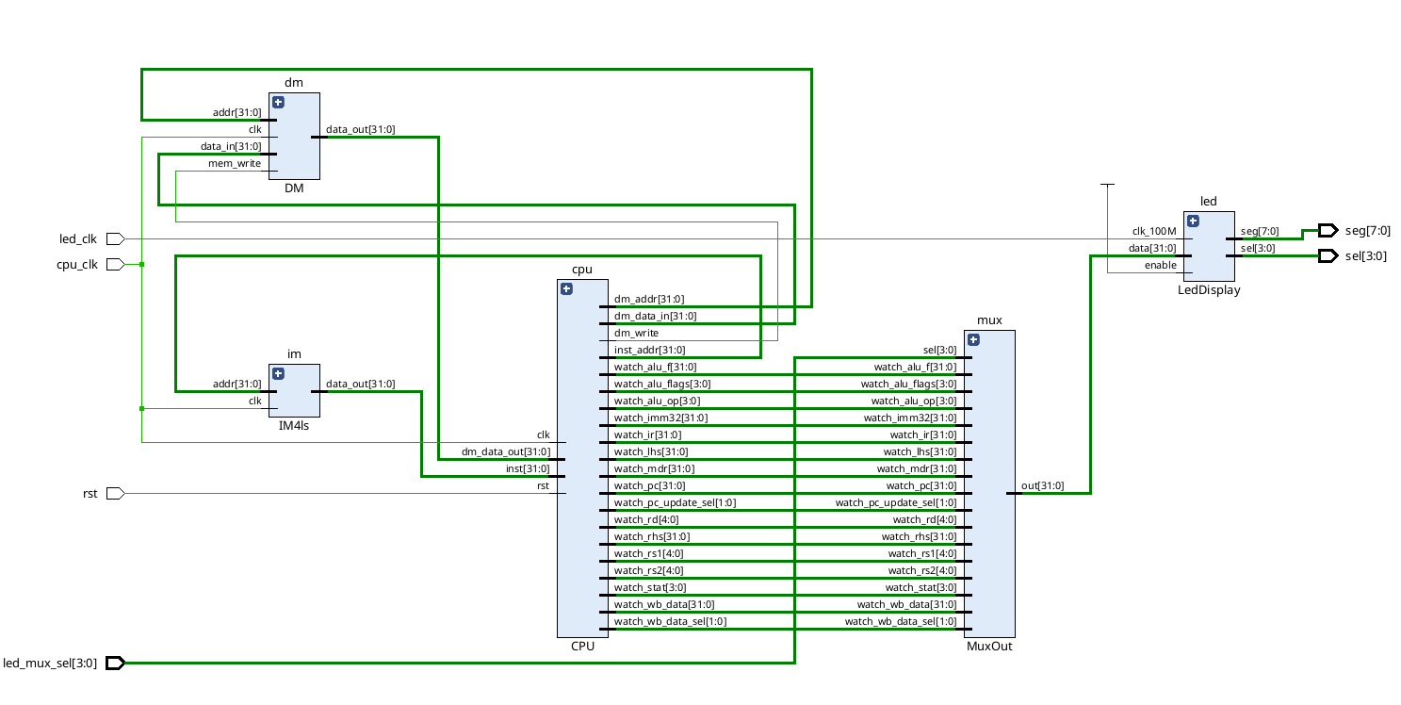

如图，本次模型机采用哈佛架构。

所以指令存储器im和数据存储器dm分开。cpu_clk是cpu, im, dm共同的工作时钟。im是指令存储器。存放运行所要的机器指令。dm是数据存储器用于存放数据。im使用inst_addr端口和inst端口和cpu模块通信。inst_addr连接地址线。inst连接数据线。dm使用dm_addr端口、dm_data_in端口、dm_data_out端口、dm_write端口和cpu模块通信。dm_addr连接地址线。数据线分为两条。一条是写数据线。一条是读数据线。dm_data_in连接写数据线。dm_data_out连接读数据线。dm_write是写允许信号。cpu的watch_*的端口输出cpu内部状态以便用开发板观察。因为开发板上没有很多输出设备所以。经过复用器后输出为复用输出信号。其中sel是复用选择信号。复用输出信号输入到led模块。led驱动数码管显示数据。

下面解析cpu的内部结构

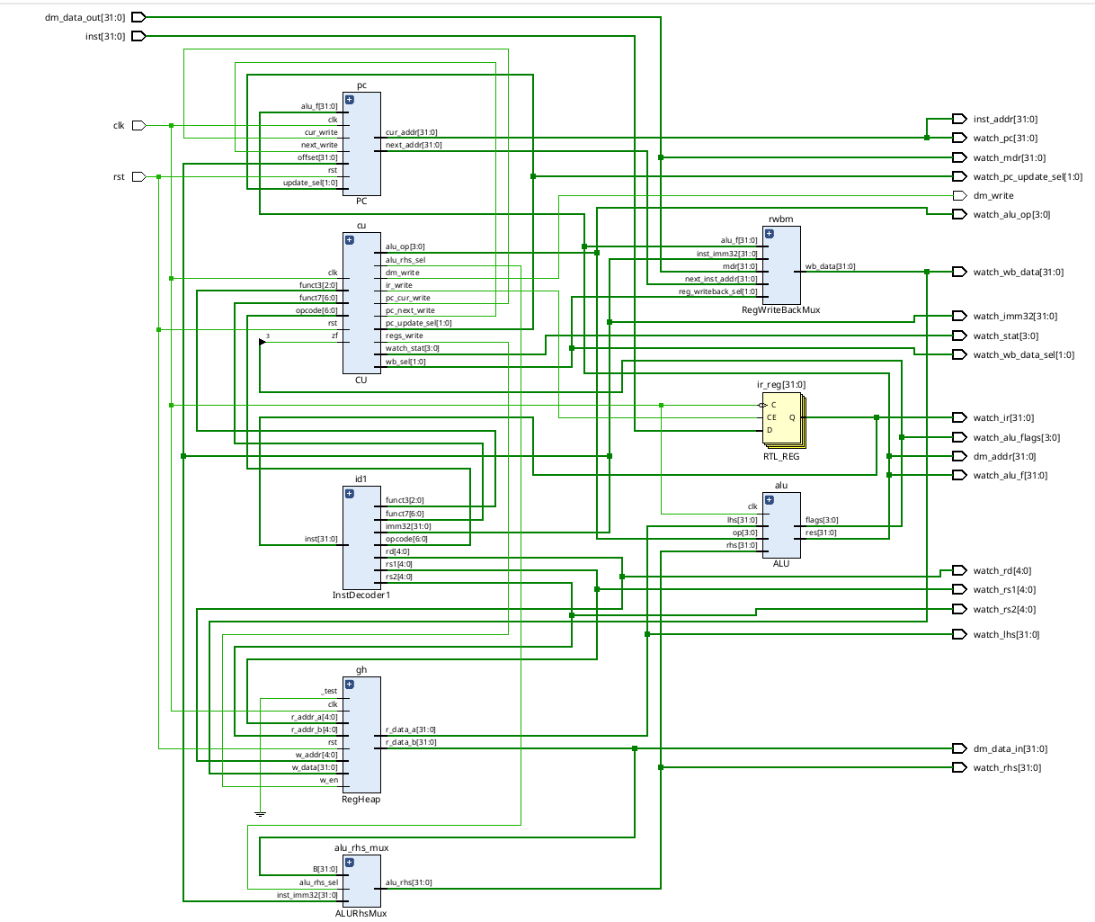如图cu是控制单元。pc是pc寄存器。id1是初级译码器。gh是寄存器堆。ir_reg是指令寄存器。

alu是运算单元。cu输入经过初级译码器解析出的opcode从而确定这一个指令周期要执行的状态转移过程。cu通过funct3，funct7，opcode确定alu_op。rst用于把cu的内部状态回归到初态。zf连接alu的0标志寄存器用于分支指令。watch_stat输出cu内部状态。*_write是对其余几个模块的写控制信号。*_sel是如果其余几个模块有多个数据输入源，对应的数据源选择信号。

pc寄存器输入时钟和复位信号。next_write控制对下一条要执行的指令的地址的修改。cur_write控制对要执行的指令的修改。pc有4个更新模式。分别使要执行的指令地址+4(顺序执行), 相对跳转: 使寄存器加上offset输入的值(jal, beq)，绝对跳转: 使寄存器变成为alu_f端口输入的值(jalr)和不变。具体更新寄存器的值用哪种模式由cu通过update_sel端口决定。输出cur_addr和next_addr分别指向本条和下一条要执行的指令地址。

ir寄存器存储本个指令周期所要执行的指令。ir_write控制该寄存器的写入。

id1寄存器根据ir存储的指令计算出rs1,rs2, rd, funct3， funct7，opcode和imm32.

funct3, funct7, opcode交给cu做进一步的处理。rs1，rs2作为寄存器堆的两个读地址。

rd作为寄存器堆的写地址。imm32交给复用输入器alu_rhs_mux。

gh是寄存器堆。clk是时钟信号，rst是复位信号。w_en是写允许信号，控制信号写回。gh根据两个读地址读出两个32位数据通过r_data_a和r_data_b端口输出。写回置写允许信号w_en为1时输入立即数inst_imm32、alu计算结果alu_f、数据存储器的数据寄存器输出数据mdr和下一条执行指令地址next_inst_addr。并输入写选择信号reg_writeback_sel。通过写回数据复用器确定写回的数据。通过w_data端口输入从而完成了数据的写入。

alu是算数逻辑单元。clk是时钟信号。lhs左操作数端口与寄存器的r_data_a端口相连，作为运算的左操作数。rhs右操作数前端接一个输入复用器。根据cu输出的右操作数选择信号选择立刻数或者是r_data_b端口数据作为右操作数。通过cu指定的op执行相应运算。输出res作为运算结果。flags是标志寄存器。

1. 板级验证方案（5分）

（说明顶层测试模块的输入/输出信号，及对应使用的I/O设备；可附图说明）

|  |  |  |  |
| --- | --- | --- | --- |
| 类型 | 端口 | 使用io设备 | 说明 |
| input | led_clk | 全局时钟信号 | 驱动数码管工作 |
| cpu_clk | 按键 | 模拟cpu时钟周期 |
| rst | 按键 | 复位信号 |
| led_mux_sel[3:0] | 一组逻辑开关 | 确定输出在数码管的是什么信号 |
| output | sel[3:0] | 数码管 | 驱动数码管工作 |
| seg[7:0] |

# 二、FPGA程序设计

（20分）

1. 实验程序源代码

（实验各个模块的代码，包含功能注释）

//alu_op.v

//alu_op编码

`define ALU_ADD_OP 4'b0000

`define ALU_SLL_OP 4'b0001

`define ALU_SLT_OP 4'b0010

`define ALU_SLTU_OP 4'b0011

`define ALU_XOR_OP 4'b0100

`define ALU_SRL_OP 4'b0101

`define ALU_OR_OP 4'b0110

`define ALU_AND_OP 4'b0111

`define ALU_SUB_OP 4'b1000

`define ALU_SRA_OP 4'b1101

`define ALU_ADDU_OP 4'b1010 //扩展不是标准实现,与add区别在标志寄存器的溢出和进位判断上

`define ALU_SUBU_OP 4'b1011 //扩展不是标准实现,与sub区别在标志寄存器的溢出和进位判断上

`define ALU_UNVALID_OP 4'b1111

//flag.v

`define FLAG_IS_ZERO 2'b11

`define FLAG_IS_POSITIVE 2'b10

`define FLAG_CARRY 2'b01

`define FLAG_OVERFLOW 2'b00

//opcode.v

//opcode编码

`define INST_R 7'b0110011 //R-type

`define INST_I 7'b0010011 //I-type

`define INST_L 7'b0000011 //L-type

`define INST_S 7'b0100011 //S-type

`define INST_B 7'b1100011 //B-type(beq)

`define INST_LUI 7'b0110111 //lui

`define INST_AUIPC 7'b0010111 //auipc 不使用

`define INST_JAL 7'b1101111 //jal

`define INST_JALR 7'b1100111 //jalr

//pc_update.v

//pc更新类型

`define PC_STEP 2'b00 //自增一个指令字

`define PC_JP_R 2'b01 //jal beq

`define PC_JP_F 2'b10 //jalr

`define PC_HOLD 2'b11 //不变

//rhs_from.v

//rhs来自imm32还是B寄存器

`define RHS_FROM_B_REG 1'b0

`define RHS_FROM_IMM32 1'b1

//wb_from.v

//回写数据来源

`define WB_FROM_IMM32 2'b00 //imm32立即数

`define WB_FROM_F_REG 2'b01 //alu运算结果F寄存器

`define WB_FROM_M_REG 2'b10 //MDR寄存器

`define WB_FROM_P_REG 2'b11 //PC寄存器

//ALU.v

`include "../define/alu_op.v"

module ALU (

input [31:0] lhs,

input [31:0] rhs,

input clk,

input [3:0] op,

output reg [31:0] res,

output reg [3:0] flags // [is_zero, is_positive, carry, overflow]

);

reg _c;

always @(negedge clk) begin

case(op)

`ALU_ADD_OP :begin { _c, res } = lhs + rhs; flags[0] = _c ^ res[31] ^ lhs[31] ^ rhs[31]; flags[1] = 0;end

`ALU_SLL_OP :begin res = lhs << rhs; flags[1:0] = 0; end

`ALU_SLT_OP :begin res = $signed(lhs) < $signed(rhs); flags[1:0] = 0;end

`ALU_SLTU_OP:begin res = lhs < rhs; flags[1:0] = 0;end

`ALU_XOR_OP :begin res = lhs ^ rhs; flags[1:0] = 0;end

`ALU_SRL_OP :begin res = lhs >> rhs; flags[1:0] = 0;end

`ALU_OR_OP :begin res = lhs | rhs; flags[1:0] = 0;end

`ALU_AND_OP :begin res = lhs & rhs; flags[1:0] = 0;end

`ALU_SUB_OP :begin { _c, res } = lhs - rhs; flags[0] = _c ^ res[31] ^ lhs[31] ^ rhs[31]; flags[1:0] = 0;end

`ALU_SRA_OP :begin res = $signed(lhs) >>> rhs; flags[1:0] = 0;end

`ALU_ADDU_OP:begin { flags[1], res } = lhs + rhs; flags[0] = 0;end

`ALU_SUBU_OP:begin { flags[1], res } = lhs - rhs; flags[0] = 0;end

default: begin res = 0; flags[1:0] = 0;end

endcase

flags[3] <= res == 32'h0000_0000 ? 1 : 0;

flags[2] <= res[31];

end

endmodule

//RegHeap.v

module RegHeap(

input clk,

input w_en,

input rst,

input _test,

input [4:0] r_addr_a,

output reg [31:0] r_data_a,

input [4:0] r_addr_b,

output reg [31:0] r_data_b,

input [4:0] w_addr,

input [31:0] w_data

);

reg [31:0]regs[31:0];

integer i;

always@(negedge clk or posedge rst) begin

if(rst) begin

if(_test) begin

regs[0] <= 0;

for(i=1;i<32;i=i+1) regs[i] <= 1 << i;

end else begin

for(i=0;i<32;i=i+1) regs[i] <= 0;

end

end else begin

if(w_en == 1 && w_addr != 0) begin

regs[w_addr] <= w_data;

end

end

end

always@(negedge clk)begin

r_data_a <= regs[r_addr_a];

r_data_b <= regs[r_addr_b];

end

endmodule

//InstDecoder1.v

`include "../define/opcode.v"

module InstDecoder1(

input [31:0] inst,

output reg [4:0] rs1, rs2, rd,

output reg [31:0] imm32,

output reg [6:0] opcode,

output reg [2:0] funct3,

output reg [6:0] funct7

);

always @(*) begin

opcode = inst[6:0];

rs1 = inst[19:15];

rs2 = inst[24:20];

rd = inst[11:7];

funct3 = inst[14:12];

funct7 = inst[31:25];

case(opcode)

`INST_R: begin imm32 = 0; end

`INST_I: begin

imm32 = (inst[14:12]==3'b101 && inst[30]==1'b1) ?

{27'b0, inst[24:20]}: //对应srai指令

{{20{inst[31]}}, inst[31:20]};

end

`INST_L: begin imm32 = {{20{inst[31]}}, inst[31:20]} ;end

`INST_S: begin imm32 = {{20{inst[31]}}, inst[31:25], inst[11:7]} ;end

`INST_B: begin imm32 = {{20{inst[31]}}, inst[7], inst[30:25], inst[11:8], 1'b0} ;end

`INST_LUI: begin imm32 = {inst[31:12], 12'b0} ;end

`INST_AUIPC: begin imm32 = {inst[31:12], 12'b0} ;end

`INST_JAL: begin imm32 ={{12{inst[31]}}, inst[19:12], inst[20], inst[30:21], 1'b0};end

`INST_JALR: begin imm32 = {{20{inst[31]}}, inst[31:20]} ;end

default: begin imm32 = 0;end

endcase

end

endmodule

//PC.v

`include "../define/pc_update.v"

//"../07-inst-fetch-decode/PC.v"的升级版，使得能够支持跳转指令

module PC (

input clk,

input rst,

input next_write,

input cur_write,

input [1:0] update_sel,

input [31:0] alu_f,

input [31:0] offset,

output reg [31:0] next_addr,

output reg [31:0] cur_addr

);

always@(posedge rst or negedge clk) begin

if(rst)begin

cur_addr <= 0;

next_addr <= 0;

end else begin

if(cur_write)begin

case(update_sel)

`PC_STEP: cur_addr <= next_addr;

`PC_JP_R: cur_addr <= cur_addr + offset;

`PC_JP_F: cur_addr <= alu_f;

`PC_HOLD: cur_addr <= cur_addr;

endcase

end

if(next_write)begin

next_addr <= cur_addr + 4;

end

end

end

endmodule

//InstDecoder2.v

`include "../define/opcode.v"

`include "../define/alu_op.v"

//次级译码模块，主要的功能是从opcode, func3, func7中译出alu_op

module InstDecoder2 (

input [6:0] opcode,

input [2:0] funct3,

input [6:0] funct7,

output reg [3:0] alu_op

);

always @(*) begin

case(opcode)

`INST_R:begin alu_op <= {funct7[5], funct3}; end

`INST_I:begin

alu_op <= (funct3==3'b101)?

{funct7[5], funct3}: //算术和逻辑移位

{1'b0, funct3}; //其他

end

`INST_L:begin alu_op <= `ALU_ADD_OP; end

`INST_S:begin alu_op <= `ALU_ADD_OP; end

`INST_B:begin alu_op <= `ALU_XOR_OP; end

`INST_JALR:begin alu_op <= `ALU_ADD_OP; end

default:begin alu_op <= `ALU_UNVALID_OP; end

endcase

end

endmodule

//CU.v

module CU (

input rst, //复位信号

input clk,

input [6:0] opcode,

input [2:0] funct3,

input [6:0] funct7,

input zf, //beq命令有用，alu做异或操作，为0则zf=1

output reg pc_cur_write,

output reg pc_next_write,

output reg [1:0] pc_update_sel, //控制pc更新类型

output reg ir_write, //控制ir寄存器写

output reg regs_write, //控制寄存器堆写操作

output reg dm_write, //控制数据存储器写

output [3:0] alu_op, //alu操作码

output reg alu_rhs_sel, //alu右操作数来源

output reg [1:0] wb_sel, //回写到rd寄存器的数据来源

output [3:0] watch_stat //当前状态

);

///IF取指令

///PI pc inc

///ID初级译码器译码

///IFID的前一个CPU周期下降沿更新pc_cur

///IFID: 上升沿根据pc寄存器,从指令寄存器中读出本次指令周期所要执行的指令，下降沿把指令打入IR寄存器，同时pc把下一条要执行的指令地址写入pc_next

///RR读寄存器 到 暂存器 A, B

///EX(I,B) 执行计算指明右操作数是立刻数还是寄存器B

///M(R,W)访存 从F寄存器读取访问地址，从w_data写入存储器/读出数据写入MDR寄存器

///WB(I,F,M,P) 从立刻数/ALU运算结果/数据存储器数据寄存器/PC寄存器写入寄存器堆

///JP(F,R) F写入PC寄存器/相对跳转

///BEQ 如果相等则（相对）跳转

///WBP_JPR 从PC寄存器写入rd，然后相对跳转

///WBP_JPF 从PC寄存器写入rd，然后把F寄存器的数据写入PC寄存器

parameter ENABLE = 1'b1;

parameter DISABLE = 1'b0;

InstDecoder2 id2(opcode, funct3, funct7, alu_op);

//对每一步的操作进行编码并把状态保存在stat和next_stat寄存器

parameter IDLE = 4'b0000;

parameter IFID = 4'b0001;

parameter RR = 4'b0010;

parameter EXI = 4'b0011;

parameter EXB = 4'b0100;

parameter MR = 4'b0101;

parameter MW = 4'b0110;

parameter WBI = 4'b0111;

parameter WBF = 4'b1000;

parameter WBM = 4'b1001;

parameter WBP_JPF = 4'b1010;

parameter WBP_JPR = 4'b1011;

parameter BEQ = 4'b1100;

reg [3:0] stat, next_stat;

assign watch_stat = stat;

//状态转移

always @(posedge rst or posedge clk) begin

if(rst) stat <= IDLE;

else stat <= next_stat;

end

///外部状态 opcode

///内部状态 stat

///R-type: IFID -> RR -> EXB -> WBF -> IFID

///I-type: IFID -> RR -> EXI -> WBF -> IFID

///U-type(lui): IFID -> WBI -> IFID

///L-type(lw): IFID -> RR -> EXI -> MR -> WBM -> IFID

///S-type(sw): IFID -> RR -> EXI -> MW -> IFID

///B-type(beq): IFID -> RR -> EXB -> BEQ -> IFID

///J-type(jal): IFID -> WBP_JPR -> IFID

///J-type(jalr): IFID -> RR -> EXI -> WBP_JPF -> IFID

//确定下一个状态

always @(*) begin

case(stat)

IDLE: next_stat = IFID;

IFID: begin

case(opcode)

`INST_R: next_stat = RR;

`INST_I: next_stat = RR;

`INST_LUI: next_stat = WBI;

`INST_L: next_stat = RR;

`INST_S: next_stat = RR;

`INST_B: next_stat = RR;

`INST_JAL: next_stat = WBP_JPR;

`INST_JALR: next_stat = RR;

default: next_stat = IDLE;

endcase

end

RR: begin

case(opcode)

`INST_R: next_stat = EXB;

`INST_I: next_stat = EXI;

`INST_L: next_stat = EXI;

`INST_S: next_stat = EXI;

`INST_B: next_stat = EXB;

`INST_JALR: next_stat = EXI;

default: next_stat = IDLE;

endcase

end

EXI: begin

case(opcode)

`INST_I: next_stat = WBF;

`INST_L: next_stat = MR;

`INST_S: next_stat = MW;

`INST_JALR: next_stat = WBP_JPF;

default: next_stat = IDLE;

endcase

end

EXB: begin

case(opcode)

`INST_R: next_stat = WBF;

`INST_B: next_stat = BEQ;

default: next_stat = IDLE;

endcase

end

MR: next_stat = WBM;

MW: next_stat = IFID;

WBI: next_stat = IFID;

WBF: next_stat = IFID;

WBM: next_stat = IFID;

WBP_JPF: next_stat = IFID;

WBP_JPR: next_stat = IFID;

BEQ: next_stat = IFID;

default: next_stat = IDLE;

endcase

end

assign pc_rst = rst;

//根据状态执行操作

always @(posedge rst or posedge clk) begin

if(rst) begin

pc_cur_write <= ENABLE;

pc_next_write <= DISABLE;

pc_update_sel <= `PC_STEP;

ir_write <= DISABLE;

regs_write <= DISABLE;

dm_write <= DISABLE;

end else begin

case(next_stat)

IDLE: begin

pc_cur_write <= ENABLE;

pc_next_write <= DISABLE;

pc_update_sel <= `PC_STEP;

ir_write <= DISABLE;

regs_write <= DISABLE;

dm_write <= DISABLE;

end

IFID: begin

pc_cur_write <= DISABLE;

pc_next_write <= ENABLE;

ir_write <= ENABLE;

regs_write <= DISABLE;

dm_write <= DISABLE;

end

RR: begin

pc_cur_write <= DISABLE;

pc_next_write <= DISABLE;

ir_write <= DISABLE;

regs_write <= DISABLE;

dm_write <= DISABLE;

end

EXI: begin

pc_cur_write <= DISABLE;

pc_next_write <= DISABLE;

ir_write <= DISABLE;

regs_write <= DISABLE;

alu_rhs_sel <= `RHS_FROM_IMM32;

dm_write <= (opcode == `INST_S) ? ENABLE : DISABLE; //数据寄存器要在上升沿写入，这里提前准备

end

EXB: begin

pc_cur_write <= DISABLE;

pc_next_write <= DISABLE;

ir_write <= DISABLE;

regs_write <= DISABLE;

alu_rhs_sel <= `RHS_FROM_B_REG;

dm_write <= DISABLE;

end

MR: begin

pc_cur_write <= DISABLE;

pc_next_write <= DISABLE;

ir_write <= DISABLE;

regs_write <= DISABLE;

dm_write <= DISABLE;

end

MW: begin

pc_cur_write <= ENABLE;

pc_next_write <= DISABLE;

pc_update_sel <= `PC_STEP;

ir_write <= DISABLE;

regs_write <= DISABLE;

dm_write <= DISABLE;

end

WBI: begin

pc_cur_write <= ENABLE;

pc_next_write <= DISABLE;

pc_update_sel <= `PC_STEP;

ir_write <= DISABLE;

regs_write <= ENABLE;

wb_sel <= `WB_FROM_IMM32;

dm_write <= DISABLE;

end

WBF: begin

pc_cur_write <= ENABLE;

pc_next_write <= DISABLE;

pc_update_sel <= `PC_STEP;

ir_write <= DISABLE;

regs_write <= ENABLE;

wb_sel <= `WB_FROM_F_REG;

dm_write <= DISABLE;

end

WBM: begin

pc_cur_write <= ENABLE;

pc_next_write <= DISABLE;

pc_update_sel <= `PC_STEP;

ir_write <= DISABLE;

regs_write <= ENABLE;

wb_sel <= `WB_FROM_M_REG;

dm_write <= DISABLE;

end

WBP_JPF: begin

pc_cur_write <= ENABLE;

pc_next_write <= DISABLE;

pc_update_sel <= `PC_JP_F;

ir_write <= DISABLE;

regs_write <= ENABLE;

wb_sel <= `WB_FROM_P_REG;

dm_write <= DISABLE;

end

WBP_JPR: begin

pc_cur_write <= ENABLE;

pc_next_write <= DISABLE;

pc_update_sel <= `PC_JP_R;

ir_write <= DISABLE;

regs_write <= ENABLE;

wb_sel <= `WB_FROM_P_REG;

dm_write <= DISABLE;

end

BEQ: begin

pc_cur_write <= ENABLE;

pc_next_write <= DISABLE;

pc_update_sel <= ( zf == 1 ) ? `PC_JP_R : `PC_STEP; //zf为1时rhs==lhs，要相对跳转，否则顺序执行

ir_write <= DISABLE;

regs_write <= DISABLE;

dm_write <= DISABLE;

end

default: begin

pc_cur_write <= DISABLE;

pc_next_write <= DISABLE;

pc_update_sel <= `PC_STEP;

ir_write <= DISABLE;

regs_write <= DISABLE;

dm_write <= DISABLE;

end

endcase

end

end

endmodule

//CPU.v

`include "../define/flag.v"

`include "../define/wb_from.v"

`include "./CU.v"

`include "../07-inst-fetch-decode/InstDecoder1.v"

`include "./PC.v"

`include "../04-reg-heap/RegHeap.v"

`include "../03-ALU/ALU.v"

module ALURhsMux(

input [31:0] B,

input [31:0] inst_imm32,

input alu_rhs_sel,

output reg [31:0] alu_rhs

);

always@(*)begin

case(alu_rhs_sel)

`RHS_FROM_B_REG: alu_rhs <= B;

`RHS_FROM_IMM32: alu_rhs <= inst_imm32;

endcase

end

endmodule

module RegWriteBackMux(

input [31:0] inst_imm32,

input [31:0] alu_f,

input [31:0] mdr,

input [31:0] next_inst_addr,

input [1:0] reg_writeback_sel,

output reg [31:0] wb_data

);

always @(*) begin

case(reg_writeback_sel)

`WB_FROM_IMM32: wb_data <= inst_imm32;

`WB_FROM_F_REG: wb_data <= alu_f;

`WB_FROM_M_REG: wb_data <= mdr;

`WB_FROM_P_REG: wb_data <= next_inst_addr;

endcase

end

endmodule

//CPU.v

module CPU(

input clk,

input rst,

//与指令存储器相连

output [31:0] inst_addr,

input [31:0] inst, //IFID阶段从指令存储器中读出的指令

//与数据存储器相连

output dm_write,

output [31:0] dm_addr,

output [31:0] dm_data_in,

input [31:0] dm_data_out,

//侵入式接口暴露CPU内部信息

output [3:0] watch_stat,

output [31:0] watch_pc,

output [31:0] watch_ir,

output [4:0] watch_rs1,

output [4:0] watch_rs2,

output [4:0] watch_rd,

output [31:0] watch_wb_data,

output [31:0] watch_imm32,

output [31:0] watch_lhs,

output [31:0] watch_rhs,

output [3:0] watch_alu_op,

output [31:0] watch_alu_f,

output [3:0] watch_alu_flags,

output [31:0] watch_mdr,

output [1:0] watch_wb_data_sel,

output [1:0] watch_pc_update_sel

);

//控制信号

wire pc_cur_write;

wire pc_next_write;

wire ir_write;

wire regs_write;

//wire dm_write;

//选择信号

wire [1:0] pc_update_sel;

wire alu_rhs_sel;

wire [1:0] reg_writeback_sel;

wire [31:0] pc_cur;

assign inst_addr = pc_cur;

wire [31:0] pc_next;

reg [31:0] ir;

wire [4:0] reg_rs1, reg_rs2, reg_rd;

wire [31:0] reg_wb_data;

wire [6:0] inst_opcode;

wire [2:0] inst_func3;

wire [6:0] inst_func7;

wire [31:0] inst_imm32;

wire [31:0] A, B;

wire [31:0] alu_lhs;

assign alu_lhs = A;

wire [31:0] alu_rhs;

wire [3:0] alu_op;

wire [31:0] alu_f;

wire [3:0] alu_flags;

assign dm_addr = alu_f;

assign dm_data_in = B;

assign watch_pc = pc_cur;

assign watch_ir = ir;

assign watch_rs1 = reg_rs1;

assign watch_rs2 = reg_rs2;

assign watch_rd = reg_rd;

assign watch_wb_data = reg_wb_data;

assign watch_lhs = alu_lhs;

assign watch_rhs = alu_rhs;

assign watch_imm32 = inst_imm32;

assign watch_alu_op = alu_op;

assign watch_alu_f = alu_f;

assign watch_alu_flags = alu_flags;

assign watch_mdr = dm_data_out;

assign watch_wb_data_sel = reg_writeback_sel;

assign watch_pc_update_sel = pc_update_sel;

CU cu(

rst,

clk,

inst_opcode,

inst_func3,

inst_func7,

alu_flags[`FLAG_IS_ZERO],

pc_cur_write,

pc_next_write,

pc_update_sel,

ir_write,

regs_write,

dm_write,

alu_op,

alu_rhs_sel,

reg_writeback_sel,

watch_stat

);

ALURhsMux alu_rhs_mux(

B,

inst_imm32,

alu_rhs_sel,

alu_rhs

);

RegWriteBackMux rwbm(

inst_imm32,

alu_f,

dm_data_out,

pc_next,

reg_writeback_sel,

reg_wb_data

);

PC pc(

clk,

rst,

pc_next_write,

pc_cur_write,

pc_update_sel,

alu_f,

inst_imm32,

pc_next,

pc_cur

);

always @(negedge clk) begin

if(ir_write)begin

ir <= inst;

end

end

InstDecoder1 id1(

ir,

reg_rs1,

reg_rs2,

reg_rd,

inst_imm32,

inst_opcode,

inst_func3,

inst_func7

);

RegHeap gh(

clk,

regs_write,

rst,

1'b0, //no test

reg_rs1,

A,

reg_rs2,

B,

reg_rd,

reg_wb_data

);

ALU alu(

alu_lhs,

alu_rhs,

clk,

alu_op,

alu_f,

alu_flags

);

endmodule

//dm.v

module DM(

input clk,

input mem_write,

input [31:0] addr, //按字节访问,必须要4字节对齐，否则结果未定义

input [31:0] data_in, //写入数据

output [31:0] data_out //读出数据

);

ip_dm mem (

clk,

mem_write,

addr[7:2],

data_in,

data_out

);

endmodule

//im_ls.v

module IM4ls (

input clk,

input [31:0] addr,

output [31:0] data_out

);

ip_inst_ls ls (

clk,

addr[7:2],

data_out

);

endmodule

//top4ls.v

`include "./ls/im_ls.v"

`include "../include/LedDisplay.v"

module MuxOut(

input [3:0] watch_stat,

input [31:0] watch_pc,

input [31:0] watch_ir,

input [4:0] watch_rs1,

input [4:0] watch_rs2,

input [4:0] watch_rd,

input [31:0] watch_wb_data,

input [31:0] watch_imm32,

input [31:0] watch_lhs,

input [31:0] watch_rhs,

input [3:0] watch_alu_op,

input [31:0] watch_alu_f,

input [3:0] watch_alu_flags,

input [31:0] watch_mdr,

input [1:0] watch_wb_data_sel,

input [1:0] watch_pc_update_sel,

input [3:0] sel,

output reg [31:0] out

);

parameter SHOW_STAT = 4'b0000;

parameter SHOW_PC = 4'b0001;

parameter SHOW_IR = 4'b0010;

parameter SHOW_RS1 = 4'b0011;

parameter SHOW_RS2 = 4'b0100;

parameter SHOW_RD = 4'b0101;

parameter SHOW_WB_DATA = 4'b0110;

parameter SHOW_IMM32 = 4'b0111;

parameter SHOW_LHS = 4'b1000;

parameter SHOW_RHS = 4'b1001;

parameter SHOW_ALU_OP = 4'b1010;

parameter SHOW_ALU_F = 4'b1011;

parameter SHOW_ALU_FLAGS = 4'b1100;

parameter SHOW_MDR = 4'b1101;

parameter SHOW_WB_DATA_SEL = 4'b1110;

parameter SHOW_PC_UPDATE_SEL= 4'b1111;

always @(*)begin

case(sel)

SHOW_STAT: out = watch_stat;

SHOW_PC: out = watch_pc;

SHOW_IR: out = watch_ir;

SHOW_RS1: out = watch_rs1;

SHOW_RS2: out = watch_rs2;

SHOW_RD: out = watch_rd;

SHOW_WB_DATA: out = watch_wb_data;

SHOW_IMM32: out = watch_imm32;

SHOW_LHS: out = watch_lhs;

SHOW_RHS: out = watch_rhs;

SHOW_ALU_OP: out = watch_alu_op;

SHOW_ALU_F: out = watch_alu_f;

SHOW_ALU_FLAGS: out = watch_alu_flags;

SHOW_MDR: out = watch_mdr;

SHOW_WB_DATA_SEL: out = watch_wb_data_sel;

SHOW_PC_UPDATE_SEL: out = watch_pc_update_sel;

endcase

end

endmodule

module top4riu(

input led_clk,

input cpu_clk,

input rst,

input [3:0] led_mux_sel,

output [3:0] sel,

output [7:0] seg

);

wire [3:0] watch_stat;

wire [31:0] watch_pc;

wire [31:0] watch_ir;

wire [4:0] watch_rs1;

wire [4:0] watch_rs2;

wire [4:0] watch_rd;

wire [31:0] watch_wb_data;

wire [31:0] watch_imm32;

wire [31:0] watch_lhs;

wire [31:0] watch_rhs;

wire [3:0] watch_alu_op;

wire [31:0] watch_alu_f;

wire [3:0] watch_alu_flags;

wire [31:0] watch_mdr;

wire [1:0] watch_wb_data_sel;

wire [1:0] watch_pc_update_sel;

wire [31:0] inst_addr;

wire [31:0] inst;

wire dm_write;

wire [31:0] dm_addr;

wire [31:0] dm_data_in;

wire [31:0] dm_data_out;

CPU cpu(

cpu_clk,

rst,

inst_addr,

inst,

dm_write,

dm_addr,

dm_data_in,

dm_data_out,

watch_stat,

watch_pc,

watch_ir,

watch_rs1,

watch_rs2,

watch_rd,

watch_wb_data,

watch_imm32,

watch_lhs,

watch_rhs,

watch_alu_op,

watch_alu_f,

watch_alu_flags,

watch_mdr,

watch_wb_data_sel,

watch_pc_update_sel

);

IM4ls im(

cpu_clk,

inst_addr,

inst

);

DM dm(

cpu_clk,

dm_write,

dm_addr,

dm_data_in,

dm_data_out

);

wire [31:0] mux_out;

MuxOut mux(

watch_stat,

watch_pc,

watch_ir,

watch_rs1,

watch_rs2,

watch_rd,

watch_wb_data,

watch_imm32,

watch_lhs,

watch_rhs,

watch_alu_op,

watch_alu_f,

watch_alu_flags,

watch_mdr,

watch_wb_data_sel,

watch_pc_update_sel,

led_mux_sel,

mux_out

);

LedDisplay led(

led_clk,

mux_out,

1'b1,

sel,

seg

);

endmodule

1. FPGA管脚约束代码

（引脚约束文件的内容，备注使用的具体设备）

led_clk使用全局时钟信号。cpu_clk使用按键模拟。rst使用按键。led_mux_sel[3:0]使用一组逻辑开关。sel[3:0]和seg[7:0]共同驱动数码管

set_property BITSTREAM.GENERAL.COMPRESS TRUE [current_design]

set_property IOSTANDARD LVCMOS18 [get_ports {seg[7]}]

set_property IOSTANDARD LVCMOS18 [get_ports {seg[6]}]

set_property IOSTANDARD LVCMOS18 [get_ports {seg[5]}]

set_property IOSTANDARD LVCMOS18 [get_ports {seg[4]}]

set_property IOSTANDARD LVCMOS18 [get_ports {seg[3]}]

set_property IOSTANDARD LVCMOS18 [get_ports {seg[2]}]

set_property IOSTANDARD LVCMOS18 [get_ports {seg[1]}]

set_property IOSTANDARD LVCMOS18 [get_ports {seg[0]}]

set_property IOSTANDARD LVCMOS18 [get_ports {sel[3]}]

set_property IOSTANDARD LVCMOS18 [get_ports {sel[2]}]

set_property IOSTANDARD LVCMOS18 [get_ports {sel[1]}]

set_property IOSTANDARD LVCMOS18 [get_ports {sel[0]}]

set_property PACKAGE_PIN H19 [get_ports {seg[7]}]

set_property PACKAGE_PIN G20 [get_ports {seg[6]}]

set_property PACKAGE_PIN J22 [get_ports {seg[5]}]

set_property PACKAGE_PIN K22 [get_ports {seg[4]}]

set_property PACKAGE_PIN K21 [get_ports {seg[3]}]

set_property PACKAGE_PIN H20 [get_ports {seg[2]}]

set_property PACKAGE_PIN H22 [get_ports {seg[1]}]

set_property PACKAGE_PIN J21 [get_ports {seg[0]}]

set_property PACKAGE_PIN L21 [get_ports {sel[3]}]

set_property PACKAGE_PIN M22 [get_ports {sel[2]}]

set_property PACKAGE_PIN M21 [get_ports {sel[1]}]

set_property PACKAGE_PIN N22 [get_ports {sel[0]}]

set_property -dict {IOSTANDARD LVCMOS18 PACKAGE_PIN H4} [get_ports led_clk]

set_property PACKAGE_PIN R4 [get_ports cpu_clk]

set_property IOSTANDARD LVCMOS18 [get_ports cpu_clk]

set_property PACKAGE_PIN AA4 [get_ports rst]

set_property IOSTANDARD LVCMOS18 [get_ports rst]

set_property PACKAGE_PIN T3 [get_ports {led_mux_sel[3]}]

set_property IOSTANDARD LVCMOS18 [get_ports {led_mux_sel[3]}]

set_property PULLDOWN true [get_ports {led_mux_sel[3]}]

set_property PACKAGE_PIN U3 [get_ports {led_mux_sel[2]}]

set_property PACKAGE_PIN T4 [get_ports {led_mux_sel[1]}]

set_property PACKAGE_PIN V3 [get_ports {led_mux_sel[0]}]

set_property IOSTANDARD LVCMOS18 [get_ports {led_mux_sel[2]}]

set_property IOSTANDARD LVCMOS18 [get_ports {led_mux_sel[1]}]

set_property IOSTANDARD LVCMOS18 [get_ports {led_mux_sel[0]}]

set_property PULLDOWN true [get_ports {led_mux_sel[2]}]

set_property PULLDOWN true [get_ports {led_mux_sel[1]}]

set_property PULLDOWN true [get_ports {led_mux_sel[0]}]

# 三、测试程序

（10分）

1、CPU测试程序

（汇编语言程序、机器指令代码及对应主存地址、每条指令执行结果）

**main:**

**addi x31,x0,16 #x31=16**

**lw x26,0(x31) #x26=DMem[16]**

**lw x27,4(x31) #x27=DMem[20]**

**sw x27,0(x31) #DMem[16]=x27**

**sw x26,4(x31) #DMem[20]=x26**

**lw x26,0(x31) #x26=DMem[16]**

**lw x27,4(x31) #x27=DMem[20]**

**add x28,x26,x27 #x28= x26+ x27**

**sw x28,16(x0) # DMem[16]=x28**

**lw x29,16(x0) #x29=DMem[16]**

**addi x1,x0,-0x78A #x1=0xFFFF_F876**

**addi x2,x0,4 #x2=0x0000_0004**

**add x3,x1,x2 #x3=0xFFFF_F87A**

**sub x4,x1,x2 #x4=0xFFFF_F872**

**sll x5,x1,x2 #x5=0xFFFF_8760**

**srl x6,x1,x2 #x6=0x0FFF_FF87**

**sra x7,x1,x2 #x7=0xFFFF_FF87**

**slt x8,x1,x2 #x8=0x0000_0001**

**sltu x9,x1,x2 #x9=0x0000_0000**

**and x10,x5,x6 #x10=0x0FFF_8700**

**or x11,x5,x6 #x11=0xFFFF_FFE7**

**xor x12,x5,x6 #x12=0xF000_78E7**

**lui x13,0x80000 #x13=0x8000_0000**

**addi x14,x13,-1 #x14=0x7FFF_FFFF**

**addi x15,x14,0x123#x15=0x8000_0122**

**slli x16,x15,3#x16=0x0000_0910**

**srli x17,x15,3#x17=0x1000_0024**

**srai x18,x15,3#x18=0xF000_0024**

**slti x19,x18,-1#x19=0x0000_0001**

**sltiu x20,x18,-1#x20=0x0000_0001**

**slti x21,x18,1#x21=0x0000_0001**

**sltiu x22,x18,1#x22=0x0000_0000**

**andi x23,x12,0xFF#x23=0x0000_00E7**

**ori x23,x12,0xFF#x23=0xF000_78FF**

**lui x24,0x00010#x24=0x0001_0000**

**addi x24,x24,-1#x24=0x0000_FFFF**

**xori x25,x24,-1#x25=0xFFFF_0000**

riuls.o: file format elf32-littleriscv

Disassembly of section .text:

00000000 <main>:

0: 01000f93 li t6,16

4: 000fad03 lw s10,0(t6)

8: 004fad83 lw s11,4(t6)

c: 01bfa023 sw s11,0(t6)

10: 01afa223 sw s10,4(t6)

14: 000fad03 lw s10,0(t6)

18: 004fad83 lw s11,4(t6)

1c: 01bd0e33 add t3,s10,s11

20: 01c02823 sw t3,16(zero) # 10 <main+0x10>

24: 01002e83 lw t4,16(zero) # 10 <main+0x10>

28: 87600093 li ra,-1930

2c: 00400113 li sp,4

30: 002081b3 add gp,ra,sp

34: 40208233 sub tp,ra,sp

38: 002092b3 sll t0,ra,sp

3c: 0020d333 srl t1,ra,sp

40: 4020d3b3 sra t2,ra,sp

44: 0020a433 slt s0,ra,sp

48: 0020b4b3 sltu s1,ra,sp

4c: 0062f533 and a0,t0,t1

50: 0062e5b3 or a1,t0,t1

54: 0062c633 xor a2,t0,t1

58: 800006b7 lui a3,0x80000

5c: fff68713 add a4,a3,-1 # 7fffffff <main+0x7fffffff>

60: 12370793 add a5,a4,291

64: 00379813 sll a6,a5,0x3

68: 0037d893 srl a7,a5,0x3

6c: 4037d913 sra s2,a5,0x3

70: fff92993 slti s3,s2,-1

74: fff93a13 sltiu s4,s2,-1

78: 00192a93 slti s5,s2,1

7c: 00193b13 seqz s6,s2

80: 0ff67b93 zext.b s7,a2

84: 0ff66b93 or s7,a2,255

88: 00010c37 lui s8,0x10

8c: fffc0c13 add s8,s8,-1 # ffff <main+0xffff>

90: fffc4c93 not s9,s8

2、存储器内容

（指令存储器和数据存储器内容，可附coe文件内容）

//dm.coe

memory_initialization_radix=16;

memory_initialization_vector= 00000000 00000001 00000002 00000003 00000004 00000005 00000006 00000007 00000008 00000009 0000000A 0000000B 0000000C 0000000D 0000000E 0000000F 00000010 00000011 00000012 00000013 00000014 00000015 00000016 00000017 00000018 00000019 0000001A 0000001B 0000001C 0000001D 0000001E 0000001F 00000020 00000021 00000022 00000023 00000024 00000025 00000026 00000027 00000028 00000029 0000002A 0000002B 0000002C 0000002D 0000002E 0000002F 00000030 00000031 00000032 00000033 00000034 00000035 00000036 00000037 00000038 00000039 0000003A 0000003B 0000003C 0000003D 0000003E 0000003F;

//inst.coe

memory_initialization_radix=16;

memory_initialization_vector=01000f93 000fad03 004fad83 01bfa023 01afa223 000fad03 004fad83 01bd0e33 01c02823 01002e83 87600093 00400113 002081b3 40208233 002092b3 0020d333 4020d3b3 0020a433 0020b4b3 0062f533 0062e5b3 0062c633 800006b7 fff68713 12370793 00379813 0037d893 4037d913 fff92993 fff93a13 00192a93 00193b13 0ff67b93 0ff66b93 00010c37 fffc0c13 fffc4c93;

# 四、实验结果分析

（20分，仿真验证可以只对CPU模块仿真）

1. 仿真代码

（含仿真源代码、仿真验证方案）

`timescale 1ns / 1ps

`include "./ls/im_ls.v"

module test4ls();

reg clk = 0;

reg rst = 0;

initial begin

forever begin

#2 clk = ~clk;

end

end

wire [3:0] watch_stat;

wire [31:0] watch_pc;

wire [31:0] watch_ir;

wire [4:0] watch_rs1;

wire [4:0] watch_rs2;

wire [4:0] watch_rd;

wire [31:0] watch_wb_data;

wire [31:0] watch_imm32;

wire [31:0] watch_lhs;

wire [31:0] watch_rhs;

wire [3:0] watch_alu_op;

wire [31:0] watch_alu_f;

wire [3:0] watch_alu_flags;

wire [31:0] watch_mdr;

wire [1:0] watch_wb_data_sel;

wire [1:0] watch_pc_update_sel;

wire [31:0] inst_addr;

wire [31:0] inst;

wire dm_write;

wire [31:0] dm_addr;

wire [31:0] dm_data_in;

wire [31:0] dm_data_out;

CPU cpu(

clk,

rst,

inst_addr,

inst,

dm_write,

dm_addr,

dm_data_in,

dm_data_out,

watch_stat,

watch_pc,

watch_ir,

watch_rs1,

watch_rs2,

watch_rd,

watch_wb_data,

watch_imm32,

watch_lhs,

watch_rhs,

watch_alu_op,

watch_alu_f,

watch_alu_flags,

watch_mdr,

watch_wb_data_sel,

watch_pc_update_sel

);

IM4ls im(

clk,

inst_addr,

inst

);

DM dm(

clk,

dm_write,

dm_addr,

dm_data_in,

dm_data_out

);

initial begin

#10 rst = 1;

#10 rst = 0;

#4000 $finish;

end

endmodule

1. 仿真波形及结果分析

（仿真波形截图，并对仿真波形进行分析）

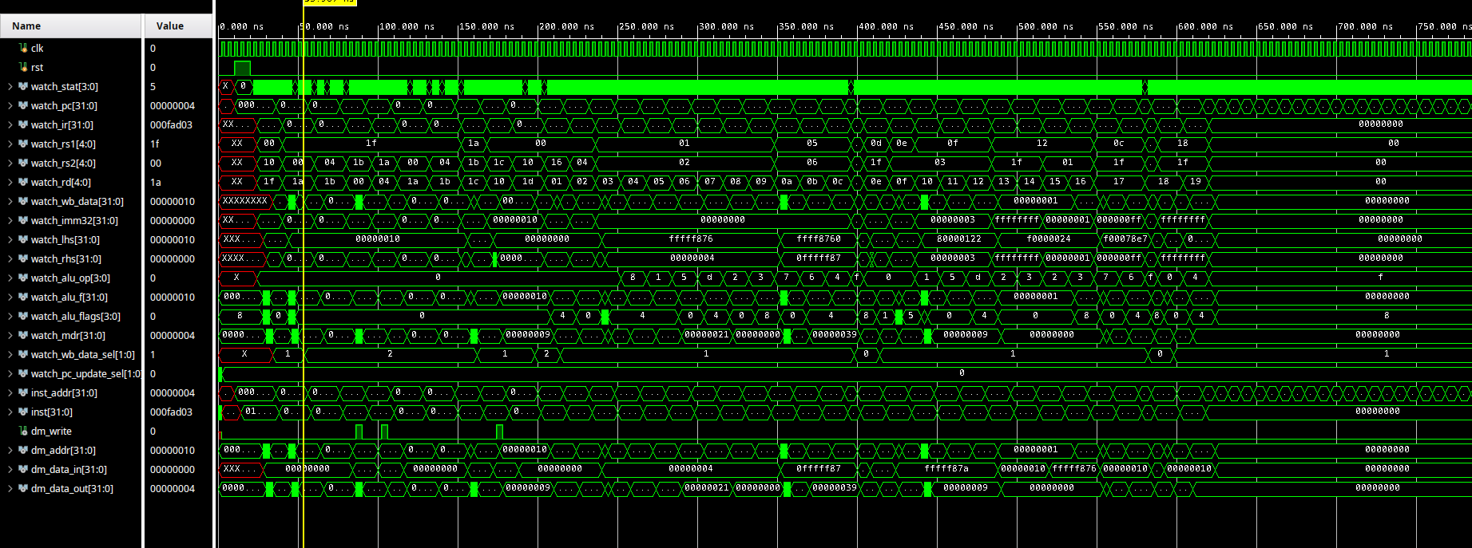

1. 板级实验操作说明

由上图可知，仿真波形基本符合实验要求

1. 板级实验结果记录

（以表格形式展现，具体见教材上实验结果记录表）

|  |  |  |  |  |  |  |  |
| --- | --- | --- | --- | --- | --- | --- | --- |
| 序号 | pc | ir | 汇编代码 | 执行结果 | clk数 | w_data | mdr |
| 00 | 00 | 0100_0f93 | addi x31,x0,16 | x31=0x0000_0010 | 4 | 0x0000_0010 |  |
| 01 | 04 | 000f_ad03 | lw x26,0(x31) | x26=DM[0x10] | 5 | 0x0000_0004 | 0x0000_0004 |
| 02 | 08 | 004f_ad83 | lw x27,4(x31) | x27=DM[0x14] | 5 | 0x0000_0005 | 0x0000_0005 |
| 03 | 0C | 01bf_a023 | sw x27,0(x31) | DM[0x10]=x27 | 4 |  |  |
| 04 | 10 | 01af_a223 | sw x26,4(x31) | DM[0x14]=x26 | 4 |  |  |
| 05 | 14 | 000f_ad03 | lw x26,0(x31) | x26=DM[0x10] | 5 | 0x0000_0005 | 0x0000_0005 |
| 06 | 18 | 004f_ad83 | lw x27,4(x31) | x27=DM[0x14] | 5 | 0x0000_0004 | 0x0000_0004 |
| 07 | 1C | 01bd_0e33 | add x28,x26,x27 | x28=x26+x27 | 4 | 0x0000_0009 |  |
| 08 | 20 | 01c0_2823 | sw x28,16(x0) | DM[0x10]=x28 | 4 |  |  |
| 09 | 24 | 0100_2e83 | lw x29,16(x0) | x29=DM[0x10] | 5 | 0x0000_0009 | 0x0000_0009 |
| 10 | 28 | 8760_0093 | addi x1,x0,-0x78A | x1=0xFFFF_F876 | 4 | 0xFFFF_F876 |  |
| 11 | 2C | 0040_0113 | addi x2,x0,4 | x2=0x0000_0004 | 4 | 0x0000_0004 |  |
| 12 | 30 | 0020_81b3 | add x3,x1,x2 | x3=0xFFFF_F87A | 4 | 0xFFFF_F87A |  |
| 13 | 34 | 4020_8233 | sub x4,x1,x2 | x4=0xFFFF_F872 | 4 | 0xFFFF_F872 |  |
| 14 | 38 | 0020_92b3 | sll x5,x1,x2 | x5=0xFFFF_8760 | 4 | 0xFFFF_8760 |  |
| 15 | 3C | 0020_d333 | srl x6,x1,x2 | x6=0x0FFF_FF87 | 4 | 0x0FFF_FF87 |  |
| 16 | 40 | 4020_d3b3 | sra x7,x1,x2 | x7=0xFFFF_FF87 | 4 | 0xFFFF_FF87 |  |
| 17 | 44 | 0020_a433 | slt x8,x1,x2 | x8=0x0000_0001 | 4 | 0x0000_0001 |  |
| 18 | 48 | 0020_b4b3 | sltu x9,x1,x2 | x9=0x0000_0000 | 4 | 0x0000_0000 |  |
| 19 | 4C | 0062_f533 | and x10,x5,x6 | x10=0x0FFF_8700 | 4 | 0x0FFF_8700 |  |
| 20 | 50 | 0062_e5b3 | or x11,x5,x6 | x11=0xFFFF_FFE7 | 4 | 0xFFFF_FFE7 |  |
| 21 | 54 | 0062_c633 | xor x12,x5,x6 | x12=0xF000_78E7 | 4 | 0xF000_78E7 |  |
| 22 | 58 | 8000_06b7 | lui x13,0x80000 | x13=0x8000_0000 | 2 | 0x8000_0000 |  |
| 23 | 5C | fff6_8713 | addi x14,x13,-1 | x14=0x7FFF_FFFF | 4 | 0x7FFF_FFFF |  |
| 24 | 60 | 1237_0793 | addi x15,x14,0x123 | x15=0x8000_0122 | 4 | 0x8000_0122 |  |
| 25 | 64 | 0037_9813 | slli x16,x15,3 | x16=0x0000_0910 | 4 | 0x0000_0910 |  |
| 26 | 68 | 0037_d893 | srli x17,x15,3 | x17=0x1000_0024 | 4 | 0x1000_0024 |  |
| 27 | 6C | 4037_d913 | srai x18,x15,3 | x18=0xF000_0024 | 4 | 0xF000_0024 |  |
| 28 | 70 | fff9_2993 | slti x19,x18,-1 | x19=0x0000_0001 | 4 | 0x0000_0001 |  |
| 29 | 74 | fff9_3a13 | sltiu x20,x18,-1 | x20=0x0000_0001 | 4 | 0x0000_0001 |  |
| 30 | 78 | 0019_2a93 | slti x21,x18,1 | x21=0x0000_0001 | 4 | 0x0000_0001 |  |
| 31 | 7C | 0019_3b13 | sltiu x22,x18,1 | x22=0x0000_0000 | 4 | 0x0000_0000 |  |
| 32 | 80 | 0ff6_7b93 | andi x23,x12,0xFF | x23=0x0000_00E7 | 4 | 0x0000_00E7 |  |
| 33 | 84 | 0ff6_6b93 | ori x23,x12,0xFF | x23=0xF000_78FF | 4 | 0xF000_78FF |  |
| 34 | 88 | 0001_0c37 | lui x24,0x00010 | x24=0x0001_0000 | 2 | 0x0001_0000 |  |
| 35 | 8C | fffc_0c13 | andi x24,x24,-1 | x24=0x0000_FFFF | 4 | 0x0000_FFFF |  |
| 36 | 90 | fffc_4c93 | xori x25,x24,-1 | x25=0xFFFF_0000 | 4 | 0xFFFF_0000 |  |

1. 实验结果分析与结论

（分析实验结果，给出实验结论）

对于riu型指令的执行，上个实验已经验证了正确性。

对于ls型指令，对照预先存进dm的值可知，mdr和w_data没有问题说明ls型指令执行也是正确的。

# 五、思考与探索

（10分）

1. 问题与解决方案：

（整个实验过程中发生了什么问题？你是如何解决的。）

1. 数据存储器输入的地址数据始终为XXXX_XXXX无法访问数据: 发现是忘记assign addr = alu_f导致的

1. 思考题：

（力所能及，尝试实践或回答教材上的思考与探索题目，至少完成1道）

1. 是

3. 哈佛架构。在数据存储器的地址线加一个掩码装置使得把0x1000_0000~0x1000_00FF的地址空间映射到0x0~0xFF

# 六、实验心得体会、意见建议

（如果是小组合作，请给出具体分工、分别给出心得体会）

在这个实验中，我学习了如何设计一个基于RISC-V指令集架构的CPU，特别是关于访存指令的实现和数据存储的控制。通过实验，我了解了存储器和寄存器之间的数据传输过程，以及CPU如何解析和执行不同的指令。

在实验过程中，我遇到了一些挑战。例如，我需要仔细研究RISC-V指令集架构的细节和指令的含义，了解不同的指令格式和操作码。我还需要考虑如何在CPU中实现存储器的访问和数据传输，并解决可能出现的数据冲突和控制信号的生成问题，以确保CPU的正确性和高效性。

通过不断的尝试和调试，我最终成功地实现了LS型指令的CPU设计，并且验证了其正确性和可靠性。这个过程让我感受到了从无到有的设计过程，提高了我的设计和调试能力，并且让我更深入地了解了计算机组成原理的核心概念和基本原理。

总之，这个实验让我受益匪浅，深刻理解了计算机组成原理的基本概念和基本原理，增强了我的计算机系统设计和调试能力，为我的未来学习和职业发展打下了坚实的基础。