Solution to resonance convergence problem in HFSS with Qiskit metal code.
Tested in NYU-HPC computer (Legion computer in 934A of 370 Jay street building 9th floor) with 64 GB of DDR5 RAM.
Written by: Moeid Jamalzadeh.

Running HFSS simulation of a resonator chip in HFSS is tricky.
To have a good convergence of resonances and coupling quality factor, meshing needs to be setup properly close to the resonators.
A sample resonator chip with 8 quarter wavelength resonators (short-open ended) are shown in the figure below. The resonators are capacitively coupled to the feedline with distance of 10-15 μm (Q4 design).
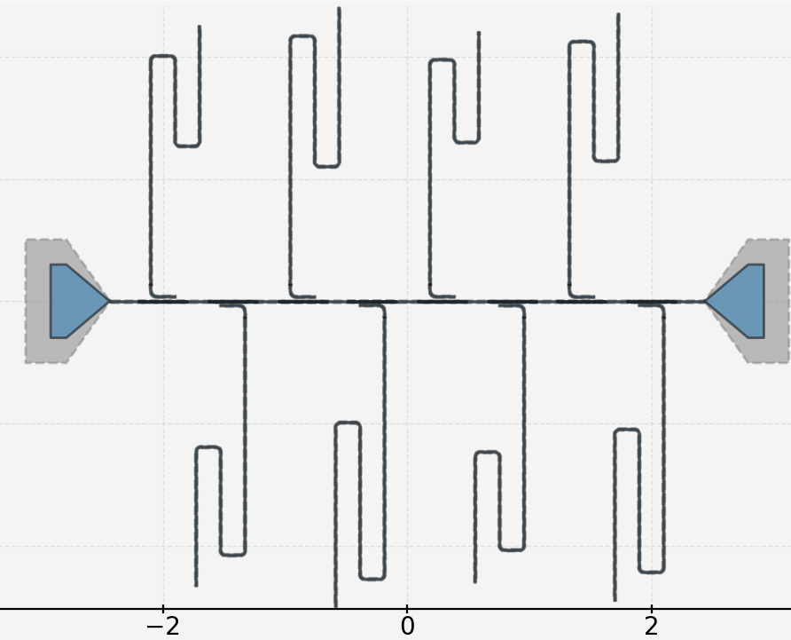

The figure below shows the meshing of this chip (270 μm silicon thickness, 800 μm thick of vacuum surrounding the chip) which results in proper convergence of the resonance frequencies and coupling quality factor of the chip. Most accurate part of the meshing is around the edges of the resonators.

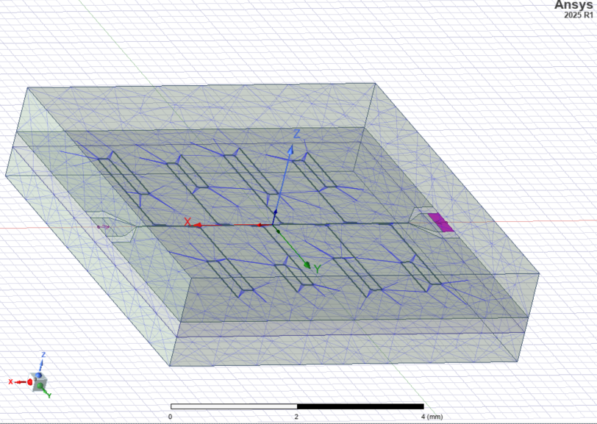

To achieve this meshing, follow the steps below.
- Remove any meshing scheme in the simulator. Qiskitmetal by default will add a Port-in mesh which concentrates the mesh around the ports on the launchpad (shown with purple in the figure above). If you do not want to include that meshing scheme in the beginning don’t run the cell below to not include the ports into your design. But that would stop you from running driven model simulations.

hfss_render.render_design(selection = [],
open_pins=[],
port_list=[('port_1','in', 50),('port_2', 'in', 50)],
box_plus_buffer = False)

- In the project manager tab in HFSS, right click on Mesh and click on Initial Mesh Settings

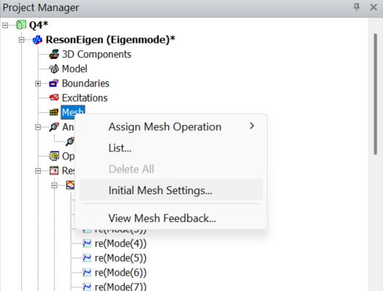

- In the opened window keep the Mesh method as is but for curved surface meshing change the resolution to Fine to increase the number of mesh blocks on the edges of the resonators.
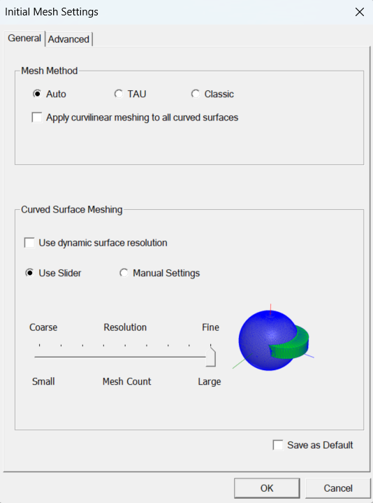

- In the Advanced tab of the Initial Mesh Setting, put a resolution at least 10 times smaller than your smallest feature. So, if your gap is 5 μm, put the resolution at maximum of 0.5 μm.

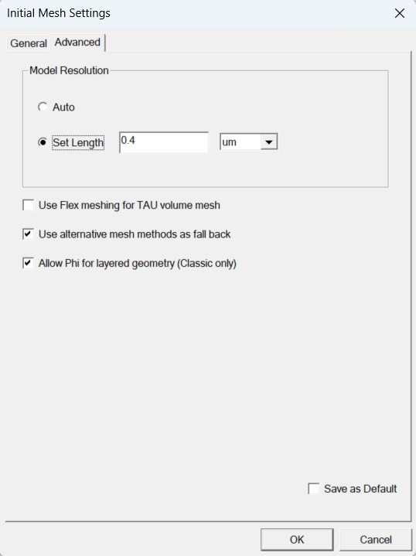

- Back in Project manager tab in HFSS, expand Analysis section and double click on Setup to open the eigenmode setting. In general settings follow the scheme below.
- For minimum frequency choose ~1 GHz lower than your expected first mode. In this example the minimum designed frequency was 5 GHz.
- For number of modes use two modes more than number of the resonators on the chip.
- For number of passes use a big number so the simulation converges before the finishing number. The simulation will either converge or crash. In the case of crash check if the result showed convergence and if it was converging take the data from the last run.
- For delta frequency I do not know what a good choice would be. Just use the default value.

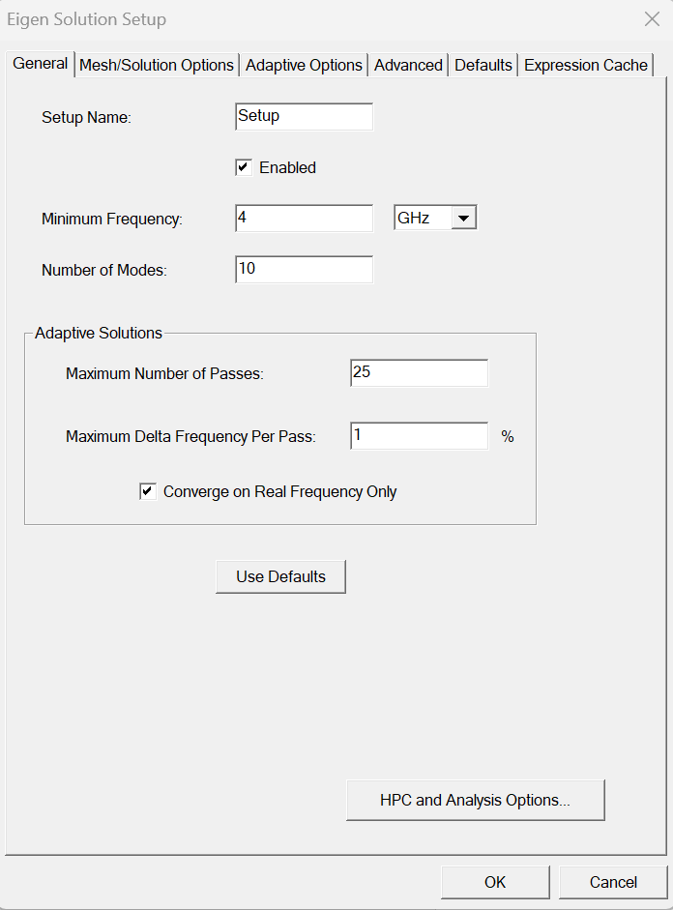
- Keep other tabs as default, you can just reduce the Adaptive Refinement Per Pass in Adaptive Options tab to less than 30% so it doesn’t make a significant change after each refinement. Increase it only in the case that the initial values are very off from predicted values. You can also increase the minimum number of passes and converged passes, so it does not converge in 1-2 steps.
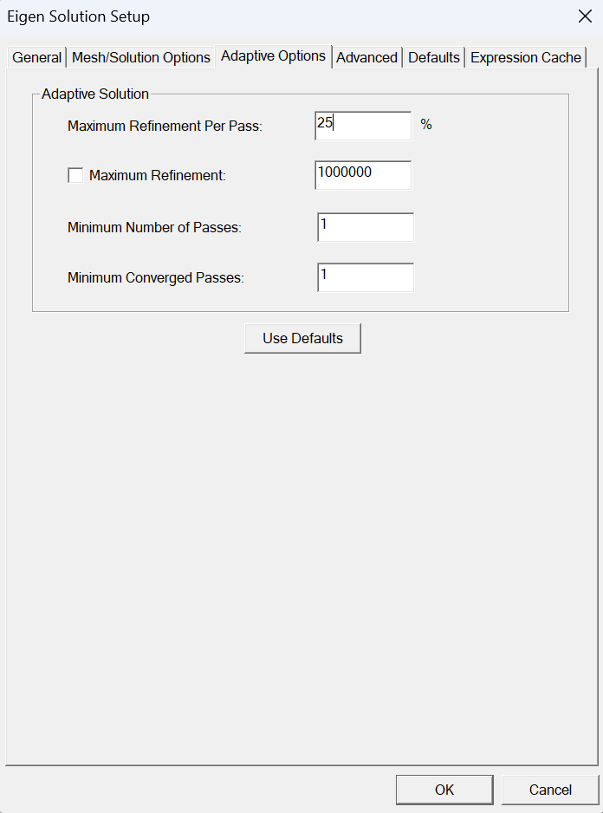
Here a saucerful example is shown that have converged after 16 passes.

Final results: (Right click on Results in Project Manager Solution data)
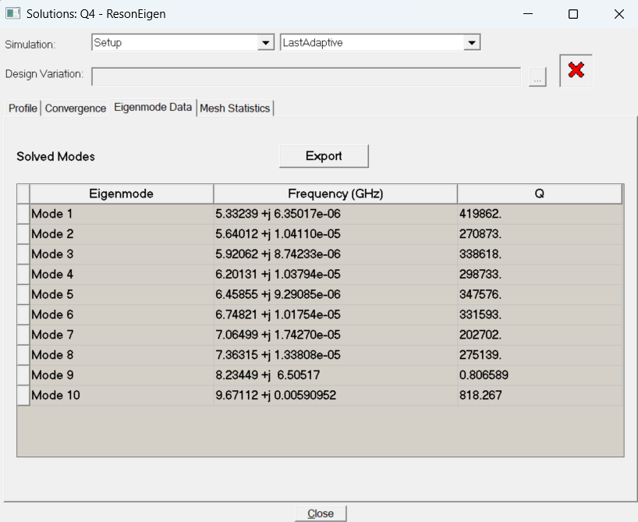
Eigenvalues (Resonance frequencies) and Eigen Q (Coupling Qaulity factors): Make sure to change the solution to Setup:AdaptivePass and change the primary Sweep to Pass and choose all the real modes in Eigen Modes for eigenvalues plot and all modes in Eigen Q for Eigen Q plot.
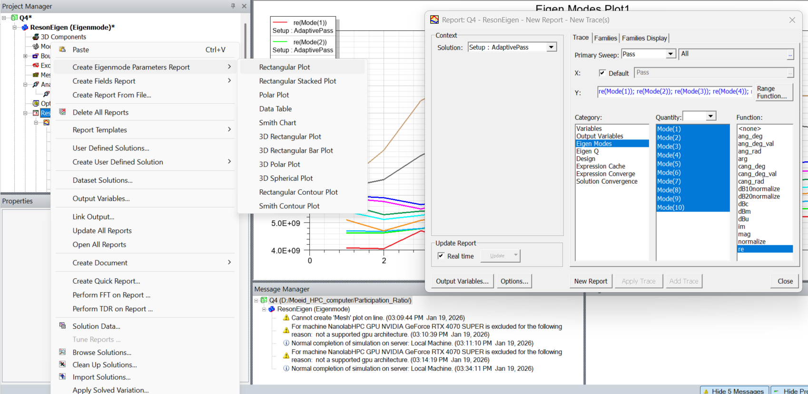

Sample example of successful Eigen modes (Mode 9 and 10 are not first mode of resonators).

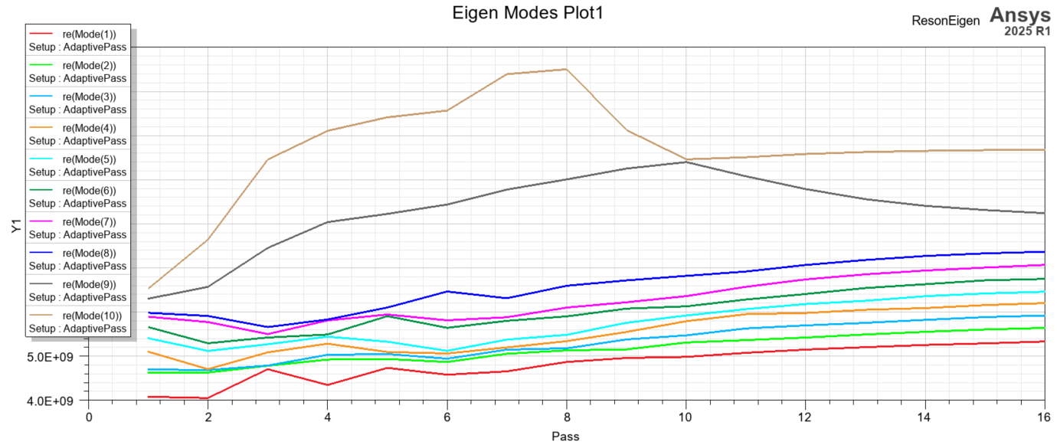

Sample example of successful Eigen Q simulations: To change the scale of Y-axis to logarithmic scale double click on the y-axis and in Y1-scaling tap change the Axis scaling to Log.
