Experiment #4 – Integrated System

Moein Karami,

810198540

# Frequency Multiplier

fin * 2n =fref / k 🡪 1 / Tin * 2n  = 1 / (Tref  * k) 🡪

done = 1

k = Tin / (Tref  * 2n)

* 1. *State Diagram of the Controller:*

rst = 0

adjust = 1

valid = 1

adjust = 0

Fin = 0

cnt_en = 1

Fin = 0

div_ld = 1

* 1. *Simulate results:*

In all of wave forms InFreq = 1MHz

Look at figures 1, 2 and 3.

# Exponential Accelerator

* 1. *Exponential Engine:*
     1. As you can see in figure 4 if we set
        + x = 0: answer will be 1
        + x = 1: answer will be e ~ 2.718
        + x = 0.5: answer will be e0.5 ~ 1.648
     2. As you can see in figure 4 maximum frequency of this accelerator is equal to 135.01MHz.
  2. *Exponential Accelerator Wrapper:*
     1. Exponential Accelerator Wrapper Controller State diagram:

ld = 1

ui_ld = 1

start = 1

start = 0

sh_en = 1

wr_req = 1

eng_start = 1

eng_done= 1

eng_start = 0

eng_start = 0

eng_done= 1

sh_en = 1

wr_req = 1

eng_start = 1

sh_en = 1

wr_req = 1

eng_start = 1

eng_done= 1

eng_start = 0

eng_start = 0

eng_done= 1

eng_start = 1

sh_en = 1

wr_req = 1

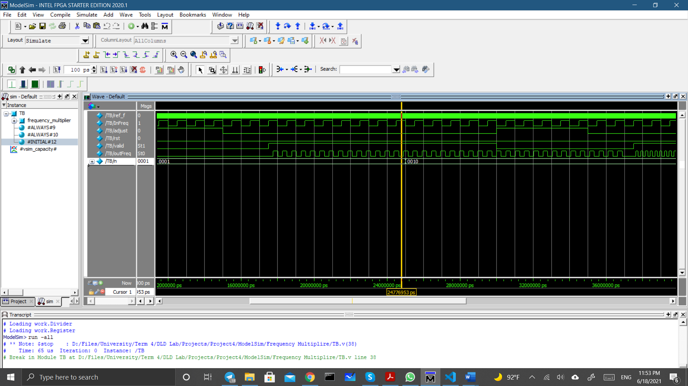

Fig. 1 n=1, outFreq frequency = 2MHz

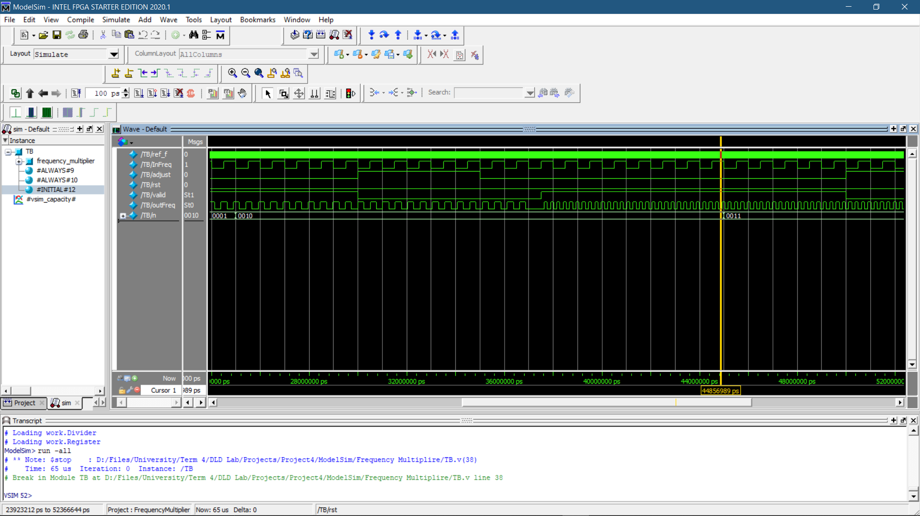

Fig. 2 n = 2, outFreq frequency = 4MHz

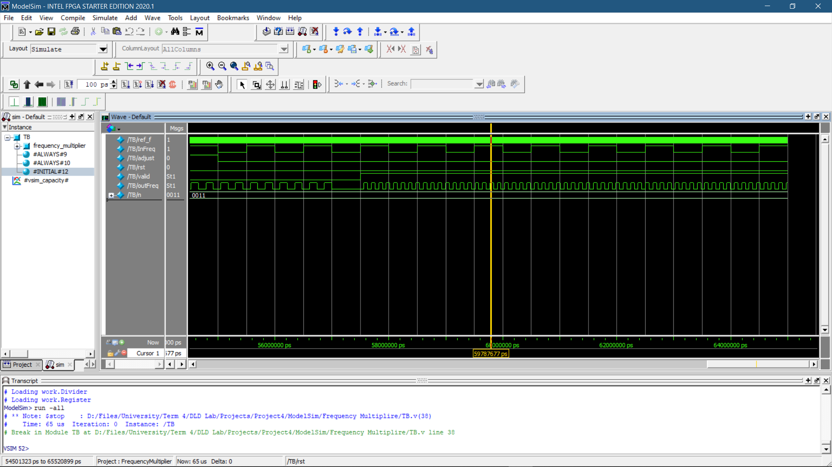

Fig. 3 n = 4, outFreq frequency = 8MHz

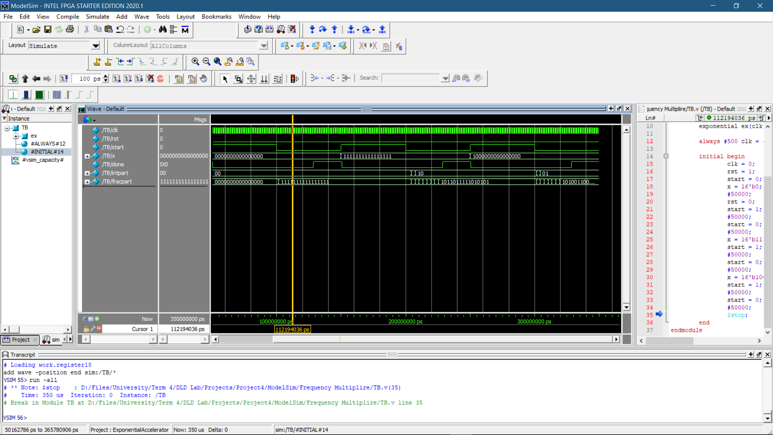

Fig. 4 simulate accelerator waveform

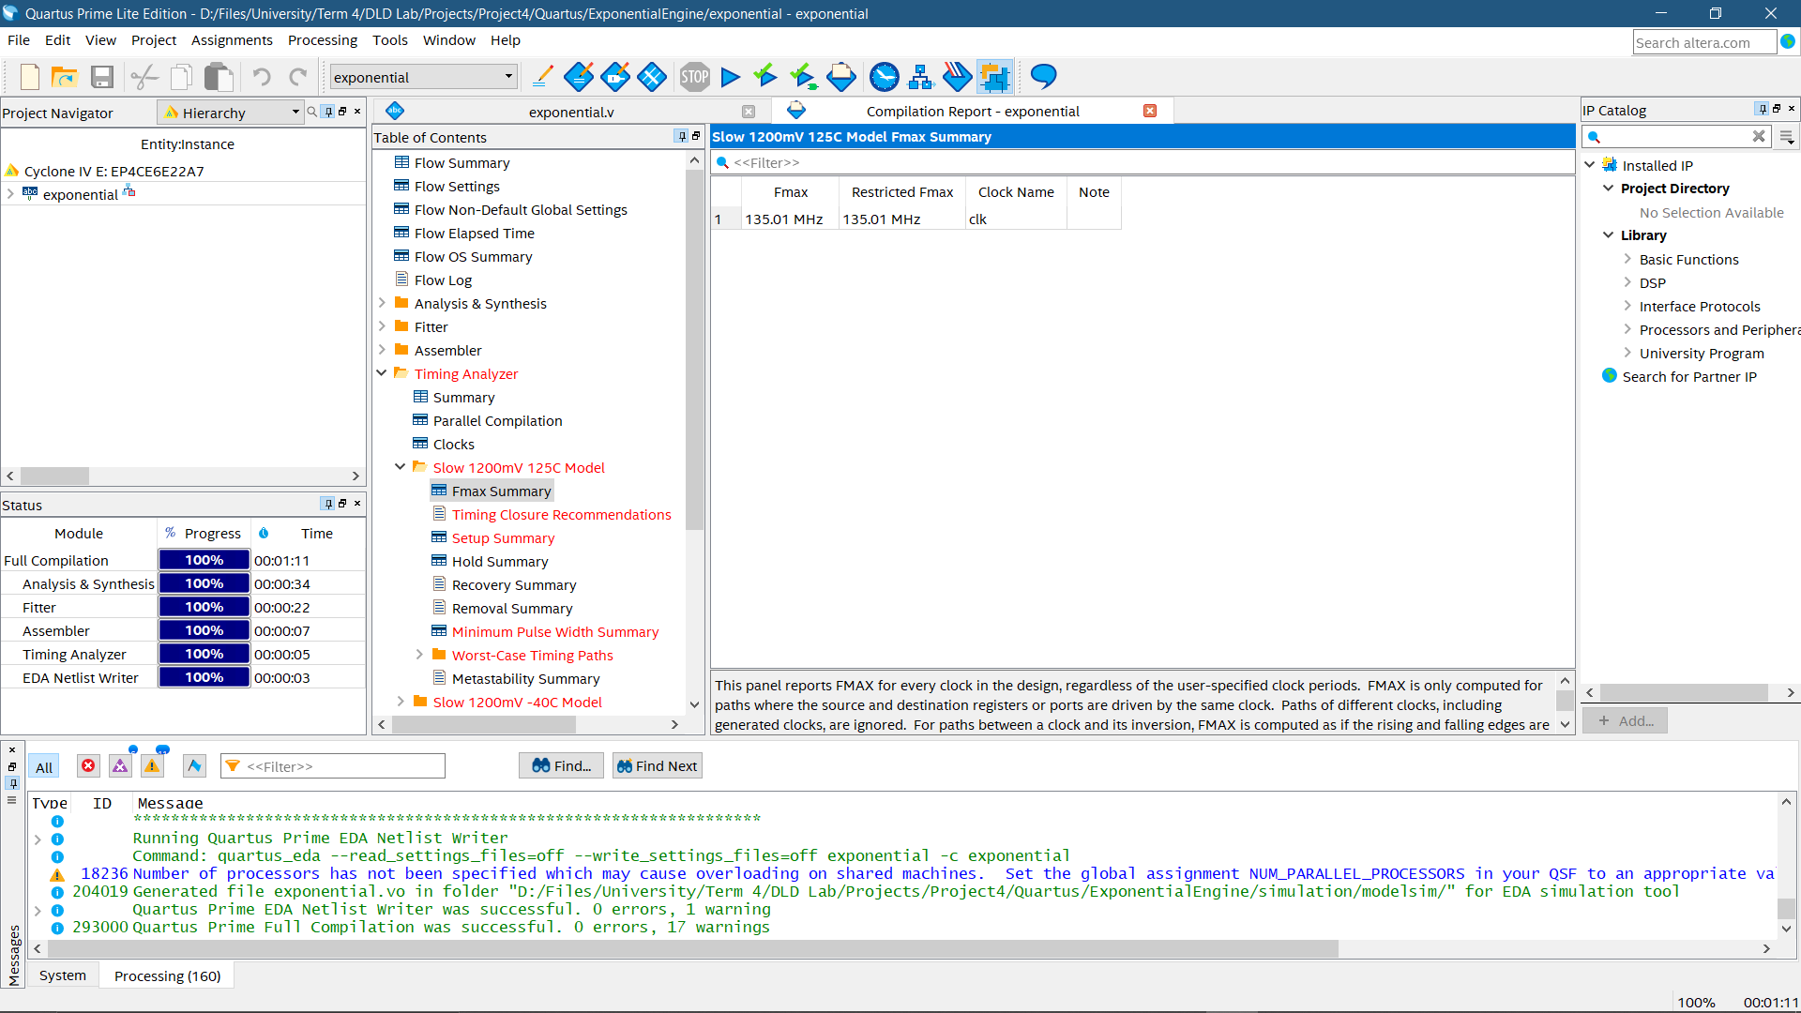

Fig. 5 Accelerator maximum frequency

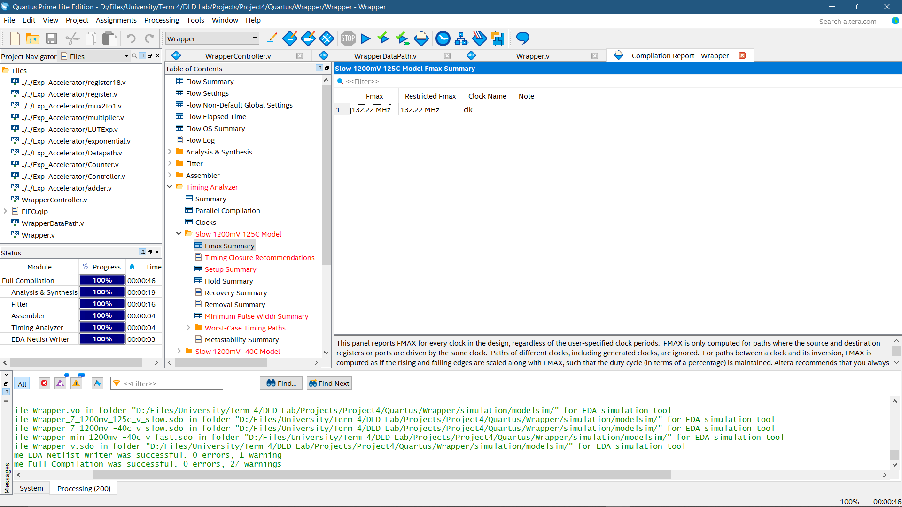

Fig. 6 Wrapper maximum frequency

2) According to figure 6 its maximum frequency = 132.22MH

# Integrated Circuit

* + 1. MultFactor <= 661 🡪 n <= 5