Experiment #1 - Clock and Periodic Signal Generation

Moein Karami,
810198540

Clock Generation using ICs and Analog Components

Ring Oscillator
Fig. 1 Output waveform
Fig. 2 Circuit simulated
    - Propagation Delay of the Chain: 18,67ns
    - Delay of a Single Inverter: 1.867ns
TABLE I
74hct04 Propagation Delays
  - LM555 Timer

Fig. 3 Output waveform
Fig. 4 Circuit

First of all we need to add a voltage power generator(V1) and connect it to GND and Vcc port to generate continuous rectangular pulse then we just need to calculate clock and duty cycle frequency using waveform.
    - Clock Frequency & Duty Cycle: 1.416KHz, 50.15%
    - Produce Different Clock Frequencies: Related waveform for each resistor shown below.
Fig. 5 R2 = 1Kohm
      - Clock frequency:
        - Expected: 0.693 * (3Kohm) * 10nF = 20.79us
        - Simulated result: 21.203us
      - Duty cycle:
        - Expected: 2/3 = 66.66%
        - Simulated result: 65.51%
Fig. 6 R2 = 10Kohm
      - Clock frequency:
        - Expected: 0.693 * (21Kohm) * 10nF = 145.53us
        - Simulated result: 146.90us
      - Duty cycle:
        - Expected: 11/21 = 52.38%
        - Simulated result: 51.95%
Fig. 7 R2 = 100Kohm
      - Clock frequency:
        - Expected: 0.693 * (201Kohm) * 10nF = 1.39293ms
        - Simulated result: 1.40446ms
      - Duty cycle:
        - Expected: 101 / 201 = 50.24%%
        - Simulated result: 49.92%
  - Schmitt Trigger Oscillator
    - Try Different Resistors: Related waveform for each resistor shown below.
Fig. 8 R = 470ohm
      - Clock frequency = 277.349KHz α = 1.3
Fig. 9 R = 1Kohm
      - Clock frequency = 139.532KHz α = 1.3
Fig. 10 R = 2.2Kohm
      - Clock frequency = 65.643KHz α = 1.4
    - α ~ 1.33

- FPGA Design
  - Simulated Ring Oscillator Frequency = 53.56MHz
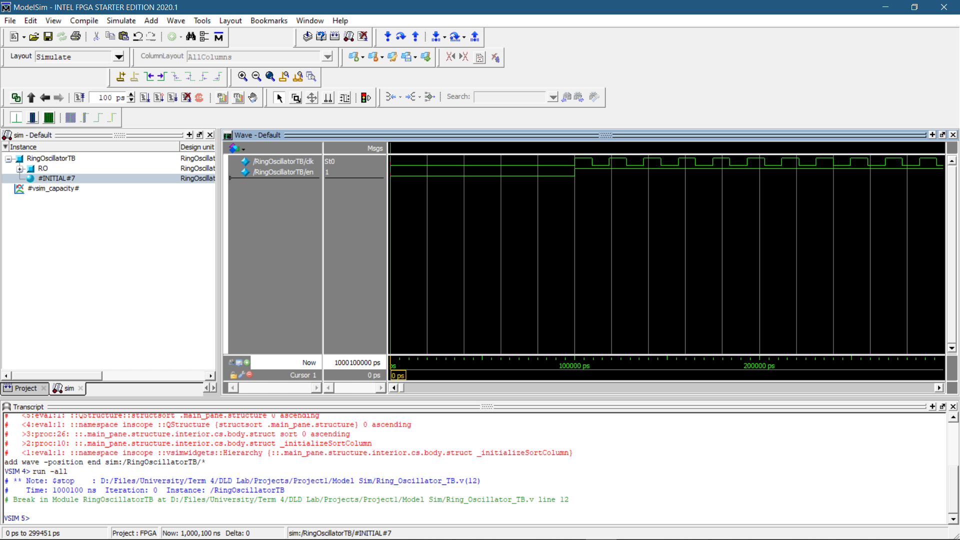
Fig. 11 Simulated waveform
  - New Frequency
New Frequency = 478.233KHz which is ring oscillator’s frequency / 112
  - T Flip-Flop
We should add JK Flip-Flop like Fig. 14.

- Baud Rate Generator for UART Serial Communication
  - Automatic Baud Rate Calculator
    - Controller state diagram has shown in Fig. 15
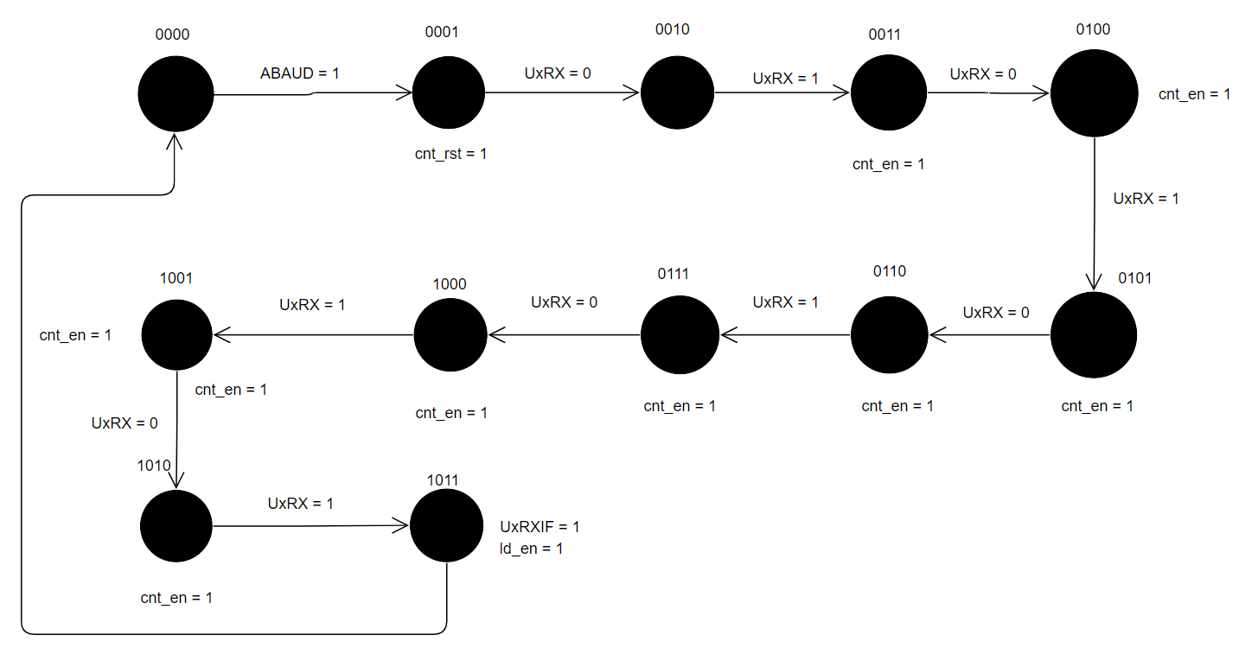
Fig. 15 State Diagram

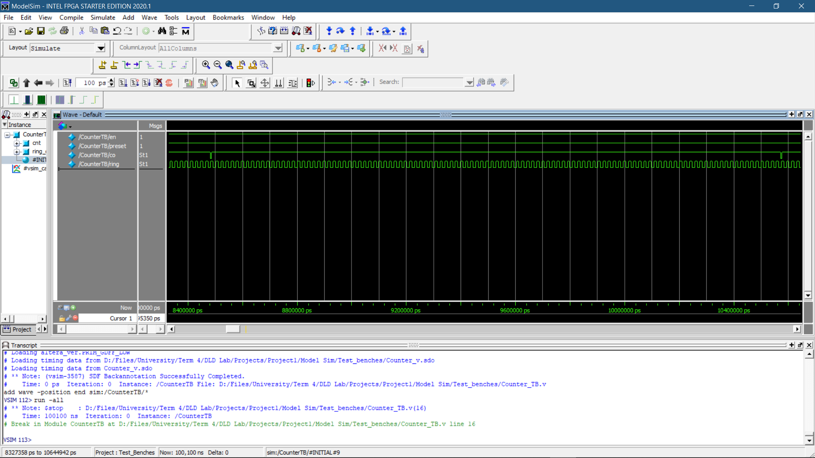

Fig. 12 MSB CO waveform
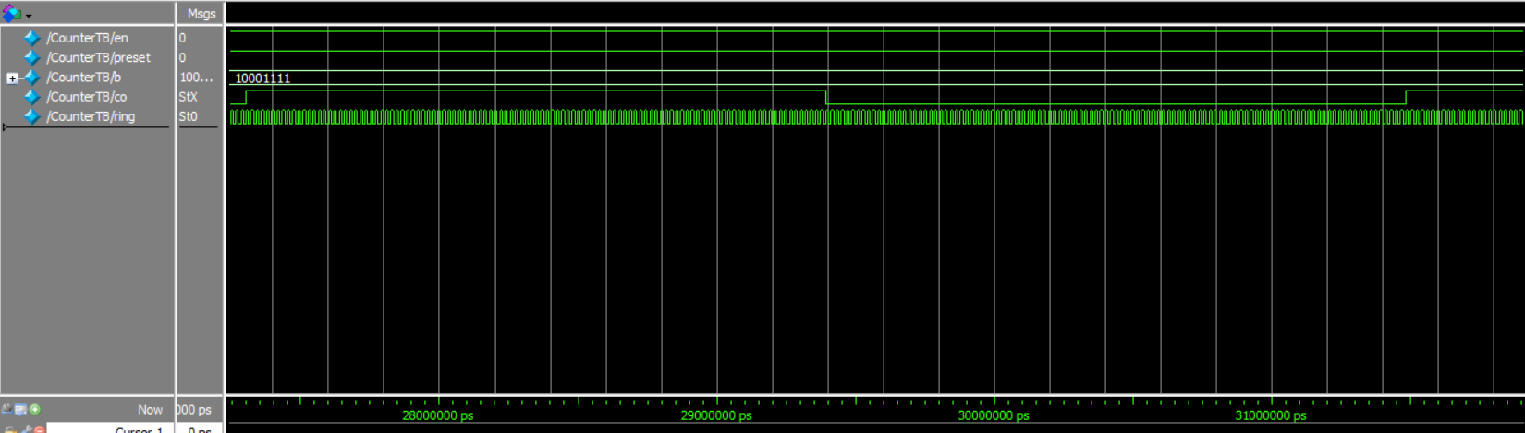
Fig. 13 New waveform after insert T Flip-Flop
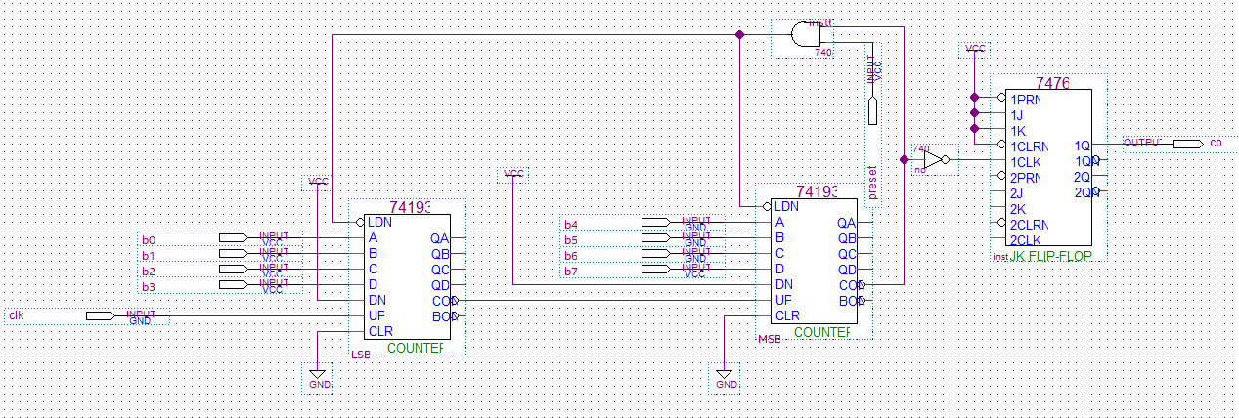
Fig. 14 Circuit after insert JK Flip-/flop
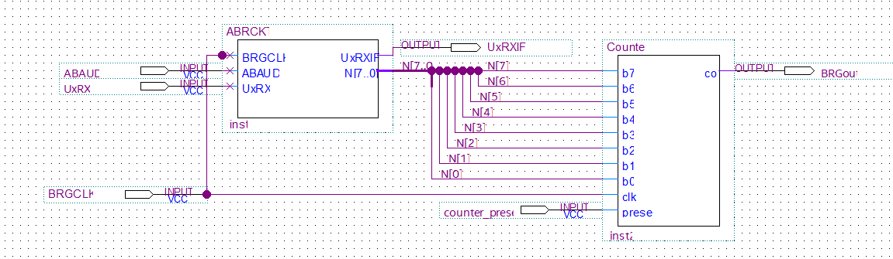
Fig. 15 Final BRGCKT schematic design
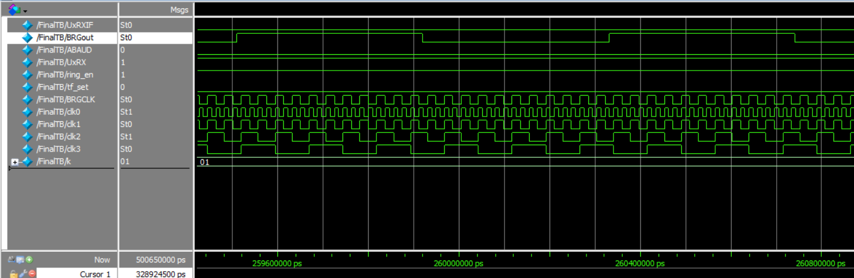
Fig. 16 BRGCKT test bench waveform
      - BRGout frequency = 1.21 MHz
      - BRGCLK = 53.56 MHz
Calculate expected fBaud frequency theoretically: k = 1, N = 11 fBaud = 53.56 * 10⁶ / (11 * 2¹ * 2 ) = 1.21MHz which is equal to BRGout frequency

