|  |
| --- |
|  |
| **Project Template** |
| Submitted for:   |  |  | | --- | --- | | Course: | CSC 426: Principles of Database Systems | | Section: | A | | Instructor: | Dr. Pierre Akiki | |
| Submitted by:   |  |  |  | | --- | --- | --- | | Student ID | Name | Major | | 20162542 | **Mohammad Diab** | **CCE** | |

**Project Description**

**A hospital management system (HMS) is a computer or web based system that acilitates managing the functioning of the hospital or any medical set up. The advancements in healthcare industry are not just confined to the quality medical care solutions but also to change the delivery system and patient experience as a whole. All the industries have understood the innate potential of automation and the results are quite optimistic. Online HMS is used to manage the functionality and events in the healthcare center. It offers modules for new and existing doctors, maintaining patient records, appointments, Etc. It is an integrated software application offering end-to-end web-based services to streamline HMS. The perks of digitalization are vast and most importantly it helps the environment. The initial steps have already been taken towards a paperless system. Still there is a lot of work that needs to be done to make the world a paperless place.**

I will start by explainaning how each entity is connected to each other. First of all, the hospital can have one to many laboratory where it contains the following attributes: ID, testavailable and components. Also, the hospital has many medicine where medicine contains: ID and Type. The hospital has many ambulance with a specific ID and arrival date. Also, the hospital contacts one pharmacy that have an ID, phone number, opening time, closing time. The hospital has many bankservices where many payment is made. The bankservices has ID, address, bank name as attributes and payment has ID,Name, Description, Amount. Many payment is paid for many supplies where it contains ID, Quantity and Name.

The hospital hires many staff like doctor, nurse, receptionist. The doctor entity contains specialization and years of experience. Also, the nurse entity contains shift and the Receptionist has shits and floor number. The doctor can have many clinic. The clinc has an ID, address and phone number. Moreover, the nurse manages many room. The room has an ID,Number and Type. The receiptionist has many records where it contains ID, description, date. The staff and patient can have an account that has an Id, username, password and Email. The patient can reserves for many appointment where the patient has ID,Name and address.The appointment contains ID, date and HourMeeting. Also, the patient can have or not a diseases. The diseaes entity contains ID, Type and Symptoms. Finally, the patient must have an insurance that has an ID, Name and Validity**.**

**Enhanced Entity Relationship (EER) Model**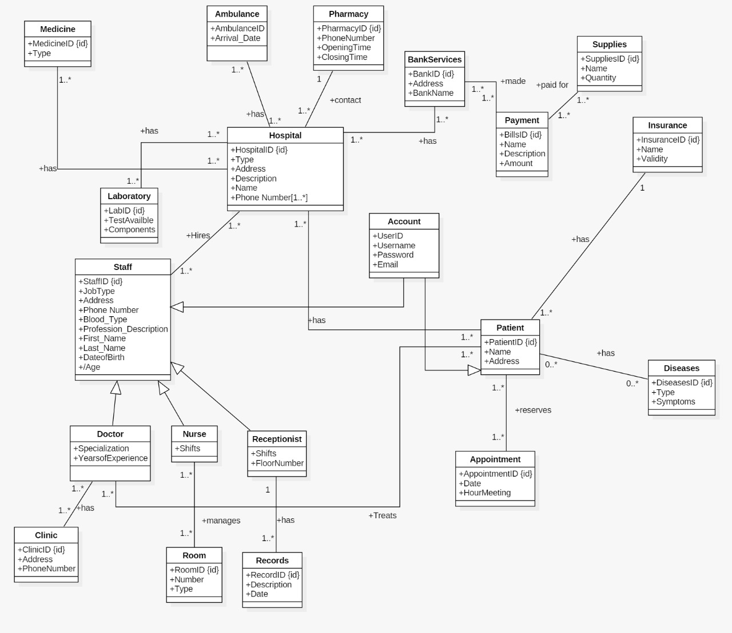

**Relational Model**



**Queries**

1. **Select address of all Nurses where their first name start with R**

select address from Staff

where StaffRole = 'Nurse' and First_Name like 'R%'

1. **Select the first name, last name, DOB of Doctors**

select First_Name,Last_Name,DOB from Staff

where StaffRole = 'Doctor'

1. **Select the patient name where doctor specialization is surgeon**

select Name from Patient

inner join Patient_Doctor as PD

On Patient.PatientID = PD.PatientID

inner join Staff

On PD.StaffID = Staff.StaffID

where Specialiaztion = 'Surgeon'

1. **List all hospital name where address is Beirut and Type is for Coronavirus**

select Name from Hospital

where Address ='Beirut'and Type = ' Coronavirus'

1. **Select the DOB and blood type of nurse where blood type is O positive**

Select Blood_Type, Age = Datediff(year, DOB,GETDATE()) from Staff

where Blood_Type = 'Positive'

1. **Select the name of the hospital that start with S and has a Lab test of Corona**

Select Name from Hospital

inner join Laboratory as L

On Hospital.HospitalID = L.TestAvailable

where TestAvailable = 'Corona'

1. **List all from patient that has reserved for appointment on 02/02/2020**

select * from Patient

inner join Appointment_Patient as AP

On Patient.PatientID = AP.PatientID

inner join Appointment

On AP.AppID = Appointment.AppID

where [Date] = '02/02/2020'

1. Select all the Patient name that has malaria symptoms

select * from Patient

inner join Patient_Diseases as PD

On Patient.PatientID = PD.PatientID

inner join Diseases

On PD.DiseasesID = Diseases.DiseasesID

where Symptoms = 'Malaria'

1. **List all the patient that has an insurance validity > 2020**

select * from Patient

inner join Insurance

On Patient.InsuranceID = Insurance.InsuranceID

where Insurance.Validity > '01/01/2020'

1. **List all the name of sterelizers in supplies that has a quantity 7**

select name from Supplies

where name = 'Sterilizers' and Quantity = '7'