Digital Design 2
Dr. Mohammed Shalan
Project 1 Report: Logic Circuit Schematic Beautifier
Group: Mohammed R. Anany and Ahmed A. Agiza

Outline:
The application receives a netlist as input, parses it into components and wires, applies Sugiyama's algorithm on it, and produces a graphical representation of the circuit.

Technology Used:
- Node.js framework for the back-end.
- Express.js application framework.
- Joint.js graphing library.

Design and Implementation:

Models:
The implementation of the system depended on the existence of three main models:
- Components
- Parser
- GraphBuilder

The Component model is capable of holding information relating to gates and connections. It currently supports a good number of gates and is designed in such a way that extending it won't be difficult (maintainable). As for the wiring, it is capable of detecting whether it is an input port, an output port, or a connection between gates. The model also features a debugging facility which notifies the user of flying wires that may exist in the input netlist, trims it, and the warning are sent to the console view tab on the browser.

The Parser model is the one that takes an an input the netlist. It is capable of detecting many key elements in the file such as gates, wires, buses, parameters (with dot notation), and assign statements as well. The parser supports receiving a simple standard cell library and use it for parsing the components. After parsing the content, it returns with the parsed gates, wires, and any possible warnings or errors that were detected while parsing. The following is a screen shot of the array of gates produced:
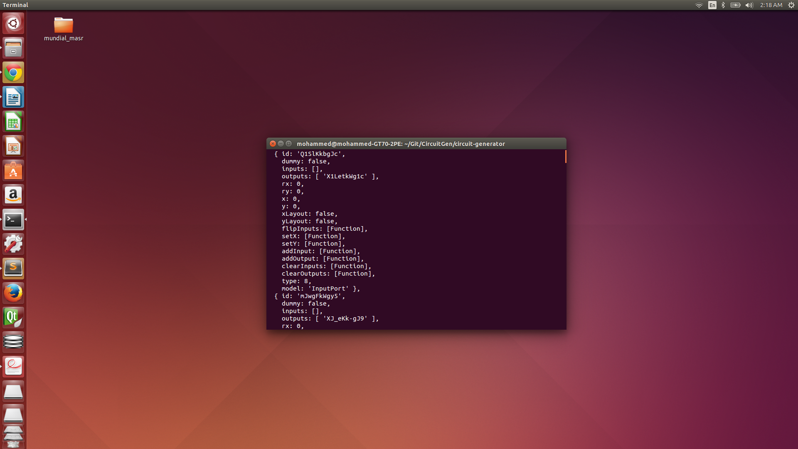

The GraphBuilder model is responsible for handling the positioning of the gates in the graph. It applies Sugiyama's algorithm which is broken down into a few steps. First, a directed graph is constructed, which involves reversing any existing cycles (Berger-Shor Algorithm), then the nodes are assigned into layers (Longest Path Layering). The graph is then properly layered by adding dummy nodes. The next step is to reduce the number of crossings between the edges (Barycenter Layer-by-Layer Sweep). Absolute values are then assigned to the gates' coordinates making it ready for plotting. Details for this step are provided at the end of the report. The following is a screen shot showing the relative and absolute values for the coordinates of the gates:
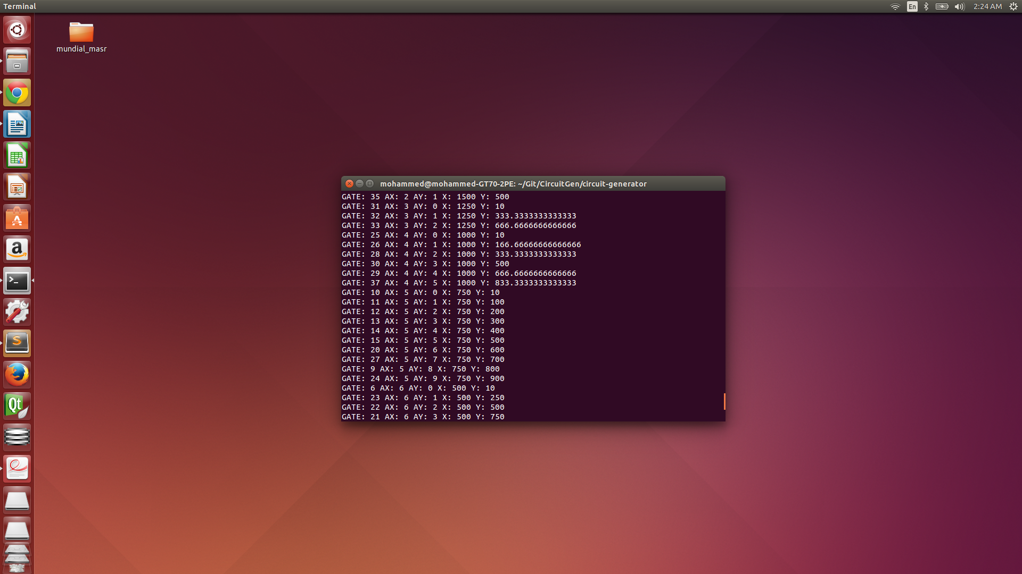

Application Interface:
Upon opening the application the user is prompted to upload the desired netlist file and custom standard cell if needed.
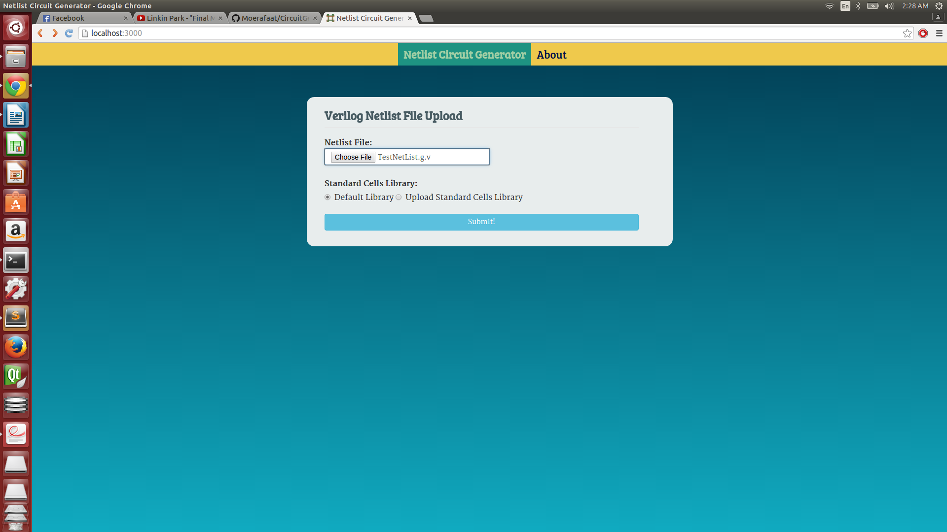

After uploading and processing the file(s), the user is then directed to another URL where the interface is divided into 3 main windows: The Verilog text viewer, the console, and the circuit. The editor looks like the following:
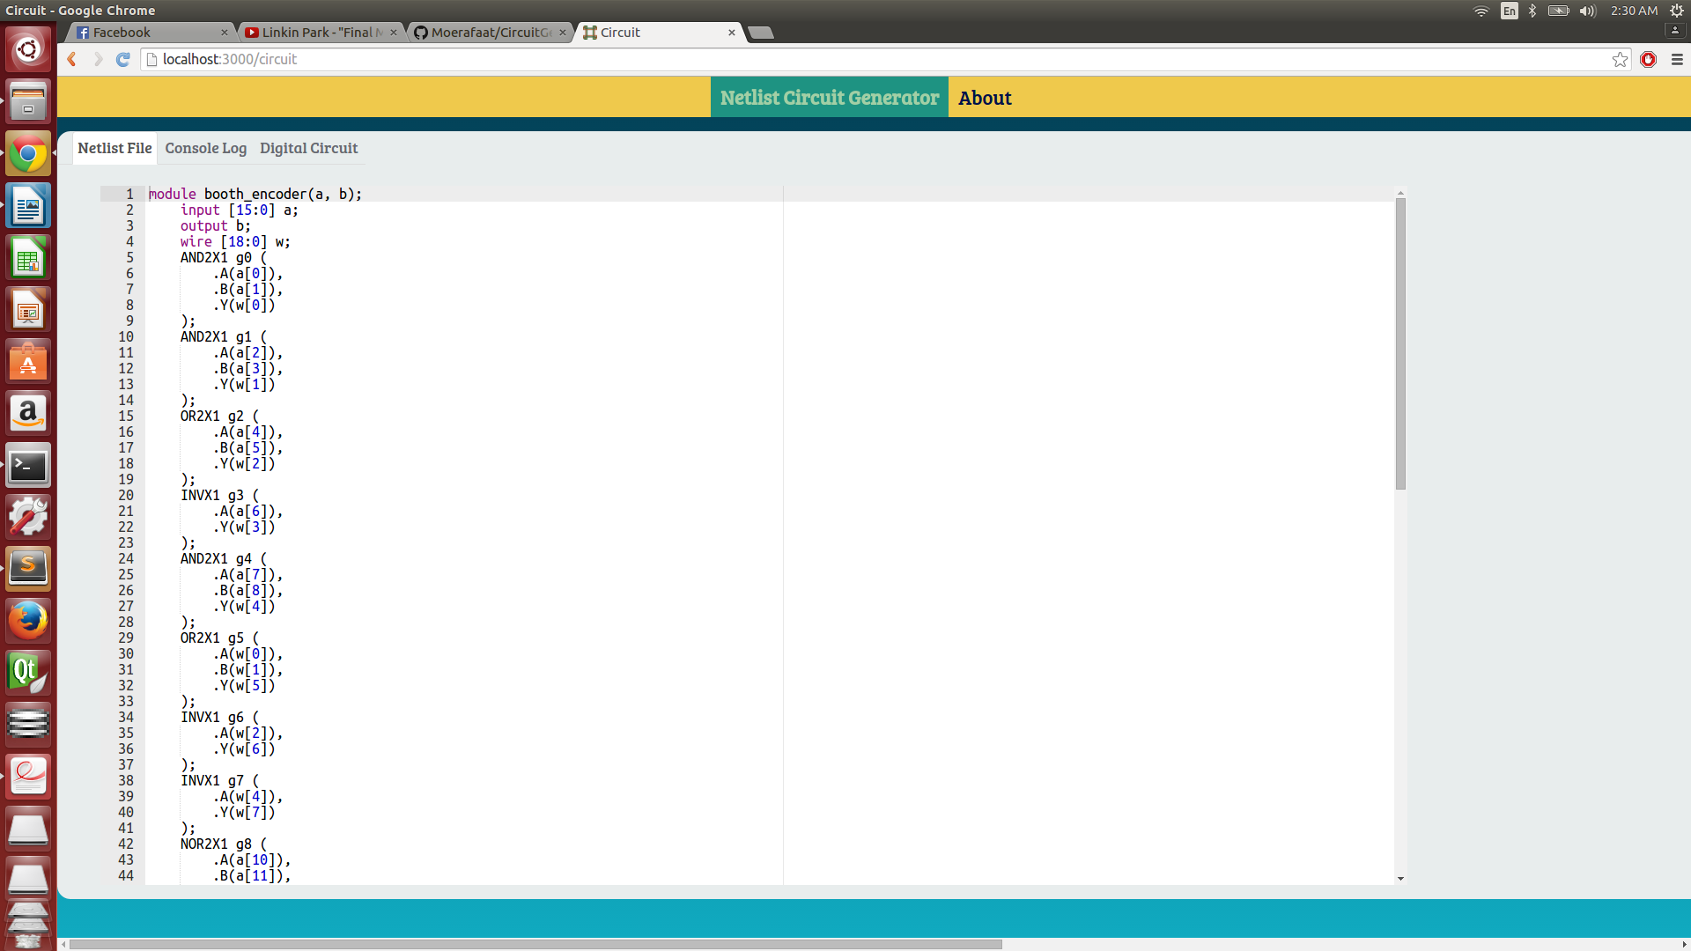
The console looks like this:
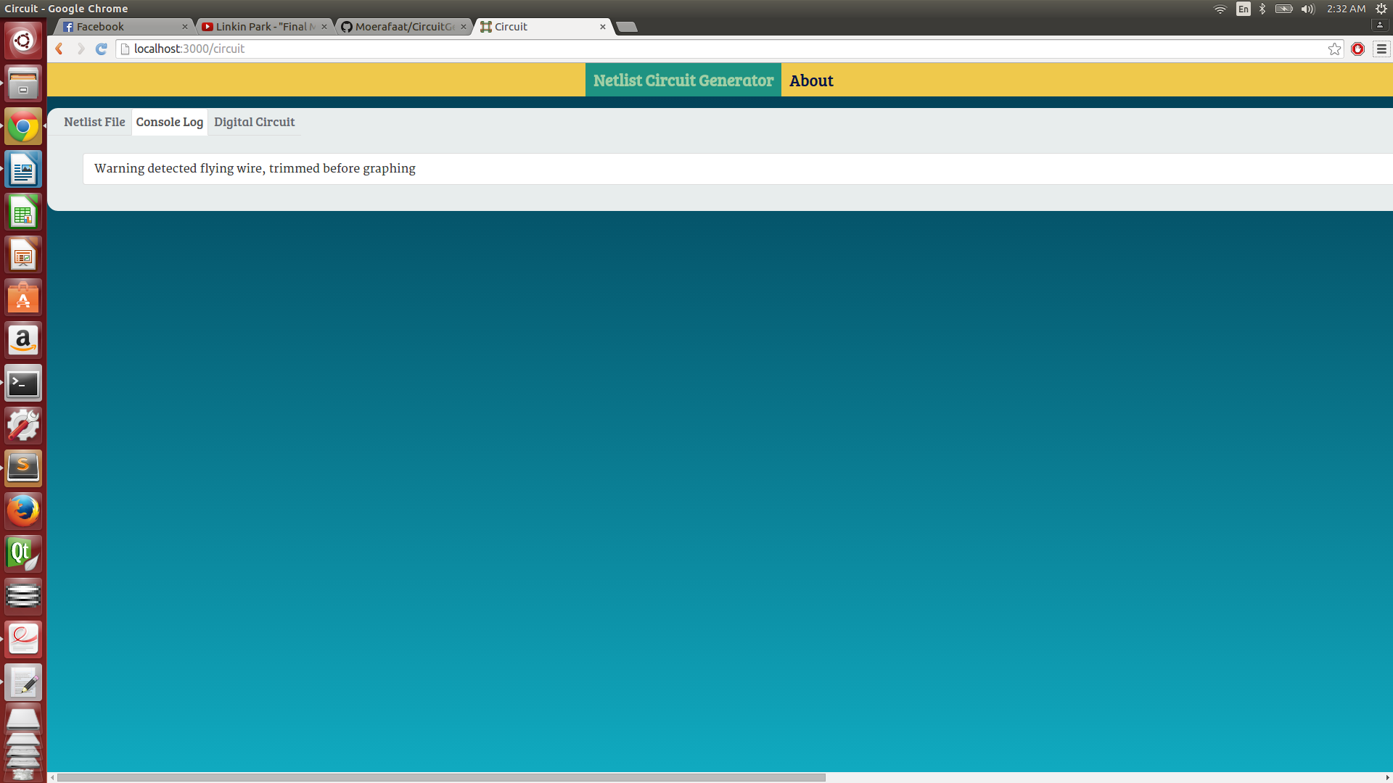

After the GraphBuilder specifies the location of the elements in the graph the returned data is then taken as input to the module responsible for graphing it using Joint.js. The following is a screen shot of a circuit after it has gone through all the stages up to the graphing:
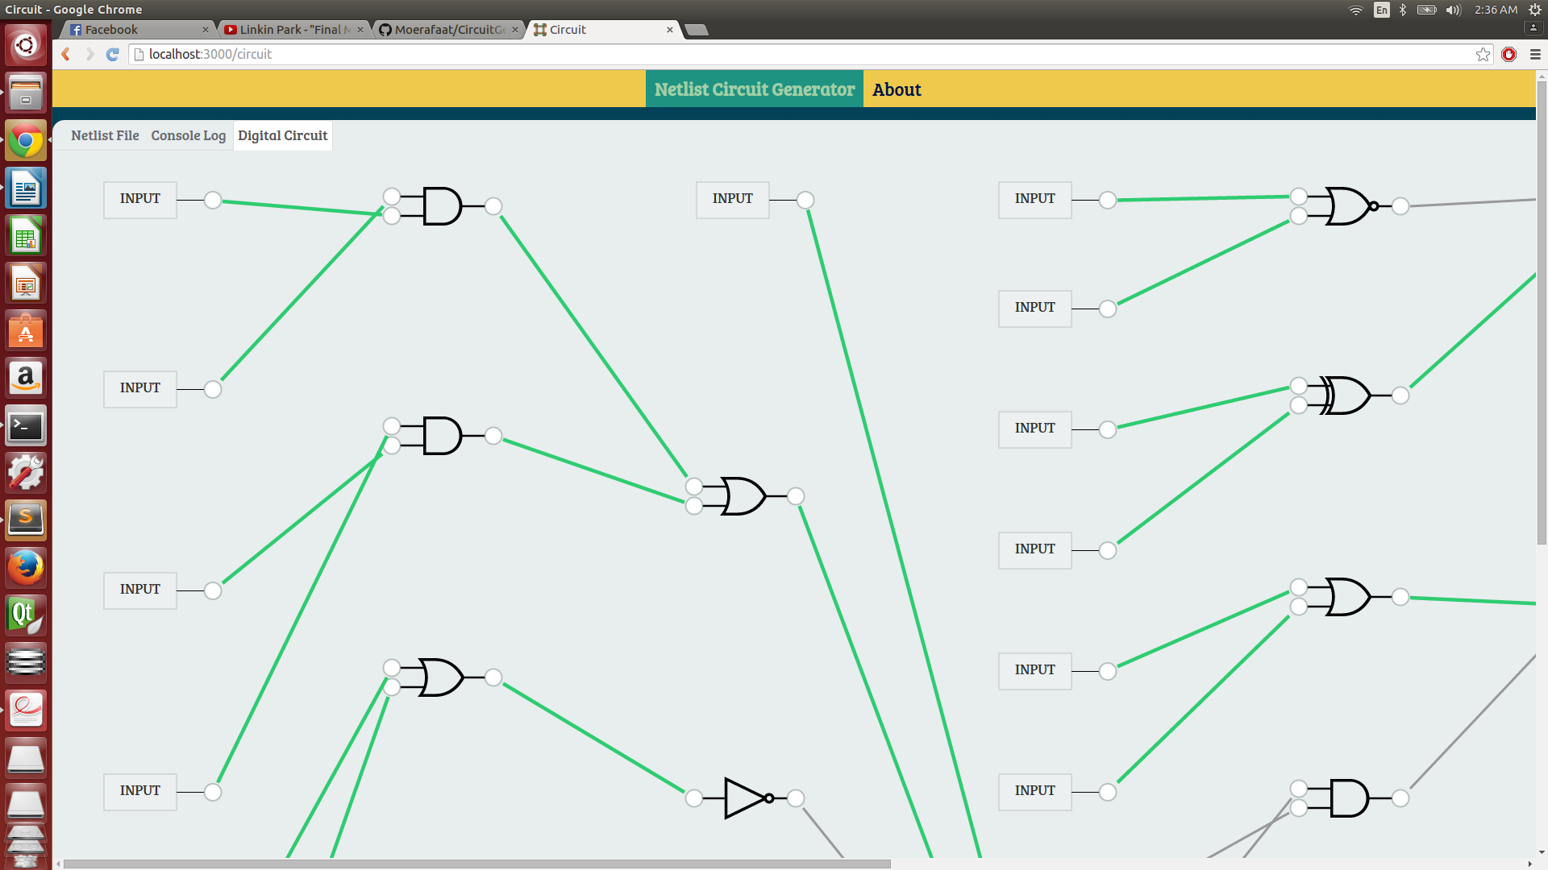

Testing Strategy:
For testing, we used an incremental approach. Each part was first tested alone. The parser was run separately from the rest of the application using multiple netlists that we wrote. The graphing library was tested using hard-coded data initially to see how the graphing elements will look. The sorting and placement algorithms were also testing initially with hard-coded graph data structures. Once each element was working separately, we combined the parser and the algorithms, then we check to see if the output is still correct. We then wired up the graphing library to the output of the algorithms stage. The User Interface was gradually introduced while the application was being developed.

Algorithmic Approach to a Layered Graph

Input: The input for this stage will be an array of Gate objects that will be used to construct a directed acyclic graph (DAG) representing the circuit that is to be generated.

Expected output: The output of this stage should be a layout for the graph that is to be drawn such that:
- The graph is organized in layers where all edges are going from top to bottom (or left to right).
- Edge crossing is minimized.
- The layers are not too wide.
- The height of the graph is reasonable.

The approach that I will be using is following the methodology of Sugiyama, which involves the following:
- Removing existing cycles by reversing the direction of some edges in the graph.
- Assigning vertices to layers using a heuristic approach.
- Introducing dummy vertices between 2 nodes that are not on 2 consecutive layers.
- Reducing the crossings among the edges by permuting the order of each layer.
- Remove the dummy nodes and replace them with edge bends.
- Reduce the number of bends by readjusting the position of vertices on each layer.

The hierarchical approach consists of 3-4 main steps:
- Layer assignment: each vertex is assigned a horizontal layer, its y-coordinate.
- Crossing reduction: the vertices within a layer are ordered to reduce edge crossings.
- Horizontal coordinate assignment: each vertex is assigned an x-coordinate such that we distribute the vertices uniformly and reduce the number of edge bends. If the graph has cycles an extra step is required:
- Cycle removal: As few edges as possible are reversed to achieve an acyclic graph. At the end of the algorithm the reversed edges are restored again to maintain the original orientation.

Most of these steps are NP-complete, and so a variety of heuristics will be used. For each of these main steps there are multiple ways to achieve the task. Listed below are the alternatives for each stage:

Cycle Removal
- Fast Heuristic.
- Enhanced Greedy Heuristic.

Layering Assignment:
- Longest path layering.
- Layering to minimize width (Coffman-Graham-Layering).
- Minimize number of dummy vertices.

Crossing Reduction (Layer-by-Layer Sweep is going to be applied for all):
- Sorting Method (Adjacent-Exchange / Split).
- Barycenter Method.
- Median Method.
- Integer Programming Method: Exact Algorithm.

Horizontal Coordinate Assignment
- Depends on how the graph is going to be laid out.

The combination that I will implement to achieve the layout:
- For the Cycles removal stage, I will be using the Berger-Shor algorithm to reverse any cycles that I have to create an acyclic directed graph.
- For the layering assignment, I will use the Longest Path Layering which minimizes the height of the graph.
- For the Crossing Reduction, I will use an averaging method (Barycenter or Median) and use the Layer-by-Layer approach (in which we will solve the two-layer crossing problem for each pair of adjacent layers.
- The Horizontal Coordinate Assignment step is still to be determined.

Reasons for the chosen approaches:
- The Berger-Shor algorithm was chosen because it performs in a polynomial complexity as opposed to other heuristics. It is also a greedy approach to the problem which is always favorable.
- The Longest Path Layering algorithm was chosen because it performs in a linear time complexity, however the graph tends to be very wide at the bottom.
- For the Crossing reduction I chose an averaging method because this is the most commonly used approach to the problem and is shown to yield better results.
- The horizontal coordinate assignment step depends on the layout of the graph (absolute references).

