**Specifications**

**Nixie-tube thermometer**

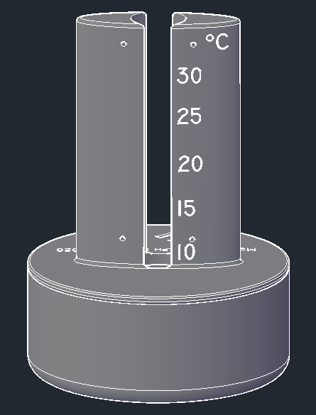

* The nixie-tube thermometer needs an input voltage of 5V DC through a USB-connector. This connector will be connected to the Arduino nano. This is the only input voltage the thermometer needs.

The nixie-tube will need 150 V but this will be generated within the PCB.

* The current power consumption will vary depending on the temperature. At the lowest the thermometer uses 0,6W and at its peak it will use 1,7W. The thermometer uses +/- 0,9W at 20°C.
* The dimensions are 160mm x 160mm x 220mm. The weight will be around 0,600 kg. The case is printed with a 3D printer in black PLA plastic.
* The range of the temperature is between 10°C and 30°C. The RGB leds have no special use except for the backlighting.
* Warnings:
  + Don’t open the case when it is operating and only use the thermometer when mounted inside the supplied case.
  + Don’t use the thermometer outside because it is not waterproof.
  + Don’t use the thermometer near water for example, near a bath tub. Also the thermometer should be kept out of direct sunlight.
* Caution:
  + Only qualified users can open the case and repair the PCB or replace the nixie-tube. The 150V generated by the thermometer can be a potential danger.
* There will be a 6 months warranty. When there is something broken after shipment, it will be replaced for free.