**User manual**

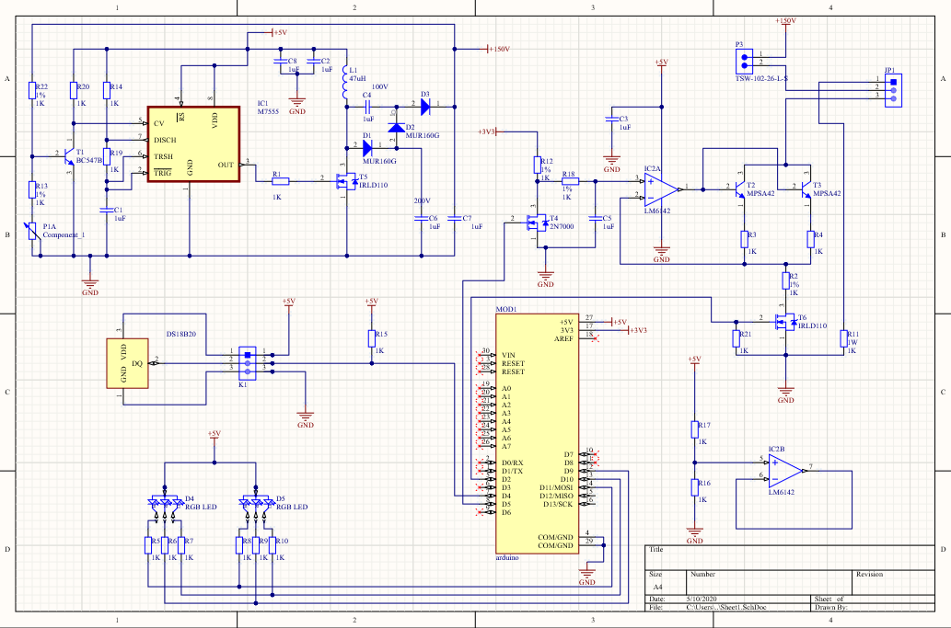

The nixie-thermometer will display the temperature on a nixie-tube. Depending on the temperature, it will heat up and give off an orange glow. A temperature sensor will collect data and transmit it to the Arduino. This data is viewed and analyzed by the Arduino Nano. Next the Arduino will calculate what voltage must be applied to the nixie tube. As the voltage increases, the orange glow will rise.

A number of LEDs will also be connected, these serve purely for decoration. To make sure the color of the RGB LEDs is visible on the outside, there are holes in de lateral aspects of the case. The LED’s will give a nice effect on the outside of the housing.

The nixie-thermometer is very simple to use. You only have to plug the USB-cable in the Arduino and plug the USB-cable into your computer or a USB socket. The Arduino is pre-programmed so there is nothing else you have to do.

It will take a few minutes for the temperature sensor to be correctly. After a few minutes the nixie-thermometer will be operational.

If the nixie-thermometer is active, don’t touch the tube. This can be very hot and you can get burns.

When choosing a place for the thermometer you will have to take into account the temperature and air flow. Avoid, for example, placing your thermometer above an electric heater. This because the hot air will rise up and interfere with the thermometer’s reading.