Title :3D Hover Vehicle Simulator Game

Project Overview
Hover vehicle(Like Futuristic Bus with wing/jetpack) Simulator Game is a 3D computer graphics–based simulation where the user controls a hoverbike that can hover, move forward, and maneuver freely in a virtual environment.
The project focuses on 3D object modeling, transformations, camera control, keyboard interaction, and basic physics, implemented using OpenGL and C++.
Surroundings / Environment Design
The virtual world is designed to enhance the feeling of free flight and hovering:

Environment Elements

Flat land, city, or floating platforms like coins that increases points.

Obstacles : Floating rings.

The surroundings remain static, while the hoverbike moves dynamically through the scene, creating an immersive 3D experience.

Camera System
- Third-person camera follows the hoverbike from behind
- Camera smoothly updates position and angle based on movement
- Optional zoom-in / zoom-out using mouse or keys

Dynamic Interactive objects
- Hover Vehicle(Bus)
- Floating Platform and rings
- Coins

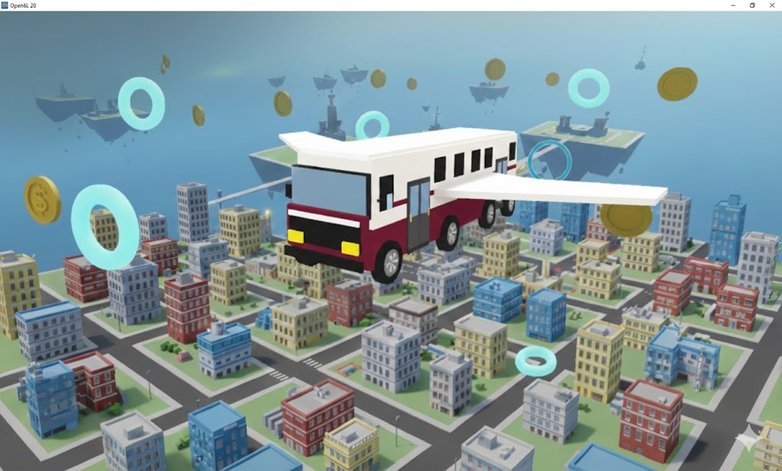
Visuals:

