

SYNBOT PROPOSAL
Your Business, Speaks Back to You.

PREPARED FOR
Premier Standard Industrial Limited

Date | April 2026
Classification | Confidential – Management Only
Prepared by | NeuroLayer Limited

Introduction — The SynBot
Premier Standard Industrial Limited has built something that most distribution businesses aspire to, a genuinely national footprint, with revenue flowing across all five branches in proportional balance, four active product lines serving established industrial accounts, and a customer base that orders on one of the shortest replenishment cycles in the sector. The commercial infrastructure is strong. The data is being collected. The relationships exist.
The challenge, as it is for most businesses operating at this pace, is not the absence of information, it is the speed at which that information reaches the people who need to act on it. In a distribution model where customers reorder every few days, where two or three days of missed stock coverage can mean a lost order, and where a single account going quiet for longer than usual could signal a shift in loyalty the cost of delayed awareness is measured in real money, every day.
SynBot is NeuroLayer's proprietary business intelligence platform, purpose-built to close this gap. It connects to your existing data environment, interprets your operational information continuously, and delivers structured, decision-ready intelligence to every level of your organisation through live dashboards, automated alerts, and a conversational interface that answers business questions in plain language, instantly. No complex navigation. No waiting for a report. No technical expertise required. Just ask.
The principle: SynBot does not replace the data your business already generates. It makes that data work harder surfacing the right insight, to the right person, at the right moment.

Executive Summary
Premier Standard Industrial Limited operates a high-frequency, high-value distribution model. Your customer accounts place repeat orders on very short cycles a just-in-time cadence that creates predictable, recurring revenue, but also demands near-perfect stock availability and proactive account management across all branches simultaneously.
A preliminary analysis of your transaction environment has already confirmed what most distribution businesses discover when they look closely: the data contains patterns that, if surfaced in real time, would change how decisions are made. Customer reorder behaviour follows identifiable cycles. Certain product sizes drive the majority of volume for most accounts. Seasonal demand peaks are consistent and predictable. Stock coverage ratios for specific SKUs can fall below supplier lead times before anyone notices not because the information isn't there, but because no system is watching continuously.
The business case for SynBot at Premier Standard is straightforward: the intelligence already exists within your data. The gap is in how quickly it reaches the people responsible for acting on it. SynBot closes that gap not by replacing your existing tools or processes, but by operating as the active intelligence layer above them.
Bottom Line: SynBot transforms the data your business already captures into a system of continuous awareness so that overdue accounts are flagged before they go elsewhere, critical stock positions are identified before they run out, and every decision is made with current, accurate information rather than last week's report.
The Intelligence Layer
Your existing systems already capture the data that drives your distribution operation: customer orders, stock movements, branch sales, product demand, and seasonal patterns. What they do not do is interpret that data in real time and present it as structured intelligence at the moment a decision needs to be made.
The result is a familiar operational pattern: risks are identified after they have already affected the business. A customer who hasn't ordered in longer than usual goes uncontacted until the sales team happens to notice or until the customer calls someone else. A product whose stock is running low against its replenishment lead time isn't flagged until a warehouse count reveals the shortfall. A branch that is tracking below its performance baseline appears in a monthly review, weeks after intervention was possible.
SynBot introduces an intelligence layer that sits between your data and your team. It continuously processes the information your business generates, identifies patterns and deviations, classifies risk, and delivers structured outputs to the right people, in the right format, at the right time. The system integrates with your existing data environment without disrupting current workflows, and is configured to reflect your specific business rules: your product lines, your customer accounts, your branch structure, and your operational thresholds. This means your team is no longer dependent on scheduled reports or manual checks. The intelligence is always current, always available, and always working even when your management team is focused elsewhere.
How it works: The system connects to your data. It learns your business. It monitors continuously. And when something requires attention, it ensures the right person knows before the window to act has closed.

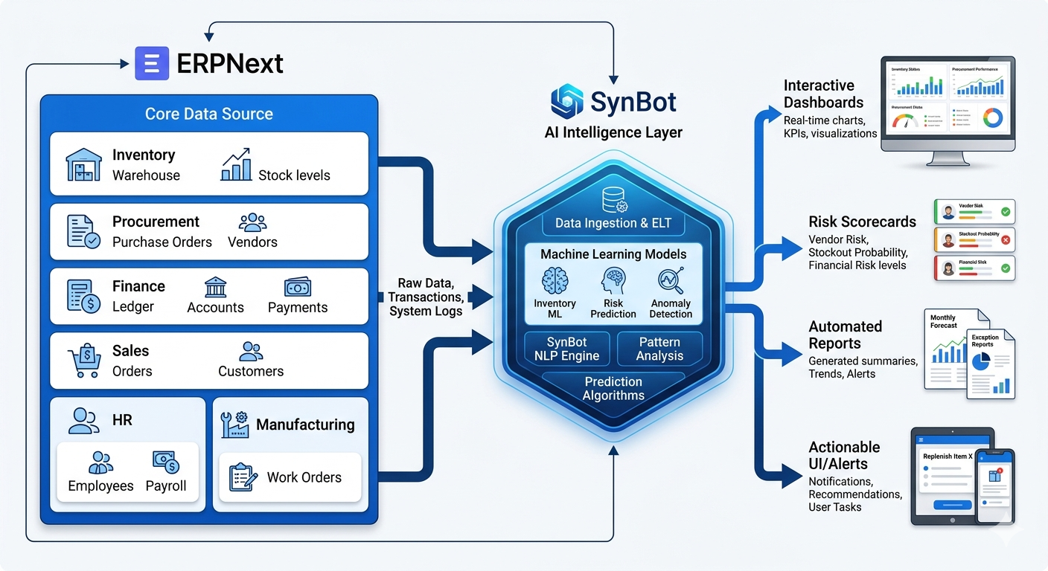
Fig.1 Integration Process.
Core Capabilities
SynBot is structured around four core capability areas, each designed to address a specific operational challenge faced by distribution businesses like Premier Standard Industrial Limited. Together, they create a complete intelligence infrastructure that spans inventory, customer relationships, branch performance, and executive oversight.
4.1 Inventory Risk Intelligence
Managing stock across multiple branches, multiple product lines, and a customer base that expects reliable fulfilment on very short reorder cycles creates a compounding availability challenge. A stockout at any one branch is not an inconvenience it is an immediate commercial event: a lost order, an opportunity for a competitor, and a signal to the customer that reliability cannot be guaranteed.
SynBot's inventory intelligence module continuously monitors stock positions across every SKU and every branch, comparing current coverage against supplier lead times and classifying each product into a live risk tier.

Four status levels are maintained at all times:
Status | Meaning
CRITICAL | Stock coverage has fallen below the supplier lead time. An order placed today may not arrive before stock is exhausted. Immediate procurement action is required.
WARNING | Coverage is sufficient for now but will breach the lead time threshold within a defined window. An order should be placed within the next 7 days.
MONITOR | Coverage is adequate but the product should be reviewed at the next procurement cycle, particularly ahead of known demand peaks.
ADEQUATE | No action required. Stock levels are healthy relative to current demand velocity and lead time.

For each SKU in CRITICAL or WARNING status, the system calculates and presents a recommended reorder quantity derived from demand velocity, lead time, and a safety buffer so that procurement decisions can be executed immediately without additional calculation. The live dashboard updates continuously as stock movements are recorded, ensuring that the risk classification is always current.
The system also accounts for size-level demand patterns. In a distribution portfolio where one or two size variants drive the majority of customer volume, SynBot applies appropriate weighting to reorder thresholds for high-velocity sizes ensuring the most commercially critical variants are always the most protected.

4.2 Customer Reorder Intelligence
In a distribution business where customers order on short, predictable cycles, the difference between a proactive sales team and a reactive one is measured directly in revenue. An account that places an order every three days represents a specific, recurring revenue event and when that cycle breaks, the business has a narrow window to respond before the customer looks elsewhere.
SynBot analyses the historical ordering behaviour of each customer account to establish individual reorder baselines. Using these baselines, the system maintains a live priority queue that tells your sales team exactly which accounts are approaching, at, or past their predicted order date ranked by urgency and weighted by average order value, so the highest-value accounts are always addressed first.
The customer intelligence view provides, for each account:
- Predicted next order date, calculated from individual reorder history
- Days until or since the predicted order surfacing overdue accounts immediately
- Average, minimum, and maximum order quantities by product and size
- Size preference profile showing which size variants the account orders most frequently
- Average order value enabling sales calls to be prioritised by commercial impact
- Pattern-break alerts flagging accounts whose behaviour deviates significantly from their baseline, which can indicate a churn risk requiring management-level engagement
This view is available every morning, updated from the latest order data, without any manual preparation. Account managers begin their day knowing who to call, in what order, and with what context so every customer conversation is purposeful, prepared, and focused on converting the interaction into a confirmed order.
Key principle: The goal is not to predict the exact day a customer will order. The goal is to ensure your team calls before the customer does — and this system makes that possible, every day, across every account.
4.3 Executive Chat Interface
SynBot introduces a conversational interface that gives every member of your team direct access to operational intelligence without navigation, without waiting, and without requiring technical skills. Any question about the current state of the business can be asked in plain language and answered immediately, drawing on live data.
The interface is role-sensitive by design:
Branch Managers — see performance data scoped to their own branch stock levels, customer activity, order trends, and branch-level comparisons against targets.
Account Managers — access customer-specific profiles, reorder predictions, size preference data, and order history everything needed to manage a relationship proactively.
Procurement Teams — query live inventory risk status, recommended reorder quantities, and supplier lead time positions all in a single question.
Managing Director — access consolidated cross-branch intelligence, revenue trend analysis, risk summaries, and strategic performance briefs presented conversationally, without requiring a scheduled report.
The conversational interface does not expose raw data. It interprets and presents it giving each user exactly the information relevant to their role and their current decision, in the clearest possible terms.

4.4 Seasonal Demand Planning
Distribution businesses that serve agricultural and industrial customers operate within well-established seasonal demand cycles. For Premier Standard's agro-allied product lines, these cycles are consistent and predictable certain months generate meaningfully higher order volumes than the annual average, and failing to anticipate them with adequate stock positions results in missed revenue that cannot be recovered.
SynBot analyses historical demand patterns by product, by size, and by branch to identify seasonal peaks and troughs. The system translates these patterns into forward-looking procurement recommendations alerting the supply chain team in advance of each peak period with specific stock-building guidance, so that inventory is in place before demand arrives rather than scrambled together as orders come in.
For Printing Ink and other product lines with different demand drivers, the same logic applies the system identifies the months that historically generate elevated order activity and ensures procurement planning reflects them.

Executive Operating System
At the centre of SynBot is what we refer to as the Executive Operating System the layer of the platform responsible for synthesising intelligence across all operational domains and presenting a unified view of the business to senior leadership.
For a Managing Director overseeing five branches, ten customer accounts, and four product lines simultaneously, the challenge is not access to information, it is the time required to consolidate it. Branch reports, sales team updates, warehouse checks, and financial summaries arrive through different channels at different times, and by the time a complete picture is assembled, the moment for intervention has often passed.
The Executive Operating System changes this. It continuously aggregates intelligence across every operational domain inventory, customer accounts, branch performance, seasonal demand, and financial indicators and presents a live, synthesised summary that gives senior leadership a complete and current view of the business at any time. No assembly required. No waiting for reports.
The Executive Operating System delivers:
- A live cross-branch performance view revenue, stock health, and customer activity across all five branches in a single consolidated dashboard
- Prioritized risk alerts the most urgent issues across inventory, accounts, and operations surfaced and ranked, so management attention goes where it is needed most
- Pattern-break escalations accounts or product lines whose behaviour deviates from established baselines, flagged automatically for management-level review
- Strategic performance summaries AI-generated daily briefings covering the state of the business, key risks, and recommended actions, produced without any manual compilation
- Scenario awareness the ability to ask forward-looking questions about the business and receive structured, data-grounded responses
This gives Premier Standard's Managing Director the operational clarity that is typically only available to businesses with large management teams and dedicated analysts delivered as a daily intelligence function, built into the platform.

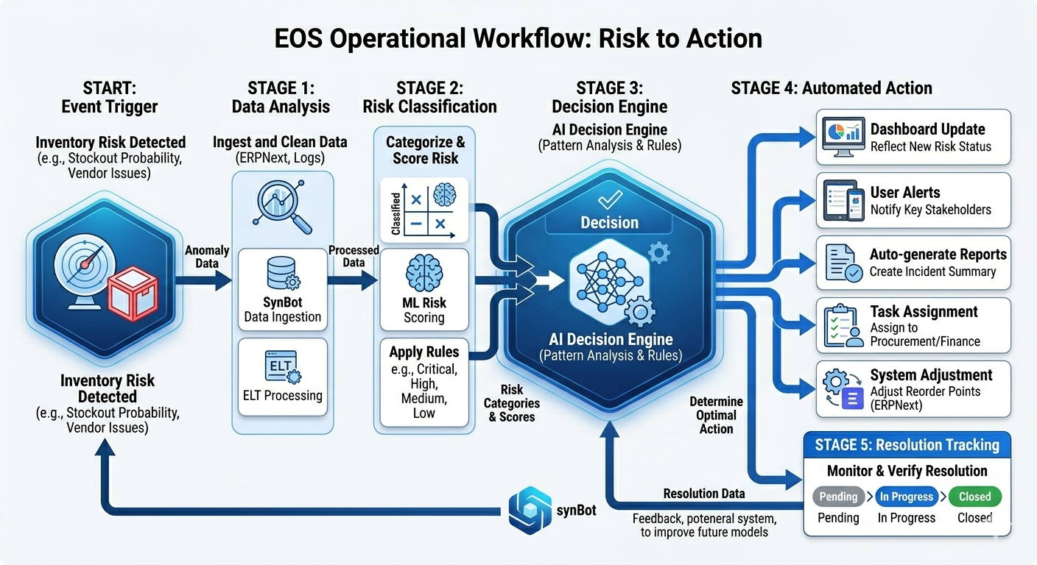
Figure. 2 – EOS workflow.
Customer Chat Interface — Always On. Always Answering.
Before a prospect picks up the phone, before a client sends an email, SynBot is already there. Embedded directly on your company website, SynBot's customer-facing chat assistant handles the first conversation so your sales team doesn't have to. Visitors can ask about your product range, available sizes, how to place an order, or how to establish a trading account at any hour, on any day, from any location.
The assistant is not a generic chatbot with scripted responses. It is built and trained on Premier Standard's own company information your products, your branches, your ordering process, and your brand. Every response reflects your business accurately and professionally, with no risk of inconsistency between channels.
Enquiries and leads captured through the customer interface are logged automatically and routed to the appropriate member of your team, with full context. No enquiry goes unrecorded. No lead is missed because someone was unavailable.

What the customer-facing interface delivers:
- Product and sizing enquiries answered instantly at any time of day
- Branch-level information surfaced for customers based on their location or need
- New client enquiries handled with consistent, brand-accurate responses
- Lead qualification and automatic routing to the appropriate account manager
- Prospect engagement maintained while your sales team focuses on active accounts
Think of it as your most consistent, tireless front-desk representative one that never misses a message, never gives a wrong answer, and always makes the right first impression on behalf of Premier Standard Industrial Limited.

What SynBot Delivers for Premier Standard Industrial Limited
The following table summarises the direct value SynBot brings to each dimension of Premier Standard's operation, mapped against the specific challenges a national multi-branch distribution business of this scale faces daily.
Capability | Value Delivered to Premier Standard
Inventory Risk Prevention | Continuous monitoring of stock coverage against lead times across every SKU and every branch. CRITICAL and WARNING alerts issued before a stockout can occur — so procurement acts in advance, not in reaction.
Proactive Account Management | A live, prioritised view of every customer account by urgency and value. Sales teams know who to call, in what order, and with what preparation — every morning, without manual work.
Churn Risk Detection | Accounts whose reorder behaviour breaks from their established pattern are automatically identified and escalated for management-level engagement, before the relationship is lost.
Seasonal Demand Readiness | Historical demand patterns translated into forward-looking procurement alerts, ensuring stock positions are built ahead of each seasonal peak — not scrambled together during it.
Branch Performance Visibility | Continuous monitoring of revenue and operational performance across all five branches. Deviations from expected performance are surfaced immediately, enabling timely investigation and response.
Volume Trend Awareness | Year-on-year and period-over-period order volume comparisons are maintained in real time. Declines are identified at account and product level before they compound into strategic-level revenue losses.
Natural Language Data Access | Any member of the team — in any role, at any branch — can ask a business question in plain language and receive an immediate, data-grounded answer. No technical skills required.
Executive Intelligence Briefing | The Managing Director receives a live, consolidated view of the entire business — cross-branch performance, risk status, customer activity, and key alerts — synthesised automatically without manual compilation.
24/7 Lead Capture | The customer-facing interface captures and qualifies enquiries around the clock, routing confirmed leads to the appropriate account manager with full context.
Operational Scalability | As Premier Standard grows — new branches, new accounts, new product lines — SynBot scales with the business. The intelligence layer is not a fixed report. It is a living system that evolves as the operation does.

Conclusion
Premier Standard Industrial Limited has built a distribution business of genuine national scale. The commercial infrastructure is proven. The customer relationships are established. The data is being generated, every day, across every branch, every account, and every product line.
The opportunity that SynBot represents is not about changing how Premier Standard operates. It is about giving the business the intelligence infrastructure it needs to operate at its full potential where stock risks are addressed before they become stockouts, where customer accounts are engaged before they go quiet, where seasonal demand peaks are prepared for rather than reacted to, and where senior leadership has a live, complete view of the business at all times.
In a market where distribution relationships are built on reliability and responsiveness, the businesses that win are the ones whose teams act with the most current, most accurate information. SynBot ensures that Premier Standard is always that business.
Every day, your data is generating the intelligence your team needs to make better decisions. SynBot makes sure that intelligence reaches them in time to act on it.
The SynBot promise: Your data is already telling you what to do. SynBot makes sure your team hears it first.

NeuroLayer Limited · SynBot · Confidential — Prepared exclusively for Premier Standard Industrial Limited · April 2026

