Lumina Creators App
System Architecture & Technical Plan
Prepared for developer review (Bill) • v2 finalized • Status: pre-development

This document is the finalized architecture for the Lumina Creators App, intended as the working reference to review together before development begins. It covers the product in brief, the full technology stack, the system architecture, our deployment and version-control plan, the data model, and the payout lifecycle. The final section lists the decisions still needed from the platform owner and the developer before we build.

1. Product in brief
Lumina Creators App is a closed, service-based UGC-creator platform operated by Lumina. It is NOT an open marketplace: only Lumina admins create campaigns, and brands are never users of the system (they book calls on the marketing site). There are two audiences and two campaign modes:
- Creators — sign up, complete a mandatory rich profile (demographics, social handles + follower counts, portfolio videos), browse campaigns, participate, and get paid on a CPM (per-1,000-views) basis.
- Admins (Lumina) — run a private, filterable creator database and a campaign builder that can launch unlimited unique campaigns.
- Campaign modes — create_new (creator films original UGC from a script/brief; higher pay) and copy_paste (creator reposts approved clips from a provided Google Drive folder; lower pay).

2. Technology stack
Layer | Choice | Why
Frontend | Next.js 15 (App Router) + TypeScript + Tailwind | One project, two apps via route groups: (creator) and (admin). Matches Lumina's existing web frontend.
Backend | FastAPI (Python 3.11+) + SQLAlchemy 2.0 + Pydantic v2 + Alembic | Typed REST/JSON API; audience-first routers; async where it pays (scraping, uploads).
Database | PostgreSQL on Render | Single managed primary DB (Oregon region), co-located with the backend. Migrations via Alembic.
Auth | JWT (HS256), separate creator/admin realms | aud/sub/jti claims; short access token + rotating refresh token (hashed, in DB); httpOnly cookie on web.
File storage | Cloudflare R2 (S3-compatible) | Presign -> upload -> finalize lifecycle for avatars, portfolio & proof videos. Swappable to AWS S3.
View scraping | Apify actors (per platform) | Drives view/like counts for earnings. Run from a durable job queue, not inline.
Payouts | PayPal / Solana / Whop | One default method per creator; provider fields validated; admin-run payout batches.
Hosting | Vercel (frontend) + Render (backend, DB, cron) | Production hosting. GitHub for version control with autodeploy on push to main.

3. System architecture
The system is a closed two-audience web application. The Next.js frontend (creator + admin apps) talks to a FastAPI backend over HTTPS with a Bearer JWT; the backend owns all business logic and is the only writer to PostgreSQL. A separate Render cron worker drains a durable scrape-job queue against Apify. The public API surface is health-check only — there is no anonymous campaign data, preserving the closed model.
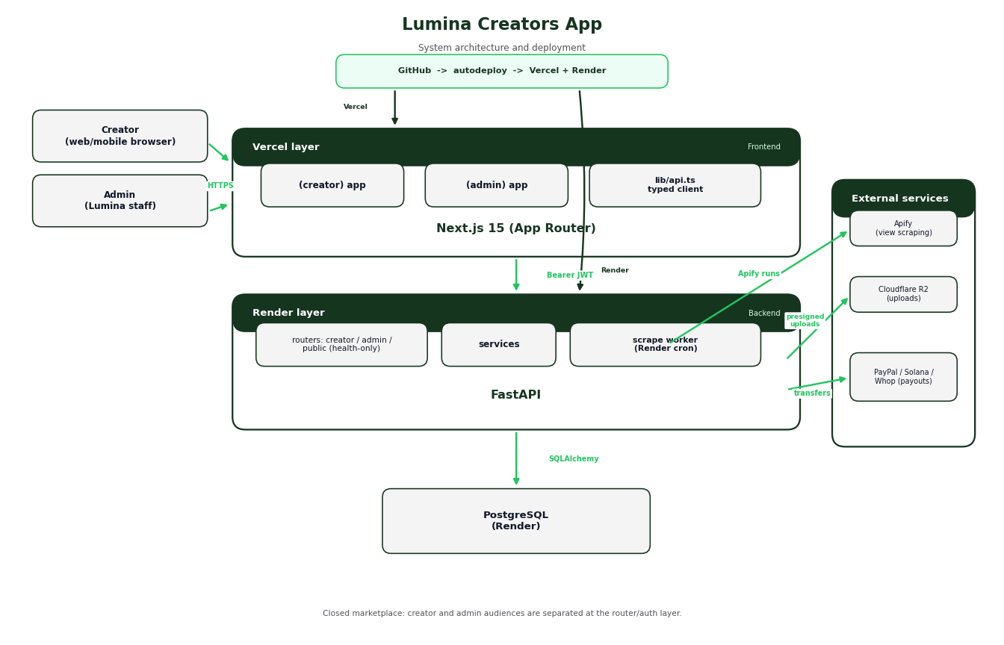
Figure 1 — System architecture and deployment topology.

4. Deployment & version control
- Version control: a single GitHub monorepo (frontend/ + backend/), trunk-based on main with PRs. One PR can span both apps; shared docs live in docs/.
- Production frontend: Vercel — autodeploys the Next.js app on push to main. Env: NEXT_PUBLIC_API_URL.
- Backend + database: Render — a FastAPI web service plus a cron job (scrape worker) and a managed Postgres instance. Migrations (alembic upgrade head) run on deploy.
- Environments: production-first (no staging initially), tested with low-stakes accounts; a Render 'dev' service can be added later. Secrets via platform env vars only.
Flow: push to GitHub main -> Vercel builds & deploys frontend + Render builds & deploys backend/worker and runs migrations.

5. Data model
The high-priority core covers auth, mandatory server-verified creator profiles, the filterable admin database, the campaign builder (both modes, soft-delete), submissions with earning snapshots, durable scraping, and a double-pay-safe payout model. Financial integrity is enforced at the schema level.
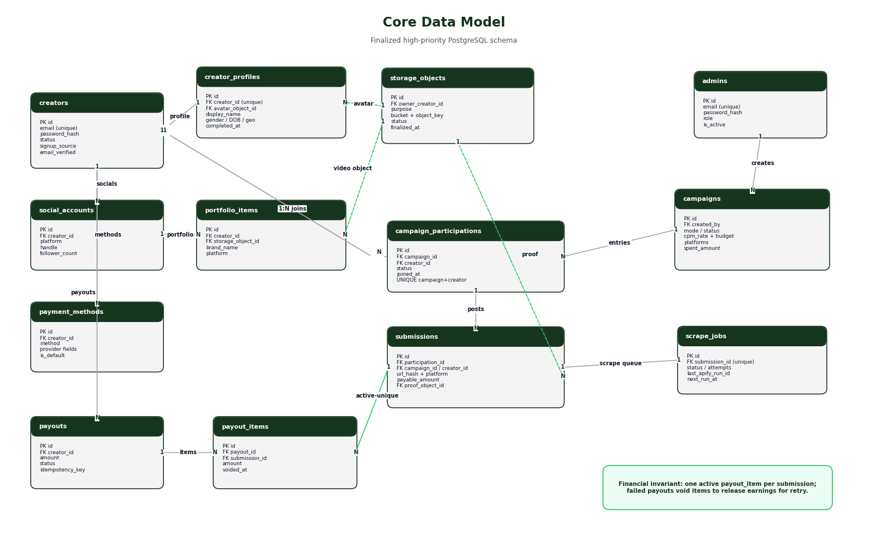
Figure 2 — Core entity-relationship model (high-priority tables).
Financial-integrity guarantees baked into the schema:
- Earnings are priced off snapshots (cpm_rate_snapshot) so editing a campaign never rewrites past earnings.
- Campaign 'delete' is an archive (soft-delete); no cascade ever destroys financial history.
- Money is NUMERIC never float — estimates at 4dp, settled amounts rounded to 2dp.
- Budget is enforced under a row lock at finalization (campaigns.spent_amount vs budget / per-creator cap).

6. Payout lifecycle (retry-safe)
A finalized submission produces a payable amount. Payouts move requested -> processing -> paid | failed. The double-pay guard is an active-unique payout item (at most one non-voided item per submission), so a submission can never be paid twice — yet a failed payout voids its items and releases the earning for retry. Provider transfers carry an idempotency key and are reconciled before being marked failed, so a timed-out-but-succeeded transfer can't become a double send.
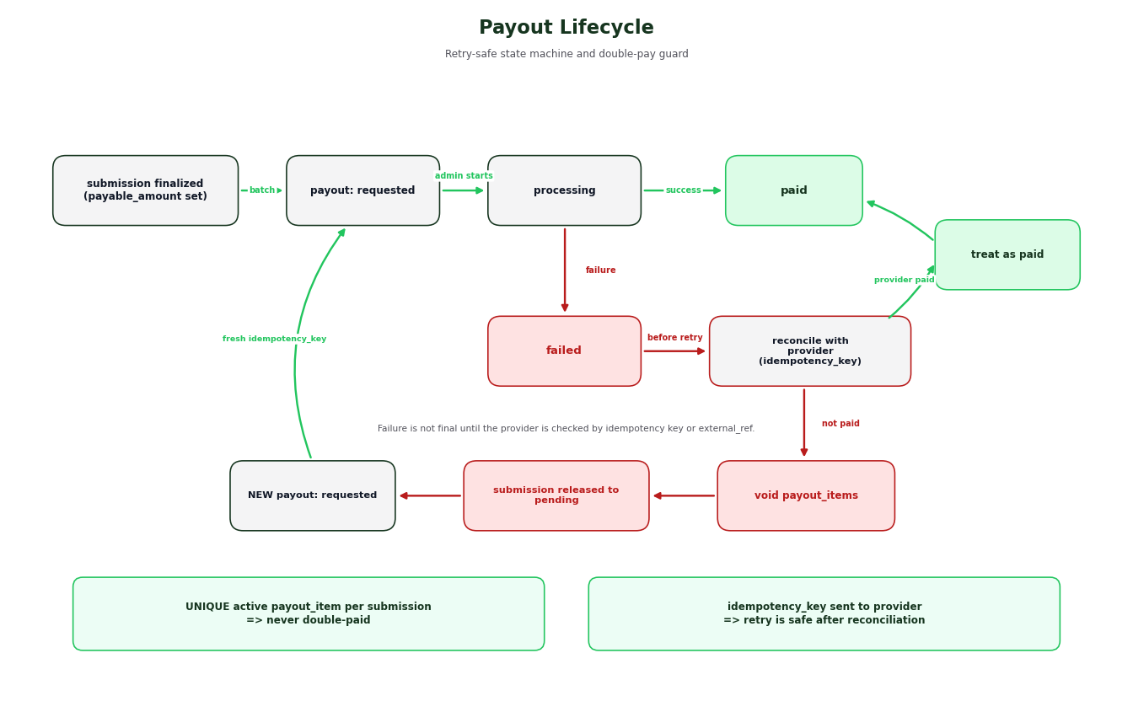
Figure 3 — Payout state machine and retry-safe settlement flow.

7. Decisions needed before development
Open items to resolve together before (or early in) the build. 'Owner' = platform-owner (Rhys) call; 'Dev' = developer/architecture (Bill) call. A default assumption is listed where we have one.
# | Question | For | Default assumption
1 | Which app do we build first after the shared foundation — creator app or admin app? | Owner | —
2 | Does this replace the existing Lumina Clippers creator portal, or run alongside it? If replace, do we migrate existing creators/campaigns? | Owner | Run alongside; migrate later
3 | Payout timing: pay once per submission when finalized, or incrementally as views keep growing? (Incremental needs an earnings-events ledger.) | Owner | Once per submission
4 | eligible_view_pct: do we discount earnings by eligible-region viewers (e.g. US-viewer %), and is it per-campaign or scraped per-submission? | Owner | Per-campaign, default 100%
5 | Demographics: self-reported by creators at signup, or admin-verified? | Owner | Self-reported; admin can edit
6 | create_new verification: is proof-video upload + admin review sufficient? | Owner | Yes
7 | Repo layout: monorepo (frontend/ + backend/) vs two separate repos? | Dev | Monorepo
8 | Storage: Cloudflare R2 vs AWS S3; and upload size/format limits for videos? | Dev | R2; limits TBD
9 | Domains: subdomains for creator vs admin (e.g. creators.* + an obfuscated admin path)? | Dev | Yes, separate
10 | Scrape cadence & retention: how often to re-scrape, and how long after a post to keep tracking? | Dev | Daily; ends at retention window
11 | Payment provider priority for MVP (build which first)? | Owner | PayPal first
12 | Staging environment now, or production-only with test accounts to start? | Dev | Prod-only initially

Full detail behind every decision lives in the repo: CONTEXT.md, docs/ARCHITECTURE.md, docs/SCHEMA.md, and docs/ARCHITECTURE_REVIEW.md (the review that produced this v2).

