Project 1:

Test a Perceptual Phenomenon ##Background information In a Stroop task, participants are presented with a list of words, with each word displayed in a color of ink. The participant’s task is to say out loud the color of the ink in which the word is printed. The task has two conditions: a congruent words condition, and an incongruent words condition. In the congruent words condition, the words being displayed are color words whose names match the colors in which they are printed. In the incongruent words condition, the words displayed are color words whose names do not match the colors in which they are printed. In each case, we measure the time it takes to name the ink colors in equally-sized lists. Each participant will go through and record a time from each condition.

Questions for investigation

1-What is our independent variable? What is our dependent variable?

Word condition (congruent, incongruent),Time

2. What is an appropriate set of hypotheses for this task? What kind of statistical test do you expect to perform?

Ho: null hypotheses is the time for congruent words is the same for incongruent words means that the condition doesn't affect the time.

H1: alternative hypotheses that the time for congruent words differs from incongruent words.

I use two tailed test because the direction is not matter.

The test is t-statistic because we have sample data and no information for populations parameters.

3. Report some descriptive statistics regarding this dataset

### Congruent:

Mean =14.1

Standard deviation=3.56

### Incongruent:

Mean=22.0

Standard deviation=4.8

4. Provide one or two visualizations that show the distribution of the sample data. Write one or two sentences noting what you observe about the plot or plots

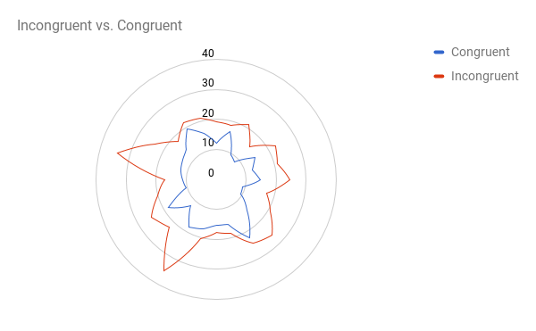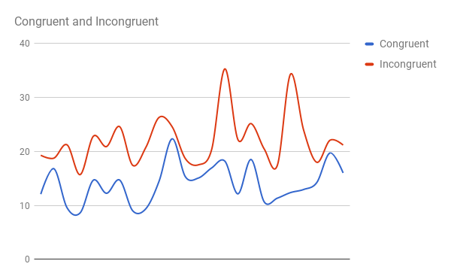

From this chart it is obvious that the time students talking for congruent words is less than the time they take for incongruent words.

5. What is your confidence level and your critical statistic value? Do you reject the null hypothesis or fail to reject it? Come to a conclusion in terms of the experiment task. Did the results match up with your expectations?

Mean difference: -7.9647

Standard error: 1.22

Df=46

T-value=-6.53

T-critical value at alpha level =.05 is +2.013, -2.013.

95% CI=(-10.468,-5.4600)

The two-tailed P value is less than 0.0001 so we reject the null which mean there is extremely difference between the mean of time for congruent words and incongruent words which meet my expectations that the time for students to say the name of the color for the congruent words Is less than the time for incongruent words.