ADMIN PORTAL

ADMIN PORTAL DESCRIPTION:

It deals with all the back-end data generation and product information. The role of the admin is to:

* Authorize the user
* Grant access to user
* Enable/disable the user
* Authorize the Cheque Book requests User Authorization:

After successful registration on the user portal, the user waits for the confirmation mail from the admin for his/her registration. The admin verifies the data given by the user and upon

verification, the status is sent to user’s email which is provided by the user at the time of registration. Only upon successful verification, the user’s account will get activated, the account

number gets generated and he/she can proceed with banking activities. In case of failure, user has

to re-register by providing the correct data. The admin also has a login to view the user details and

perform actions accordingly

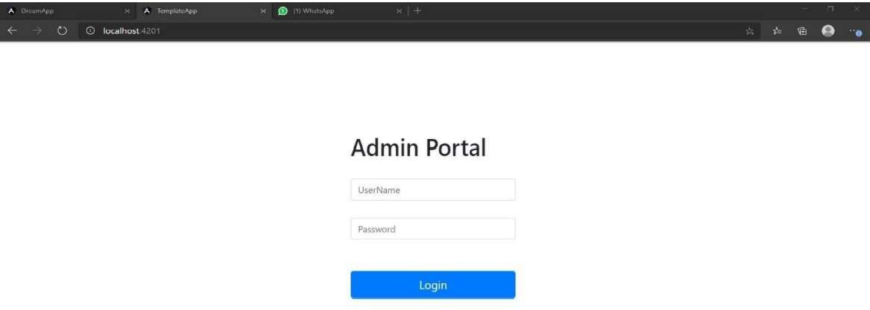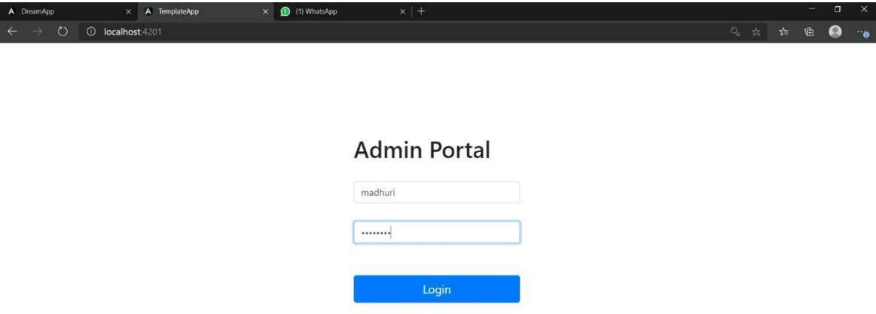

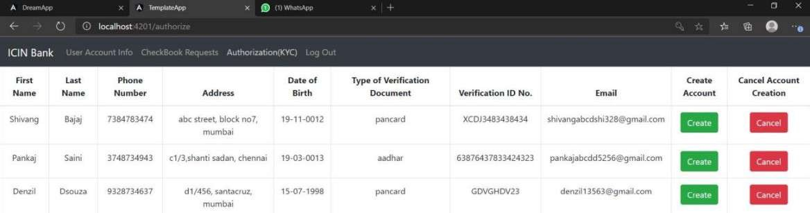

Access Granting:

The admin must set the transaction rights for the user. The three transaction rights are:

* Credit – User is allowed only to deposit.
* Credit + Debit – User is allowed to deposit and withdraw money.
* Credit + Debit + Transfer – User is granted full transaction rights (i.e) he/she can deposit, withdraw and also perform transfer of money to other account holders

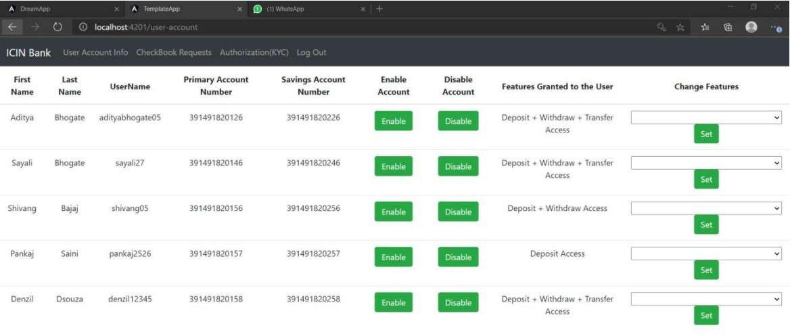

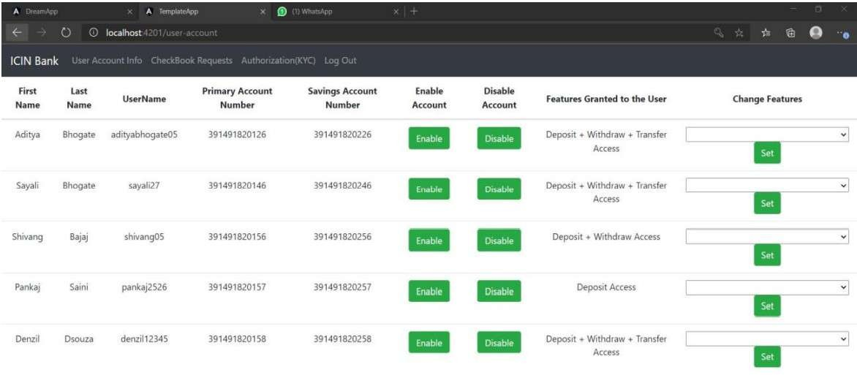

Enabling/Disabling the User:

The admin can disable(block) the user if he/she is found to be suspicious. If the user is

disabled, he/she cannot login and hence is restricted from performing transactions. The admin can

also enable the disabled user after verification in person.

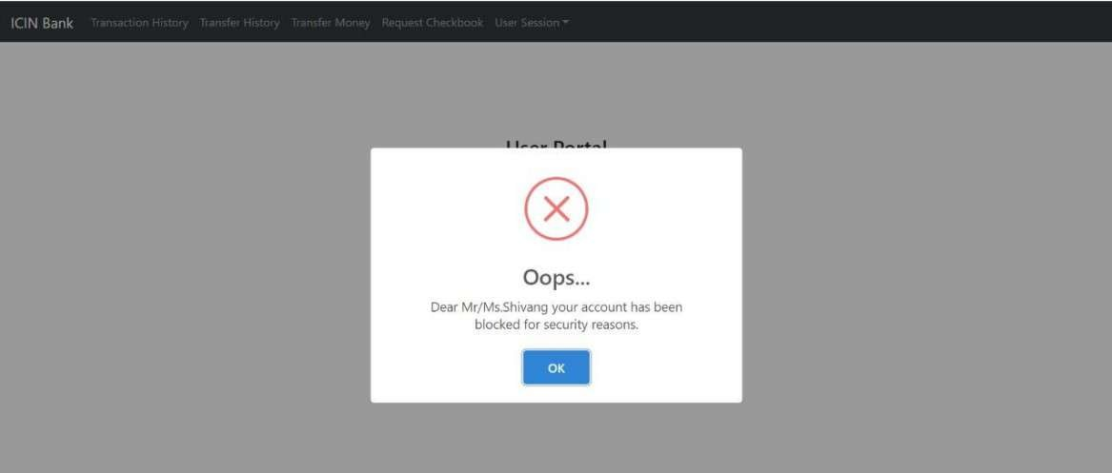

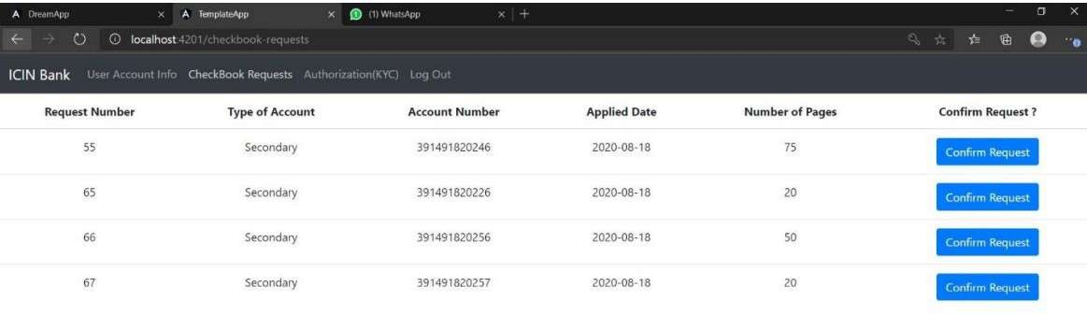

Authorizing Cheque Book Requests:

The admin has to authorize the user’s request for cheque book issue.

Only upon admin’s

confirmation, cheque books are issued to respective user and the confirmation mail is also sent to

the user’s email id

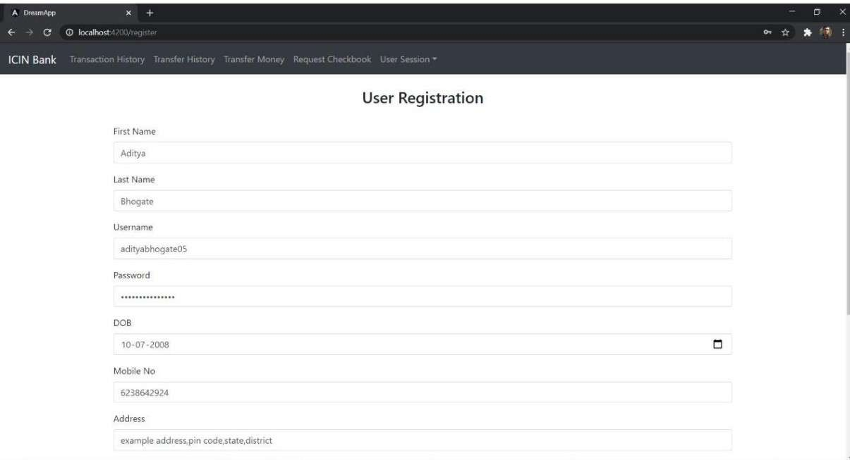

User Portal Description Features:

1) Registration:

The registration is the first step to get started with the application. The user will have to enter his first name, last name, email, phone number, address, username, password, date of birth, and an select an identity card (Aadhaar card, pan card or voters id) and enter its number and the scanned copy of the identity provided. If the username given by the user is checked for duplication in the database if a similar username exists then he or she will have to register with a new username. On registration the user information is passed on to the admin for verification. Once the admin verifies an email will be send to the user that his/her account is activated and a primary and saving account is created for the user

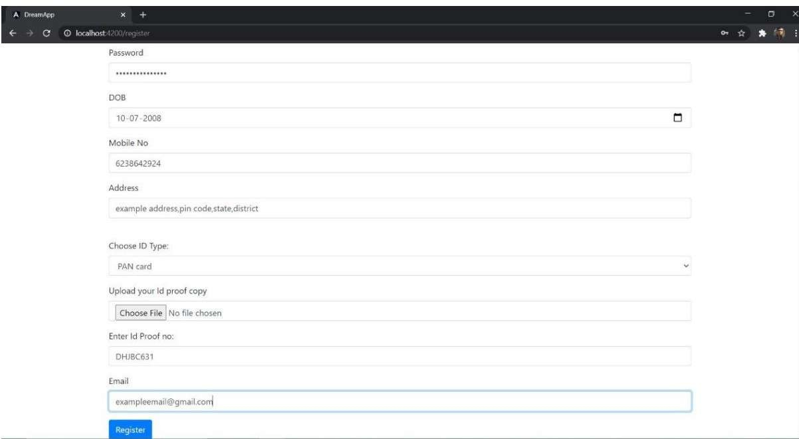

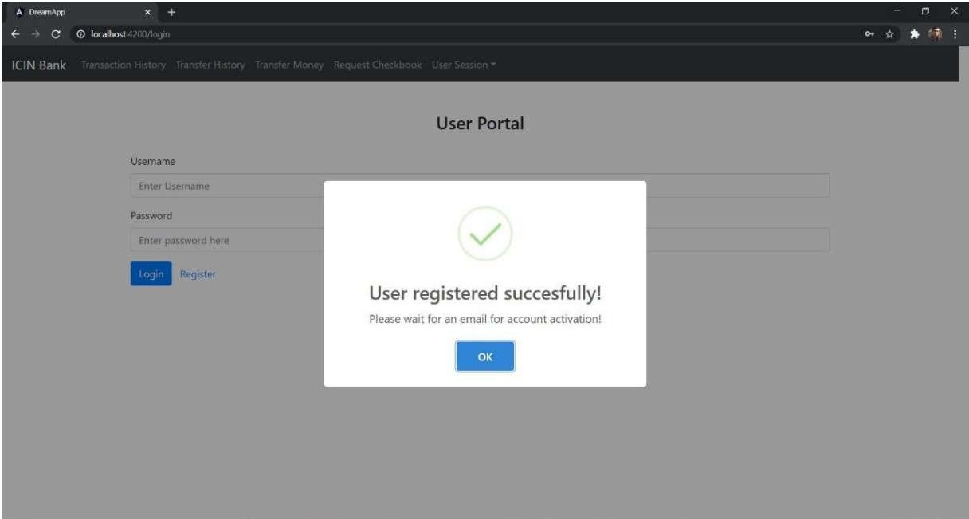

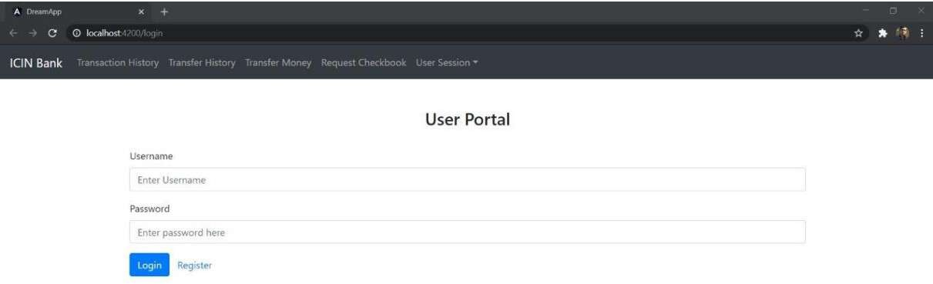

2)Login:

The user can login with the username and password that he had provided on registration after the

admin authorizes his account. The admin can also enable or disable the account. So, for successful

login the user has to enter correct username, correct password and the user has to be authorized

and enabled by the admin

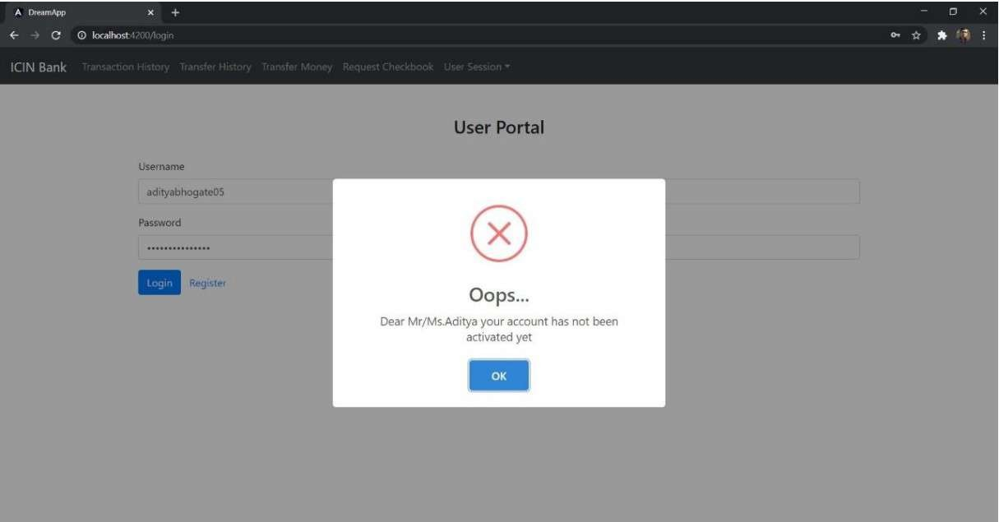

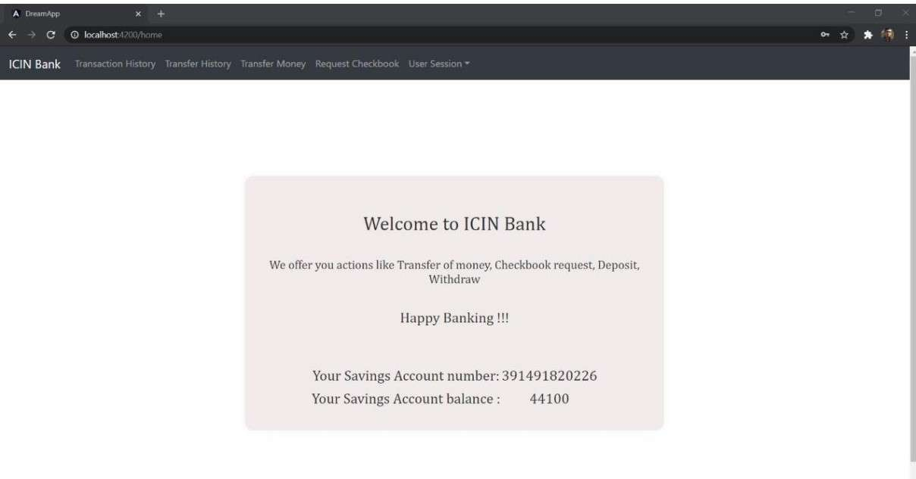

3)Deposit:

The user can deposit money in his/her accounts by entering the correct account number and the

amount if the feature is enabled by the admin.

4)Withdraw:

The user can withdraw money from his/her accounts by entering the account number and the

amount if the feature is enabled by the admin. The operation won’t go through if the amount to be

withdrawn is more than the users account balance.

On successful login we are navigated to the home page.

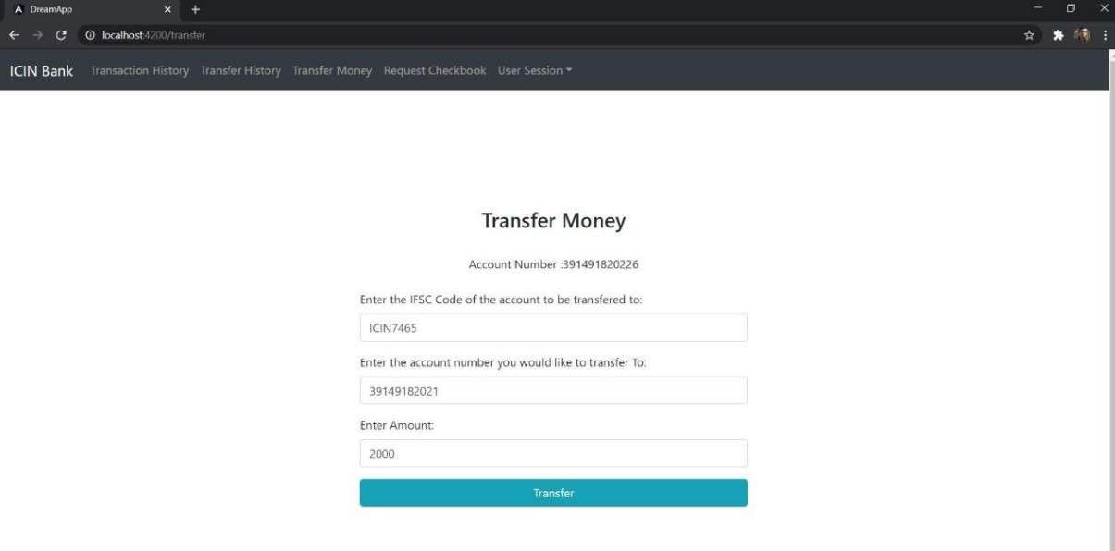

5)Transfer:

The user can transfer money from his/her accountsto other accounts by entering the his/her account

number, the receivers account number, the IFSC code of the receivers account and the amount if

the feature is enabled by the admin. The operation won’t go through if the amount to be transferred

is more than the users account balance or the IFSC code of the receiver account is incorrect.

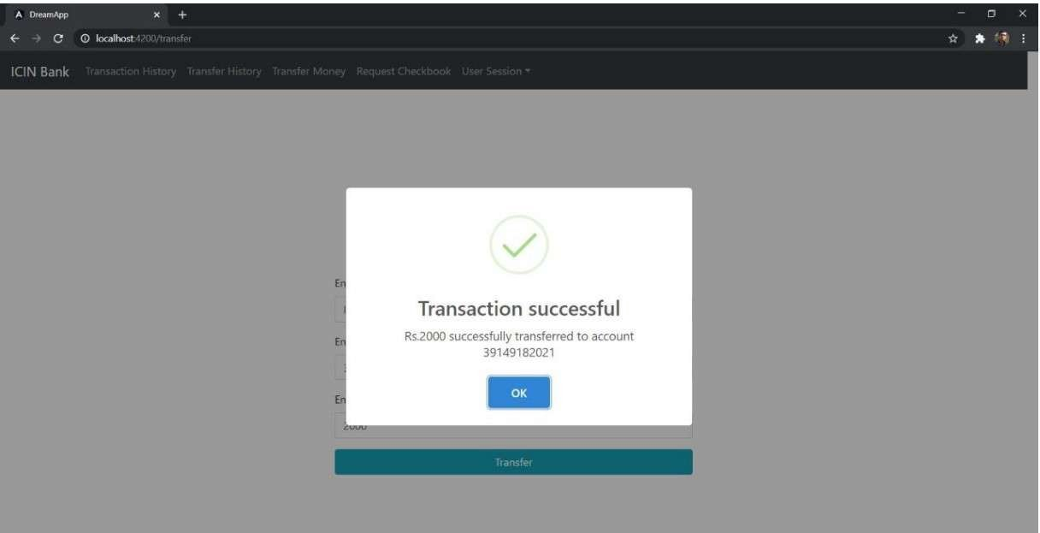

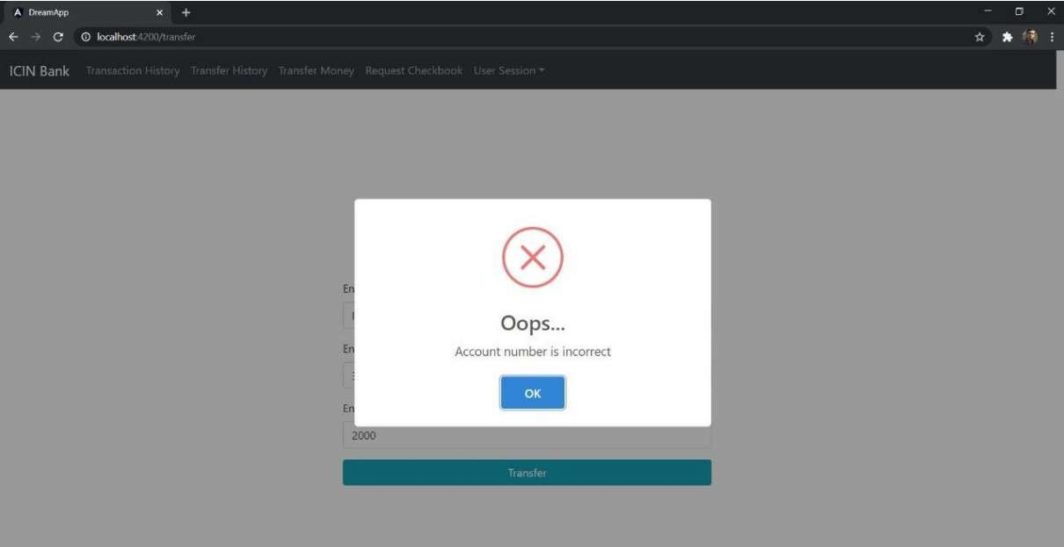

If the receivers account number is wrong.

If the IFSC code is incorrect.

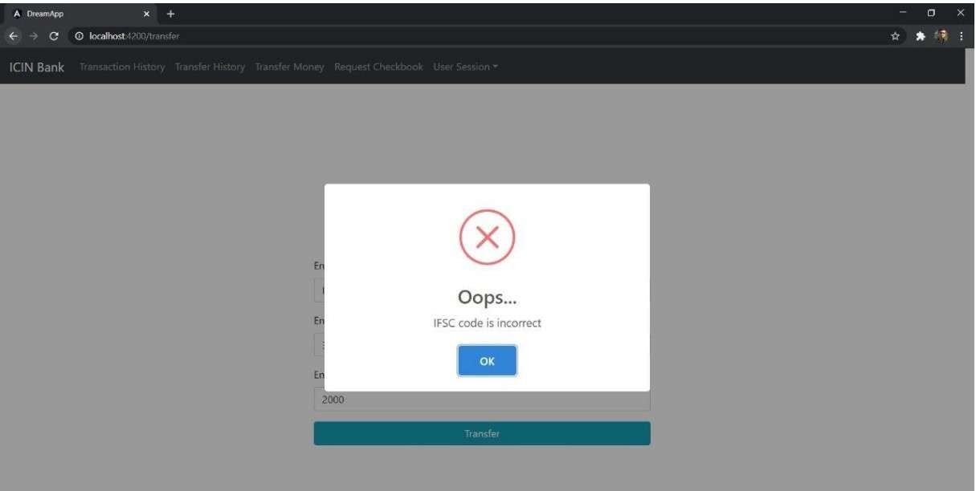

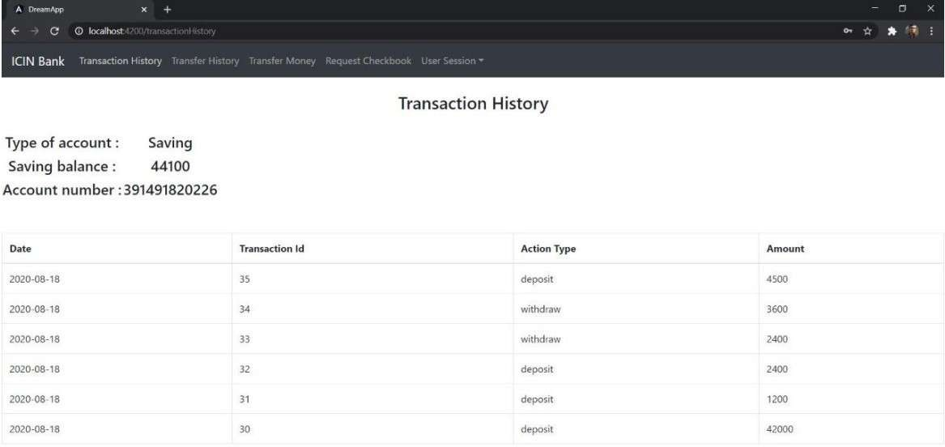

6)Transaction History

In the view transaction history section, you can view transactions for a particular account. Both

when money was deposited or withdrawn.

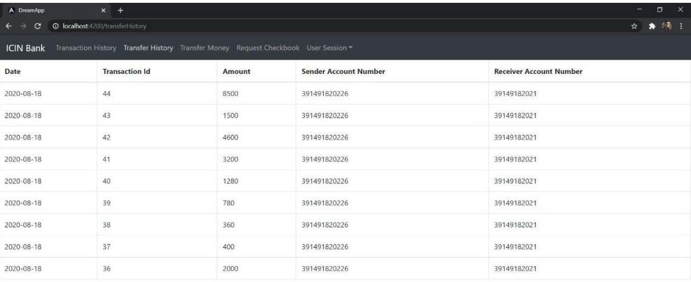

7)View Transfer History:

In the view transfer history section, you can view transfers for a particular account. Both when

money was transferred or received from the account will be displayed

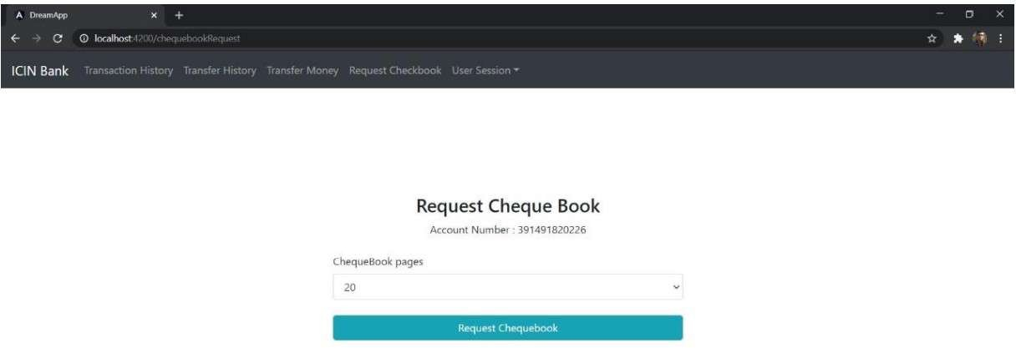

8)Cheque Book Request:

The user can request cheque books for his/her accounts by entering the account number and

number of pages. Once admin accepts or rejects the request the user will get a mail

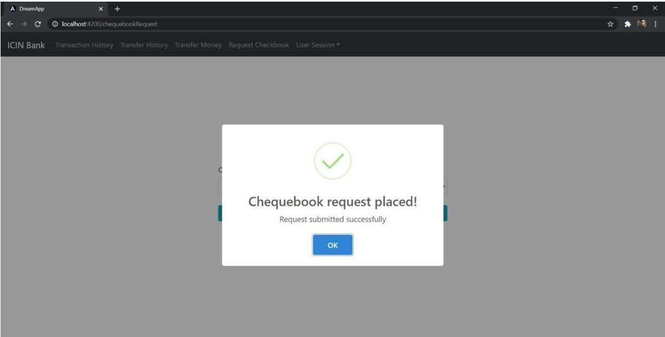

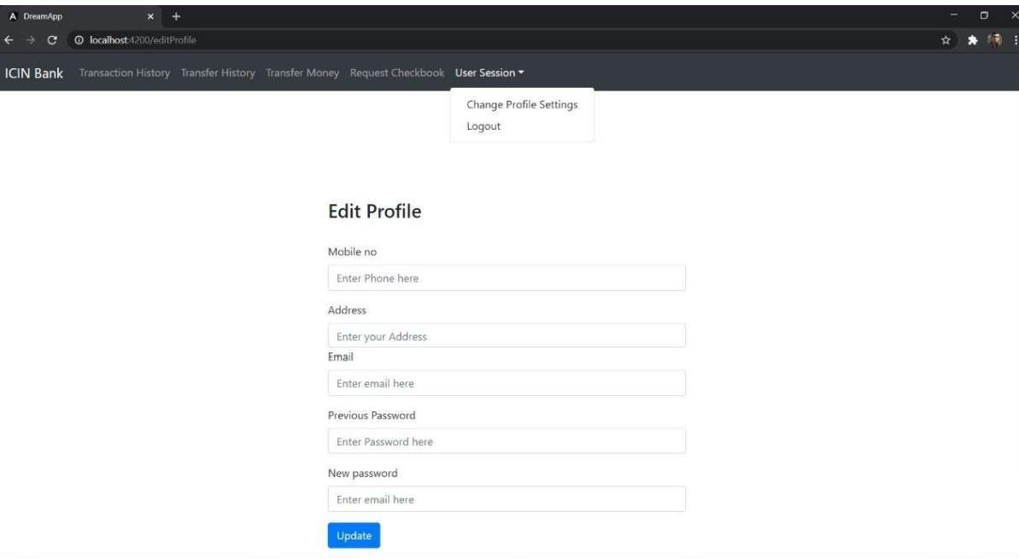

9) Update User:

The user can update some of his details with this function. The user can reset his password by

entering the new password and the correct old password. The user only has to enter the fields that

he wants to update.

